Appendix

Contents

Appendix 1 Search strategies 2

Appendix 2 WinBUGs code for network meta-analysis 10

Appendix 3 Characteristics of the included studies 17

Appendix 4 Methodological quality of the included studies 23

Appendix 5 Conventional meta-analyses results for general topical NSAIDs 26

Appendix 6 Results of SUCRA 35

Appendix 7 Meta-regression results 37

Appendix 8 Detailed results of network meta-analysis 38

# Appendix 1 Search strategies

**A. Search strategies for randomized controlled trials**

**Pubmed**

1. (“non-steroidal anti-inflammatory agents”[Text Word] OR “anti-inflammatory agents, non-steroidal”[MeSH Terms] OR “antiinflammatory agents, non-steroidal”[Pharmacological Action] OR Anti-Inflammatory Agents, Non-Steroidal[Text Word])
2. acetylsalicyl* OR carbasalaatcalcium OR diflunisal OR aceclofenac OR alclofenac OR apazone OR etodolac OR eltenac OR diclofenac OR indometacin OR sulindac OR meloxicam OR piroxicam OR dexibuprofen OR dexketoprofen OR fenoprofen OR fenbufen OR indomethacin OR flurbiprofen OR ibuprofen OR ketoprofen OR naproxen OR tiapro* OR metamizol OR phenylbutazone OR phenazone OR propyphenazone OR celecoxib OR etoricoxib OR nabumetone OR parecoxib OR salicylate* OR tenoxicam OR "tiaprofenic acid"
3. bufexamac OR bufexine OR calmaderm OR ekzemase OR dicoflenac OR solaraze OR pennsaid OR voltarol OR emulgel OR voltarene OR optha OR voltaren OR etofenamate OR afrolate OR algesalona OR bayro OR deiron OR etofen OR flexium OR flogoprofen OR rheuma-gel OR rheumon OR traumalix OR traumon OR zenavan OR felbinac OR dolinac OR flexfree OR napageln OR target OR traxam OR fentiazac OR domureuma OR fentiazaco OR norvedan OR riscalon OR fepradinol OR dalgen OR flexidol OR cocresol OR rangozona OR reuflodol OR pinazone OR zepelin OR flufenamic OR dignodolin
4. rheuma OR lindofluid OR sastridex OR lunoxaprofen OR priaxim OR flubiprofen OR fenomel OR ocufen OR ocuflur OR “Trans Act LAT” OR tulip OR ibuprofen OR cuprofen OR “deep relief” OR fenbid OR ibu-cream OR ibugel OR ibuleve OR ibumousse OR ibuspray OR “nurofen gel” OR proflex OR motrin OR advil OR radian OR ralgex OR ibutop OR indomethacin OR indocin OR indospray OR isonixin OR nixyn OR ketoprofen OR tiloket OR oruvail OR powergel OR solpaflex OR ketorolac OR acular OR trometamol OR meclofenamic OR naproxen OR naprosyn OR niflumic OR actol OR flunir OR niflactol topico OR niflugel OR nifluril OR oxyphenbutazone OR californit OR diflamil OR otone OR tanderil OR piketoprofen OR calmatel OR triparsean OR piroxicam OR feldene OR pranoprofen OR oftalar OR pranox OR suxibuzone OR danilon OR flamilon OR ufenamate OR fenazol
5. OR/1-4
6. “Administration, Topical”[Mesh]
7. topical* OR cutaneous OR dermal OR transcutaneous OR transdermal OR percutaneous OR skin OR massage OR embrocation OR gel OR ointment OR aerosol OR cream OR crème OR lotion OR mousse OR foam OR liniment OR spray OR rub OR balm OR salve OR emulsion OR oil OR patch OR plaster
8. 6 OR 7
9. osteoarthriti*[tiab] OR osteoarthriti*[mh]
10. osteoarthro*[tiab] OR gonarthriti*[tiab] OR gonarthro*[tiab] OR coxarthriti*[tiab] OR coxarthro*[tiab] OR osteo?arthritis[tiab]
11. (knee*[tiab] OR hip[tiab] OR joint*[tiab]) AND (pain*[tiab] OR discomfort*[tiab])
12. (knee*[tiab] OR hip[tiab] OR joint*[tiab]) AND stiff*[tiab]
13. OR/9-12
14. randomized[tiab] OR placebo[tiab] OR controlled[tiab] OR random*[tiab] OR “rct”[text word] OR trial*[tiab] OR groups[tiab]
15. ((singl*[tiab] OR doubl*[tiab] OR tripl*[tiab]) AND (mask*[tiab] OR blind*[tiab]))
16. 14 OR 15
17. 5 AND 8 AND 13 AND 16

**Embase**

1. ‘osteoarthritis’/exp
2. (osteoarthriti* OR osteoarthro* OR gonarthriti* OR gonarthro* OR gonarthro* OR coxarthriti* OR coxarthro* OR arthros* OR arthrot*):ti,ab
3. ((knee* OR hip* OR joint*) near/3 (pain* OR ach* OR discomfort*)):ti,ab
4. ((knee* OR hip* OR joint*) near/3 stiff*):ti,ab
5. OR/1-4
6. ‘nonsteroid antiinflammatory agent’/exp
7. (acetylsalicyl* OR carbasalaatcalcium OR diflunisal OR aceclofenac OR alclofenac OR apazone OR etodolac OR eltenac OR diclofenac OR indometacin OR sulindac OR meloxicam OR piroxicam OR dexibuprofen OR dexketoprofen OR fenoprofen OR fenbufen OR indomethacin OR flurbiprofen OR ibuprofen OR ketoprofen OR naproxen OR tiapro* OR metamizol OR phenylbutazone OR phenazone OR propyphenazone OR celecoxib OR etoricoxib OR nabumetone OR parecoxib OR salicylate* OR tenoxicam OR "tiaprofenic acid" or bufexamac OR bufexine OR calmaderm OR ekzemase OR dicoflenac OR solaraze OR pennsaid OR voltarol OR emulgel OR voltarene OR optha OR voltaren OR etofenamate OR afrolate OR algesalona OR bayro OR deiron OR etofen OR flexium OR flogoprofen OR rheuma-gel OR rheumon OR traumalix OR traumon OR zenavan OR felbinac OR dolinac OR flexfree OR napageln OR target OR traxam OR fentiazac OR domureuma OR fentiazaco OR norvedan OR riscalon OR fepradinol OR dalgen OR flexidol OR cocresol OR rangozona OR reuflodol OR pinazone OR zepelin OR flufenamic OR dignodolin or rheuma OR lindofluid OR sastridex OR lunoxaprofen OR priaxim OR flubiprofen OR fenomel OR ocufen OR ocuflur OR “Trans Act LAT” OR tulip OR ibuprofen OR cuprofen OR “deep relief” OR fenbid OR ibu-cream OR ibugel OR ibuleve OR ibumousse OR ibuspray OR “nurofen gel” OR proflex OR motrin OR advil OR radian OR ralgex OR ibutop OR indomethacin OR indocin OR indospray OR isonixin OR nixyn OR ketoprofen OR tiloket OR oruvail OR powergel OR solpaflex OR ketorolac OR acular OR trometamol OR meclofenamic OR naproxen OR naprosyn OR niflumic OR actol OR flunir OR niflactol topico OR niflugel OR nifluril OR oxyphenbutazone OR californit OR diflamil OR otone OR tanderil OR piketoprofen OR calmatel OR triparsean OR piroxicam OR feldene OR pranoprofen OR oftalar OR pranox OR suxibuzone OR danilon OR flamilon OR ufenamate OR fenazol):ti,ab
8. 6 OR 7
9. ‘topical drug administration’/exp
10. (topical* OR cutaneous OR dermal OR transcutaneous OR transdermal OR percutaneous OR skin OR massage OR embrocation OR gel OR ointment OR aerosol OR cream OR crème OR lotion OR mousse OR foam OR liniment OR spray OR rub OR balm OR salve OR emulsion OR oil OR patch OR plaster):ti,ab
11. 9 OR 10
12. (random* OR control* OR trial* OR placebo):ti,ab
13. ‘rct’:ti,ab
14. ((singl* OR doubl*OR tripl*) AND (mask* OR blind*)):ti,ab
15. OR/12-14
16. 5 AND 8 AND 11 AND 15

**Cochrane Library**

1. MeSH descriptor Osteoarthritis explode all trees
2. (osteoarthritis* OR osteoarthro* OR gonarthriti* OR gonarthro* OR coxarthriti* OR coxarthro* OR arthros* OR arthrot*):ab,ti
3. 1 OR 2
4. MESH descriptor anti-inflammatory agents, non-steroidal explode all trees
5. (acetylsalicyl* OR carbasalaatcalcium OR diflunisal OR aceclofenac OR alclofenac OR apazone OR etodolac OR eltenac OR diclofenac OR indometacin OR sulindac OR meloxicam OR piroxicam OR dexibuprofen OR dexketoprofen OR fenoprofen OR fenbufen OR indomethacin OR flurbiprofen OR ibuprofen OR ketoprofen OR naproxen OR tiapro* OR metamizol OR phenylbutazone OR phenazone OR propyphenazone OR celecoxib OR etoricoxib OR nabumetone OR parecoxib OR salicylate* OR tenoxicam OR "tiaprofenic acid" OR bufexamac OR bufexine OR calmaderm OR ekzemase OR dicoflenac OR solaraze OR pennsaid OR voltarol OR emulgel OR voltarene OR optha OR voltaren OR etofenamate OR afrolate OR algesalona OR bayro OR deiron OR etofen OR flexium OR flogoprofen OR rheuma-gel OR rheumon OR traumalix OR traumon OR zenavan OR felbinac OR dolinac OR flexfree OR napageln OR target OR traxam OR fentiazac OR domureuma OR fentiazaco OR norvedan OR riscalon OR fepradinol OR dalgen OR flexidol OR cocresol OR rangozona OR reuflodol OR pinazone OR zepelin OR flufenamic OR dignodolin OR rheuma OR lindofluid OR sastridex OR lunoxaprofen OR priaxim OR flubiprofen OR fenomel OR ocufen OR ocuflur OR “Trans Act LAT” OR tulip OR ibuprofen OR cuprofen OR “deep relief” OR fenbid OR ibu-cream OR ibugel OR ibuleve OR ibumousse OR ibuspray OR “nurofen gel” OR proflex OR motrin OR advil OR radian OR ralgex OR ibutop OR indomethacin OR indocin OR indospray OR isonixin OR nixyn OR ketoprofen OR tiloket OR oruvail OR powergel OR solpaflex OR ketorolac OR acular OR trometamol OR meclofenamic OR naproxen OR naprosyn OR niflumic OR actol OR flunir OR niflactol topico OR niflugel OR nifluril OR oxyphenbutazone OR californit OR diflamil OR otone OR tanderil OR piketoprofen OR calmatel OR triparsean OR piroxicam OR feldene OR pranoprofen OR oftalar OR pranox OR suxibuzone OR danilon OR flamilon OR ufenamate OR fenazol):ti,ab
6. 4 OR 5
7. MESH descriptor Administration, Topical explode all trees
8. (topical* OR cutaneous OR dermal OR transcutaneous OR transdermal OR percutaneous OR skin OR massage OR embrocation OR gel OR ointment OR aerosol OR cream OR crème OR lotion OR mousse OR foam OR liniment OR spray OR rub OR balm OR salve OR emulsion OR oil OR patch OR plaster):ti,ab
9. 7 OR 8
10. 3 AND 6 AND 9

**World Health Organization International Clinical Trials Registry (ICTRP)**

1. ((NASID or etodolac OR eltenac OR diclofenac OR indometacin OR sulindac OR sulindac OR meloxicam OR piroxicam OR dexibuprofen OR fenoprofen OR fenbufen OR indomethacin OR flurbiprofen OR ibuprofen OR ketoprofen OR naproxen OR metamizol OR phenylbutazone OR phenazone OR propyphenazone OR celecoxib OR metamizol OR phenylbutazone OR phenazone OR propyphenazone OR celecoxib OR etoricoxib OR nabumeton OR parecoxib OR salicylate OR tenoxicam) AND (topical OR gel OR ointment OR cream OR lotion OR oil OR patch OR plaster)) in the intervention

2. Osteoarthritis in the title

3. 1 and 2

**B. Search strategies for observational studies**

**Pubmed**

1. (“non-steroidal anti-inflammatory agents”[Text Word] OR “anti-inflammatory agents, non-steroidal”[Mesh] OR “antiinflammatory agents, non-steroidal”[Pharmacological Action] OR Anti-Inflammatory Agents, Non-Steroidal[Text Word]) OR “NSAID*”[tiab] OR “nonsteroidal antiinflammatory”[tiab] OR “non-steroidal anti-inflammatory”[tiab]
2. (acetylsalicyl*[tiab] OR carbasalaatcalcium[tiab] OR diflunisal[tiab] OR aceclofenac[tiab] OR alclofenac[tiab] OR apazone[tiab] OR etodolac[tiab] OR eltenac[tiab] OR diclofenac[tiab] OR indometacin[tiab] OR sulindac[tiab] OR meloxicam[tiab] OR piroxicam[tiab] OR dexibuprofen[tiab] OR dexketoprofen[tiab] OR fenoprofen[tiab] OR fenbufen[tiab] OR indomethacin[tiab] OR flurbiprofen[tiab] OR ibuprofen[tiab] OR ketoprofen[tiab] OR naproxen[tiab])
3. (tiapro*[tiab] OR metamizol[tiab] OR phenylbutazone[tiab] OR phenazone[tiab] OR propyphenazone[tiab] OR celecoxib[tiab] OR etoricoxib[tiab] OR nabumetone[tiab] OR parecoxib[tiab] OR salicylate*[tiab] OR tenoxicam[tiab] OR "tiaprofenic acid"[tiab])
4. (bufexamac[tiab] OR bufexine[tiab] OR calmaderm[tiab] OR ekzemase[tiab] OR dicoflenac[tiab] OR solaraze[tiab] OR pennsaid[tiab] OR voltarol[tiab] OR emulgel[tiab] OR voltarene[tiab] OR optha[tiab] OR voltaren[tiab] OR etofenamate[tiab] OR afrolate[tiab] OR algesalona[tiab] OR bayro[tiab] OR deiron[tiab] OR etofen[tiab] OR flexium[tiab] OR flogoprofen[tiab] OR rheuma-gel[tiab] OR rheumon[tiab] OR traumalix[tiab] OR traumon[tiab] OR zenavan[tiab] OR felbinac[tiab])
5. (dolinac[tiab] OR flexfree[tiab] OR napageln[tiab] OR target[tiab] OR traxam[tiab] OR fentiazac[tiab] OR domureuma[tiab] OR fentiazaco[tiab] OR norvedan[tiab] OR riscalon[tiab] OR fepradinol[tiab] OR dalgen[tiab] OR flexidol[tiab] OR cocresol[tiab] OR rangozona[tiab] OR reuflodol[tiab] OR pinazone[tiab] OR zepelin[tiab] OR flufenamic[tiab] OR dignodolin[tiab])
6. rheuma[tiab] OR priaxim[tiab] OR flubiprofen[tiab] OR ocufen[tiab] OR ocuflur[tiab] OR “Trans Act LAT”[tiab] OR tulip[tiab] OR ibuprofen[tiab] OR cuprofen[tiab] OR “deep relief”[tiab] OR fenbid[tiab] OR ibu-cream[tiab] OR ibugel[tiab] OR ibuleve[tiab]
7. (ibumousse[tiab] OR ibuspray[tiab] OR “nurofen gel”[tiab] OR proflex[tiab] OR motrin[tiab] OR advil[tiab] OR radian[tiab] OR ralgex[tiab] OR ibutop[tiab] OR indomethacin[tiab] OR indocin[tiab] OR indospray[tiab] OR isonixin[tiab] OR nixyn[tiab] OR ketoprofen[tiab] OR tiloket[tiab] OR oruvail[tiab] OR powergel[tiab] OR solpaflex[tiab] OR ketorolac[tiab])
8. (acular[tiab] OR trometamol[tiab] OR meclofenamic[tiab] OR naproxen[tiab] OR naprosyn[tiab] OR niflumic[tiab] OR actol[tiab] OR flunir[tiab] OR niflactol topico[tiab] OR niflugel[tiab] OR nifluril[tiab] OR oxyphenbutazone[tiab] OR californit[tiab] OR diflamil[tiab] OR otone[tiab] OR tanderil[tiab] OR piketoprofen[tiab] OR calmatel[tiab])
9. (triparsean[tiab] OR piroxicam[tiab] OR feldene[tiab] OR pranoprofen[tiab] OR oftalar[tiab] OR pranox[tiab] OR suxibuzone[tiab] OR danilon[tiab] OR flamilon[tiab] OR ufenamate[tiab] OR fenazol[tiab])
10. Or/1-9
11. “Administration, Topical”[Mesh]
12. (topical*[tiab] OR cutaneous[tiab] OR dermal[tiab] OR transcutaneous[tiab] OR transdermal[tiab] OR percutaneous[tiab] OR skin[tiab] OR massage[tiab] OR embrocation[tiab] OR gel[tiab] OR ointment[tiab] OR aerosol[tiab] OR cream[tiab] OR crème[tiab] OR lotion[tiab] OR mousse[tiab] OR foam[tiab] OR liniment[tiab] OR spray[tiab] OR rub[tiab] OR balm[tiab] OR salve[tiab] OR emulsion[tiab] OR oil[tiab] OR patch[tiab] OR plaster[tiab])
13. 11 or 12
14. (cross[tiab] and sectional[tiab]) or longitudinal[tiab] or (case[tiab] and control[tiab]) or case-control[tiab] or cohort*[tiab] or observational[tiab] or population?based[tiab]
15. 10 and 13 and 14

**Embase**

1. ‘nonsteroid antiinflammatory agent’/exp
2. (acetylsalicyl* OR carbasalaatcalcium OR diflunisal OR aceclofenac OR alclofenac OR apazone OR etodolac OR eltenac OR diclofenac OR indometacin OR sulindac OR meloxicam OR piroxicam OR dexibuprofen OR dexketoprofen OR fenoprofen OR fenbufen OR indomethacin OR flurbiprofen OR ibuprofen OR ketoprofen OR naproxen OR tiapro* OR metamizol OR phenylbutazone OR phenazone OR propyphenazone OR celecoxib OR etoricoxib OR nabumetone OR parecoxib OR salicylate* OR tenoxicam OR "tiaprofenic acid" or bufexamac OR bufexine OR calmaderm OR ekzemase OR dicoflenac OR solaraze OR pennsaid OR voltarol OR emulgel OR voltarene OR optha OR voltaren OR etofenamate OR afrolate OR algesalona OR bayro OR deiron OR etofen OR flexium OR flogoprofen OR rheuma-gel OR rheumon OR traumalix OR traumon OR zenavan OR felbinac OR dolinac OR flexfree OR napageln OR target OR traxam OR fentiazac OR domureuma OR fentiazaco OR norvedan OR riscalon OR fepradinol OR dalgen OR flexidol OR cocresol OR rangozona OR reuflodol OR pinazone OR zepelin OR flufenamic OR dignodolin or rheuma OR lindofluid OR sastridex OR lunoxaprofen OR priaxim OR flubiprofen OR fenomel OR ocufen OR ocuflur OR “Trans Act LAT” OR tulip OR ibuprofen OR cuprofen OR “deep relief” OR fenbid OR ibu-cream OR ibugel OR ibuleve OR ibumousse OR ibuspray OR “nurofen gel” OR proflex OR motrin OR advil OR radian OR ralgex OR ibutop OR indomethacin OR indocin OR indospray OR isonixin OR nixyn OR ketoprofen OR tiloket OR oruvail OR powergel OR solpaflex OR ketorolac OR acular OR trometamol OR meclofenamic OR naproxen OR naprosyn OR niflumic OR actol OR flunir OR niflactol topico OR niflugel OR nifluril OR oxyphenbutazone OR californit OR diflamil OR otone OR tanderil OR piketoprofen OR calmatel OR triparsean OR piroxicam OR feldene OR pranoprofen OR oftalar OR pranox OR suxibuzone OR danilon OR flamilon OR ufenamate OR fenazol):ti,ab
3. 1 OR 2
4. ‘topical drug administration’/exp
5. (topical* OR cutaneous OR dermal OR transcutaneous OR transdermal OR percutaneous OR skin OR massage OR embrocation OR gel OR ointment OR aerosol OR cream OR crème OR lotion OR mousse OR foam OR liniment OR spray OR rub OR balm OR salve OR emulsion OR oil OR patch OR plaster):ti,ab
6. 4 OR 5
7. ((cross near/1 sectional) or longitudinal or (case near/1 control) or cohort* or observational or (population near/1 based)):ti,ab
8. 3 AND 6 AND 7

**Web of Science**

1. TOPIC: (“non-steroidal anti-inflammatory agents” OR “anti-inflammatory agents, non-steroidal” OR “antiinflammatory agents, non-steroidal” OR “Anti-Inflammatory Agents, Non-Steroidal” OR “NSAID*” OR “nonsteroidal antiinflammatory” OR “non-steroidal anti-inflammatory”)
2. TITLE:(acetylsalicyl* OR carbasalaatcalcium OR diflunisal OR aceclofenac OR alclofenac OR apazone OR etodolac OR eltenac OR diclofenac OR indometacin OR sulindac OR meloxicam OR piroxicam OR dexibuprofen OR dexketoprofen OR fenoprofen OR fenbufen OR indomethacin OR flurbiprofen OR ibuprofen OR ketoprofen OR naproxen OR tiapro* OR metamizol OR phenylbutazone OR phenazone OR propyphenazone OR celecoxib OR etoricoxib OR nabumetone OR parecoxib OR salicylate* OR tenoxicam OR "tiaprofenic acid" or bufexamac OR bufexine OR calmaderm OR ekzemase OR dicoflenac OR solaraze OR pennsaid OR voltarol OR emulgel OR voltarene OR optha OR voltaren OR etofenamate OR afrolate OR algesalona OR bayro OR deiron OR etofen OR flexium OR flogoprofen OR rheuma-gel OR rheumon OR traumalix OR traumon OR zenavan OR felbinac OR dolinac OR flexfree OR napageln OR target OR traxam OR fentiazac OR domureuma OR fentiazaco OR norvedan OR riscalon OR fepradinol OR dalgen OR flexidol OR cocresol OR rangozona OR reuflodol OR pinazone OR zepelin OR flufenamic OR dignodolin or rheuma OR lindofluid OR sastridex OR lunoxaprofen OR priaxim OR flubiprofen OR fenomel OR ocufen OR ocuflur OR “Trans Act LAT” OR tulip OR ibuprofen OR cuprofen OR “deep relief” OR fenbid OR ibu-cream OR ibugel OR ibuleve OR ibumousse OR ibuspray OR “nurofen gel” OR proflex OR motrin OR advil OR radian OR ralgex OR ibutop OR indomethacin OR indocin OR indospray OR isonixin OR nixyn OR ketoprofen OR tiloket OR oruvail OR powergel OR solpaflex OR ketorolac OR acular OR trometamol OR meclofenamic OR naproxen OR naprosyn OR niflumic OR actol OR flunir OR niflactol topico OR niflugel OR nifluril OR oxyphenbutazone OR californit OR diflamil OR otone OR tanderil OR piketoprofen OR calmatel OR triparsean OR piroxicam OR feldene OR pranoprofen OR oftalar OR pranox OR suxibuzone OR danilon OR flamilon OR ufenamate OR fenazol)
3. 1 OR 2
4. TOPIC: (topical* OR cutaneous OR dermal OR transcutaneous OR transdermal OR percutaneous OR skin OR massage OR embrocation OR gel OR ointment OR aerosol OR cream OR crème OR lotion OR mousse OR foam OR liniment OR spray OR rub OR balm OR salve OR emulsion OR oil OR patch OR plaster)
5. TOPIC: ((cross near/1 sectional) OR longitudinal OR (case near/1 control) OR cohort* OR observational OR (population near/1 based))
6. 3 AND 4 AND 5

# Appendix 2 WinBUGs code for network meta-analysis

**2.1 Random effects model for continuous outcome**

model{

for(i in 1:ns){

w[i,1] <- 0

delta[i,1] <- 0

mu[i] ~ dnorm(0,.0001) # vague priors for all trials baselines

for (k in 1:na[i]) {

var[i,k] <- pow(se[i,k],2)

prec[i,k] <- 1/var[i,k] # set precisions

y[i,k] ~ dnorm(phi[i,k], prec[i,k]) # normal likelihood

phi[i,k] <- theta[i,k] * Pooled.sd[i]

theta[i,k] <- mu[i] + delta[i,k]

# deviance arm k, study i

dev[i,k] <- (y[i,k]-phi[i,k])*(y[i,k]-phi[i,k])/var[i,k]

}

for (k in 2:na[i]){

# distributions for trial-specific SMD

delta[i,k] ~ dnorm(md[i,k], taud[i,k])

md[i,k] <- (d[t[i,k]] - d[t[i,1]]) + sw[i,k]

#precision of diff in means distributions

taud[i,k] <- tau *2*(k-1)/k

#adjustment, multi-arm RCTs

w[i,k] <- delta[i,k] - d[t[i,k]] + d[t[i,1]]

# cumulative adjustment for multi-arm trials

sw[i,k] <-sum(w[i,1:k-1])/(k-1)

}

resdev[i] <- sum(dev[i, 1:na[i]]) # residual deviance for study i

}

d[1]<-0

for (k in 2:nt){d[k] ~ dnorm(0,.0001) } # vague priors for basic parameters

sd.d ~ dunif(0,10) # vague prior for RE st dev

var.d <- pow(sd.d,2)

tau <- 1/var.d

# overall residual deviance

totresdev <- sum(resdev[])

# all pairwise differences

for (c in 1:(nt-1)) { for (k in (c+1):nt) {pwdiff[c,k] <- (d[k]-d[c]) } }

#Ranking of treatments#

for(k in 1:nt) {

order[k]<-rank(d[],k)

# this is when the outcome is positive - omit 'nt+1-' when the outcome is negative

most.effective[k]<-equals(order[k],1)

for(j in 1:nt) {

effectiveness[k,j]<- equals(order[k],j)}}

for(k in 1:nt) {

for(j in 1:nt) {cumeffectiveness[k,j]<-sum(effectiveness[k,1:j])}}

#SUCRAS#

for(k in 1:nt) {

SUCRA[k]<- sum(cumeffectiveness[k,1:(nt-1)]) /(nt-1)}}

**2.2 Random effect model for binary outcome**

model{ # *** PROGRAM STARTS

for(i in 1:ns){ # LOOP THROUGH STUDIES

w[i,1] <- 0 # adjustment for multi-arm trials is zero for control arm

delta[i,1] <- 0 # treatment effect is zero for control arm

mu[i] ~ dnorm(0,.0001) # vague priors for all trial baselines

for (k in 1:na[i]) { # LOOP THROUGH ARMS

r[i,k] ~ dbin(p[i,k],n[i,k]) # binomial likelihood

logit(p[i,k]) <- mu[i] + delta[i,k] # model for linear predictor

rhat[i,k] <- p[i,k] * n[i,k] # expected value of the numerators

dev[i,k] <- 2 * (r[i,k] * (log(r[i,k])-log(rhat[i,k])) #Deviance contribution

+ (n[i,k]-r[i,k]) * (log(n[i,k]-r[i,k]) - log(n[i,k]-rhat[i,k])))

}

resdev[i] <- sum(dev[i,1:na[i]]) # summed residual deviance contribution for this trial

for (k in 2:na[i]) { # LOOP THROUGH ARMS

delta[i,k] ~ dnorm(md[i,k],taud[i,k]) # trial-specific LOR distributions

md[i,k] <- d[t[i,k]] - d[t[i,1]] + sw[i,k] # mean of LOR distributions (with multi-arm correction)

taud[i,k] <- tau *2*(k-1)/k # precision of LOR distributions (with multi-arm correction)

w[i,k] <- (delta[i,k] - d[t[i,k]] + d[t[i,1]]) # adjustment for multi-arm RCTs

sw[i,k] <- sum(w[i,1:k-1])/(k-1) # cumulative adjustment for multi-arm trials

}

}

totresdev <- sum(resdev[]) #Total Residual Deviance

d[1]<- 0 # treatment effect is zero for reference treatment

for (k in 2:nt) { d[k] ~ dnorm(0,.0001)} # vague priors for treatment effects

sd ~ dunif(0,2)

tau <- pow(sd,-2)

# pairwise ORs and LORs for all possible pair-wise comparisons

for (c in 1:(nt-1)) { for (k in (c+1):nt) {

or[c,k] <- exp(d[k] - d[c])

lor[c,k] <- (d[k]-d[c])

}

}

# ranking

for (k in 1:nt) {

#rk[k] <- nt+1-rank(d[],k) # assumes events are “good”

rk[k] <- rank(d[],k) # assumes events are “bad”

best[k] <- equals(rk[k],1) #calculate probability that treat k is best

for (j in 1:nt) {

effectiveness[k,j]<-equals(rk[k],j)

}

}

for (k in 1:nt) {

for (j in 1:nt) {

cumeffectiveness[k,j]<- sum(effectiveness[k,1:j])

}

}

#SUCRAS#

for(k in 1:nt) {

SUCRA[k]<- sum(cumeffectiveness[k,1:(nt-1)]) /(nt-1)

}

} # *** PROGRAM ENDS

**2.3 Network meta-analysis regression model for continuous outcome**

model{

for(i in 1:ns){

w[i,1] <- 0

delta[i,1] <- 0

mu[i] ~ dnorm(0,.0001) # vague priors for 24 trial baselines

for (k in 1:na[i]) {

var[i,k] <- pow(se[i,k],2)

prec[i,k] <- 1/var[i,k] # set precisions

y[i,k] ~ dnorm(phi[i,k], prec[i,k]) # normal likelihood

phi[i,k] <- theta[i,k] * Pooled.sd[i]

theta[i,k] <- mu[i] + delta[i,k]+(beta[t[i,k]]-beta[t[i,1]])*(x[i]-mx)

# deviance arm k, study i

dev[i,k] <- (y[i,k]-phi[i,k])*(y[i,k]-phi[i,k])/var[i,k]

}

for (k in 2:na[i]){

# distributions for trial-specific SMD

delta[i,k] ~ dnorm(md[i,k], taud[i,k])

md[i,k] <- (d[t[i,k]] - d[t[i,1]]) + sw[i,k]

#precision of diff in means distributions

taud[i,k] <- tau *2*(k-1)/k

#adjustment, multi-arm RCTs

w[i,k] <- delta[i,k] - d[t[i,k]] + d[t[i,1]]

# cumulative adjustment for multi-arm trials

sw[i,k] <-sum(w[i,1:k-1])/(k-1)

}

resdev[i] <- sum(dev[i, 1:na[i]]) # residual deviance for study i

}

d[1]<-0

beta[1]<-0

for (k in 2:nt){d[k] ~ dnorm(0,.0001)

beta[k]<-B

} # vague priors for basic parameters

B~dnorm(0,.00001)

sd.d ~ dunif(0,10) # vague prior for RE st dev

var.d <- pow(sd.d,2)

tau <- 1/var.d

# overall residual deviance

totresdev <- sum(resdev[])

# all pairwise differences

for (c in 1:(nt-1)) { for (k in (c+1):nt) {pwdiff[c,k] <- (d[k]-d[c]) } }

}

**2.4 Network meta-analysis regression model for binary outcome**

# Binomial likelihood, logit link

# Random effect model, multi-arm trials

model{ # *** PROGRAM STARTS

for(i in 1:ns){ # LOOP THROUGH STUDIES

w[i,1] <- 0 # adjustment for multi-arm trials is zero for control arm

delta[i,1] <- 0 # treatment effect is zero for control arm

mu[i] ~ dnorm(0,.0001) # vague priors for all trial baselines

for (k in 1:na[i]) { # LOOP THROUGH ARMS

r[i,k] ~ dbin(p[i,k],n[i,k]) # binomial likelihood

logit(p[i,k]) <- mu[i] + delta[i,k]+(beta[t[i,k]]-beta[t[i,1]])*(x[i]-mx) # model for linear predictor

rhat[i,k] <- p[i,k] * n[i,k] # expected value of the numerators

dev[i,k] <- 2 * (r[i,k] * (log(r[i,k])-log(rhat[i,k])) #Deviance contribution

+ (n[i,k]-r[i,k]) * (log(n[i,k]-r[i,k]) - log(n[i,k]-rhat[i,k])))

}

resdev[i] <- sum(dev[i,1:na[i]]) # summed residual deviance contribution for this trial

for (k in 2:na[i]) { # LOOP THROUGH ARMS

delta[i,k] ~ dnorm(md[i,k],taud[i,k]) # trial-specific LOR distributions

md[i,k] <- d[t[i,k]] - d[t[i,1]] + sw[i,k] # mean of LOR distributions (with multi-arm correction)

taud[i,k] <- tau *2*(k-1)/k # precision of LOR distributions (with multi-arm correction)

w[i,k] <- (delta[i,k] - d[t[i,k]] + d[t[i,1]]) # adjustment for multi-arm RCTs

sw[i,k] <- sum(w[i,1:k-1])/(k-1) # cumulative adjustment for multi-arm trials

}

}

totresdev <- sum(resdev[]) #Total Residual Deviance

d[1]<- 0 # treatment effect is zero for reference treatment

beta[1]<-0

for (k in 2:nt) { d[k] ~ dnorm(0,.0001)

beta[k]<-B

}

sd ~ dunif(0,2)

tau <- pow(sd,-2)

# pairwise ORs and LORs for all possible pair-wise comparisons

for (c in 1:(nt-1)) { for (k in (c+1):nt) {

or[c,k] <- exp(d[k] - d[c])

lor[c,k] <- (d[k]-d[c])

}

}

# *** PROGRAM ENDS

# Appendix 3 Characteristics of the included studies

Table 3.1 Characteristics of the included randomized controlled trials.

|  |  |  |  |  |  |  |
| --- | --- | --- | --- | --- | --- | --- |
| Studies | Interventions | Sample size  (female %) | Mean age  (years) | | Joint | Follow-up  (weeks) |
| Diclofenac gel vs. placebo | | | | | | |
| 1995 Roth1 | G1: Diclofenac gel, 3% (2 g), 4 times daily, 2 weeks  G2: Placebo | G1:59  G2:60  (86.6) | 67 | | Multiple joints | 2 |
| 1999 Grace2 | G1: Diclofenac gel, 2% (2.5 g), 3 times daily, 3 weeks  G2: Placebo | G1:38  G2:36  (60.8) | 62 | | Knee | 3 |
| 2005 Niethard3 | G1: Diclofenac gel, 1.16% (4 g), 4 times daily, 3 weeks  G2: Placebo | G1:117 (62)  G2:120 (65) | G1: 66  G2: 66 | | Knee | 3 |
| 2009 Barthel4 | G1: Diclofenac gel, 1% (4 g), 4 times daily, 12 weeks  G2: Placebo (Vehicle) | G1:254 (67.3)  G2:238 (65.5) | G1: 59.7  G2: 59.2 | | Knee | 12 |
| 2009 Altman5 | G1: Diclofenac gel, 1% (2 g), 4 times daily, 8 weeks  G2: Placebo (Vehicle) | G1:198 (76.8)  G2:187 (77.0) | G1: 63.6  G2: 64.7 | | Hand | 8 |
| 2010 Baraf6 | G1: Diclofenac gel, 1% (4 g), 4 times daily, 12 weeks  G2: Placebo (Vehicle) | G1:208 (60.6)  G2:212 (66.5) | G1: 61.8  G2: 60.9 | | Knee | 12 |
| 2015 Shoara7 | G1: Diclofenac gel, X% (X g), 3 times daily, 3 weeks  G2: Placebo | G1:28 (75.0)  G2:28 (85.7) | G1: 52.7  G2: 52.0 | | Knee | 3 |
| Diclofenac solution vs. placebo | | | | | | |
| 2004 Bookman8 | G1: Diclofenac solution, 1.5% (40 drops), 4 times daily, 4 weeks  G2: Placebo (Vehicle) | G1:84 (62)  G2:80 (68) | G1: 62.5  G2: 62.1 | | Knee | 4 |
| 2004 Roth9 | G1: Diclofenac solution, 1.5% (40 drops), 4 times daily, 12 weeks  G2: Placebo (Vehicle) | G1:164 (68.9)  G2:162 (66.7) | G1: 63.4  G2: 64.9 | | Knee | 12 |
| 2005 Baer10 | G1: Diclofenac solution, 1.5% (40 drops), 4 times daily, 6 weeks  G2: Placebo (Vehicle) | G1:107 (52.3)  G2:109 (60.6) | G1: 65.0  G2: 64.6 | | Knee | 6 |
| 2009 Simon11 | G1: Diclofenac solution, 1.5% (40 drops), 4 times daily, 12 weeks  G2: Placebo (Vehicle) | G1:154 (67.5)  G2:161 (55.9) | G1: 61.7  G2: 62.1 | | Knee | 12 |
| 2016 Wadsworth12 | G1: Diclofenac solution, 2% (2 ml), 2 times daily, 4 weeks  G2: Placebo (Vehicle) | G1:130 (64.6)  G2:129 (69.8) | G1: 60.2  G2: 61.9 | | Knee | 4 |
| Unpublished data13 | G1: Diclofenac solution, (40 drops) 4 times daily, 6 weeks  G2: Placebo (Vehicle) | 122 (NR) | NR | | Knee | 6 |
| Diclofenac patch vs. placebo | | | | | | |
| 1993 Dreiser14 | G1: Diclofenac patch, 2 times daily, 2 weeks  G2: Placebo | G1:78 (74.4)  G2:77 (80.5) | G1: 67  G2: 65 | | Knee | 2 |
| 2003 Brühlmann15 | G1: Diclofenac patch, 2 times daily, 2 weeks  G2: Placebo | G1:51 (53)  G2:52 (64) | G1: 64.0  G2: 64.8 | | Knee | 2 |
| Ketoprofen vs. placebo | | | | | | |
| 2007 Rother16 | G1: Ketoprofen gel, 110 mg, 2 times daily, 6 weeks  G2: Placebo | G1:138 (54.3)  G2:127 (63.0) | G1: 63.3  G2: 62.8 | | Knee | 6 |
| 2013 Kneer17 | G1: Ketoprofen gel, 25 mg, 2 times daily, 12 weeks  G2: Ketoprofen gel, 50 mg, 2 times daily, 12 weeks  G3: Ketoprofen gel, 100 mg, 2 times daily, 12 weeks  G4: Placebo (Vehicle) | G1:214 (71.0)  G2:213 (70.4)  G3:211 (69.7)  G4:190 (75.8) | G1:61.6  G2:61.9  G3:61.8  G4:61.3 | | Knee | 12 |
| 2013 Conaghan18 | G1: Ketoprofen gel, 50 mg, 2 times daily, 12 weeks  G2: Placebo (Vehicle) (2.2 g)  G3: Ketoprofen gel, 100 mg, 2 times daily, 12 weeks  G4: Placebo (Vehicle) (4.4 g) | G1:233 (65.8)  G2:238 (71.8)  G3:230 (62.6)  G4:234 (72.2) | G1:61.6  G2:60.1  G3:59.9  G4:62.3 | | Knee | 12 |
| 2013 Rother19 | G1: Ketoprofen gel, 100 mg, 2 times daily, 12 weeks  G2: Placebo (Vehicle) | G1:274 (61.7)  G2:284 (63.0) | G1: 61.8  G2: 62.6 | | Knee | 12 |
| 1984 Kageyama20 | G1: Ketoprofen gel, 1g, 3-4 times daily, 2 weeks  G2: Placebo (Vehicle) | G1: 84 (83.3)  G2: 86 (77.9) | NR | | Knee | 2 |
| 1996 Yoo21 | G1: Ketoprofen plaster, 4 weeks  G2: Placebo | G1: 16 (NR)  G2: 15 (NR) | G1: 61  G2: 59 | | Knee | 4 |
| Ketoprofen vs. diclofenac gel | | | | | | |
| 1997 Waikakul22 | G1: Ketoprofen gel, 1g, 4 times daily, 4 weeks  G2: Diclofenac gel, 1g, 4 times daily, 4 weeks | G1: 43 (79)  G2: 42 (90) | G1: 60.4  G2: 57.1 | | Knee | 4 |
| |  |  |  |  |  |  | | --- | --- | --- | --- | --- | --- | | Eltenac vs. placebo | | | | | | | 1997 Sandelin23 | G1: Eltenac gel, 30 mg, 3 times daily, 4 weeks  G2: Placebo | G1:124 (62.1)  G2:79 (73.1) | G1: 61  G2: 61 | Knee | 4 | | 2001 Ottillinger24 | G1: Eltenac gel, 3 mg, 3 times daily, 4 weeks  G2: Eltenac gel, 9 mg, 3 times daily, 4 weeks  G3: Eltenac gel, 30 mg, 3 times daily, 4 weeks  G4: Placebo | G1:59 (80)  G2:59 (71)  G3:57 (82)  G4:59 (76) | G1:67  G2:66  G3:66  G4:66 | Knee | 4 |   Ibuprofen vs. placebo | | | | | | |
| 2004 Trnavsky25 | G1: Ibuprofen cream, 200 mg, 3 times daily, 1 week  G2: Placebo | G1:25 (92)  G2:25 (64) | G1: 67.0  G2: 66.9 | | Knee | 1 |
| 2013 Varadi26 | G1: Ibuprofen cream, 200 mg, 2 times daily, 2 weeks  G2: Placebo | G1:39 (61.5)  G2:36 (66.7) | G1: 60.8  G2: 61.8 | | Knee | 2 |
| 2001 Rovensky27 | G1: Ibuprofen cream, 200 mg, 3 times daily, 1 week  G2: Placebo | G1: 50 (68)  G2: 50 (80) | G1: 62.7  G2: 64.1 | | Knee | 1 |
| |  |  |  |  |  |  | | --- | --- | --- | --- | --- | --- | | Nimesulide vs. placebo | | | | | | | 2007 Ergun28 | G1: Nimesulide gel, 1%, 3 times daily, 30 days  G2: Placebo | G1:49 (84)  G2:21 (86) | G1: 54.2  G2: 53.1 | Knee | 4 | | Salicylate vs. placebo | | | | | | | 1997 Shackel29 | G1: Salicylate gel, 65.7 mg, 2 times daily, 4 weeks  G2: Placebo | G1:58 (53.4)  G2:58 (56.9) | G1: 62.4  G2: 69.0 | Knee or hip | 4 |   Etoricoxib vs. placebo | | | | | | |
| 2016 NCT0198094030 | G1: Etoricoxib gel, 50 mg, 2 times daily, 2 weeks  G2: Placebo | G1:24 (75.0)  G2:24 (62.5) | G1: 61.5  G2: 61.2 | | Knee | 4 |
| Indomethacin vs. placebo | | | | | | |
| 1979 Yamamoto31 | G1: Indomethacin embrocation, 1% (2g), 3-4 times per day, 2 weeks  G2: Placebo | G1:52 (67.3)  G2:48 (77.1) | NR | | Knee or ankle | 2 |
| |  |  |  |  |  |  | | --- | --- | --- | --- | --- | --- | | Indomethacin vs. diclofenac gel | | | | | | | 1996 Ding32 | G1: Indomethacin embrocation, 15g/L (3 ml), 3 times per day, 2 weeks  G2: Diclofenac gel, 1% (3 g), 3 times per day, 2 weeks | G1:45 (63.04)  G2:54 (74.07) | G1: 54.02  G2:.54.33 | Knee, hip or hand | 2 |   Piroxicam vs. placebo | | | | | | |
| 2009 Allegrini33 | G1: Piroxicam Patch, 14 mg, once daily, 8 days  G2: Piroxicam cream, 1% (1.4 g), 3 times per day, 8 days  G3: Placebo | G1: 60  G2: 60  G3: 59 (43.3%) | | 51 | Lumbar | 2 |
| 1987 Kageyama34 | G1: Piroxicam gel, 0.5% (5 mg), 3 to 4 times per day, 2 weeks  G2: Placebo | G1: 108 (80.6)  G2: 104 (83.6) | | NR | Knee | 2 |
| 1991 Rose35 | G1: Piroxicam gel, 0.5% (5 mg), 4 times per day, 2 weeks  G2: Placebo | G1: 15  G2: 15 | NR | | Knee | 2 |
| Piroxicam vs. diclofenac gel | | | | | | |
| 1989 Rau36 | G1: Piroxicam gel, 5 mg, 4 times per day, 4 weeks  G2: Diclofenac gel, 40 mg, 4 times per day, 4 weeks | G1: 36 (58.3)  G2: 33 (63.6) | G1: 56  G2: 57 | | Knee | 4 |

G, group; NR, not reported.

Table 3.2 Characteristics of the included observational studies.

|  |  |  |  |  |  |
| --- | --- | --- | --- | --- | --- |
| Studies | Study design, Setting, study population | Sample size  (female %) | Mean age  (years) | Exposure | AE (cases) |
| Evans 1995 (1)37 | Case-control, community, population from linkage database of the medicines monitoring unit at the University of Dundee. | 7694 (NR) | NR | Topical NSAIDs | Upper gastrointestinal bleeding or perforation |
| Evans 1995 (2)38 | Case-control, community, population from the Medicines Monitoring Unit's (MEMO) record-linkage database in Tayside. | 1445 (NR) | NR | Topical NSAIDs | Acute renal failure |
| García Rodríguez 200439 | Nested case-control, community, population from General Practice Research Database (GPRD) | 11197 (NR) | NR | Topical NSAIDs | Symptomatic peptic ulcer |
| Diaz 200640 | Case-control, hospital-based, patients from Dermatology Departments of Hospital de Cruces and Hospital de Galdakao | 139 (NR) | NR | Topical ketoprofen, other topical NSAIDs | Photosensitivity |
| Cazzaniga 201641 | Case-control, hospital-based, population from general hospitals located in the Paris metropolitan area in France, the Lombardy region in Italy, and the Prague area in the Czech Republic | 920 (50.8) | 44 | Topical ketoprofen, other topical NSAIDs | Severe photosensitivity |
| Johannesdottir42 2012 | Case-control, community, population in the prescription databases in northern Denmark | 196529 (49.3%) | 65 | Topical NSAIDs | Skin cancer |
| Yagüe-Sebastián 201343 | Cross-sectional, hospital-based, population belonged to an urban health center | 150 (NR) | NR | Topical NSAIDs | NR |

AE, adverse effect; NR, not reported

# Appendix 4 Methodological quality of the included studies

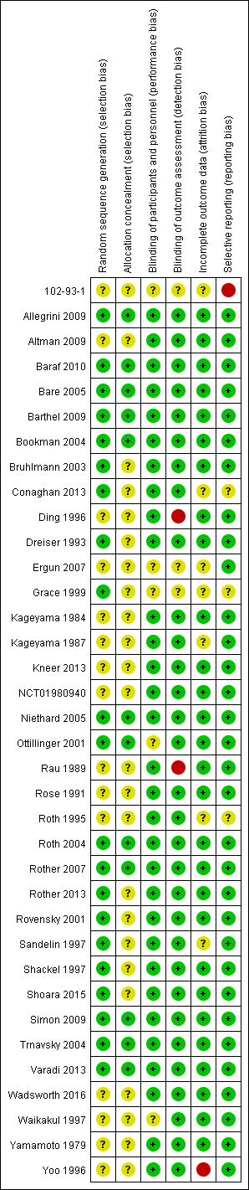

Figure 4.1 Risk of bias summary: review authors' judgements for each risk of bias item for the included randomized controlled trials. Most studies had adequate blinding of participants (31 studies). Blinding of assessors (2 studies), incomplete outcome (1 study) and selective reporting (1 studies) were the main source of high risk of bias. Allocation concealment (24 studies) and random sequence generation (15 studies) were the main source of unclear risk of bias.

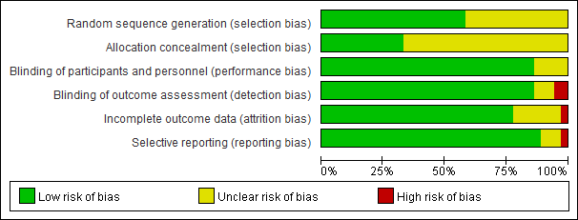

Figure 4.2 Risk of bias graph: review authors' judgements about each risk of bias item presented as percentages across all included randomized controlled studies.

Table 4.1 Methodological quality assessment for observational studies according to Newcastle-Ottawa Scale (NOS)

|  |  |  |  |  |  |  |  |  |  |
| --- | --- | --- | --- | --- | --- | --- | --- | --- | --- |
| Study | Selection | | | | Comparability | Exposure/outcome | | | Total score |
| Adequate definition of case/  exposed cohort | Representativeness of the cases/ exposed cohort | Selection of Controls | Definition of Controls | Comparability of cases and controls (worth 2 points) | Ascertainment of exposure/  outcome | Same method of ascertainment for cases and controls/long enough for outcomes to occur | Non-Response Rate |
| Evans 1995 (1) | 1 | 1 | 1 | 1 | 2 | 1 | 1 | 1 | 9 |
| Evans 1995 (2) | 1 | 1 | 1 | 1 | 2 | 1 | 1 | 1 | 9 |
| García Rodríguez 2004 | 1 | 1 | 1 | 1 | 2 | 1 | 1 | 1 | 9 |
| Johannesdottir 2012 | 1 | 1 | 1 | 1 | 2 | 1 | 1 | 1 | 9 |
| Cazzaniga 2016 | 1 | 1 | 0 | 1 | 1 | 1 | 1 | 1 | 7 |
| Diaz 2006 | 1 | 1 | 0 | 1 | 1 | 1 | 1 | 1 | 7 |
| Yagüe-Sebastián 2013 | 1 | 1 | 0 | 1 | 1 | 1 | 1 | 1 | 7 |

# Appendix 5 Conventional meta-analyses results for general topical NSAIDs

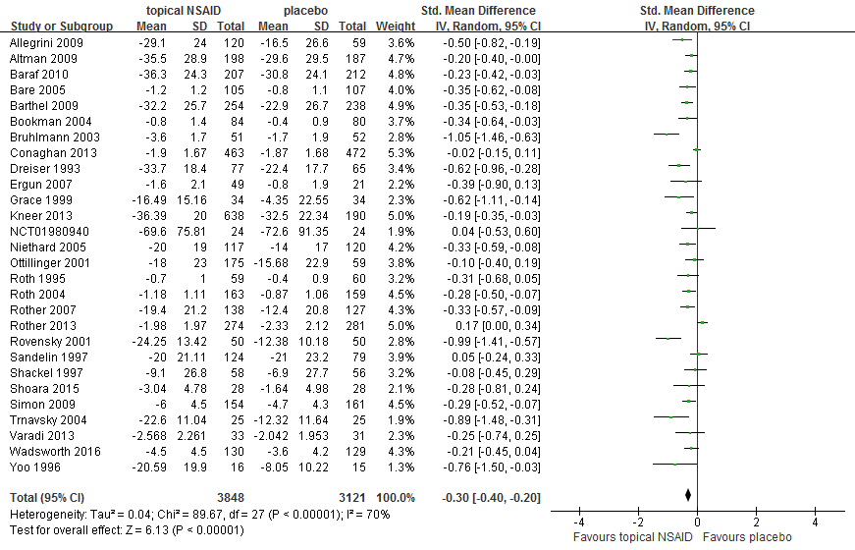

Figure 5.1 Conventional meta-analysis of treatment effects on pain relief for topical NSAIDs overall compared with placebo in RCTs.

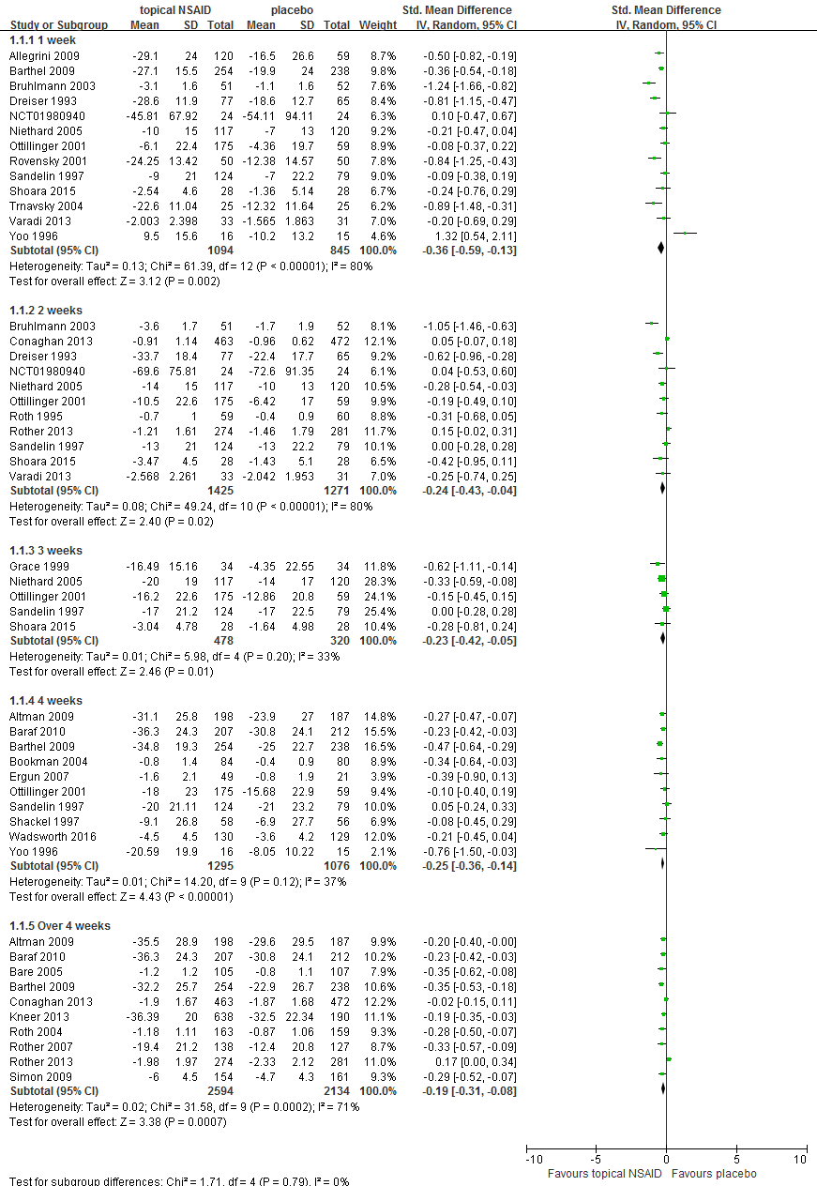

Figure 5.2 Subgroup analysis (different follow-up time points) of treatment effects on pain relief for topical NSAIDs overall compared with placebo in RCTs.

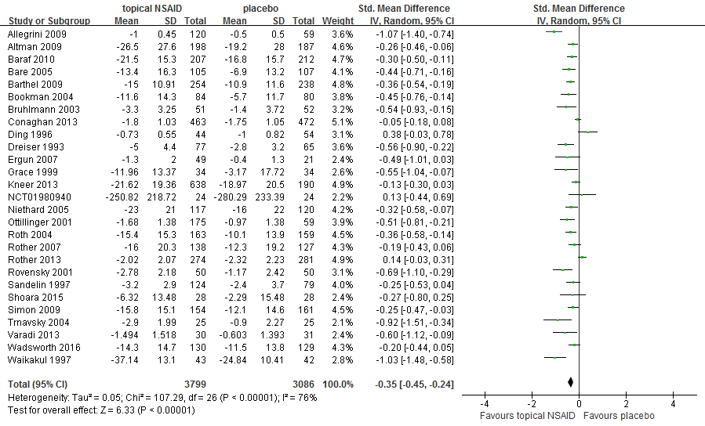

Figure 5.3 Conventional meta-analysis of treatment effects on function improvement for topical NSAIDs overall compared with placebo in RCTs.

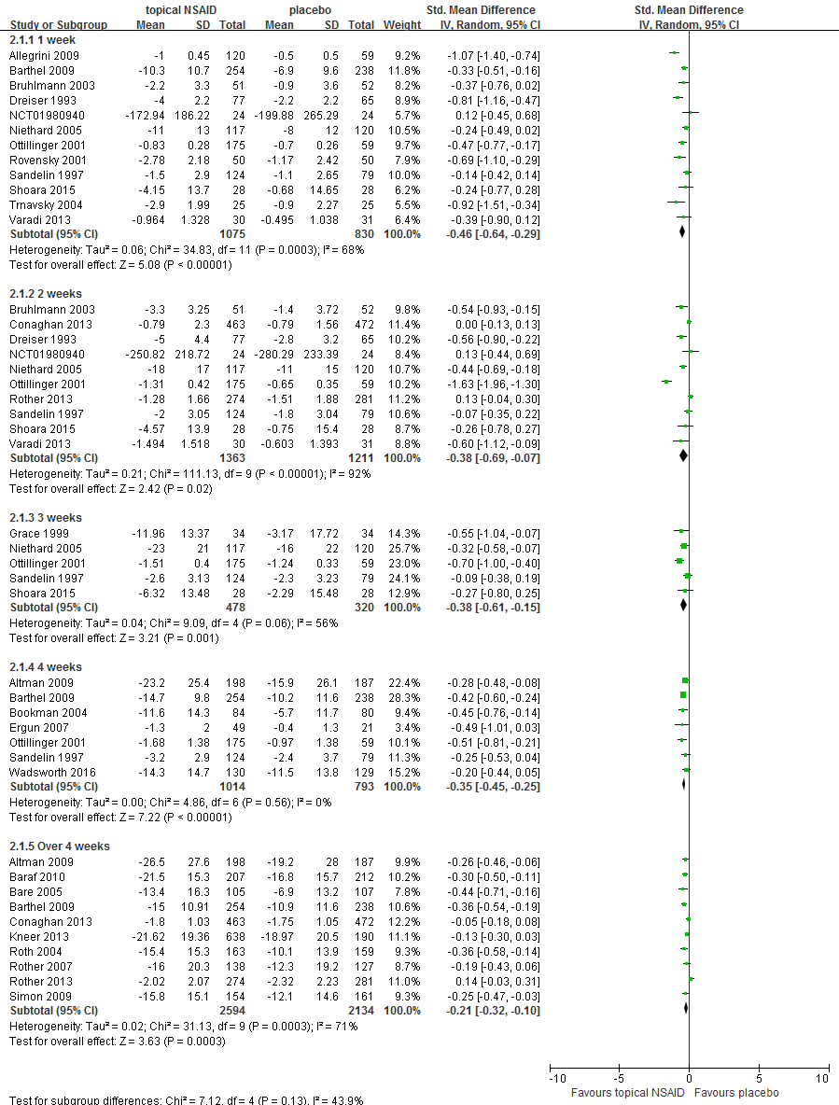

Figure 5.4 Subgroup analysis (different follow-up time points) of functional improvement for topical NSAIDs overall compared with placebo in RCTs.

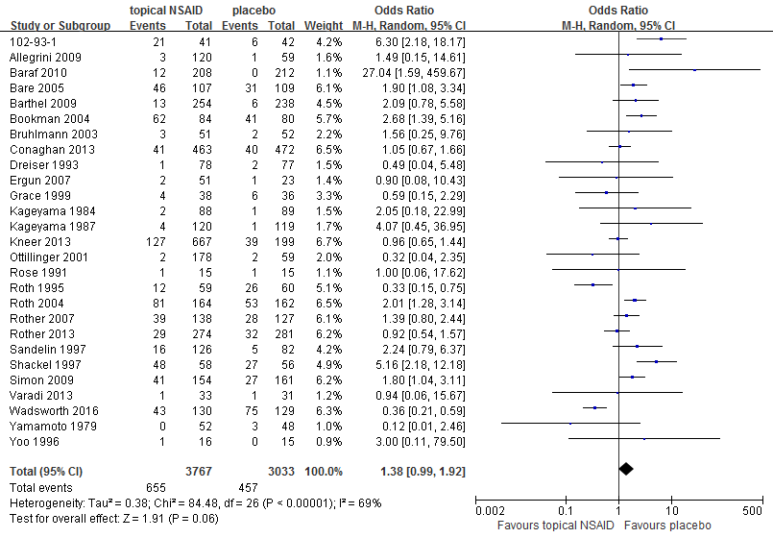

Figure 5.5 Conventional meta-analysis of skin adverse effects for topical NSAIDs overall compared with placebo in RCTs.

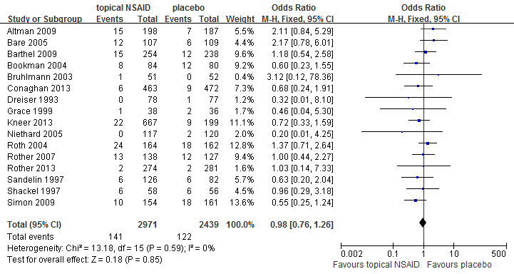

Figure 5.6 Conventional meta-analysis of gastrointestinal adverse effects for topical NSAIDs overall compared with placebo in RCTs.

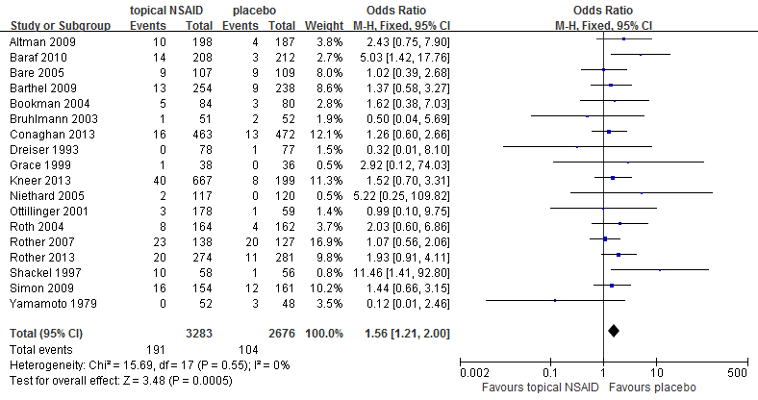

Figure 5.7 Conventional meta-analysis of withdrawals due to adverse effects for topical NSAIDs overall compared with placebo in RCTs.

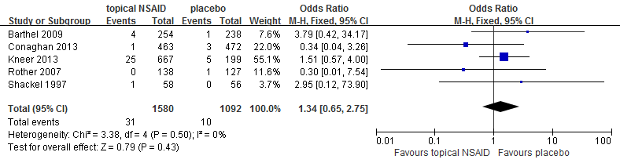

Figure 5.8 Conventional meta-analysis of cardiovascular adverse effects for topical NSAIDs overall compared with placebo in RCTs.

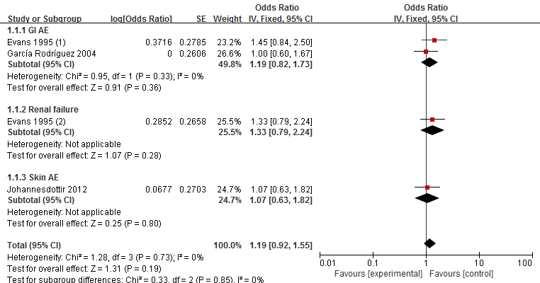

Figure 5.9 Conventional meta-analysis of total adverse effects for topical NSAID users compared with non-users in observational studies.

# Appendix 6 Results of SUCRA



Figure 6.1 Rankings for effects on pain relief. Graph displays distribution of probabilities for each treatment. X-axis represents the possible rank of each treatment (from the best to worst according to the outcomes), Y-axis represents the cumulative probability for each treatment to be the best option, among the best two options, among the best three options, and so on.

The SUCRA values were as followed:

|  |  |
| --- | --- |
| Treatment | SUCRA (%) |
| Diclofenac patch | 95.7 |
| Ibuprofen | 88.81 |
| Piroxicam | 75.99 |
| Nimesulide | 65.17 |
| Diclofenac gel | 60.6 |
| Diclofenac solution | 58.44 |
| Ketoprofen | 33.16 |
| Salicylate | 32.24 |
| Eltenac | 24.48 |
| Indomathacin | 23.74 |
| Etoricoxib | 23.34 |
| Placebo | 18.33 |



Figure 6.2 Rankings for effects of function improvement. Graph displays distribution of probabilities for each treatment. X-axis represents the possible rank of each treatment (from the best to worst according to the outcomes), Y-axis represents the cumulative probability for each treatment to be the best option, among the best two options, among the best three options, and so on.

The SUCRA values were as followed:

|  |  |
| --- | --- |
| Treatment | SUCRA (%) |
| Piroxicam | 95.6 |
| Ibuprofen | 84.4 |
| Diclofenac patch | 72.6 |
| Nimesulide | 68.0 |
| Eltenac | 56.9 |
| Diclofenac solution | 53.1 |
| Diclofenac gel | 39.4 |
| Ketoprofen | 37.0 |
| Etoricoxib | 16.6 |
| Placebo | 15.1 |
| Indomethacin | 11.4 |

# Appendix 7 Meta-regression results

Table 7.1 Posterior median, SD, and 95%CI for the interaction estimate (b) by meta-regression

|  |  |  |  |
| --- | --- | --- | --- |
| Covariate | mean | SD | 95%CI |
| Baseline pain level (for pain relief) | -0.0003 | 0.01 | (-0.01, 0.01) |
| Follow up duration (for pain relief) | 0.013 | 0.01 | (-0.01, 0.04) |
| Baseline function level (for function improvement) | 0.0001 | 0.01 | (-0.02, 0.02) |
| Follow up duration (for function improvement) | 0.018 | 0.02 | (-0.02, 0.06) |
| Treatment duration (for skin AE) | 0.073 | 0.07 | (-0.06, 0.21) |
| Treatment duration (for GI AE) | 0.054 | 0.07 | (-0.08, 0.21) |
| Treatment duration (for withdrawal due to AE) | 0.079 | 0.06 | (-0.04, 0.21) |

SD, standard deviation; CI, credibility interval; AE, adverse effect; GI, gastrointestinal

# Appendix 8 Detailed results of network meta-analysis

Table 8.1 Detailed results of network meta-analysis for withdrawals due to adverse effect (white) and gastrointestinal adverse effects (grey). Data are odds ratio (from the top left to the bottom right, higher comparator versus lower comparator) and their related 95%CI.

|  |  |  |  |  |  |  |  |
| --- | --- | --- | --- | --- | --- | --- | --- |
| **Indomethacin** | 0.18  (0,2.91) | 2.51  (0.06,50.74) | 2.32  (0.4,13.23) | 7.08  (0.5,146) | 2.25  (0.38,13.17) | 1.68  (0.34,8.61) | 3.22  (0.63,17.43) |
| **-** | **Salicylate** | 13.62  (0.31,728.6) | 12.12  (1.4,372.4) | 40.2  (1.89,2629) | 11.97  (1.29,375.7) | 8.9  (0.97,269.9) | 16.83  (2.12,499.3) |
| - | 1.55  (0.18,13.12) | **Eltenac** | 0.91  (0.08,26.08) | 2.97  (0.12,178.1) | 0.89  (0.07,24.14) | 0.67  (0.05,19.05) | 1.27  (0.11,35.04) |
| - | 1.19  (0.22,6.43) | 0.76  (0.15,4.02) | **Ketoprofen** | 3  (0.36,47.1) | 0.99  (0.4,2.38) | 0.72  (0.3,1.88) | 1.4  (0.8,2.55) |
| - | 0.97  (0.03,22.93) | 0.62  (0.02,14.67) | 0.82  (0.03,14) | **Diclofenac**  **patch** | 0.33  (0.02,2.85) | 0.24  (0.02,2.15) | 0.47  (0.03,3.7) |
| - | 0.97  (0.19,5.16) | 0.63  (0.13,3.31) | 0.82  (0.33,2.09) | 1.01  (0.06,25.36) | **Diclofenac solution** | 0.74  (0.28,2.05) | 1.43  (0.73,2.86) |
| - | 0.77  (0.15,4.74) | 0.5  (0.1,3.03) | 0.66  (0.24,2.05) | 0.81  (0.05,20.97) | 0.8  (0.31,2.37) | **Diclofenac**  **gel** | 1.93  (0.94,3.91) |
| - | 0.97  (0.21,4.54) | 0.62  (0.14,2.86) | 0.82  (0.41,1.64) | 0.99  (0.06,23.14) | 0.99  (0.54,1.86) | 1.25  (0.52,2.59) | **Placebo** |

Table 8.2 Detailed results of network meta-analysis for skin adverse effects. Data are odds ratio (from the top left to the bottom right, higher comparator versus lower comparator) and their related 95%CI.

|  |  |  |  |  |  |  |  |  |  |  |
| --- | --- | --- | --- | --- | --- | --- | --- | --- | --- | --- |
| **Indomethacin** | 0.04  (0,2.16) | 0.01  (0,0.81) | 0.05  (0,7.71) | 0.06(  0,16.36) | 0.06(  0,3.09) | 0.06  (0,2.29) | 0.07  (0,4.54) | 0.04  (0,1.44) | 0.04  (0,1.71) | 0.07  (0,2.37) |
| - | **Piroxicam** | 0.28  (0.02,3.77) | 1.32  (0.02,47.67) | 1.63  (0.02,124.3) | 1.25  (0.13,13.63) | 1.27  (0.23,7.58) | 1.59  (0.13,21.66) | 0.84  (0.16,4.8) | 0.95  (0.18,4.81) | 1.49  (0.34,7.11) |
| - | - | **Salicylate** | 4.62  (0.06,220.4) | 5.8  (0.05,544.4) | 4.47  (0.32,69.69) | 4.58  (0.47,43.72) | 5.7  (0.31,109.5) | 3  (0.32,28.12) | 3.4  (0.31,33.04) | 5.34  (0.68,43.38) |
| - | - | - | **Nimesulide** | 1.27  (0.01,327.7) | 0.97(  0.03,69.36) | 0.97  (0.03,54.06) | 1.23  (0.03,102.2) | 0.64  (0.02,34.69) | 0.72  (0.02,40.57) | 1.14  (0.05,58.1) |
| - | - | - | - | **Ibuprofen** | 0.77  (0.01,73.21) | 0.79  (0.01,57.66) | 0.99  (0.01,114) | 0.52  (0.01,37.63) | 0.58  (0.01,43.9) | 0.93  (0.02,62.38) |
| - | - | - | - | - | **Eltenac** | 1.02  (0.14,6.89) | 1.27  (0.09,18.56) | 0.67  (0.09,4.36) | 0.76  (0.09,5.33) | 1.19  (0.2,6.57) |
| - | - | - | - | - | - | **Ketoprofen** | 1.24  (0.14,12.49) | 0.65  (0.2,2.24) | 0.74  (0.18,2.84) | 1.17  (0.48,2.96) |
| - | - | - | - | - | - | - | **Diclofenac patch** | 0.53  (0.06,4.64) | 0.6  (0.05,5.59) | 0.94  (0.11,7.11) |
| - | - | - | - | - | - | - | - | **Diclofenac solution** | 1.13  (0.28,4.1) | 1.78  (0.79,4.08) |
| - | - | - | - | - | - | - | - | - | **Diclofenac gel** | 1.58  (0.58,4.87) |
| - | - | - | - | - | - | - | - | - | - | **Placebo** |

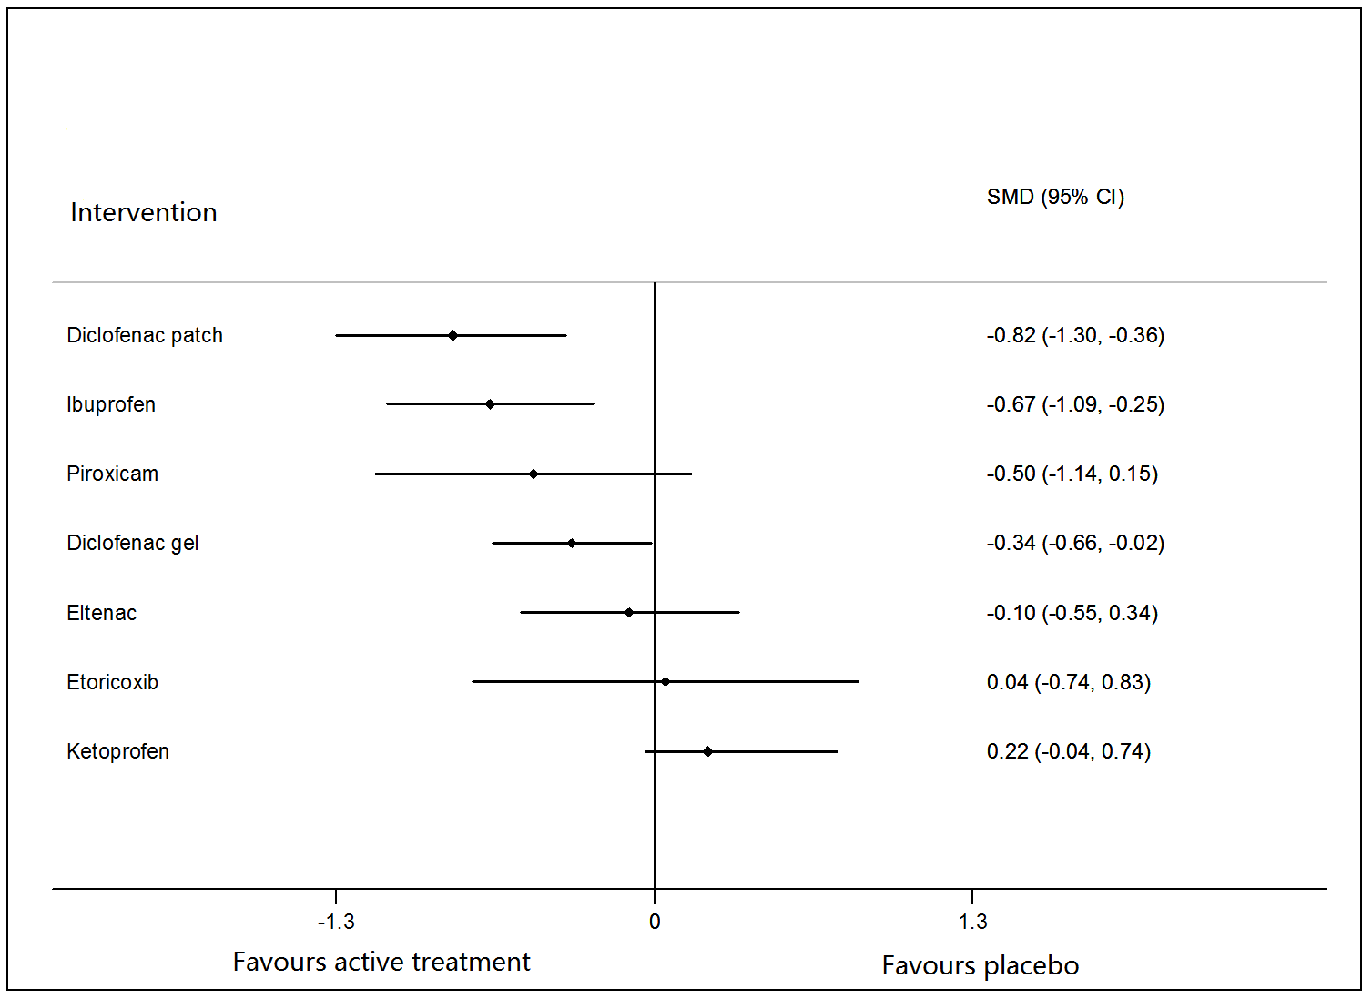

Figure 8.1 Network meta-analysis of treatment effects on pain relief in 1 or 2 week for different active interventions compared with placebo.

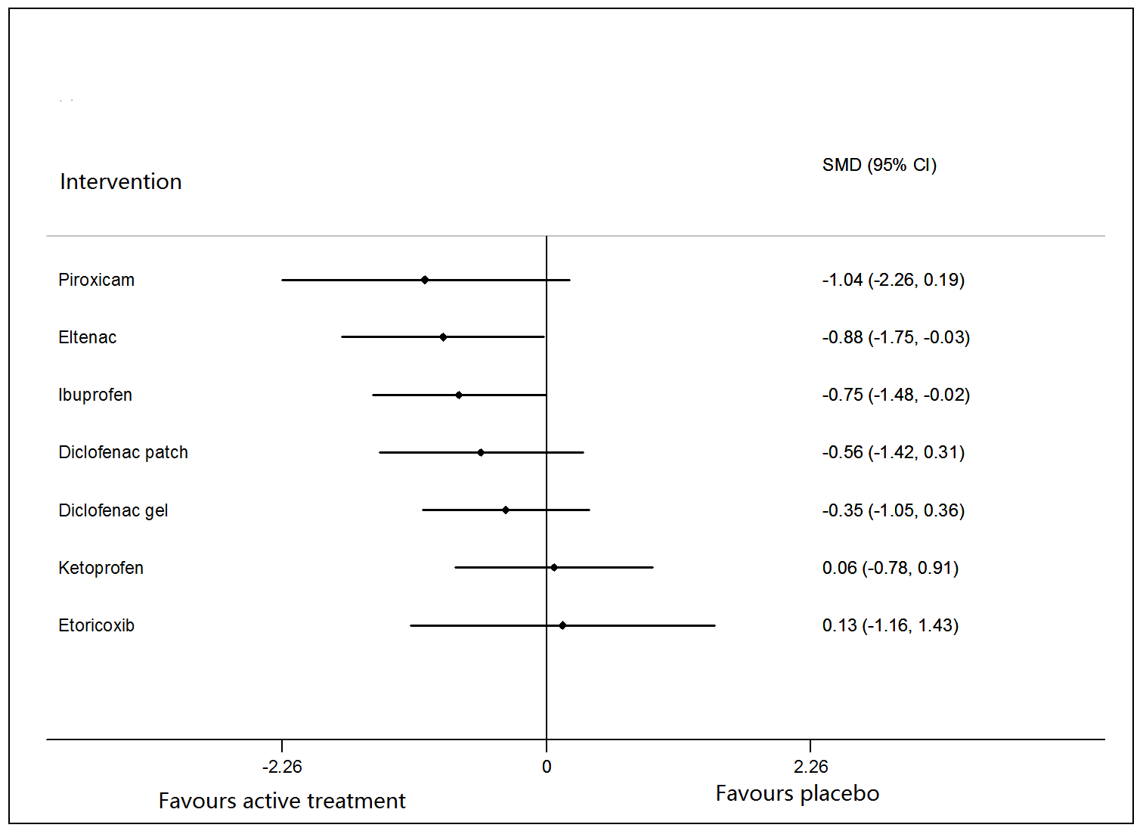

Figure 8.2 Network meta-analysis of treatment effects on function improvement in 1 or 2 week for different active interventions compared with placebo.

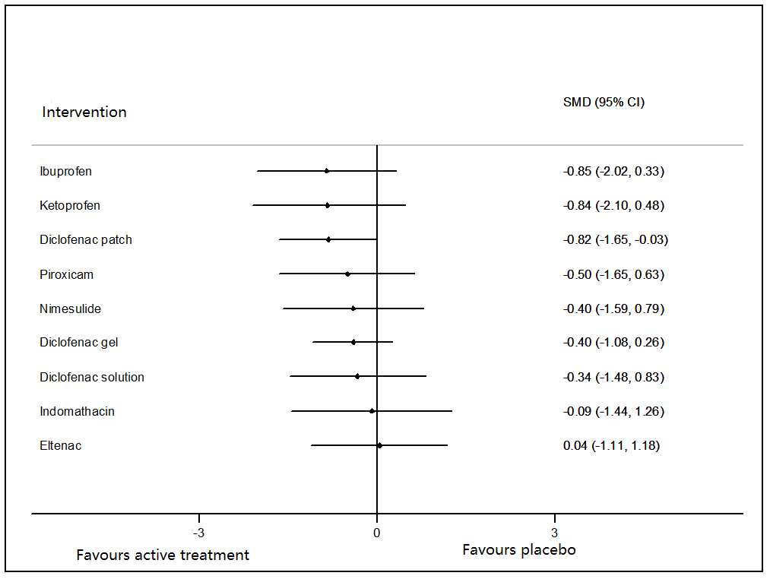

Figure 8.3 Network meta-analysis of treatment effects on pain relief for active interventions compared with placebo in non-commercially funded/sponsored studies.

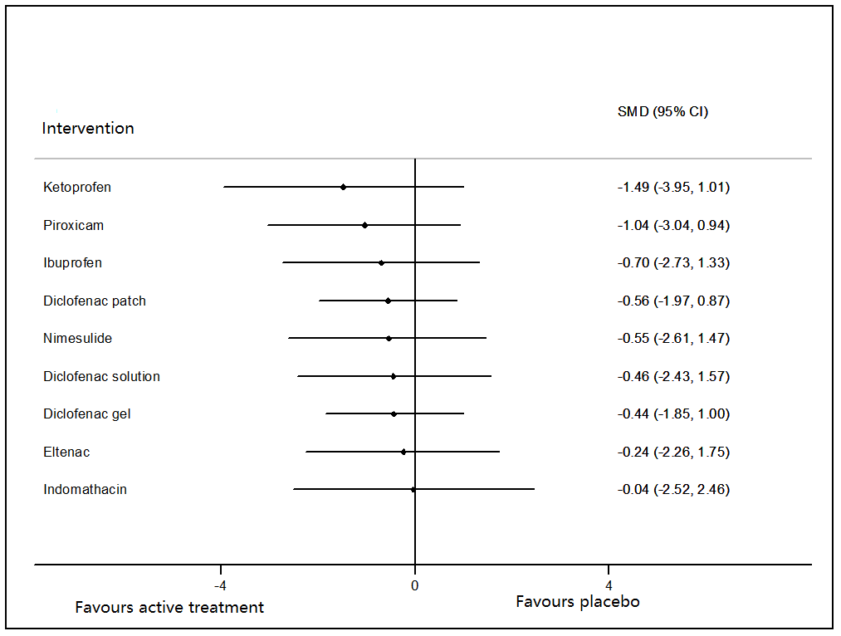

Figure 8.4 Network meta-analysis of treatment effects on function improvement for active interventions compared with placebo in non-commercially funded/sponsored studies.

**References:**

1 Roth SH. A controlled clinical investigation of 3% diclofenac/2.5% sodium hyaluronate topical gel in the treatment of uncontrolled pain in chronic oral NSAID users with osteoarthritis*. Int J Tissue React* 1995;17:129-32.

2 Grace D, Rogers J, Skeith K*, et al*. Topical diclofenac versus placebo: a double blind, randomized clinical trial in patients with osteoarthritis of the knee*. J Rheumatol* 1999;26:2659-63.

3 Niethard FU, Gold MS, Solomon GS*, et al*. Efficacy of topical diclofenac diethylamine gel in osteoarthritis of the knee*. J Rheumatol* 2005;32:2384-92.

4 Barthel HR, Haselwood D, Longley S*, et al*. Randomized Controlled Trial of Diclofenac Sodium Gel in Knee Osteoarthritis*. Semin Arthritis Rheu* 2009;39:203-12.

5 Altman RD, Dreiser RL, Fisher CL*, et al*. Diclofenac sodium gel in patients with primary hand osteoarthritis: a randomized, double-blind, placebo-controlled trial*. J Rheumatol* 2009;36:1991-9.

6 Baraf HS, Gold MS, Clark MB*, et al*. Safety and efficacy of topical diclofenac sodium 1% gel in knee osteoarthritis: a randomized controlled trial*. Phys Sportsmed* 2010;38:19-28.

7 Shoara R, Hashempur MH, Ashraf A*, et al*. Efficacy and safety of topical Matricaria chamomilla L. (chamomile) oil for knee osteoarthritis: A randomized controlled clinical trial*. Complementary Therapies in Clinical Practice* 2015;21:181-7.

8 Bookman AA, Williams KS, Shainhouse JZ. Effect of a topical diclofenac solution for relieving symptoms of primary osteoarthritis of the knee: a randomized controlled trial*. CMAJ* 2004;171:333-8.

9 Roth SH, Shainhouse JZ. Efficacy and safety of a topical diclofenac solution (pennsaid) in the treatment of primary osteoarthritis of the knee: a randomized, double-blind, vehicle-controlled clinical trial*. Arch Intern Med* 2004;164:2017-23.

10 Baer PA, Thomas LM, Shainhouse Z. Treatment of osteoarthritis of the knee with a topical diclofenac solution: a randomised controlled, 6-week trial [ISRCTN53366886]*. BMC Musculoskelet Disord* 2005;6:44.

11 Simon LS, Grierson LM, Naseer Z*, et al*. Efficacy and safety of topical diclofenac containing dimethyl sulfoxide (DMSO) compared with those of topical placebo, DMSO vehicle and oral diclofenac for knee osteoarthritis*. Pain* 2009;143:238-45.

12 Wadsworth LT, Kent JD, Holt RJ. Efficacy and safety of diclofenac sodium 2% topical solution for osteoarthritis of the knee: a randomized, double-blind, vehicle-controlled, 4 week study*. Curr Med Res Opin* 2016;32:241-50.

13 Unpublished data (102-93-1) from Cochrane Library. Available from: http://www.cochrane.org*.*

14 Dreiser RL, Tisne-Camus M. DHEP plasters as a topical treatment of knee osteoarthritis--a double-blind placebo-controlled study*. Drugs Exp Clin Res* 1993;19:117-23.

15 Bruhlmann P, Michel BA. Topical diclofenac patch in patients with knee osteoarthritis: a randomized, double-blind, controlled clinical trial*. Clin Exp Rheumatol* 2003;21:193-8.

16 Rother M, Lavins BJ, Kneer W*, et al*. Efficacy and safety of epicutaneous ketoprofen in Transfersome (IDEA-033) versus oral celecoxib and placebo in osteoarthritis of the knee: multicentre randomised controlled trial*. Ann Rheum Dis* 2007;66:1178-83.

17 Kneer W, Rother M, Mazgareanu S*, et al*. A 12-week randomized study of topical therapy with three dosages of ketoprofen in Transfersome&reg; gel (IDEA-033) compared with the ketoprofen-free vehicle (TDT 064), in patients with osteoarthritis of the knee*. Journal of Pain Research* 2013:743.

18 Conaghan PG, Dickson J, Bolten W*, et al*. A multicentre, randomized, placebo- and active-controlled trial comparing the efficacy and safety of topical ketoprofen in Transfersome gel (IDEA-033) with ketoprofen-free vehicle (TDT 064) and oral celecoxib for knee pain associated with osteoarthritis*. Rheumatology* 2013;52:1303-12.

19 Rother M, Conaghan PG. A randomized, double-blind, phase III trial in moderate osteoarthritis knee pain comparing topical ketoprofen gel with ketoprofen-free gel*. J Rheumatol* 2013;40:1742-8.

20 Kageyama T. Pharmaceutical evaluation of KPG-200 (Ketoprofen Ointment) on Arthrosis Deformans - Double blind controlled study compared with KPG-200 base*. Jpn Pharmacol Ther* 1984;12

21 Yoo B, Choi SW, Lee MS*, et al*. Treatment of Knee Osteoarthritis with Ketoprofen(Ketotop): A Double-blind Placebo-controlled Randomized Trial*. The Journal of the Korean Rheumatism Association* 1996;3:70-5.

22 Waikakul S, Penkitti P, Soparat K*, et al*. Topical analgesics for knee arthrosis: a parallel study of ketoprofen gel and diclofenac emulgel*. J Med Assoc Thai* 1997;80:593-7.

23 Sandelin J, Harilainen A, Crone H*, et al*. Local NSAID gel (eltenac) in the treatment of osteoarthritis of the knee. A double blind study comparing eltenac with oral diclofenac and placebo gel*. Scand J Rheumatol* 1997;26:287-92.

24 Ottillinger B, Gömör B, Michel BA*, et al*. Efficacy and safety of eltenac gel in the treatment of knee osteoarthritis*. Osteoarthr Cartilage* 2001;9:273-80.

25 Trnavsky K, Fischer M, Vogtle-Junkert U*, et al*. Efficacy and safety of 5% ibuprofen cream treatment in knee osteoarthritis. Results of a randomized, double-blind, placebo-controlled study*. J Rheumatol* 2004;31:565-72.

26 Varadi G, Zhu Z, Blattler T*, et al*. Randomized clinical trial evaluating transdermal Ibuprofen for moderate to severe knee osteoarthritis*. Pain Physician* 2013;16:E749-62.

27 Rovensky J, Micekova D, Gubzova Z*, et al*. Treatment of knee osteoarthritis with a topical non-steroidal antiinflammatory drug. Results of a randomized, double-blind, placebo-controlled study on the efficacy and safety of a 5% ibuprofen cream*. Drugs Exp Clin Res* 2001;27:209-21.

28 Ergün H, Külcü D, Kutlay Ş*, et al*. Efficacy and Safety of Topical Nimesulide in the Treatment of Knee Osteoarthritis*. JCR: Journal of Clinical Rheumatology* 2007;13:251-5.

29 Shackel NA, Day RO, Kellett B*, et al*. Copper-salicylate gel for pain relief in osteoarthritis: a randomised controlled trial*. Med J Aust* 1997;167:134-6.

30 The Single Dose Pharmacokinetics of Two and Proof of Efficacy of One New Etoricoxib Gel Formulation in Participants With Osteoarthritis (MK-0663-168). [NCT01980940] Available from: http://www.clinicaltrials.gov*.*

31 Yamamoto S, Kodama T, Hasegawa Y*, et al*. [Clinical evaluation of indomethacin ointment on osteoarthritis--evaluation by a multicenter double-blind trial (author's transl)]*. Ryumachi* 1979;19:328-36.

32 Ding C, Xu J, Chen X. Clinical study on therapeutic effect of diclofenac sodium gel on patients with osteoarthritis*. Chinese Pharmaceutical Journal* 1996;31:238-42.

33 Allegrini A, Nuzzo L, Pavone D*, et al*. Efficacy and safety of piroxicam patch versus piroxicam cream in patients with lumbar osteoarthritis. A randomized, placebo-controlled study*. Arzneimittelforschung* 2009;59:403-9.

34 Kageyama T. A double bind placebo controlled multicenter study of piroxicam 0.5% gel in osteoarthritis of the knee*. Eur. J. Rheumatol. Inflamm* 1987;8:114-5.

35 Rose W, Manz G, Lemmel EM. Behandlung der aktivierten gonarthrose mit topisch appliziertem piroxicam-gel.[Topical application of Piroxicam-gel in the treatment of activated gonarthrosis]*. Münch Med Wschr* 1991;133:562-6.

36 Rau R, H Ckel S. Piroxicam gel versus diclofenac gel in active gonarthroses*. Fortschritte der Medizin* 1989;107:485.

37 Evans JM, McMahon AD, McGilchrist MM*, et al*. Topical non-steroidal anti-inflammatory drugs and admission to hospital for upper gastrointestinal bleeding and perforation: a record linkage case-control study*. BMJ* 1995;311:22-6.

38 Evans JM, McGregor E, McMahon AD*, et al*. Non-steroidal anti-inflammatory drugs and hospitalization for acute renal failure*. QJM* 1995;88:551-7.

39 Garcia Rodriguez LA. Risk of Uncomplicated Peptic Ulcer among Users of Aspirin and Nonaspirin Nonsteroidal Antiinflammatory Drugs*. Am J Epidemiol* 2004;159:23-31.

40 Diaz RL, Gardeazabal J, Manrique P*, et al*. Greater allergenicity of topical ketoprofen in contact dermatitis confirmed by use*. Contact Dermatitis* 2006;54:239-43.

41 Cazzaniga S, Naldi L, Lecchi S*, et al*. A pilot study on the incidence of severe photosensitivity reactions leading to hospitalization linked to topical ketoprofen and other medications in selected European regions*. Pharmacol Res Perspect* 2016;4:e225.

42 Johannesdottir SA, Chang ET, Mehnert F*, et al*. Nonsteroidal anti-inflammatory drugs and the risk of skin cancer*. Cancer-Am Cancer Soc* 2012;118:4768-76.

43 Yagüe-Sebastián MM, Coscollar-Escartín I, Muñoz-Albadalejo P*, et al*. Uso de antiinflamatorios tópicos en un centro de salud urbano. Estudio comparativo con la evidencia actual [Use of topical non-steroidal anti-inflammatory agents in an urban health center. Comparison with the current evidence]. *SEMERGEN - Medicina de Familia* 2013;39:304-8.