Appendix 5: Distribution of Chondrocalcinosis in Ex-Footballers compared to the general population.

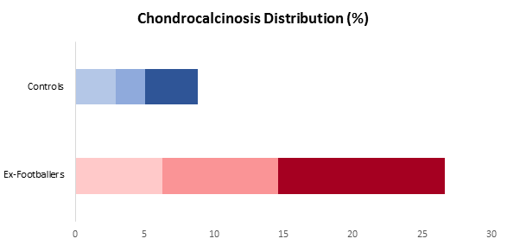
Ex-Footballers
General Population
BK
BK
LK
LK
RK
RK

# RK: right knee; LK: left knee; BK: bilateral (both knees)

