Diastolic Blood Pressure (DBP)



ß =

p =

Systolic Blood Pressure (SBP)



ß =

p =

Low-Density Lipoprotein (LDL)



ß =

p =

Low-Density Lipoprotein (LDL)



ß =

p =

Triglyceride (TG)



ß =

p =

VO2max



ß =

p =

Body fat



Low-Density Lipoprotein (LDL)





The studies are sorted in the sequence of largest to smallest intervention group sample size

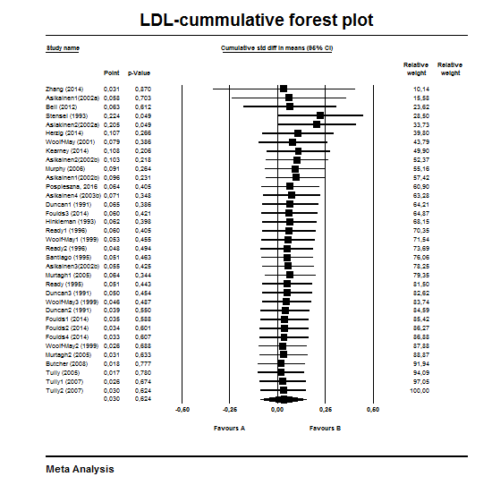

The studies are sorted in the sequence of largest to smallest intervention group sample size