Supplementary Table 1. Frequency of true positives, false negatives, false positives and true negatives.

 | Concussion with positive sign | Concussion with negative sign | No Concussion with positive sign | No Concussion with negative sign
Sign or Mechanism | True Positive | False Negative | False Positive | True Negative
LOC/MOTIONLESS | 13 | 81 | 12 | 755
INCOORDINATION/BALANCE PROBLEMS | 35 | 59 | 77 | 690
FIGHT | 7 | 87 | 5 | 762
INITIAL HIT BY STICK | 4 | 90 | 231 | 536
INITIAL HIT BY SHOULDER | 47 | 47 | 165 | 602
SECONDARY CONTACT ON ICE | 20 | 74 | 25 | 742
NO SECONDARY CONTACT | 41 | 53 | 467 | 300
Elevated Risk Cut Score (At or above .5) | 76 | 18 | 218 | 549
High Risk Cut Score (At or above 2) | 34 | 60 | 46 | 721

Note: Risk Cut scores derived from decision rules outlined in Figure 1.

Supplemental Figure 1. Receiver Operating Characteristic Curve for Concussion Prediction Log Total Score (see Figure 1) predicting subsequent concussion diagnosis.

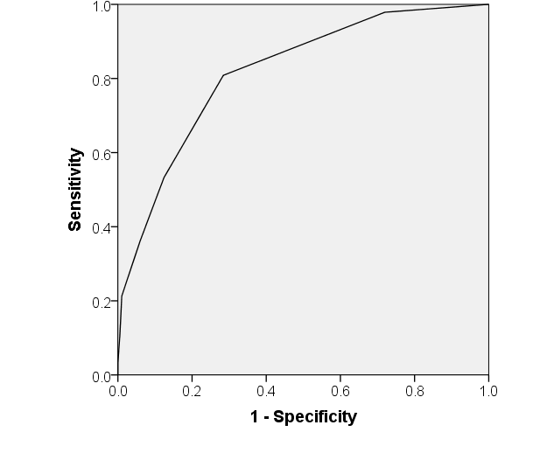
Note: AUC = .818 (95% CI = .77-.86). Youden’s Index was used to identify a cut point that maximized sensitivity and specificity.

Total Score = .5

