Supplementary 1 Search Strategy
Supplementary 1a Search strategy for MEDLINE, CENTRAL and AMED
- osteoarthritis/ or osteoarthritis, hip/ or osteoarthritis, knee/
- ((hip or knee or hand or wrist) adj2 osteoarthr*).tw.
- arthrosis.tw.
- (degenerative adj2 arthritis).tw.
- 1 or 2 or 3 or 4
- exp Dietary Supplements/
- (diet* supplement* or Probiotics or prebiotics or Synbiotics).tw.
- Functional Food/
- functional food.tw.
- (nutraceutical* or pharmaconutraceutical or pharmaconutrition or nutrient*).tw.
- Glucosamine 6-Phosphate N-Acetyltransferase/ or exp Glucosamine/
- (Glucosamine or acetylglucosamine or n-acetylglucosamine or n-acetyl-d-glucosamine).tw.
- exp Chondroitin/
- chondroitin.tw.
- (diacerein* or diacerhein or diacetylrhein).tw.
- S-Adenosylmethionine/
- (S-Adenosylmethionine or S-Adenosyl-L-methionine or ademetionine or adomet).tw.
- (methylsulfonylmethane or methyl sulfone or dimethyl sulfone).tw.
- Dimethyl Sulfoxide/
- Dimethyl Sulfoxide.tw.
- Curcumin/
- (curcumin or demethoxycurcumin or didemethoxycurcumin or bisdemethoxycurcumin).tw.
- gamma-Linolenic Acid/
- gamma linolenic acid*.tw.
- (piascledine or avocado soybean unsaponifiable*).tw.
- exp Fish Oils/
- (fish oil* or omega 3 fatty acid* or n-3 fatty acid*).tw.
- (eicosapentaenoic acid* or icosapentaenoic acid* or docosahexaenoic acid*).tw.
- cetyl myristoleate.tw.
- exp Vitamins/
- (vitamin* adj1 (a or b or c or d or e or k)).tw.
- exp Minerals/
- exp Trace Elements/
- (mineral* or trace element*).tw.
- Selenium/ or exp Selenium Compounds/
- Selenium.tw.
- exp Manganese Compounds/ or Manganese/
- Manganese.tw.
- exp Boron Compounds/ or Boron/
- boron.tw.
- Zinc/ or exp Zinc Compounds/
- zinc.tw.
- Copper/ or Copper Sulfate/
- copper.tw.
- (hydrolyzed collagen or collagen hydrolysate or collagen peptide or gelatine or gelatine hydrolysate or hydrolyzed gelatine).tw.
- Milk/
- (milk or hyperimmune milk).tw.
- Polyphenols/
- (polyphenol* or polyhydroxyphenol*).tw.
- nobiletin.tw.
- (pycnogenol or condensed tannin*).tw.
- Genistein/
- Genistein.tw.
- (Epigallocatechin-3-gallate or Epigallocatechin gallate).tw.
- Resveratrol.tw.
- Quercetin/
- Quercetin.tw.
- prodelphinidin*.tw.
- Bromelains/
- bromelain*.tw.
- exp Flavonoids/
- (flavonoid* or bioflavonoid* or Flavanone* or Flavone* or Flavonol* or Isoflavone* or Anthocyanin* or Benzoflavone* or Catechin or Chalcone* or Flavonolignan* or Proanthocyanidin*).tw.
- 6 or 7 or 8 or 9 or 10 or 11 or 12 or 13 or 14 or 15 or 16 or 17 or 18 or 19 or 20 or 21 or 22 or 23 or 24 or 25 or 26 or 27 or 28 or 29 or 30 or 31 or 32 or 33 or 34 or 35 or 36 or 37 or 38 or 39 or 40 or 41 or 42 or 43 or 44 or 45 or 46 or 47 or 48 or 49 or 50 or 51 or 52 or 53 or 54 or 55 or 56 or 57 or 58 or 59 or 60 or 61 or 62
- 5 and 63
- randomized controlled trial.pt.
- controlled clinical trial.pt.
- randomized.ab.
- placebo.ab.
- clinical trials as topic.sh.
- randomly.ab.
- trial.ti.
- 65 or 66 or 67 or 68 or 69 or 70 or 71
- exp animals/ not humans.sh.
- 72 not 73
- 64 and 74
- limit 75 to (english language and humans)
Supplementary 1b Search strategy for EMBASE
- #1 'osteoarthritis'/de OR 'hand osteoarthritis'/de OR 'hip osteoarthritis'/de OR 'knee osteoarthritis'/de AND [embase]/lim
- #2 ((hip OR knee OR hand OR wrist) NEAR/2 osteoarthr*):ab,ti AND [embase]/lim
- #3 (degenerative NEAR/2 arthritis):ab,ti AND [embase]/lim
- #4 arthrosis:ab,ti AND [embase]/lim
- #5 #1 OR #2 OR #3 OR #4
- #6 'diet supplementation'/exp AND [embase]/lim
- #7 (diet NEAR/2 supplementation):ab,ti AND [embase]/lim
- #8 'functional food'/exp AND [embase]/lim
- #9 (functional NEAR/2 food):ab,ti AND [embase]/lim
- #10 'nutrient management'/exp AND [embase]/lim
- #11 (nutrient NEAR/2 management):ab,ti AND [embase]/lim
- #12 'nutraceutical'/exp AND [embase]/lim
- #13 nutraceutical:ab,ti AND [embase]/lim
- #14 'glucosamine'/exp AND [embase]/lim
- #15 glucosamine:ab,ti AND [embase]/lim
- #16 'n acetylglucosamine'/exp AND [embase]/lim
- #17 'n acetylglucosamine':ab,ti AND [embase]/lim
- #18 'chondroitin'/exp AND [embase]/lim
- #19 chondroitin:ab,ti AND [embase]/lim
- #20 'diacerein'/exp AND [embase]/lim
- #21 diacerein*:ab,ti AND [embase]/lim
- #22 diacerhein:ab,ti AND [embase]/lim
- #23 diacetylrhein:ab,ti AND [embase]/lim
- #24 's adenosylmethionine'/exp AND [embase]/lim
- #25 's adenosylmethionine':ab,ti AND [embase]/lim
- #26 'sadenosylmethionine':ab,ti AND [embase]/lim
- #27 's adenosyl l methionine':ab,ti AND [embase]/lim
- #28 ademetionine:ab,ti AND [embase]/lim
- #29 adomet:ab,ti AND [embase]/lim
- #30 'dimethyl sulfone'/exp AND [embase]/lim
- #31 'dimethyl sulfone':ab,ti AND [embase]/lim
- #32 methylsulfonylmethane:ab,ti AND [embase]/lim
- #33 'methyl sulfone':ab,ti AND [embase]/lim
- #34 'dimethyl sulfoxide'/exp AND [embase]/lim
- #35 'dimethyl sulfoxide':ab,ti AND [embase]/lim
- #36 'curcumin'/exp AND [embase]/lim
- #37 curcumin:ab,ti AND [embase]/lim
- #38 'demethoxycurcumin'/exp AND [embase]/lim
- #39 demethoxycurcumin:ab,ti AND [embase]/lim
- #40 'didemethoxycurcumin'/exp AND [embase]/lim
- #41 bisdemethoxycurcumin:ab,ti AND [embase]/lim
- #42 'gamma linolenic acid'/exp AND [embase]/lim
- #43 'gamma linolenic acid':ab,ti AND [embase]/lim
- #44 'γ-linolenic acid':ab,ti AND [embase]/lim
- #45 'piascledine'/exp AND [embase]/lim
- #46 piascledine:ab,ti AND [embase]/lim
- #47 ('avocado soybean' NEXT/1 unsaponifiable*):ab,ti AND [embase]/lim
- #48 'omega 3 fatty acid'/exp AND [embase]/lim
- #49 ('omega 3 fatty' NEXT/1 acid*):ab,ti AND [embase]/lim
- #50 ('ω-3 fatty' NEXT/1 acid*):ab,ti AND [embase]/lim
- #51 ('n-3 fatty' NEXT/1 acid*):ab,ti AND [embase]/lim
- #52 'eicosapentaenoic acid':ab,ti AND [embase]/lim
- #53 'icosapentaenoic acid':ab,ti AND [embase]/lim
- #54 'docosahexaenoic acid'/exp AND [embase]/lim
- #55 'docosahexaenoic acid':ab,ti AND [embase]/lim
- #56 'fish oil'/exp AND [embase]/lim
- #57 'fish oil':ab,ti AND [embase]/lim
- #58 'cetyl myristoleate':ab,ti AND [embase]/lim
- #59 'vitamin'/exp AND [embase]/lim
- #60 (vitamin* NEXT/1 (a OR b OR c OR d OR e OR k)):ab,ti AND [embase]/lim
- #61 'mineral'/exp AND [embase]/lim
- #62 mineral*:ab,ti AND [embase]/lim
- #63 'selenium'/exp AND [embase]/lim
- #64 selenium:ab,ti AND [embase]/lim
- #65 'manganese'/exp AND [embase]/lim
- #66 manganese:ab,ti AND [embase]/lim
- #67 'boron'/exp AND [embase]/lim
- #68 boron:ab,ti AND [embase]/lim
- #69 'zinc'/exp AND [embase]/lim
- #70 zinc:ab,ti AND [embase]/lim
- #71 'copper'/exp AND [embase]/lim
- #72 copper:ab,ti AND [embase]/lim
- #73 'hydrolyzed collagen':ab,ti AND [embase]/lim
- #74 'collagen hydrolysate':ab,ti AND [embase]/lim
- #75 'collagen peptide':ab,ti AND [embase]/lim
- #76 gelatine:ab,ti AND [embase]/lim
- #77 'gelatine hydrolysate':ab,ti AND [embase]/lim
- #78 'hydrolyzed gelatine':ab,ti AND [embase]/lim
- #79 'milk'/exp AND [embase]/lim
- #80 milk:ab,ti AND [embase]/lim
- #81 'hyperimmune milk':ab,ti AND [embase]/lim
- #82 'probiotic agent'/exp AND [embase]/lim
- #83 probiotic*:ab,ti AND [embase]/lim
- #84 'prebiotic agent'/exp AND [embase]/lim
- #85 prebiotic*:ab,ti AND [embase]/lim
- #86 'synbiotic agent'/exp AND [embase]/lim
- #87 symbiotic*:ab,ti AND [embase]/lim
- #88 'polyphenol'/exp AND [embase]/lim
- #89 polyphenol*:ab,ti AND [embase]/lim
- #90 polyhydroxyphenol*:ab,ti AND [embase]/lim
- #91 'nobiletin'/exp AND [embase]/lim
- #92 nobiletin:ab,ti AND [embase]/lim
- #93 'pycnogenol'/exp AND [embase]/lim
- #94 pycnogenol* AND [embase]/lim
- #95 (condensed NEAR/1 tannin*):ab,ti AND [embase]/lim
- #96 'genistein'/exp AND [embase]/lim
- #97 genistein:ab,ti AND [embase]/lim
- #98 'epigallocatechin gallate'/exp AND [embase]/lim
- #99 'epigallocatechin gallate':ab,ti AND [embase]/lim
- #100 'epigallocatechin-3-gallate':ab,ti AND [embase]/lim
- #101 'resveratrol'/exp AND [embase]/lim
- #102 resveratrol:ab,ti AND [embase]/lim
- #103 'quercetin'/exp AND [embase]/lim
- #104 quercetin:ab,ti AND [embase]/lim
- #105 prodelphinidin*:ab,ti AND [embase]/lim
- #106 'bromelain'/exp AND [embase]/lim
- #107 bromelain:ab,ti AND [embase]/lim
- #108 'flavonoid'/exp AND [embase]/lim
- #109 flavonoid*:ab,ti AND [embase]/lim
- #110 'bioflavonoid'/exp AND [embase]/lim
- #111 bioflavonoid*:ab,ti AND [embase]/lim
- #112 #6 OR #7 OR #8 OR #9 OR #10 OR #11 OR #12 OR #13 OR #14 OR #15 OR #16 OR #17 OR #18 OR #19 OR #20 OR #21 OR #22 OR #23 OR #24 OR #25 OR #26 OR #27 OR #28 OR #29 OR #30 OR #31 OR #32 OR #33 OR #34 OR #35 OR #36 OR #37 OR #38 OR #39 OR #40 OR #41 OR #42 OR #43 OR #44 OR #45 OR #46 OR #47 OR #48 OR #49 OR #50 OR #51 OR #52 OR #53 OR #54 OR #55 OR #56 OR #57 OR #58 OR #59 OR #60 OR #61 OR #62 OR #63 OR #64 OR #65 OR #66 OR #67 OR #68 OR #69 OR #70 OR #71 OR #72 OR #73 OR #74 OR #75 OR #76 OR #77 OR #78 OR #79 OR #80 OR #81 OR #82 OR #83 OR #84 OR #85 OR #86 OR #87 OR #88 OR #89 OR #90 OR #91 OR #92 OR #93 OR #94 OR #95 OR #96 OR #97 OR #98 OR #99 OR #100 OR #101 OR #102 OR #103 OR #104 OR #105 OR #106 OR #107 OR #108 OR #109 OR #110 OR #111
- #113 #5 AND #112
- #114 random* OR factorial* OR crossover* OR cross AND over* OR placebo* OR (doubl* AND blind*) OR (singl* AND blind*) OR assign* OR allocat* OR volunteer* OR 'crossover procedure'/exp OR 'double blind procedure'/exp OR 'randomized controlled trial'/exp OR 'single blind procedure'/exp AND [embase]/lim
- #115 #113 AND #114
- #116 #113 AND #114 AND [humans]/lim AND [english]/lim
Supplementary 1c Search strategy for CINAHL
- S1 (MH "Osteoarthritis+") OR (MH "Osteoarthritis, Wrist") OR (MH "Osteoarthritis, Hip") OR (MH "Osteoarthritis, Knee")
- S2 TI (hip or knee or hand or wrist) N2 osteoarthr* OR AB (hip or knee or hand or wrist) N2 osteoarthr*
- S3 TI degenerative N2 arthritis OR AB degenerative N2 arthritis
- S4 TI arthrosis OR AB arthrosis
- S5 S1 OR S2 OR S3 OR S4
- S6 (MH "Dietary Supplementation") OR (MH "Dietary Supplements+")
- S7 TI diet* supplement* OR AB diet* supplement*
- S8 (MH "Functional Food")
- S9 TI functional food OR AB functional food
- S10 (MH "Glucosamine")
- S11 TI (Glucosamine or acetylglucosamine or n-acetylglucosamine or n-acetyl-d-glucosamine) OR AB (Glucosamine or acetylglucosamine or n-acetylglucosamine or n-acetyl-d-glucosamine)
- S12 (MH "Chondroitin+") OR (MH "Chondroitin Sulfates")
- S13 TI chondroitin OR AB chondroitin
- S14 TI (diacerein* or diacerhein or diacetylrhein) OR AB (diacerein* or diacerhein or diacetylrhein)
- S15 (MH "S-Adenosylmethionine")
- S16 TI (S-Adenosylmethionine or S-Adenosyl-L-methionine or ademetionine or adomet) OR AB (S-Adenosylmethionine or S-Adenosyl-L-methionine or ademetionine or adomet)
- S17 (MH "Dimethyl Sulfoxide")
- S18 TI (dimethyl sulfoxide or methyl sulfone or methylsulfonylmethane or dimethyl sulfone) OR AB (dimethyl sulfoxide or methyl sulfone or methylsulfonylmethane or dimethyl sulfone)
- S19 (MH "Curcumin")
- S20 TI (curcumin or demethoxycurcumin or didemethoxycurcumin or bisdemethoxycurcumin) OR AB (curcumin or demethoxycurcumin or didemethoxycurcumin or bisdemethoxycurcumin)
- S21 (MH "gamma-Linolenic Acid")
- S22 TI (gamma linolenic acid* or γ-linolenic acid*) OR AB (gamma linolenic acid* or γ-linolenic acid*)
- S23 TI (piascledine or avocado soybean unsaponifiable*) OR AB (piascledine or avocado soybean unsaponifiable*)
- S24 (MH "Fish Oils+") OR (MH "Fatty Acids, Omega-3+")
- S25 TI (fish oil* or omega 3 fatty acid* or ω-3 fatty acid* or n-3 fatty acid*) OR AB (fish oil* or omega 3 fatty acid* or ω-3 fatty acid* or n-3 fatty acid*)
- S26 (MH "Eicosapentaenoic Acid")
- S27 TI (eicosapentaenoic acid* or icosapentaenoic acid*) OR AB (eicosapentaenoic acid* or icosapentaenoic acid*)
- S28 (MH "Docosahexaenoic Acids")
- S29 TI docosahexaenoic acid* OR AB docosahexaenoic acid*
- S30 TI (cetyl myristoleate) OR AB (cetyl myristoleate)
- S31 (MH "Vitamins+")
- S32 TI vitamin* N1 (a OR b OR c OR d OR e OR k) OR AB vitamin* N1 (a OR b OR c OR d OR e OR k)
- S33 (MH "Minerals+")
- S34 TI mineral* OR AB mineral*
- S35 (MH "Trace Elements+")
- S36 TI trace element* OR AB trace element*
- S37 (MH "Selenium") OR (MH "Selenium Compounds")
- S38 TI (selenium or selenium compound*) OR AB (selenium or selenium compound*)
- S39 (MH "Manganese")
- S40 TI manganese OR AB manganese
- S41 (MH "Boron Compounds+")
- S42 TI (boron or boron compound*) OR AB (boron or boron compound*)
- S43 (MH "Zinc") OR (MH "Zinc Compounds+")
- S44 TI (zinc or zinc oxide or Zinc Sulfate or zinc compound*) OR AB (zinc or zinc oxide or Zinc Sulfate or zinc compound*)
- S45 (MH "Copper")
- S46 TI copper OR AB copper
- S47 TI (hydrolyzed collagen or collagen hydrolysate or collagen peptide or gelatine or gelatine hydrolysate or hydrolyzed gelatine) OR AB (hydrolyzed collagen or collagen hydrolysate or collagen peptide or gelatine or gelatine hydrolysate or hydrolyzed gelatine)
- S48 (MH "Milk+")
- S49 TI (milk or hyperimmune milk) OR AB (milk or hyperimmune milk)
- S50 (MH "Probiotics") OR (MH "Prebiotics")
- S51 TI (probiotic* or prebiotic* or synbiotic*) OR AB (probiotic* or prebiotic* or synbiotic*)
- S52 (MH "Polyphenols+")
- S53 TI (polyphenol* or polyhydroxyphenol*) OR AB (polyphenol* or polyhydroxyphenol*)
- S54 TI nobiletin OR AB nobiletin
- S55 TI (pycnogenol or condensed tannin*) OR AB (pycnogenol or condensed tannin*)
- S56 (MH "Genistein")
- S57 TI genistein OR AB genistein
- S58 TI (epigallocatechin-3-gallate or Epigallocatechin gallate ) OR AB (epigallocatechin-3-gallate or Epigallocatechin gallate )
- S59 (MH "Resveratrol")
- S60 TI resveratrol OR AB resveratrol
- S61 (MH "Quercetin")
- S62 TI quercetin OR AB quercetin
- S63 TI prodelphinidin* OR AB prodelphinidin*
- S64 TI (bromelain) OR AB (bromelain)
- S65 (MH "Flavonoids+")
- S66 TI (flavonoid* or bioflavonoid* or Flavanone* or Flavone* or Flavonol* or Isoflavone*) OR AB (flavonoid* or bioflavonoid* or Flavanone* or Flavone* or Flavonol* or Isoflavone*)
- S67 S6 OR S7 OR S8 OR S9 OR S10 OR S11 OR S12 OR S13 OR S14 OR S15 OR S16 OR S17 OR S18 OR S19 OR S20 OR S21 OR S22 OR S23 OR S24 OR S25 OR S26 OR S27 OR S28 OR S29 OR S30 OR S31 OR S32 OR S33 OR S34 OR S35 OR S36 OR S37 OR S38 OR S39 OR S40 OR S41 OR S42 OR S43 OR S44 OR S45 OR S46 OR S47 OR S48 OR S49 OR S50 OR S51 OR S52 OR S53 OR S54 OR S55 OR S56 OR S57 OR S58 OR S59 OR S60 OR S61 OR S62 OR S63 OR S64 OR S65 OR S66
- S68 S5 AND S67
- S69 S5 AND S67 Limiters - English Language; Human; Randomized Controlled Trial

Supplementary Table 1 Baseline Characteristics of Included Trials
Study | Supplement | Design | Treat-ed (N) | Contr-ol (N) | Age Mean(SD) | Fem-ale, % | Site | Dosage | Outcomes | Time Points
Appelboom 2001¹ | Avocado/soybean unsaponifiables | Parallel | 86 | 88 | 65.0(8.5) | 78.8 | Knee | 300mg QD | Pain VAS; Lequesne’s Index; NSAIDs and analgesics intake; adverse events | Day 90
 |  |  | 86 |  |  |  |  | 600mg QD
Arden, 2016² | Vitamin D | Parallel | 237 | 237 | 64.0(8.0) | 61 | Knee | 800 IU QD | JSN/JSW, WOMAC, Pain VAS, Get up and Go test | Year 3
Beer, 2013³ | Cynatine® FLX | Parallel | 25 | 25 | - | - | Knee | 2 caps QD | WOMAC index; SF-36; adverse events | Day 60
Belcaro, 2008⁴ | Pine Bark Extract (Pycnogenol®) | Parallel | 77 | 79 | 48.2(7.8) | 50 | Knee | 50 mg BID | Pain on walking; walking disability; stiffness | Month 3
Benito-Ruiz, 2009⁵ | Collagen hydrolysate (Colnatur®) | Parallel | 126 | 124 | 59.1(11.0) | 92.4 | Knee | 10g/day | Pain VAS; WOMAC function, stiffness; adverse events | Month 5
Biegert, 2004⁶ | Willow bark extract | Parallel | 43 | 41 | 62.7(8.0) | 54.9 | Knee & Hip | 680 mg BID | WOMAC index; SF-36; adverse events | Day 42
Blotman, 1997⁷ | Avocado/soybean unsaponifiables | Parallel | 81 | 83 | 64.2(7.3) | 66.3 | Knee & Hip | 300mg QD | Pain VAS; Lequesne’s Index; NSAID diclofenac equivalent (daily dose ); adverse events | Day 90
Bourgeois, 1998⁸ | Chondroitin sulfate (Condrosulf®) | Parallel | 40 | 44 | 63.3(9.3) | 76.1 | Knee | 1200 mg QD | Pain VAS; Lequesne index; NSAIDs consumption; adverse event | Day 91
 |  |  | 43 |  |  |  |  | 400 mg TID
Brahmachari, 2009⁹ | Diacerein | Parallel | 28 | 27 | 49.2(11.7) | 83.4 | Knee | 50 mg BID | Pain VAS; WOMAC function, stiffness; adverse events | Week 12
Brand, 2001¹⁰ | Vitamin E | Parallel | 38 | 39 | 66.6(9.0) | 58.5 | Knee | 500 IU QD | WOMAC index | Month 3, 6
Brien, 2006¹¹ | Bromelain | Parallel | 24 | 23 | 61.6(8.6) | 51 | Knee | 800 mg /day | WOMAC index; SF-36 physical/mental; adverse events | Week 12
(Continued)

Supplementary Table 1 Baseline Characteristics of Included Trials
Study | Supplement | Design | Treat-ed (N) | Contr-ol (N) | Age Mean(SD) | Fem-ale, % | Site | Dosage | Outcomes | Time Points
Bucsi, 1998¹² | Chondroitin sulfate (Condrosulf®) | Parallel | 39 | 46 | 60(9.2) | 59.7 | Knee | 800 mg /day | Pain VAS; 20-meter walking time; paracetamol consumption (monthly); adverse events | Month 3, 6
Cibere, 2004¹³ | Glucosamine sulfate | Paralllel,Disconti-nuation | 71 | 66 | 64.5(11.0) | 57.5 | Knee | 1500 mg QD | WOMAC index; analgesic use | Month 6 or flare
Cisar, 2008¹⁴ | Pine Bark Extract (Pycnogenol®) | Parallel | 50 | 50 | 54.0(9.3) | 68 | Knee | 50 mg TID | Pain VAS; WOMAC activity; adverse events | Week 12
Clegg, 2006¹⁵ | Glucosamine hydrochloride | Parallel | 317 | 313 | 58.3(10.0) | 63.7 | Knee | 500 mg TID | WOMAC index; adverse events; No. of acetamino-phen tablets/day | Month 6
 | Chondroitin sulfate |  | 318 |  |  |  |  | 400 mg TID
Debbi, 2011¹⁶ | Methylsulfonylme-thane (MSM) | Parallel | 25 | 25 | 69.0(9.2) | 66 | Knee | 1.125 g TID | WOMAC index; Pain VAS; SF-36 | Week 12
Dougados, 2001¹⁷ | Diacerein | Parallel | 255 | 252 | 62.6(6.9) | 60 | Knee | 50 mg BID | Pain VAS; Lequesne’s Index; JSW/JSN rate; adverse events | Year 3
Farid, 2007¹⁸ | Pine Bark Extract (Pycnogenol) | Parallel | 19 | 18 | 48.2(8.5) | 94.6 | Knee | 50 mg TID | WOMAC index; Changed NSAIDs or COX-2 inhibitors use | Day 90
Farid, 2010¹⁹ | Passion fruit peel extract (PFP) | Parallel | 20 | 20 | 52.4(14.1) | 75.9 | Knee | 150mg /day | WOMAC index | Month 2
Fransen, 2015²⁰ | Glucosamine sulfate | Factorial | 152 | 151 | 60.4(7.9) | 55 | Knee | 1500mg QD | Medial JSW/JSN; pain VAS; 50 ft walk (s); SF-12 PCS/MCS; No. of patients with NSAIDs /Opioids; adverse events | Year 2
 | Chondroitin sulfate |  | 151 |  |  |  |  | 800mg QD
Frestedt, 2008²¹ | Glucosamine sulfate | Parallel | 19 | 16 | 58.9(9.5) | 55.1 | Knee | 167 mg *3 TID | WOMAC; 6 MWD; total Consumption of rescue medication; adverse event | Week 12
(Continued)

Supplementary Table 1 Baseline Characteristics of Included Trials
Study | Supplement | Design | Treat-ed (N) | Contr-ol (N) | Age Mean(SD) | Fem-ale, % | Site | Dosage | Outcomes | Time Points
Gabay, 2011²² | Chondroitin sulfate | Parallel | 80 | 82 | 63.4(7.9) | 74.1 | Hand | 800 mg QD | Global pain; FIHOA; grip strength; stiffness; aminophen consumption (weekly); adverse events | Month 6
Giordano, 2009²³ | Glucosamine sulfate | Parallel | 30 | 30 | 57.7(7.7) | 70 | Knee | 1500 mg QD | WOMAC index; NSAID/ analgesic consumption (daily); adverse events | Week 12
Herrero-Beaumont, 2007²⁴ | Glucosamine sulfate | Parallel | 106 | 104 | 63.9(7.1) | 88.5 | Knee | 1500 mg QD | WOMAC pain, physical function; adverse events | Month 6
Houpt, 1999²⁵ | Glucosamine hydrochloride | Parallel | 58 | 60 | 64.5(9.8) | 62 | Knee | 500 mg TID | WOMAC index | Week 8
Hughes, 2002²⁶ | Glucosamine sulphate | Parallel | 40 | 40 | 62.3(9.1) | 68 | Knee | 500 mg TID | Pain VAS; WOMAC index; mean No. of paracetamol tablets | Month 6
Jin, 2016²⁷ | Vitamin D | Parallel | 209 | 204 | 63.2(7.0) | 50 | knee | 50000IU/month | WOMAC, tibial cartilage volume | Year 2
Kahan, 2009²⁸ | Chondroitins 4 and 6 Sulfate | Parallel | 309 | 313 | 62.3(8.8) | 68.5 | Knee | 800 mg QD | JSW/JSN; Pain VAS; analgesic consumption; adverse events | Month 3, 6; year 2
Kim, 2006²⁹ | Methylsulfonylme-thane (MSM) | Parallel | 25 | 25 | 56.1 (8.6) | 62.8 | Knee | 6 g/day | WOMAC index; SF-36 physical; acetaminophen use; adverse events | Week 13
Kolahi, 2015³⁰ | L-carnitine | Parallel | 36 | 36 | 52.0(6.1) | 100 | Knee | 250mg TID | WOMAC Index; adverse events | Week 8
Kumar, 2015³¹ | Collagen peptide | Parallel | 38 | 22 | - | 75 | Knee | 5g BID | WOMAC, VAS, QOL | Day 91
Kwoh, 2014³² | Glucosamine hydrochloride | Parallel | 98 | 103 | 52.3(6.4) | 48.8 | Knee | 1500 mg QD | WOMAC pain, function; adverse events | Week 12, 24
Lau, 2004³³ | Lipid extract of green-lipped mussel (Lyprinol®) | Parallel | 40 | 40 | 62.5 (7.6) | 86.3 | Knee | 2 caps BID | Pain VAS; adverse events | Week 12, 24
(Continued)

Supplementary Table 1 Baseline Characteristics of Included Trials
Study | Supplement | Design | Treat-ed (N) | Contr-ol (N) | Age Mean(SD) | Fem-ale, % | Site | Dosage | Outcomes | Time Points
Lequesne, 2002³⁴ | Avocado/soybean unsaponifiables (Piascledine 300) | Parallel | 85 | 78 | 63.2(8.7) | 37.3 | Hip | 300mg QD | JSW; Lequesne’s Index; pain VAS; NSAID use; adverse events | Year 1, 2
Lugo, 2016³⁵ | Undenatured type II collagen (UC-II) | Parallel | 63 | 58 | 53.3(7.8) | 49.7 | knee | 40mg QD | WOMAC | Day 90,180
Madhu, 2013³⁶ | Curcuma longa extract | Parallel | 30 | 30 | 56.7 (9.5) | 65.6 | Knee | 500 mg BID | Pain VAS; WOMAC index; use of acetaminophen; adverse events | Week 3, 6
 | Glucosamine sulfate |  | 30 |  |  |  |  | 750mg BID
Maheu, 1998³⁷ | Avocado/soybean unsaponifiables (Piascledine 300) | Parallel | 85 | 79 | 64.2(7.3) | 71.9 | Knee & Hip | 300mg QD | Pain VAS; VAS disability; No. of patients with NSAIDs; adverse events | Month 6
Maheu, 2014³⁸ | Avocado/soybean unsaponifiables (Piascledine 300) | Parallel | 189 | 210 | 62.2(8.0) | 53.5 | Hip | 300mg QD | Minimum JSW; pain VAS; WOMAC index; No. of patients with NSAIDs, adverse events | Year 3
Mazieres, 2001³⁹ | Chondroitin sulfate | Parallel | 64 | 68 | 67.1(7.9) | 74.5 | Knee | 500 mg BID | Pain VAS; Lequesne index; paracetamol & NSAIDs consumption; adverse events | Day 90
Mazières, 2007⁴⁰ | Chondroitin sulfate | Parallel | 153 | 154 | 66 (8.3) | 70 | Knee | 500 mg BID | Pain VAS; Lequesne index; SF-12 PCS/MCS; No. of days with NSAIDs; adverse events | Week 12, 24
McAlindon, 2004⁴¹ | Glucosamine sulfate | Parallel | 101 | 104 | - | 64 | Knee | 1500 mg QD | WOMAC; acetaminophen equivalents consumption; adverse events | Week 12
McAlindon, 2011⁴² | Collagen hydrolysate (Fortigel®) | Parallel | 15 | 15 | 59.6 (8.1) | 60 | Knee | 10 g/day | WOMAC index; 20m walk; adverse events | Week 24, 48
McAlindon, 2013⁴³ | Vitamin D | Parallel | 73 | 73 | 62.4(8.5) | 60.5 | Knee | 2,000 IU QD | WOMAC index; 20m walk; JSW; adverse events | Year 2
Michel, 2005⁴⁴ | Chondroitin sulfate | Parallel | 150 | 150 | 62.8(9.9) | 51.5 | Knee | 800 mg QD | Minimum JSW; WOMAC index; adverse events | Year 2
(Continued)
Supplementary Table 1 Baseline Characteristics of Included Trials
Study | Supplement |  | Design | Treat-ed (N) | Contr-ol (N) | Age Mean(SD) | Fem-ale, % | Site | Dosage | Outcomes | Time Points
Nakagawa, 2014⁴⁵ | Curcumin (Theracurmin®) |  | Parallel | 25 | 25 | 69.0(6.9) | 78.1 | Knee | 90mg BID | Pain VAS;NSAIDs consumption; adverse events | Week 8
Nguyen, 1994⁴⁶ | Diacerein |  | Factorial | 75 | 71 | 64(10.5) | 54.8 | Hip | 50 mg BID | Pain VAS; Lequesne’s Index; analgesic consumption; adverse events | Week 8
Noack, 1994⁴⁷ | Glucosamine sulphate |  | Parallel | 126 | 126 | 55.0(14.5) | 76 | Knee | 500 mg TID | Lequesne's Index; adverse events | Week 4
Panahi, 2014⁴⁸ | Curcuminoid (C3 complex®) |  | Parallel | 27 | 26 | 57.4(8.8) | 77.4 | Knee | 500mg TID | Pain VAS; WOMAC index; adverse events | Week 6
Pavelká, 2002⁴⁹ | Glucosamine sulfate |  | Parallel | 101 | 101 | 62.4 (7.2) | 77.5 | Knee | 1500 mg QD | JSW; WOMAC; adverse events | Year 3
Pavelka, 2007⁵⁰ | Diacerein |  | Parallel | 84 | 84 | 63.7(8.2) | 79.4 | Knee | 50 mg BID | WOMAC; acetaminophen consumption; adverse events | Month 3
Pelletier, 2000⁵¹ | Diacer-ein | Low dose | Parallel | 126 | 125 | 63.5(8.9) | 79.5 | Knee | 25 mg BID | Pain VAS; WOMAC index; adverse events | Week 24
 |  | Medium dose |  | 111 |  |  |  |  | 50 mg BID
 |  | High dose |  | 122 |  |  |  |  | 75 mg BID
Pujalte, 1980⁵² | Glucosamine sulphate |  | Parallel | 10 | 10 | 61.7(7.7) | 85 | Knee | 500 mg TID | Pain; restricted movement; adverse events | Week 6-8
Railhac, 2012⁵³ | Chondroitin sulfate |  | Parallel | 25 | 23 | 65.0 (8.2) | 65 | Knee | 500 mg BID | Pain on motion; Lequesne index; adverse event | Week 12, 24, 48
Reginster, 2001⁵⁴ | Glucosamine sulphate |  | Parallel | 106 | 106 | 65·8 (7·8) | 76.5 | Knee | 1500 mg QD | Minimum JSW/JSN; WOMAC index; adverse events | Year 3
Rindone, 2000⁵⁵ | Glucosamine |  | Parallel | 49 | 49 | 63.5 (11.5) | 5.1 | Knee | 500 mg TID | Pain VAS; adverse events | Day 60
(Continued)
Supplementary Table 1 Baseline Characteristics of Included Trials
Study | Supplement |  | Design | Treat-ed (N) | Contr-ol (N) | Age Mean(SD) | Fem-ale, % | Site | Dosage | Outcomes | Time Points
Rozendaal, 2008⁵⁶ | Glucosamine sulfate |  | Parallel | 111 | 111 | 63.4 (9.0) | 69.4 | Hip | 1500 mg QD | Pain VAS; WOMAC index; pain medication use; adverse events; Minimum JSW/JSN | Month 3, 24
Sanghi, 2013⁵⁷ | Vitamin D |  | Parallel | 53 | 53 | 53.1(8.6) | 64.6 | Knee | 60,000 IU/day* 10 day then 60,000 IU/mon | Pain VAS; WOMAC index | Year 1
Schmid, 2001⁵⁸ | Willow bark extract |  | Parallel | 39 | 39 | 53.0(8.9) | 24.4 | Knee & Hip | 680 mg BID | WOMAC index; adverse events | Day 14
Sengupta, 2008⁵⁹ | Boswellia serrata extract (5-Loxin®) | Low dose | Parallel | 25 | 25 | 52.7 (8.8) | 71.4 | Knee | 50 mg BID | Pain VAS; WOMAC function, stiffness | Day 90
 |  | High dose |  | 25 |  |  |  |  | 125 mg BID
Sengupta, 2010⁶⁰ | Boswellia serrata extract (5-Loxin®) |  | Parallel | 20 | 20 | 52.4(8.4) | 66.7 | Knee | 50 mg BID | Pain VAS; WOMAC function, stiffness; adverse events | Day 90
 | Boswellia serrata extract (Aflapin®) |  |  | 20 |  |  |  |  | 50 mg BID
Shin, 2013⁶¹ | Diacerein |  | Parallel | 42 | 44 | 57.8(7.0) | 96.6 | Hand | 50 mg BID | AUSCAN index; No. of tablets acetaminophen use; adverse events | Week 12
Stebbings, 2015⁶² | Artemisia annua extract (Arthrem) | Low dose | Parallel | 14 | 14 | 62.9 (9.3) | 47.6 | Knee & Hip | 150 mg BID | Pain VAS; WOMAC function, stiffness; adverse events | Week 12
 |  | High Dose |  | 14 |  |  |  |  | 300 mg BID
Uebelhart, 1998⁶³ | Chondroitin sulfate (Condrosulf®) |  | Parallel | 23 | 23 | 58.5(12) | 52.2 | Knee | 800 mg QD | Pain VAS; mobility VAS; medial JSW | Month 3, 6, 12
Uebelhart, 2004⁶⁴ | Chondroitin sulfate (Condrosulf®) |  | Parallel | 54 | 56 | 63.5(8.6) | 80.9 | Knee | 800 mg QD | Pain VAS; 20-meter walking time; Lequesne's Index | Month 3
(Continued)
Supplementary Table 1 Baseline Characteristics of Included Trials
Study | Supplement | Design | Treat-ed (N) | Contr-ol (N) | Age Mean(SD) | Fem-ale, % | Site | Dosage | Outcomes | Time Points
Usha, 2004⁶⁵ | Glucosamine sulfate | Parallel | 30 | 28 | 51(8.3) | 63.5 | Knee | 500 mg TID | Pain index; Lequesne's Index; cumulative paracetamol use | Week 12
 | Methylsulfonylme-thane (MSM) |  | 30 |  |  |  |  | 500 mg TID
Vishal, 2011⁶⁶ | Boswellia serrata extract (Aflapin®) | Parallel | 30 | 30 | 54.3 (7.7) | 62.7 | Knee | 50 mg BID | Pain VAS; WOMAC index; adverse events | Day 30
Wildi, 2011⁶⁷ | Chondroitin sulfate | Parallel | 35 | 34 | 62.3(9.7) | 59.4 | Knee | 800 mg QD | Pain VAS; No. of patients with paracetomol | Month 6
Wluka, 2002⁶⁸ | Vitamin E | Parallel | 67 | 69 | 64.0 (10.5) | 55.5 | Knee | 500 IU QD | WOMAC index; SF-36; No. % of patients with NSAIDs | Year 2
Zegels, 2013⁶⁹ | Chondroitin sulfate | Parallel | 117 | 117 | 65.2(9.9) | 64.6 | Knee | 1200 mg QD | Pain VAS; Lequesne index; No. of caps paracetamol used; adverse events | Month 3
 |  |  | 119 |  |  |  |  | 400 mg TID
Abbreviations: QD, one a day; BID, twice a day; TID, three times a day; VAS, visual analogue scale; WOMAC, the Western Ontario and McMaster Universities Arthritis Index; JSW, joint space width; JSN, joint space narrowing; SF-36, 36-item, patient-reported survey of patient health; NSAIDs, nonsteroidal anti-inflammatory drugs; SF-12 PCS/MCS, physical and mental health survey; 50 ft walk, 50 foot walk test; 6 WMD, 6-min walking distance; FIHOA, Functional Index for Hand Osteoarthritis; AUSCAN, Australian/Canadian Hand Osteoarthritis Index; caps, capsule; -, not reported.

Supplementary Table 2 Summary of findings for efficacy outcomes
Supple-ment | Time Point | Outcome  (No. of Supplements) | No. of Studies (Patients) | Summary Estimate^{c} | I², % | Quality of evidence assessment (GRADE)
 |  |  |  |  |  | Study limitation | Inconsi-stency | Impre-cision | Publica-tion bias | Rating^{d}
Overall analysis results | Short-term | Pain (18) | 46 (5005) | -0.53 (-0.61 to -0.46) | 78 | -1e | -1 | None | -1ª | Very Low
 |  | Function (16) | 42 (4344) | -0.53 (-0.62 to-0.45) | 80 | -1 | -1 | None | -1ª | Very Low
 |  | Stiffness (13) | 23 (1854) | -0.25 (-0.34 to -0.15) | 64 | -1 | -1 | None | -1 ª | Very Low
 | Medium-term | Pain (8) | 18 (4103) | -0.26 (-0.35 to -0.16) | 73 | -1 | -1 | None | -1 ª | Very Low
 |  | Function (7) | 15 (3345) | -0.22 (-0.33 to -0.12) | 60 | -1 | -1 | None | -1 ª | Very Low
 |  | Stiffness (6) | 8 (2319) | -0.12 (-0.23 to -0.01) | 66 | -1 | -1 | None | None | Low
 | Long-term | Pain (7) | 17 (4231) | -0.11 (-0.17 to -0.04) | 29 | -1 | None | None | None ª | Moderate
 |  | Function (7) | 16 (3609) | -0.09 (-0.18 to 0.00) | 67 | -1 | -1 | None | None ª | Low
 |  | Stiffness (5) | 7 (1492) | -0.03 (-0.15 to 0.08) | 29 | -1 | None | None | None | Moderate
 |  | Radiograph (5) | 13 (3412) | -0.14 (-0.22 to -0.06) | 62 | None | -1 | None | None ª | Moderate
Artemisia annua extract | Short-term | Pain | 1 (39) | -0.37 (-1.03 to 0.29) | 0 | -1 | None | -1 | None | Low
 |  | Function | 1 (39) | -0.15 (-0.81 to 0.50) | 0 | -1 | None | -1 | None | Low
 |  | Stiffness | 1 (39) | -0.03 (-0.68 to 0.63) | 0 | -1 | None | -1 | None | Low
Avocado soybean unsaponifi-ables | Short-term | Pain | 2 (404) | -0.57 (-0.95 to -0.19) | 69 | -1 | -1 | None | None | Low
 |  | Function | 2 (395) | -0.48 (-0.69 to -0.28) | 0 | -1 | None | -1 | None | Low
 |  | NSAIDs Use | 2 (366) | -0.51 (-0.73 to -0.30) | 0 | -1 | None | -1 | None | Low
 | Medium-term | Pain | 1 (162) | -0.45 (-0.77to -0.14) | 0 | None | None | -1 | None | Moderate
 |  | Function | 1 (162) | -0.58 (-0.94 to -0.23) | 0 | None | None | -1 | None | Moderate
 |  | NSAIDs Use^{b} | 1 (162) | 0.8 (0.6-1.2) | 0 | None | None | -1 | None | Moderate
 | Long-term | Pain | 2 (508) | 0.04 (-0.14 to 0.21) | 0 | None | None | None | None | High
 |  | Function | 2 (508) | -0.03 (-0.21 to 0.14) | 0 | None | None | None | None | High
 |  | Stiffness | 1 (345) | -0.02 (-0.23 to 0.20) | 0 | None | None | -1 | None | Moderate
 |  | NSAIDs Use | 1 (163) | -0.08 (-0.39 to 0.22) | 0 | None | None | -1 | None | Moderate
 |  | NSAIDs Use^{b} | 1 (345) | 1.0 (0.9-1.2) | 0 | None | None | None | None | High
 |  | Radiograph | 2 (453) | -0.05 (-0.23 to 0.14) | 0 | None | None | None | None | High
Boswellia serrata extract | Short-term | Pain | 3 (186) | -1.61 (-2.10 to -1.13) | 47 | -1 | None | -1 | None | Low
 |  | Function | 3 (186) | -1.15 (-1.63 to -0.68) | 51 | -1 | -1 | -1 | None | Very Low
 |  | Stiffness | 3 (186) | -0.94 (-1.26 to -0.62) | 0 | -1 | None | -1 | None | Low
Bromelain | Short-term | Pain | 1 (32) | -0.05 (-0.75 to 0.64) | 0 | -1 | None | -1 | None | Low
 |  | Function | 1 (32) | -0.34 (-1.04 to 0.36) | 0 | -1 | None | -1 | None | Low
 |  | Stiffness | 1 (32) | 0.14 (-0.56 to 0.83) | 0 | -1 | None | -1 | None | Low
(Continued)

Supplementary Table 2 Summary of findings for efficacy outcomes
Supplement | Time Point | Outcome | No. of Studies (Patients) | Summary Estimate^{c} | I², % | Quality of evidence assessment (GRADE)
 |  |  |  |  |  | Study limitation | Inconsi-stency |  | Impre-cision | Publica-tion bias | Rating^{d}
Chondroitin | Short -term | Pain | 9 (1822) | -0.34 (-0.49 to -0.19) | 51 | -1 | -1 | None |  | None | Low
 |  | Function | 8 (1200) | -0.36 (-0.58 to -0.13) | 70 | -1 | -1 | None |  | None | Low
 |  | Analgesic Use | 3 (559) | -0.04 (-0.21 to 0.13) | 0 | -1 | None | None |  | None | Moderate
 |  | NSAIDs Use | 1 (62) | -0.28 (-0.79 to 0.22) | 0 | -1 | None | -1 |  | None | Low
 | Medium-term | Pain | 8 (1937) | -0.26 (-0.47 to -0.05) | 75 | -1 | -1 | None |  | None | Low
 |  | Function | 6 (1246) | -0.22 (-0.42 to -0.01) | 56 | -1 | -1 | None |  | None | Low
 |  | Stiffness | 2 (793) | -0.10 (-0.54 to 0.33) | 84 | None | -1 | None |  | None | Moderate
 |  | QoL (M) | 1 (279) | -0.08 (-0.32 to 0.15) | 0 | -1 | None | -1 |  | None | Low
 |  | QoL (P) | 1 (279) | -0.21 (-0.44 to 0.03) | 0 | -1 | None | -1 |  | None | Low
 |  | Analgesic Use | 4 (1157) | 0.02 (-0.10 to 0.13) | 0 | None | None | None |  | None | High
 |  | Analgesic Use^{b} | 1 (69) | 0.9 (0.7-1.2) | 0 | -1 | None | -1 |  | None | Low
 |  | NSAIDs Use | 1 (279) | -0.10 (-0.34 to 0.13) | 0 | -1 | None | -1 |  | None | Low
 | Long-term | Pain | 4 (1009) | -0.18 (-0.41 to 0.05) | 53 | -1 | -1 |  | None | None | Low
 |  | Function | 3 (387) | -0.34 (-1.06 to 0.39) | 85 | -1 | -1 |  | -1 | None | Very Low
 |  | QoL (M) | 1 (302) | -0.09 (-0.32 to 0.13) | 0 | None | None |  | -1 | None | Moderate
 |  | QoL (P) | 1 (302) | -0.10 (-0.33 to 0.12) | 0 | None | None |  | -1 | None | Moderate
 |  | Radiograph | 4 (1101) | -0.30 (-0.42 to -0.17) | 5 | None | None |  | None | None | High
 |  | Analgesic Use | 1 (622) | -0.01 (-0.17 to 0.14) | 0 | -1 | None |  | None | None | Moderate
 |  | NSAIDs Use | 1 (622) | -0.09 (-0.25 to 0.07) | 0 | -1 | None |  | None | None | Moderate
 |  | NSAIDs Use^{b} | 1 (302) | 0.6 (0.3-1.1) | 0 | None | None |  | None | None | High
Collagen Hydrolysate | Short-term | Pain | 1 (58) | -1.81 (-2.44 to -1.18) | 0 | -1 | None |  | -1 | None | Low
 | Medium-term | Pain | 2 (237) | -0.28 (-0.54 to -0.02) | 0 | -1 | None |  | -1 | None | Low
 |  | Function | 2 (237) | 0.11 (-0.57 to 0.78) | 68 | -1 | -1 |  | -1 | None | Very Low
 |  | Stiffness | 2 (237) | -0.26 (-0.92 to 0.40) | 67 | -1 | -1 |  | -1 | None | Very Low
 | Long-term | Pain | 1 (29) | -0.11 (-0.84 to 0.62) | 0 | -1 | None |  | -1 | None | Low
 |  | Function | 1 (29) | 0.22 (-0.51 to 0.95) | 0 | -1 | None |  | -1 | None | Low
 |  | Stiffness | 1 (29) | -0.41 (-1.15 to 0.32) | 0 | -1 | None |  | -1 | None | Low
Curcuma longa extract | Short-term | Pain | 1 (58) | -1.63 (-2.22 to -1.03) | 0 | -1 | None |  | -1 | None | Low
 |  | Function | 1 (58) | -1.27 (-1.83 to -0.70) | 0 | -1 | None |  | -1 | None | Low
 |  | Analgesic Use^{b} | 1 (60) | 0.5 (0.3-0.8) | 0 | -1 | None |  | -1 | None | Low
(Continued)

Supplementary Table 2 Summary of findings for efficacy outcomes
Supplement | Time Point | Outcome | No. of Studies (Patients) | Summary Estimate^{c} | I², % | Quality of evidence assessment (GRADE)
 |  |  |  |  |  | Study limitation | Inconsi-stency | Impre-cision | Publica-tion bias | Rating^{d}
Curcumin | Short-term | Pain | 2 (75) | -1.19 (-1.93 to -0.45) | 55 | -1 | -1 | -1 | None | Very low
 |  | Function | 1 (40) | -1.13 (-1.80 to -0.46) | 0 | None | None | -1 | None | Moderate
 |  | Stiffness | 1 (40) | 0.05 (-0.57 to 0.67) | 0 | None | None | -1 | None | Moderate
 |  | NSAIDs Use^{b} | 1 (41) | 0.5 (0.3-1.1) | 0 | -1 | None | -1 | None | Low
Diacerein | Short-term | Pain | 4 (427) | -0.44 (-0.63 to -0.24) | 0 | -1 | None | None | None | Moderate
 |  | Function | 4 (427) | -0.35 (-0.54 to -0.16) | 0 | -1 | None | None | None | Moderate
 |  | Stiffness | 3 (281) | -0.23 (-0.47 to 0.00) | 0 | -1 | None | -1 | None | Low
 |  | Analgesic Use | 3 (397) | -0.01 (-0.24 to 0.23) | 26 | -1 | None | -1 | None | Low
 | Medium-term | Pain | 1 (480) | -0.25 (-0.46 to -0.05) | 0 | None | None | None | None | High
 |  | Function | 1 (480) | -0.24 (-0.44 to -0.03) | 0 | None | None | None | None | High
 |  | Stiffness | 1 (480) | -0.28 (-0.49 to -0.08) | 0 | None | None | None | None | High
 | Long-term | Pain | 1 (493) | 0.00 (-0.18 to 0.18) | 0 | None | None | None | None | High
 |  | Function | 1 (493) | 0.00 (-0.18 to 0.18) | 0 | None | None | None | None | High
 |  | Radiograph | 1 (446) | 0.00 (-0.19 to 0.19) | 0 | None | None | None | None | High
Glucosamine | Short-term | Pain | 10 (1046) | -0.28 (-0.52 to -0.04) | 69 | -1 | -1 | None | -1ª | Very low
 |  | Function | 10 (1189) | -0.45 (-0.73 to -0.17) | 80 | -1 | -1 | None | -1ª | Very low
 |  | Stiffness | 4 (284) | -0.02 (-0.18 to 0.15) | 0 | -1 | None | -1 | None | Low
 |  | Analgesic Use | 2 (236) | -0.20 (-0.45 to 0.06) | 0 | -1 | None | -1 | None | Low
 |  | Analgesics Use^{b} | 1 (60) | 0.9 (0.7-1.2) | 0 | -1 | None | -1 | None | Low
 |  | NSAIDs Use | 1 (60) | -1.32 (-1.88 to -0.76) | 0 | None | None | -1 | None | Moderate
 | Medium-term | Pain | 3 (1041) | -0.01 (-0.22 to 0.19) | 59 | -1 | -1 | None | None | Low
 |  | Function | 3 (1041) | -0.03 (-0.28 to 0.21) | 71 | -1 | -1 | None | None | Low
 |  | Stiffness | 1 (630) | 0.03 (-0.12 to 0.19) | 0 | None | None | None | None | High
 |  | Analgesic Use | 2 (710) | -0.05 (-0.20 to 0.09) | 0 | None | None | None | None | High
 | Long-term | Pain | 4 (939) | -0.17 (-0.30 to -0.04) | 0 | None | None | None | None | High
 |  | Function | 4 (939) | -0.17 (-0.34 to -0.00) | 0 | None | None | None | None | High
 |  | Stiffness | 2 (424) | -0.16 (-0.53 to 0.22) | 74 | -1 | -1 | None | None | Low
 |  | Radiograph | 4 (792) | -0.19 (-0.48 to 0.09) | 76 | None | -1 | None | None | Moderate
 |  | QoL (M) | 1 (303) | 0.06 (-0.17 to 0.28) | 0 | None | None | -1 | None | Moderate
 |  | QoL (P) | 1 (303) | -0.09 (-0.32 to 0.13) | 0 | None | None | -1 | None | Moderate
 |  | NSAIDs Use^{b} | 1 (303) | 1.1 (0.7-1.7) | 0 | None | None | None | None | High
(Continued)
Supplementary Table 2 Summary of findings for efficacy outcomes
Supplement | Time Point | Outcome | No. of Studies (Patients) | Summary Estimate^{c} | I², % | Quality of evidence assessment (GRADE)
 |  |  |  |  |  | Study limitation | Inconsi-stency | Impre-cision | Publica-tion bias | Rating^{d}
Lipid extract of green-lipped mussel | Short-term | Pain | 1 (80) | -0.37 (-0.81 to 0.08) | 0 | -1 | None | -1 | None | Low
 | Medium-term | Pain | 1 (67) | -1.12 (-1.63 to -0.60) | 0 | -1 | None | -1 | None | Low
L-carnitine | Short-term | Pain | 1 (69) | -0.96 (-1.46 to -0.46) | 0 | None | None | -1 | None | Moderate
 |  | Function | 1 (69) | -1.15 (-1.66 to -0.64) | 0 | None | None | -1 | None | Moderate
 |  | Stiffness | 1 (69) | -0.78 (-1.27 to -0.29) | 0 | None | None | -1 | None | Moderate
Methylsulf-onylmethane | Short-term | Pain | 3 (148) | -0.47 (-0.80 to -0.14) | 0 | -1 | None | -1 | None | Low
 |  | Function | 3 (148) | -1.10 (-1.81 to -0.38) | 76 | -1 | -1 | -1 | None | Very Low
 |  | Stiffness | 2 (90) | -0.58 (-1.07 to -0.10) | 23 | -1 | None | -1 | None | Low
 |  | Quality of Life | 2 (90) | -0.42 (-0.86 to 0.01) | 7 | -1 | None | -1 | None | Low
 |  | Analgesic Use | 1 (40) | -0.45 (-1.08 to 0.18) | 0 | None | None | -1 | None | Moderate
Passion fruit peel extract | Short-term | Pain | 1 (33) | -1.65 (-2.44 to -0.86) | 0 | None | None | -1 | None | Moderate
 |  | Function | 1 (33) | -1.55 (-2.33 to -0.77) | 0 | None | None | -1 | None | Moderate
 |  | Stiffness | 1 (33) | -0.42 (-1.11 to 0.27) | 0 | None | None | -1 | None | Moderate
Pine Bark Extract  (Pycnogenol®) | Short-term | Pain | 2 (182) | -1.21 (-1.53 to -0.89) | 0 | None | None | -1 | None | Moderate
 |  | Function | 2 (182) | -1.84 (-2.32 to -1.35) | 36 | None | None | -1 | None | Moderate
 |  | Stiffness | 2 (182) | -0.78 (-1.34 to -0.22) | 59 | None | -1 | -1 | None | Low
 |  | NSAIDs Use | 1 (37) | -1.68 (-2.43 to -0.93) | 0 | None | None | -1 | None | Moderate
Undenatured type II collagen | Short-term | Pain | 1 (107) | -0.67 (-1.01 to -0.33) | 0 | -1 | None | -1 | None | Low
 |  | Function | 1 (107) | -0.55 (-0.94 to -0.17) | 0 | -1 | None | -1 | None | Low
 |  | Stiffness | 1 (107) | -0.58 (-0.96 to -0.19) | 0 | -1 | None | -1 | None | Low
 | Medium-term | Pain | 1 (107) | -0.77 (-1.16 to -0.38) | 0 | -1 | None | -1 | None | Low
 |  | Function | 1 (107) | -0.59 (-0.98 to -0.20) | 0 | -1 | None | -1 | None | Low
 |  | Stiffness | 1 (107) | -0.63 (-1.02 to -0.24) | 0 | -1 | None | -1 | None | Low
Vitamin D | Long-term | Pain | 4 (1136) | -0.19 (-0.31 to -0.06) | 9 | -1 | None | -1 | None | Low
 |  | Function | 4 (1136) | -0.36 (-0.61 to -0.11) | 74 | -1 | -1 | -1 | None | Very Low
 |  | Stiffness | 2 (577) | -0.05 (-0.21 to 0.12) | 0 | None | None | None | None | High
 |  | Radiograph | 2 (620) | 0.00 (-0.19 to 0.20) | 25 | None | None | None | None | High
Vitamin E | Short-term | Pain | 1 (77) | 0.01 (-0.44 to 0.45) | 0 | None | None | -1 | None | Moderate
 |  | Function | 1 (77) | -0.10 (-0.55 to 0.35) | 0 | None | None | -1 | None | Moderate
 |  | Stiffness | 1 (77) | 0.10 (-0.34 to 0.55) | 0 | None | None | -1 | None | Moderate
(Continued)
Supplementary Table 2 Summary of findings for efficacy outcomes
Supplement | Time Point | Outcome | No. of Studies (Patients) | Summary Estimate^{c} | I², % | Quality of evidence assessment (GRADE)
 |  |  |  |  |  | Study limitation | Inconsi-stency | Impre-cision | Publica-tion bias | Rating^{d}
Vitamin E | Medium-term | Pain | 1 (72) | 0.44 (-0.03 to 0.91) | 0 | None | None | -1 | None | Moderate
 |  | Function | 1 (72) | 0.14 (-0.32 to 0.60) | 0 | None | None | -1 | None | Moderate
 |  | Stiffness | 1 (72) | 0.16 (-0.30 to 0.62) | 0 | None | None | -1 | None | Moderate
 | Long-term | Pain | 1 (117) | 0.23 (-0.14 to 0.59) | 0 | None | None | -1 | None | Moderate
 |  | Function | 1 (117) | 0.26 (-0.10 to 0.62) | 0 | None | None | -1 | None | Moderate
 |  | Stiffness | 1 (117) | 0.20 (-0.17 to 0.56) | 0 | None | None | -1 | None | Moderate
 |  | Quality of Life | 1 (117) | -0.10 (-0.47 to 0.26) | 0 | None | None | -1 | None | Moderate
 |  | NSAIDs Use^{b} | 1 (136) | 0.9 (0.5-1.7) | 0 | None | None | -1 | None | Moderate
Willow bark extract | Short-term | Pain | 2 (162) | -0.29 (-0.62 to 0.04) | 12 | -1 | None | -1 | None | Low
 |  | Function | 2 (162) | -0.24 (-0.55 to 0.07) | 0 | -1 | None | -1 | None | Low
 |  | Stiffness | 2 (162) | -0.01 (-0.32 to 0.29) | 0 | -1 | None | -1 | None | Low
 |  | QoL (M) | 1 (84) | 0.18 (-0.25 to 0.61) | 0 | -1 | None | -1 | None | Low
 |  | QoL (P) | 1 (84) | -0.26 (-0.69 to 0.17) | 0 | -1 | None | -1 | None | Low

Abbreviations: I², measures of heterogeneity; NSAIDs, nonsteroidal anti-inflammatory drugs; QoL (M), quality of life (mental); QoL (P), quality of life (physical)
ª A funnel plot and Egger's test was used to judge publication bias (see Supplementary Figure 2 Funnel Plots)
^{b} The outcome was measured using dichotomous data, the result was reported as risk ratio and 95% confidence interval
^{c} The results were reported as standardized mean difference and 95% confidence interval if not specified
^{d} GRADE Working Group grades of evidence High: further research is very unlikely to change our confidence in the estimate of effect; Moderate: further research is likely to have an important impact on our confidence in the estimate of effect and may change the estimate; Low: further research is very likely to have an important impact on our confidence in the estimate of effect and is likely to change the estimate; Very Low: we are very uncertain about the estimate
^{e} -1 means downgrade by one level according to GRADE approach

Supplementary Table 3 Summary of findings for safety outcomes
Adverse Events categories | Supplement | No. of Studies (patients) | Summary Risk Ratio (95%CI) | I², % | Quality of evidence assessment (GRADE)
 |  |  |  |  | Study limitation | Inconsi-stency | Impre-cision | Publica-tion bias | Rating^{b}
Any | Artemisia annua extract | 1 (42) | 1.1 (0.6-2.0) | 0 | -1^{c} | None | -1 | None | Low
 | Avocado soybean unsaponifiables | 5 (1147) | 1.0 (1.0-1.1) | 0 | None | None | None | None | High
 | Boswellia serrata extract | 2 (117) | 0.7 (0.1-4.8) | 0 | None | None | -1 | None | Low
 | Bromelain | 1 (47) | 1.1 (0.7-1.8) | 0 | -1 | None | -1 | None | Low
 | Chondroitin | 4 (627) | 1.1 (0.9-1.4) | 25 | -1 | None | None | None | Moderate
 | Collagen Hydrolysate | 1 (30) | 1.0 (0.8-1.3) | 0 | -1 | None | -1 | None | Low
 | Curcuma longa extract | 1 (60) | 1.0 (0.2-6.6) | 0 | -1 | None | -1 | None | Low
 | Diacerein | 5 (1300) | 1.3 (1.1-1.6) | 75 | -1 | -1 | None | None | Low
 | Glucosamine | 10 (1543) | 1.0 (0.9-1.1) | 0 | -1 | None | None | Noneª | Moderate
 | Methylsulfonylmethane | 1 (50) | 1.1 (0.8-1.5) | 0 | None | None | -1 | None | Moderate
 | Vitamin D | 1 (146) | 1.0 (0.8-1.3) | 0 | None | None | -1 | None | Moderate
 | Willow bark extract | 2 (162) | 0.9 (0.7-1.3) | 0 | -1 | None | -1 | None | Low
 | Overall | 34 (5271) | 1.0 (1.0-1.1) | 20 | -1 | None | None | Noneª | Moderate
Withdrawal | Avocado soybean unsaponifiables | 4 (887) | 1.1 (0.6-2.1) | 0 | None | None | None | None | High
 | Bromelain | 1 (47) | 1.2 (0.4-3.9) | 0 | -1 | None | -1 | None | Low
 | Chondroitin | 10 (3021) | 1.1 (0.8-1.5) | 0 | -1 | None | None | Noneª | Moderate
 | Curcumin | 1 (50) | 2.0 (0.2-20.7) | 0 | -1 | None | -1 | None | Low
 | Diacerein | 5 (1360) | 1.7 (1.2-2.3) | 8 | -1 | None | None | None | Moderate
 | Glucosamine | 11 (2566) | 0.9 (0.6-1.2) | 0 | -1 | None | None | Noneª | Moderate
 | Lipid extract of green-lipped mussel | 1 (80) | 3.0 (0.3-27.6) | 0 | -1 | None | -1 | None | Low
 | Pine Bark Extract | 1 (100) | 0.7 (0.1-3.8) | 0 | -1 | None | -1 | None | Low
 | Overall | 34 (8111) | 1.2 (1.0-1.4) | 0 | -1 | None | None | -1ª | Low
Serious | Avocado soybean unsaponifiables | 1 (399) | 1.2 (0.9-1.6) | 0 | None | None | None | None | High
 | Bromelain | 1 (47) | 1.9 (0.5-6.8) | 0 | -1 | None | -1 | None | Low
 | Chondroitin | 2 (662) | 1.3 (0.6-2.9) | 0 | -1 | None | None | None | Moderate
 | Diacerein | 1 (484) | 2.8 (0.6-11.9) | 0 | None | None | None | None | High
 | Glucosamine | 2 (282) | 2.0 (0.5-7.8) | 0 | None | None | -1 | None | Moderate
 | Vitamin D | 2 (620) | 0.9 (0.7-1.2) | 0 | None | None | None | None | High
 | Overall | 9 (2494) | 1.3 (1.0-1.6) | 0 | -1 | None | None | None | Moderate

Abbreviations: AE, adverse events; I², measures of heterogeneity
ª A funnel plot and Egger's test was used to judge publication bias (see Supplementary Figure 2 Funnel Plots)
^{b} GRADE Working Group grades of evidence High: further research is very unlikely to change our confidence in the estimate of effect; Moderate: further research is likely to have an important impact on our confidence in the estimate of effect and may change the estimate; Low: further research is very likely to have an important impact on our confidence in the estimate of effect and is likely to change the estimate; Very Low: we are very uncertain about the estimate
^{c} -1 means downgrade by one level according to GRADE approach

Supplementary Figure 2 Funnel Plots
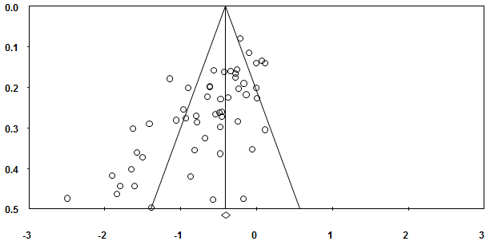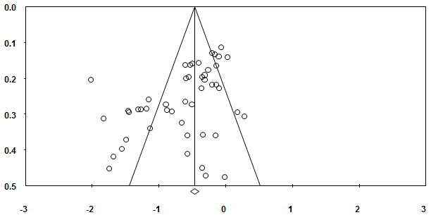
- (b)
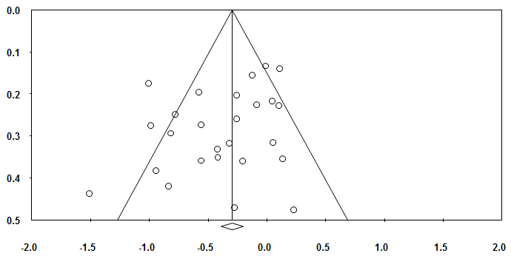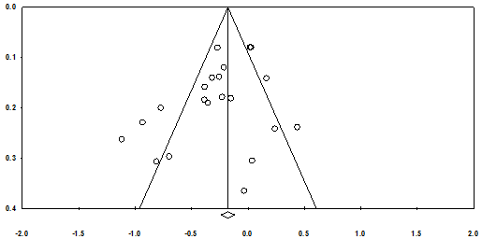
- (d)
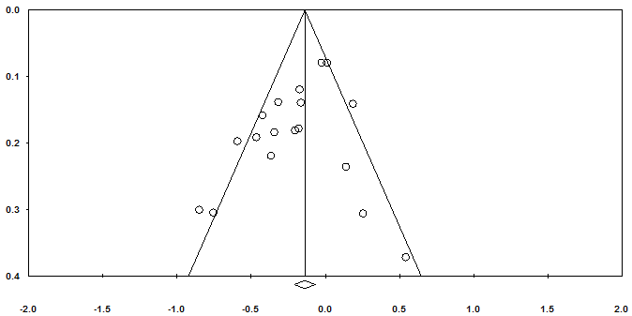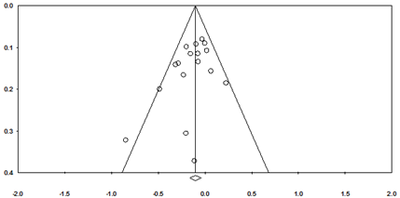
(e) (f)
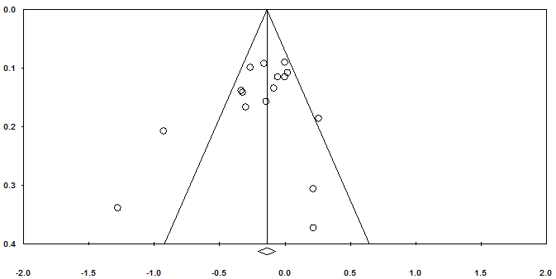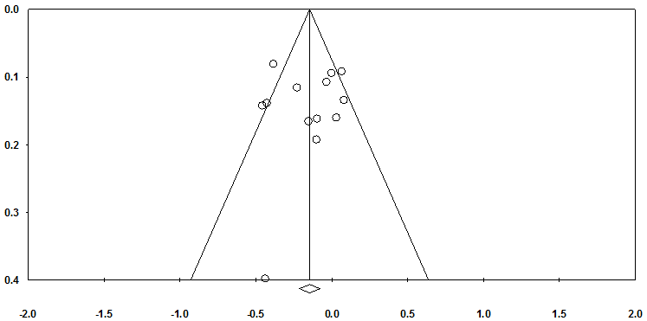
(g) (h)
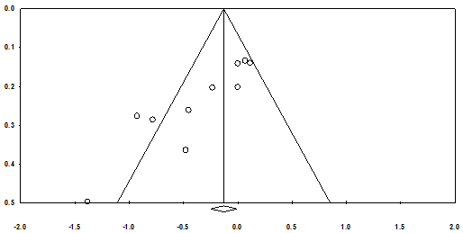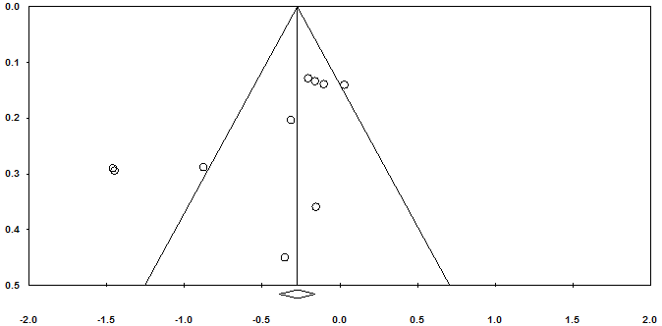
- (j)
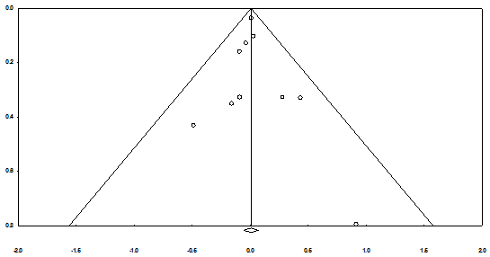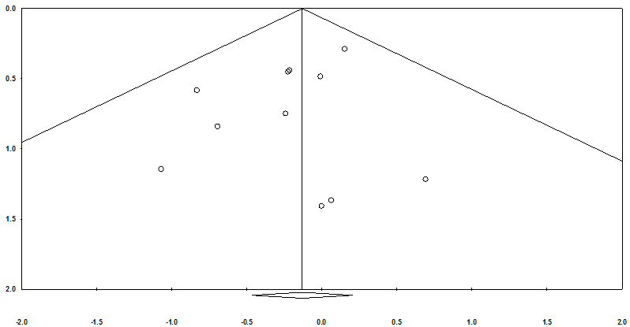
(k) (l)
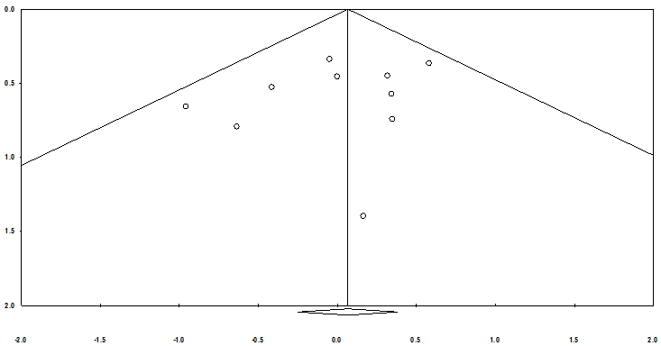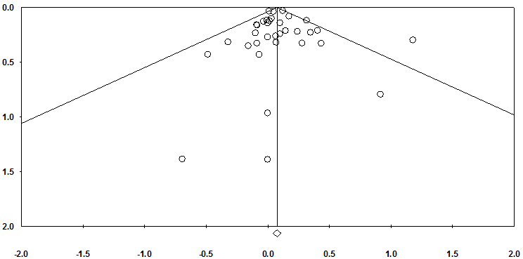
(m) (n)
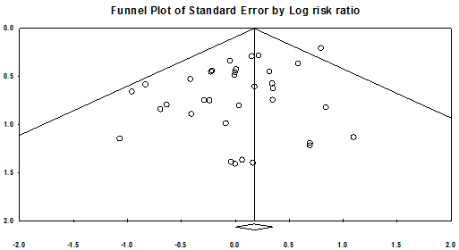
(o)

- Funnel plot for overall results in terms of pain at short term, Egger’s test P<0.001.
- Funnel plot for overall results in terms of physical function at short term, Egger’s test P<0.001.
- Funnel plot for overall results in terms of stiffness at short term, Egger’s test P=0.08.
- Funnel plot for overall results in terms of pain at medium term, Egger’s test P=0.06.
- Funnel plot for overall results in terms of physical function at medium term, Egger’s test P=0.098.
- Funnel plot for overall results in terms of pain at long term, Egger’s test P=0.10.
- Funnel plot for overall results in terms of physical function at long term, Egger’s test P=0.29.
- Funnel plot for overall results in terms of radiograph at long term, Egger’s test P=0.88.
- Funnel plot for glucosamine in terms of pain at short-term, Egger’s test P<0.001.
- Funnel plot for glucosamine in terms of physical function at short-term, Egger’s test P=0.04.
- Funnel plot for glucosamine in terms of any adverse events, Egger’s test P=0.75.
- Funnel plot for glucosamine in terms of withdrawal due to adverse events, Egger’s test P=0.30.
- Funnel plot for chondroitin in terms of withdrawal due to adverse events, Egger’s test P=0.34.
- Funnel plot for overall results in terms of any adverse events, Egger’s test P=0.67.
- Funnel plot for overall results in terms of withdrawal due to adverse events, Egger’s test P=0.01.

Supplementary References
1. Appelboom T, Schuermans J, Verbruggen G, Henrotin Y, Reginster JY. Symptoms modifying effect of avocado/soybean unsaponifiables (ASU) in knee osteoarthritis: A double blind, prospective, placebo-controlled study. Scandinavian Journal of Rheumatology. 2001;30(4):242-247.
2. Arden NK, Cro S, Sheard S, et al. The effect of vitamin D supplementation on knee osteoarthritis, the VIDEO study: a randomised controlled trial. Osteoarthritis and cartilage. 2016;24(11):1858-1866.
3. Beer C, Wood S, Veghte RH. A Randomized, Double-Blind, Placebo-Controlled Clinical Trial to Investigate the Effect of Cynatine® FLX on Symptoms of Osteoarthritis. Journal of Dietary Supplements. 2013;10(3):184-194.
4. Belcaro G, Cesarone MR, Errichi S, et al. Treatment of osteoarthritis with Pycnogenol. The SVOS (San Valentino Osteo-arthrosis Study). Evaluation of signs, symptoms, physical performance and vascular aspects. Phytotherapy Research. 2008;22(4):518-523.
5. Benito-Ruiz P, Camacho-Zambrano MM, Carrillo-Arcentales JN, et al. A randomized controlled trial on the efficacy and safety of a food ingredient, collagen hydrolysate, for improving joint comfort. International Journal of Food Sciences and Nutrition. 2009;60(SUPPL. 2):99-113.
6. Biegert C, Wagner I, Ludtke R, et al. Efficacy and safety of willow bark extract in the treatment of osteoarthritis and rheumatoid arthritis: results of 2 randomized double-blind controlled trials. J Rheumatol. 2004;31(11):2121-2130.
7. Blotman F, Maheu E, Wulwik A, Caspard H, Lopez A. Efficacy and safety of avocado/soybean unsaponifiables in the treatment of symptomatic osteoarthritis of the knee and hip: A prospective, multicenter, three-month, randomized, double-blind, placebo-controlled trial. Revue du Rhumatisme (English Edition). 1997;64(12):825-834.
8. Bourgeois P, Chales G, Dehais J, Delcambre B, Kuntzi JL, Rozenberg S. Efficacy and tolerability of chondroitin sulfate 1200 mg/day vs chondroitin sulfate 3 x 400 mg/day vs placebo. Osteoarthritis and Cartilage. 1998;6(SUPPL. A):25-30.
9. Brahmachari B, Chatterjee S, Ghosh A. Efficacy and safety of diacerein in early knee osteoarthritis: A randomized placebo-controlled trial. Clinical Rheumatology. 2009;28(10):1193-1198.
10. Brand C, Snaddon J, Bailey M, Cicuttini F. Vitamin E is ineffective for symptomatic relief of knee osteoarthritis: A six month double blind, randomised, placebo controlled study. Annals of the Rheumatic Diseases. 2001;60(10):946-949.
11. Brien S, Lewith G, Walker AF, Middleton R, Prescott P, Bundy R. Bromelain as an adjunctive treatment for moderate-to-severe osteoarthritis of the knee: A randomized placebo-controlled pilot study. QJM. 2006;99(12):841-850.
12. Bucsi L, Poor G. Efficacy and tolerability of oral chondroitin sulfate as a symptomatic slow-acting drug for osteoarthritis (SYSADOA) in the treatment of knee osteoarthritis. Osteoarthritis and Cartilage. 1998;6(SUPPL. A):31-36.
13. Cibere J, Kopec JA, Thorne A, et al. Randomized, double-blind, placebo-controlled glucosamine discontinuation trial in knee osteoarthritis. Arthritis Care and Research. 2004;51(5):738-745.
14. Cisar P, Jany R, Waczulikova I, et al. Effect of pine bark extract (Pycnogenol) on symptoms of knee osteoarthritis. Phytotherapy Research. 2008;22(8):1087-1092.
15. Clegg DO, Reda DJ, Harris CL, et al. Glucosamine, chondroitin sulfate, and the two in combination for painful knee osteoarthritis. New England Journal of Medicine. 2006;354(8):795-808.
16. Debbi EM, Agar G, Fichman G, et al. Efficacy of methylsulfonylmethane supplementation on osteoarthritis of the knee: A randomized controlled study. BMC Complementary and Alternative Medicine. 2011;11.
17. Dougados M, Nguyen M, Berdah L, Maziéres B, Vignon E, Lequesne M. Evaluation of the structure-modifying effects of diacerein in hip osteoarthritis: ECHODIAH, a three-year, placebo-controlled trial. Arthritis and Rheumatism. 2001;44(11):2539-2547.
18. Farid R, Mirfeizi Z, Mirheidari M, et al. Pycnogenol supplementation reduces pain and stiffness and improves physical function in adults with knee osteoarthritis. Nutrition Research. 2007;27(11):692-697.
19. Farid R, Rezaieyazdi Z, Mirfeizi Z, et al. Oral intake of purple passion fruit peel extract reduces pain and stiffness and improves physical function in adult patients with knee osteoarthritis. Nutrition Research. 2010;30(9):601-606.
20. Fransen M, Agaliotis M, Nairn L, et al. Glucosamine and chondroitin for knee osteoarthritis: A double-blind randomised placebo-controlled clinical trial evaluating single and combination regimens. Annals of the Rheumatic Diseases. 2015;74(5):851-858.
21. Frestedt JL, Walsh M, Kuskowski MA, Zenk JL. A natural mineral supplement provides relief from knee osteoarthritis symptoms: A randomized controlled pilot trial. Nutrition Journal. 2008;7(1).
22. Gabay C, Medinger-Sadowski C, Gascon D, Kolo F, Finckh A. Symptomatic effects of chondroitin 4 and chondroitin 6 sulfate on hand osteoarthritis: A randomized, double-blind, placebo-controlled clinical trial at a single center. Arthritis and Rheumatism. 2011;63(11):3383-3391.
23. Giordano N, Fioravanti A, Papakostas P, Montella A, Giorgi G, Nuti R. The efficacy and tolerability of glucosamine sulfate in the treatment of knee osteoarthritis: A randomized, double-blind, placebo-controlled trial. Current Therapeutic Research - Clinical and Experimental. 2009;70(3):185-196.
24. Herrero-Beaumont G, Román Ivorra JA, Trabado MDC, et al. Glucosamine sulfate in the treatment of knee osteoarthritis symptoms: A randomized, double-blind, placebo-controlled study using acetaminophen as a side comparator. Arthritis and Rheumatism. 2007;56(2):555-567.
25. Houpt JB, McMillan R, Wein C, Paget-Dellio SD. Effect of glucosamine hydrochloride in the treatment of pain of osteoarthritis of the knee. Journal of Rheumatology. 1999;26(11):2423-2430.
26. Hughes R, Carr A. A randomized, double-blind, placebo-controlled trial of glucosamine sulphate as an analgesic in osteoarthritis of the knee. Rheumatology. 2002;41(3):279-284.
27. Jin X, Jones G, Cicuttini F, et al. Effect of Vitamin D Supplementation on Tibial Cartilage Volume and Knee Pain Among Patients With Symptomatic Knee Osteoarthritis: A Randomized Clinical Trial. JAMA. 2016;315(10):1005-1013.
28. Kahan A, Uebelhart D, De Vathaire F, Delmas PD, Reginster JY. Long-term effects of chondroitins 4 and 6 sulfate on knee osteoarthritis: the study on osteoarthritis progression prevention, a two-year, randomized, double-blind, placebo-controlled trial. Arthritis & Rheumatism. 2009;60(2):524-533.
29. Kim LS, Axelrod LJ, Howard P, Buratovich N, Waters RF. Efficacy of methylsulfonylmethane (MSM) in osteoarthritis pain of the knee: A pilot clinical trial. Osteoarthritis and Cartilage. 2006;14(3):286-294.
30. Kolahi S, Malek Mahdavi A, Mahdavi R, Lak S. Effect of l-carnitine supplementation on clinical symptoms in women with osteoarthritis of the knee: A randomized, double-blind, placebo-controlled trial. European Journal of Integrative Medicine. 2015.
31. Kumar S, Sugihara F, Suzuki K, Inoue N, Venkateswarathirukumara S. A double-blind, placebo-controlled, randomised, clinical study on the effectiveness of collagen peptide on osteoarthritis. Journal of the science of food and agriculture. 2015;95(4):702-707.
32. Kwoh CK, Roemer FW, Hannon MJ, et al. Effect of oral glucosamine on joint structure in individuals with chronic knee pain: a randomized, placebo-controlled clinical trial. Arthritis & Rheumatology. 2014;66(4):930-939.
33. Lau CS, Chiu PKY, Chu EMY, et al. Treatment of knee osteoarthritis with Lyprinol, lipid extract of the green-lipped mussel - A double-blind placebo-controlled study. Progress in Nutrition. 2004;6(1):17-31.
34. Lequesne M, Maheu E, Cadet C, Dreiser RL. Structural effect of avocado/soybean unsaponifiables on joint space loss in osteoarthritis of the hip. Arthritis & Rheumatism. 2002;47(1):50-58.
35. Lugo JP, Saiyed ZM, Lane NE. Efficacy and tolerability of an undenatured type II collagen supplement in modulating knee osteoarthritis symptoms: A multicenter randomized, double-blind, placebo-controlled study. Nutrition journal. 2016;15(1).
36. Madhu K, Chanda K, Saji MJ. Safety and efficacy of Curcuma longa extract in the treatment of painful knee osteoarthritis: A randomized placebo-controlled trial. Inflammopharmacology. 2013;21(2):129-136.
37. Maheu E, Mazieres B, Valat JP, et al. Symptomatic efficacy of avocado/soybean unsaponifiables in the treatment of osteoarthritis of the knee and hip: a prospective, randomized, double-blind, placebo-controlled, multicenter clinical trial with a six-month treatment period and a two-month followup demonstrating a persistent effect. Arthritis & Rheumatism. 1998;41(1):81-91.
38. Maheu E, Cadet C, Marty M, et al. Randomised, controlled trial of avocado-soybean unsaponifiable (Piascledine) effect on structure modification in hip osteoarthritis: The ERADIAS study. Annals of the Rheumatic Diseases. 2014;73(2):376-384.
39. Mazieres B, Combe B, Van AP, Tondut J, Grynfeltt M. Chondroitin sulfate in osteoarthritis of the knee: A prospective, double blind, placebo controlled multicenter clinical study. Journal of Rheumatology. 2001;28(1):173-181.
40. Mazières B, Hucher M, Zaïm M, Garnero P. Effect of chondroitin sulphate in symptomatic knee osteoarthritis: A multicentre, randomised, double-blind, placebo-controlled study. Annals of the Rheumatic Diseases. 2007;66(5):639-645.
41. McAlindon T, Formica M, LaValley M, Lehmer M, Kabbara K. Effectiveness of glucosamine for symptoms of knee osteoarthritis: Results from an internet-based randomized double-blind controlled trial. American Journal of Medicine. 2004;117(9):643-649.
42. McAlindon TE, Nuite M, Krishnan N, et al. Change in knee osteoarthritis cartilage detected by delayed gadolinium enhanced magnetic resonance imaging following treatment with collagen hydrolysate: A pilot randomized controlled trial. Osteoarthritis and Cartilage. 2011;19(4):399-405.
43. McAlindon T, LaValley M, Schneider E, et al. Effect of vitamin D supplementation on progression of knee pain and cartilage volume loss in patients with symptomatic osteoarthritis: A randomized controlled trial. JAMA - Journal of the American Medical Association. 2013;309(2):155-162.
44. Michel BA, Stucki G, Frey D, et al. Chondroitins 4 and 6 sulfate in osteoarthritis of the knee: A randomized, controlled trial. Arthritis and Rheumatism. 2005;52(3):779-786.
45. Nakagawa Y, Mukai S, Yamada S, et al. Short-term effects of highly-bioavailable curcumin for treating knee osteoarthritis: a randomized, double-blind, placebo-controlled prospective study. Journal of Orthopaedic Science. 2014;19(6):933-939.
46. Nguyen M, Dougados M, Berdah L, Amor B. Diacerhein in the treatment of osteoarthritis of the hip. Arthritis and Rheumatism. 1994;37(4):529-536.
47. Noack W, Fischer M, Forster KK, Rovati LC, Setnikar I. Glucosamine sulfate in osteoarthritis of the knee. Osteoarthritis and Cartilage. 1994;2(1):51-59.
48. Panahi Y, Rahimnia AR, Sharafi M, Alishiri G, Saburi A, Sahebkar A. Curcuminoid treatment for knee osteoarthritis: A randomized double-blind placebo-controlled trial. Phytotherapy Research. 2014;28(11):1625-1631.
49. Pavelká K, Gatterová J, Olejarová M, Machacek S, Giacovelli G, Rovati LC. Glucosamine sulfate use and delay of progression of knee osteoarthritis: A 3-year, randomized, placebo-controlled, double-blind study. Archives of Internal Medicine. 2002;162(18):2113-2123.
50. Pavelka K, Trč T, Karpaš K, et al. The efficacy and safety of diacerein in the treatment of painful osteoarthritis of the knee: A randomized, multicenter, double-blind, placebo-controlled study with primary end points at two months after the end of a three-month treatment period. Arthritis and Rheumatism. 2007;56(12):4055-4064.
51. Prahalad S, Ryan MH, Shear ES, Thompson SD, Giannini EH, Glass DN. Efficacy and safety of diacerein in osteoarthritis of the knee: A double-blind, placebo-controlled trial. Arthritis and Rheumatism. 2000;43(10):2339-2348.
52. Pujalte JM, Llavore EP, Ylescupidez FR. Double-blind clinical evaluation of oral glucosamine sulphate in the basic treatment of osteoarthrosis. Current Medical Research & Opinion. 1980;7(2):110-114.
53. Railhac JJ, Zaim M, Saurel AS, Vial J, Fournie B. Effect of 12 months treatment with chondroitin sulfate on cartilage volume in knee osteoarthritis patients: A randomized, double-blind, placebo-controlled pilot study using MRI. Clinical Rheumatology. 2012;31(9):1347-1357.
54. Reginster JY, Deroisy R, Rovati LC, et al. Long-term effects of glucosamine sulphate on osteoarthritis progression: A randomised, placebo-controlled clinical trial. Lancet. 2001;357(9252):251-256.
55. Rindone JP, Hiller D, Collacott E, Nordhaugen N, Arriola G. Randomized, controlled trial of glucosamine for treating osteoarthritis of the knee... including commentary by Katz MD. WJM: Western Journal of Medicine. 2000;172(2):91-95.
56. Rozendaal RM, Koes BW, Van Osch GJVM, et al. Effect of glucosamine sulfate on hip osteoarthritis: A randomized trial. Annals of Internal Medicine. 2008;148(4):268-277.
57. Sanghi D, Mishra A, Sharma AC, et al. Does vitamin D improve osteoarthritis of the knee: A randomized controlled pilot trial. Clinical Orthopaedics and Related Research. 2013;471(11):3556-3562.
58. Schmid B, Ludtke R, Selbmann HK, et al. Efficacy and tolerability of a standardized willow bark extract in patients with osteoarthritis: randomized placebo-controlled, double blind clinical trial. Phytother Res. 2001;15(4):344-350.
59. Sengupta K, Alluri KV, Satish AR, et al. A double blind, randomized, placebo controlled study of the efficacy and safety of 5-Loxin for treatment of osteoarthritis of the knee. Arthritis Res Ther. 2008;10(4):R85.
60. Sengupta K, Krishnaraju AV, Vishal AA, et al. Comparative efficacy and tolerability of 5-Loxin and AflapinAgainst osteoarthritis of the knee: a double blind, randomized, placebo controlled clinical study. Int J Med Sci. 2010;7(6):366-377.
61. Shin K, Kim JW, Moon KW, et al. The Efficacy of Diacerein in Hand Osteoarthritis: A Double-Blind, Randomized, Placebo-Controlled Study. Clinical Therapeutics. 2013;35(4):431-439.
62. Stebbings S, Beattie E, McNamara D, Hunt S. A pilot randomized, placebo-controlled clinical trial to investigate the efficacy and safety of an extract of Artemisia annua administered over 12 weeks, for managing pain, stiffness, and functional limitation associated with osteoarthritis of the hip and knee. Clinical Rheumatology. 2015:1-8.
63. Uebelhart D, Thonar EJMA, Delmas PD, Chantraine A, Vignon E. Effects of oral chondroitin sulfate on the progression of knee osteoarthritis: A pilot study. Osteoarthritis and Cartilage. 1998;6(SUPPL. A):39-46.
64. Uebelhart D, Malaise M, Marcolongo R, et al. Intermittent treatment of knee osteoarthritis with oral chondroitin sulfate: a one-year, randomized, double-blind, multicenter study versus placebo.[Erratum appears in Osteoarthritis Cartilage. 2007 Aug;15(8):979 Note: DeVathaire, Florent [corrected to de Vathaire, Florent]]. Osteoarthritis & Cartilage. 2004;12(4):269-276.
65. Usha PR, Naidu MUR. Randomised, double-blind, parallel, placebo-controlled study of oral glucosamine, methylsulfonylmethane and their combination in osteoarthritis. Clinical Drug Investigation. 2004;24(6):353-363.
66. Vishal AA, Mishra A, Raychaudhuri SP. A double blind, randomized, placebo controlled clinical study evaluates the early efficacy of aflapin in subjects with osteoarthritis of knee. Int J Med Sci. 2011;8(7):615-622.
67. Wildi LM, Raynauld JP, Martel-Pelletier J, et al. Chondroitin sulphate reduces both cartilage volume loss and bone marrow lesions in knee osteoarthritis patients starting as early as 6 months after initiation of therapy: A randomised, double-blind, placebo-controlled pilot study using MRI. Annals of the Rheumatic Diseases. 2011;70(6):982-989.
68. Wluka AE, Stuckey S, Brand C, Cicuttini FM. Supplementary vitamin E does not affect the loss of cartilage volume in knee osteoarthritis: A 2 year double blind randomized placebo controlled study. Journal of Rheumatology. 2002;29(12):2585-2591.
69. Zegels B, Crozes P, Uebelhart D, Bruyère O, Reginster JY. Equivalence of a single dose (1200 mg) compared to a three-time a day dose (400 mg) of chondroitin 4&6 sulfate in patients with knee osteoarthritis. Results of a randomized double blind placebo controlled study. Osteoarthritis and Cartilage. 2013;21(1):22-27.

