Additional Results:

Study Characteristics

Fetal heart rate during acute exercise

Randomized controlled trials
There was one randomized controlled trial (RCT) which reported on FHR during exercise (n=7); it could not be included in the meta-analysis because it did not report standard deviations.¹

Non-randomized interventions
There were three non-randomized interventions (n=70) reporting on FHR during acute exercise sessions.²⁻⁴ The women in these studies were tested between 24-40 weeks gestation, and all women were performing vigorous to high intensity aerobic exercise between 7 and 25 minutes.

Cross sectional studies
There were six cross-sectional studies (n=72) reporting on FHR during acute exercise sessions.⁵⁻¹⁰ The women were tested in the second⁵ and third trimester.⁶⁻¹⁰ Exercise modality included only aerobic exercise. Exercise sessions included low,⁹ moderate,⁷ ⁸ ¹⁰ and vigorous to high⁵ ⁶ intensity activities performed for 5 to 40 minutes in duration. One study included women with small for gestational age (SGA) fetuses (n=20).¹¹

Cohort Studies
There were nine cohort studies reporting on FHR during acute exercise sessions (n=193).¹¹⁻¹⁹ The women were tested between 15-40 weeks gestation, and all but one study tested women exclusively in the third trimester.¹⁴ Exercise modality included aerobic activities¹¹⁻¹⁴ ¹⁶ ¹⁷ ¹⁹ and resistance training.¹⁵ ¹⁸ Exercise intensity included low,¹⁵ ¹⁸ moderate¹³ ¹⁷ ¹⁹ and vigorous¹² ¹⁶ activities ranging from 10 to 20 minutes in duration.

Fetal heart rate following acute exercise

Randomized controlled trials
There were seven RCTs (n=245 women) reporting on FHR following acute exercise sessions.¹ ²⁰⁻²⁵ One study (n=13) could not be included in the meta-analysis because it did not report standard deviations.¹ One study included women (n=17) who were diagnosed with gestational diabetes mellitus receiving insulin therapy.²⁰ Women were 12-38 weeks gestation when they were tested for acute FHR responses. Exercise modality included aerobic,¹ ²⁰⁻²⁴ and yoga.²⁵ Exercise intensity included low,²⁵ moderate ¹ ²¹⁻²⁴ and vigorous²⁰ ²³ ²⁴ activities ranging from 3-60 minutes in duration.

Non-randomized interventions
There were four non-randomized interventions (n=130 women) reporting on FHR following acute exercise sessions.²⁻⁴ ²⁶ All but one study included women who were previously inactive.³ Women were tested in both the second and third trimesters in all studies.²⁻⁴ ²⁶ All exercise studies include aerobic activities of moderate² and vigorous³ ⁴ ²⁶ intensities ranging from 7 to 50 minutes in duration.

Cross Sectional Studies
There were 20 cross-sectional studies (n=513 women) reporting on FHR following acute exercise sessions.⁵⁻¹⁰ ²⁷⁻⁴⁰ Women were tested between 26 and 41 weeks gestation. All but one study included aerobic exercise; this study was a resistance training study.³⁰ Exercise sessions included low,⁶ ⁹ ³² ³⁴ moderate,⁷ ⁸ ¹⁰ ³⁰ ³² ³³ ³⁵⁻⁴⁰ and vigorous⁵ ²⁷⁻²⁹ ³¹ ³² intensity activities ranging from 5 to 40 minutes in duration.

Cohort Studies
There were 33 cohort studies (n=882 women) reporting on FHR following acute exercise sessions.¹¹⁻¹⁶ ¹⁸ ¹⁹ ⁴¹⁻⁶⁴ Women were tested between 12 and 41 weeks gestation. Exercise sessions included aerobic activities, ¹¹⁻¹⁴ ¹⁶ ¹⁹ ⁴¹⁻⁵¹ ⁵⁴⁻⁶⁴ resistance training,¹⁵ ¹⁸ ⁵² and yoga.⁵³ Exercise sessions included low,¹⁸ ⁵² ⁵³ ⁶² moderate¹¹ ¹³ ¹⁴ ¹⁹ ⁴⁹ ⁵⁵ ⁵⁷ ⁶¹ and vigorous14 44-48 50 51 54 56 58-60 63 64 intensity activities ranging from 5 to 60 minutes in duration.

Case Control Studies
There were two case-control studies (n=84 women) reporting on FHR following acute exercise sessions.⁶⁵ ⁶⁶ Women were tested between 22 weeks gestation⁶⁵ and term (not defined).⁶⁶ They all preformed aerobic exercise of low⁶⁵ and moderate⁶⁶ intensity for 17.5 to 60 minutes in duration.

Incidence of bradycardia and tachycardia

Incidence of bradycardia at rest
There were 24 studies (n=1,711 women) reporting on the incidence of bradycardia at rest. They include two RCTs ,²⁵ ⁶⁷ three non-randomized interventions,² ⁴ ⁶⁸ nine cross sectional,⁵ ⁷ ⁸ ¹⁰ ²⁸ ³⁸ ⁶⁹⁻⁷¹ and 10 cohort studies.¹⁴ ¹⁵ ⁴⁸ ⁵⁰ ⁵¹ ⁵⁶ ⁵⁹ ⁷²⁻⁷⁴ Two of the studies were identified to potentially have artifact, which would increase the reported incidence of bradycardia.⁷ ⁷¹ Women were tested between 25-40 weeks gestation. With the exception of one resistance training study¹⁵ and one yoga intervention,²⁵ all exercise sessions included aerobic exercise. Exercise sessions were of low,¹⁵ ²⁵ ⁷¹ moderate,² ⁷ ⁸ ¹⁰ ¹⁴ ³⁸ ⁶⁷⁻⁷⁰ ⁷³ and vigorous intensity⁴ ⁵ ¹⁴ ²⁸ ⁴⁸ ⁵⁰ ⁵¹ ⁵⁶ ⁵⁹ ⁷² ⁷⁴. Exercise sessions were between 5 and 60 minutes in duration.

Incidence of tachycardia
There were 13 studies (n=644 women) reporting on the incidence of tachycardia at rest, during exercise, or following exercise.1 2 4 8 15 25 27 40 48 50 54 58 72 They include one RCTs,²⁵ three non-randomized interventions,¹ ² ⁴ three cross sectional,⁸ ²⁷ ⁴⁰ and six cohort studies.¹⁵ ⁴⁸ ⁵⁰ ⁵⁴ ⁵⁸ ⁷² All but one study included aerobic exercises; this study was a yoga session.²⁵ Studies ranged from 7-60 minutes in duration and took place from 12-38 weeks gestation. Exercise sessions included low,¹⁵ ²⁵ moderate,¹ ² ⁸ ⁴⁰ and vigorous⁴ ²⁷ ⁴⁸ ⁵⁰ ⁵⁴ ⁵⁸ ⁷² intensity activities.

Chronic Prenatal Exercise

Effect of chronic prenatal exercise on fetal heart rate at rest
There were 16 studies (n=595 women) reporting on FHR at rest following an exercise intervention.¹⁻⁴ ²¹⁻²⁶ ⁴⁹ ⁵⁴ ⁷⁵⁻⁷⁸ Of these, there were eight RCTs (n=323 women), ¹ ²¹⁻²⁵ ⁷⁵ three non-randomized interventions (n=70 women),¹ ² ⁴ one cross-sectional study (n=61 women) and four cohort studies (n=118 women). Of the RCTs, four included aerobic exercise only,¹ ²¹ ²² ²⁶ one was a superiority trial comparing yoga to walking,⁷⁵ while the other two included a combination of aerobic activities and resistance training.²³ ²⁴ One RCT consisted of a single exercise session only (yoga).²⁵ Two of the non-randomized interventions included aerobic exercise only⁴ and the third included a combination of aerobic activities and resistance training.² Exercise frequency ranged from three to six days per week and consisted of sessions lasting 15 to 60 minutes. Nine of the interventions were supervised (all sessions supervised), ¹⁻⁴ ²²⁻²⁶ one was unsupervised,⁷⁵ and it was unclear from one trial whether it was supervised or not.²¹ The compliance to the interventions was reported in six studies and ranged from 74-100%.²⁻⁴ ²³ ²⁴ ⁴⁹ Four studies included women who were previously inactive⁴ ²²⁻²⁴ while the rest did not spcify previous exercise levels of the women.

Effect of chronic prenatal exercise on the fetal heart rate response during exercise
There were no RCTs reporting on FHR during exercise post-intervention. There were two non-randomized interventions (n=58 women) which reported on the change in FHR during exercise post-intervention. ² ⁴ One included aerobic activities only⁴ while the other included a combination of aerobic activities and resistance training intervention.² The exercise frequency for both interventions was three times per week, at a moderate intensity for 15-25 minutes. ² ⁴ The acute exercise sessions included aerobic activities lasting from 7-15 minutes and were of moderate to vigorous intensity. ² ⁴ Both interventions were supervised, with compliance ranging between 74-86%.² ⁴ One study included women who were previously inactive,⁴ the other did not define previous physical activity levels of the women.²

Effect of chronic prenatal exercise on the fetal heart rate response following exercise
There were six studies (n=249 women) which reported on the change in FHR following exercise post-intervention.² ⁴ ²¹⁻²⁴ Four were RCTs (n=91 women) ²¹⁻²⁴ and two were non-randomized interventions (n=58 women) ² ⁴ Three included aerobic activities only⁴ ²¹ ²² while the other three included a combination of aerobic activities and resistance training.² ²³ ²⁴ The exercise frequency was three to six times per week, at a moderate to vigorous intensity for 15-60 minutes. ² ⁴ ²¹⁻²⁴ The acute exercise sessions included aerobic activities lasting from 3-20 minutes and were of moderate to vigorous intensity. ² ⁴ ²¹⁻²⁴ All but one²¹ interventions were supervised, with compliance ranging between 74-86%.² ⁴ ²³ ²⁴ Four studies included women who were previously inactive,⁴ ²²⁻²⁴ and two did not define previous physical activity levels of the women.² ²¹

Umbilical Artery Blood Flow

Umbilical artery blood flow during acute exercise
There were two studies (n=41 women) reporting on the change in umbilical artery blood flow during acute exercise sessions compared to rest.¹⁶ ²⁵ Both studies reported on the umbilical artery systolic/diastolic ratio (S/D; arbitrary units).¹⁶ ²⁵ One cohort study included an aerobic exercise session lasting less 12 minutes at a vigorous to high intensity,¹⁶ while the other was a randomized controlled trial which included a single yoga session (low intensity) for 60 minutes.²⁵

Umbilical artery blood flow following acute exercise
There were 17 studies (n=469 women) reporting on the change in umbilical artery blood flow following acute exercise sessions compared to rest.16 25 29-31 34 41 42 46 49 61 70 74 79-82 Two studies (49 women) were RCTs,²⁵ ⁸⁰ eight were cohort studies (279 women),¹⁶ ⁴¹ ⁴² ⁴⁶ ⁴⁹ ⁶¹ ⁷⁴ ⁸¹ ⁸² and six studies (141 women) were cross-sectional.²⁹⁻³¹ ³⁴ ⁷⁰ ⁷⁹ Ten studies (197 women) reported on the change in umbilical artery S/D following acute exercise. ¹⁶ ²⁵ ²⁹ ³¹ ³⁴ ⁴² ⁴⁶ ⁴⁹ ⁷⁰ ⁷⁴ Seven studies (293 women) reported on the change in umbilical artery pulsatility index (PI) following exercise.²⁵ ³⁰ ³¹ ⁶¹ ⁷⁹ ⁸⁰ ⁸². Five studies (128 women) reported on the change in umbilical artery resistance index (RI) following acute exercise.²⁵ ³¹ ⁴¹ ⁶¹ ⁸¹ Women were tested between 14-42 weeks gestation. The exercise sessions were all aerobic exercise except one study which included yoga²⁵ and one study which included resistance exercise.³⁰ ⁸⁰ Three studies included women who were previously inactive,³¹ ⁴¹ ⁴⁹ two included women who were active,³¹ ⁷⁹ and the rest were undefined. Exercise sessions were of low,²⁵ ³⁴ ⁸⁰ moderate,³⁰ ⁴² ⁴⁹ ⁶¹ ⁷⁰ ⁸¹ ⁸² and vigorous to high¹⁶ ²⁹ ³¹ ⁴¹ ⁴⁶ ⁷⁴ ⁷⁹ intensity. Exercise session were between 5-60 minutes in duration.

Effects of chronic exercise on umbilical blood flow
There were five studies (n=403 women) which reported on the effects of exercise intervention on resting umbilical artery S/D, PI, or RI.⁷⁵ ⁸⁰ ⁸³⁻⁸⁵ Three were RCTs, although one was a superiority trial comparing a yoga program to a walking program.⁷⁵ There was one non-randomized intervention comparing a yoga program to walking program.⁸⁴ Two studies (n=99 women) reported on umbilical artery S/D at rest following exercise intervention.⁷⁵ ⁸³ Three studies (n=158 women) reported on umbilical artery PI at rest following exercise intervention.⁷⁵ ⁸⁰ ⁸³ Two studies (n=99 women) reported on umbilical artery RI at rest following exercise intervention.⁷⁵ ⁸³ Exercise frequency ranged from two to seven days per week. Exercise types included aerobic exercise,⁷⁵ ⁸³ ⁸⁴ yoga,⁷⁵ ⁸⁴ and pelvic floor muscle training (PFMT).⁸⁰ The duration of the session lasted between 20 to 60 minutes and included low⁷⁵ ⁸⁰ ⁸⁴ and moderate⁸³ intensity activities. Two studies included supervised exercise sessions,⁸⁰ ⁸³ while two did not.⁷⁵ ⁸⁴
One RCT (n=26 women) reported on the umbilical artery PI response to acute exercise following exercise intervention.⁸⁰ The intervention was supervised PFMT (low intensity) for two to seven days per week for approximately 20 minutes each session.⁸⁰

Uterine Artery Blood Flow

Uterine artery blood flow during acute exercise
There were two studies (n=32 women) reporting on the change in uterine artery blood flow during acute exercise sessions compared to rest.¹⁶ ¹⁸ Both studies reported on the uterine artery S/D.¹⁶ ¹⁸ One cohort study included aerobic activities for less than 12 minutes in duration at a vigorous intensity,¹⁶ while one cohort study included supine resistance exercise (leg lifts; low intensity) for 10 minutes.¹⁸

Uterine artery blood flow following acute exercise
There were 14 studies (n=429 women) reporting on the change in uterine artery blood flow following an acute exercise session compared to rest.16 18 31 34 36 41 61 65 80 81 86-89 One was a RCT (n=26 women),⁸⁰ five were cross-sectional (n=193 women),³¹ ³⁴ ³⁶ ⁸⁶ ⁸⁷ seven were cohort studies (n=198 women),¹⁶ ¹⁸ ⁴¹ ⁶¹ ⁸¹ ⁸⁸ ⁸⁹ and one was a case control study (n=12 women).⁶⁵ There were five studies (n=103 women) reporting on the change in uterine artery S/D following acute exercise. ¹⁶ ¹⁸ ³¹ ³⁴ ⁸⁶ There were seven studies (n=312 women) reporting on the change in uterine artery PI following acute exercise.³¹ ³⁶ ⁶¹ ⁶⁵ ⁸⁰ ⁸⁷ ⁸⁸ There were five studies (n=117 women) reporting on the change un uterine artery RI following acute exercise.³¹ ⁴¹ ⁶¹ ⁸¹ ⁸⁹ Women were tested between 16-41 weeks gestation and included aerobic activities in all but two studies which did resistance training¹⁸ or PFMT.⁸⁰ Exercise sessions were 5-22 minutes in duration and were of low,¹⁸ ⁶⁵ ⁸⁰ ⁸⁹ moderate,³⁶ ⁶¹ ⁸¹ and vigorous¹⁶ ³¹ ⁴¹ ⁸⁶ ⁸⁷ intensity activities.

Effects of chronic exercise on uterine artery blood flow
There were four studies (n=256 women) which reported on the effects of exercise intervention on resting uterine artery S/D, PI, or RI.⁷⁵ ⁸⁰ ⁸⁴ ⁸⁵ Three studies (n=243 women) were RCTs,⁷⁵ ⁸⁰ ⁸⁵ although one (n=59 women) was a superiority trial comparing a yoga program to a walking program.⁷⁵ One study was a non-randomized intervention comparing yoga to walking.⁸⁴ One study (n=59 women) reported on uterine artery S/D at rest following exercise intervention.⁷⁵ Two studies (n=118 women) reported on uterine artery PI at rest following exercise intervention.⁷⁵ ⁸⁰ One study (n=59 women) reported on uterine artery RI at rest following exercise intervention.⁷⁵ Exercise frequency ranged from two to seven days per week, and included aerobic exercise,⁷⁵ ⁸⁴ ⁸⁵ yoga,⁷⁵ ⁸⁴ and pelvic floor muscle training (PFMT).⁸⁰ Exercise sessions lasted 15 to 60 minutes in duration and included low⁷⁵ ⁸⁰ ⁸⁴ and vigorous⁸⁵ intensity activities. Two studies included supervised exercise sessions,⁸⁰ ⁸⁵ while two did not.⁷⁵ ⁸⁴
One study (n=26 women) reported on the uterine artery PI response to acute exercise following exercise intervention.⁸⁰ The intervention was supervised PFMT (low intensity) for two to seven days per week for approximately 20 minutes each session.⁸⁰

Results for fetal tachycardia, the effects of chronic exercise on fetal heart rate, umbilical blood flow, and uterine blood flow.

Fetal tachycardia
There was “very low” quality evidence from eight studies (n=505 women; 524 assessments) reporting the proportion of tachycardia at rest to be 3% (95% CI 0.00, 0.14; I²= 86%; See Online Supplement Figure 88; proportions).¹ ¹⁵ ²⁵ ²⁷ ⁴⁸ ⁵⁰ ⁵⁴ ⁵⁸ The quality of evidence was downgraded from “low” to “very low” due to serious inconsistency. There was “very low” quality evidence from five studies (n=77 women; 188 assessments) reporting tachycardia during 5% of acute exercise sessions (95% CI 0.02, 0.16; I²= 72%; See Online Supplement Figure 89; proportions).¹ ⁴ ⁸ ¹⁵ ²⁷ There was “very low” quality evidence from 13 studies (n=644 women; 769 assessments) reporting fetal tachycardia following exercise (up to 20 minutes) in 7% of exercise sessions (95% CI 0.03, 0.15; I²=83%; See Online Supplement Figure 90; proportions).1 2 4 8 15 25 27 40 48 50 54 58

The effects of chronic exercise on resting fetal heart rate
There was “moderate” quality evidence from four RCTs (n=191 women) showing no impact of exercise training on resting FHR post-intervention (MD= -1.72 bpm, 95% CI -3.94, 0.50, I²= 0%, p=0.13, see Online Supplement Figure 15).²¹⁻²⁴ The quality of evidence was downgraded from “high” to “moderate” due to serious risk of bias and serious inconsistency. The tests for subgroup differences performed for exercise-only interventions were not significant (see Online Supplement Figures 16 and 17).
There was “very low” quality evidence (downgraded due to serious risk of bias) from two non-randomized interventions (n=58 women) demonstrated a decrease in resting FHR of 2.1bpm in the exercise group compared to the control group post-intervention (95% CI -3.38, -0.89, I²= 0%, p=0.013, see Online Supplement Figure 18).² ⁴ The tests for subgroup differences performed for exercise-only interventions were not significant (see Online Supplement Figures 19 and 20). There was “low” quality evidence from one superiority trial (n=59 women) showed no difference in resting FHR following yoga or walking intervention (MD= 3.70bpm, 95%CI, 1.34, 8.74, I²=n/a, p=0.15; see Online Supplement Figure 21).⁷⁵ Evidence was downgraded from “high” to “low” due to serious risk of bias and serious inconsistency. Four interventional studies (n=108 women; two RCTs and two non-randomized interventions) could not be included in the pooled analysis due to the absence of a control group,¹ ²⁶ ⁵⁴ or because they only included FHR information from single exercise sessions.²⁵ These studies found resting FHR was 6.5 to 18.5 bpm lower post-intervention in the exercise intervention group.
Further, there was “very low” quality of evidence from three cohort studies (n=120 women) reported on the effects of chronic prenatal exercise on resting FHR. Evidence was downgraded from “low” to “very low” due to serious inconsistency. One cohort study (n=32 women) reported a decrease in resting FHR in the exercise group compared to the control group in late pregnancy (MD= -9.21, 95% CI, -15.86, -2.55, I²=0%, p=0.007; see Online Supplement Figure 22).⁷⁶ Two studies were not included in the pooled analysis because they had no control group,⁴⁹ or did not present raw data.⁷⁸ Additional data for these studies can be found in the Online Supplement Table 1 & 2. They reported that resting FHR decreased with advancing gestation in women who exercised,⁴⁹ and that FHR at rest in the third trimester was correlated with minutes of LTPA spent in non-continuous activities (e.g. resistance training).⁷⁸ There was “very low” quality evidence from one cross-sectional study (n=62 women; downgraded from “low” to “very low” due to serious inconsistency) reported decrease in resting FHR in the exercise group compared to the control group in late pregnancy (MD= -4.93, 95% CI, -8.32, -1.54, I²=90%, p=0.004; see Online Supplement Figure 23).³ ⁷⁷

The effect of chronic exercise on the FHR response to acute exercise

FHR response during exercise
There was “very low” quality evidence from two non-randomized interventions (n=49 women) showing no difference in the FHR response during exercise between exercise and control groups (MD= -1.95bpm, 95% CI -15.06, 11.17, I²= 77%, p=0.77, see Online Supplement Figure 24).² ⁴ The quality of evidence was downgraded from “low” to “very low” due to serious risk of bias, serious inconsistency, and serious imprecision. The tests for subgroup differences performed for exercise-only interventions were not significant (see Online Supplement Figures 25 and 26).

FHR response following exercise
There was “low” quality evidence from four RCTs (n=193 women) showed no difference in the FHR between exercise and control groups following an acute exercise session (MD= -3.39bpm, 95% CI -10.51, 3.73, I²=81%, p=0.35, see Online Supplement Figure 27). ²¹⁻²⁴ The quality of evidence was downgraded due to serious risk of bias and serious inconsistency. The tests for subgroup differences performed for exercise-only interventions were only significant when comparing studies by the type of exercise included in the intervention (p<0.00001) (see Online Supplement Figures 28 and 29). Specifically, there was “moderate” quality evidence (downgraded due to serious risk of bias) showing that the increase in FHR following acute exercise was greater in exercising women who participated in aerobic exercise only interventions (MD= 6.52 bpm, 95% CI, 2.31, 10.74, I²= 0%, p= 0.002) while the increase in FHR following acute exercise was lesser in the exercising women who engaged in interventions with various types of exercise (MD= -9.16bpm, 95% CI, -13.46, -4.86, I²= 0%, p< 0.0001; see Online Supplement Figure 29).
There was “very low” quality evidence (downgraded due to serious risk of bias) from two non-randomized interventions (n=58 women) showed no overall difference in FHR following exercise between exercise and control groups (MD= -1.19bpm, 95% CI -6.08, 3.70, I²= 0%, p=0.63, see Online Supplement Figure 30). The tests for subgroup differences performed for exercise-only interventions were not significant (see Online Supplement Figures 31 and 32).

The effects of prenatal exercise on umbilical artery blood flow metrics

The effects of acute exercise on umbilical artery S/D ratio
There was “low” quality evidence from two studies (n=41 women) reporting on the change in umbilical artery S/D during acute exercise suggesting no change from resting values (MD= -0.04, 95% CI, -0.10, 0.01, I²= 0%, p=0.14, see Online Supplement Figure 33).
There was “very low” quality evidence from 10 studies (n=197 women) showing no changes in umbilical artery S/D within three minutes following acute exercise compared to baseline (MD= -0.00, 95% CI, -0.14, 0.13, I²= 67%, p= 0.97, see Online Supplement Figure 34).¹⁶ ²⁵ ²⁹ ³¹ ³⁴ ⁴² ⁴⁶ ⁴⁹ ⁷⁰ ⁷⁴ The quality of evidence was downgraded from “low” to “very low” due to serious inconsistency. The tests for subgroup differences were not significant for a priori subgroup analyses (see Online Supplement Figures 35 and 36). In contrast, the tests for subgroup differences were significant for post-hoc subgroup analysis when comparing studies looking at different exercise intensities and durations (see Online Supplement Figures 37-39). Specifically, there was “very low” to “low” quality evidence (downdgraded from “low” to “very low” due to serious inconsistency) showing that following acute exercise of low and vigorous intensity umbilical artery S/D was not altered (MD= -0.03, 95% CI, -0.5, 0.19, I²=3%, p=0.80; MD= 0.08, 95%CI, -0.03, 0.19, I²= 30%, p=0.17, respectively), whereas following acute exercise of moderate intensity activities, umbilical artery S/D was decreased by -0.30 (95% CI, -0.47, -0.13, I²= 11%, p= 0.0007). Moreover, there was “very low” to “low” quality evidence (downdgraded from “low” to “very low” due to serious inconsistency) reporting that acute exercise of 0-20minutes and > 40 minutes decreased umbilical artery S/D (MD -0.16, 95% CI, -0.32, -0.00, I²= 39%, p=0.05; MD= -0.09, 95%CI, -0.30, 0.12, I²= 0%, p=0.41, respectively), whereas acute exercise of 21-39 minutes did not alter umbilical artery S/D (MD= 0.02, 95%CI, -0.32, 0.36, I²=n/a, p=0.91).

The effects of acute exercise on umbilical artery PI
No study reported on the umbilical artery PI during acute exercise. There was “very low” quality evidence from six studies (n=280 women) showing no change in the umbilical artery PI within five minutes following exercise (MD= -0.01, 95%CI -0.04, 0.02, I²= 71%, p= 0.58, see Online Supplement Figure 40).²⁵ ³⁰ ³¹ ⁷⁹ ⁸⁰ ⁸² The quality of evidence was downgraded due to serious inconsistency. The tests for subgroup differences were not significant for both a priori subgroup analyses and post-hoc subgroup analyses (see Online Supplement Figures 41-45). One cohort study (n=13 women) could not be included in the pooled analysis because it did not report mean or SD and showed that the umbilical artery PI decreased following exercise.⁶¹

The effects of acute exercise on umbilical artery RI
There were no studies reporting on umbilical artery RI during acute exercise. There was “low” quality evidence from four studies (n=115 women) showing no difference in umbilical artery RI following exercise (MD= -0.02, 95% CI -0.04, 0.00, I²= 0%, p=0.02, see Online Supplement Figure 46).²⁵ ³¹ ⁴¹ ⁸¹ The tests for subgroup differences were not significant for a priori subgroup analyses (see Online Supplement Figure 47 and 48). One cohort study (n=13 women) could not be included in the pooled analysis because it did not report mean or SD and showed that umbilical artery RI decreased following exercise.⁶¹

The effects of acute exercise on umbilical artery volumetric blood flow and mean blood velocity
There were no studies reporting on umbilical artery volumetric blood flow or mean blood velocity during exercise. There were no studies reporting on umbilical artery volumetric blood flow following acute exercise. Thre was “very low” quality evidence from one cohort study (n=14 women; graded from “low” to “very low” due to serious inconsistency) which reported no chnage in umbilical artery mean blood velocity following acute exercise (MD= 1.5, 95% CI, -4.2, 1.20, I2 = n/a, p=0.28; see Online Supplement Figure 49).⁴¹

The effects of chronic exercise on resting umbilical artery blood flow metrics

Resting umbilical artery S/D
There was “low” quality evidence from one RCT (n=40 women; downgraded due to serious risk of bias and serious inconsistency) showing a decrease in resting umbilical artery S/D in the women who exercised compared to the controls post-intervention (MD= -0.52, 95% CI -0.56, -0.48, I²⁼ n/a, p<0.00001, see Online Supplement Figure 50).⁸³ “Moderate” quality evidence from one RCT, which was a superiority trial, (n=59 women; downgraded due to serious inconsistency) showed a decrease in resting umbilical artery S/D in the yoga group compared to the walking group post-intervention (-0.30, 95%CI, -0.58, -0.02, I2 n/a, p= 0.04; see Online Supplement Figure 51).⁷⁵

Resting umbilical artery PI
There was “moderate” quality evidence from two RCTs (n=99 women; downgraded due to serious risk of bias) reporting lower resting umbilical artery PI in the women who exercised compared to the controls post-intervention (MD= -0.06, 95% CI -0.08, -0.04, I2= 0%, p<0.00001, see Online Supplement Figure 52).⁸⁰ ⁸³ “Moderate” quality evidence from one randomized controlled trial, which was a superiority trial, (59 women; downgraded due to serious inconsistency) showed lower resting umbilical artery PI in yoga compared to walking (-0.18, 95%CI -0.28, -0.08, I² not applicable, p=0.0008; see Online Supplement Figure 53).⁷⁵

Resting umbilical artery RI
There was “low” quality evidence from one RCT (n=40 women; downgraded from “high” to “low” due to serious risk of bias and serious inconsistency) reporting a decrease in umbilical artery RI in the women who exercised compared to the controls post-intervention (MD= -0.07, 95% CI -0.07, -0.06, I² not applicable, p<0.00001; see Online Supplement Figure 54).⁸³ There was “moderate” quality evidence from one randomized controlled trial, which was a superiority trial, (59 women; downgraded from “high” to “moderate” due to serious inconsistency) showed no difference between yoga or walking groups following the interventions (-0.03, 95% CI -0.07, 0.01, I²= n/a, p=0.11; see Online Supplement Figure 55).⁷⁵
One non-randomized intervention could not be included in the pooled analysis because it did not report blood flow, S/D, PI or RI; there was “very low” quality evidence from this study (n=13 women; downgraded from “low” to “very low” due to serious inconsistency) reporting no difference between groups on the umbilical Doppler velocimetry score before and after a yoga intervention .⁸⁴

The effects of chronic exercise on the response of umbilical artery blood flow metrics to acute exercise
There were no RCTs or non-randomized interventions reporting on the umbilical artery S/D, or RI response to acute exercise. There was “moderate” quality evidence from one RCT including pelvic floor muscle training (PFMT; n=26 women; downgraded from “high” to “moderate” due to serious inconsistency) reported on acute exercise responses of the umbilical artery PI before and after the intervention and showed a smaller change in PI following exercise in the intervention group; however, the control group did not do acute exercise and therefore they could not be compared.⁸⁰

The effects of prenatal exercise on uterine artery blood flow metrics

The effects of acute exercise on uterine artery S/D
There was “very low” quality evidence from two studies (n=32 women) reporting no change in uterine artery S/D during acute exercise compared to rest (MD= 0.20, 95%CI, -0.38, 0.77, I²= 95%, p=0.51; see Online Supplemnt Figure 56).¹⁶ ¹⁸ The quality of evidence was downgraded from “low” to “very low” due to serious inconsistency. There was “very low” quality evidence from five studies (n=103 women) reporting no change in uterine S/D following acute exercise compared to rest (MD= 0.15, 95%CI, -0.08, 0.38, I²= 87%, p=0.20; see Online Supplement Figure 57).¹⁶ ¹⁸ ³¹ ³⁴ ⁸⁶ The tests for subgroup differences were only statistically significant when comparing studies including women with different previous previous physical activity levels and not by type of exercise (see Online Supplement Figures 58 and 59). Specifically, there was “very low” to “low” quality evidence (downgraded due to serious inconsistency) showing that uterine S/D did not change following exercise in previously inactive women (MD= -0.11, 95%CI, -0.32, 0.10, I²=n/a, p=0.31) or in previously active women (MD= 0.02, 95%CI, -0.10, 0.14, I²= 26%, p=0.75), but was increased by 0.56 (95% CI, 0.41, 0.70, I²-0%, p<0.00001) in those whose previous activity levels were not defined (see Online Supplement Figure 58). Moreover, the tests for subgroup differences were not statistically significant for post hoc subgroup analysis (see Online Supplement Figures 59-62).

The effects of acute exercise on uterine artery PI
No study reported on the uterine artery PI during acute exercise. There was “low” quality evidence from seven studies (n=309 women) reporting on the uterine artery PI following exercise. ³¹ ³⁶ ⁶¹ ⁶⁵ ⁸⁰ ⁸⁷ ⁸⁸ The pooled estimate wasbased on five studies (n=205 women) and showed no change within five minutes following exercise (MD=-0.01, 95%CI, -0.04, 0.01, I²= 8%, p= 0.29, see Online Supplement Figure 63).³¹ ³⁶ ⁶⁵ ⁸⁰ ⁸⁷ The tests for subgroup differences were not statistically significant (see Online Supplement Figures 64 and 65). The two cohort studies (n=107 women) that could not be included in the pooled analysis (did not report SD,⁶¹ or reported moment of the median (MoM))⁸⁸ showed no change in the uterine artery PI before and after acute exercise.⁶¹ ⁸⁸

The effects of acute exercise on uterine artery RI
Uterine artery RI was not determined during exercise in any study. There was “very low” quality evidence from four studies (n=104 women) indicating uterine artery RI was not changed following acute exercise (MD=0.01, 95%CI -0.02, 0.04, I²= 50%, p=0.44, see Online Supplement Figure 65).³¹ ⁴¹ ⁸¹ ⁸⁹ The quality of evidence was downgraded from “low to “very low” due to serious inconsistency. The tests for subgroup differences were not statistically significant (see Online Supplement Figure 67). In contrast, the tests for subgroup differences were statistically significant for post-hoc subgroup analyses (see Online Supplement Figures 68 and 69). Specifically, there was “very low” to “low” quality evidence (downgraded from “low” to “very low” due to serious inconsistency) showing that low intensity exercise increased uterine artery RI by 0.07 (95% CI, 0.02, 0.12, I²= n/a, p=0.005), whereas moderate and vigorous intensity exercise did not change uterine artery RI (MD= -0.03, 95% CI, -0.08, 0.02, I²=n/a, p=0.19; MD= 0.01, 95% CI, -0.01, 0.03, I²=0%, p=0.47, respectively). Further, there was “very low” to “low” quality evidence (downgraded from “low” to “very low” due to serious inconsistency) showing that durations of 0-20 minutes and 20+ minutes do not result in an increase in uterine artery RI (MD= -0.01, 95% CI, -0.03, 0.01, I²=0%, p=0.38; MD= 0.04, 95% CI, -0.00, 0.08, I²=n/a, p=0.07, respectively), while undefined exercise durations report n increase in uterine artery RI following exercise (MD=0.07, 95% CI, 0.02, 0.12, I²= n/a, p= 0.005). There was “very low” quality evidence from one cohort study (n=13; downgraded from “low” to “very low” due to serious inconsistency) that was narratively summarized (did not report SD) showed no change in the uterine artery RI before and after acute exercise.⁶¹

The effects of acute exercise on uterine artery blood flow
There was “very low” quality evidence from one study (n=14 women; downgraded from “low” to “very low” due to serious inconsistency) reporting on uterine artery blood flow (ml/min) and blood velocity (cm/s) during and following supine exercise.¹⁸ Specifically, volumetric blood flow (ml/min) was not changed from left-lateral rest to during supine exercise (MD= -55, 95%CI, -113.9, 3.98, I²= n/a, p=0.07; see Online Supplement Figure 70), and was unchanged at left-lateral rest following supine exercise (MD= -1.0, 95%CI -53.76, 51.76, I²= n/a, p=0.97; see Online Supplement Figure 71).¹⁸ Mean blood velocity (cm/s) was not changed from left-lateral rest to during supine exercise (MD= 5.0, 95% CI, -2.1, 12.1, I²=n/a, p=0.17; see Online Supplement Figure 72) and was not changed during left-lateral rest following supine exercise (MD= -1.0, 95% CI, -7.8, 5.8, I²= n/a, p=0.77; see Online Supplement Figure 73).¹⁸ This study also included a supine baseline which was not included in the pooled analysis; details can be found in Table 1.¹⁸

The effects of chronic exercise on resting uterine blood flow measurements

Uterine artery S/D
There was “moderate” quality evidence from one superiority trial (n=60 women; downgraded from “high” to “moderate” due to serious inconsistency) which reported that resting uterine artery S/D ratio was lower in the yoga group compared to the walking group (MD= -0.40, 95% CI -0.72, -0.08, I² = 0%, p=0.01, see Online Supplement Figure 74).⁷⁵

Uterine artery PI
There was “low” quality evidence from one RCT (n=59 women; downgraded from “high” to “low” due to serious risk of bias and serious inconsistency) reporting no difference in resting uterine artery PI between groups following an exercise intervention (MD= 0.02. 95% CI -0.10, 0.14, I²= n/a, p=0.75, see Online Supplement Figure 75).⁸⁰ There was “moderate” quality evidence from one superiority trial (60 women, downgraded from “high” to “moderate” due to serious inconsistency) showing a decrease in resting uterine artery PI by -0.21 in the yoga group compared to the walking groups at the end of the intervention (95% CI -0.41, -0.01, I² =0%, p=0.04, see Online Supplement Figure 76).⁷⁵

Uterine artery RI
There was “moderate” quality evidence from one superiority trial (60 women, downgraded from “high” to “moderate” due to serious inconsistency) showing a decrease in resting uterine artery artery RI by -0.10 in the yoga group compared to the walking group (95% CI -0.16, -0.04, I²= 0%, p=0.002, see Online Supplement Figure 77).⁷⁵ Two studies (n=245 women) could not be included in the pooled analysis because they were missing SD,⁸⁵ or reported unusable values.⁸⁴ Specifically, one RCT (n=125 women) reported on uterine artery PI at rest before and after intervention it showed no difference in resting uterine PI between exercise and control groups at the end of the intervention⁸⁵ and one non-randomized intervention (n=120 women) showed no difference in uterine doppler velocimetry score between groups before and after a yoga intervention.⁸⁴

The effects of chronic exercise on uterine artery blood flow metrics response to acute exercise
There were no studies reporting on uterine artery S/D, RI, volumetric blood flow or mean blood velocity response during or following acute exercise sessions post-intervention. There was “moderate” quality evidence (downgraded from “high” to “moderate” due to serious inconsistency) from one RCT (n=59 women) that was narratively summarized (did not report measure in control group) reported a greater decrease in uterine artery PI following acute exercise post-intervention in the exercise group (pelvic floor muscle training; PFMT).⁸⁰

Supplementary Tables: Study Characteristics

Table 1: Study characteristics: Acute exercise sessions
Author, year, country, study type, study name | Sample size (n) | Age (years) | Complications/ pre-pregnancy PA level | PA Assessment | Definition of PA groups | Time point | Acute exercise session characteristics (FITT) | Results
Arfi.  1986  France.  Cross-sectional⁶ | 14 | 25.6 ± 4 | N/A | Objective | Acute exercise session only | 37.9 ± 0.9 weeks | -Cycle ergometer  -Resistance increased by 0.5watt/kg every 3 minutes  -15.14min average | Data in forest plots
Artal et al.  1984  USA  Cross-sectional.⁷¹ | 19 | 27 ± 1 | Moderately active | Self- reported & objective | Women performed one symptom limited VO₂max test | 34 ± 3 weeks | -Treadmill  -Incremental to maximal (160bpm max)  -7.5min average | Narrative Summary:  -Case report for three women with fetuses experiencing bradycardia during exercise.  -This paper was identified to potentially have artifact in the FHR measurement during exercise. Therefore, a sensitivity analysis was done removing it from the bradycardia analysis.
Artal et al.  1986.  USA.  Cross-sectional.³² | Light: 15  Mod: 15  Strenuous: 15 | - | “Moderately fit with mild exercise group slightly less fit” | Objective | Acute exercise only.  Mild, moderate & strenuous exercise sessions. | 34-35 weeks | -Treadmill  -mild:15 minutes at 2.3-3.0 METs/2.0mph  -moderate: 15 minutes at 5.0-6.0 METs/ 2.0mph @ 10% incline  -strenuous: 7.0-9.0 METs/ 2.5mph incline increases 2% every minute to exhaustion (time varied) | Data in forest plots
Artal et al.  1995.  USA.  Cross-sectional.⁶⁹ | 7 | 24.86 ± 2.18 | Sedentary. | Objective | All women participated in acute exercise sessions at sea level and at altitude. | 33.86 ± 1 weeks | -Cycle ergometer  -Incremental 25W increase 3x5min stages, then increase every 2 minutes until max.  Sea level:  -MHRmax = 167.86; VO_{2max} = 1.39L/min; 167.86 ml/kg/min  High Altitude:  -MHRmax = 161.64; VO_{2max} = 1.21L/min; 164.64 ml/kg/min | Data in forest plots.
Avery et al.  1997  USA.  RCT.⁶⁷ | E: 15  C: 14 | - | No current exercise regime >30 minutes 2x/week.  GDM. | Self-reported, objective & LTPA | Women were enrolled in an RCT.  FITT in Table 2. | FHR was measured at supervised exercise sessions and bradycardia was reported across all 77 sessions. | -cycle ergometer  -30 minutes  -70% HRmax | Data in forest plots.
Avery et al.  1999  Canada  Cohort¹⁵ | 12 | 29 ± 1 | Inexperienced/ Low (according to Health and Lifestyle questionnaire) | Objective & LTPA | Acute exercise session only  Each exercise was done sitting and semi-supine | 31 ± 1 weeks | -Resistance Training: handgrip, single-leg extension, double-leg extension.  -1 rep max (RM) and 10RM (80% of 1RM) | Data in forest plots
Backiuk et al.  2008.  Brazil.  RCT²² | E: 34  C: 27 | - | Sedentary | Objective & LTPA | Women were enrolled in a RCT.  FITT in Table 2. | 19, 25, 35 weeks | -Treadmill  -12 minutes  -four 3-min stages:  1) 2.7kph, 0%;  2) 2.7kph, 10%;  3) 4kph, 12%;  4) 5.5kph, 14%  -MHR at peak: 160-180 (fig 3) | Data in forest plots
Barakat et al.  2008  Spain  Cohort ¹⁷  Barakat et al.  2010.  Spain.  Cross-sectional.⁷⁹ | 20 | 29.6 ± 4.3 | 18 (90%) were active; 2 were not active (10%) | Self-reported, objective & LTPA | Acute exercise session only Data extracted to plots was at the end of 20 minutes of exercise. | 3rd trimester | -Cycle ergometer  -20 minutes  -RPE: 12-14  - “moderate” intensity | Narrative Summary:  Mean FHR during exercise was 149 ± 5.91 (FHR increase was 11-36bpm, mean 24bpm)  Pearson correlation of FHR during exercise and gestational age: 006; p=0.803
Baumann et al.  1989.  Switzerland.  Cohort.⁶¹ | 13 | - | Untrained | Objective & LTPA | Acute exercise session only. | 38 weeks | -semi-supine cycle ergometer (60º angle for exercise)  -3 minutes for 5 trials with rest between to assess each vessel. | Narrative Summary:  Data is presented in Table 2 as medians and ranges and cannot be used in plots.  Uterine Artery RI (NSD pre-post)  pre- median 0.40; range 0.27-0.55  post- median: 0.39; range 0.26-0.55  Uterine Artery PI (NSD pre-post)  pre- median 0.64; range 0.48-0.98  post- median 0.69; range 0.40-1.06  Umbilical Artery RI (p<0.01 pre-post)  pre- median 0.59; range 0.46-0.71  post- median: 0.53; range 0.45-0.67  Umbilical Artery PI (p<0.02 pre-post)  pre- median 0.98; range 0.68-1.24  post- median 0.87; range 0.67-1.19  From the text: median FHR before exercise was 133 (range 114 to 166) after exercise also 133 (range 114 to 167).
Bgeginski et al.  2015.  Brazil.  Cohort.⁵² | 10 | 25.2 ± 4.4 | Sedentary prior to pregnancy. At 22-24 weeks women were not practicing regular exercise in the last three months. | Objective & LTPA | Three separate acute exercise sessions. | 22-24 weeks  28-32 weeks  34-36 weeks | -Resistance exercise  - bilateral leg extension & pec-deck fly machine  -1 & 3 sets of 15 reps each  -weight at 50% of 1 rep max  -MHR varied (98.7 ± 11.9 to 114.8 ± 17.0). | Narrative Summary:  As per statistician (NB) recommendation, FHR was determined as the average value from of all four types of activity at each gestational age. Therefore, only three data points are presented in the forest plots.  At 28-32 weeks n=6  At 34-36 weeks n=5  Data in forest plots.
Bonen et al.  1992.  Canada.  Cross-Sectional¹⁰ | T2: 6  T3: 8 | - | - | Self-reported & objective | All women were regularly active (2-3x/week) and participated in aerobics classes (n-10) or walking (n=2).  Acute exercise sessions included for this study. | 2nd trimester & 3rd trimester | -Cycle ergometer  -30 minutes  T2: 67W; 4.1L/min  T3: 78W; 6.4L/min | Narrative Summary:  -FHR measures in figure 1 were not possible to extract due to the quality of the image. “FHR did not differ between T2 & T3 at rest, during exercise, or after exercise (P>0.05; Figure 1). Responses in heart rates did not differ over time between the two groups (groups x time, p>0.05)”
Bonnin,  1997.  Finland.  Cohort.⁴¹ | 14 | 28 ± 7 | Sedentary prior to pregnancy | Objective & LTPA | Exercise was performed in the sitting position | 36 ± 3 weeks | -Cycle ergometer  - 3-9minutes  - incremental; 3minute stages at 60,90 & 120Watts  -peak: 80 ± 8 %HRmax (153 ± 14 bpm) | -Umbilical artery blood flow is also presented as a maximum systolic velocity (extracted from figure 4)  At rest: 28.8 ± 3.8  Following exercise (1min): 30.3 ± 5.9
Brenner et al. 1999  Canada  Non- randomized Intervention² | E(T2): 14  E(T3): 14  C: 6 | E: 28.7 ± 3.5  C: 29.3 ± 3.2 |  | Objective & LTPA | Women were enrolled in a non-randomized exercise intervention.  FITT in table 2 | 37 ± 1 weeks | -Cycle ergometer  -Incremental to RPE 18 or 170bpm  -8.9 ± 0.7 minutes average | Narrative Summary:  We contacted the authors for clarification about differences between table 4 and figure. The values for FHR in table 4 represent and average over 20 minutes. Therefore, for recovery data, we extracted the 1-minute time point from Figure 2.
Bung.  1993.  Germany.  RCT.²⁰ | E: 17  C: 17 | E:38.97 ±1.74  C:38.18 ±2.04 | All women having GDM and requiring insulin | Objective | -Women were enrolled in a RCT. FITT in table 2  -Women also performed symptom limited VO₂max sessions. | 27-41 weeks | -Semi-reclined cycle ergometer  -45 minutes  -50% VO₂max | Data in forest plots.
Carpenter et al. 1988.  USA.  Cohort¹⁴ | 45 | 29.0 ± 3.7 | 21 reported vigorous exercise one or more times per week pre-pregnancy.  16 reported regular exercise during pregnancy. | Objective & LTPA | Subjects were studied twice on separate days.  One submaximal exercise session and one maximal exercise session. | 25.2 ± 3.0 weeks | Submaximal sessions:  -Cycle ergometer  -0, 30, and 60W for 6-min each work load  Maximal sessions:  -Cycle ergometer  -Started at 60 W, increased every 2min to fatigue. | Data in forest plots
Chaddha et al.  2005.  Canada.  Case control.⁶⁵ | Healthy: 23  Complicated: 12 | Healthy:  34.4 ± 6.38  Complicated: 29.6 ± 3.2 | Women in the complicated group had uteroplacental insufficiency (uterine artery PI >1.45) | Objective & LTPA | Acute exercise only | 22-26 weeks | -cycle ergometer  -5 minutes  -10% & 15% of “maximum” (not defined) | Data in forest plots.
Clapp.  1985.  USA.  Cross sectional.³³ | 6 | - | - | Objective | Acute exercise only | 20 & 32 weeks | -treadmill  -20 minutes  “running” (no speed or grade given) | Data in forest plots
Clapp et al.  1993  USA  Cohort¹² | 120 | - | “well-conditioned women” | Self-reported & LTPA | Women continued to exercise at 50% or more of their pre-conception exercise levels (running or aerobics, ≥3x/week, ≥30 minutes).  FITT in table 2 | 33-38 weeks | -Cycle ergometer  -60 ± 3% of VO₂max  -20 minutes | Data in forest plots
Clapp et al.  1995  USA  Case Control.⁶⁶ | E:31  C:29 | 31 ± 1 | - | Self-reported & LTPA | Control group exercised until 28 weeks gestation and then discontinued exercise regularly. |  | -Various aerobic (running, swimming, stair machine, aerobics, bicycling)  -3 to 6x/week  -20 to 60 minutes  -50 to 88% VO2max  -exercise up until onset of labor with last exercise session occurring within 48 hours of delivery | Narrative Summary:  Women in the exercise group were selected at 36-38 weeks gestation based on “an exercise associated increase in FHR >5bpm after regular exercise. "The magnitude of the increase in FHR with maternal exercise ranged between 8-34 bpm"
Clapp et al.  2000.  USA.  RCT.²¹ | E: 6  C:6 | E: 30 ± 1  C: 31 ± 1 | Pre-pregnancy VO₂max (ml/kg/min)  E: 42.8 ± 2.7  C: 38.2 ± 2.4 | Objective, Total PA, & LTPA | Women were enrolled in a RCT. Separated based on their pre-pregnancy VO₂max and regularly (>3x/ week) vs not regularly exercising.  FITT in table 2 | 15, 26, 37 weeks | -Treadmill  -20 minutes  -55% pre-pregnancy VO₂max | Data in forest plots
Collings et al.  1983  USA  Non-randomized intervention³ | E: 12  C: 8 | - |  | Objective & LTPA | Women were enrolled in a non-randomized intervention.  FITT in table 2 | unclear | -Cycle ergometer  -65-70% VO₂, MHR 152  -10 minutes | Data in forest plots.
Collings et al.  1985.  USA.  Cohort⁵⁴ | 25  for FHR data n=11 | 25-35 | - | Objective & LTPA | Women were participating in regular exercise program.  FITT in table 2 | 28, 32, 34, 36 & 38 weeks | -aerobic exercise (walking, jogging, stationary bike)  -10min warm up, 30min aerobics  -68.5% of maximal aerobic capacity | Data in forest plots.
Cooper et al.  1987.  Australia.  Cohort⁵⁵ | 14 | 30 ± 3 | - | Objective& LTPA | Acute exercise session only.  Data for FHR was presented as a mean of all six exercise sessions (2T & 3T, at 2,3 & 4 METS). | 21 ± 2 weeks  36 ± 1 weeks | -Treadmill  - 10-minutes at each 2,3, & 4 METS (3kph at 0%, 3.5% & 7%) | Data in forest plots.
Dale et al.  1982.  USA.  Cohort⁵⁶ | E (pro): 12  E (retro): 21  C: 11  For FHR data n=4 | Retro: 30  Pro(E &C): 28 | All exercise groups were runners (average 4yrs experience).  Control women were non-runners | Self-reported & LTPA | Retrospective:  -1T- 14.2 mpw;  -2T- 10.9 mpw;  -3T- 6.6 mpw;  -8 of 21 (38%) competed in races during pregnancy  Prospective:  -1T- 13 mpw;  -2T- 12.9 mpw;  -3T- 9.2mpw;  - 4 of 11 competed in races during pregnancy | 31-38 weeks | -Running  -no other information given | Data in forest plots.
Dressendorfer et al.  1980.  USA.  Cohort¹³ | 54 | Range: 26-30 | “exercising women with above average CV fitness” | Self-reported & LTPA | Women continued swimming throughout pregnancy (30-45min; 3-4x/week).  Completed two acute exercise sessions each. | 32-39 weeks | -Cycle ergometer  -Incremental, 150kg-m/min load increases  -Time varied; at least four stages (up to 600kg-m)  -160bpm max | Narrative Summary:  Baseline FHR was 142 (range 135-152); FHR during peak exercise was 149 ± 5 bpm. SD not given.
Einsenberg de Smoler et al.  1974.  Mexico.  Cross-sectional.³⁹ | 16 | - | - | Objective | Acute exercise session only. | 36 weeks | -Treadmill  Variable:  -10 min  -4 stages:  1.7mph/3min; 3.0mph/2min; 4.0mph/2min; 5.0mph/3min  Constant:  -30 min  -2.5mph | Narrative Summary:  Variable: rest, 133; post-exercise, 141  Constant: rest, 136; post-exercise, 141  SD not given.
Erkkola et al.  1992  Finland  Cohort¹⁶ | 8 | 31.4 ± 4.9 | The subjects had not pursued athletics or undertaken any “hard physical training” during pregnancy. | Objective & LTPA | Acute exercise session only. | 36.9 ± 1.1 weeks | -Cycle ergometer  -4minutes stages at 73, 114, & 161 watts per stage | Data in forest plots
Ertan et al.  2004.  USA.  Cohort.⁸¹ | Healthy: 33  Complicated: 10 | - | Complicated pregnancies= IUGR | Objective & LTPA | Acute exercise session only. | 3rd trimester | -Cycle ergometer  -10minutes  -1.25W/kg (moderate exercise; mean= 79 ± 11W) | Data in forest plots.
Ferland et al.  2013.  Canada.  Cohort.⁸⁸ | 94  PA 0-1: 15  PA 2-4: 36  PA >4: 43 | Subdivided by PA frequency (per month):  PA 0-1: 27.7  PA 2-4: 29.2  PA >4: 29.5 |  | Self-reported & total PA | Subdivided by PA frequency (per month): 0-1; 2-4, >4  . | 11-13 weeks | -Resting measures only. | Narrative Summary:  Uterine artery data presented as a multiple of the median and could not be extracted to plots:  Associations between frequency of PA and uterine artery mean PI (MoM)  2-4x/month: B (95%CI):  -0.006 (-0.186 to 0.175), p=0.95  >4x/month: B (95%CI):  0.031 (-0.147 to 0.209), p=0.73  From text: There is a "trend towards decreasing [mean PI] with increasing PA frequency"
Golomer et al.  1989.  France.  Cohort.⁶² | 10  For FHR data n=5 | 28yr 8 month ± 3yr 5 month | - | Unclear | Acute exercise sessions once per month. | 3-8 months | -Walking with or without carrying weights (5kg)  -30 meters | Narrative Summary:  -FHR data was reported as a range and therefore could not be extracted to the plots.  FHR at rest was 140-160bpm. Following exercise there was no significant increase in FHR (values not reported).
Hackett et al.  1992.  UK.  Cohort.⁸⁹ | Healthy: 12  Normal: 14  Abnormal: 8 | Healthy:  27.7 ± 7.2  Normal:  25.1 ±4.7  Abnormal:  25.8 ± 4.6 | None of them had ever been enrolled in a physical training program. | Objective & LTPA | Acute exercise session only. | 3rd trimester | -Cycle ergometer  -50 watts  -Duration not given | Data in forest plots
Hall et al.  1987.  USA.  Cohort.⁷³ | E(L): 82  E(M): 309  E(H): 61  C: 393 | E(L): 26.2  E(M): 24.5  E(H): 25.2  C: 30.0 | - | Objective & LTPA | Women self-selected into the exercise program. Groups were created based on the number of sessions the women attended (mean 0.8, 15, 32, 64 sessions for control, low, medium, and high exercise groups, respectively).  FITT in table 2. | 28 & 38 weeks | -Various aerobic, resistance, & stretching  -45 minutes  -85%HRmax; <140bpm | Data in forest plots
Hauth et al.  1982.  USA.  Cross-sectional.⁴⁰ | 7 | - | Active prior to and during pregnancy | Self-reported & Objective | Women routinely jogged ≥1.5 miles, ≥3x/week  -Studied before and after one session for this study  -15 assessments complete for FHR data (does not say how many per woman) | 28-38 weeks | -Jogging (not treadmill)  -12 to 14.5 minutes  -1.5miles | Narrative Summary: (FHR):  -FHR data presented as a range and therefore could not be extracted to plots.  Rest: 140-155  Post-exercise: 155-204  Data in forest plots.
Jeffreys et al.  2008  USA  Cohort¹⁸ | 14 | 34 ± 3 | Physically active | Self-reported and LTPA | Women continued regular exercise throughout pregnancy, including supine exercise.  FITT in table 2 | 3rd trimester | -left lateral rest, supine rest, supine exercise (abdominal crunches and leg exercise), left lateral recovery  -RPE 13-17  -10 minutes | Narrative Summary:  -Used left lateral rest as baseline for plots. Supine Rest data as follows:  FHR: 137 ± 11  Uterine blood flow (ml/min): 267 ± 93  Uterine blood velocity (cm/s): 32 ± 11  Uterine Artery S/D: 2.0 ± 0.6  Data in forest plots
Jones et al.  1985.  USA.  Cohort.⁶³ | 4 | - | “aerobically conditioned women” | Self-reported & objective | -Women were all running >4x/week; ≥3miles @ 10min/mile pace or better during their pregnancies.  -Studied before and after one exercise session in each trimester for this study. | 24 ± 1 weeks 32 ± 1 weeks | -Running- not on treadmill  -30 minutes  -80 to 90% of predicted VO_{2max} | Narrative Summary:  FHR data was given without SD, therefore could not be extracted to plots.  Resting FHR was 132bpm. FHR increased 15bpm above resting values after exercise.
Jovanovic et al.  1985.  USA  Cross sectional⁷ | 6 | 28.5 ± 1.7 | - | Self-reported a& LTPA | Women exercised throughout pregnancy (jogging, bicycling, other; at least 2x/week; self-reported).  Data for acute exercise session only. | 3rd trimester | -cycle ergometer  -12.8 ±1.7 min  -79 ± 9Watts | Narrative Summary:  Potential artifact during exercise, therefore sensitivity analysis was performed removing it from both acute FHR analysis and bradycardia analysis.
Kardel et al.  2009.  Norway.  Cohort.  STORK.⁷² | 59 | 30.3 ± 3.9 | - | Objective & LTPA | Acute exercise session only. | 35-37 weeks | -cycle ergometer  -8 to 12 minutes  -incremental (increased 10% of predicted max per minute)  At peak:  MHR=174 ± 8.5  VO₂ (L/min) =2.1 ± 0.3  Work load=171.3± 29.3Watts  RPE=8.6 ± 1.2 | Data in forest plots
Katz et al.  1988  USA  Cohort (Longitudtinal)¹⁹ | 12  One subject did not participate in 35week assessment | 29.5 | 6 sedentary  5 light activity  1 moderate activity | Objective | Acute exercise sessions only. | 16 ± 1 weeks 26 ± 1 weeks  36 ± 1 weeks | -Cycle ergometer  -Incremental exercise was performed beginning at zero workload, with increasing load of 12-25W in 3-minute stages. After reaching 60% of age predicted HR max, subjects pedaled for 3 minutes at that workload | Data in forest plots
Katz et al.  1990.  USA.  Cross sectional.²⁷ | 7 | - | - | Objective | Acute exercise session only. | 25 weeks | Water exercise:  -immersed bicycle  -20 minutes  -70% HRmax (1.38l/min)  Land exercise:  -Cycle ergometer  -20 minutes  -70% HRmax (1.40l/min) | Data in forest plots.
Kennelly et al.  2002.  Ireland.  Cohort⁴⁷ | 22 | 25.96 ± 4.9 | - | Objective | Acute exercise session only. | 30-34 weeks | -Cycle ergometer  -incremental (time varied)  -peak at 85.8 ± 4.2% HRmax; 102.3 ± 15.7 Watt; VO₂ 23.9 ± 5.6 (ml/kg/min) | Narrative Summary:  The nadir of the umbilical artery PI was at 5 minutes post exercise.
Kennelly et al.  2002.  Ireland.  Cohort.⁴⁸ | No: 112  Mild: 119  Mod: 27 | None:  25.8 ± 5.6  Mild:  28.4 ± 5.1  Mod:  30.4 ± 4.3 | Varied | Objective & LTPA | Acute exercise session only. FHR combined for all women (not reported based on activity level). | 32-38 weeks | -Cycle ergometer  -Incremental exercise; increased by 10W each minute at a constant speed of 50-60rpm. Aim was to reach AT.  -time varied | Data in forest plots.
Lindqvist et al.  2003.  Sweden.  Cohort.⁹⁰ | 14 | 29 ± 5 | Healthy and physically active but not participating in specific exercise programs. | Objective & LTPA | Acute exercise session only. | “Throughout pregnancy” | -Cycle ergometer  -85% HRmax  -Duration not given | Narrative Summary:  “no abnormal FHR tracings”
Lotgering et al.  1998.  Netherlands.  Cohort.⁶⁴ | 22 | - | Women did not exercise regularly before or during pregnancy | Objective | Acute exercise session only. Data was calculated from median and IQR. | 18-36 weeks | -Cycle ergometer  -5 minutes  -75Watt | Data in forest plots.
Lynch et al.  2003  Australia.  Cohort.⁴⁹ | 23 | 28.7 ± 4 | Sedentary in the first four months of pregnancy. | Self-reported & LTPA | FHR taken before and after supervised exercise sessions (swimming) during a longitudinal study where all women were part of a structured exercise program.  FITT in table 2. | 16, 20, 24, 28, 32 & 36 weeks | Exercise program:  -Swimming  -40minutes  -<70%HRmax, <140bpm  Fitness testing:  (16wks only)  -Cycle ergometer  -incremental: initial load 60rpm, no resistance; increase 0.5-1Kp every 3 minutes “depending on exercise history”. | Data in forest plots
Macphail et al.  2000.  Canada.  Cohort⁵⁰ | 23 | 32 ± 4 | All women had a BMI <37 pre-pregnancy and were active throughout pregnancy. | Objective & LTPA | Acute exercise session only.  Used data from 10-minute baseline closest to exercise, and first 10-minute recovery. | Range:  31-38 weeks  Mean:35±1.6 weeks | -Cycle ergometer  -incremental: 20W for 4min, increased 20W/min to fatigue.  -Peak 184W; MHR 176 ± 6 | Data in forest plots.
Manders et al.  1997.  Netherlands.  Cross-sectional.²⁸ | 12 | 20-36  Median: 29 | None of the women was a conditioned athlete. | Objective. | Acute exercise session only. | 29-32 weeks | -Cycle ergometer  -Incremental: initial load of 50W, increased 25W every 5min to maximal exertion, and maintained for 5min at maximal load.  -peak: 53-99% HRmax (mean: 82%)  -15-30min (mean: 20) | Data in forest plots.
Marsal et al.  1979.  Sweden.  Cohort.⁵⁷ | 40 | 18-30  Median: 25 | - | Objective & LTPA | Acute exercise session only. | Range:  32-37 weeks  Median:  34 weeks | -Bed cycle ergometer  -5 minutes  -80Watts | Data in forest plots.
McMurray et al.  1995  USA  Cross-sectional⁵ | 10 | 32 ± 5 | Varied. | Objective | Acute exercise session only.  Data during exercise was extracted as the last data point during exercise. | 21-28 weeks | -Dance, walking, treadmill  -40 minutes  -133-135bpm | Data in forest plots.
Moore et al.  1988.  USA.  Cross-sectional.⁸⁶ | 11 | 26.6 | 8/11 were regular exercisers during their pregnancy (3x/wk; 1hr) | Self-reported & LTPA | Acute exercise session only | 16-28 weeks | -Cycle ergometer  -Incremental  -60-75%HRmax  -up to 20min | Data in forest plots.
Morrow et al.  1989.  Canada.  Cross-sectional.³⁴ | 15 | - | - | Objective | Acute exercise session only. | 36-41 weeks | -Cycle ergometer  -5 minutes  -20W | Data in forest plots
Nabeshima et al.  1997  Japan.  Cross-sectional.²⁹ | Healthy: 17  Complicated:7 | - | Complication= IUGR- not extracted | Objective | Acute exercise session only. | 36-42 weeks | -Treadmill  -Incremental: 3kph, increase every 3min (4 stages: 0, 15, 20, & 25%).  -peak MHR: 150bpm  -4-15min (mean: 8.8± 2.8) | Data in forest plots.
Nesler et al.  1988.  USA.  Cross-sectional.⁹ | 2T: n= 12  3T: n= 13 | - | “healthy, regularly exercising women” | Self-reported  & Objective | Participants all participated in a YMCA pregnancy fitness program (no details given). | 2T: 24-28 weeks  3T: 32-36 weeks | -Supine abdominal exercises  -5 minutes | Narrative Summary:  FHR data is described as “percent maximal pulse” at rest and during exercise.  24-28weeks  max (rest): 40 +/-5  max (EX): 46 +/-5  32-36weeks  max (rest): 40 +/- 29  max (EX): 49 +/-6
O’Neill et al.  1996,  Australia.  Cohort.⁴³ | 11 | 30.3 ± 3.3 | -5 sedentary  -2 somewhat active  -4 “trained” | Objective & LTPA | All women performed three acute exercise tests (A, B & C).  Test C includes 15min of exercise (Test B), up to 15min rest, and then an additional 15min exercise (Test C) all on the same day. Therefore, the baseline for test C and B are the same. | 34-37 weeks | Test A:  -cycle ergometer  -15 minutes  -MHR 138; 62.5W  Test B:  -cycle ergometer  -15 minutes  -MHR 156; 87.5W  Test C:  -cycle ergometer  -30min total  -MHR 142; 87.5W | Data in forest plots.
O’Neill et al.  1991  Australia.  Cohort.⁴² | study n= 21  For FHR data:  MHR<140bpm: 10  MHR>140bpm: 8 | MHR<140bpm 28.9 ± 4.2  MHR>140bpm 27.9 ± 4.6 | Varied. | Objective | Acute exercise session only. | 34-38 weeks | MHR<140bpm  -Cycle ergometer  -Incremental (time varied)  -HRpeak <140bpm  MHR>140bpm  -cycle ergometer  -incremental (time varied)  HRpeak >140bpm | Data in forest plots.
O’Neill, et al.  2006.  Australia.  Cohort.⁴⁴ | Semi-supine: 27  Upright: 23 | Group 1:  30 ± 5  Group 2:  30 ± 4 | Group 1:  19% trained, 59% sedentary  Group 2:  22% trained, 65% sedentary | Objective & LTPA | Acute exercise session only. | 34-36 weeks | Group 1:  -semi-supine (45º) cycling  -12 minutes  -resistance increased until MHR was 135-145bpm  Group 2:  -upright cycling  -10 minutes at MHR 135-145 | Data in forest plots.
Paolone et al.  1987  USA  Cross-sectional⁸ | 4 | 28 | - | Objective | Three acute exercise sessions. | 30-37 weeks | -Treadmill: 1.5-2.0mph  -Cycle: 50,60,70rpm  -5 minutes | Narrative Summary:  For the treadmill exercise, we use the pre-exercise sitting values for extraction because the recovery position was also sitting. The standing, resting FHR values were 140 ± 3.6
Perales et al.  2015.  Spain.  RCT.²³  NCT 01723293 | E: 38  C: 25 | 31.9 ±3.2 | - | Objective & LTPA | All Women were participating in a RCT.  FITT in table 2 | 34.08 ± 2.27 weeks | 40% HRR  -walking  -3minutes  60% HRR  -walking  -3minutes | Data in forest plots
Pijpers et al.  1984  Netherlands  Cross-sectional.³⁵ | E: 14  C: 14  FHR data from n=11 (all from exercise group | 26.1  Range:  22-29 | All nulliparous women | Objective | Women performed two sequential exercise sessions separated by a rest period.  Women in the control group did not exercise. | Range:  34-38 weeks  Mean:  35.6 weeks | Stimulus 1 (period III) & Stimulus 2 (period VIII):  -bed-type cycle ergometer  -5 minutes  -25W  stimulus 1 & 2 are extracted as separate sessions in plots. | Data in forest plots.
Polis et al.  2015.  USA.  Cohort.⁵³ | E(1): 10  E(2): 8  E(3): 7 | All: 31.7± 3.1  E(1):32.2±3.4  E(2):30.3±2.0  E(3):32.7±3.5 | E(1): regular yoga practice  E(2): yoga familiar  E(3): no yoga experience | Self-reported & Total PA | Acute exercise session only | 35-38 weeks | -Yoga (26 postures)  -110-115minutes  Intensity/inclusion:  -SBP <200mmHg  -MHR<HRmax (220-age)  -SaO₂>94%  -FHR110-160  –no uterine contractions | Data in forest plots
Pomerance et al.  1974  USA  Cohort.⁵⁸ | 54 | - | Pre-pregnancy weight between 100-169lbs | Objective | Acute exercise session only. | 35-37 weeks | -Cycle ergometer | Narrative Summary:  Definition of bradycardia was not consistent with clinical definitions (<110bpm), and data from paper shows that FHR did not decrease below 110bpm, therefore instances of bradycardia reported in this paper were not included in bradycardia analysis.
Rafla & Beazely,  1991.  UK.  Cross-sectional.⁷⁰ | 21 | - | - | Objective | Acute exercise session only. | 3rd trimester | -Cycle ergometer  -5 minutes  -70% of submaximal exercise | Data in forest plots.
Rafla & Cook.  1999.  UK.  Cross-sectional.³⁸ | 193 | Range: 16-38 | Uncomplicated  This study recruited 44 “high risk women” including 9 women with diabetes, 18 with IUGR and 17 with unspecified hypertensive disorders not used in the analysis. | Objective | Acute exercise session only. | 3rd trimester | -Cycle ergometer  -5 minutes  -70% of submaximal exercise | Data in forest plots.  Narrative Summary (FHR):  SD and p-values not given for FHR, so could not be included in forest plots.  Rest: 143  Recovery: 143.4
Rafla & Etokowo.  1998.  UK.  Cross-sectional.⁸⁷ | 102 | Range: 17-38 | -78 women “involved in active sports”  -24 women  “not involved in active sports” | Objective | Acute exercise session only | 25-39 weeks | -Cycle ergometer  -5 minutes  -67.2% (range: 51-90) | Data in forest plots.
Rafla et al.  1999.  UK.  Cohort.⁸² | 143 | 25.5 | “healthy” | Objective & LTPA | Acute exercise session only | 3rd trimester | -Cycle ergometer  -5 minutes  -MHR 116-200bpm; mean= 144bpm  -55-90%VO_{2max} | Data in forest plots.
Rakhshani et al.  2015.  India.  RCT.⁷⁵ | yoga: 27  walking: 31 | yoga:  27.2 ± 4.8  walking:  27.5 ±5.5 | All “high-risk pregnant women” none experiencing PE, 3 had PIH. | Self-reported, objective & LTPA | Women were enrolled in an exercise intervention (RCT) where one group attended yoga classes while the other group walked on their own.  FITT in table 2. | 12, 20, & 28 weeks  Only uterine artery SD, RI & PI have measures at 12 weeks, all other measures done at 20 & 28 weeks only. | Exercise group:  -Yoga  -60 minutes  Control group:  “conventional antenatal exercises; walking” | Data in forest plots.
Rauramo et al.  1987.  Finland.  Cohort.⁵⁹ | Healthy: 38  Diabetes: 11  n varied following exercise: Healthy, n=31 Diabetes, n=8 | Healthy:  27 ± 3  Diabetes:  27 ± 5 | The other two groups were women with preeclampsia (n=13) and women with cholestasis (n= 9) not included in the analysis. | Objective & LTPA | Acute exercise session only.  FHR data was extracted for the first timepoint following exercise only. | 32-40 weeks | -Cycle ergometer  -submaximal  Healthy:  -MHR peak =152 ± 12  Diabetes:  -MHR peak =149 ± 6 | -Data in forest plots.
Roldan et al.  2015.  Spain.  RCT.²⁴ | E: 25  C:20 | - | - | Objective & LTPA | Women were enrolled in an exercise intervention (RCT). They performed one acute exercise session in which FHR was measured in the third trimester.  FITT in table 2 | 34-36 weeks | -Treadmill  -40% and 60%  -3 minutes each stage | Data in forest plots.
Ruissen et al  1990  Netherlands  Cross-sectional.³⁰ | 23 | 28.8 | - | Objective | Acute exercise session only. | 14-37 weeks | 20 deep knee bends  No other information given. | Data in forest plots.
Shilpa et al.  2016.  USA.  No intervention RCT.²⁵  “TRY YOGA” | E: 23  C: 23 | E: 25.5 ± 4.4  C: 25.4 ± 4.6 | No previous yoga experience | Objective & LTPA | Women were enrolled in a “RCT” however only one acute session was performed. | 28-37 weeks | -Yoga  -60 minutes  -23 postures  Women in the control group watched a PowerPoint presentation on exercise and nutrition during pregnancy in the seated position for 60-minutes. | Data in forest plots.
Sibley et al.  1981.  USA  RCT.¹ | E: 7  C: 6 | 25.5 ± 3.6 | Varied egress of fitness and ability | Objective & LTPA | Women were enrolled in a RCT. FITT in Table 2 | 13-36 weeks. | -Swimming  -60minutes  -MHR 110-163 | Narrative Summary:  -Data has no SD and no control group to compare to for FHR data, therefore could not be extracted to plots.  “Actual fetal heart rate values in beats per minute for the conditioning program ranged from 133 - 155 prior to exercise, from 140- 187 during exercise, and from 137-160 at 5 min of recovery.”
Silveira,  2010.  Brazil.  Non-RCT intervention.²⁶ | 133 | ≤19: 9  20-24: 23  25-219: 57  30-34: 29  ≥35: 15 | Sedentary | Objective & LTPA | Women were enrolled in a non-randomized intervention.  FITT in Table 2 | 24-27 weeks  28-31 weeks  32-35 weeks  36-40 weeks  Women are included in more than one range. Number of sessions for each woman is 1.8 | -Aqua aerobics  -50 minutes  -60 to 90% HRmax | Data in forest plots.
Sorensen et al.  1986  Denmark.  Cross-sectional.³⁷ | 22 | Range:  17-37  Median: 24 | Sedentary | Objective | Acute exercise session only.  Data was calculated from median and IQR | 18-36 weeks | -Cycle ergometer  -5 minutes  -75W | Data in forest plots.
Steegers et al.  1988  Netherlands.  Cross-sectional.³⁶ | 20 | 25 ± 4 | Had not taken part in exercise programs before or during pregnancy | Self-reported & Objective | Two acute exercise sessions on the same day.  FHR baseline was taken before both treadmill sessions and FHR post-exercise was taken after the second 10-minute treadmill session. The time between (rest) was not given. For subgroup analysis 10 minutes of exercise was used. | 34 ± 2 weeks | Treadmill 1:  -incremental to 130bpm (equivalent to 65% HRmax; 50% VO₂max)  -time varied  Treadmill 2:  -10 minutes at 130bpm | Data in forest plots.
Szymanski et al.  2012.  USA.  Cross-sectional.³¹ | Inactive: 15  Regularly active: 15  Highly active: 15 | Inactive: 32.9  Regularly active: 34.3  Highly active: 32.9 | Inactive group was sedentary before pregnancy.  Groups defined according to activity in last 6 months (includes pre-pregnancy):  Inactive defined as < 20min 3x/week; Regularly active defined as mild-moderate activity 20min 3x/week; Highly active (mostly runners) defined as vigorously active >3x/week | Self-reported & LTPA | Acute exercise session only. | 30 weeks | -Treadmill  -Incremental: warm-up at 3.0 mph and 0%, then incline increased 2% every 2min. At 12%, speed increased 0.2 mph every 2min  -Time to volitional fatigue:  Inactive: 12.1 ± 6 min  Regular: 16.6 ± 3.4 min  Highly: 22.3 ± 2.9 min | Data in forest plots.
Tufnell et al.  1990  UK  Cohort¹¹ | AGA: 50  SGA: 20 | - | - | Objective & LTPA | Acute exercise session only. | 35-40 weeks | -Up/down 30 flights of stairs  -10 minutes  - moderate | Narrative Summary:  The FHR responses after "warming" were not included in the plots and are:  Resting, AGA: 143 ± 9.9; SGA: 139.7 ± 5.4. During exercise, AGA: 151.1 ± 6.3; SGA: 137.2 ± 12.2.  Following exercise, AGA: 143.2 ± 10.1; SGA: 139.4 ± 7.8
Van Doorrn et al.  1993.  Netherlands.  Cohort.⁴⁵ | 33 | 30.9 ± 0.7 | - | Objective & LTPA | Acute exercise session only. | 16.1 ± 1.0 weeks  25.3 ± 0.7 weeks  35.0 ± 0.6 weeks | -Cycle ergometer  -Incremental: 3minute at 30W, followed by a 10W increase every 30s to maximal.  -MHR max = 174 ± 2  -Time varied | Data in forest plots.
Van Leeuwan et al.  2014  USA.  Cross-sectional.⁹¹ | E: 21  C: 19 | Range:  20-35 | 21 exercised regularly (criteria for assignment to exercise group) | Self-reported & LTPA | MPAQ used to assign groups to exercise or control.  Women in the exercise group exercised regularly (at least 30min 3x/week). | 36 weeks | -Sitting- slightly reclined  -18 minutes  -Rest | Narrative Summary:  FHR was only determined at rest and was therefore not included in the plots.
Vega et al.  2011.  Germany.  Cohort.⁵¹ | 20 | 35.2 ± 3.6 | - | Objective & LTPA | Acute exercise session only. | 32-36 weeks | -Cycle ergometer  -Incremental: 25W increase every 2 minutes to 150bpm (RPE 16 ± 0.9).  -Time varied | Data in forest plots.
Veille et al.  1985.  USA.  Cohort.⁶⁰ | Walking: 10  Cycle: 10  Total women n=17. | 31 ± 1 | 95% exercised pre-pregnancy | Self-reported & Objective | Acute exercise session only | Range:  32-40 weeks  Mean:  35 ± 2 weeks | Group 1:  -walking on track  -10 to 15minutes  Group 2:  -cycle ergometer  -10 to 15 minutes  -50W | Data in forest plots.
Veille et al.  1989.  USA.  Cohort.⁷⁴ | 18 | 29.4 ± 3.7 | 15 women active pre-pregnancy and continued to exercise regularly throughout pregnancy. | Self-reported & objective. | Acute exercise session only. | 28.4 ± 6.3 weeks | -cycle ergometer  -150kpm increase every 3min to 85% HRmax  -time varied | Data in forest plots
Watson et al.  1991  USA  Cohort.⁴⁶ | 13 | 30  Range:  24-34 | Not participating in organized exercise program. | Objective | Acute exercise session only | 25 & 35 weeks | -Tethered swim: weight was added to provide resistance, 3 min swim at each resistance with 1 min break between  -Cycle ergometer: increasing resistance by 25W every 3 minutes until volitional maximum. | Narrative Summary:  Definition of bradycardia was not consistent with clinical definitions (<110bpm), and data from paper shows that FHR did not decrease below 110bpm, therefore instances of bradycardia reported in this paper were not included in bradycardia analysis.
Webb et al,  1994.  Canada.  Non-randomized intervention⁴ | E: 22  C: 16 | E: 30.2 ± 0.9  C: 29.1 ± 0.9 | Previously sedentary women “not regularly participating in recreational or occupational physical activity” | Self-reported & Objective | Women were enrolled in a non-randomized intervention. Participation in the exercise program (exercise group) was voluntary (self-selected)  FITT in Table 2. | 28 ± 1 weeks  37 ± 1 weeks | -Upright cycling  -15 minutes  -145 to 150bpm | Data in forest plots.
Abbreviations: AT, anaerobic threshold; AGA, average for gestational age; BMI, body mass index; bpm, beats per minute; C, control group; E, exercise group; FHR, fetal heart rate; FITT, frequency, intensity, timing, type; GDM, gestational diabetes mellitus; HR, heart arte; IQR, interquartile range; IUGR, intrauterine growth restriction; LTPA, leisure time physical activity; MET, metabolic equivalent; MoM, multiple of the median; MHR, maternal heart rate; mpw, miles per week; PA, physical activity; PE, preeclampsia; PI, Pulsatility index; PIH, pregnancy induced hypertension; RCT, randomized controlled trial; RI, resistance index; RPE, rating of perceived exertion; SD, standard deviation; S/D, systolic diastolic ratio; SGA, small for gestational age; UmbA, umbilical artery; UtA, uterine artery; VO₂, velocity of oxygen (measure of oxygen use); W, watts; 2T, second trimester; 3T, third trimester

Table 2. Study characteristics: Exercise interventions/ chronic exercise studies
Author, year, country, study type, study name | Sample size (n) | Age, years | Complications/ pre-pregnancy PA level | PA Assessment | Exercise Intervention (FITT) | Intervention start point & length | Compliance | Outcomes (Including Narrative Data)
Artal et al.  2007  USA.  Non-RCT intervention.⁶⁸ | E: 39  C: 57 | E: 32.4 ± 5.3  C: 30.6 ± 5.5 | -Overweight/ Obese  -GDM.  -Not taking insulin. | Objective & LTPA | -7x/week  -cycle ergometer  -semi-self-enrollment into groups  -1x/week supervised | Start:  >GDM diagnosis  (<33wk)  Length:  unclear | 50% >150min/ week.  -30/39 women regularly exercised (153min/wk on average). | Narrative Summary:  -Co-intervention (Diet)  -Data was unable to be extracted to plots because it was unclear (“abnormal tracings” not defined).  -If women were prescribed insulin, they were dropped from the study.
Avery et al.  1997  USA.  RCT.⁶⁷ | E: 15  C: 14 | - | No current exercise regime >30 minutes 2x/week.  GDM. | Self-reported, objective & LTPA | Supervised  -2x/week  -cycle ergometer  -30 minutes  70% HRmax  Self-Reported  -1 to 2x/week  -walking  -70% HRmax | Start:  >GDM diagnosis  (<34wk)  E: 28.7 ± 3.0 weeks  C: 26.3 ±8.1 weeks  Length:  Remainder of pregnancy | Not reported. | Data in forest plots.  Narrative Summary:  Bradycardia was reported for 77 exercise sessions.
Brenner et al. 1999.  Canada.  Non-RCT Intervention.² | E(T2):14  E(T3):14  C: 6 | E: 28.7 ± 3.5  C: 29.3 ± 3.2 | - | Objective & LTPA | -3x/week  -140-150bpm (70% HR_{max})  -15-25minutes  -Aerobic (cycle ergometer) & muscular conditioning  -Supervised | Start:  18-20 weeks  Length: unclear | -attendance to classes  -self reported  E(T2): 82±47  E(T3): 74% | Data in forest plots
Backiuk et al.  2008.  Brazil  RCT.²² | E: 34  C:27 | - | Sedentary | Regular, moderate practice or water aerobics. | - 3x /week  -70% HRmax  -50 minutes  -Water aerobics  - Supervised | From first assessment to delivery | Author contacted- no reply | Data in forest plots
Bung.  1993.  Germany.  RCT.²⁰ | E: 17  C: 17  FHR in exercise group only | E:38.97 ±1.74  C:38.18 ± 2.04 | All women having GDM and requiring insulin | Objective | -3x/week  -Semi-reclined cycle ergometer  -45 minutes (3x 15min stages interspersed with 5min rest)  -50% VO2max (varied)  -supervised | Start: unclear.  (after GDM diagnosis)  Length: unclear | Author contacted- no reply | Data in forest plots  Narrative Summary:  Data for FHR is from before and after the 45-minute exercise sessions at 50% of VO₂max.  Symptom limited VO₂max tests were performed every 3-4 weeks and target workload adjusted
Clapp et al.  2000.  USA.  RCT.²¹ | E: 6  C: 6 | E: 30 ± 1  C: 31 ±1 | Pre-pregnancy VO₂max (ml/kg/min)  E: 42.8 ± 2.7  C: 38.2 ± 2.4 Women were recruited from a larger RCT (no reference given). | Objective, Total PA, & LTPA | -Randomized to perform either aerobics, treadmill, or stair-stepping at ≥55% pre-pregnancy VO₂max  -4 to 6x/week  -40 to 60min  -unclear if supervised or not | Start: pre-conception  Length: unclear | Author contacted- no reply | Data in forest plots.
Collings et al.  1983  USA  Non-randomized intervention³ | E: 12  C: 8 | - | - | Objective & LTPA | -3x/week  -50-70% VO_{2max}  -cycle ergometer  -40minutes  -supervised | Start: 22.5weeks  Length:  7-9 weeks (mean 13.4) | - | Data in forest plots.  Narrative Summary:  FHR at rest, during, and following exercise post-intervention could not be included in plots because it had no control group and combined data for both pre-and-post-intervention timepoints. From text (with respect to exercise testing): “FHR remained well within the normal range of 120-160bpm)”
Collings et al.  1985.  USA.  Cohort.⁵⁴ | 25 | 25-35 | - | Objective & LTPA | -3x/week  -aerobic exercise  -intensity & time not given  -supervise  -FHR data extracted for acute exercise sessions only (see Table 1). | Start:  13-18 weeks  Continued until 38wks | - | Data in forest plots.
de Oliveria Melo et al.  2012.  Brazil.  RCT.⁸⁵  NCT00641550 | E(13):62  E(20):62  C:62 | E(13):  24 ± 5.8  E(20):  26 ± 5.3  C:  24 ± 5.4 | Sedentary at study admission (13&20w) | Objective & LTPA | -3x/week  -60-80% HRmax; RPE 12-16  -start at 15minutes, increased over time (varied by person).  -walking  -supervised | Start:  13 or 20 weeks  Length:  Continued to 38 weeks | >85% for both groups.  attendance taken | Narrative Summary:  Data was extracted from Figures 3A & 3C, however did not have SD and therefore could not include in plots.  -UmbA PI- 13/20 weeks rest:  E(13): 1.18002; E(20): 1.202985; C: 1.198815  -UmbA PI- 38 weeks rest:  E(13): 0.8339895; E(20): 0.8663465; C: 0.8230285  -UtA PI- 13/20 weeks rest:  E(13): 1.59764; E(20): 1.56627; C: 1.60472  -UtA PI -38 weeks rest:  E(13): 0.662732; E(20): 0.648567; C: 0.702192
E-Mekawy et al.  2012.  Egypt.  RCT.⁸³ | E: 20  C:20 | Range: 25-32 | Women had pre-existing diabetes (type 2) before pregnancy. All receiving insulin therapy | Objective | -3x/week  -cycle ergometer  -60% HRmax  -30minutes  -supervised | Start:  20 weeks  Length:  16 weeks | Author contacted- no reply | Data in forest plots.
Gustafson et al.  2011.  USA.  Cohort.⁷⁶ | E: 24  C: 27  for FHR data n=15 per group | - | - | Self-reported & LTPA | -3x/week  - aerobic exercise  -moderate to vigorous  ≥30 minutes | N/A  FHR was taken at rest | -Self-reported  -Based on MPAQ | Narrative Summary:  FHR taken during breathing & apnea, both extracted.  Data in forest plots
Hall et al.  1987.  USA.  Cohort.⁷³ | E(L): 82  E(M): 309  E(H): 61  C: 393 | E(L): 26.2  E(M): 24.5  E(H): 25.2  C: 30.0 | - | Objective & LTPA | Self-selected exercise groups based on number of sessions attended.  Control: 0-10  Low: 11-20  Medium: 21-59  High: 60-99  Sessions consisted of:  -45 minutes  -85%HRmax; <140bpm  -Various aerobic, resistance, & stretching  -Supervised | Start:  Unclear  Length:  Continued to 38 weeks | Separated into groups based on compliance (# of classes attended).
Lynch et al.  2003  Australia.  Cohort.⁴⁹ | 23 | 28.7 ± 4 | Sedentary in the first four months of pregnancy. | Self-reported & LTPA | -3x/week  -Swimming  -40minutes  -<70%HRmax, <140bpm  -supervised  FHR measures made at separate session. Details in Table 1. | Start:  16 weeks  Length: continues to 28- 36weeks | 100% attendance | Data in forest plots.  Narrative Summary:  No control group to compare to. From text: “The mean fetal heart rates decreased with advancing gestational age”.  FHR pre-intervention: 152 ± 10  FHR post-intervention: 136 ± 13
Narendran et al.  2005.  India.  Non-RCT intervention. | Yoga:  68  Walking: 52 | Yoga:  26.5 ± 3.9  Walking:  26.8 ± 4.6 | - | Self-reported & LTPA | Yoga:  -7x/week  -60minutes  Walking  -2x/day  -30minutes  -Doppler values at rest only. | Start:  18-20 weeks  Length: continued to delivery | “Compliance was ensured by frequent telephone calls and strict maintenance of an activity diary.”  Values not given. | Narrative Summary:  “control group” was advised to walk 30 minutes twice per day during the study period. Therefore, could not be considered a non-exercise control.
May et al.  2010.  USA.  Cross-sectional.⁷⁷ | E: 26  C: 35 | E:29.0±4  C:29.6±4 | - | Self-reported & LTPA | Women were regularly exercising (>30minutes of aerobic exercise, 3x per week). | N/A  FHR was taken at rest. | -Self-reported  -Based on MPAQ | Narrative Summary:  FHR taken during fetal active and quiet states at rest, both extracted.  Data in forest plots.
May et al.  2014.  USA.  Cohort.⁷⁸ | 40 | Range:  23-39 | - | Self-reported & LTPA | Women separated into two groups based on MPAQ data:  Continuous LTPA:  -e.g. walking or jogging  -133.6(127.3) min  Non-continuous LTPA:  -e.g. weight lifting or yoga  -51.8(70.5) min | N/A  FHR was taken at rest at 36 weeks | -Self-reported  -Based on MPAQ | Narrative summary:  Zero order correlation between FHR and minutes of LTPA performed by mothers in three-months preceding the 36-week gestational age point  Continuous LTPA: -0.07 (NSD)  Non-continuous LTPA: -0.34 (p<0.05)  Associations between FHR and minutes of LTPA:  Continuous LTPA: β, 0.054, t-value, 0.35 (NSD)  Non-continuous LTPA: β, -0.248, t-value, -0.162 (NSD)
Okido et al. 2015  Brazil  RCT.⁸⁰ | E: 26  C: 33 | E: 23.41 ± 5.31 C: 23.38 ± 4.79 | - | Objective & LTPA | -2-7x/week  -10 sets of maximum pelvic floor muscle contractions held for 6–8 s followed by three fast contractions.  -repeated in four different positions in the following sequence: left lateral decubitus, sitting, four arm supports, and standing.  -approximately 20 min.  -supervised | Start: 18-20 weeks  Length: 10 weeks | =84.6% attendance at supervised sessions | Data in forest plots.  Narrative summary:  Uterine and umbilical artery PI from pre-following acute exercise was not reported in the control group post-intervention.  Pre-intervention  Umbilical PI rest: 1.10 ± 0.1  Umbilical PI following exercise: 1.14 ± 0.13  Uterine PI rest: 0.68 ± 0.17  Uterine PI following exercise: 0.69 ± 0.28  Post-Intervention  Umbilical PI rest: 0.91 ± 0.19  Umbilical PI following exercise: 0.90 ± 0.18  Uterine PI rest: 0.69 ± 0.28  Umbilical PI following exercise: 0.60 ± 0.16
Perales et al.  2015.  Spain.  RCT.²³  NCT 01723293 | E: 38  C: 25 | 31.9 ±3.2 | - | Objective & LTPA | -3x/week  -55-60minutes total/session -7 to 8 minutes warm up  -aerobic dance for 25-30 minutes at 55-60% HRR  -10 minutes of pelvic floor muscle training  –average BORG 12.2  -Supervised.  FHR was measured at acute session at 34 weeks (see Table 1). | Start:  9-12 weeks  Length:  To end of 3rd trimester. 38-40 weeks | >80% adherence to program | Data in forest plots.
Rakhshani et al.  2015.  India.⁷⁵  RCT. | yoga:  27  walking: 31 | yoga:  27.2 ± 4.8  walking: 27.5 ±5.5 | All “high-risk pregnant women” none experiencing PE, 3 had PIH. | Self-reported, objective & LTPA | Yoga & breathing  - 60 minutes  -3x/week  -supervised  Walking  -30 minutes  -7x/week  -unsupervised | Start:  12 weeks  Length:  16 weeks | yoga: 79%  41% drop out  27 analyzed  walking: 100%  32% drop out | Data in forest plots.
Roldan et al.  2015.  Spain.  RCT.²⁴ | E: 25  C:20 | - | - | Objective & LTPA | -3x/week  -Combination of resistance training, aerobics, and PFMT  -155 to 180min/week  -supervised | Start:  10-15 weeks  Length:  38-39 weeks; 80 sessions | 100% of women attended at least 80% of classes. | Data in forest plots.
Sibley et al.  1981.  USA  RCT.¹ | E: 7  C: 6 | 25.5 ± 3.6 | Varied egress of fitness and ability | Objective & LTPA | -3x/week  -Swimming  -60 minutes  -MHR 110-163  -Supervised. | Start:  13-26 weeks  Length:  10 weeks | Emailed author. No reply. | Data in forest plots.  Narrative Summary:  -Data has no SD and no control group to compare to for FHR data, therefore could not be extracted to plots.  “Actual fetal heart rate values in beats per minute for the conditioning program ranged from 133 - 155 prior to exercise, from 140- 187 during exercise, and from 137-160 at 5 min of recovery.”
Silveira,  2010.  Brazil.  Non-RCT intervention.²⁶ | 133 | ≤19: 9  20-24: 23  25-29: 57  30-34: 29  ≥35: 15 | Sedentary | Objective & LTPA | -Water aerobics  -50 minutes  -60 to 90% HRmax  -supervised  -frequency not given | Unclear | Unclear | Data in forest plots.
Webb et al,  1994.  Canada.  Non-RCT intervention.⁴ | E: 22  C: 16 | E: 30.2 ± 0.9  C: 29.1 ± 0.9 | Previously sedentary women “not regularly participating in recreational or occupational physical activity” | Self-reported & Objective | -Self-selection into exercise group  -3x/week  -upright cycling  -70% HRmax  - increased from 14 to 25 minutes in 2T; constant at 25 minutes in 3T  -supervised group classes | Start:  2nd trimester  Length:  20 weeks | -Attendance to classes  -Instructor monitored  2T: 82 ± 2%  3T: 76 ± 3% | Data in forest plots.

Abbreviations: bpm, beats per minute; C, control group; E, exercise group; FHR, fetal heart rate; FITT, frequency, intensity, timing, type; GDM, gestational diabetes mellitus; HR, heart rate; LTPA, leisure time physical activity; MHR, maternal heart rate; PA, physical activity; PE, preeclampsia; PFMT, pelvic floor muscle training; PI, Pulsatility index; PIH, pregnancy induced hypertension; RCT, randomized controlled trial; SD, standard deviation; UtA, uterine artery; UmbA, umbilical artery; VO₂, velocity of oxygen (measure of oxygen use); 2T, second trimester; 3T, third trimester

Supplementary Tables: GRADE analysis

Fetal heart rate during exercise

Online Supplement Table 3: The association between prenatal exercise and fetal heart rate response from before to during exercise.

Quality assessment |  |  |  |  |  |  | № of participants | Effect |  | Quality | Importance
№ of studies | Study design | Risk of bias | Inconsistency | Indirectness | Imprecision | Other considerations | Acute Prenatal Exercise | Relative  (95% CI) | Absolute  (95% CI)
Association between prenatal exercise and fetal heart rate response from before to during exercise.
19 (pooled estimate of effect, n=15ª; 4 studies synthesized narratively) | observational studies | not serious ^{b} | serious ^{c} | not serious | not serious | none | 291 | - | MD 6.35 higher  (2.3 higher to 10.41 higher) | ⨁◯◯◯  VERY LOW | CRITICAL
 |  |  |  |  |  |  | Narrative synthesis: Four studies were included (n=57). Three studies reported an increase in fetal heart rate from before to after an acute bout of exercise.¹ ⁹ ¹³ In contrast, Bonen et al.¹⁰ indicated that fetal heart rate did not differ between trimesters during exercise.
CI: Confidence interval; MD: Mean difference; OR: Odds ratio

Explanations

a. Eight studies reported data on different sub-groups of women. These studies were only counted once.
b. No serious risk of bias. Reporting bias was an issue in 4 studies (results were narratively reported).
c. Serious inconsistency. High heterogeneity (I² >50%).

Fetal heart rate following exercise

Online Supplement Table 4: Association between prenatal exercise and fetal heart rate from before to after exercise.
Quality assessment |  |  |  |  |  |  | № of participants | Effect |  | Quality | Importance
№ of studies | Study design | Risk of bias | Inconsistency | Indirectness | Imprecision | Other considerations | Acute prenatal exercise | Relative  (95% CI) | Absolute  (95% CI)
Association between prenatal exercise and fetal heart rate from before to after exercise.
65 (pooled estimate of effect, n=54^{g}; 11 studies synthesized narratively) | observational studies | not serious º | serious ª | not serious | not serious | none | 1494 | - | MD 4.05 higher  (2.98 higher to 5.12 higher) | ⨁◯◯◯  VERY LOW | CRITICAL
 |  |  |  |  |  |  | Narrative synthesis: Eleven studies were included (n=360). Eight studies demonstrated an increase in FHR ¹ ⁹ ¹³ ³⁸⁻⁴⁰ ⁶³ ⁶⁶ and three studies report no change in FHR ¹⁰ ⁶¹ ⁶² following acute exercise.
Subgroup analysis: Association between prenatal exercise and fetal heart rate response from before to after aerobic exercise alone.
48 ^{i} | observational studies | not serious | serious ª | not serious | not serious | none | 1388 | - | MD 4.41 higher  (3.28 higher to 5.54 higher) | ⨁◯◯◯  VERY LOW | CRITICAL
Subgroup analysis: Association between prenatal exercise and fetal heart rate response from before to after resistance training alone.
4 ^{d} | observational studies | not serious | not serious | not serious | not serious | none | 58 | - | MD 0.38 higher  (2.26 lower to 3.02 higher) | ⨁⨁◯◯  LOW | CRITICAL
Subgroup analysis: Association between prenatal exercise and fetal heart rate response from before to after yoga exercise.
2 ^{c} | observational studies | not serious | not serious | not serious | not serious | none | 48 | - | MD 0.17 lower  (2.82 lower to 2.49 higher) | ⨁⨁◯◯  LOW | CRITICAL
Subgroup analysis: Association between prenatal exercise in the second trimester and fetal heart rate response from before to after exercise.
15 ^{j} | observational studies | not serious | serious ª | not serious | not serious | none | 236 | - | MD 2.01 higher  (0.21 higher to 3.8 higher) | ⨁◯◯◯  VERY LOW | CRITICAL
Subgroup analysis: Association between prenatal exercise in the third trimester and fetal heart rate response from before to after exercise.
49 ^{k} | observational studies | not serious | serious ª | not serious | not serious | none | 1244 | - | MD 4.61 higher  (3.36 higher to 5.86 higher) | ⨁◯◯◯  VERY LOW | CRITICAL
Subgroup analysis: Association between prenatal exercise and fetal heart rate response from before to after exercise in trimester not specified or combined.
1 | observational studies | not serious | serious ^{e} | not serious | not serious ^{f} | none | 14 | - | MD 7.1 higher  (5.69 higher to 8.51 higher) | ⨁◯◯◯  VERY LOW | CRITICAL
Subgroup analysis: Association between prenatal exercise and fetal heart rate response from before to after exercise of unspecified duration.
11 ^{h} | observational studies | not serious | serious ª | not serious | not serious | none | 443 | - | MD 1.39 higher  (0.79 lower to 3.57 higher) | ⨁◯◯◯  VERY LOW | CRITICAL
Subgroup analysis: Association between prenatal exercise and fetal heart rate response from before to after exercise of 0-20 min.
35 ^{l} | observational studies | not serious | serious ª | not serious | not serious | none | 861 | - | MD 4.57 higher  (3.29 higher to 5.84 higher) | ⨁◯◯◯  VERY LOW | CRITICAL
Subgroup analysis: Association between prenatal exercise and fetal heart rate response from before to after exercise of 21-40 min.
5 ^{b} | observational studies | not serious | serious ª | not serious | not serious | none | 60 | - | MD 6.51 higher  (2.88 higher to 10.15 higher) | ⨁◯◯◯  VERY LOW | CRITICAL
Subgroup analysis: Association between prenatal exercise and fetal heart rate response from before to after exercise > 40 min.
4 ^{d} | observational studies | not serious | serious ª | not serious | not serious | none | 130 | - | MD 1.38 higher  (2.28 lower to 5.05 higher) | ⨁◯◯◯  VERY LOW | CRITICAL
Subgroup analysis: Association between prenatal exercise and fetal heart rate response before to after exercise using 2D Ultrasound.
4 ^{d} | observational studies | not serious | serious ª | not serious | not serious | none | 79 | - | MD 8.32 higher  (3.06 higher to 13.59 higher) | ⨁◯◯◯  VERY LOW | CRITICAL
Subgroup analysis: Association between prenatal exercise and fetal heart rate response before to after exercise using Doppler Ultrasound.
40 ^{m} | observational studies | not serious | serious ª | not serious | not serious | none | 1022 | - | MD 3.46 higher  (2.16 higher to 4.77 higher) | ⨁◯◯◯  VERY LOW | CRITICAL
Subgroup analysis: Association between prenatal exercise and fetal heart rate response before to after exercise using Electronic Fetal Monitor or Telemetry.
10 ^{n} | observational studies | not serious | serious ª | not serious | not serious | none | 339 | - | MD 4.66 higher  (2.63 higher to 6.7 higher) | ⨁◯◯◯  VERY LOW | CRITICAL
Subgroup analysis: Association between prenatal exercise and fetal heart rate response before to after exercise using Ausculation.
1 | observational studies | not serious | serious ^{e} | not serious | not serious ^{f} | none | 54 | - | MD 0.44 lower  (3.07 lower to 2.19 higher) | ⨁◯◯◯  VERY LOW | CRITICAL
CI: Confidence interval; MD: Mean difference; OR: Odds ratio

Explanations
a. Serious inconsistency. High heterogeneity (I² >50%)
b. Three studies reported data on different sub-groups of women. These studies were counted only once.
c. One study reported data on different sub-groups of women. This study was counted only once.
d. Two studies reported data on different sub-groups of women. These studies were counted only once.
e. Serious inconsistency. Only only one study included.
f. No serious imprecision; only one study but already downgraded for serious inconsistency for this reason.
g. Thirty-two studies reported data on different sub-groups of women. These studies were counted only once.
h. Four studies reported data on different sub-groups of women. These studies were counted only once.
i. Twenty-nine studies reported data on different sub-groups of women. These studies were counted only once.
j. Eleven studies reported data on different sub-groups of women. These studies were counted only once.
k. Twenty-five studies reported data on different sub-groups of women. These studies were counted only once.
l. Twenty-four studies reported data on different sub-groups of women. These studies were counted only once.
m. Twenty-one studies reported data on different sub-groups of women. These studies were counted only once.
n. Eight studies reported data on different sub-groups of women. These studies were counted only once.
o. No serious risk of bias. Reporting bias was an issue in 11 studies (results were reported narratively).

Effects of chronic prenatal exercise on FHR

Online Supplement Table 5: Association between prenatal exercise and fetal heart rate post-intervention.
Quality assessment |  |  |  |  |  |  | № of participants |  |  |  | Effect |  |  | Quality | Importance
№ of studies | Study design | Risk of bias | Inconsistency | Indirectness | Imprecision | Other considerations | Prenatal Exercise |  | No Exercise |  | Relative  (95% CI) |  | Absolute  (95% CI)
Association between prenatal exercise (exercise only interventions) and fetal heart rate at rest post intervention.
4 | randomized trials | serious ^{h} | not serious | not serious | not serious | none | 103 |  | 88 |  | - |  | MD 1.72 lower  (3.94 lower to 0.5 higher) | ⨁⨁⨁◯  MODERATE | CRITICAL
Evidence from non-randomized interventions (exercise only interventions) and fetal heart rate at rest post-intervention.
2 | observational studies ^{g} | serious ^{k} | not serious | not serious | not serious | none | 36 |  | 22 |  | - |  | MD 2.13 lower  (3.38 lower to 0.89 lower) | ⨁◯◯◯  VERY LOW | CRITICAL
Association between different types of exercise (walking vs. yoga) and fetal heart rate at rest after exercise post-intervention.
1 | randomized trials | serious ^{j} | serious ^{e} | not serious | not serious ^{f} | none | 27 |  | 32 |  | - |  | MD 3.7 higher  (1.34 lower to 8.74 higher) | ⨁⨁◯◯  LOW | CRITICAL
Evidence from a cohort study and fetal heart rate at rest after exercise post-intervention.
3 (pooled estimate of effect, n=1 ^{c}; 2 studies synthesized narratively) | observational studies ^{l} | not serious | serious ^{e} | not serious | not serious ^{f} | none | 16 | 16 |  | - |  | MD 9.21 lower  (15.86 lower to 2.55 lower) |  | ⨁◯◯◯  VERY LOW | CRITICAL
 |  |  |  |  |  |  | Narrative synthesis: Two studies were included (n=63). One study reported that fetal heart rate at rest was correlated with minutes of leisure time physical activity.⁷⁸ The second study reported that average fetal heart rate decreased from pre to post intervention (as gestation advanced).⁴⁹
Evidence from a cross sectional study and fetal heart rate at rest after exercise post-intervention.
1 ^{c} | observational studies ^{m} | not serious | serious ^{e} | not serious | not serious ^{f} | none | 26 |  | 36 |  | - |  | MD 4.93 lower  (8.32 lower to 1.54 lower) | ⨁◯◯◯  VERY LOW | CRITICAL
Evidence from non-randomized interventions: Association between exercise only interventions and fetal heart rate during exercise post-Intervention.
2 | observational studies ^{g} | serious ^{k} | serious ª | not serious | serious ^{b} | none | 31 |  | 18 |  | - |  | MD 1.95 lower  (15.06 lower to 11.17 higher) | ⨁◯◯◯  VERY LOW | CRITICAL
Evidence from non-randomized interventions: Subgroup analysis: Association between exercise only interventions and fetal heart rate during exercise post-intervention in women who were previously active.
1 | observational studies ^{g} | serious ^{j} | serious ^{e} | not serious | not serious ^{f} | none | 9 |  | 2 |  | - |  | MD 10.2 lower  (22.73 lower to 2.33 higher) | ⨁◯◯◯  VERY LOW | CRITICAL
Evidence from non-randomized interventions: Subgroup analysis: Association between exercise only interventions and fetal heart rate during exercise post-Intervention in women who were previously inactive.
1 | observational studies ^{g} | serious ^{k} | serious ^{e} | not serious | not serious ^{f} | none | 22 |  | 16 |  | - |  | MD 3.48 higher  (0.59 higher to 6.37 higher) | ⨁◯◯◯  VERY LOW | CRITICAL
Evidence from non-randomized interventions: Subgroup analysis: Association between exercise only interventions and fetal heart rate during aerobic exercise alone post-intervention.
1 | observational studies ^{g} | serious ^{j} | serious ^{e} | not serious | not serious ^{f} | none | 22 |  | 16 |  | - |  | MD 3.48 higher  (0.59 higher to 6.37 higher) | ⨁◯◯◯  VERY LOW | CRITICAL
Evidence from non-randomized interventions: Subgroup analysis: Association between exercise only interventions and fetal heart rate during different types of exercise post-intervention.
1 | observational studies ^{g} | serious ^{k} | serious ^{e} | not serious | not serious ^{f} | none | 9 |  | 2 |  | - |  | MD 10.2 lower  (22.73 lower to 2.33 higher) | ⨁◯◯◯  VERY LOW | CRITICAL
Association between prenatal exercise (exercise only interventions) and fetal heart rate following acute exercise post-Intervention.
4 ^{d} | randomized trials | serious ^{k} | serious ª | not serious | not serious | none | 104 |  | 89 |  | - |  | MD 3.39 lower  (10.51 lower to 3.73 higher) | ⨁⨁◯◯  LOW | CRITICAL
Subgroup analysis: Association between exercise only interventions and fetal heart rate following acute exercise post-intervention of aerobic exercise alone.
2 | randomized trials | serious ^{i} | not serious | not serious | not serious | none | 40 |  | 43 |  | - |  | MD 6.52 higher  (2.31 higher to 10.74 higher) | ⨁⨁⨁◯  MODERATE | CRITICAL
Subgroup analysis: Association between exercise only interventions and fetal heart rate following acute exercise post-intervention including combinations of different types of exercise.
2 ^{d} | randomized trials | serious ^{k} | not serious | not serious | not serious | none | 64 |  | 46 |  | - |  | MD 9.16 lower  (13.46 lower to 4.86 lower) | ⨁⨁⨁◯  MODERATE | CRITICAL
Evidence from non-randomized interventions: Association between prenatal exercise (exercise only interventions) and fetal heart rate following acute exercise post-intervention.
2 | observational studies ^{g} | serious ^{j} | not serious | not serious | not serious | none | 36 |  | 22 |  | - |  | MD 1.19 lower  (6.08 lower to 3.7 higher) | ⨁◯◯◯  VERY LOW | CRITICAL
CI: Confidence interval; MD: Mean difference; OR: Odds ratio

Explanations
a. Serious inconsistency. High heterogeneity (I² >50%)
b. Serious imprecision. The 95% CI crossed the line of no effect, and is wide, such that the interpretation of the data would be different if the true effect were at one end of the CI or the other.
c. One study reported data on different sub-groups of women. This study was counted only once.
d. Two studies reported data on different sub-groups of women. These studies were counted only once.
e. Serious inconsistency. Only one study included.
f. No serious imprecision; only one study but already downgraded for serious inconsistency for this reason.
g. Non-randomized intervention
h. Serious risk of bias. High performance and attrition risk of bias. Unclear risk of selection bias; it was unclear if sequence was adequately generated and if allocation was adequately concealed.
i. Serious risk of bias. High performance risk of bias.
j. Serious risk of bias. High attrition risk of bias.
k. Serious risk of bias. High risk of performance and attrition bias.
l. Cohort study
m. Cross-sectional study
n. No serious risk of bias. Reporting bias was an issue in one study; results were reported narratively.

Effects of prenatal exercise on fetal bradycardia and tachycardia

Online Supplement Table 6: The association between prenatal exercise (acute) and fetal bradycardia and tachycardia.
Quality assessment |  |  |  |  |  |  | № of participants | Effect |  | Quality | Importance
№ of studies | Study design | Risk of bias | Inconsistency | Indirectness | Imprecision | Other considerations | Acute prenatal exercise | Relative  (95% CI) | Absolute  (95% CI)
Association between prenatal exercise and fetal bradycardia at rest.
8 ^{d} | observational studies | not serious | not serious | not serious | not serious | none | 423 | OR 0.00  (0.00 to 0.03) | -- per 1,000  (from -- to 0 fewer) | ⨁⨁◯◯  LOW | CRITICAL
Sensitivity analysis: Association between prenatal exercise and fetal bradycardia at rest without artifact.
7 ^{d} | observational studies | not serious | not serious | not serious | not serious | none | 4117 | OR 0.00  (0.00 to 0.03) | -- per 1,000  (from -- to 0 fewer) | ⨁⨁◯◯  LOW | CRITICAL
Association between prenatal exercise and fetal bradycardia during exercise.
7 ^{e} | observational studies | not serious | serious ª | not serious | not serious | none | 755 | OR 0.01  (0.01 to 0.01) | 0 fewer per 1,000  (from 0 fewer to 0 fewer) | ⨁◯◯◯  VERY LOW | CRITICAL
Sensitivity analysis: Association between prenatal exercise and fetal bradycardia during exercise without artifact.
6 ^{e} | observational studies | not serious | serious ª | not serious | not serious | none | 749 | OR 0.01  (0.00 to 0.04) | 0 fewer per 1,000  (from -- to 0 fewer) | ⨁◯◯◯  VERY LOW | CRITICAL
Association between prenatal exercise and fetal bradycardia after exercise.
22 ^{c} | observational studies | not serious | serious ª | not serious | not serious | none | 1614 | OR 0.01  (0.00 to 0.03) | 0 fewer per 1,000  (from -- to 0 fewer) | ⨁◯◯◯  VERY LOW | CRITICAL
Sensitivity analysis: Association between prenatal exercise and fetal bradycardia after exercise without artifact.
20 ^{c} | observational studies | not serious | serious ª | not serious | not serious | none | 1589 | OR 0.01  (0.00 to 0.03) | 0 fewer per 1,000  (from -- to 0 fewer) | ⨁◯◯◯  VERY LOW | CRITICAL
Association between prenatal exercise and fetal tachycardia at rest.
8 ^{d} | observational studies | not serious | serious ª | not serious | not serious | none | 505 | OR 0.03  (0.00 to 0.14) | 0 fewer per 1,000  (from -- to 0 fewer) | ⨁◯◯◯  VERY LOW | CRITICAL
Association between prenatal exercise and fetal tachycardia during exercise.
6 ^{b} | observational studies | not serious | serious ª | not serious | not serious | none | 77 | OR 0.50  (0.20 to 0.16) | 1 fewer per 1,000  (from 0 fewer to 0 fewer) | ⨁◯◯◯  VERY LOW | CRITICAL
Association between prenatal exercise and fetal tachycardia after exercise.
14 ^{b} | observational studies | not serious | serious ª | not serious | not serious | none | 644 | OR 0.07  (0.03 to 0.15) | 0 fewer per 1,000  (from 0 fewer to 0 fewer) | ⨁◯◯◯  VERY LOW | CRITICAL
CI: Confidence interval; MD: Mean difference; OR: Odds ratio

Explanations
a. Serious inconsistency. High heterogeneity (I² >50%)
b. Three studies reported data on different sub-groups of women. These studies were counted only once.
c. Seven studies reported data on different sub-groups of women. These studies were counted only once.
d. Two studies reported data on different sub-groups of women. These studies were counted only once.
e. Four studies reported data on different sub-groups of women. These studies were counted only once.

Umbilical blood flow during and following acute prenatal exercise

Online Supplement Table 7: The association between prenatal exercise and umbilical blood flow.
Quality assessment |  |  |  |  |  |  |  |  |  |  |  |  |  | № of participants |  |  | Effect |  | Quality | Importance
№ of studies |  | Study design |  | Risk of bias |  | Inconsistency |  | Indirectness |  | Imprecision |  | Other considerations |  | Prenatal exercise |  |  | Relative  (95% CI) | Absolute  (95% CI)
Association between prenatal exercise and umbilical systolic/diastolic (S/D) ratio blood flow velocities from before to during exercise.
3 (pooled estimate of effect, n=2; 1 study reported narratively) |  | observational studies |  | not serious ^{g} |  | not serious |  | not serious |  | not serious |  | none |  | 41 | - |  |  | MD 0.04 lower  (0.1 lower to 0.01 higher) | ⨁⨁◯◯  LOW | CRITICAL
 |  |  |  |  |  |  |  |  |  |  |  |  |  | Narrative summary: One study (n=14) reported that umbilical blood flow decreased with exercise in the supine position compared to left-lateral rest.¹⁸
Association between prenatal exercise and umbilical systolic/diastolic (S/D) ratio blood flow velocities from before to after exercise.
10 ª |  | observational studies |  | not serious |  | serious ^{b} |  | not serious |  | not serious |  | none |  | 197 |  |  | - | MD 0  (0.14 lower to 0.13 higher) | ⨁◯◯◯  VERY LOW | CRITICAL
Subgroup analysis: Association between prenatal exercise and umbilical systolic/diastolic (S/D) ratio blood flow velocities from before to after exercise of low intensity.
2 |  | observational studies |  | not serious |  | serious ^{b} |  | not serious |  | not serious |  | none |  | 38 |  |  | - | MD 0.03 lower  (0.25 lower to 0.19 higher) | ⨁◯◯◯  VERY LOW | CRITICAL
Subgroup analysis: Association between prenatal exercise and umbilical systolic/diastolic (S/D) ratio blood flow velocities from before to after exercise of moderate intensity.
3 ^{c} |  | observational studies |  | not serious |  | not serious |  | not serious |  | not serious |  | none |  | 48 |  |  | - | MD 0.03 lower  (0.47 lower to 0.13 lower) | ⨁⨁◯◯  LOW | CRITICAL
Subgroup analysis: Association between prenatal exercise and umbilical systolic/diastolic (S/D) ratio blood flow velocities from before to after exercise of vigorous intensity.
6 ^{d} |  | observational studies |  | not serious |  | not serious |  | not serious |  | not serious |  | none |  | 111 |  |  | - | MD 0.08 higher  (0.03 lower to 0.19 higher) | ⨁⨁◯◯  LOW | CRITICAL
Subgroup analysis: Association between prenatal exercise and umbilical systolic/diastolic (S/D) ratio blood flow velocities from before to after exercise of 0-20 min.
6 ^{d} |  | observational studies |  | not serious |  | not serious |  | not serious |  | not serious |  | none |  | 119 |  |  | - | MD 0.16 lower  (0.32 lower to 0 ) | ⨁⨁◯◯  LOW | CRITICAL
Subgroup analysis: Association between prenatal exercise and umbilical systolic/diastolic (S/D) ratio blood flow velocities from before to after exercise of 20-39 min.
1 |  | observational studies |  | not serious |  | serious ^{e} |  | not serious |  | not serious ^{f} |  | none |  | 15 |  |  | - | MD 0.02 higher  (0.32 lower to 0.36 higher) | ⨁◯◯◯  VERY LOW | CRITICAL
Subgroup analysis: Association between prenatal exercise and umbilical systolic/diastolic (S/D) ratio blood flow velocities from before to after exercise of 40 minutes or greater.
2 ^{c} |  | observational studies |  | not serious |  | not serious |  | not serious |  | not serious |  | none |  | 32 |  |  | - | MD 0.09 lower  (0.3 lower to 0.12 higher) | ⨁⨁◯◯  LOW | CRITICAL
Subgroup analysis: Association between prenatal exercise and umbilical systolic/diastolic (S/D) ratio blood flow velocities from before to after exercise of duration not specified.
2 ^{c} |  | observational studies |  | not serious |  | not serious |  | not serious |  | not serious |  | none |  | 31 |  |  | - | MD 0.18 higher  (0.08 higher to 0.28 higher) | ⨁⨁◯◯  LOW | CRITICAL
Association between prenatal exercise and umbilical blood flow pulsatility index (PI) from before to after exercise.
7 (pooled estimate of effect, n=6^{d}; 1 study reported narratively) |  | observational studies |  | not serious ^{g} |  | serious ^{b} |  | not serious |  | not serious |  | none |  | 280 |  |  | - | MD 0.01 lower  (0.04 lower to 0.02 higher) | ⨁◯◯◯  VERY LOW | CRITICAL
 |  |  |  |  |  |  |  |  |  |  |  |  |  | Narrative summary: One study was included (n=13) and reported that umbilical blood flow pulsatility index decreased following acute exercise.⁶¹
Association between prenatal exercise and umbilical blood flow resistance index (RI) from before to after exercise.
5 (pooled estimate of effect, n=4^{c}; 1 study reported narratively) |  | observational studies |  | not serious ^{g} |  | not serious |  | not serious |  | not serious |  | none |  | 115 |  |  | - | MD 0.02 lower  (0.04 lower to 0 ) | ⨁⨁◯◯  LOW | CRITICAL
 |  |  |  |  |  |  |  |  |  |  |  |  |  | Narrative summary: One study was included (n=13) and reported that umbilical blood flow resistance index decreased following acute exercise.⁶¹
Association between prenatal exercise and umbilical blood flow velocity from before to after exercise.
1 | observational studies |  | not serious |  | serious ^{e} |  | not serious |  | not serious ^{f} |  | none |  | 14 |  |  | - |  | MD 1.5 higher  (1.2 lower to 4.2 higher) | ⨁◯◯◯  VERY LOW | CRITICAL

CI: Confidence interval; MD: Mean difference

Explanations
a. Four studies reported data on different sub-groups of women. These studies were counted only once.
b. Serious inconsistency. High heterogeneity (I² >50%).
c. One study reported data on different sub-groups of women. This study was counted only once.
d. Two studies reported data on different sub-groups of women. These studies were counted only once.
e. Serious inconsistency. Only one study included.
f. No serious imprecision; only one study but already downgraded for serious inconsistency for this reason.
g. No serious risk of bias. Reporting bias was an issue in one study; results were reported narratively.

Effects of chronic exercise on umbilical artery blood flow

Online Supplement Table 8: The association between prenatal exercise trials and umbilical blood flow.
Quality assessment |  |  |  |  |  |  | № of participants |  | Effect |  | Quality | Importance
№ of studies | Study design | Risk of bias | Inconsistency | Indirectness | Imprecision | Other considerations | exercise (acute or chronic) | no exercise or different frequency, intensity, time, volume and type of exercise | Relative  (95% CI) | Absolute  (95% CI)
Association between prenatal exercise (exercise only interventions) and umbilical blood flow systolic/diastolic ratio (S/D) at rest post-intervention.
1 | randomized trial | serious ^{c} | serious ª | not serious | not serious ^{b} | none | 20 | 20 | - | MD 0.52 lower  (0.56 lower to 0.48 lower) | ⨁⨁◯◯  LOW | CRITICAL
Association between prenatal exercise (superiority trial) and umbilical blood flow systolic/diastolic ratio (S/D) at rest post-intervention.
1 | randomized trial | not serious | serious ª | not serious | not serious ^{b} | none | 27 | 32 | - | MD 0.3 lower  (0.58 lower to 0.02 lower) | ⨁⨁⨁◯  MODERATE | CRITICAL
Association between prenatal exercise (exercise only interventions) and umbilical blood flow pulsatile index (PI) at rest post-intervention.
2 | randomized trials | serious ^{c} | not serious | not serious | not serious | none | 46 | 53 | - | MD 0.06 lower  (0.08 lower to 0.04 lower) | ⨁⨁⨁◯  MODERATE | CRITICAL
Association between prenatal exercise (superiority trial) and umbilical blood flow pulsatile index (PI) at rest post-intervention.
1 | randomized trial | not serious | serious ª | not serious | not serious ^{b} | none | 27 | 32 | - | MD 0.18 lower  (0.28 lower to 0.08 lower) | ⨁⨁⨁◯  MODERATE | CRITICAL
Association between prenatal exercise (exercise only interventions) and umbilical blood flow resistance index (RI) at rest post-intervention.
1 | randomized trial | serious ^{c} | serious ª | not serious | not serious ^{b} | none | 20 | 20 | - | MD 0.07 lower  (0.07 lower to 0.06 lower) | ⨁⨁◯◯  LOW | CRITICAL
Association between prenatal exercise (superiority trial) and umbilical blood flow resistance index (RI) at rest post-intervention.
1 | randomized trial | not serious | serious ª | not serious | not serious ^{b} | none | 27 | 32 | - | MD 0.03 lower  (0.07 lower to 0.01 higher) | ⨁⨁⨁◯  MODERATE | CRITICAL
Evidence from a non-randomized intervention: Association between prenatal exercise and umbilical Doppler velocimetry score at rest post-intervention.
1 | observational | not serious ^{d} | serious ª | not serious | not serious ^{b} | none | Narrative summary: One study was included (n=13) and reported that the umbilical Doppler velocimetry score did not change between groups.⁸⁴ |  |  |  | ⨁◯◯◯  VERY LOW | CRITICAL
Association between prenatal exercise and umbilical blood flow pulsatile index (PI) after acute exercise post-intervention.
1 | randomized trial | not serious ^{d} | serious ª | not serious | not serious ^{b} | none | Narrative summary: One study was included (n=26) and reported that the umbilical blood flow pulsatile index (PI) did not change after acute exercise post-intervention in the intervention group. The control group was not measured.⁸⁰ |  |  |  | ⨁⨁⨁◯  MODERATE | CRITICAL

CI: Confidence interval; MD: Mean difference

Explanations
a. Serious inconsistency. Only one study included.
b. No serious imprecision; only one study but already downgraded for serious inconsistency for this reason.
c. Serious risk of bias. High risk of performance and attrition bias.
d. No serious risk of bias. Reporting bias was an issue in one study; results were reported narratively.

Uterine artery blood flow during and following acute prenatal exercise

Online Supplement Table 9: The association between prenatal exercise and uterine blood flow.
Quality assessment |  |  |  |  |  |  |  | № of participants | Effect |  | Quality | Importance
№ of studies | Study design | Risk of bias |  | Inconsistency | Indirectness | Imprecision | Other considerations | Prenatal exercise | Relative  (95% CI) | Absolute  (95% CI)
Association between prenatal exercise and uterine artery systolic/diastolic (S/D) ratio from before to during exercise.
2 | observational studies | not serious |  | serious ª | not serious | not serious | none | 32 | - | MD 0.2 higher  (0.38 lower to 0.77 higher) | ⨁◯◯◯  VERY LOW | CRITICAL
Association between prenatal exercise and uterine artery systolic/diastolic (S/D) ratio from before to after exercise
5 ^{b} | observational studies | not serious |  | serious ª | not serious | not serious | none | 103 | - | MD 0.15 higher  (0.08 lower to 0.38 higher) | ⨁◯◯◯  VERY LOW | CRITICAL
Subgroup analysis: Association between prenatal exercise and uterine artery systolic/diastolic (S/D) ratio from before to after exercise in women who were previously inactive.
1 | observational studies | not serious |  | serious ^{c} | not serious | not serious ^{d} | none | 15 | - | MD 0.11 lower  (0.32 lower to 0.1 higher) | ⨁◯◯◯  VERY LOW | CRITICAL
Subgroup analysis: Association between prenatal exercise and uterine artery systolic/diastolic (S/D) ratio from before to after exercise in women who were previously active.
3 ^{b} | observational studies | not serious |  | not serious | not serious | not serious | none | 55 | - | MD 0.02 higher  (0.1 lower to 0.14 higher) | ⨁⨁◯◯  LOW | CRITICAL
Subgroup analysis: Association between prenatal exercise and uterine artery systolic/diastolic (S/D) ratio from before to after exercise in women with previously unspecified activity levels.
2 | observational studies | not serious |  | not serious | not serious | not serious | none | 33 | - | MD 0.56 higher  (0.41 higher to 0.7 higher) | ⨁⨁◯◯  LOW | CRITICAL
Association between prenatal exercise and uterine artery pulsatility index (PI) from before to after exercise.
7 (pooled estimate of effect, n=5e; 2 studies synthesized narratively) | observational studies | not serious ^{g} |  | not serious | not serious | not serious | none | 205 | - | MD 0.01 lower  (0.04 lower to 0.01 higher) | ⨁⨁◯◯  LOW | CRITICAL
 |  |  |  |  |  |  |  | Narrative synthesis: Two studies were included (n=107) and reported no change in the uterine artery PI from before to after exercise.⁶¹ ⁸⁸
Association between prenatal exercise and uterine artery resistance index (RI) from before to after exercise.
5 (pooled estimate of effect, n=4^{f}; 1 study reported narratively) | observational studies | not serious ^{g} |  | serious ª | not serious | not serious | none | 104 | - | MD 0.01 higher  (0.02 lower to 0.04 higher) | ⨁◯◯◯  VERY LOW | CRITICAL
 |  |  |  |  |  |  |  | Narrative summary: One study was included (n=13) and showed no change in uterine artery RI from before to after exercise.⁶¹
Subgroup analysis: Association between prenatal exercise and uterine artery (RI) from before to after exercise of low intensity.
1 | observational studies | not serious |  | serious ^{c} | not serious | not serious ^{d} | none | 12 | - | MD 0.07 higher  (0.02 higher to 0.12 higher) | ⨁◯◯◯  VERY LOW | CRITICAL
Subgroup analysis: Association between prenatal exercise and uterine artery (RI) from before to after exercise of moderate intensity.
1 | observational studies | not serious |  | serious ^{c} | not serious | not serious ^{d} | none | 33 | - | MD 0.03 lower  (0.08 lower to 0.02 higher) | ⨁◯◯◯  VERY LOW | CRITICAL
Subgroup analysis: Association between prenatal exercise and uterine artery (RI) from before to after exercise of vigorous intensity.
2 ^{f} | observational studies | not serious |  | not serious | not serious | not serious | none | 59 | - | MD 0.01 higher  (0.01 lower to 0.03 higher) | ⨁⨁◯◯  LOW | CRITICAL
Subgroup analysis: Association between prenatal exercise and uterine artery (RI) from before to after exercise <20 min.
3 ^{f} | observational studies | not serious |  | not serious | not serious | not serious | none | 77 | - | MD 0.01 lower  (0.03 lower to 0.01 higher) | ⨁⨁◯◯  LOW | CRITICAL
Subgroup analysis: Association between prenatal exercise and uterine artery (RI) from before to after exercise of 20 min. or greater.
1 | observational studies | not serious |  | serious ^{c} | not serious | not serious | none | 15 | - | MD 0.04 higher  (0 to 0.08 higher) | ⨁◯◯◯  VERY LOW | CRITICAL
Subgroup analysis: Association between prenatal exercise and uterine artery (RI) from before to after exercise with unspecified duration.
1 | observational studies | not serious |  | serious ^{c} | not serious | not serious | none | 12 | - | MD 0.07 higher  (0.02 higher to 0.12 higher) | ⨁◯◯◯  VERY LOW | CRITICAL
Association between prenatal exercise and uterine blood flow (ml/min) from before to during exercise.
1 | observational studies |  | not serious | serious ª | not serious | not serious ^{b} | none | 14 | - | MD 55 lower  (113.9 lower to 3.9 higher) | ⨁◯◯◯  VERY LOW | CRITICAL
 |  |  |  |  |  |  |  | Additional data from study included in the pooled estimate. When baseline values occurred in the supine position, there was no change in uterine blood flow (ml/min) from before to during supine exercise. ¹⁸ ^{h}
Association between prenatal exercise and uterine blood flow (ml/min) from before to after exercise.
1 | observational studies |  | not serious | serious ª | not serious | not serious ^{b} | none | 14 | - | MD 1 lower  (53.76 lower to 51.76 higher) | ⨁◯◯◯  VERY LOW | CRITICAL
 |  |  |  |  |  |  |  | Additional data from study included in the pooled estimate. When baseline values occurred in the supine position, there was no change in uterine blood flow (ml/min) from before to after supine exercise. ¹⁸ ^{h}
Association between prenatal exercise and uterine blood velocity (cm/s) from before to during exercise.
1 | observational studies |  | not serious | serious ª | not serious | not serious ^{b} | none | 14 | - | MD 5 higher  (2.1 lower to 12.1 higher) | ⨁◯◯◯  VERY LOW | CRITICAL
 |  |  |  |  |  |  |  | Additional data from study included in the pooled estimate. When baseline values occurred in the supine position, there was no change in uterine blood velocity (cm/s) from before to during supine exercise.¹⁸ ^{h}
Association between prenatal exercise and uterine blood velocity (cm/s) from before to after exercise.
1 | observational studies |  | not serious | serious ª | not serious | not serious ^{b} | none | 14 | - | MD 1 lower  (7.8 lower to 5.8 higher) | ⨁◯◯◯  VERY LOW | CRITICAL
 |  |  |  |  |  |  |  | Additional data from study included in the pooled estimate. When baseline values occurred in the supine position, there was no change in uterine blood velocity (cm/s) from before to after supine exercise. ¹⁸ ^{h}
CI: Confidence interval; MD: Mean difference

Explanations
a. Serious inconsistency. High heterogeneity (I² >50%).
b. One study reported data on different sub-groups of women. This study was only counted once.
c. Serious inconsistency. Only one study was included.
d. No serious imprecision; only one study but already downgraded for serious inconsistency for this reason
e. Three studies reported data on different sub-groups of women. These studies were counted only once.
f. Two studies reported data on different sub-groups of women. These studies were counted only once.
g. No serious risk of bias. Reporting bias was an issue in one study; results were reported narratively.
h. One study reported data that was included in the meta-analysis and additional data reported narratively. This study was counted only once.

Effects of chronic exercise on uterine artery blood flow

Online Supplement Table 10: The association between prenatal exercise trials and uterine artery blood flow.
Quality assessment |  |  |  |  |  |  | № of participants |  |  |  | Effect |  |  | Quality | Importance
№ of studies | Study design | Risk of bias | Inconsistency | Indirectness | Imprecision | Other considerations | Prenatal exercise |  | No exercise |  | Relative  (95% CI) |  | Absolute  (95% CI)
Association between prenatal exercise (superiority trial) and uterine artery systolic/ diastolic ratios (S/D) at rest post-intervention.
1 ª | randomized trials | not serious | serious ^{b} | not serious | not serious ^{c} | none | 28 |  | 32 |  | - |  | MD 0.4 lower  (0.72 lower to 0.08 lower) | ⨁⨁⨁◯  MODERATE | CRITICAL
Association between prenatal exercise (exercise only interventions) and uterine artery pulsatility index (PI) at rest post-intervention.
3 (pooled estimate of effect, n=1; 2 studies synthesized narratively) | randomized trials | serious ^{d} | serious ^{b} | not serious | not serious ^{c} | none | 26 | 33 |  | - |  | MD 0.02 higher  (0.1 lower to 0.14 higher) |  | ⨁⨁◯◯  LOW | CRITICAL
 |  |  |  |  |  |  | Narrative synthesis: Two studies were included (n=245) and reported no difference in uterine artery PI between exercise and control groups.⁸⁴ ⁸⁵
Association between prenatal exercise (superiority trial) and uterine artery pulsatility index (PI) at rest post-intervention.
1 ª | randomized trial | not serious | serious ^{b} | not serious | not serious ^{c} | none | 28 |  | 32 |  | - |  | MD 0.21 lower  (0.41 lower to 0.01 lower) | ⨁⨁⨁◯  MODERATE | CRITICAL
Association between prenatal exercise (superiority trial) and uterine artery resistance index (RI) at rest post-intervention.
1 ª | randomized trial | not serious | serious ^{b} | not serious | not serious ^{c} | none | 28 |  | 32 |  | - |  | MD 0.1 lower  (0.16 lower to 0.04 lower) | ⨁⨁⨁◯  MODERATE | CRITICAL
Association between prenatal exercise and uterine blood flow pulsatile index (PI) after acute exercise post-intervention.
1 | randomized trial | not serious | serious ^{b} | not serious | not serious ^{c} | none | Narrative summary: One study was included (n=26) and reported that the uterine blood flow pulsatile index (PI) did not change after acute exercise post-intervention in the intervention group. The control group was not measured.⁸⁰ |  |  |  |  |  |  | ⨁⨁⨁◯  MODERATE | CRITICAL

CI: Confidence interval; MD: Mean difference

Explanations
a. One study reported data on different sub-groups of women. This study was counted only once.
b. Serious inconsistency. Only one study was included.
c. No serious imprecision; only one study but already downgraded for serious inconsistency for this reason
d. Serious risk of bias. High risk of attrition bias. Reporting bias was an issue in one study; results were reported narratively.

Supplemental Figures: Forest Plots

Fetal heart rate during exercise
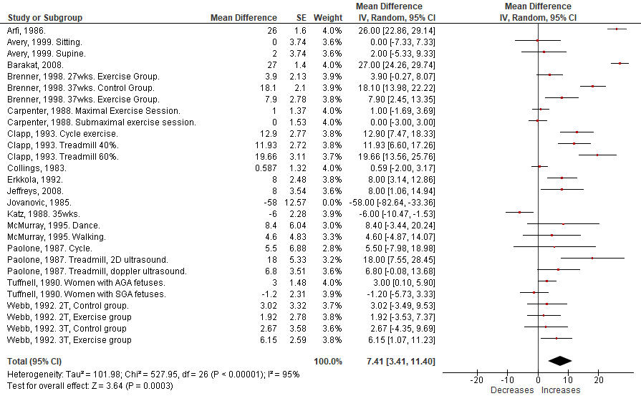
Online Supplement Figure 1. Impact of acute prenatal exercise on fetal heart rate (FHR) from pre-to-during exercise. Sensitivity analyses removing study with potential bias.⁷ FHR values are reported in bpm. Analyses conducted with a random effects model. CI, confidence interval; df, degrees of freedom; IV, inverse variance; SE, standard error; AGA, average for gestational age; SGA, small for gestational age.
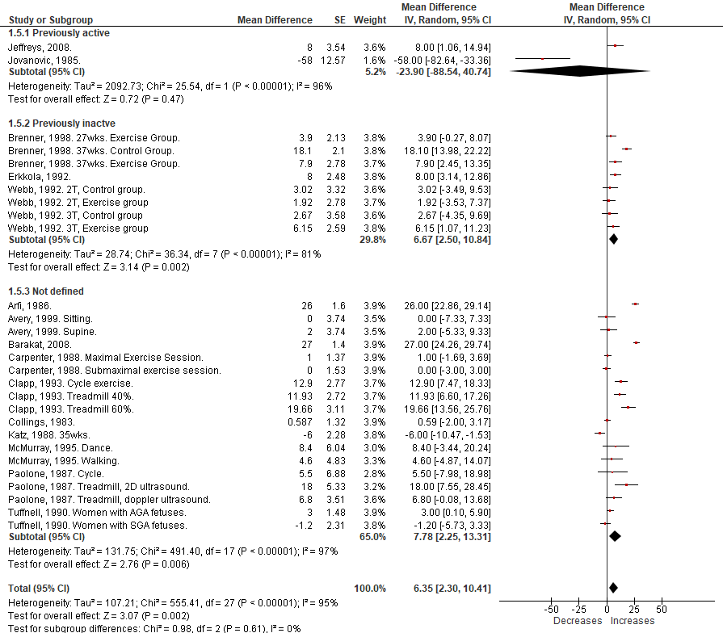
Online Supplement Figure 2. Impact of acute prenatal exercise on fetal heart rate (FHR) from pre-to-during exercise. Subgroup analyses were comparing women who were previously active to those previous inactive. FHR values are reported in bpm. Analyses conducted with a random effects model. CI, confidence interval; df, degrees of freedom; IV, inverse variance; SE, standard error; AGA, average for gestational age; SGA, small for gestational age; 2T, second trimester; 3T, third trimester.
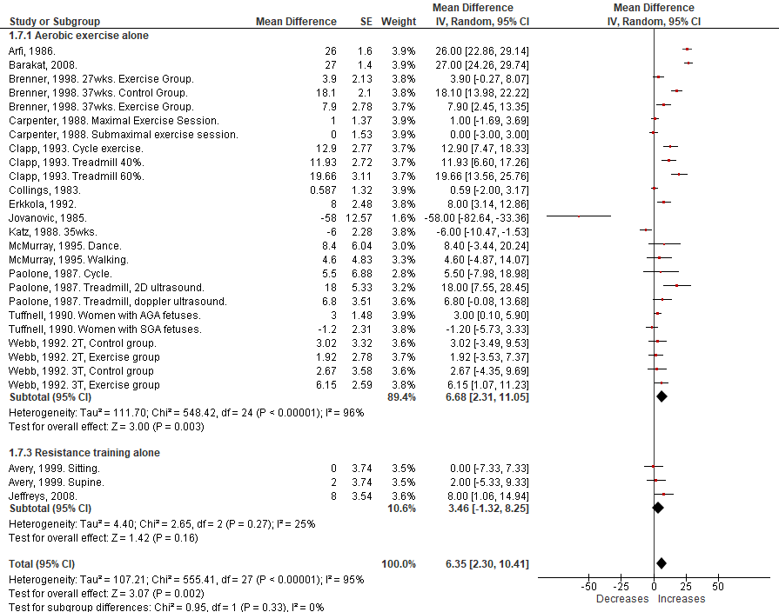
Online Supplement Figure 3. Impact of acute prenatal exercise on fetal heart rate (FHR) from pre-to-during exercise. Subgroup analyses were comparing women engaging in aerobic versus resistance training activities. FHR values are reported in bpm. Analyses conducted with a random effects model. CI, confidence interval; df, degrees of freedom; IV, inverse variance; SE, standard error; AGA, average for gestational age; SGA, small for gestational age; 2T, second trimester; 3T, third trimester.
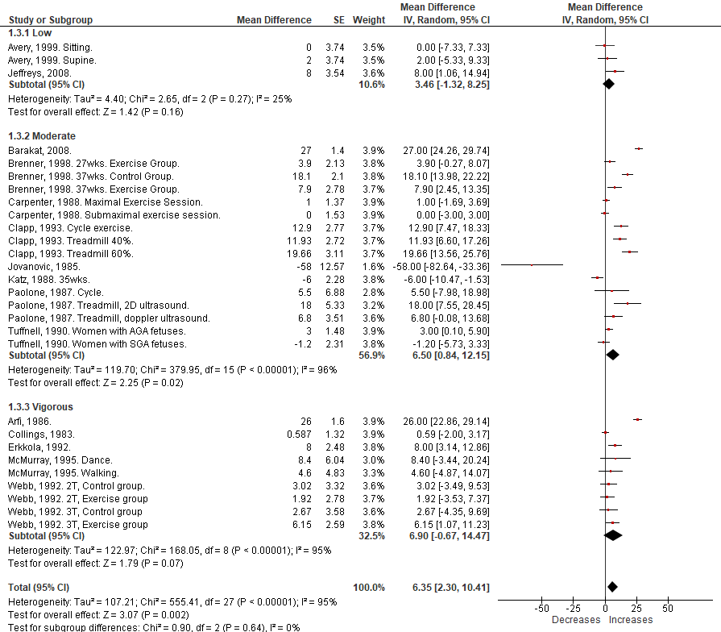Online Supplement Figure 4. Impact of acute prenatal exercise on fetal heart rate (FHR) from pre-to-during exercise. Subgroup analyses were comparing women engaging in activities of different intensities. FHR values are reported in bpm. Analyses conducted with a random effects model. CI, confidence interval; df, degrees of freedom; IV, inverse variance; SE, standard error; AGA, average for gestational age; SGA, small for gestational age; 2T, second trimester; 3T, third trimester.
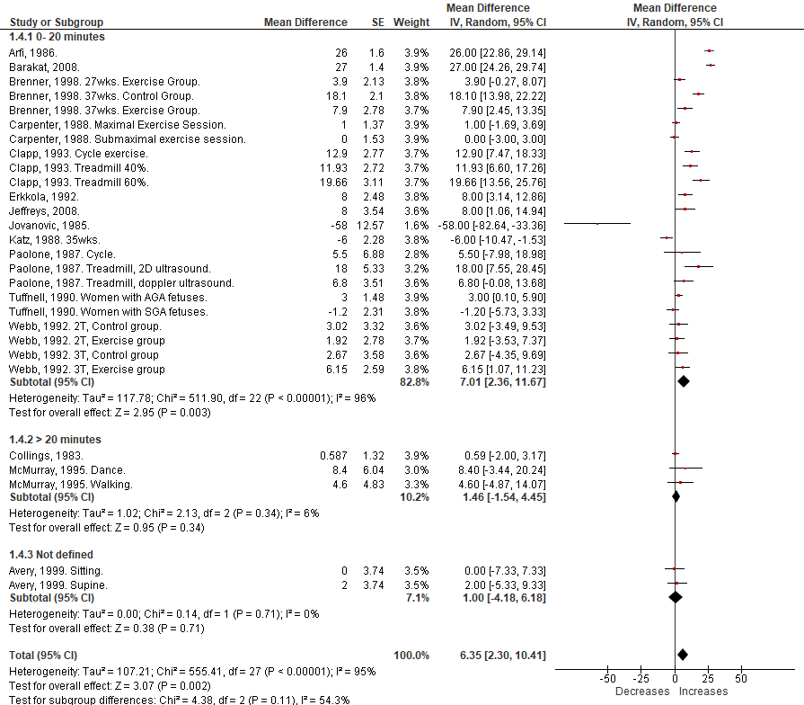

Online Supplement Figure 5. Impact of acute prenatal exercise on fetal heart rate (FHR) from pre-to-during exercise. Subgroup analyses were comparing women engaging in activities of different durations. FHR values are reported in bpm. Analyses conducted with a random effects model. CI, confidence interval; df, degrees of freedom; IV, inverse variance; SE, standard error; AGA, average for gestational age; SGA, small for gestational age; 2T, second trimester; 3T, third trimester.

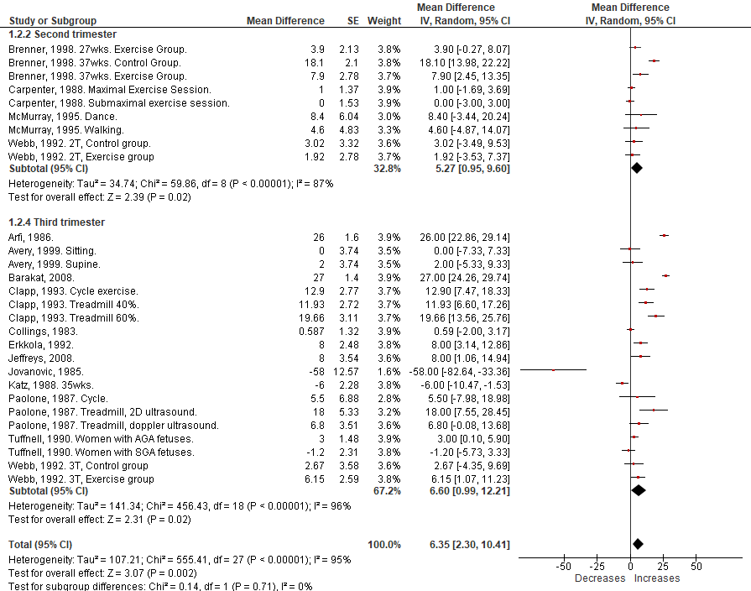
Online Supplement Figure 6. Impact of acute prenatal exercise on fetal heart rate (FHR) from pre-to-during exercise. Subgroup analyses were comparing women engaging in activities in the second and third trimester. FHR values are reported in bpm. Analyses conducted with a random effects model. CI, confidence interval; df, degrees of freedom; IV, inverse variance; SE, standard error; AGA, average for gestational age; SGA, small for gestational age; 2T, second trimester; 3T, third trimester.

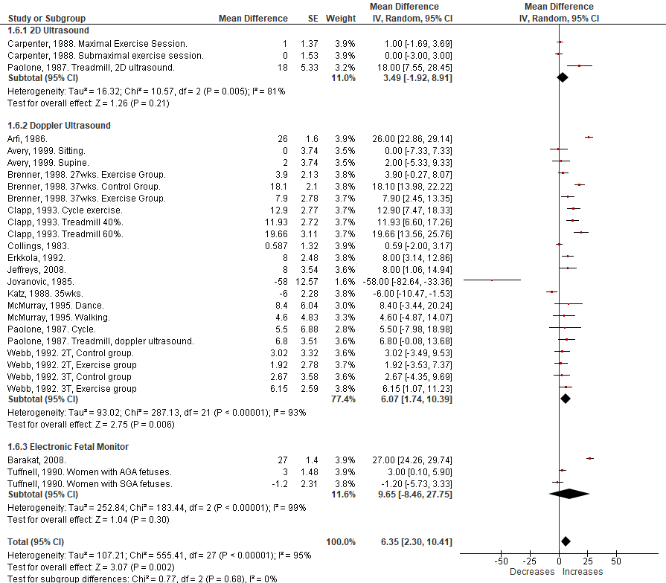
Online Supplement Figure 7. Impact of acute prenatal exercise on fetal heart rate (FHR) from pre-to-during exercise. Subgroup analyses were comparing different methods of determining FHR during acute exercise. FHR values are reported in bpm. Analyses conducted with a random effects model. CI, confidence interval; df, degrees of freedom; IV, inverse variance; SE, standard error; AGA, average for gestational age; SGA, small for gestational age; 2T, second trimester; 3T, third trimester.

Fetal heart rate following exercise
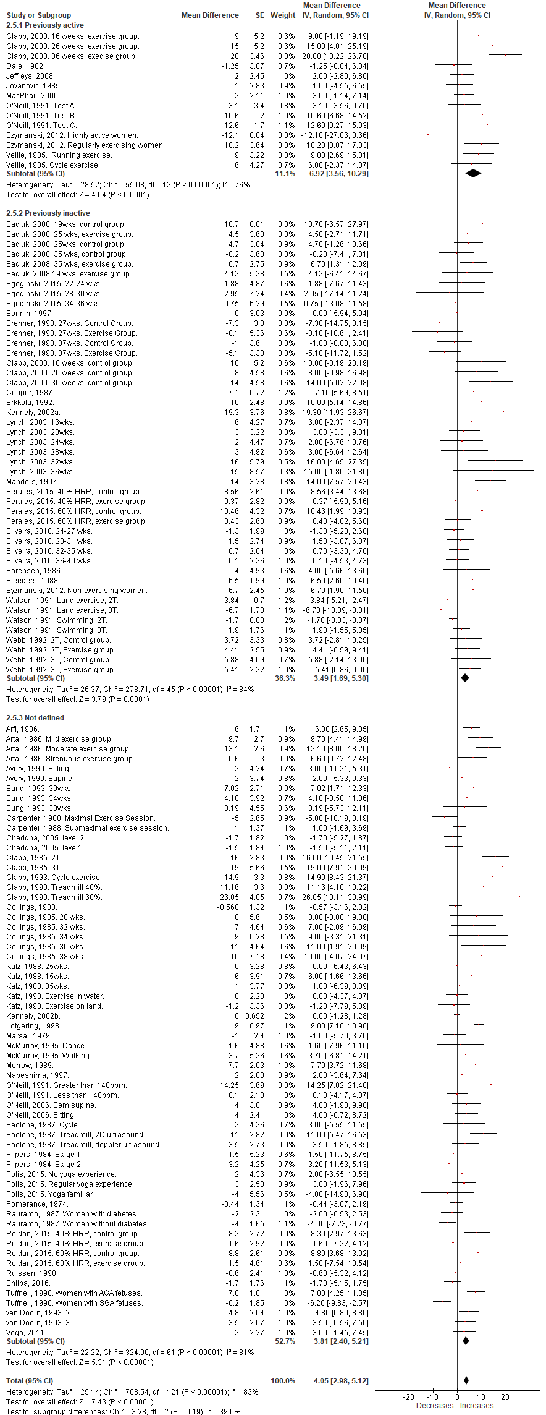
Online Supplement Figure 8. Effect of acute prenatal exercise on fetal heart rate (FHR) following exercise. Data reported as a mean difference compared to baseline, resting conditions. Subgroup analysis were comparing women who were previously active to those who were previously inactive. Analysis conducted using a random effects model. SE, standard error; IV, inverse variance, AGA, average for gestational age; SGA, small for gestational age, 2T, second trimester; 3T, third trimester; EX, exercise group; CTRL, control group; HRR, heart rate reserve.

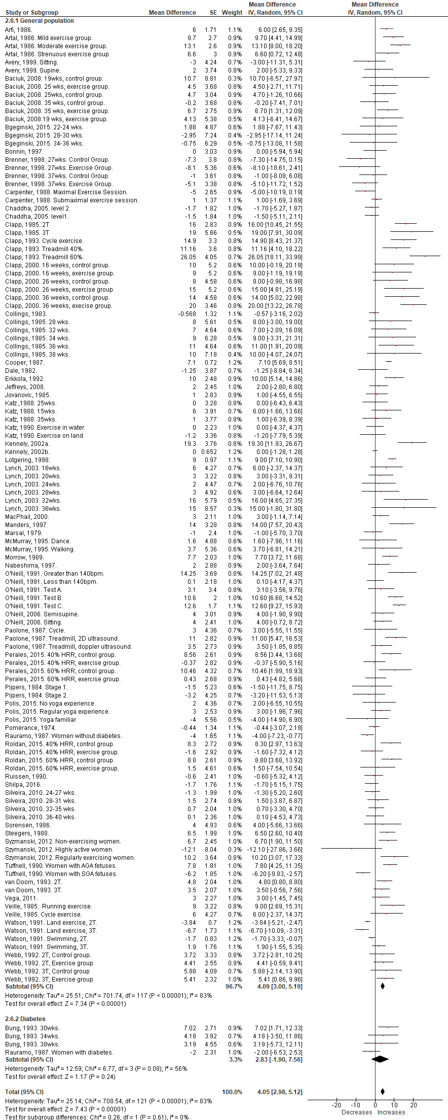
Online Supplement Figure 9. Effect of acute prenatal exercise on fetal heart rate (FHR) following exercise. Data reported as a mean difference compared to baseline, resting conditions. Subgroup analysis were comparing women with diabetes compared to women without diabetes. Analysis conducted using a random effects model. SE, standard error; IV, inverse variance, AGA, average for gestational age; SGA, small for gestational age, 2T, second trimester; 3T, third trimester; EX, exercise group; CTRL, control group; HRR, heart rate reserve.

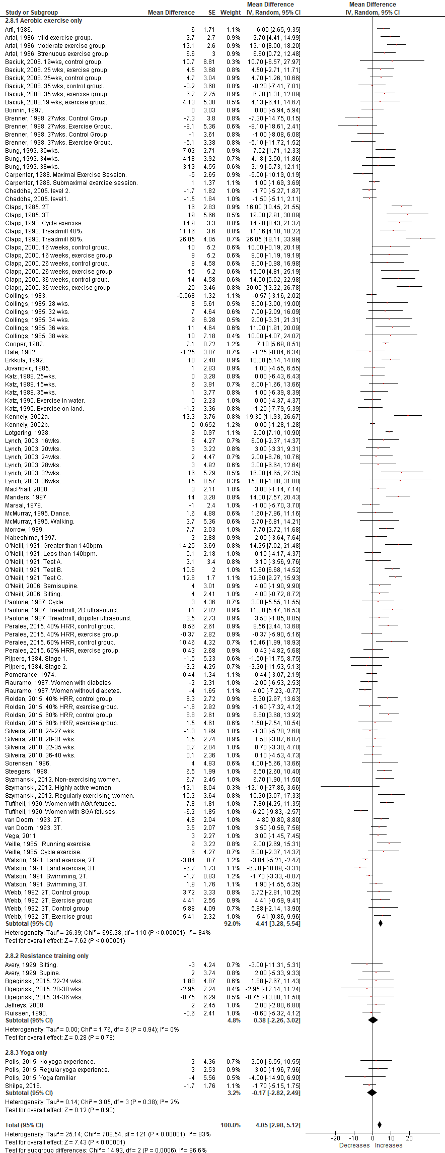
Online Supplement Figure 10. Effect of acute prenatal exercise on fetal heart rate (FHR) following exercise. Data reported as a mean difference compared to baseline, resting conditions. Subgroup analysis were comparing different exercise modalities. Analysis conducted using a random effects model. SE, standard error; IV, inverse variance, AGA, average for gestational age; SGA, small for gestational age, 2T, second trimester; 3T, third trimester; EX, exercise group; CTRL, control group; HRR, heart rate reserve.

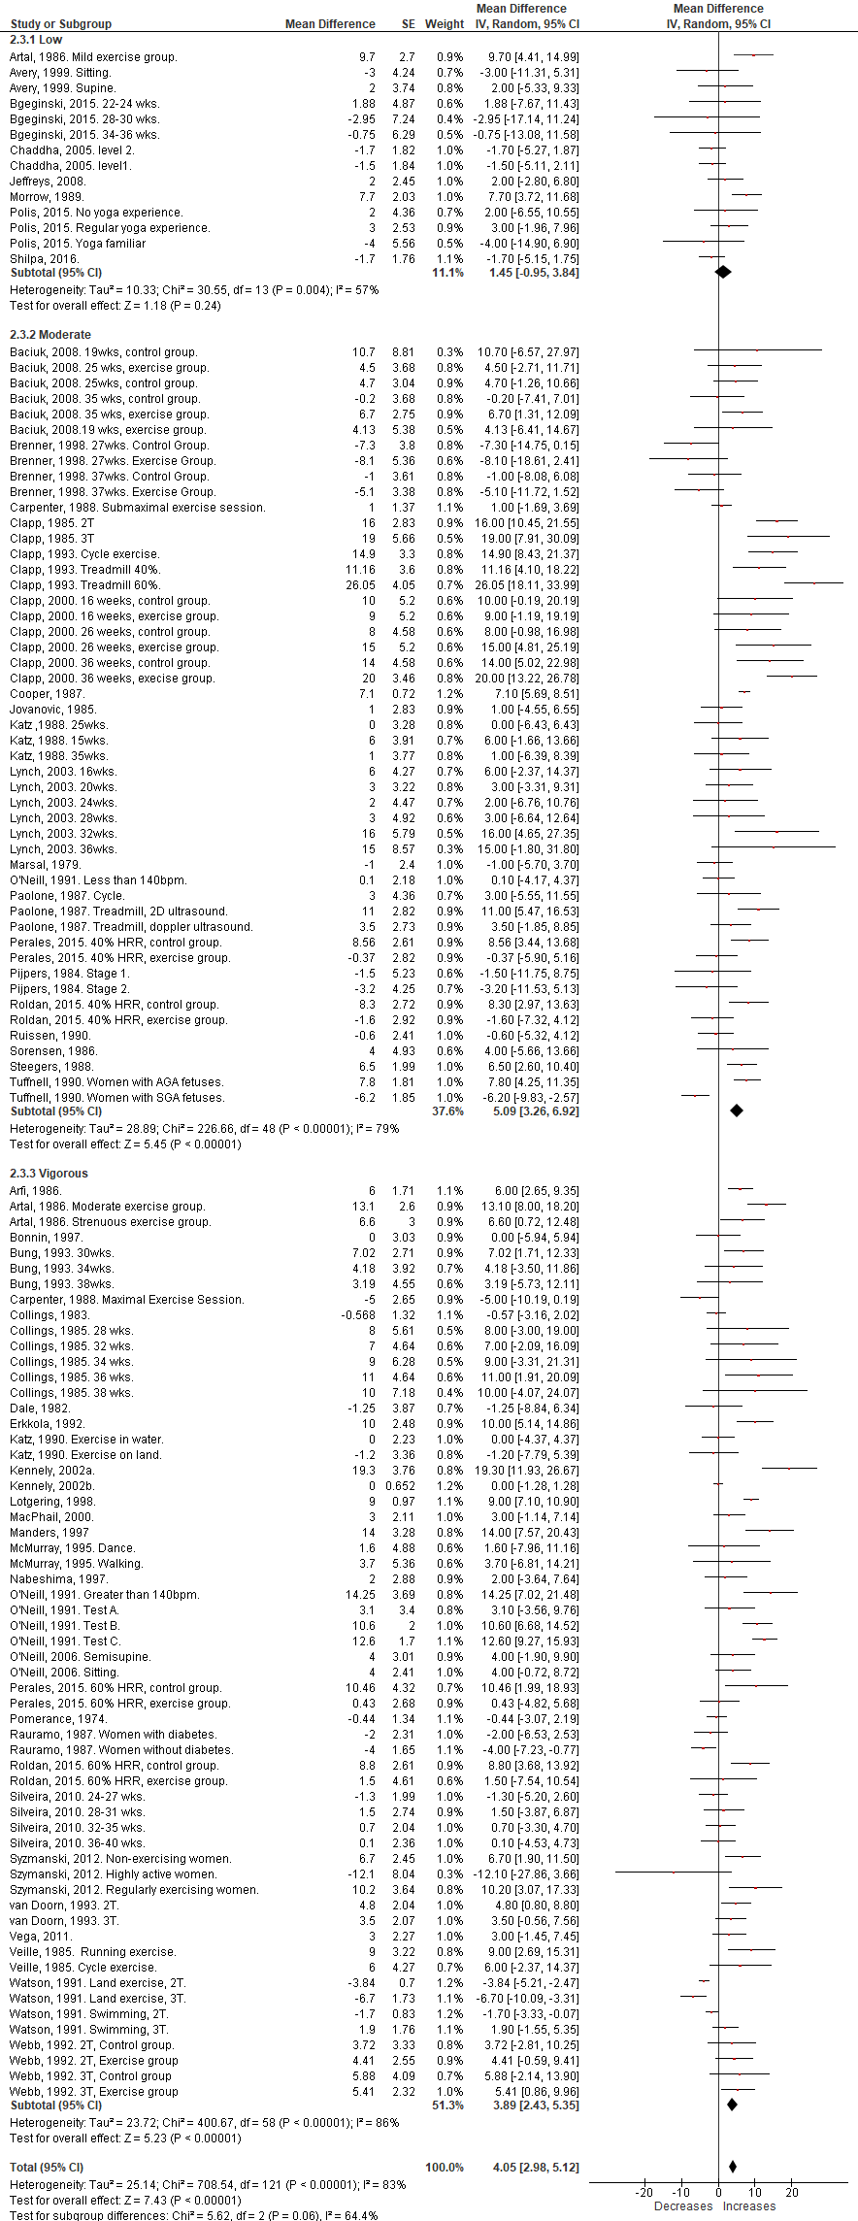
Online Supplement Figure 11. Effect of acute prenatal exercise on fetal heart rate (FHR) following exercise. Data reported as a mean difference compared to baseline, resting conditions. Subgroup analysis were comparing women who were exercising at different intensities. Analysis conducted using a random effects model. SE, standard error; IV, inverse variance, AGA, average for gestational age; SGA, small for gestational age, 2T, second trimester; 3T, third trimester; EX, exercise group; CTRL, control group; HRR, heart rate reserve.

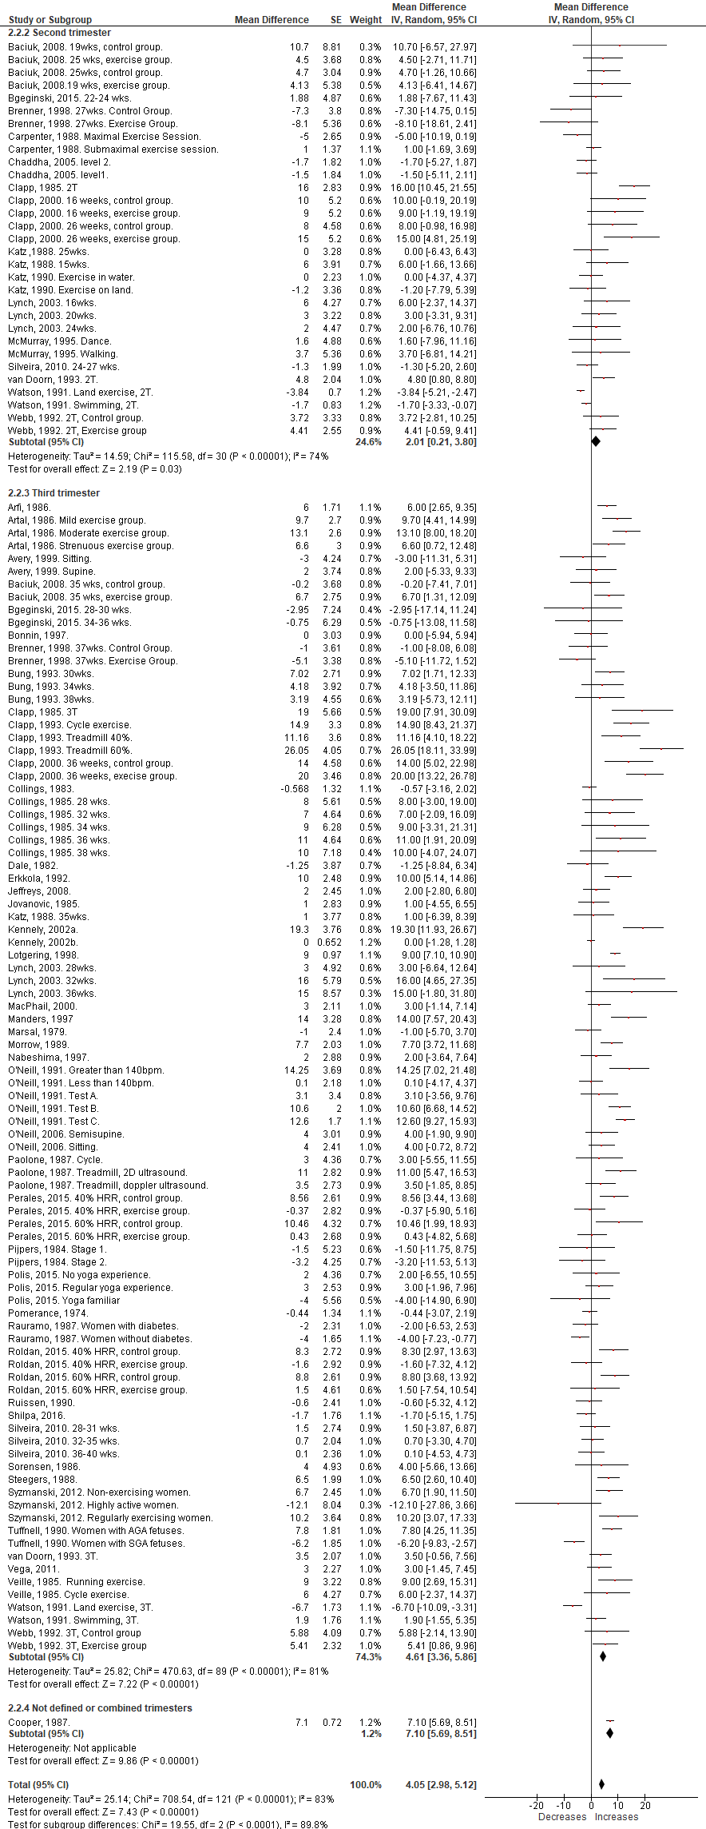
Online Supplement Figure 12. Effect of acute prenatal exercise on fetal heart rate (FHR) following exercise. Data reported as a mean difference compared to baseline, resting conditions. Subgroup analysis were comparing women who were exercising in different trimesters. Analysis conducted using a random effects model. SE, standard error; IV, inverse variance, AGA, average for gestational age; SGA, small for gestational age, 2T, second trimester; 3T, third trimester; EX, exercise group; CTRL, control group; HRR, heart rate reserve.

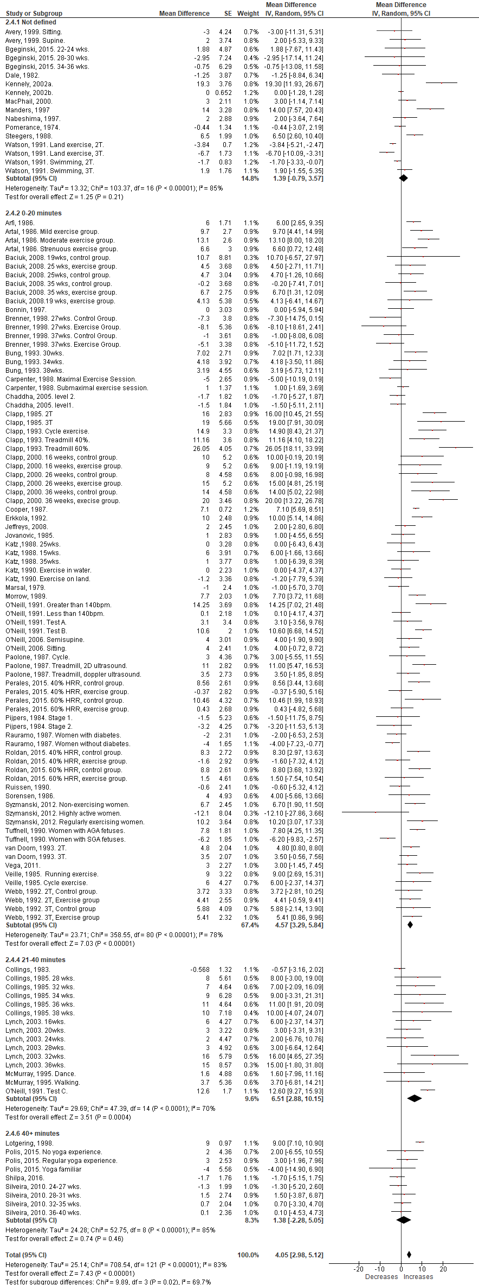
Online Supplement Figure 13. Effect of acute prenatal exercise on fetal heart rate (FHR) following exercise. Data reported as a mean difference compared to baseline, resting conditions. Subgroup analysis were comparing women who were exercising for different durations. Analysis conducted using a random effects model. SE, standard error; IV, inverse variance, AGA, average for gestational age; SGA, small for gestational age, 2T, second trimester; 3T, third trimester; EX, exercise group; CTRL, control group; HRR, heart rate reserve.

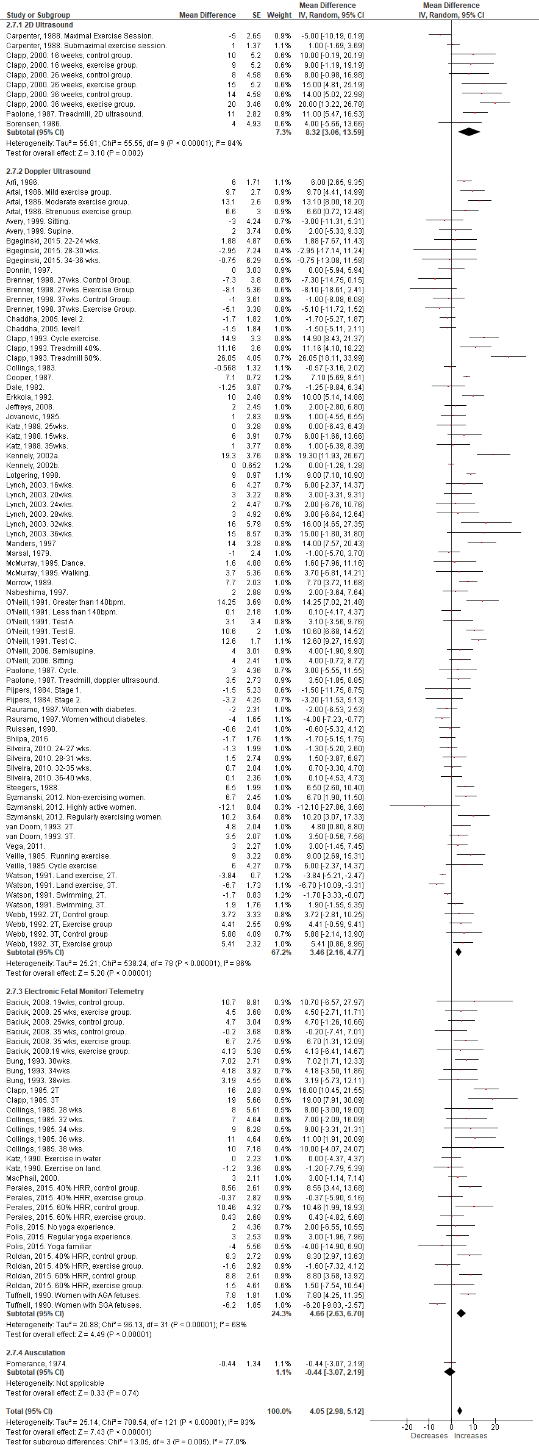
Online Supplement Figure 14. Effect of acute prenatal exercise on fetal heart rate (FHR) following exercise. Data reported as a mean difference compared to baseline, resting conditions. Subgroup analysis were comparing different methods for measuring FHR. Analysis conducted using a random effects model. SE, standard error; IV, inverse variance, AGA, average for gestational age; SGA, small for gestational age, 2T, second trimester; 3T, third trimester; EX, exercise group; CTRL, control group; HRR, heart rate reserve.

Fetal heart rate responses to chronic exercise

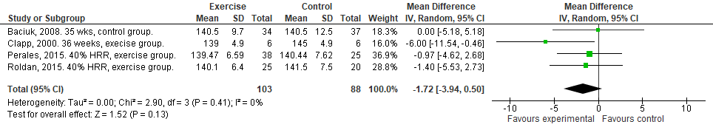
Online Supplement Figure 15. Randomized controlled trials examining the impact of prenatal exercise on resting fetal heart rate (FHR) post-intervention. All studies were “exercise only” trials. FHR was reported in beats per minute. Analyses conducted with a random effects model. CI, confidence interval; df, degrees of freedom; IV, inverse variance; HRR, heart rate reserve.

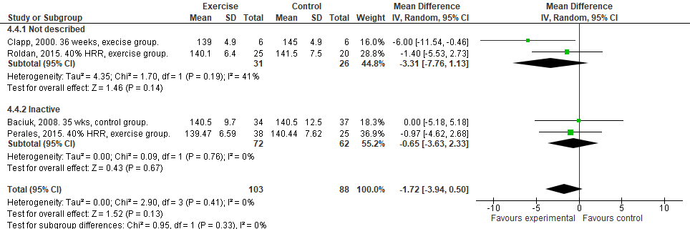
Online Supplement Figure 16. Randomized controlled trials examining the impact of prenatal exercise on resting fetal heart rate (FHR) post-intervention. Subgroup analysis separating women who were previously inactive. FHR was reported in beats per minute. Analyses conducted with a random effects model. CI, confidence interval; df, degrees of freedom; IV, inverse variance; HRR, heart rate reserve.
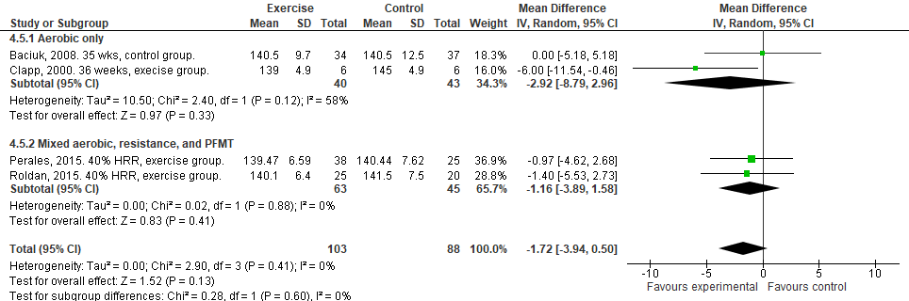

Online Supplement Figure 17. Randomized controlled trials examining the impact of prenatal exercise on resting fetal heart rate (FHR) post-intervention. FHR was reported in beats per minute. Subgroup analysis separating studies by type of exercise during intervention. Analyses conducted with a random effects model. CI, confidence interval; df, degrees of freedom; IV, inverse variance; HRR, heart rate reserve.

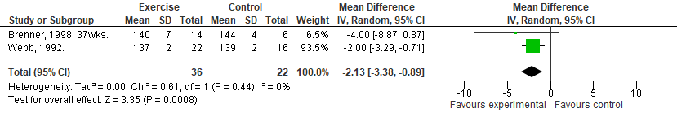
Online Supplement Figure 18. Non-randomized exercise interventions examining the impact of prenatal exercise on resting fetal heart rate (FHR) post-intervention. FHR was reported in beats per minute. Analyses conducted with a random effects model. CI, confidence interval; df, degrees of freedom; IV, inverse variance.

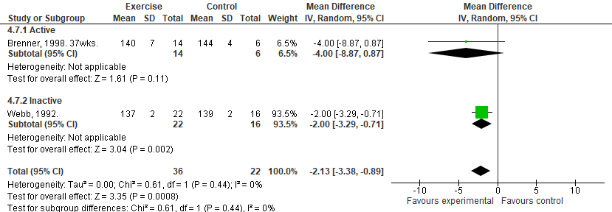
Online Supplement Figure 19. Non-randomized exercise interventions examining the impact of prenatal exercise on resting fetal heart rate (FHR) post-intervention. FHR was reported in beats per minute. Subgroup analysis separating women by previous physical activity levels. Analyses conducted with a random effects model. CI, confidence interval; df, degrees of freedom; IV, inverse variance.
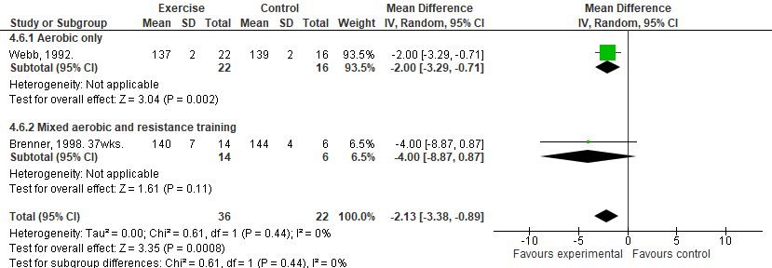
Online Supplement Figure 20. Non-randomized exercise interventions examining the impact of prenatal exercise on resting fetal heart rate (FHR) post-intervention. FHR was reported in beats per minute. Subgroup analysis separating studies by type of exercise during intervention. Analyses conducted with a random effects model. CI, confidence interval; df, degrees of freedom; IV, inverse variance.
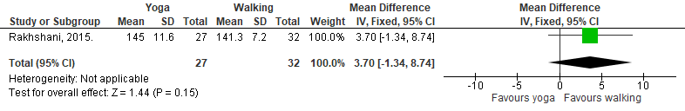
Online Supplement Figure 21. Superiority trial examining the impact of prenatal exercise on resting fetal heart rate (FHR) post-intervention comparing women enrolled in a yoga program to a walking program. FHR was reported in beats per minute. Analyses conducted with a random effects model. CI, confidence interval; df, degrees of freedom; IV, inverse variance.
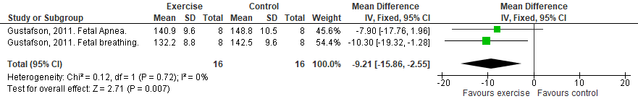
Online Supplement Figure 22. Cohort study examining the impact of prenatal exercise on resting fetal heart rate (FHR) post-intervention. FHR was reported in beats per minute. Analyses conducted with a random effects model. CI, confidence interval; df, degrees of freedom; IV, inverse variance.
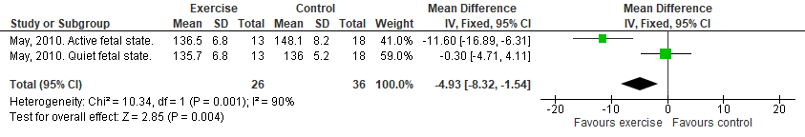
Online Supplement Figure 23. Cross-sectional study examining the impact of prenatal exercise on resting fetal heart rate (FHR) post-intervention. FHR was reported in beats per minute. Analyses conducted with a random effects model. CI, confidence interval; df, degrees of freedom; IV, inverse variance.

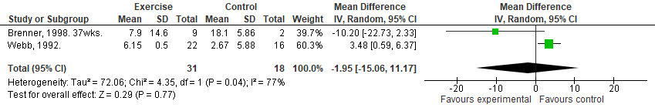
Online Supplement Figure 24. Non-randomized exercise interventions examining the impact of prenatal exercise on the fetal heart rate (FHR) response during acute exercise post-intervention. FHR response was reported as a change from pre-to-during exercise in beats per minute. Analyses conducted with a random effects model. CI, confidence interval; df, degrees of freedom; IV, inverse variance.
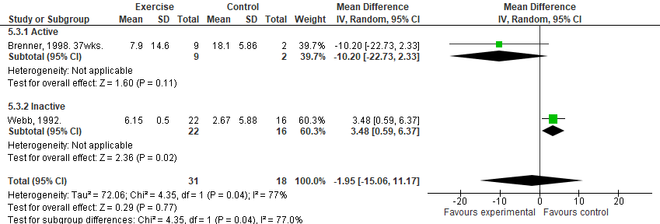
Online Supplement Figure 25. Non-randomized exercise interventions examining the impact of prenatal exercise on the fetal heart rate (FHR) response during acute exercise post-intervention. FHR response was reported as a change from pre-to-during exercise in beats per minute. Subgroups analysis separating women based on previous physical activity levels. Analyses conducted with a random effects model. CI, confidence interval; df, degrees of freedom; IV, inverse variance.
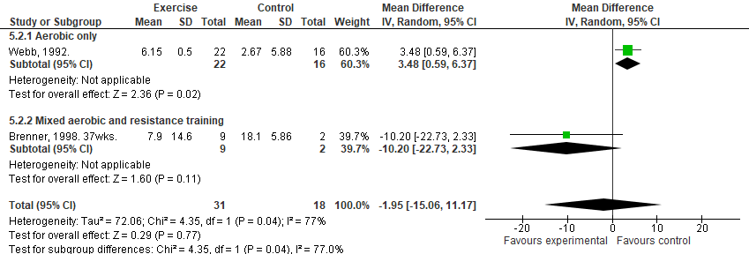
Online Supplement Figure 26. Non-randomized exercise interventions examining the impact of prenatal exercise on the fetal heart rate (FHR) response during acute exercise post-intervention. FHR response was reported as a change from pre-to-during exercise in beats per minute. Subgroups analysis separating studies by type of exercise during intervention. Analyses conducted with a random effects model. CI, confidence interval; df, degrees of freedom; IV, inverse variance.

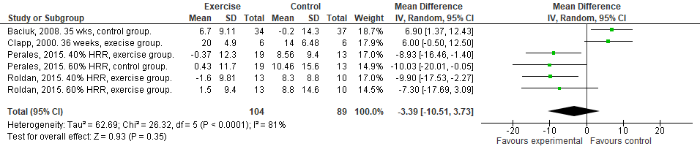
Online Supplement Figure 27. Randomized controlled trials examining the impact of prenatal exercise on the fetal heart rate (FHR) response following acute exercise post-intervention. FHR response was reported as a change from pre-to-post exercise in beats per minute. Analyses conducted with a random effects model. CI, confidence interval; df, degrees of freedom; IV, inverse variance; HRR, heart rate reserve.
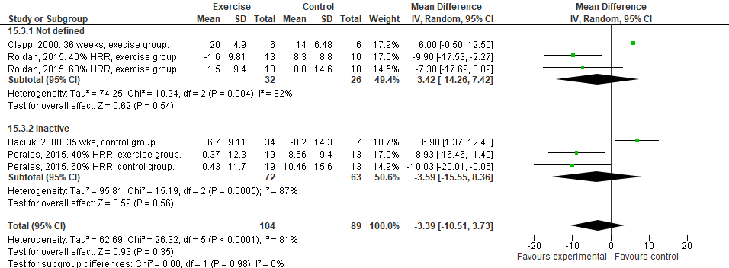
Online Supplement Figure 28. Randomized controlled trials examining the impact of prenatal exercise on the fetal heart rate (FHR) response following acute exercise post-intervention. FHR response was reported as a change from pre-to-post exercise in beats per minute. Subgroup analysis separating women who were previously inactive. Analyses conducted with a random effects model. CI, confidence interval; df, degrees of freedom; IV, inverse variance; HRR, heart rate reserve.

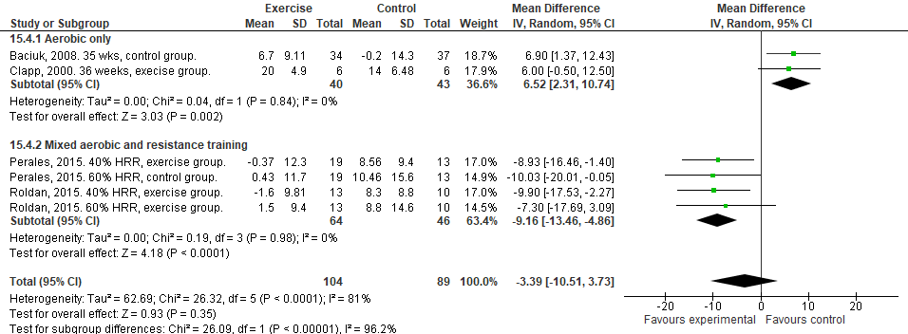
Online Supplement Figure 29. Randomized controlled trials examining the impact of prenatal exercise on the fetal heart rate (FHR) response following acute exercise post-intervention. FHR response was reported as a change from pre-to-post exercise in beats per minute. Subgroup analysis separating studies by type of exercise during intervention. Analyses conducted with a random effects model. CI, confidence interval; df, degrees of freedom; IV, inverse variance; HRR, heart rate reserve.
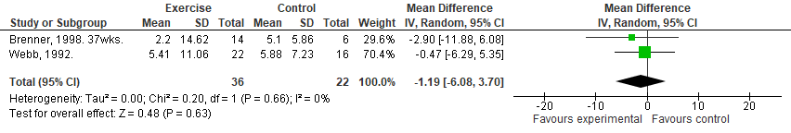
Online Supplement Figure 30. Non-randomized interventions examining the impact of prenatal exercise on the fetal heart rate (FHR) response following acute exercise post-intervention. FHR response was reported as a change from pre-to-post exercise in beats per minute. Analyses conducted with a random effects model. CI, confidence interval; df, degrees of freedom; IV, inverse variance.
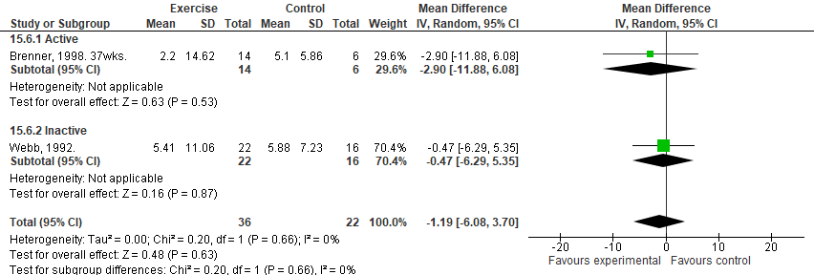
Online Supplement Figure 31. Non-randomized interventions examining the impact of prenatal exercise on the fetal heart rate (FHR) response following acute exercise post-intervention. FHR response was reported as a change from pre-to-post exercise in beats per minute. Subgroup analysis separating women by previous physical activity levels. Analyses conducted with a random effects model. CI, confidence interval; df, degrees of freedom; IV, inverse variance.
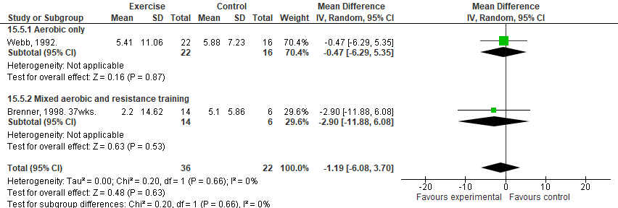
Online Supplement Figure 32. Non-randomized interventions examining the impact of prenatal exercise on the fetal heart rate (FHR) response following acute exercise post-intervention. FHR response was reported as a change from pre-to-post exercise in beats per minute. Subgroup analysis separating women by type of exercise. Analyses conducted with a random effects model. CI, confidence interval; df, degrees of freedom; IV, inverse variance.

Umbilical artery during and following acute exercise
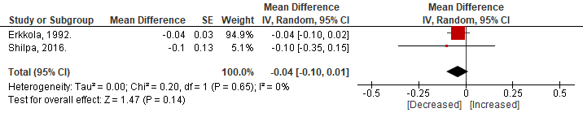
Online Supplement Figure 33. Effect of acute prenatal exercise on umbilical artery S/D ratio. Data presented as a mean difference from pre-to-during exercise. S/D ratio is expressed in arbitrary units. Analyses conducted with a random effects model. CI, confidence interval; df, degrees of freedom; IV, inverse variance; SE, standard error.
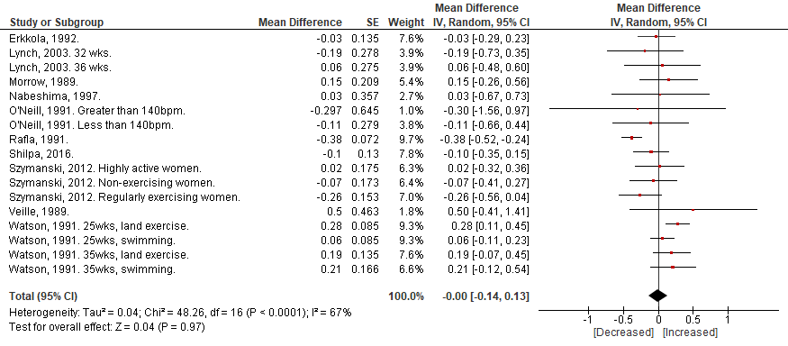
Online Supplement Figure 34. Effect of acute prenatal exercise on umbilical artery S/D ratio. Data presented as a mean difference from pre-to-following exercise. S/D ratio is expressed in arbitrary units. Analyses conducted with a random effects model. CI, confidence interval; df, degrees of freedom; IV, inverse variance; SE, standard error; IUGR, intrauterine growth restriction.

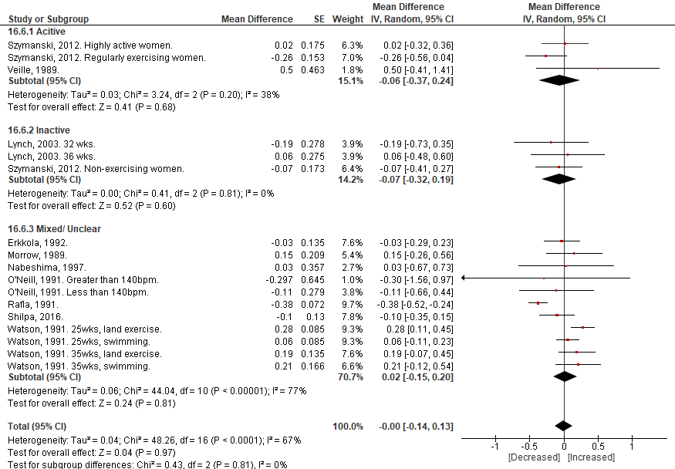
Online Supplement Figure 35. Effect of acute prenatal exercise on umbilical artery S/D ratio. Data presented as a mean difference from pre-to-following exercise. Subgroup analysis separating studies by previous physical activity levels. S/D ratio is expressed in arbitrary units. Analyses conducted with a random effects model. CI, confidence interval; df, degrees of freedom; IV, inverse variance; SE, standard error; IUGR, intrauterine growth restriction.

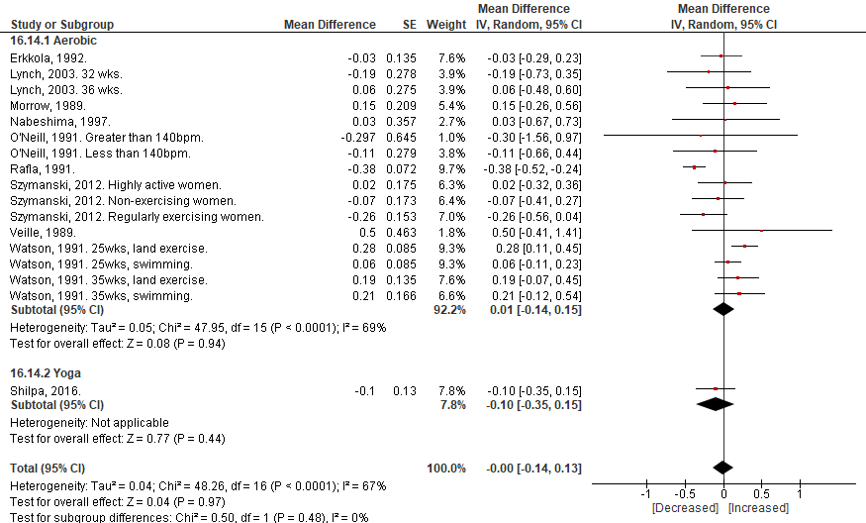
Online Supplement Figure 36. Effect of acute prenatal exercise on umbilical artery S/D ratio. Data presented as a mean difference from pre-to-following exercise. Subgroup analysis separating studies by type of exercise. S/D ratio is expressed in arbitrary units. Analyses conducted with a random effects model. CI, confidence interval; df, degrees of freedom; IV, inverse variance; SE, standard error; IUGR, intrauterine growth restriction.

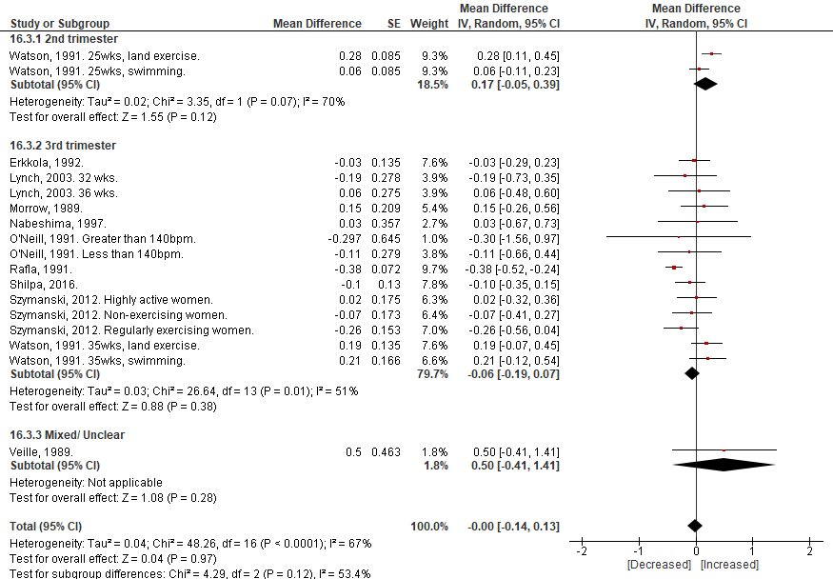
Online Supplement Figure 37. Effect of acute prenatal exercise on umbilical artery S/D ratio. Data presented as a mean difference from pre-to-following exercise. Subgroup analysis separating studies by trimester. S/D ratio is expressed in arbitrary units. Analyses conducted with a random effects model. CI, confidence interval; df, degrees of freedom; IV, inverse variance; SE, standard error; IUGR, intrauterine growth restriction.

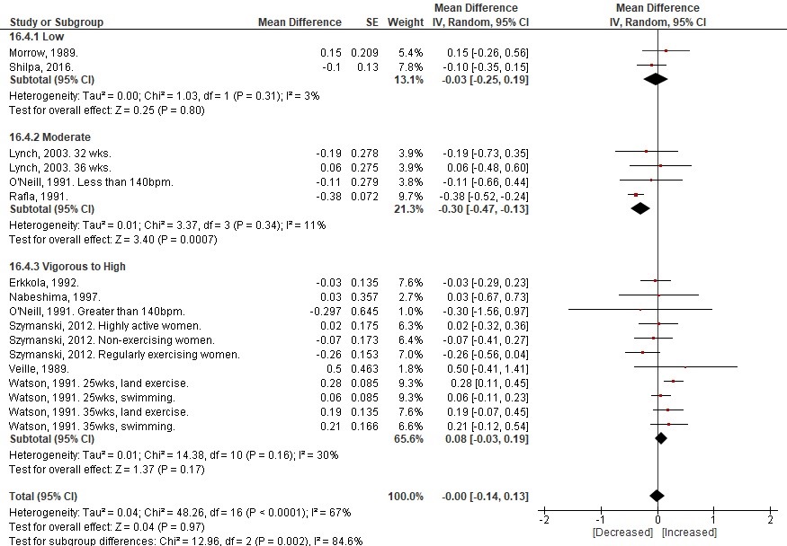
Online Supplement Figure 38. Effect of acute prenatal exercise on umbilical artery S/D ratio. Data presented as a mean difference from pre-to-following exercise. Subgroup analysis separating studies by intensity of exercise. S/D ratio is expressed in arbitrary units. Analyses conducted with a random effects model. CI, confidence interval; df, degrees of freedom; IV, inverse variance; SE, standard error; IUGR, intrauterine growth restriction.

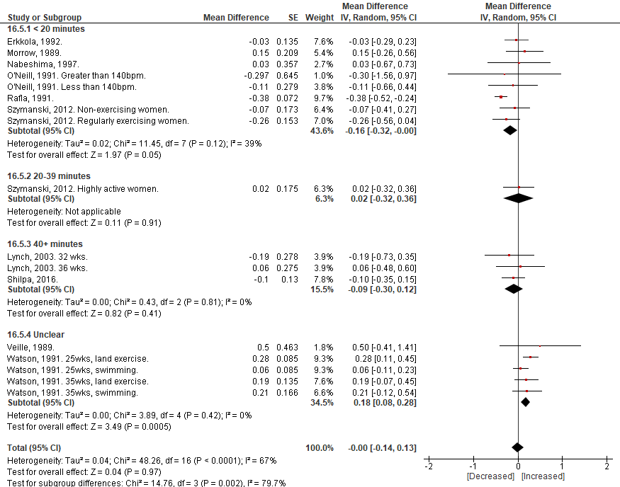
Online Supplement Figure 39. Effect of acute prenatal exercise on umbilical artery S/D ratio. Data presented as a mean difference from pre-to-following exercise. Subgroup analysis separating studies by duration of exercise. S/D ratio is expressed in arbitrary units. Analyses conducted with a random effects model. CI, confidence interval; df, degrees of freedom; IV, inverse variance; SE, standard error; IUGR, intrauterine growth restriction.

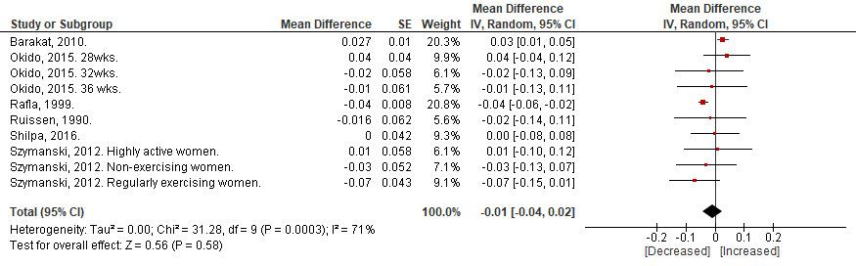
Online Supplement Figure 40. Effect of acute prenatal exercise on umbilical artery pulsatility index (PI). Data presented as a mean difference from pre-to-following exercise. PI is expressed in arbitrary units. Analyses conducted with a random effects model. CI, confidence interval; df, degrees of freedom; IV, inverse variance; SE, standard error.

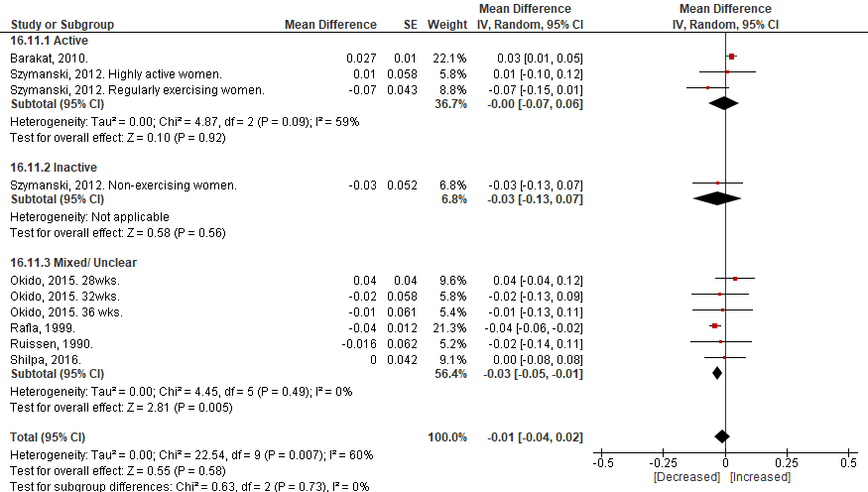
Online Supplement Figure 41. Effect of acute prenatal exercise on umbilical artery pulsatility index (PI). Data presented as a mean difference from pre-to-following exercise. Subgroup analysis separating studies by previous physical activity levels. PI is expressed in arbitrary units. Analyses conducted with a random effects model. CI, confidence interval; df, degrees of freedom; IV, inverse variance; SE, standard error.

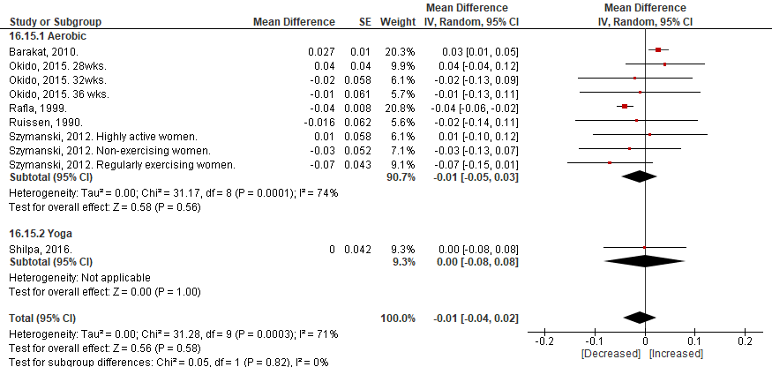
Online Supplement Figure 42. Effect of acute prenatal exercise on umbilical artery pulsatility index (PI). Data presented as a mean difference from pre-to-following exercise. Subgroup analysis separating studies by type of exercise. PI is expressed in arbitrary units. Analyses conducted with a random effects model. CI, confidence interval; df, degrees of freedom; IV, inverse variance; SE, standard error.
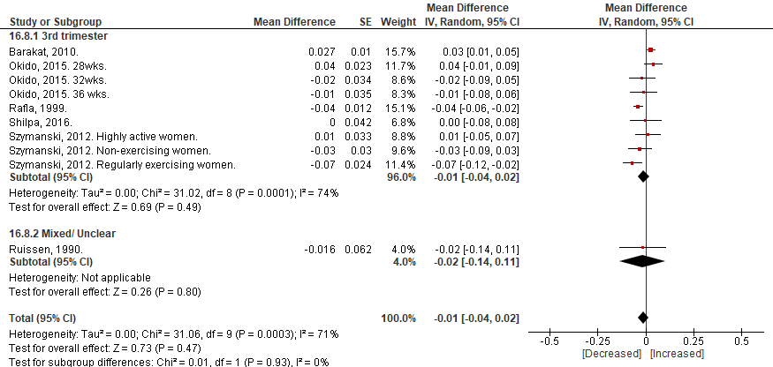
Online Supplement Figure 43. Effect of acute prenatal exercise on umbilical artery pulsatility index (PI). Data presented as a mean difference from pre-to-following exercise. Subgroup analysis separating studies by trimester. PI is expressed in arbitrary units. Analyses conducted with a random effects model. CI, confidence interval; df, degrees of freedom; IV, inverse variance; SE, standard error.
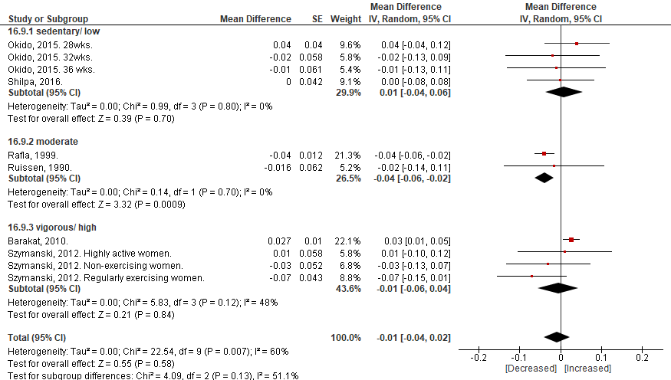
Online Supplement Figure 44. Effect of acute prenatal exercise on umbilical artery pulsatility index (PI). Data presented as a mean difference from pre-to-following exercise. Subgroup analysis separating studies by intensity. PI is expressed in arbitrary units. Analyses conducted with a random effects model. CI, confidence interval; df, degrees of freedom; IV, inverse variance; SE, standard error.

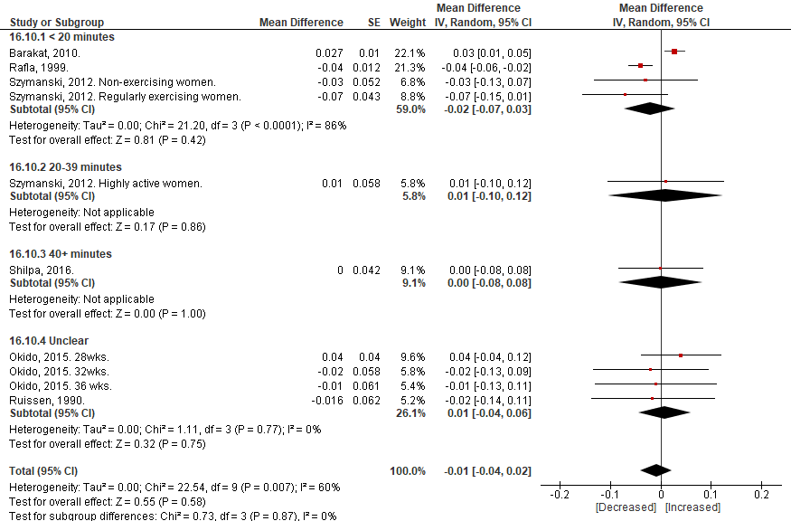
Online Supplement Figure 45. Effect of acute prenatal exercise on umbilical artery pulsatility index (PI). Data presented as a mean difference from pre-to-following exercise. Subgroup analysis separating studies by duration of exercise. PI is expressed in arbitrary units. Analyses conducted with a random effects model. CI, confidence interval; df, degrees of freedom; IV, inverse variance; SE, standard error.

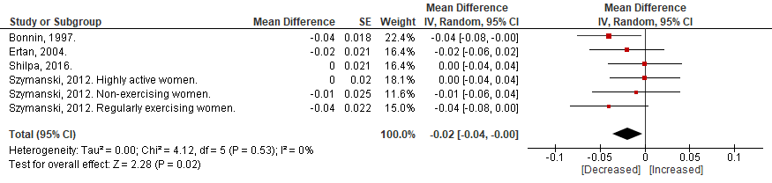
Online Supplement Figure 46. Effect of acute prenatal exercise on umbilical artery resistance index (RI). Data presented as a mean difference from pre-to-following exercise. RI is expressed in arbitrary units. Analyses conducted with a random effects model. CI, confidence interval; df, degrees of freedom; IV, inverse variance; SE, standard error; IUGR, intrauterine growth restriction.

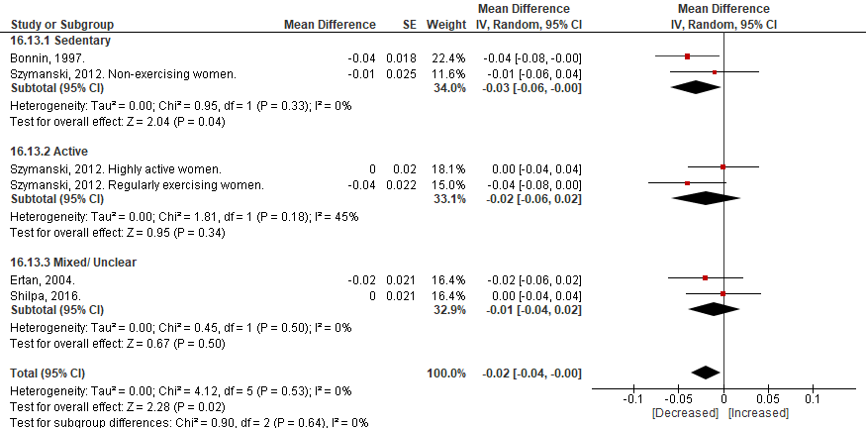
Online Supplement Figure 47. Effect of acute prenatal exercise on umbilical artery resistance index (RI). Data presented as a mean difference from pre-to-following exercise. Subgroup analysis separating studies by previous physical activity levels. RI is expressed in arbitrary units. Analyses conducted with a random effects model. CI, confidence interval; df, degrees of freedom; IV, inverse variance; SE, standard error; IUGR, intrauterine growth restriction.

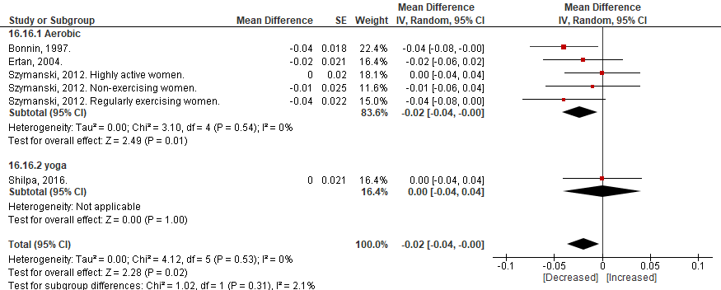
Online Supplement Figure 48. Effect of acute prenatal exercise on umbilical artery resistance index (RI). Data presented as a mean difference from pre-to-following exercise. Subgroup analysis separating studies by types of exercise. RI is expressed in arbitrary units. Analyses conducted with a random effects model. CI, confidence interval; df, degrees of freedom; IV, inverse variance; SE, standard error; IUGR, intrauterine growth restriction.
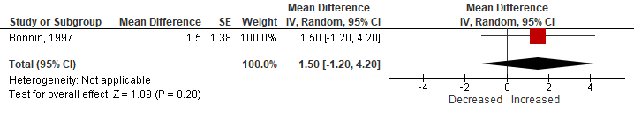
Online Supplement Figure 49. Effect of acute prenatal exercise on umbilical artery mean blood velocity (Vmean). Data presented as a mean difference from pre-to-following exercise. Subgroup analysis separating studies by types of exercise. Vmean is expressed in cm/s. Analyses conducted with a random effects model. CI, confidence interval; df, degrees of freedom; IV, inverse variance; SE, standard error; IUGR, intrauterine growth restriction.

Umbilical artery responses to chronic exercise
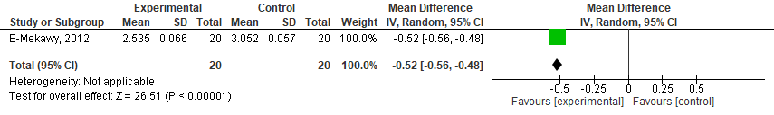Online Supplement Figure 50. Randomized controlled trial reporting on the effect of prenatal exercise intervention compared to control on umbilical artery systolic/diastolic ratio (S/D) at rest. Analyses conducted with a random effects model. CI, confidence interval; df, degrees of freedom; IV, inverse variance; SE, standard error.

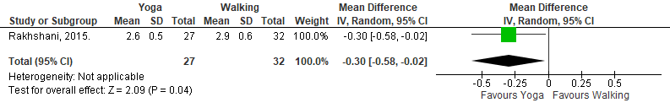
Online Supplement Figure 51. Superiority trial (randomized controlled trial) reporting on the effect of prenatal yoga compared with walking interventions on umbilical artery systolic/diastolic ratio (S/D) at rest. Analyses conducted with a random effects model. CI, confidence interval; df, degrees of freedom; IV, inverse variance; SE, standard error.

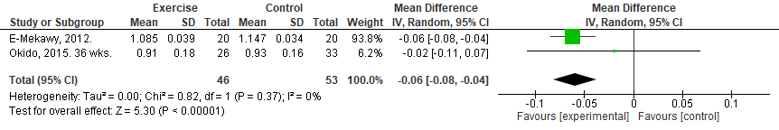
Online Supplement Figure 52. Randomized controlled trial reporting on the effect of prenatal exercise intervention compared to control on umbilical artery pulsatility index at rest. Analyses conducted with a random effects model. CI, confidence interval; df, degrees of freedom; IV, inverse variance; SE, standard error.

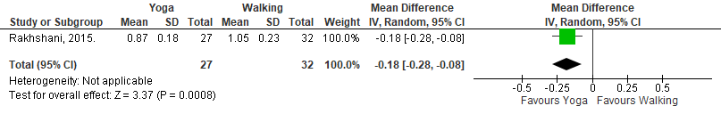
Online Supplement Figure 53. Superiority trial (randomized controlled trial) reporting on the effect of prenatal yoga compared to walking interventions on umbilical artery pulsatility index at rest. Analyses conducted with a random effects model. CI, confidence interval; df, degrees of freedom; IV, inverse variance; SE, standard error.

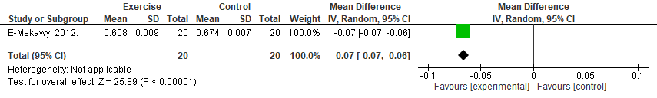
Online Supplement Figure 54. Randomized controlled trial reporting on the effect of prenatal exercise intervention compared to control on umbilical artery resistance index at rest. Analyses conducted with a random effects model. CI, confidence interval; df, degrees of freedom; IV, inverse variance; SE, standard error.

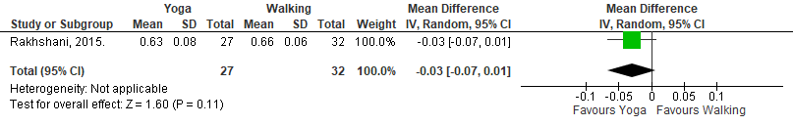
Online Supplement Figure 55. Superiority trial (randomized controlled trial) reporting on the effect of prenatal yoga compared to walking interventions on umbilical artery resistance index at rest. Analyses conducted with a random effects model. CI, confidence interval; df, degrees of freedom; IV, inverse variance; SE, standard error.

Uterine artery during and following acute exercise
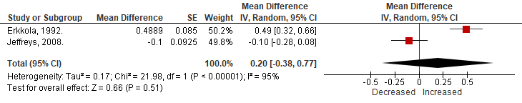Online Supplement Figure 56. Effect of acute prenatal exercise on uterine artery S/D ratio. Data presented as a mean difference from pre-to-during exercise. S/D ratio is expressed in arbitrary units. Analyses conducted with a random effects model. CI, confidence interval; df, degrees of freedom; IV, inverse variance; SE, standard error.
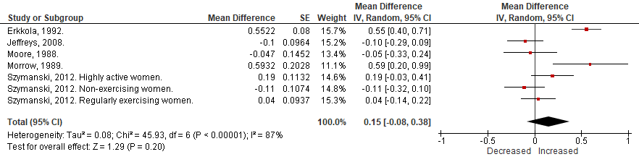Online Supplement Figure 57. Effect of acute prenatal exercise on uterine artery S/D ratio. Data presented as a mean difference from pre-to-following exercise. S/D ratio is expressed in arbitrary units. Analyses conducted with a random effects model. CI, confidence interval; df, degrees of freedom; IV, inverse variance; SE, standard error.
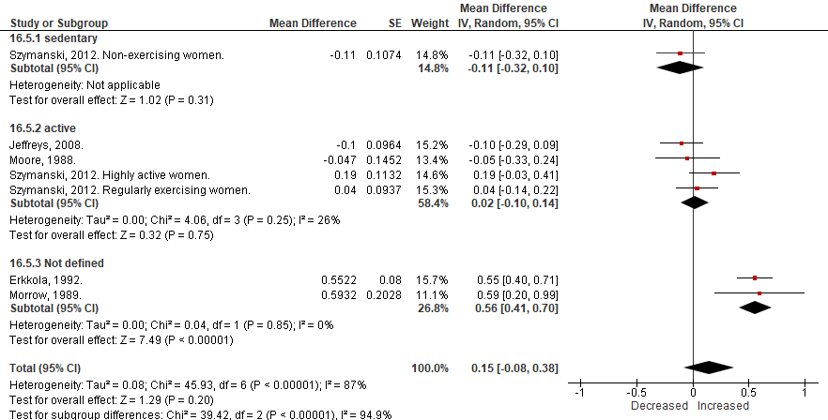Online Supplement Figure 58. Effect of acute prenatal exercise on uterine artery S/D ratio. Data presented as a mean difference from pre-to-following exercise. S/D ratio is expressed in arbitrary units. Subgroup analysis separating studies by previous physical activity levels. Analyses conducted with a random effects model. CI, confidence interval; df, degrees of freedom; IV, inverse variance; SE, standard error.
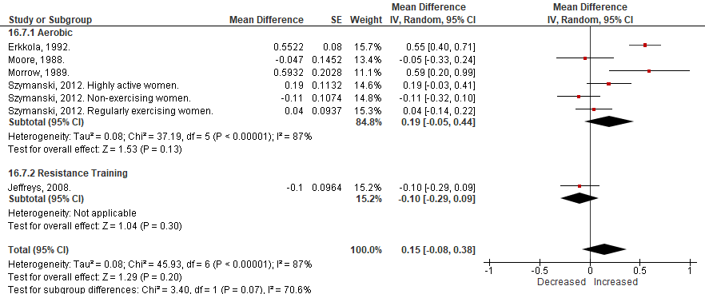
Online Supplement Figure 59. Effect of acute prenatal exercise on uterine artery S/D ratio. Data presented as a mean difference from pre-to-following exercise. S/D ratio is expressed in arbitrary units. Subgroup analysis separating studies by type of exercise. Analyses conducted with a random effects model. CI, confidence interval; df, degrees of freedom; IV, inverse variance; SE, standard error.
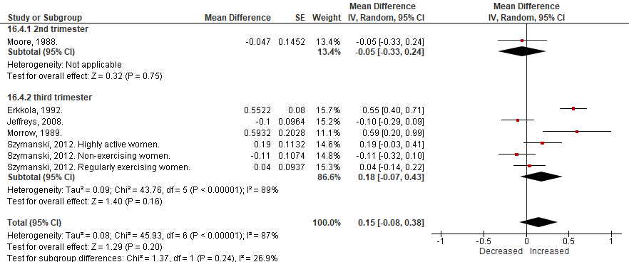Online Supplement Figure 60. Effect of acute prenatal exercise on uterine artery S/D ratio. Data presented as a mean difference from pre-to-following exercise. S/D ratio is expressed in arbitrary units. Subgroup analysis separating studies by trimester. Analyses conducted with a random effects model. CI, confidence interval; df, degrees of freedom; IV, inverse variance; SE, standard error.
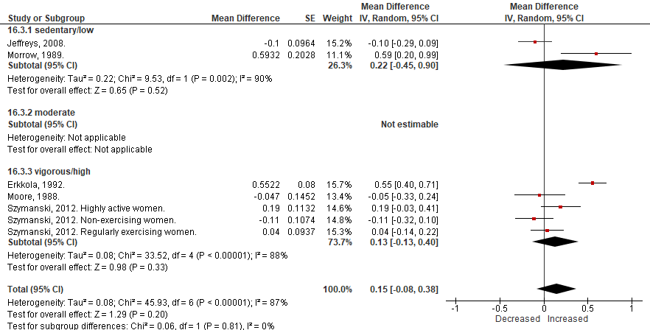
Online Supplement Figure 61. Effect of acute prenatal exercise on uterine artery S/D ratio. Data presented as a mean difference from pre-to-following exercise. S/D ratio is expressed in arbitrary units. Subgroup analysis separating studies by intensity of exercise. Analyses conducted with a random effects model. CI, confidence interval; df, degrees of freedom; IV, inverse variance; SE, standard error.
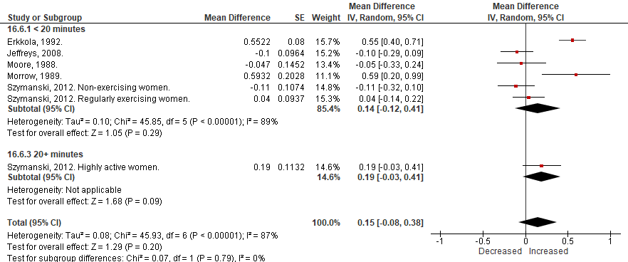
Online Supplement Figure 62. Effect of acute prenatal exercise on uterine artery S/D ratio. Data presented as a mean difference from pre-to-following exercise. S/D ratio is expressed in arbitrary units. Subgroup analysis separating studies by duration of exercise. Analyses conducted with a random effects model. CI, confidence interval; df, degrees of freedom; IV, inverse variance; SE, standard error.
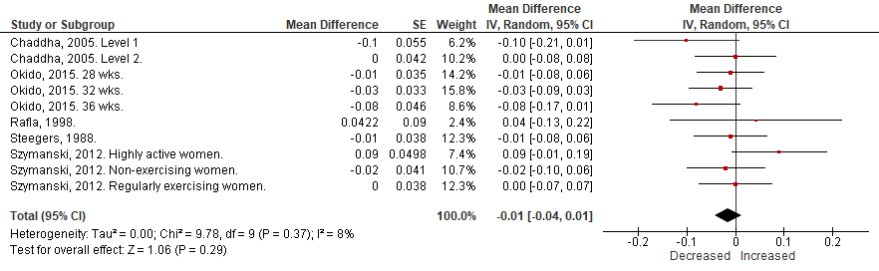Online Supplement Figure 63. Effect of acute prenatal exercise on uterine artery pulsatility index (PI). Data presented as a mean difference from pre-to-following exercise. PI is expressed in arbitrary units. Analyses conducted with a random effects model. CI, confidence interval; df, degrees of freedom; IV, inverse variance; SE, standard error; UPVI, uteroplacental vessel insufficiency.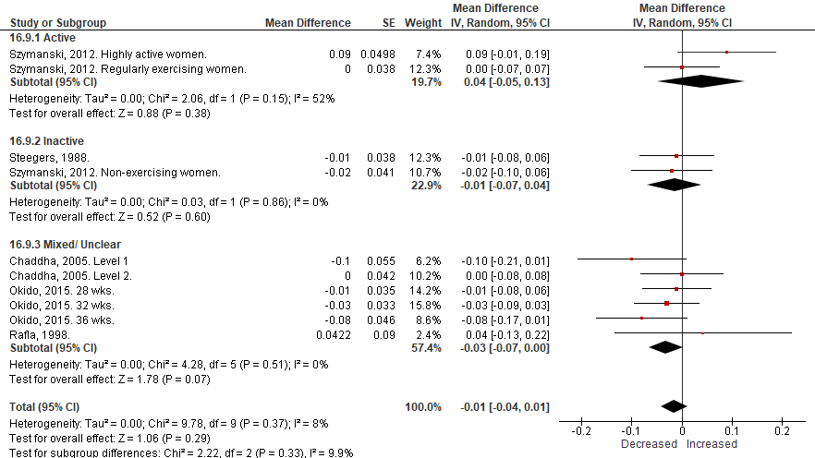Online Supplement Figure 64. Effect of acute prenatal exercise on uterine artery pulsatility index (PI). Data presented as a mean difference from pre-to-following exercise. PI is expressed in arbitrary units. Subgroup analysis separating studies by previous physical activity levels. Analyses conducted with a random effects model. CI, confidence interval; df, degrees of freedom; IV, inverse variance; SE, standard error; UPVI, uteroplacental vessel insufficiency.
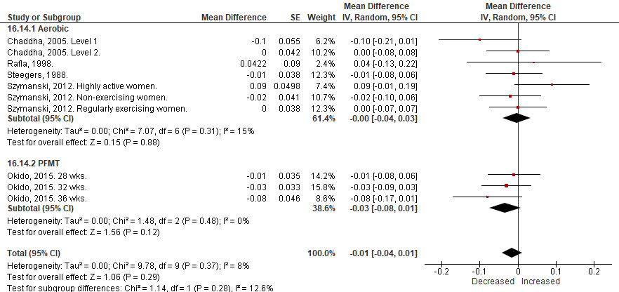
Online Supplement Figure 65. Effect of acute prenatal exercise on uterine artery pulsatility index (PI). Data presented as a mean difference from pre-to-following exercise. PI is expressed in arbitrary units. Subgroup analysis separating studies by type of exercise. Analyses conducted with a random effects model. CI, confidence interval; df, degrees of freedom; IV, inverse variance; SE, standard error; PFMT, pelvic floor muscle training; UPVI, uteroplacental vessel insufficiency.
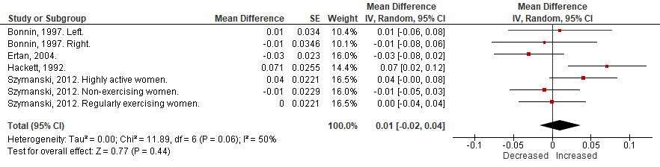Online Supplement Figure 66. Effect of acute prenatal exercise on uterine artery resistance index (RI). Data presented as a mean difference from pre-to-following exercise. RI is expressed in arbitrary units. Analyses conducted with a random effects model. CI, confidence interval; df, degrees of freedom; IV, inverse variance; SE, standard error; IUGR, intrauterine growth restriction.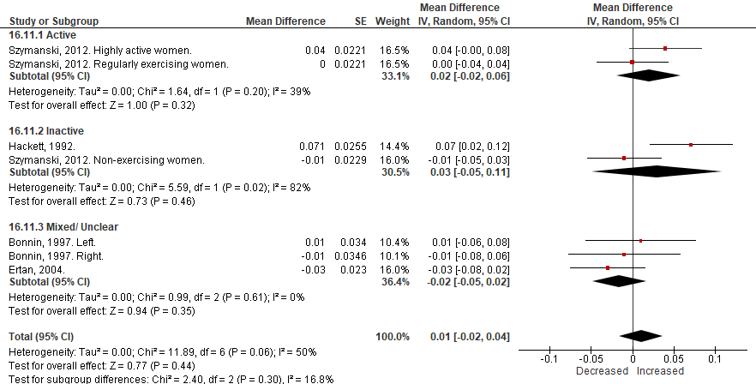 Online Supplement Figure 67. Effect of acute prenatal exercise on uterine artery resistance index (RI). Data presented as a mean difference from pre-to-following exercise. RI is expressed in arbitrary units. Subgroup analysis separating studies by previous physical activity levels. Analyses conducted with a random effects model. CI, confidence interval; df, degrees of freedom; IV, inverse variance; SE, standard error; IUGR, intrauterine growth restriction.
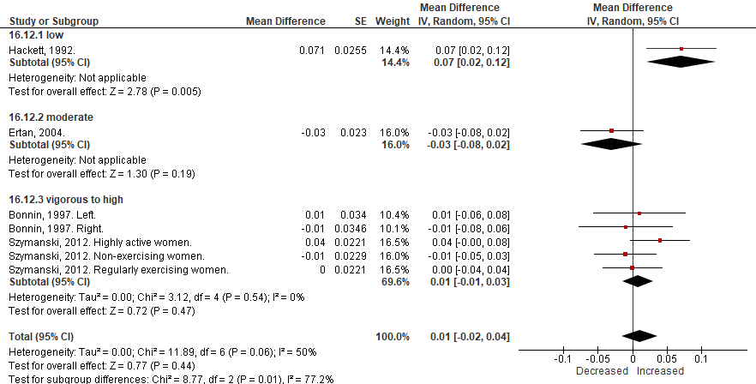Online Supplement Figure 68. Effect of acute prenatal exercise on uterine artery resistance index (RI). Data presented as a mean difference from pre-to-following exercise. RI is expressed in arbitrary units. Subgroup analysis separating studies by intensity of exercise. Analyses conducted with a random effects model. CI, confidence interval; df, degrees of freedom; IV, inverse variance; SE, standard error; IUGR, intrauterine growth restriction.

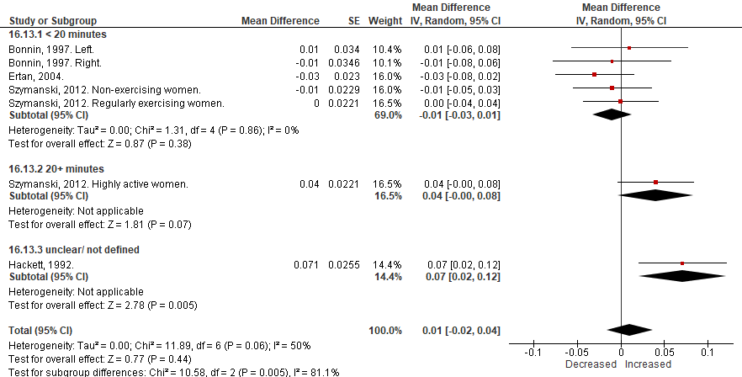
Online Supplement Figure 69. Effect of acute prenatal exercise on uterine artery resistance index (RI). Data presented as a mean difference from pre-to-following exercise. RI is expressed in arbitrary units. Subgroup analysis separating studies by duration of exercise. Analyses conducted with a random effects model. CI, confidence interval; df, degrees of freedom; IV, inverse variance; SE, standard error; IUGR, intrauterine growth restriction.

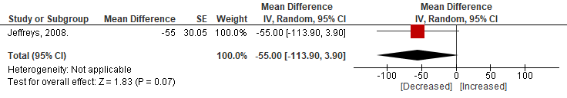
Online Supplement Figure 70. Effect of acute prenatal exercise on uterine artery volumetric blood flow. Data presented as a mean difference from pre-to-during exercise. Volumetric blood flow is expressed in ml/min. Analyses conducted with a random effects model. CI, confidence interval; df, degrees of freedom; IV, inverse variance; SE, standard error.

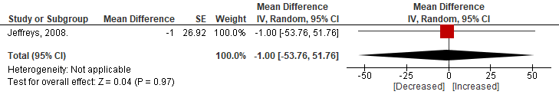
Online Supplement Figure 71. Effect of acute prenatal exercise on uterine artery volumetric blood flow. Data presented as a mean difference from pre-to-following exercise. Volumetric blood flow is expressed in ml/min. Analyses conducted with a random effects model. CI, confidence interval; df, degrees of freedom; IV, inverse variance; SE, standard error.

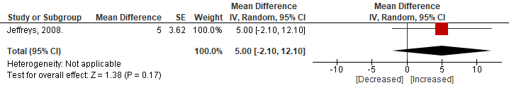
Online Supplement Figure 72. Effect of acute prenatal exercise on uterine artery blood velocty. Data presented as a mean difference from pre-to-during exercise. Blood velocity is expressed in cm/s. Analyses conducted with a random effects model. CI, confidence interval; df, degrees of freedom; IV, inverse variance; SE, standard error.

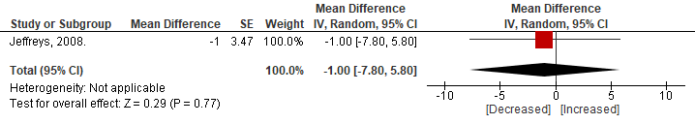
Online Supplement Figure 73. Effect of acute prenatal exercise on uterine artery blood velocty. Data presented as a mean difference from pre-to-following exercise. Blood velocity is expressed in cm/s. Analyses conducted with a random effects model. CI, confidence interval; df, degrees of freedom; IV, inverse variance; SE, standard error.

Uterine artery responses to chronic exercise
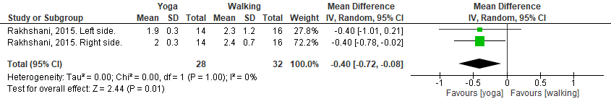Online Supplement Figure 74. Superiority trial (randomized controlled trial) reporting on the effect of prenatal yoga compared with walking interventions on uterine artery systolic/diastolic ratio (S/D) at rest. Analyses conducted with a random effects model. CI, confidence interval; df, degrees of freedom; IV, inverse variance; SE, standard error.
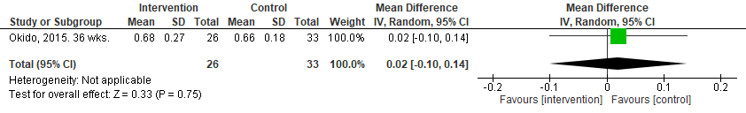Online Supplement Figure 75. Randomized controlled trial reporting on the effect of prenatal exercise intervention compared to control. Analyses conducted with a random effects model. CI, confidence interval; df, degrees of freedom; IV, inverse variance; SE, standard error.
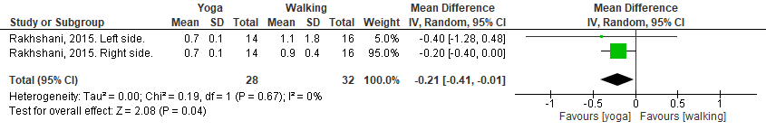
Online Supplement Figure 76. Superiority trial (randomized controlled trial) reporting on the effect of prenatal yoga compared with walking interventions on uterine artery pulsatility index at rest. Analyses conducted with a random effects model. CI, confidence interval; df, degrees of freedom; IV, inverse variance; SE, standard error.
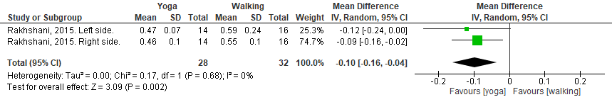
Online Supplement Figure 77. Superiority trial (randomized controlled trial) reporting on the effect of prenatal yoga compared with walking interventions on uterine artery resistance index at rest. Analyses conducted with a random effects model. CI, confidence interval; df, degrees of freedom; IV, inverse variance; SE, standard error.

Supplemental Figures (Funnel Plots)

Fetal Heart Rate During Exercise
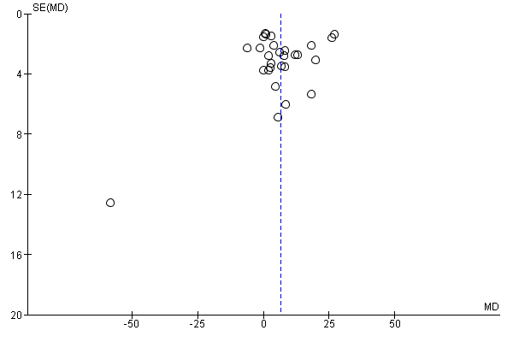
Online Supplement Figure 78. Funnel plot of the meta-analysis of published acute prenatal exercise on the fetal heart rate response during exercise. Each plotted point represents the mean difference (pre-during exercise) in FHR for a distinct group within each study. The vertical line represents the average mean difference of 6.35bpm found in the meta-analysis.

Fetal Heart Rate Following Exercise
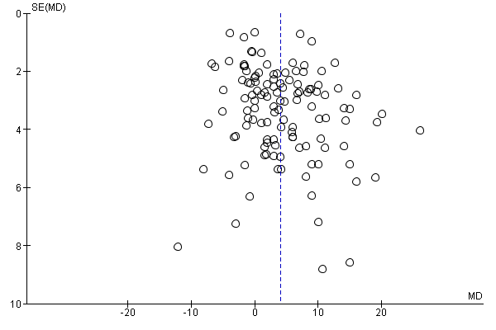
Online Supplement Figure 79. Funnel plot of the meta-analysis of published acute prenatal exercise on the fetal heart rate response following exercise. Each plotted point represents the mean difference (pre-following exercise) in FHR for a distinct group within each study. The vertical line represents the average mean difference of 4.05bpm found in the meta-analysis.

Meta-regressions

Fetal heart rate (during exercise), Predictor: Volume (MET minutes) per session.
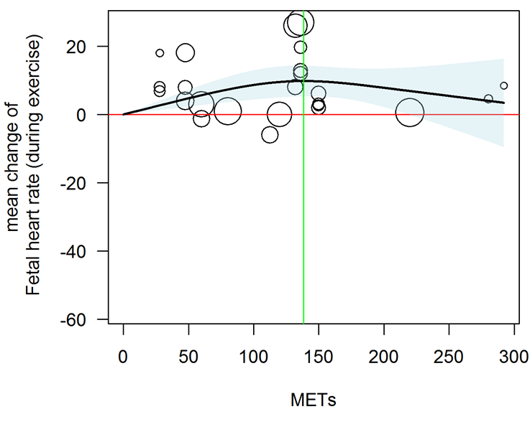
Online Supplement Figure 80. Curvilinear (spline) regression of the mean change in fetal heart rate from pre-to-during acute exercise. p <0.001. Black line, line of best fit; red line, mean difference of zero; green line, maximum of non-linear curve; shaded area, 95% confidence intervals. Volume of exercise per session was assessed as MET minutes per session and was determined by multiplying the METs associated with the activity by the duration (minutes) of the activity. Circle size is related to the weight of the study in the regression.
P-values, nonlinear: <0.001. Maximum of nonlinear curve: 9.8 at 138.3 METs
## df AIC BIC AICc logLik LRT pval QE tau^2 R^2
## Full 3 178.1944 181.7286 179.3944 -86.0972 468.3329 69.4584
## Reduced 2 180.2508 182.6069 180.8223 -88.1254 4.0564 0.0440 577.1653 82.9822 16.30%
Data set
Date filename: ../Data/CONVERSION OF SE TO SD FOR NICK - FHR - meta-regressions May 31, 2018.xlsx
Sheet: FHR 1.1 DURING
Data file last modified: 01-Jun-2018 at 08:18
The data set has 28 rows and 9 columns.
Random effects meta-analysis of mean change of fetal heart rate (during exercise)
##
## Random-Effects Model (k = 28; tau^2 estimator: REML)
##
## tau^2 (estimated amount of total heterogeneity): 88.8918 (SE = 27.2472)
## tau (square root of estimated tau^2 value): 9.4282
## I^2 (total heterogeneity / total variability): 94.20%
## H^2 (total variability / sampling variability): 17.23
##
## Test for Heterogeneity:
## Q(df = 27) = 555.4115, p-val < .0001
##
## Model Results:
##
## estimate se zval pval ci.lb ci.ub
## 6.4520 1.9001 3.3957 0.0007 2.7280 10.1761 ***
##
## ---
## Signif. codes: 0 '***' 0.001 '**' 0.01 '*' 0.05 '.' 0.1 ' ' 1
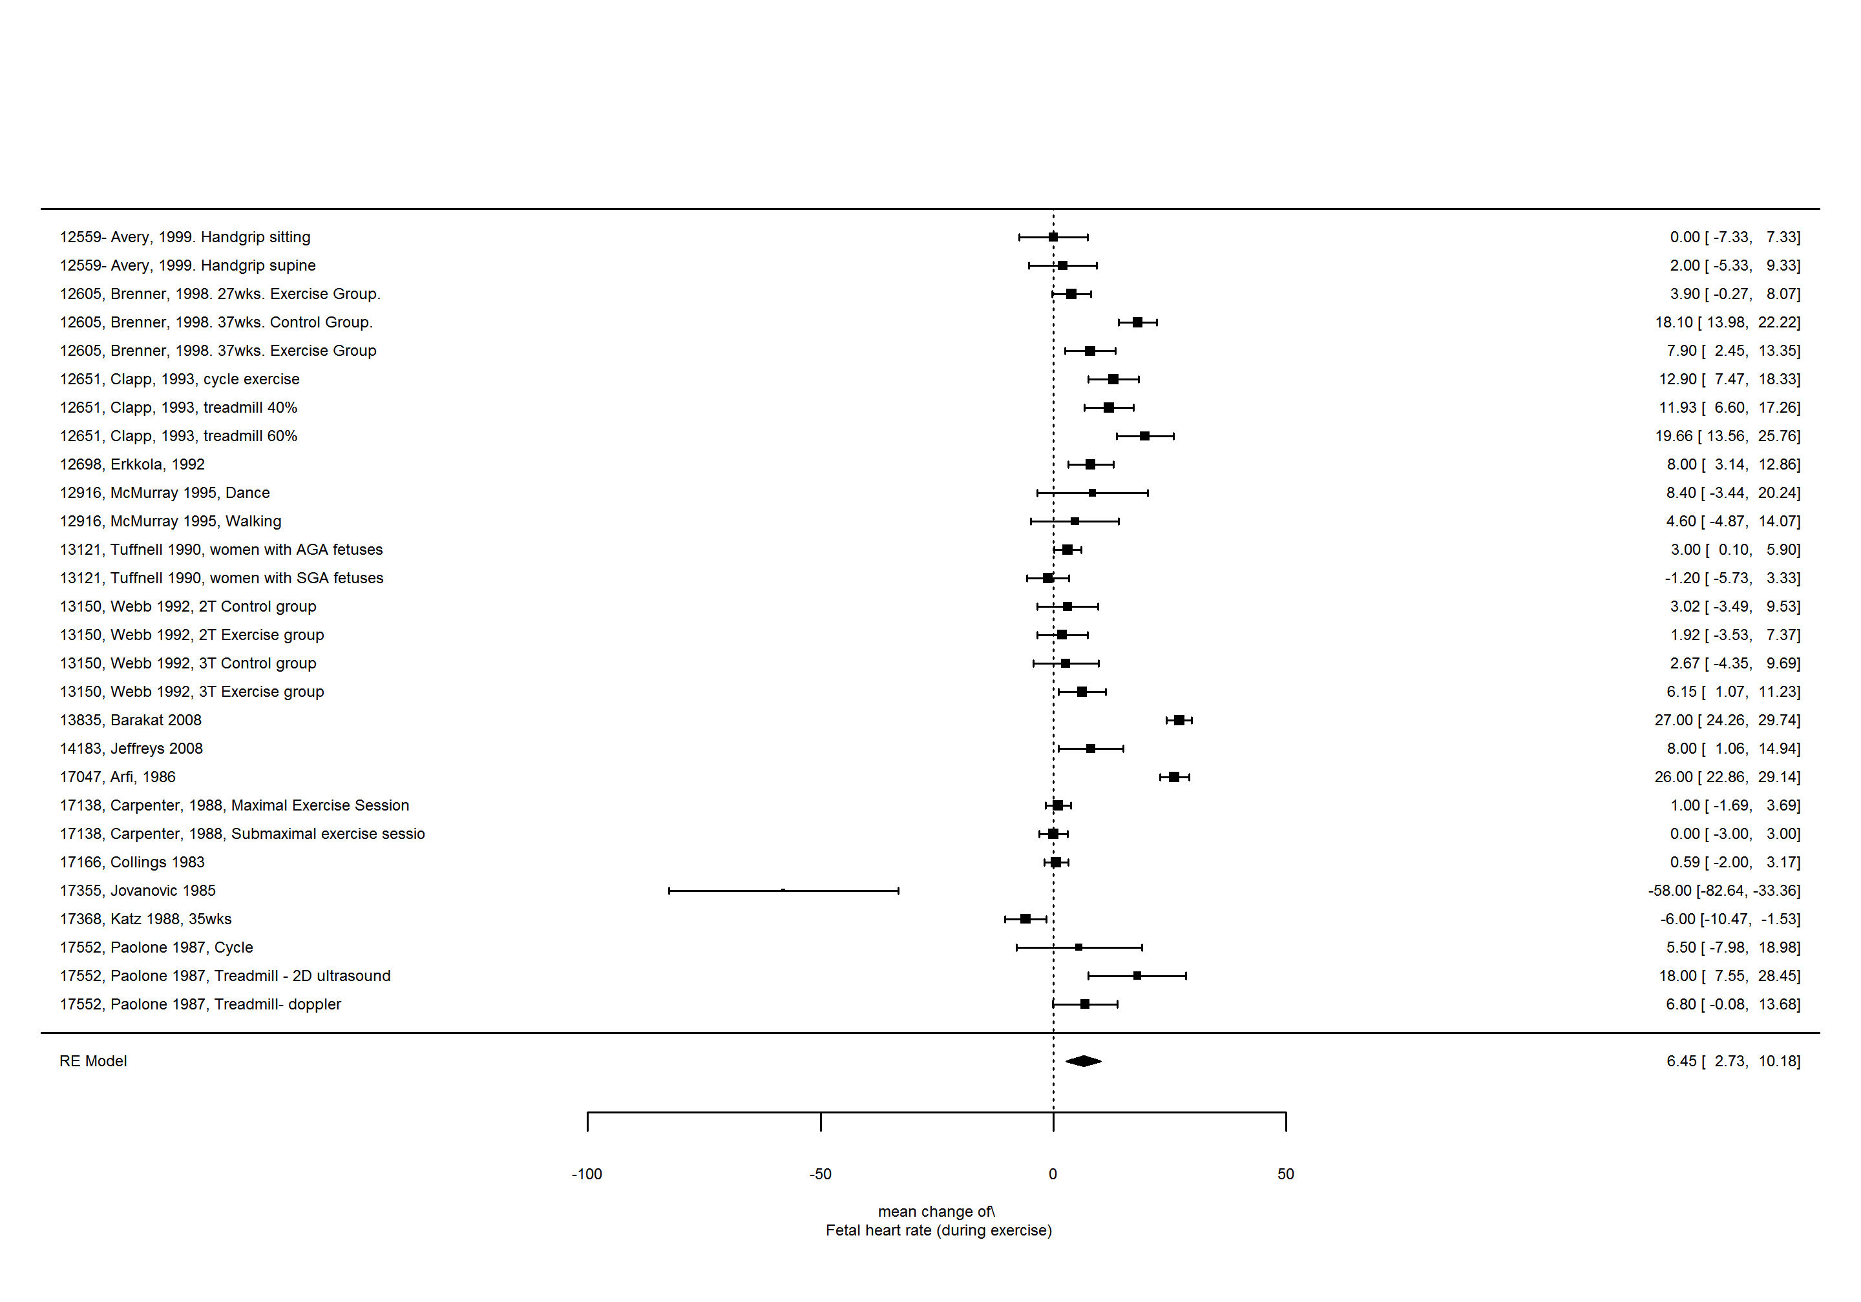

Fetal heart rate (following exercise), Predictor: Volume (MET minutes) per session.
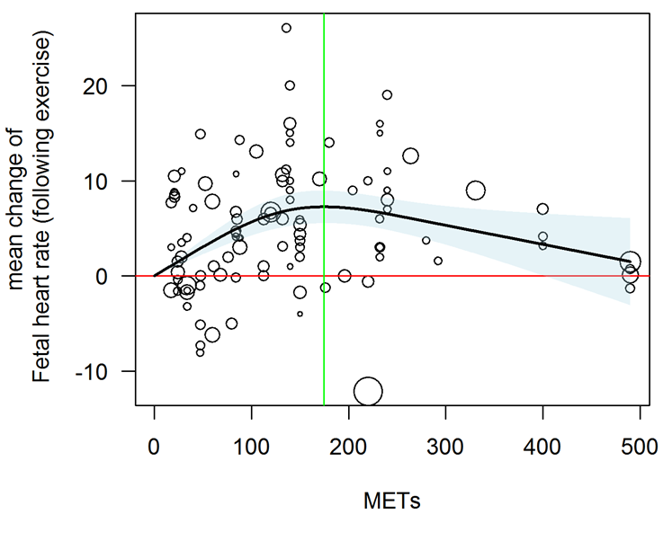
Online Supplement Figure 81. Curvilinear (spline) regression of the mean change in fetal heart rate from pre-to-following acute exercise. p <0.001. Black line, line of best fit; red line, mean difference of zero; green line, maximum of non-linear curve; shaded area, 95% confidence intervals. Volume of exercise per session was assessed as MET minutes per session and was determined by multiplying the METs associated with the activity by the duration (minutes) of the activity. Circle size is related to the weight of the study in the regression.
P-values, nonlinear: <0.001. Maximum of nonlinear curve: 7.2 at 174.6 METs
## df AIC BIC AICc logLik LRT pval QE tau^2 R^2
## Full 3 667.5133 675.3883 667.7582 -330.7567 798.0272 26.8195
## Reduced 2 692.1861 697.4361 692.3073 -344.0931 26.6728 <.0001 860.9723 37.1016 27.71%
Data set
Date filename: ../Data/CONVERSION OF SE TO SD FOR NICK - FHR - meta-regressions May 31, 2018.xlsx
Sheet: following
Data file last modified: 01-Jun-2018 at 08:18
The data set has 122 rows and 9 columns.
Random effects meta-analysis of mean change of fetal heart rate (following exercise)
##
## Random-Effects Model (k = 122; tau^2 estimator: REML)
##
## tau^2 (estimated amount of total heterogeneity): 30.8783 (SE = 5.3762)
## tau (square root of estimated tau^2 value): 5.5568
## I^2 (total heterogeneity / total variability): 86.12%
## H^2 (total variability / sampling variability): 7.20
##
## Test for Heterogeneity:
## Q(df = 121) = 1018.9645, p-val < .0001
##
## Model Results:
##
## estimate se zval pval ci.lb ci.ub
## 4.0616 0.5940 6.8377 <.0001 2.8974 5.2259 ***
##
## ---
## Signif. codes: 0 '***' 0.001 '**' 0.01 '*' 0.05 '.' 0.1 ' ' 1
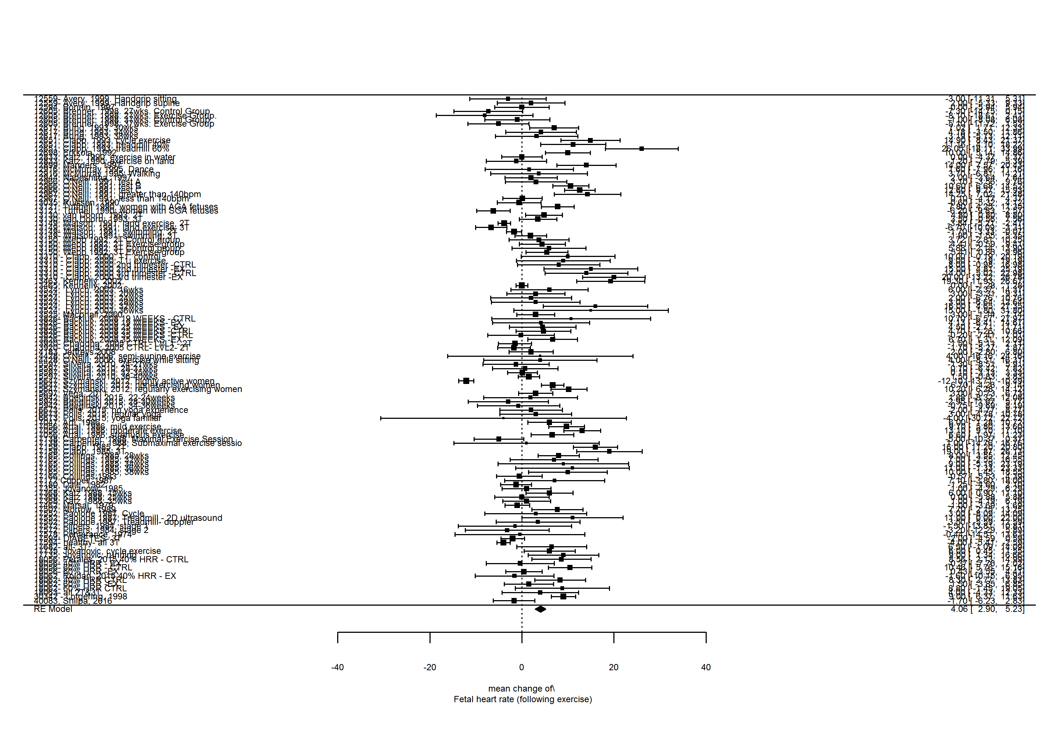

Proportions/ Incidence

To assess bradycardia and tachycardia in response to acute exercise, the pooled proportion of bradycardia or tachycardia events was obtained through random effects pooling of logit-transformed proportions in R (version 3.4.1) using the rma.glmm function for generalized linear mixed effects models in the metaphor package.⁹²

Bradycardia occurring during pre-exercise rest
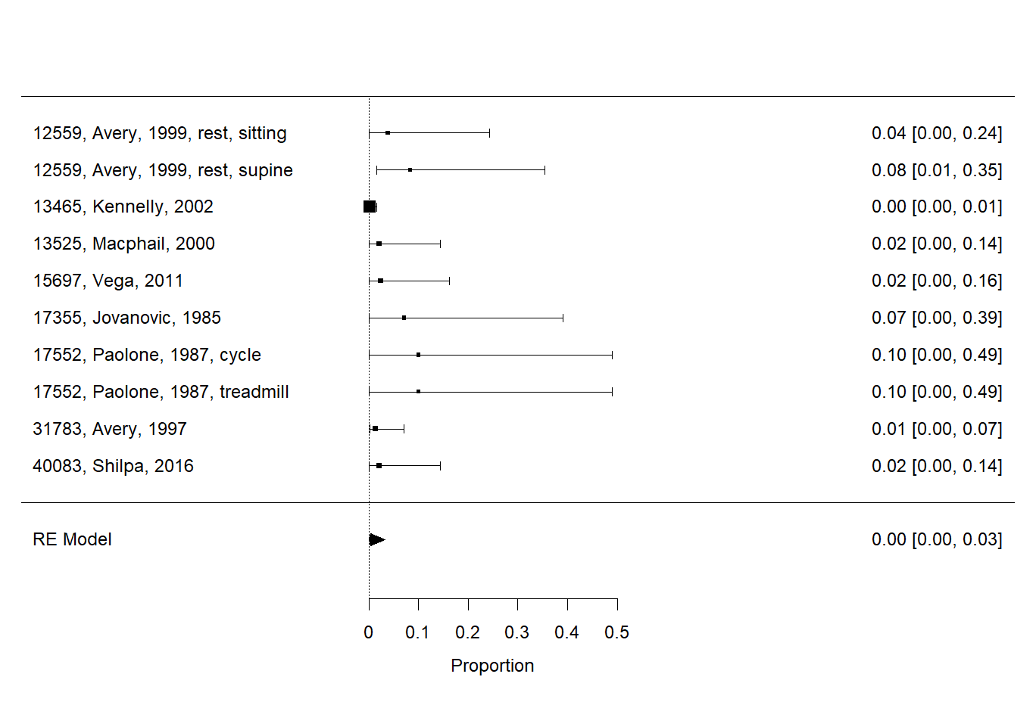
Online Supplement Figure 82. Proportion of bradycardia events occurring at rest prior to prenatal exercise. Incidence of bradycardia at rest was used and pooled proportion of bradycardia events was obtained through random effects pooling of logit-transformed proportions. Data from all studies reporting on bradycardia (author defined). I²= 40%.

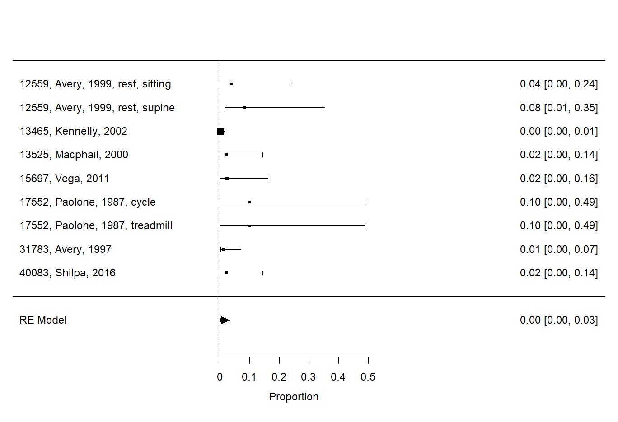
Online Supplement Figure 83. Proportion of bradycardia events occurring at rest prior to prenatal exercise. Incidence of bradycardia at rest was used and pooled proportion of bradycardia events was obtained through random effects pooling of logit-transformed proportions. Sensitivity analysis removing study which may have artifact⁷ I²= 42%

Bradycardia occurring during acute exercise sessions
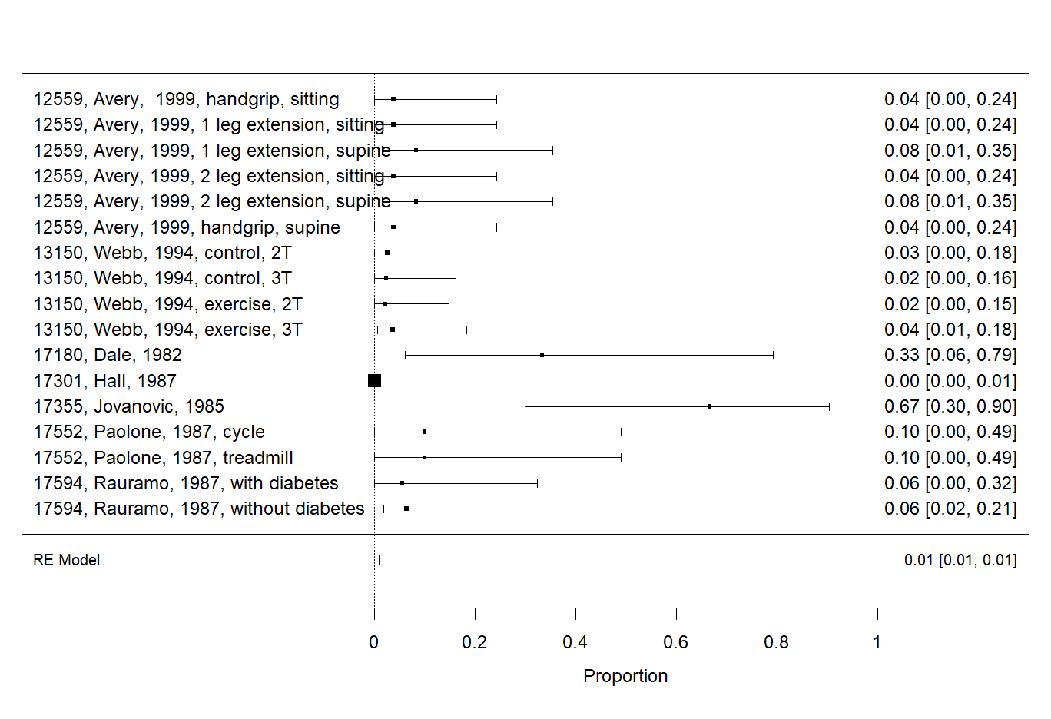
Online Supplement Figure 84. Proportion of bradycardia events occurring during prenatal exercise. Incidence of bradycardia during acute exercise sessions was used and pooled proportion of bradycardia events was obtained through random effects pooling of logit-transformed proportions. Data from all studies reporting on bradycardia (author defined). I²= 80%
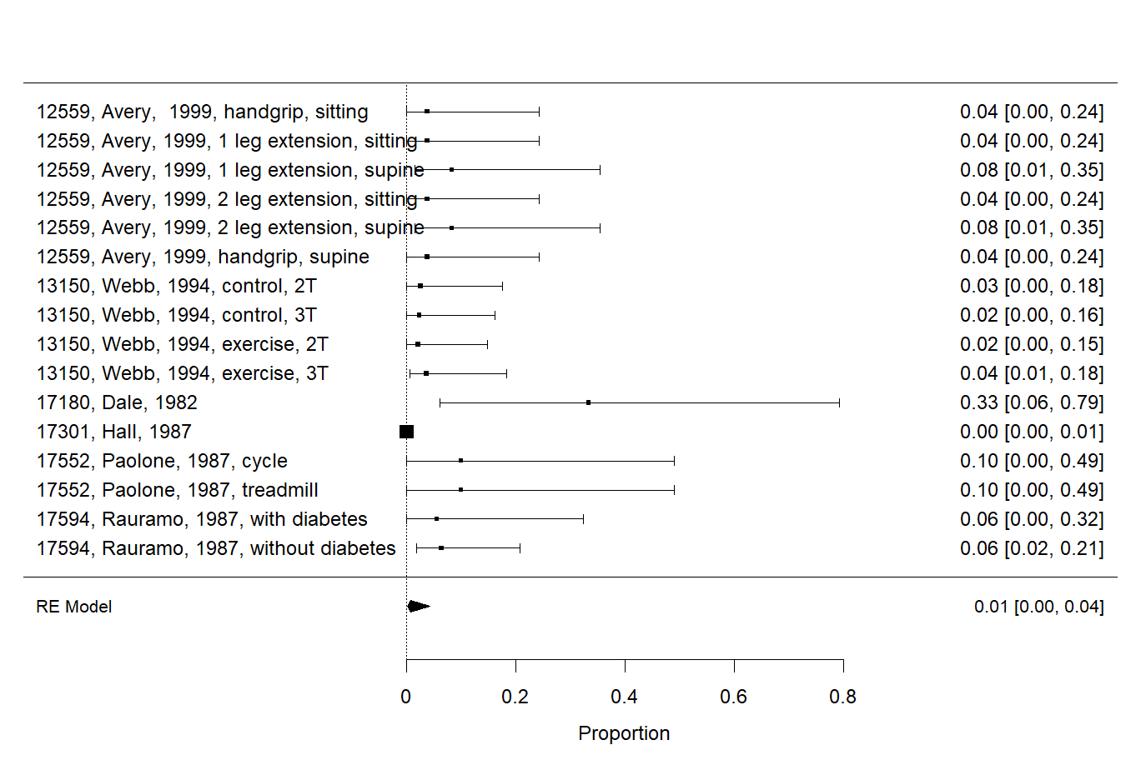
Online Supplement Figure 85. Proportion of bradycardia events occurring during prenatal exercise. Incidence of bradycardia during acute exercise sessions was used and pooled proportion of bradycardia events was obtained through random effects pooling of logit-transformed proportions. Sensitivity analysis removing study which may have artifact. ⁷ I²= 67%.

Bradycardia occurring during post-exercise recovery
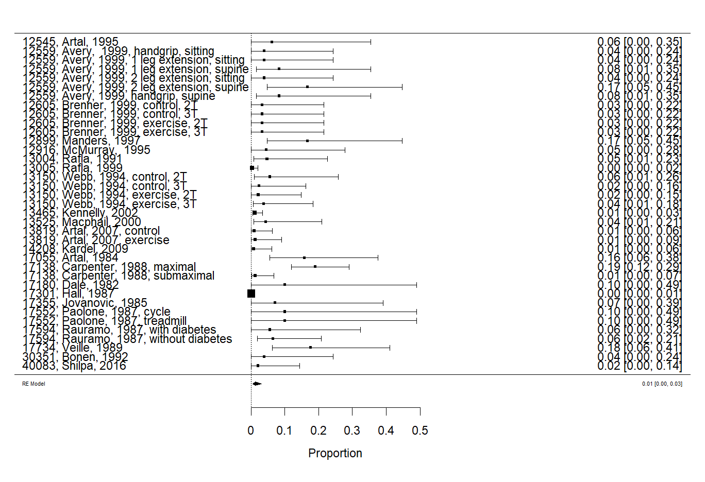
Online Supplement Figure 86. Proportion of bradycardia events occurring at rest following acute prenatal exercise. Incidence of bradycardia following exercise was used and pooled proportion of bradycardia events was obtained through random effects pooling of logit-transformed proportions. I²= 76%

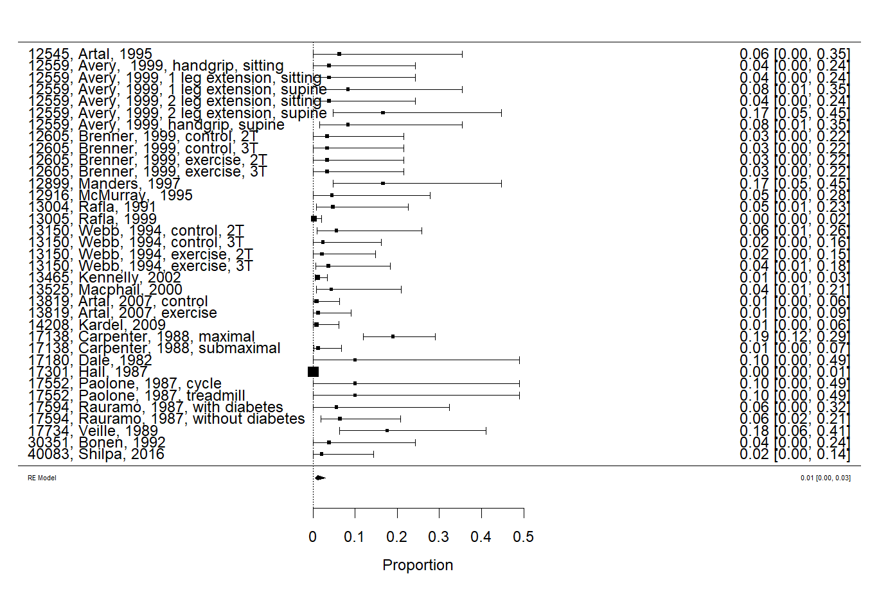
Online Supplement Figure 87. Proportion of bradycardia events occurring at rest following acute prenatal exercise. Incidence of bradycardia following exercise was used and pooled proportion of bradycardia events was obtained through random effects pooling of logit-transformed proportions. Sensitivity analysis removing two studies which may have artifact.⁷ ⁷¹ I²= 75%

Tachycardia occurring during pre-exercise rest.

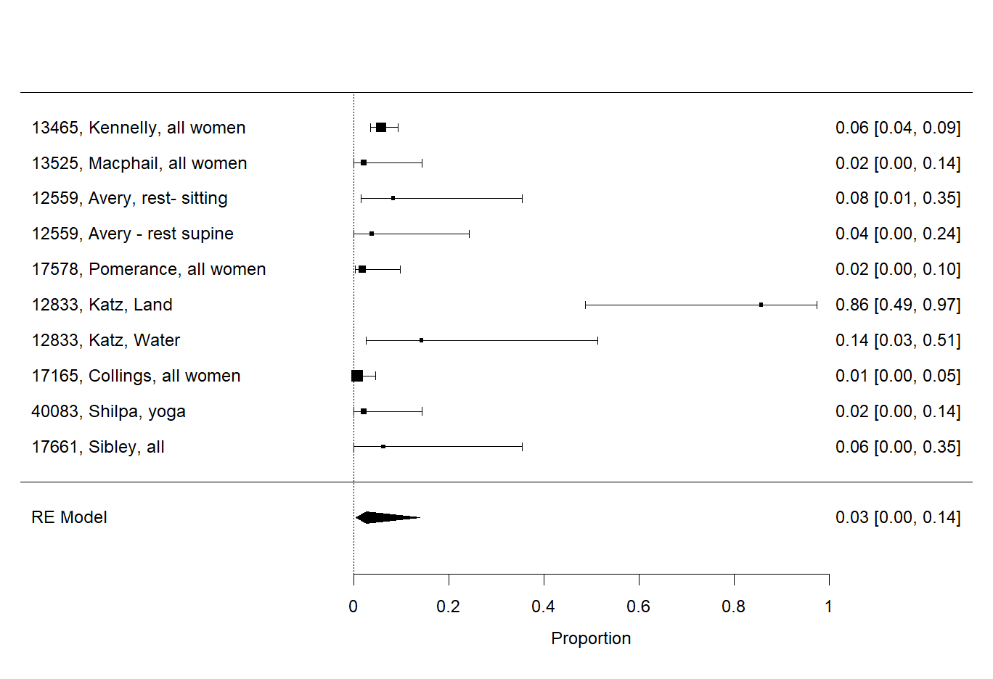
Online Supplement Figure 88. Proportion of tachycardia events occurring at rest prior to prenatal exercise. Incidence of tachycardia at rest was used and pooled proportion of bradycardia events was obtained through random effects pooling of logit-transformed proportions. I²= 86%

Tachycardia occurring during acute exercise session.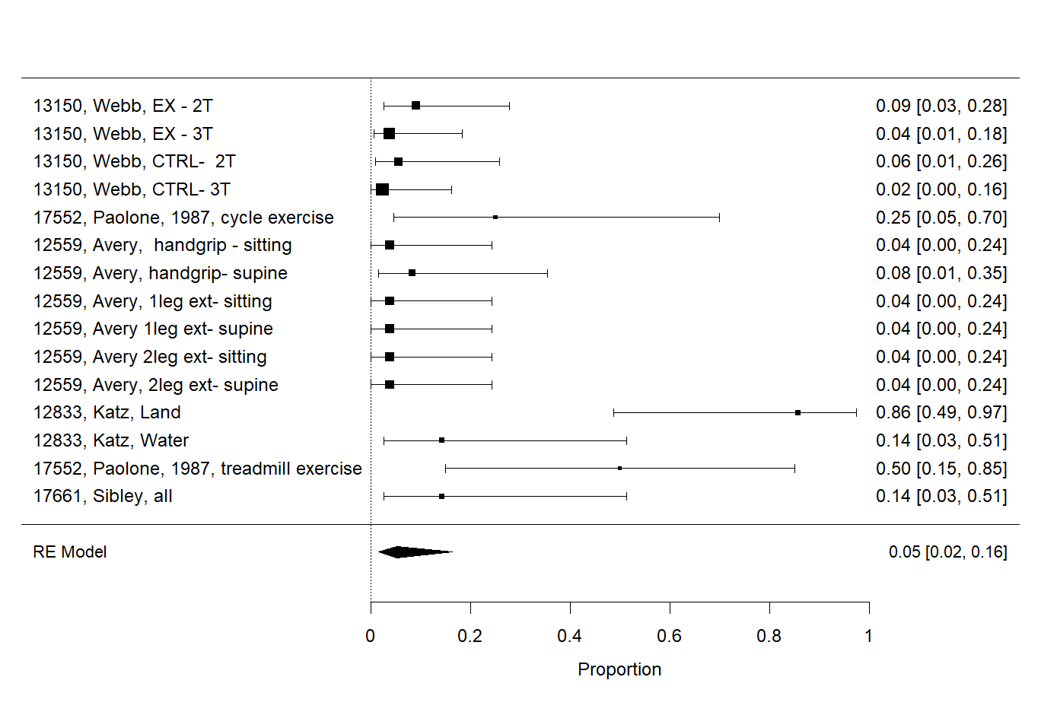
Online Supplement Figure 89. Proportion of tachycardia events occurring during acute prenatal exercise. Incidence of tachycardia during exercise was used and pooled proportion of bradycardia events was obtained through random effects pooling of logit-transformed proportions. I²= 72%

Tachycardia occurring following an acute exercise session
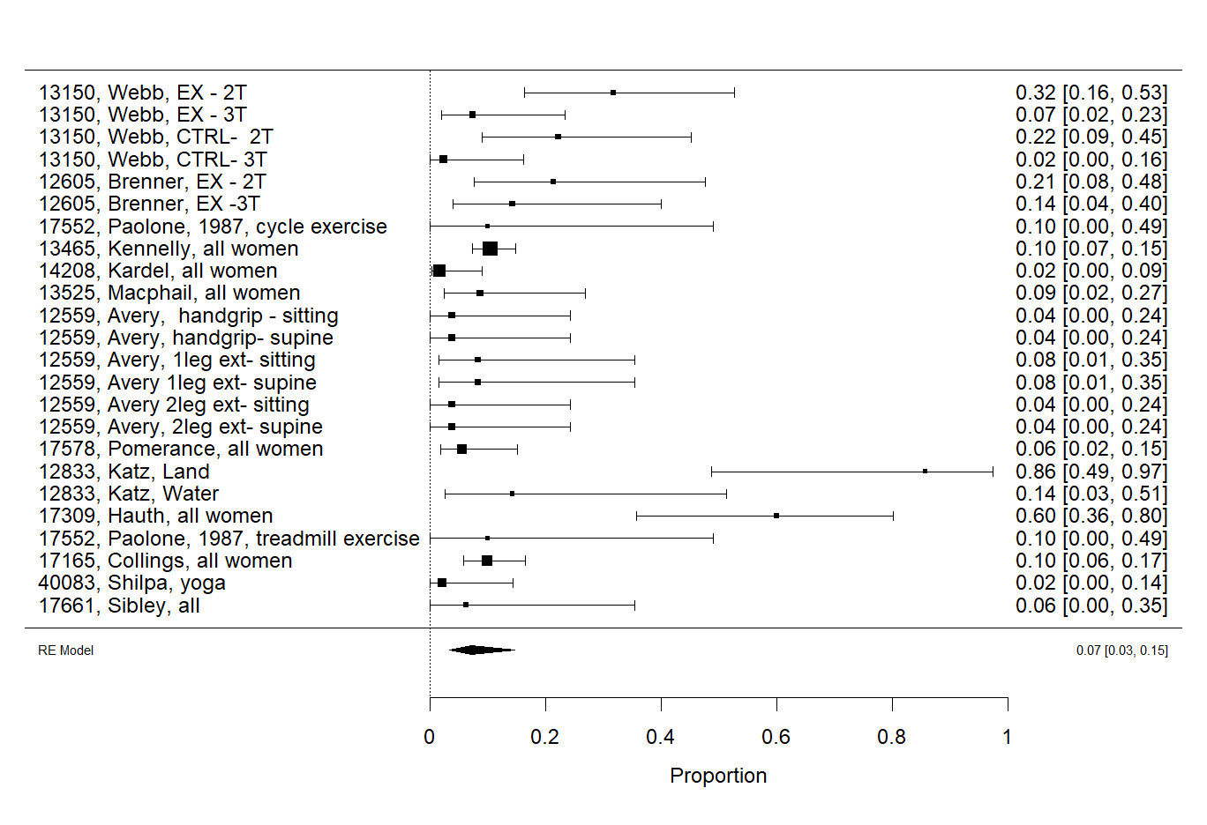
Online Supplement Figure 90. Proportion of tachycardia events occurring at rest following acute prenatal exercise. Incidence of tachycardia following exercise was used and pooled proportion of bradycardia events was obtained through random effects pooling of logit-transformed proportions. I²= 83%

Search strategies
The following databases were searched on January 6th, 2017:
- Ovid MEDLINE(R) In-Process & Other Non-Indexed Citations, Ovid MEDLINE(R) Daily and Ovid MEDLINE(R)
- Ovid EMBASE
- Ovid All EBM [Evidence-Based Medicine] Reviews: Cochrane Database of Systematic and Cochrane Central Register of Controlled Trials
- Ovid PsycInfo 1806-Present
- EBSCO CINAHL Plus with Full-text, 1937-Present
- EBSCO Sport Discus with Full-text. 1975-Present
- EBSCO ERIC, 1966-Present
- EBSCO Child Development and Adolescent Studies, 1927-Present
- Scopus, 1960-Present
- Web of Science Core Collection (including Emerging Sources Citation Index) , 1900-Present
- Clinicaltrials.gov
- TRIP database

Maternal Outcomes Strategy

MEDLINE
1. exp Exercise/ or Athletes/ or exp Exercise Movement Techniques/ or Physical Exertion/ or exp Exercise Therapy/ or exp Sports/ or Motor Activity/ or Sedentary Lifestyle/ or (exercise or physical* activ* or strenuous activit* or physical* inactiv* or sedentary or running or plyometric* or yoga or tai chi or weight training or resistance training or swim* or sport* or athlet* or walk or walking or mvpa or ltpa or stretching or aerobic capacity).ti,kf. or exercise.ab. /freq=2 or physical* activ*.ab. /freq=2 or (weight* adj2 lift*).ti,kf. or ((muscle or muscular or strength*) adj2 conditioning).ti,kf.
2. exp Pregnancy Complications/ or Pregnancy Outcome/ or exp Labor, Obstetric/ or exp Delivery, Obstetric/ or exp Extraction, Obstetrical/ or pregnan*.ti,hw,kf.
3. ((birth or pregnancy or childbirth) adj3 (outcome* or complication*)).mp.
4. (((spontaneous or induc* or onset or length) adj3 (labor or labour)) or c?esarean).mp.
5. (episiotom* or vaginal delivery or gestational diabetes or pre-eclampsia or preeclampsia or gestosis).mp.
6. (((normal or instrumental or assisted) adj2 (delivery or birth or childbirth)) or (forceps or ventouse or vacuum extraction)).mp.
7. ((mode of delivery or type of delivery) and (pregnan* or birth or childbirth or obstetric* or labor or labour)).mp.
8. ((tear* or ruptur* or hemorrhage*) adj2 (placent* or vagin* or membran* or periton*)).mp.
9. (miscarriage* or spontaneous abortion*).mp.
10. or/2-9
11. 1 and 10
12. Pregnancy/ or pregnan*.ti,hw,kf. or exp Pregnancy Trimesters/ or Peripartum Period/ or Postpartum Period/ or (antenatal or prenatal or perinatal or postnatal or prepartum or antepartum or postpartum or pre partum or ante partum or post partum or puerper* or primigravid* or primiparous or multiparous or nulliparous or multigravid* or trimester* or obstetric*).ti,kf.
13. 1 and 12
14. ((pregnan* or antenatal or prenatal or perinatal or postnatal or prepartum or antepartum or postpartum or pre partum or ante partum or post partum or puerper*) adj5 (exercise or physical* activ* or strenuous activit* or physical inactiv* or sedentary or running or plyometric* or yoga or tai chi or weight training or resistance training or (weight* adj2 lift*) or swim* or sport* or athlet* or walk or walking or ((muscle or muscular or strength*) adj2 conditioning))).ab.
15. 13 or 14
16. exp Insulins/ or diabetes mellitus/ or exp diabetes mellitus, type 1/ or exp diabetes mellitus, type 2/ or diabetes, gestational/ or prediabetic state/ or hemoglobin a, glycosylated/ or (insulin or glucose or glyc?emic control or blood sugar or diabet* or prediabet* or hba1c or glycosylated h?emoglobin or hyperglyc?emi* or hypoglyc?emi* or (weight adj3 (gain* or change* or loss or lose or retention)) or bmi or body mass index or body composition or skinfold thickness or ((hip or waist) adj2 ratio) or ((waist or abdominal) adj2 circumference) or overweight or obes* or adipos* or underweight or normal weight or healthy weight or hypertension or hypotension or fainting or syncope or lightheaded* or light headed* or dizziness or blood pressure or tox?emi* or eph complex or proteinuria or edema or hemodynamic* or haemodynamic* or systolic or diastolic or cardiovascular or cardiometabolic or cardio-metabolic or metabolic or heart or cardio* or cardiac or lipid* or placental growth factor* or triglyceride* or ldl or hdl or lipoprotein or cholesterol).mp.
17. dehydration/ or exp Cardiovascular Diseases/ or (dehydrat* or heart disease* or cardiovascular disease*).mp.
18. adaptation, physiological/ or body temperature regulation/
19. Physical Fitness/ or exp Physical Endurance/ or me.fs. or (safe* or harm* or risk* or fitness or aerobic capacity or oxygen consumption or vo2 max or vo2max or vo2 peak or vo2peak or frequency or intensity or duration or dose response or fitt or zone or (type* adj2 exercise)).mp.
20. exp Chronic disease/ or exp Osteoporosis/ or exp Urinary Incontinence/ or (chronic disease* or chronic illness* or osteoporosis or incontinen*).mp.
21. exp Back Pain/ or Pelvic Pain/ or Muscle Cramp/ or (Pain/ and exp Hip Joint/) or ((hip or back or pelvic or pelvis) adj3 (pain or discomfort or ache)).mp. or cramp*.mp.
22. Mental Health/ or exp Mental Disorders/ or Body Image/ or Self Concept/ or (mental health or mental disorder* or mental illness* or mental disease* or depression or depressive or mood or anxiety or well being or wellbeing or wellness or body image or self perception).mp.
23. (postur* or supine or valsalva or diastasis recti or rectus abdominis or inter rectus distance or interrectus distance).mp.
24. Fatigue/ or (fatigue or exhaustion or injur* or trauma).mp.
25. or/16-24
26. 15 and 25
27. 11 or 26
28. limit 27 to medline
29. animals/ not (animals/ and humans/)
30. 28 not 29
31. 27 not 28
32. ((rat or rats or mouse or mice or cow or cows or bovine or sheep or ewe*) not ((rat or rats or mouse or mice or cow or cows or bovine or sheep or ewe*) and (human* or women))).ti,ab,kf.
33. 31 not 32
34. 30 or 33
35. remove duplicates from 34

EMBASE
1. exp *exercise/ or *athlete/ or exp *kinesiotherapy/ or exp *sport/ or exp *physical activity/ or *sedentary lifestyle/ or (exercise or physical* activ* or physical* inactiv* or sedentary or running or plyometric* or yoga or tai chi or weight training or resistance training or swim* or sport* or athlet* or walk or walking or mvpa or ltpa or stretching or aerobic capacity).ti,kw. or exercise.ab. /freq=2 or physical* activ*.ab. /freq=2 or (weight* adj2 lift*).ti,kw. or ((muscle or muscular or strength*) adj2 conditioning).ti,kw.
2. exp pregnancy complication/ or pregnancy outcome/ or exp labor/ or exp delivery/ or pregnan*.ti,kw.
3. ((birth or pregnancy or childbirth) adj3 (outcome* or complication*)).mp.
4. (((spontaneous or induc* or onset or length) adj3 (labor or labour)) or c?esarean).mp.
5. (episiotom* or vaginal delivery or gestational diabetes or pre-eclampsia or preeclampsia or gestosis).mp.
6. (((normal or instrumental or assisted) adj2 (delivery or birth or childbirth)) or (forceps or ventouse or vacuum extraction)).mp.
7. ((mode of delivery or type of delivery) and (pregnan* or birth or childbirth or obstetric* or labor or labour)).mp.
8. ((tear* or ruptur* or hemorrhage*) adj2 (placent* or vagin* or membran* or periton*)).mp.
9. (miscarriage* or spontaneous abortion*).mp.
10. or/2-9
11. 1 and 10
12. Pregnancy/ or pregnan*.ti,hw,kw. or exp Pregnancy Trimesters/ or Peripartum Period/ or Postpartum Period/ or (antenatal or prenatal or perinatal or postnatal or prepartum or antepartum or postpartum or pre partum or ante partum or post partum or puerper* or primigravid* or primiparous or multiparous or nulliparous or multigravid* or trimester* or obstetric*).ti,kw.
13. 1 and 12
14. ((pregnan* or maternal or antenatal or prenatal or perinatal or postnatal or prepartum or antepartum or postpartum or pre partum or ante partum or post partum or puerper*) adj5 (exercise or physical* activ* or strenuous activit* or physical* inactiv* or sedentary or running or plyometric* or yoga or tai chi or weight training or resistance training or (weight* adj2 lift*) or swim* or sport* or athlet* or walk or walking or mvpa or ltpa or stretching or aerobic capacity or fitness or ((muscle or muscular or strength*) adj2 conditioning))).ab.
15. 13 or 14
16. exp insulin/ or exp diabetes mellitus/ or glycosylated hemoglobin/ or (insulin or glucose or glyc?emic control or blood sugar or diabet* or prediabet* or hba1c or glycosylated h?emoglobin or hyperglyc?emi* or hypoglyc?emi* or (weight adj3 (gain* or change* or loss or lose or retention)) or bmi or body mass index or body composition or skinfold thickness or ((hip or waist) adj2 ratio) or ((waist or abdominal) adj2 circumference) or overweight or obes* or adipos* or underweight or normal weight or healthy weight or hypertension or hypotension or fainting or syncope or lightheaded* or light headed* or dizziness or blood pressure or tox?emi* or eph complex or proteinuria or edema or hemodynamic* or haemodynamic* or systolic or diastolic or cardiovascular or cardiometabolic or cardio-metabolic or metabolic or heart or cardio* or cardiac or lipid* or placental growth factor* or triglyceride* or ldl or hdl or lipoprotein or cholesterol).mp.
17. dehydration/ or exp cardiovascular disease/ or (dehydrat* or heart disease* or cardiovascular disease*).mp.
18. adaptation/ or exp thermoregulation/ or fitness/ or endurance/ or (safe* or harm* or risk* or fitness or aerobic capacity or oxygen consumption or vo2 max or vo2max or vo2 peak or vo2peak or frequency or intensity or duration or dose response or fitt or zone or (type* adj2 exercise)).mp.
19. exp backache/ or exp pelvic pain/ or hip pain/ or muscle cramp/ or heat cramp/ or leg cramp/ or ((hip or back or pelvic or pelvis) adj3 (pain or discomfort or ache)).mp. or cramp*.mp.
20. mental health/ or psychological well being/ or exp mental disease/ or body image/ or self concept/ or (mental health or mental disorder* or mental illness* or mental disease* or depression or depressive or mood or anxiety or well being or wellbeing or wellness or body image or self perception).mp.
21. (postur* or supine or valsalva or diastasis recti or rectus abdominis or inter rectus distance or interrectus distance).mp.
22. fatigue/ or exhaustion/ or (fatigue or exhaustion or injur* or trauma or blood loss).mp.
23. chronic disease/ or exp osteoporosis/ or exp urine incontinence/ or (chronic disease* or chronic illness* or osteoporosis or incontinen*).mp.
24. or/16-23
25. 15 and 24
26. 11 or 25
27. exp animal/ not (exp animal/ and human/)
28. 26 not 27
29. remove duplicates from 28

PsycInfo
1. physical activity/ or exp exercise/ or activity level/ or athletes/ or exp sports/ or ((exercise or physical* activ* or strenuous activit* or physical* inactiv* or sedentary or running or plyometric* or yoga or tai chi or weight training or resistance training or swim* or sport* or athlet* or walk or walking or mvpa or ltpa or stretching or aerobic capacity).ti,ab,id. or ((weight* adj2 lift*) or ((muscle or muscular or strength*) adj2 conditioning))).ti,ab,id.
2. obstetrical complications/ or pregnancy outcomes/ or spontaneous abortion/ or "labor (childbirth)"/ or birth/
3. (pregnan* or ((birth or pregnancy or childbirth) adj3 (outcome* or complication*))).mp.
4. (((spontaneous or induc* or onset or length) adj3 (labor or labour)) or c?esarean).mp.
5. (episiotom* or vaginal delivery or gestational diabetes or pre-eclampsia or preeclampsia or gestosis).mp.
6. (((normal or instrumental or assisted) adj2 (delivery or birth or childbirth)) or (forceps or ventouse or vacuum extraction)).mp.
7. ((mode of delivery or type of delivery) and (pregnan* or birth or childbirth or obstetric* or labor or labour)).mp.
8. ((tear* or ruptur* or hemorrhage*) adj2 (placent* or vagin* or membran* or periton*)).mp.
9. (miscarriage* or spontaneous abortion*).mp.
10. or/2-9
11. 1 and 10
12. exp pregnancy/ or pregnan*.ti,hw,id. or (antenatal or prenatal or perinatal or postnatal or prepartum or antepartum or postpartum or primigravid* or primiparous or multiparous or nulliparous or multigravid* or trimester* or obstetric*).ti,id.
13. 1 and 12
14. ((pregnan* or antenatal or prenatal or perinatal or postnatal or prepartum or antepartum or postpartum or pre partum or ante partum or post partum or puerper*) adj5 (exercise or physical* activ* or strenuous activit* or physical inactiv* or sedentary or running or plyometric* or yoga or tai chi or weight training or resistance training or (weight* adj2 lift*) or swim* or sport* or athlet* or walk or walking or ((muscle or muscular or strength*) adj2 conditioning))).ab.
15. 13 or 14
16. insulin/ or diabetes/ or diabetes mellitus/ or (insulin or glucose or glyc?emic control or blood sugar or diabet* or prediabet* or hba1c or glycosylated h?emoglobin or hyperglyc?emi* or hypoglyc?emi* or (weight adj3 (gain* or change* or loss or lose or retention)) or bmi or body mass index or body composition or skinfold thickness or ((hip or waist) adj2 ratio) or ((waist or abdominal) adj2 circumference) or overweight or obes* or adipos* or underweight or normal weight or healthy weight or hypertension or hypotension or fainting or syncope or lightheaded* or light headed* or dizziness or blood pressure or tox?emi* or eph complex or proteinuria or edema or hemodynamic* or haemodynamic* or systolic or diastolic or cardiovascular or cardiometabolic or cardio-metabolic or metabolic or heart or cardio* or cardiac or lipid* or placental growth factor* or triglyceride* or ldl or hdl or lipoprotein or cholesterol).mp.
17. dehydration/ or exp Cardiovascular Disorders/ or (dehydrat* or heart disease* or cardiovascular disease*).mp.
18. "thermoregulation (body)"/ or physical fitness/ or physical endurance/ or (safe* or harm* or risk* or fitness or aerobic capacity or oxygen consumption or vo2 max or vo2max or vo2 peak or vo2peak or frequency or intensity or duration or dose response or fitt or zone or (type* adj2 exercise)).mp.
19. back pain/ or ((hip or back or pelvic or pelvis) adj3 (pain or discomfort or ache)).mp. or cramp*.mp.
20. mental health/ or exp Mental Disorders/ or exp body image/ or self concept/ or (mental health or mental disorder* or mental illness* or mental disease* or depression or depressive or mood or anxiety or well being or wellbeing or wellness or body image or self perception).mp.
21. (postur* or supine or valsalva or diastasis recti or rectus abdominis or inter rectus distance or interrectus distance).mp.
22. fatigue/ or (fatigue or exhaustion or injur* or trauma).mp.
23. Physical Fitness/ or exp Physical Endurance/ or (safe* or harm* or risk* or fitness or aerobic capacity or oxygen consumption or vo2 max or vo2max or vo2 peak or vo2peak or frequency or intensity or duration or dose response or fitt or zone or (type* adj2 exercise)).mp.
24. chronic illness/ or osteoporosis/ or urinary incontinence/ or (chronic disease* or chronic illness* or osteoporosis or incontinen*).mp.
25. or/16-24
26. 15 and 25
27. 11 or 26
28. first posting.ps.
29. (27 not first posting).ps.
30. limit 29 to human
31. 27 and 28
32. 30 or 31

Cochrane Library
#1 [mh Exercise] or [mh "Exercise Movement Techniques"] or [mh "Physical Exertion"] or [mh "Exercise Therapy"] or [mh "Motor Activity"] or [mh "Sedentary Lifestyle"] or (exercise or "physical* activ*" or "strenuous activit* " or " physical* inactiv* " or sedentary or running or plyometric* or yoga or " tai chi" or weight training or resistance training or swim* or sport* or athlet* or walk or walking or mvpa or ltpa or stretching or aerobic capacity or physical* active*):ti,ab,kw (weight* near/2 lift*):ti,ab,kw or ((muscle or muscular or strength*) near/2 conditioning):ti,ab,kw
#2 [mh "Pregnancy Complications"] or [mh "Pregnancy Outcome"] or [mh "Labor, Obstetric"] or [mh "Delivery, Obstetric"] or [mh "Extraction, Obstetrical"] or (pregnan*) .ti,ab,kw
#3 ((birth or pregnancy or childbirth) near/3 (outcome* or complication*)):ti,ab,kw
#4 (((spontaneous or induc* or onset or length) near/3 (labor or labour)) or (cesarean or caesarean)):ti,ab,kw
#5 (episiotom* or vaginal delivery or gestational diabetes or pre-eclampsia or preeclampsia or gestosis):ti,ab,kw
#6 (((normal or instrumental or assisted) near/2 (delivery or birth or childbirth)) or (forceps or ventouse or vacuum extraction)):ti,ab,kw
#7 ((mode of delivery or type of delivery) and (pregnan* or birth or childbirth or obstetric* or labor or labour)):ti,ab,kw
#8 ((tear* or ruptur* or hemorrhage*) near/2 (placent* or vagin* or membran* or periton*)):ti,ab,kw
#9 (miscarriage* or spontaneous abortion*):ti,ab,kw
#10 #2 or #3 or #4 or #5 or #6 or #7 or #8 or #9
#11 #1 AND #10
#12 [mh Pregnancy] or (pregnan*):ti,ab,kw or [mh "Pregnancy Trimesters"] or [mh "Peripartum Period"] or [mh "Postpartum Period"] or (antenatal or prenatal or perinatal or postnatal or prepartum or antepartum or postpartum or pre partum or ante partum or post partum or puerper* or primigravid* or primiparous or multiparous or nulliparous or multigravid* or trimester* or obstetric*):ti,ab,kw
#13 #1 AND #12
#14 ((pregnan* or antenatal or prenatal or perinatal or postnatal or prepartum or antepartum or postpartum or pre partum or ante partum or post partum or puerper*) near/5 (exercise or physical* activ* or strenuous activit* or physical inactiv* or sedentary or running or plyometric* or yoga or tai chi or weight training or resistance training or (weight* near/2 lift*) or swim* or sport* or athlet* or walk or walking or ((muscle or muscular or strength*) near/2 conditioning))) .ab.
#15 #13 or #14
#16 [mh Insulins] or [mh "diabetes mellitus"] or [mh "diabetes, gestational"] or [mh "prediabetic state"] or [mh "hemoglobin a, glycosylated"] or (insulin or glucose or "glycemic control" or "blood sugar" or diabet* or prediabet* or hba1c or "glycosylated hemoglobin" or "glycosylated haemoglobin" or hyperglycemi* or hypoglycemi* or hyperglycaemi* or hypoglycaemi* or (weight near/3 (gain* or change* or loss or lose or retention)) or bmi or (weight near/3 (gain* or change* or loss or lose or retention)) or bmi or "body mass index" or "body composition" or "skinfold thickness" or ((hip or waist) near/2 ratio) or ((waist or abdominal) near/2 circumference) or overweight or obes* or adipos* or underweight or "normal weight" or "healthy weight" or hypertension or hypotension or fainting or syncope or lightheaded* or "light headed*" or dizziness or "blood pressure" or toxemi* or "eph complex" or proteinuria or edema or hemodynamic* or haemodynamic* or systolic or diastolic or cardiovascular or cardiometabolic or "cardio-metabolic" or metabolic or heart or cardio* or cardiac or lipid* or "placental growth factor*" or triglyceride* or ldl or hdl or lipoprotein or cholesterol):ti,ab,kw
#17 [mh dehydration] or [mh "Cardiovascular Diseases"] or (dehydrat* or heart disease* or "cardiovascular disease*"):ti,ab,kw
#18 [mh "adaptation, physiological"] or [mh "body temperature regulation"]
#19 [mh "Physical Fitness"] or [mh "Physical Endurance"] or (safe* or harm* or risk* or fitness or "aerobic capacity" or "oxygen consumption" or "vo2 max" or vo2max or "vo2 peak" or vo2peak or frequency or intensity or duration or "dose response" or fitt or zone or (type* near/2 exercise)):ti,ab,kw
#20 [mh "Chronic disease"] or [mh Osteoporosis] or [mh "Urinary Incontinence"] or ("chronic disease*" or "chronic illness*" or osteoporosis or incontinen*):ti,ab,kw
#21 [mh "Back Pain"] or [mh "Pelvic Pain"] or [mh "Muscle Cramp"] or cramp*:ti,ab,kw or ([mh Pain] and ([mh "Hip Joint"] or ((hip or back or pelvic or pelvis) near/3 (pain or discomfort or ache))):ti,ab,kw)
#22 [mh "Mental Health"] or [mh "Mental Disorders"] or [mh "Body Image"] or [mh "Self Concept"] or ("mental health" or "mental disorder*" or "mental illness*" or "mental disease*" or depression or depressive or mood or anxiety or "well being" or wellbeing or wellness or "body image" or "self perception"):ti,ab,kw
#23 [mh Fatigue] or (fatigue or exhaustion or injur* or trauma):ti,ab,kw
#24 (postur* or supine or valsalva or "diastasis recti" or "rectus abdominis" or "inter rectus distance" or "interrectus distance"):ti,ab,kw
#25 #16 or #17 or #18 or #19 or #20 or #21 or #22 or #23 or #24
#26 #15 and #25
#27 #11 or #26

CINAHL
S1 ( (MH "Exercise+") OR (MH "Athletes+") OR (MH "Therapeutic Exercise+") OR (MH "Physical Fitness+") OR (MH "Physical Activity") OR (MH "Physical Endurance+") OR (MH "Exertion+") OR (MH "Sports+") OR (MH "Life Style, Sedentary") OR (MH "Yoga+") OR (MH "Tai Chi") ) OR TI ( exercise or "physical* activ*" or "strenuous activit*" or "physical* inactiv*" or sedentary or running or plyometric* or yoga or "tai chi" or "weight training" or "resistance training" or swim* or sport* or athlet* or walk or walking or mvpa or ltpa or stretching or "aerobic capacity" or fitness or weight* n2 lift* or (muscle or muscular or strength*) n2 conditioning )
S2 ((MH "Pregnancy Complications+") OR (MH "Pregnancy Outcomes") OR (MH "Pregnancy Trimesters+") OR (MH "Labor+") OR (MH "Delivery, Obstetric+") OR (MH "Surgery, Obstetrical+")) OR TI pregnan* OR MW pregnan*
S3 (birth or pregnancy or childbirth) n3 (outcome* or complication*) or (spontaneous or induc* or onset or length) n3 (labor or labour) or cesarean or caesarean or episiotom* or "vaginal delivery" or "gestational diabetes" or "pre-eclampsia" or preeclampsia or gestosis OR (normal or instrumental or assisted) n2 (delivery or birth or childbirth) or forceps or ventouse or "vacuum extraction" or miscarriage* or "spontaneous abortion*" OR ( ("mode of delivery" or "type of delivery") and (pregnan* or birth or childbirth or obstetric* or labor or labour) ) OR (tear* or ruptur* or hemorrhage*) n2 (placent* or vagin* or membran* or periton*)
S4 S2 OR S3
S5 S1 AND S4
S6 ( (MH "Pregnancy") OR (MH "Pregnancy Trimesters+") ) OR TI ( pregnan* or trimester* or antenatal or prenatal or perinatal or postnatal or prepartum or antepartum or postpartum or "pre partum" or "ante partum" or "post partum" or puerper* or primigravid* or primiparous or multiparous or nulliparous or multigravid* ) OR MW ( antenatal or prenatal or perinatal or postnatal or prepartum or antepartum or postpartum or primigravid* or primiparous or multiparous or nulliparous or multigravid* or trimester* or obstetric* )
S7 S1 and S6
S8 (pregnan* or trimester* or antenatal or prenatal or perinatal or postnatal or prepartum or antepartum or postpartum or "pre partum" or "ante partum" or "post partum" or puerper*) n5 (exercise or "physical* activ*" or "strenuous activit*" or "physical* inactiv*" or sedentary or running or plyometric* or yoga or "tai chi" or "weight training" or "resistance training" or (weight* n2 lift*) or swim* or sport* or athlet* or walk or walking or (muscle or muscular or strength*) n2 conditioning)
S9 S7 or S8
S10 ((MH "Insulin+") OR (MH "Diabetes Mellitus+") OR (MH "Prediabetic State") OR (MH "Hemoglobin A, Glycosylated") ) OR ( insulin or glucose or "glycemic control" or "glycaemic control" or "blood sugar" or diabet* or prediabet* or hba1c or "glycosylated hemoglobin" or "glycosylated haemoglobin" or hyperglycemi* or hyperglycaemi* or hypoglycemi* or hypoglycaemi* or weight n3 (gain* or change* or loss or lose or retention) or bmi or "body mass index" or "body composition" or "skinfold thickness" or (hip or waist) n2 ratio or (waist or abdominal) n2 circumference or overweight or obes* or adipos* or underweight or "normal weight" or "healthy weight" or hypertension or hypotension or fainting or syncope or lightheaded* or "light headed*" or dizziness or "blood pressure" or toxemi* or toxaemi* or "eph complex" or proteinuria or edema or hemodynamic* or haemodynamic* or systolic or diastolic or cardiovascular or cardiometabolic or "cardio-metabolic" or metabolic or heart or cardio* or cardiac or lipid* or "placental growth factor*" or triglyceride* or ldl or hdl or lipoprotein or cholesterol )
S11 ((MH "Dehydration") OR (MH "Cardiovascular Diseases+") ) OR ( dehydrat* or heart disease* or "cardiovascular disease*" )
S12 ((MH "Adaptation, Physiological") OR (MH "Body Temperature Regulation+") OR (MH "Physical Fitness+") OR (MH "Physical Endurance+") ) OR MW metabolism OR ( safe* or harm* or risk* or fitness or "aerobic capacity" or "oxygen consumption" or "vo2 max" or vo2max or "vo2 peak" or vo2peak or frequency or intensity or duration or "dose response" or fitt or zone or type* n2 exercise )
S13 ((MH "Chronic Disease") OR (MH "Urinary Incontinence+") OR (MH "Osteoporosis+") ) OR ( "chronic disease*" or "chronic illness*" or osteoporosis or incontinen* )
S14 ((MH "Back Pain+") OR (MH "Pelvic Pain+") OR (MH "Muscle Cramp") ) OR ( cramp* or (hip or back or pelvic or pelvis) n3 (pain or discomfort or ache) )
S15 ((MH "Mental Health") OR (MH "Mental Disorders+") OR (MH "Psychological Well-Being") OR (MH "Body Image") OR (MH "Self Concept")) OR ( "mental health" or "mental disorder*" or "mental illness*" or "mental disease*" or depression or depressive or mood or anxiety or "well being" or wellbeing or wellness or "body image" or "self perception" )
S16 (MH "Fatigue") or fatigue or exhaustion or injur* or trauma
S17 postur* or supine or valsalva or "diastasis recti" or "rectus abdominis" or "inter rectus distance" or "interrectus distance"
S18 S10 OR S11 OR S12 OR S13 OR S14 OR S15 OR S16 OR S17
S19 S9 AND S18
S20 S5 OR S19

Sport Discus
S1 (birth or pregnancy or childbirth) n3 (outcome* or complication*) or (spontaneous or induc* or onset or length) n3 (labor or labour) or cesarean or caesarean or episiotom* or "vaginal delivery" or "gestational diabetes" or "pre-eclampsia" or preeclampsia or gestosis) OR (normal or instrumental or assisted) n2 (delivery or birth or childbirth) or forceps or ventouse or "vacuum extraction" or miscarriage* or "spontaneous abortion*" OR ( ("mode of delivery" or "type of delivery") and (pregnan* or birth or childbirth or obstetric* or labor or labour) ) OR (tear* or ruptur* or hemorrhage*) n2 (placent* or vagin* or membran* or periton*) OR antenatal or prenatal or perinatal or postnatal or prepartum or antepartum or postpartum or "pre partum" or "ante partum" or "post partum" or puerper* or primigravid* or primiparous or multiparous or nulliparous or multigravid* or pregnan* or trimester* or obstetric*
S2 exercise or "physical* activ*" or "strenuous activit*" or "physical* inactiv*" or sedentary or running or plyometric* or yoga or "tai chi" or "weight training" or "resistance training" or swim* or sport* or athlet* or walk or walking or mvpa or ltpa or stretching or "aerobic capacity" or fitness or weight* n2 lift* or (muscle or muscular or strength*) n2 conditioning
S3 S1 and S2
[Limited to Academic Journal, Dissertation, Report]

Child Development & Adolescent Studies
exercise or "physical* activ*" or "strenuous activit*" or "physical* inactiv*" or sedentary or running or plyometric* or yoga or "tai chi" or "weight training" or "resistance training" or swim* or sport* or athlet* or walk or walking or mvpa or ltpa or stretching or "aerobic capacity" or fitness or weight* n2 lift* or (muscle or muscular or strength*) n2 conditioning
AND
pregnan* or antenatal or prenatal or perinatal or postnatal or prepartum or antepartum or postpartum or primigravid* or primiparous or multiparous or nulliparous or multigravid* or or trimester* or obstetric* or ( (birth or pregnancy or childbirth) n3 (outcome* or complication*) or (spontaneous or induc* or onset or length) n3 (labor or labour) or cesarean or caesarean or episiotom* or "vaginal delivery" or "gestational diabetes" or "pre-eclampsia" or preeclampsia or gestosis OR (normal or instrumental or assisted) n2 (delivery or birth or childbirth) or forceps or ventouse or "vacuum extraction" or miscarriage* or "spontaneous abortion*" OR ( ("mode of delivery" or "type of delivery") and (pregnan* or birth or childbirth or obstetric* or labor or labour) ) OR ( (tear* or ruptur* or hemorrhage*) n2 (placent* or vagin* or membran* or periton*)
[Limitedto Academic Journal]

ERIC
exercise or "physical* activ*" or "strenuous activit*" or "physical* inactiv*" or sedentary or running or plyometric* or yoga or "tai chi" or "weight training" or "resistance training" or swim* or sport* or athlet* or walk or walking or mvpa or ltpa or stretching or "aerobic capacity" or fitness or weight* n2 lift* or (muscle or muscular or strength*) n2 conditioning
AND
pregnan* or antenatal or prenatal or perinatal or postnatal or prepartum or antepartum or postpartum or primigravid* or primiparous or multiparous or nulliparous or multigravid* or or trimester* or obstetric* or ( (birth or pregnancy or childbirth) n3 (outcome* or complication*) or (spontaneous or induc* or onset or length) n3 (labor or labour) or cesarean or caesarean or episiotom* or "vaginal delivery" or "gestational diabetes" or "pre-eclampsia" or preeclampsia or gestosis OR (normal or instrumental or assisted) n2 (delivery or birth or childbirth) or forceps or ventouse or "vacuum extraction" or miscarriage* or "spontaneous abortion*" OR ( ("mode of delivery" or "type of delivery") and (pregnan* or birth or childbirth or obstetric* or labor or labour) ) OR ( (tear* or ruptur* or hemorrhage*) n2 (placent* or vagin* or membran* or periton*)
[Limited to Academic Journals]

Scopus
(((TITLE-ABS-KEY(((birth or pregnancy or childbirth) w/3 (outcome* or complication*)) or ((spontaneous or induc* or onset or length) w/3 (labor or labour)) or cesarean or caesarean or episiotom* or "vaginal delivery" or "gestational diabetes" or "pre-eclampsia" or preeclampsia or gestosis OR ( (normal or instrumental or assisted) w/2 (delivery or birth or childbirth) or forceps or ventouse or "vacuum extraction" or miscarriage* or "spontaneous abortion*" ) OR (("mode of delivery" or "type of delivery") and (pregnan* or birth or childbirth or obstetric* or labor or labour) ) OR ( (tear* or ruptur* or hemorrhage*) w/2 (placent* or vagin* or membran* or periton*)) OR antenatal or prenatal or perinatal or postnatal or prepartum or antepartum or postpartum or "pre partum" or "ante partum" or "post partum" or puerper* or primigravid* or primiparous or multiparous or nulliparous or multigravid* or pregnan* or obstetric* or trimester*))) AND (TITLE ( exercise* OR "physical* activ*" OR "strenuous activit*" OR "physical inactiv*" OR sedentary OR running OR plyometric* OR yoga OR "tai chi" OR "weight training" OR "resistance training" OR swim* OR sport* OR athlet* OR walk OR walking OR "muscle strengthening" OR "muscle conditioning" OR "muscular conditioning" OR "weight lifting" OR "lifting weight*" ))) OR ((TITLE-ABS-KEY((insulin or glucose or "glycemic control" or "glycaemic control" or "blood sugar" or diabet* or prediabet* or hba1c or "glycosylated hemoglobin" or "glycosylated haemoglobin" or hyperglycemi* or hyperglycaemi* or hypoglycemi* or hypoglycaemi* or (weight w/3 (gain* or change* or loss or lose or retention)) or bmi or "body mass index" or "body composition" or "skinfold thickness" or ((hip or waist) w/2 ratio) or ((waist or abdominal) w/2 circumference) or overweight or obes* or adipos* or underweight or "normal weight" or "healthy weight" or hypertension or hypotension or fainting or syncope or lightheaded* or "light headed*" or dizziness or "blood pressure" or toxemi* or toxaemi* or "eph complex" or proteinuria or edema or hemodynamic* or haemodynamic* or systolic or diastolic or cardiovascular or cardiometabolic or "cardio-metabolic" or metabolic or heart or cardio* or cardiac or lipid* or "placental growth factor*" or triglyceride* or ldl or hdl or lipoprotein or cholesterol or dehydrat* or heart disease* or "cardiovascular disease*" or safe* or harm* or risk* or fitness or "aerobic capacity" or "oxygen consumption" or "vo2 max" or vo2max or "vo2 peak" or vo2peak or frequency or intensity or duration or "dose response" or fitt or zone or (type* w/2 exercise) or "chronic disease*" or "chronic illness*" or osteoporosis or incontinen* or cramp* or ((hip or back or pelvic or pelvis) w/3 (pain or discomfort or ache)) or "mental health" or "mental disorder*" or "mental illness*" or "mental disease*" or depression or depressive or mood or anxiety or "well being" or wellbeing or wellness or fatigue or exhaustion or injur* or trauma or postur* or supine or valsalva or "diastasis recti" or "rectus abdominis" or "inter rectus distance" or "interrectus distance"))) AND (((TITLE(exercise* or "physical* activ*" or "strenuous activit*" or "physical inactiv*" or sedentary or running or plyometric* or yoga or "tai chi" or "weight training" or "resistance training" or swim* or sport* or athlet* or walk or walking OR "muscle strengthening" or "muscle conditioning" or "muscular conditioning" or "weight lifting" or "lifting weight*") AND TITLE-ABS-KEY(pregnan* or antenatal or prenatal or perinatal or postnatal or prepartum or antepartum or postpartum or "pre partum" or "ante partum" or "post partum" or puerper*)) AND (TITLE-ABS-KEY ( pregnan* OR antenatal OR prenatal OR perinatal OR postnatal OR prepartum OR antepartum OR postpartum OR "pre partum" OR "ante partum" OR "post partum" OR puerper* ))))) AND NOT (TITLE(rat or rats or mouse or mice or cow or cows or bovine or sheep or ewe*))

Web of Science Core Collection (including Emerging Science Citation Index)
#1 TI=(exercise* or "physical* activ*" or "strenuous activit*" or "physical inactiv*" or sedentary or running or plyometric* or yoga or "tai chi" or "weight training" or "resistance training" or swim* or sport* or athlet* or walk or walking or (muscle* or muscular or strength) near/2 conditioning or weight* near/2 lift*)
#2 TS=(pregnan* or antenatal or prenatal or perinatal or postnatal or prepartum or antepartum or postpartum or "pre partum" or "ante partum" or "post partum" or puerper* or primigravid* or primiparous or multiparous or nulliparous or multigravid* or trimester* or obstetric*)
#3 #1 AND #2
#4 TS=(insulin or glucose or "glycemic control" or "glycaemic control" or "blood sugar" or diabet* or prediabet* or hba1c or "glycosylated hemoglobin" or "glycosylated haemoglobin" or hyperglycemi* or hyperglycaemi* or hypoglycemi* or hypoglycaemi* or (weight near/3 (gain* or change* or loss or lose or retention)) or bmi or "body mass index" or "body composition" or "skinfold thickness" or ((hip or waist) near/2 ratio) or ((waist or abdominal) near2 circumference) or overweight or obes* or adipos* or underweight or "normal weight" or "healthy weight" or hypertension or hypotension or fainting or syncope or lightheaded* or "light headed*" or dizziness or "blood pressure" or toxemi* or toxaemi* or "eph complex" or proteinuria or edema or hemodynamic* or haemodynamic* or systolic or diastolic or cardiovascular or cardiometabolic or "cardio-metabolic" or metabolic or heart or cardio* or cardiac or lipid* or "placental growth factor*" or triglyceride* or ldl or hdl or lipoprotein or cholesterol or dehydrat* or heart disease* or "cardiovascular disease*" or safe* or harm* or risk* or fitness or "aerobic capacity" or "oxygen consumption" or "vo2 max" or vo2max or "vo2 peak" or vo2peak or frequency or intensity or duration or "dose response" or fitt or zone or (type* near2 exercise) or "chronic disease*" or "chronic illness*" or osteoporosis or incontinen* or cramp* or ((hip or back or pelvic or pelvis) near/3 (pain or discomfort or ache)) or "mental health" or "mental disorder*" or "mental illness*" or "mental disease*" or depression or depressive or mood or anxiety or "well being" or wellbeing or wellness or fatigue or exhaustion or injur* or traumaor postur* or supine or valsalva or "diastasis recti" or "rectus abdominis" or "inter rectus distance" or "interrectus distance")
#5 #3 AND #4
#6 TS=((birth or pregnancy or childbirth) near/3 (outcome* or complication*) or (spontaneous or induc* or onset or length) near/3 (labor or labour) or cesarean or caesarean or episiotom* or "vaginal delivery" or "gestational diabetes" or "pre-eclampsia" or preeclampsia or gestosis OR (normal or instrumental or assisted) near/2 (delivery or birth or childbirth) or forceps or ventouse or "vacuum extraction" or miscarriage* or "spontaneous abortion*" OR ("mode of delivery" or "type of delivery") and (pregnan* or birth or childbirth or obstetric* or labor or labour) OR (tear* or ruptur* or hemorrhage*) near/2 (placent* or vagin* or membran* or periton*))
#7 #1 AND #6
#8 #5 OR #7
#9 TS=(rat or rats or mouse or mice or cow or cows or bovine or sheep or ewe*)
#10 #9 NOT #8

Clinicatrials.gov
(exercise OR "physical activity" ) AND (antenatal OR prenatal OR perinatal OR postnatal OR prepartum OR antepartum OR postpartum OR "pre partum" OR fetus OR foetus OR fetal OR foetal)
(exercise OR "physical activity" ) AND ("ante partum" OR "post partum" OR puerper* OR primigravida OR primiparous OR multiparous OR nulliparous OR multigravida OR trimester OR trimesters OR obstetric)

Trip Database
title(exercise OR "physical activity" ) AND title(pregnan* or antenatal OR prenatal OR perinatal OR postnatal OR prepartum OR antepartum OR postpartum OR "pre partum" OR fetus OR foetus OR fetal OR foetal)

Fetal Outcomes Strategies

MEDLINE
1. exp Exercise/ or Athletes/ or exp Exercise Movement Techniques/ or exp Exercise Therapy/ or exp Sports/ or Motor Activity/ or Physical Exertion/ or Sedentary Lifestyle/ or (exercise or physical* activ* or physical* inactiv* or sedentary or running or plyometric* or yoga or tai chi or weight training or resistance training or swim* or sport* or athlet* or walk or walking or mvpa or ltpa or stretching or aerobic capacity or fitness).ti,kf. or exercise.ab. /freq=2 or (weight* adj2 lift*).ti,kf. or ((muscle or muscular or strength*) adj2 conditioning).ti,kf.
2. Pregnancy/ or exp Pregnancy Complications/ or Pregnancy Outcome/ or exp Pregnancy Trimesters/ or Peripartum Period/ or Postpartum Period/ or pregnan*.hw. or (pregnan* or antenatal or prenatal or perinatal or postnatal or prepartum or antepartum or postpartum or pre partum or ante partum or post partum or puerper* or primigravid* or primiparous or multiparous or nulliparous or multigravid* or trimester* or obstetric*).ti,kf.
3. 1 and 2
4. ((pregnan* or maternal or antenatal or prenatal or perinatal or postnatal or prepartum or antepartum or postpartum or puerper* or pre partum or ante partum or post partum) adj5 (exercise or physical* activ* or strenuous activit* or physical* inactiv* or sedentary or running or plyometric* or yoga or tai chi or weight training or resistance training or (weight* adj2 lift*) or swim* or sport* or athlet* or walk or walking or mvpa or ltpa or stretching or aerobic capacity or fitness or ((muscle or muscular or strength*) adj2 conditioning))).ab.
5. 3 or 4
6. exp birth weight/ or fetal weight/
7. infant, low birth weight/ or infant, small for gestational age/ or exp infant, very low birth weight/ or infant, postmature/ or exp infant, premature/
8. ((preterm or pre matur* or prematur* or post matur* or postmatur*) adj2 birth).mp.
9. Fetal Growth Retardation/ or fetal hypoxia/ or fetal macrosomia/
10. exp Fetal Development/ or exp Congenital Abnormalities/ or exp Fetus/ or (f?etus or f?etal).ti,hw,kf.
11. maternal fetal exchange/ or (exp Uterus/ and exp Regional Blood Flow/) or (placenta* or uteroplacenta* or ((maternal f?etal or f?etomaternal or transplacental) adj2 (transfusion or exchange))).mp.
12. ((f?etal or f?etus) adj2 (response or matur*)).mp.
13. ((f?etal or f?etus or neonat* or newborn or infant) adj3 (growth or develop* or viability or viable or weight or wellbeing or well being or health or heart rate or heartrate or bradycardia or hypoxi* or hypoglyc?emi* or movement or oxygenation)).mp.
14. (((uterine or uterus) adj2 (blood flow or circulat*)) or ((uterine or umbilical or mid* cerebral) adj2 doppler)).mp.
15. (intrauterine growth or iugr).mp.
16. ((perinatal or f?etal or f?etus or neonat* or newborn* or infant*) adj3 (mortality or morbidity or death or outcome* or complication*)).mp.
17. (still birth or stillbirth).mp.
18. (birth weight or birthweight or macrosomia or gestational age or lga or sga or preterm or (prematur* adj2 (infant* or neonat* or newborn* or birth or labo?r))).mp.
19. ((neonatal or newborn* or infant* or f?etus or f?etal) and (fat* or abdominal circumference or body composition or bmi or body mass index or waist circumference or skeletal size or height or anthropometric* or apgar or adipos* or ph or base excess or metabolic or acidosis or insulin or diabet* or hyperbilirubin?emi*)).mp.
20. (f?etus or f?etal).mp. and (adaptation, physiological/ or me.fs.)
21. (((birth or delivery) adj3 (trauma or injur* or defect*)) or (dystocia or nicu or neonatal intensive care or brachial plexus)).mp.
22. exp Birth Injuries/
23. ((neonat* or infant* or newborn*) and (ponderal index or skinfold or bmi or body mass index)).mp.
24. Cerebral Palsy/ or exp Neural Tube Defects/ or Cleft Palate/ or (cerebral palsy or neural tube defect* or spina bifida or anencephal* or encephalocele* or iniencephal* or spinal dyraphism or diastematomyel* or lipomingocele* or lipmyelomeningocele* or meningomyelocele* or cleft palate* or cleft lip*).mp.
25. (((development* or learning or intellectual* or cognitive* or language or communication or speech or motor) adj2 (disorder* or disab* or delay*)) or behavio?r disorder* or attention deficit or autis* or asperger* or child development or developmental milestone* or neurodevelopment* or cognitive development or motor development or motor skill* or psychosocial development or chronic disease* or chronic illness* or cardiovascular or cardiometabolic or diabet* or heart disease*).mp. or exp Heart Disease/ or exp Mental Disorders Diagnosed in Childhood/
26. Pediatric Obesity/ or ((child* or p?ediatric) adj2 (obes* or overweight)).mp.
27. or/6-25
28. 5 and 27
29. (animals/ not (animals/ and humans/)) or ((rat or rats or mouse or mice or cow or cows or bovine or sheep or ewe*) not ((rat or rats or mouse or mice or cow or cows or bovine or cattle or sheep or ewe*) and (human* or women))).ti,ab,kf. or (rat or rats or mouse or mice or cow or cows or bovine or cattle or sheep or ewe*).ti.
30. 28 not 29

EMBASE
1. exp *exercise/ or *athlete/ or exp *kinesiotherapy/ or exp *sport/ or exp *physical activity/ or *sedentary lifestyle/ or (exercise or physical* activ* or physical* inactiv* or sedentary or running or plyometric* or yoga or tai chi or weight training or resistance training or swim* or sport* or athlet* or walk or walking or mvpa or ltpa or stretching or aerobic capacity or fitness or sport*).ti,kw. or exercise.ab. /freq=2 or (weight* adj2 lift*).ti,kw. or ((muscle or muscular or strength*) adj2 conditioning).ti,kw.
2. exp pregnancy/ or exp pregnancy complications/ or pregnancy outcome/ or perinatal period/ or puerperium/ or pregnan*.hw. or (pregnan* or antenatal or prenatal or perinatal or postnatal or prepartum or antepartum or postpartum or pre partum or ante partum or post partum or puerper* or primigravid* or primiparous or multiparous or nulliparous or multigravid* or trimester* or obstetric*).ti,kw.
3. 1 and 2
4. ((pregnan* or maternal or antenatal or prenatal or perinatal or postnatal or prepartum or antepartum or postpartum or pre partum or ante partum or post partum or puerper*) adj5 (exercise or physical* activ* or strenuous activit* or physical* inactiv* or sedentary or running or plyometric* or yoga or tai chi or weight training or resistance training or (weight* adj2 lift*) or swim* or sport* or athlet* or walk or walking or mvpa or ltpa or stretching or aerobic capacity or fitness or ((muscle or muscular or strength*) adj2 conditioning))).ab.
5. 3 or 4
6. fetus/ or exp birth weight/ or fetus weight/ or "parameters concerning the fetus, newborn and pregnancy"/ or apgar score/ or fetus heart rate/ or exp fetus maturity/ or fetus mortality/ or fetus outcome/ or fetus risk/ or gestational age/ or live birth/ or exp perinatal morbidity/ or exp perinatal mortality/ or prenatal mortality/ or exp intrauterine growth retardation/ or exp "immature and premature labor"/ or exp fetus growth/ or exp prenatal growth/ or fetus hypoxia/ or macrosomia/ or exp fetus development/ or exp congenital disorder/ or exp fetus disease/ or fetomaternal transfusion/ or exp stillbirth/ or spontaneous abortion/ or birth injury/ or cerebral palsy/ or exp neural tube defect/ or child development/ or postnatal development/ or exp mental development/ or childhood obesity/ or exp body composition/ or anthropometric parameters/ or abdominal circumference/ or hip circumference/ or sagittal abdominal diameter/ or waist circumference/ or waist hip ratio/ or waist to height ratio/ or weight height ratio/
7. placenta insufficiency/
8. 6 or 7
9. (f?etus or f?etal).ti,hw,kw. or ((f?etal or f?etus) adj2 (response or matur*)).mp.
10. (placenta* or uteroplacenta* or ((maternal f?etal or transplacental or f?etomaternal) adj2 (exchange or transfusion))).mp.
11. ((f?etal or f?etus or neonat* or newborn or infant) adj3 (growth or develop* or viability or viable or weight or wellbeing or well being or health or heart rate or heartrate or bradycardia or hypoxi* or hypoglyc?emi* or movement or oxygenation)).mp.
12. (((uterine or uterus) adj2 (blood flow or circulat*)) or ((uterine or umbilical or mid* cerebral) adj2 doppler)).mp.
13. (intrauterine growth or iugr).mp.
14. ((perinatal or f?etal or f?etus or neonat* or newborn* or infant*) adj3 (mortality or death or outcome* or complication*)).mp.
15. (still birth or stillbirth).mp.
16. (birth weight or birthweight or macrosomia or gestational age or lga or sga or preterm or (prematur* adj2 (infant* or neonat* or newborn* or birth or labo?r))).mp.
17. ((neonatal or newborn* or infant* or f?etus or f?etal) and (fat* or abdominal circumference or body composition or bmi or body mass index or waist circumference or skeletal size or height or anthropometric* or apgar or adipos* or ph or base excess or metabolic or acidosis or insulin or diabet* or hyperbilirubin?emi*)).mp.
18. (((birth or delivery) adj3 (trauma or injur* or defect*)) or (dystocia or nicu or neonatal intensive care or brachial plexus)).mp.
19. ((neonat* or infant* or newborn*) and (ponderal index or skinfold or bmi or body mass index)).mp.
20. (cerebral palsy or neural tube defect* or spina bifida or anencephal* or encephalocele* or iniencephal* or spinal dyraphism or diastematomyel* or lipomingocele* or lipmyelomeningocele* or meningomyelocele* or cleft palate* or cleft lip*).mp.
21. (((development* or learning or intellectual* or cognitive* or language or communication or speech or motor) adj2 (disorder* or disab* or delay* or impair*)) or behavio?r disorder* or attention deficit or autis* or asperger* or child development or developmental milestone* or neurodevelopment* or cognitive development or motor development or motor skill* or psychosocial development or chronic disease* or chronic illness* or cardiovascular or cardiometabolic or diabet* or heart disease*).mp. or childhood disease/ or exp infant disease/ or exp "disorders of higher cerebral function"/ or exp heart disease/
22. ((child* or p?ediatric) adj2 (obes* or overweight)).mp.
23. or/9-22
24. 8 or 23
25. 5 and 24
26. exp animal/ not (exp animal/ and human/)
27. 25 not 26

PsycInfo
1. physical activity/ or exp exercise/ or activity level/ or athletes/ or exp sports/ or ((exercise or physical* activ* or strenuous activit* or physical* inactiv* or sedentary or running or plyometric* or yoga or tai chi or weight training or resistance training or swim* or sport* or athlet* or walk or walking or mvpa or ltpa or stretching or aerobic capacity).ti,ab,id. or ((weight* adj2 lift*) or ((muscle or muscular or strength*) adj2 conditioning))).ti,ab,id.
2. exp pregnancy/ or obstetrical complications/ or pregnancy outcomes/ or pregnan*.ti,hw,id. or (antenatal or prenatal or perinatal or postnatal or prepartum or antepartum or postpartum or primigravid* or primiparous or multiparous or nulliparous or multigravid* or trimester* or obstetric*).ti,ab,id.
3. 1 and 2
4. prenatal development/ or birth weight/ or prenatal exposure/ or premature birth/ or fetus/ or amniotic fluid/ or (blood flow/ and uterus/)
5. (f?etus or f?etal or ((preterm or pre matur* or prematur* or post matur* or postmatur*) adj2 birth)).mp.
6. (placenta* or uteroplacenta* or ((maternal f?etal or f?etomaternal or transplacental) adj2 (transfusion or exchange))).mp.
7. ((neonat* or newborn or infant) adj3 (growth or develop* or viability or viable or weight or wellbeing or well being or health or heart rate or heartrate or bradycardia or hypoxi* or hypoglyc?emi* or movement or oxygenation)).mp.
8. (((uterine or uterus) adj2 (blood flow or circulat*)) or ((uterine or umbilical or mid* cerebral) adj2 doppler)).mp.
9. (intrauterine growth or iugr).mp.
10. ((perinatal or f?etal or f?etus or neonat* or newborn* or infant*) adj3 (mortality or morbidity or death or outcome* or complication*)).mp.
11. (still birth or stillbirth).mp.
12. (birth weight or birthweight or macrosomia or gestational age or lga or sga or preterm or (prematur* adj2 (infant* or neonat* or newborn* or birth or labo?r))).mp.
13. ((neonatal or newborn* or infant* or f?etus or f?etal) and (fat* or abdominal circumference or body composition or bmi or body mass index or waist circumference or skeletal size or height or anthropometric* or apgar or adipos* or ph or base excess or metabolic or acidosis or insulin or diabet* or hyperbilirubin?emi*)).mp.
14. (((birth or delivery) adj3 (trauma or injur* or defect*)) or (dystocia or nicu or neonatal intensive care or brachial plexus)).mp.
15. birth injuries/ or birth trauma/
16. ((neonat* or infant* or newborn*) and (ponderal index or skinfold or bmi or body mass index)).mp.
17. exp congenital disorders/ or cerebral palsy/ or cleft palata/ or (cerebral palsy or neural tube defect* or spina bifida or anencephal* or encephalocele* or iniencephal* or spinal dyraphism or diastematomyel* or lipomingocele* or lipmyelomeningocele* or meningomyelocele* or cleft palate* or cleft lip*).mp.
18. exp developmental disabilities/ or exp communication disorders/ or exp delayed development/ or exp intellectual development disorder/ or exp learning disorders/ or exp nervous system disorders/ or exp pervasive developmental disorders/
19. (((development* or learning or intellectual* or cognitive* or language or communication or speech or motor) adj2 (disorder* or disab* or delay*)) or behavio?r disorder* or attention deficit or autis* or asperger* or child development or developmental milestone* or neurodevelopment* or cognitive development or motor development or motor skill* or psychosocial development or chronic disease* or chronic illness* or cardiovascular or cardiometabolic or diabet* or heart disease*).mp. or health disorders/
20. ((child* or p?ediatric) adj2 (obes* or overweight)).mp.
21. or/4-20
22. 3 and 21
23. first posting.ps.
24. 22 not 23
25. limit 24 to human
26. 22 not 24
27. 25 or 26

Cochrane Library
#1 [mh Exercise] or [mh "Exercise Movement Techniques"] or [mh "Physical Exertion"] or [mh "Exercise Therapy"] or [mh "Motor Activity"] or [mh "Sedentary Lifestyle"] or (exercise or "physical* activ*" or "strenuous activit* " or " physical* inactiv* " or sedentary or running or plyometric* or yoga or " tai chi" or weight training or resistance training or swim* or sport* or athlet* or walk or walking or mvpa or ltpa or stretching or aerobic capacity or physical* active*):ti,ab,kw (weight* near/2 lift*):ti,ab,kw or ((muscle or muscular or strength*) near/2 conditioning):ti,ab,kw
#2 [mh Pregnancy] or [mh "Pregnancy Complications"] or [mh "Pregnancy Outcome"] or [mh "Pregnancy Trimesters"] or [mh "Peripartum Period"] or [mh "Postpartum Period"] or (pregnan* or antenatal or prenatal or perinatal or postnatal or prepartum or antepartum or postpartum or "pre partum" or "ante partum" or "post partum" or puerper* or primigravid* or primiparous or multiparous or nulliparous or multigravid* or trimester* or obstetric*):ti,kw
#3 #1 AND #2
#4 ((pregnan* or maternal or antenatal or prenatal or perinatal or postnatal or prepartum or antepartum or postpartum or puerper* or "pre partum" or "ante partum" or "post partum") near/5 (exercise or "physical* activ*" or "strenuous activit*" or "physical* inactiv*" or sedentary or running or plyometric* or yoga or "tai chi" or "weight training" or "resistance training" or (weight* near/2 lift*) or swim* or sport* or athlet* or walk or walking or mvpa or ltpa or stretching or "aerobic capacity" or fitness or ((muscle or muscular or strength*) near/2 conditioning))):ab
#5 #3 or #4
#6 [mh "birth weight"] or [mh "fetal weight"]
#7 [mh "infant, low birth weight"] or [mh "infant, small for gestational age"] or [mh "infant, very low birth weight"] or [mh "infant, postmature"] or [mh "infant, premature"]
#8 ((preterm or pre matur* or prematur* or post matur* or postmatur*) near/2 birth):ti,ab,kw
#9 [mh "Fetal Growth Retardation"] or [mh "fetal hypoxia"] or [mh "fetal macrosomia"]
#10 [mh "Fetal Development"] or [mh "Congenital Abnormalities"] or [mh "Fetus"] or (fetus or fetal):ti,kw
#11 [mh "maternal fetal exchange"] or ([mh "Uterus"] and [mh "Regional Blood Flow"]) or (placenta* or uteroplacenta* or (("maternal feta"l or fetomaternal or transplacental) near/2 (transfusion or exchange))):ti,ab,kw
#12 ((fetal or fetus) near/2 (response or matur*)):ti,ab,kw
#13 ((fetal or fetus or neonat* or newborn or infant) near/3 (growth or develop* or viability or viable or weight or wellbeing or "well being" or health or "heart rate" or heartrate or bradycardia or hypoxi* or hypoglycemi* or movement or oxygenation)):ti,ab,kw
#14 (((uterine or uterus) near/2 (blood flow or circulat*)) or ((uterine or umbilical or mid* cerebral) near/2 doppler)):ti,ab,kw
#15 (intrauterine growth or iugr):ti,ab,kw
#16 ((perinatal or fetal or fetus or neonat* or newborn* or infant*) near/3 (mortality or morbidity or death or outcome* or complication*)):ti,ab,kw
#17 ("still birth" or stillbirth):ti,ab,kw
#18 ("birth weight" or birthweight or macrosomia or "gestational age" or lga or sga or preterm or (prematur* near/2 (infant* or neonat* or newborn* or birth or labor))):ti,ab,kw
#19 ((neonatal or newborn* or infant* or fetus or fetal) and (fat* or "abdominal circumference" or "body composition" or bmi or "body mass index" or "waist circumference" or "skeletal size" or height or anthropometric* or apgar or adipos* or ph or "base excess" or metabolic or acidosis or insulin or diabet* or hyperbilirubinemi*)):ti,ab,kw
#20 (fetus or fetal):ti,ab,kw and [mh "adaptation, physiological"]
#21 (((birth or delivery) near/3 (trauma or injur* or defect*)) or (dystocia or nicu or "neonatal intensive care" or "brachial plexus")):ti,ab,kw
#22 [mh "Birth Injuries"]
#23 ((neonat* or infant* or newborn*) and ("ponderal index" or skinfold or bmi or "body mass index")):ti,ab,kw
#24 [mh "Cerebral Palsy"] or [mh "Neural Tube Defects"] or [mh "Cleft Palate"] or ("cerebral palsy" or "neural tube defect*" or "spina bifida" or anencephal* or encephalocele* or iniencephal* or spinal dyraphism or diastematomyel* or lipomingocele* or lipmyelomeningocele* or meningomyelocele* or "cleft palate*" or "cleft lip*"):ti,ab,kw
#25 (((development* or learning or intellectual* or cognitive* or language or communication or speech or motor) near/2 (disorder* or disab* or delay*)) or "behavior disorder*" or "attention deficit" or autis* or asperger* or "child development" or "developmental milestone*" or neurodevelopment* or "cognitive development" or "motor development" or "motor skill*" or "psychosocial development" or "chronic disease*" or "chronic illness*" or cardiovascular or cardiometabolic or diabet* or "heart disease*"):ti,ab,kw or [mh "Heart Disease"] or [mh "Mental Disorders Diagnosed in Childhood"]
#26 [mh "Pediatric Obesity"] or ((child* or pediatric) near/2 (obes* or overweight)):ti,ab,kw
#27 #6 or #7 or #8 or #9 or #10 or #11 or #12 or #13 or #14 or #15 or #16 or #17 or #18 or #19 or #20 or #21 or #22 or #23 or #24 or #25 or #26
#28 #5 AND #27

CINAHL
S1 ( (MH "Exercise+") OR (MH "Athletes+") OR (MH "Therapeutic Exercise+") OR (MH "Physical Fitness+") OR (MH "Physical Activity") OR (MH "Physical Endurance+") OR (MH "Exertion+") OR (MH "Sports+") OR (MH "Life Style, Sedentary") OR (MH "Yoga+") OR (MH "Tai Chi") ) OR TI ( exercise or "physical* activ*" or "strenuous activit*" or "physical* inactiv*" or sedentary or running or plyometric* or yoga or "tai chi" or "weight training" or "resistance training" or swim* or sport* or athlet* or walk or walking or mvpa or ltpa or stretching or "aerobic capacity" or fitness or weight* n2 lift* or (muscle or muscular or strength*) n2 conditioning )
S2 ( (MH "Pregnancy") OR (MH "Pregnancy Complications+") OR (MH "Pregnancy Outcomes") OR (MH "Pregnancy Trimesters+") OR (MH "Postnatal Period") OR (MH "Puerperium") ) OR MW pregnan* OR TI ( pregnan* or antenatal or prenatal or perinatal or postnatal or prepartum or antepartum or postpartum or pre partum or ante partum or post partum or puerper* or primigravid* or primiparous or multiparous or nulliparous or multigravid* or trimester* or obstetric* )
S3 S1 AND S2
S4 AB ((pregnan* or maternal or antenatal or prenatal or perinatal or postnatal or prepartum or antepartum or postpartum or puerper* or "pre partum" or "ante partum" or "post partum") n5 (exercise or "physical* activ*" or "strenuous activit*" or "physical* inactiv*" or sedentary or running or plyometric* or yoga or "tai chi" or "weight training" or "resistance training" or weight* n2 lift* or "lift* weight*" or swim* or sport* or athlet* or walk or walking or mvpa or ltpa or stretching or "aerobic capacity" or fitness or (muscle or muscular or strength*) n2 conditioning)
S5 S3 OR S4
S6 (MH "Birth Weight") OR (MH "Infant, Very Low Birth Weight") OR (MH "Infant, Low Birth Weight+") OR (MH "Fetal Weight") OR (MH "Infant, Small for Gestational Age") OR (MH "Infant, Premature") OR (MH "Infant, Premature, Diseases+") OR (MH "Fetal Growth Retardation") OR (MH "Fetal Anoxia") OR (MH "Fetal Macrosomia") OR (MH "Infant, Postmature") OR (MH "Infant, Large for Gestational Age") OR (MH "Fetus+") OR (MH "Maternal-Fetal Exchange") OR (MH "Perinatal Death") OR (MH "Birth Injuries+") OR (MH "Cerebral Palsy") OR (MH "Neural Tube Defects+") OR (MH "Cleft Palate") OR (MH "Heart Diseases+") OR (MH "Mental Disorders Diagnosed in Childhood+") OR (MH "Pediatric Obesity")
S7 (MH "Uterus+") AND (MH "Blood Circulation+")
S8 ( TI (f#etus or f#etal) or MW (f#etus OR f#etal OR ( placenta* or uteroplacenta* or ("maternal f#etal" or f#etomaternal or transplacental) w2 (transfusion or exchange) or (f#etal or f#etus) w2 (response or matur*) )
S9 ( (f#etal or f#etus or neonat* or newborn or infant) n3 (growth or develop* or viability or viable or weight or wellbeing or "well being" or health or "heart rate" or heartrate or bradycardia or hypoxi* or hypoglyc#emi* or movement or oxygenation) ) OR ( (uterine or uterus) n2 ("blood flow" or circulat*) or (uterine or umbilical or mid* cerebral) n2 doppler ) OR ( "intrauterine growth" or iugr )
S10 ( (perinatal or f#etal or f#etus or neonat* or newborn* or infant*) n3 (mortality or morbidity or death or outcome* or complication*) ) OR ( "still birth" or stillbirth or (preterm or "pre matur*" or prematur* or "post matur*" or postmatur*) w2 (birth or childbirth or labo#r or infant* or newborn* or neonat*) ) OR ( "birth weight" or birthweight or macrosomia or "gestational age" or lga or sga )
S11 ( (perinatal or f#etal or f#etus or neonat* or newborn* or infant*) n3 (mortality or morbidity or death or outcome* or complication*) ) OR ( "still birth" or stillbirth or (preterm or pre matur* or prematur* or post matur* or postmatur*) w2 (birth or childbirth or labo#r or infant* or newborn* or neonat*) ) OR ( "birth weight" or birthweight or macrosomia or gestational age or lga or sga ) OR ( (neonatal or newborn* or infant* or fetus or fetal or foetus or foetal) and (fat* or "abdominal circumference" or "body composition" or bmi or "body mass index" or "waist circumference" or "skeletal size" or height or anthropometric* or apgar or adipos* or ph or base n2 excess or metabolic or acidosis or insulin or diabet* or hyperbilirubin#emi*) )
S12 ( (MH "Adaptation, Physiological") OR MM metabolism ) AND ( f#etus or f#etal )
S13 ( (birth or delivery) n3 (trauma or injur* or defect*) or dystocia or nicu or "neonatal intensive care" or "brachial plexus" ) OR ( (neonat* or infant* or newborn*) and (ponderal index or skinfold or bmi or body mass index) ) OR ( "cerebral palsy" or "neural tube defect*" or "spina bifida" or anencephal* or encephalocele* or iniencephal* or "spinal dyraphism" or diastematomyel* or lipomingocele* or lipmyelomeningocele* or meningomyelocele* or "cleft palate*" or "cleft lip*" )
S14 ( (development* or learning or intellectual* or cognitive* or language or communication or speech or motor) n2 (disorder* or disab* or delay*) ) OR ( "behavio#r disorder*" or "attention deficit" or autis* or asperger* or "child development" or "developmental milestone*" or neurodevelopment* or "cognitive development" or "motor development" or "motor skill*" or "psychosocial development" or "chronic disease*" or "chronic illness*" or cardiovascular or cardiometabolic or diabet* or "heart disease*" ) OR ( (child* or p#ediatric) n2 (obes* or overweight) )
S15 S6 OR S7 OR S8 OR S9 OR S10 OR S11 OR S12 OR S13 OR S14
S16 S5 AND S15

Sport Discus/Child Development & Adolescent Studies/ERIC
S1 exercise or "physical* activ*" or "strenuous activit*" or "physical* inactiv*" or sedentary or running or plyometric* or yoga or "tai chi" or "weight training" or "resistance training" or swim* or sport* or athlet* or walk or walking or mvpa or ltpa or stretching or "aerobic capacity" or fitness or weight* n2 lift* or (muscle or muscular or strength*) n2 conditioning
S2 pregnan* or antenatal or prenatal or perinatal or postnatal or prepartum or antepartum or postpartum or "pre partum" or "ante partum" or "post partum" or puerper* or primigravid* or primiparous or multiparous or nulliparous or multigravid* or trimester* or obstetric*
S3 S1 and S2
S4 ( f#etus or f#etal or ( placenta* or uteroplacenta* or ("maternal f#etal" or f#etomaternal or transplacental) w2 (transfusion or exchange) or (f#etal or f#etus) w2 (response or matur*) ) ) OR ( (f#etal or f#etus or neonat* or newborn or infant) n3 (growth or develop* or viability or viable or weight or wellbeing or "well being" or health or heart rate or heartrate or bradycardia or hypoxi* or hypoglyc#emi* or movement or oxygenation) ) OR ( (uterine or uterus) n2 ("blood flow" or "blood circulat*") or (uterine or umbilical or mid* cerebral) n2 doppler or "intrauterine growth" or iugr )
S5 ( (perinatal or f#etal or f#etus or neonat* or newborn* or infant*) n3 (mortality or morbidity or death or outcome* or complication*) ) OR ( "still birth" or stillbirth or (preterm or "pre matur*" or prematur* or "post matur*" or postmatur*) w2 (birth or childbirth or labo#r or infant* or newborn* or neonat*) ) OR ( “birth weight" or birthweight or macrosomia or "gestational age" or lga or sga ) OR ( (neonatal or newborn* or infant* or f#etus or f#etal) and (fat* or "abdominal circumference" or "body composition" or bmi or "body mass index" or "waist circumference" or "skeletal size" or height or anthropometric* or apgar or adipos* or ph or base n2 excess or metabolic or acidosis or insulin or diabet* or hyperbilirubin#emi*) )
S6 ( birth or delivery) n3 (trauma or injur* or defect*) or dystocia or nicu or "neonatal intensive care" or "brachial plexus" ) OR ( (neonat* or infant* or newborn*) and ("ponderal index" or skinfold or bmi or body mass index) ) OR ( "cerebral palsy" or "neural tube defect*" or "spina bifida" or anencephal* or encephalocele* or iniencephal* or "spinal dyraphism" or diastematomyel* or lipomingocele* or lipmyelomeningocele* or meningomyelocele* or "cleft palate*" or "cleft lip*" )
S7 ( (development* or learning or intellectual* or cognitive* or language or communication or speech or motor) n2 (disorder* or disab* or delay*) ) OR ( "behavio#r disorder*" or "attention deficit" or autis* or asperger* or "child development" or "developmental milestone*" or neurodevelopment* or "cognitive development" or "motor development" or "motor skill*" or "psychosocial development" or "chronic disease*" or "chronic illness*" or cardiovascular or cardiometabolic or diabet* or "heart disease*" ) OR ( (child* or p#ediatric) n2 (obes* or overweight) )
S8 S4 OR S5 OR S6 OR S7
S9 S3 AND S8

Scopus
((TITLE-ABS-KEY( fetus or fetal or foetus or foetal or "intrauterine growth" or iugr) OR TITLE-ABS-KEY((placenta* or uteroplacenta* or "maternal fetal" or "maternal foetal" or fetomaternal or foetomaternal or transplacental) w/2 transfusion)) or (TITLE-ABS-KEY((fetal or foetal or fetus or foetus) w/2 (response or matur*))) or (TITLE-ABS-KEY ( ( ( uterine OR uterus ) W/2 ( "blood flow" OR circulat* ) ) OR ( ( uterine OR umbilical OR "mid* cerebral" ) W/2 doppler ) OR "intrauterine growth" OR iugr )) or (TITLE-ABS-KEY((fetal or foetal or fetus or foetus or neonat* or newborn or infant) and (growth or develop* or viability or viable or weight or wellbeing or "well being" or health or heart rate or heartrate or bradycardia or hypoxi* or hypoglycemi* or hypoglycaemi* or movement or oxygenation))) or (TITLE-ABS-KEY("still birth" or stillbirth or ((preterm or "pre matur*" or prematur* or "post matur*" or postmatur*) w/2 (birth or childbirth or labor or labour or infant* or newborn* or neonat*))) OR TITLE-ABS-KEY(( "birth weight" or birthweight or macrosomia or "gestational age" or lga or sga ) ) OR TITLE-ABS-KEY(((neonatal or newborn* or infant* or fetus or fetal or foetus or foetal) and (fat* or "abdominal circumference" or "body composition" or bmi or "body mass index" or "waist circumference" or "skeletal size" or height or anthropometric* or apgar or adipos* or ph or "base excess" or metabolic or acidosis or insulin or diabet* or hyperbilirubinemi* or hyperbilirubinaemi*)))) or (TITLE-ABS-KEY((perinatal or fetal or fetus or foetal or foetus or neonat* or newborn* or infant*) W/3 (mortality or morbidity or death or outcome* or complication*) )) or (TITLE-ABS-KEY((( birth or delivery) w/3 (trauma or injur* or defect*)) or dystocia or nicu or "neonatal intensive care" or "brachial plexus" ) OR TITLE-ABS-KEY(( (neonat* or infant* or newborn*) and ("ponderal index" or skinfold or bmi or body mass index) ) ) OR TITLE-ABS-KEY("cerebral palsy" or "neural tube defect*" or "spina bifida" or anencephal* or encephalocele* or iniencephal* or "spinal dyraphism" or diastematomyel* or lipomingocele* or lipmyelomeningocele* or meningomyelocele* or "cleft palate*" or "cleft lip" )) or (TITLE-ABS-KEY(( (development* or learning or intellectual* or cognitive* or language or communication or speech or motor) w/2 (disorder* or disab* or delay*) )) OR TITLE-ABS-KEY("behavior disorder*" or "behaviour disorder*" or "attention deficit" or autis* or asperger* or "child development" or "developmental milestone*" or neurodevelopment* or "cognitive development" or "motor development" or "motor skill*" or "psychosocial development" or "chronic disease*" or cardiovascular or cardiometabolic or diabet* or "heart disease*") OR TITLE-ABS-KEY(( (child* or pediatric or paediatric) w/2 (obes* or overweight) )))) and ((TITLE( exercise* OR "physical* activ*" OR "strenuous activit*" OR "physical inactiv*" OR sedentary OR running OR plyometric* OR yoga OR "tai chi" OR "weight training" OR "resistance training" OR swim* OR sport* OR athlet* OR walk OR walking OR "muscle strengthening" OR "muscle conditioning" OR "muscular conditioning" OR "weight lifting" OR "lifting weight*" )) AND (TITLE-ABS-KEY ( pregnan* or antenatal or prenatal or perinatal or postnatal or prepartum or antepartum or postpartum or "pre partum" or "ante partum" or "post partum" or puerper* or primigravid* or primiparous or multiparous or nulliparous or multigravid* or trimester* or obstetric*))) AND NOT TITLE-ABS-KEY(rat or rats or mouse or mice or cow or cows or bovine or cattle or sheep or ewe*)

Web of Science Core Collection (including Emerging Sources Citation Index)
#1 TI=(exercise* or "physical* activ*" or "strenuous activit*" or "physical inactiv*" or sedentary or running or plyometric* or yoga or "tai chi" or "weight training" or "resistance training" or swim* or sport* or athlet* or walk or walking or (muscle* or muscular or strength) near/2 conditioning or weight* near/2 lift*)
#2 TS=(pregnan* or antenatal or prenatal or perinatal or postnatal or prepartum or antepartum or postpartum or pre partum or ante partum or post partum or puerper* or primigravid* or primiparous or multiparous or nulliparous or multigravid* or trimester* or obstetric*)
#3 #1 AND #2
#4 TI=(f$etus or f$etal) or TS=(placenta* or uteroplacenta* or ("maternal f$etal" or f$etomaternal or transplacental) near/2 (transfusion or exchange) or (f$etal or f$etus) near/2 (response or matur*) )
#5 TS=((f$etal or f$etus or neonat* or newborn or infant) near/3 (growth or develop* or viability or viable or weight or wellbeing or "well being" or health or "heart rate" or heartrate or bradycardia or hypoxi* or hypoglyc$emi* or movement or oxygenation) OR (uterine or uterus) near/2 ("blood flow" or "circulat*") or ((uterine or umbilical or "mid* cerebral") near/2 doppler) OR "intrauterine growth" or iugr )
#6 TS=( (perinatal or f$etal or f$etus or neonat* or newborn* or infant*) near/3 (mortality or morbidity or death or outcome* or complication*) OR "still birth" or stillbirth OR "birth weight" or birthweight or macrosomia or "gestational age" or lga or sga )
#7 TS=( (perinatal or f$etal or f$etus or neonat* or newborn* or infant*) near/3 (mortality or morbidity or death or outcome* or complication*) OR "still birth" or stillbirth or (preterm or "pre matur*" or prematur* or "post matur*" or postmatur*) near/2 (birth or childbirth or labo$r or infant* or newborn* or neonat*) OR "birth weight" or birthweight or macrosomia or gestational age or lga or sga OR (neonatal or newborn* or infant* or f$etus or f$etal) and (fat* or "abdominal circumference" or "body composition" or bmi or "body mass index" or "waist circumference" or "skeletal size" or height or anthropometric* or apgar or adipos* or ph or base near/2 excess or metabolic or acidosis or insulin or diabet* or hyperbilirubin$emi*))
#8 TS=((birth or delivery) near/3 (trauma or injur* or defect*) or dystocia or nicu or "neonatal intensive care" or "brachial plexus" OR ( (neonat* or infant* or newborn*) and (ponderal index or skinfold or bmi or body mass index) ) OR "cerebral palsy" or "neural tube defect*" or "spina bifida" or anencephal* or encephalocele* or iniencephal* or "spinal dyraphism" or diastematomyel* or lipomingocele* or lipmyelomeningocele* or meningomyelocele* or "cleft palate*" or "cleft lip*" )
#9 TS=( (development* or learning or intellectual* or cognitive* or language or communication or speech or motor) near/2 (disorder* or disab* or delay*) OR "behavio$r disorder*" or "attention deficit" or autis* or asperger* or "child development" or "developmental milestone*" or neurodevelopment* or "cognitive development" or "motor development" or "motor skill*" or "psychosocial development" or "chronic disease*" or "chronic illness*" or cardiovascular or cardiometabolic or diabet* or "heart disease*" OR (child* or p$ediatric) near/2 (obes* or overweight) )
#10 #9 OR #8 OR #7 OR #6 OR #5 OR #4
#11 #3 AND #10
#12 TS=(rat or rats or mouse or mice or cow or cows or bovine or cattle or sheep or ewe*)
#13 #11 NOT #12

Clinicatrials.gov
(exercise OR "physical activity" ) AND (antenatal OR prenatal OR perinatal OR postnatal OR prepartum OR antepartum OR postpartum OR "pre partum" OR fetus OR foetus OR fetal OR foetal)
(exercise OR "physical activity" ) AND ("ante partum" OR "post partum" OR puerper* OR primigravida OR primiparous OR multiparous OR nulliparous OR multigravida OR trimester OR trimesters OR obstetric)

Trip Database
title(exercise OR "physical activity" ) AND title(pregnan* or antenatal OR prenatal OR perinatal OR postnatal OR prepartum OR antepartum OR postpartum OR "pre partum" OR fetus OR foetus OR fetal OR foetal)

Exclusion list with reasons

No outcome of interest
A. A. Amaeze, M. T. Anasonye, U. O. Abaraogu, S. E. Igwe and U. A. C. Okafor. Birth weight does not associate with gestational physical activity profile: A retrospective cohort study. African Journal for Physical, Health Education, Recreation & Dance. 2015. 21:860-868
A. A. Johnson, E. M. Knight, C. H. Edwards, et al. Selected lifestyle practices in urban African American women--relationships to pregnancy outcome, dietary intakes and anthropometric measurements. J.Nutr. 1994. 124:963S-972S
A. Alegre, F. Rodriguez-Escudero, E. Cruz and M. Prada. Influence of work during pregnancy on fetal weight. J.Reprod.Med. 1984. 29:334-336
A. B. Granath, M. S. Hellgren and R. K. Gunnarsson. Water aerobics reduces sick leave due to low back pain during pregnancy. Journal of obstetric, gynecologic, and neonatal nursing : JOGNN. 2006. 35:465-471
A. Bener and N. M. Saleh. The impact of socio-economic, lifestyle habits, and obesity in developing of pregnancy-induced hypertension in fast-growing country: global comparisons. 2013. 40:52-57
A. Bergmann, M. Zygmunt and J. F. Clapp 3. Running throughout pregnancy: effect on placental villous vascular volume and cell proliferation. Placenta. 2004. 25:694-698
A. Bertolotto, L. Volpe, A. Calianno, et al. Physical activity and dietary habits during pregnancy: effects on glucose tolerance. Journal of Maternal-Fetal & Neonatal Medicine. 2010. 23:1310-1314
A. Besnier, P. Therme and T. Marqueste. Influence of physical activity and sports practice before and during pregnancy on the development of gestational diabetes. Revue Sage - Femme. 2015.
A. Bonen, P. Campagna, L. Gilchrist, D. C. Young and P. Beresford. Substrate and endocrine responses during exercise at selected stages of pregnancy. J.Appl.Physiol. 1992. 73:134-142
A. Bonen, P. D. Campagna, L. Gilchrist and P. Beresford. Substrate and hormonal responses during exercise classes at selected stages of pregnancy. Canadian Journal of Applied Physiology. 1995. 20:440-451
A. Bowen, N. Stewart, M. Baetz and N. Muhajarine. Antenatal depression in socially high-risk women in Canada. 2009. 63:414-416
A. Bugalho, A. Bacci and S. Bergstrom. Risk factors in Mozambican women with eclampsia: a case-referent study. 2001. 5:30-35
A. C. Hackney, V. L. Katz, W. J. Watson, M. M. Gall and R. G. McMurray. Alpha-fetoprotein, prolactin and cortisol responses to maximal exercise during pregnancy. Scandinavian Journal of Medicine and Science in Sports. 1993. 3:41-45
A. Chiolero, G. Paradis and J. S. Kaufman. Assessing the possible direct effect of birth weight on childhood blood pressure: a sensitivity analysis. Am.J.Epidemiol. 2014. 179:4-11
A. Coban, G. G. Arslan, A. Colakfakioglu and A. Sirlan. Impact on quality of life and physical ability of pregnancy-related back pain in the third trimester of pregnancy. 2011. 61:1122-1124
A. Coxon and J. W. Haggith. The effects of abdominal decompression on vascular haemodynamics in pregnancy and labour. Journal of Obstetrics & Gynaecology of the British Commonwealth. 1971. 78:49-54
A. Croteau, S. Marcoux and C. Brisson. Work activity in pregnancy, preventive measures, and the risk of delivering a small-for-gestational-age infant. Am.J.Public Health. 2006. 96:846-855
A. D. Larsen, H. Hannerz, M. Juhl, et al. Psychosocial job strain and risk of adverse birth outcomes: A study within the Danish national birth cohort. 2013. 70:845-851
A. D. McDonald, B. Armstrong and N. M. Cherry. Spontaneous abortion and occupation. Journal of Occupational Medicine. 1986. 28:1232-1238
A. D. McDonald, B. Armstrong and N. M. Cherry. Spontaneous abortion and occupation. 1986. 28:1232-1238
A. D. McDonald, J. C. McDonald, B. Armstrong, et al. PMC1007961; Fetal death and work in pregnancy. Br.J.Ind.Med. 1988. 45:148-157
A. D. McDonald, J. C. McDonald, B. Armstrong, N. M. Cherry, A. D. Nolin and D. Robert. Prematurity and work in pregnancy. Br.J.Ind.Med. 1988. 45:56-62
A. D. Stein, J. M. Rivera and J. M. Pivarnik. Measuring energy expenditure in habitually active and sedentary pregnant women. Med.Sci.Sports Exerc. 2003. 35:1441-1446
A. Dinc, N. Kizilkaya Beji and O. Yalcin. Effect of pelvic floor muscle exercises in the treatment of urinary incontinence during pregnancy and the postpartum period. Int.Urogynecol.J.Pelvic Floor Dysfunct. 2009. 20:1223-1231
A. E. Beddoe, C. P. P. Yang, H. P. Kennedy, S. J. Weiss and K. A. Lee. The Effects of Mindfulness-Based Yoga During Pregnancy on Maternal Psychological and Physical Distress. Jognn-Journal of Obstetric Gynecologic and Neonatal Nursing. 2009. 38:310-319
A. E. Beddoe, K. A. Lee, S. J. Weiss, H. P. Kennedy and C. P. Yang. Effects of mindful yoga on sleep in pregnant women: a pilot study. 2010. 11:363-370
A. E. Montpetit, H. Plourde, T. R. Cohen and K. G. Koski. Modeling the impact of prepregnancy BMI, physical activity, and energy intake on gestational weight gain, infant birth weight, and postpartum weight retention. Journal of Physical Activity & Health. 2012. 9:1020-1029
A. E. Ruifrok, E. Althuizen, N. Oostdam, et al. PMC4189770; The relationship of objectively measured physical activity and sedentary behaviour with gestational weight gain and birth weight. Journal of Pregnancy. 2014. 2014:567379
A. ElDeeb, A. A. Sabbour, K. Abd-Ghafar and W. A. Ayad. Effect of Stabilizing Exercises Augmented by Pelvic Floor Training on Postpartum Low Back Pain. Journal of Womens Health. 2016. 25:A11
A. F. Adeniyi and O. O. Ogwumike. Physical activity and energy expenditure: findings from the Ibadan Pregnant Women's Survey. 2014. 18:117-126
A. F. Robledo-Colonia, N. Sandoval-Restrepo, Y. F. Mosquera-Valderrama, C. Escobar-Hurtado and R. Ramirez-Velez. Aerobic exercise training during pregnancy reduces depressive symptoms in nulliparous women: a randomised trial. 2012. 58:9-15
A. F. Saftlas, N. Logsden-Sackett, W. Wang, R. Woolson and M. B. Bracken. Work, leisure-time physical activity, and risk of preeclampsia and gestational hypertension. Am.J.Epidemiol. 2004. 160:758-765
A. Fast, L. Weiss, E. J. Ducommun, E. Medina and J. G. Butler. Low-back pain in pregnancy. Abdominal muscles, sit-up performance, and back pain. 1990. 15:28-30
A. Ferrara, M. M. Hedderson, C. L. Albright, et al. A pregnancy and postpartum lifestyle intervention in women with gestational diabetes mellitus reduces diabetes risk factors: a feasibility randomized control trial. 2011. 34:1519-1525
A. Fraser, K. Tilling, C. Macdonald-Wallis, et al. Associations of gestational weight gain with maternal body mass index, waist circumference, and blood pressure measured 16 y after pregnancy: The Avon Longitudinal Study of Parents and Children (ALSPAC). Am.J.Clin.Nutr. 2011. 93:1285-1292
A. G. Cramp and L. R. Brawley. Moms in motion: a group-mediated cognitive-behavioral physical activity intervention. 2006. 3:23
A. G. Cramp and S. R. Bray. Pre- and postnatal women's leisure time physical activity patterns: a multilevel longitudinal analysis. 2009. 80:403-411
A. G. El-Metwalli, A. M. Badawy, L. A. El-Baghdadi and A. El-Wehady. Occupational physical activity and pregnancy outcome. 2001. 100:41-45
A. Garshasbi and S. Faghih Zadeh. The effect of exercise on the intensity of low back pain in pregnant women. International Journal of Gynaecology & Obstetrics. 2005. 88:271-275
A. Gaston and C. A. Vamos. Leisure-time physical activity patterns and correlates among pregnant women in Ontario, Canada. Maternal & Child Health Journal. 2013. 17:477-484
A. Gaston and H. Prapavessis. Tired, moody and pregnant? Exercise may be the answer. 2013. 28:1353-1369
A. Gaston and H. Prapavessis. Using a combined protection motivation theory and health action process approach intervention to promote exercise during pregnancy. 2014. 37:173-184
A. Gaston, A. G. Cramp and H. Prapavessis. Pregnancy--should women put up their feet or lace up their running shoes?: Self-presentation and the exercise stereotype phenomenon during pregnancy. 2012. 34:223-237
A. Gollenberg, P. Pekow, G. Markenson, K. L. Tucker and L. Chasan-Taber. Dietary behaviors, physical activity, and cigarette smoking among pregnant Puerto Rican women. Am.J.Clin.Nutr. 2008. 87:1844-1851
A. Goodwin, J. Astbury and J. McMeeken. Body image and psychological well-being in pregnancy. A comparison of exercisers and non-exercisers. Australian and New Zealand Journal of Obstetrics and Gynaecology. 2000. 40:442-447
A. Goodwin, J. Astbury and J. McMeeken. Pregnancy: Does it change exercise participation?. 2000. 6:15-26
A. Gradmark, J. Pomeroy, F. Renstrom, et al. Physical activity may offset pregnancy-related insulin resistance. Diabetologia. 2010. 53:S276
A. Gradmark, J. Pomeroy, F. Renstrom, et al. PMC3130709; Physical activity, sedentary behaviors, and estimated insulin sensitivity and secretion in pregnant and non-pregnant women. BMC Pregnancy & Childbirth. 2011. 11:44
A. Gutke, H. C. Ostgaard and B. Oberg. Predicting persistent pregnancy-related low back pain. 2008. 33:E386-93
A. Hart, N. Morris, S. B. Osborn and H. P. Wright. Source: CLML. 5731:14586; Effective uterine bloodflow during exercise in normal and pre-eclamptic pregnancies. Lancet. 1956. 271:481-484
A. Himmelmann, A. Svensson, L. Sigstrom and L. Hansson. Predictors of blood pressure and left ventricular mass in the young: the Hypertension in Pregnancy Offspring Study. American Journal of Hypertension. 1994. 7:381-389
A. Hui, L. Back, S. Ludwig, et al. Exercise and dietary intervention increases physical activity, promotes healthy diet and reduces excessive gestational weight gain in pregnant women: A randomized controlled trial in Urban community. Diabetes. 2011. 60:A351
A. Hui, L. Back, S. Ludwig, et al. Lifestyle intervention on diet and exercise reduced excessive gestational weight gain in pregnant women under a randomised controlled trial. Bjog-an International Journal of Obstetrics and Gynaecology. 2012. 119:70-77
A. J. Agopian, P. J. Lupo, M. A. Canfield, L. E. Mitchell and Defects Prevention National Birth. Swimming pool use and birth defect risk. American Journal of Obstetrics & Gynecology. 2013. 209:219.e1-219.e9
A. J. Martin Campillo. Desarrollo motor del periodo prenatal al primer ano de vida, relacion conla Natacion. / Motor development from the prenatal period to the first year of life, relationship with Swimming. Comunicaciones Tecnicas. 1992. 5-19
A. Jakobovits. The effect of maternal physical activity on fetal breathing movements. Arch.Gynecol. 1983. 234:47-48
A. Jayasudha. Effect of antenatal exercises on labour outcome among primigravid mothers. Nurs.J.India. 2013. 104:10-13
A. Jukic, K. Evenson, J. Daniels, A. H. Herring, A. Wilcox and K. Hartmann. A prospective study of the association between vigorous physical activity during pregnancy and length of gestation and birthweight. Am.J.Epidemiol. 2010. 171:S33
A. K. Jenum, K. R. Richardsen, S. Berntsen and K. Morkrid. Gestational diabetes, insulin resistance and physical activity in pregnancy in a multi-ethnic population - a public health perspective. 2013. 23:45-54
A. K. Ronnberg, I. Ostlund, H. Fadl, T. Gottvall and K. Nilsson. Intervention during pregnancy to reduce excessive gestational weight gain-a randomised controlled trial. 2015. 122:537-544
A. Karabulut, A. U. Derbent, M. Yildirim, S. Simavli and N. O. Turhan. Evaluation of risk factors and effect of physical activity in caesarean section in nulliparous women. Journal of Maternal-Fetal & Neonatal Medicine. 2012. 25:1456-1459
A. Kariminia, M. E. Chamberlain, J. Keogh and A. Shea. PMC351839; Randomised controlled trial of effect of hands and knees posturing on incidence of occiput posterior position at birth. BMJ. 2004. 328:490
A. Kerssen, H. W. de Valk and G. H. Visser. Day-to-day glucose variability during pregnancy in women with Type 1 diabetes mellitus: glucose profiles measured with the Continuous Glucose Monitoring System. 2004. 111:919-924
A. Khaledan, S. Mirdar, N. S. Motahari Tabari and M. A. Shirvani. Effect of an Aerobic Exercise Program on Fetal Growth in Pregnant Women. HAYAT. 2010. 16:55-64 10p
A. L. Brearley, M. Sherburn, M. P. Galea and S. J. Clarke. Pregnant women maintain body temperatures within safe limits during moderate-intensity aqua-aerobic classes conducted in pools heated up to 33 degrees Celsius: an observational study. 2015. 61:199-203
A. L. Deierlein, A. M. Siega-Riz and A. Herring. Dietary energy density but not glycemic load is associated with gestational weight gain. 2008. 88:693-699
A. L. Deierlein, A. Siega-Riz and K. R. Evenson. PMC3387759; Physical activity during pregnancy and risk of hyperglycemia. Journal of Women's Health. 2012. 21:769-775
A. L. Gollenberg, P. Pekow, E. Bertone-Johnson, P. S. Freedson, G. Markenson and L. Chasan-Taber. Physical activity and risk of small-for-gestational-age birth among predominantly Puerto Rican women. Maternal & Child Health Journal. 2011. 15:49-59
A. L. Gollenberg, P. Pekow, E. R. Bertone-Johnson, P. S. Freedson, G. Markenson and L. Chasan-Taber. Sedentary behaviors and abnormal glucose tolerance among pregnant Latina women. 2010. 42:1079-1085
A. L. Hui, L. Back, A. Reid, et al. Effects of physical activity and dietary intakes on weight gain of pregnant women with normal and above normal prepregnancy weight. Canadian Journal of Diabetes. 2012. 1):S8
A. L. Hui, L. Back, S. Ludwig, et al. PMC4287470; Effects of lifestyle intervention on dietary intake, physical activity level, and gestational weight gain in pregnant women with different pre-pregnancy Body Mass Index in a randomized control trial. BMC Pregnancy & Childbirth. 2014. 14:331
A. L. Hui, S. Ludwig, P. Gardiner, et al. Exercise and dietary intervention during pregnancy results in reduced excessive gestational weight gain. Diabetes. 2010. Conference Publication: (var.pagings).:
A. L. Hui, S. M. Ludwig, P. Gardiner, et al. Community-based exercise and dietary intervention during pregnancy: A pilot study. Canadian Journal of Diabetes. 2006. 30:169-175
A. L. Vallim, M. J. Osis, J. G. Cecatti, E. P. Baciuk, C. Silveira and S. R. Cavalcante. PMC3113331; Water exercises and quality of life during pregnancy. Reproductive Health. 2011. 8:14
A. Lee, J. Karpavicius, E. Gasparini and D. Forster. Implementing a diet and exercise program for limiting maternal weight gain in obese pregnant women: A pilot study. Australian and New Zealand Journal of Obstetrics and Gynaecology. 2012. 52:427-432
A. Lemos, A. I. de Souza, J. N. Figueiroa, J. E. Cabral-Filho and A. D. de Andrade. Respiratory muscle strength in pregnancy. 2010. 104:1638-1644
A. Lewkowitz, B. O'Donnell, S. Nakagawa, J. Vargas, Y. Cheng and M. Zlatnik. Social media messaging in pregnancy: How Text4Baby compares to popular smart phone applications. Obstet.Gynecol. 2014. 1):S249-S250
A. Liquori, G. Widener and L. Clark. Effects of a 6-week prenatal water exercise program on physiological parameters and well-being in women with pregnancies in the 2nd-3rd trimesters: a pilot study. Journal of the Section on Women's Health. 2003. 27:11-19 9p
A. Lynch, C. Goodman, P. L. Choy, et al. Maternal physiological responses to swimming training during the second trimester of pregnancy. Research in Sports Medicine. 2007. 15:33-45 13p
A. M. Jukic, D. A. Lawlor, M. Juhl, et al. Physical activity during pregnancy and language development in offspring. Am.J.Epidemiol. 2012. 175:S76
A. M. Jukic, K. R. Evenson, A. H. Herring, A. J. Wilcox, K. E. Hartmann and J. L. Daniels. NIHMS494001 PMC3749786; Correlates of physical activity at two time points during pregnancy. Journal of Physical Activity & Health. 2012. 9:325-335
A. M. Lynch, C. Goodman, P. L. Choy, et al. Maternal physiological responses to swimming training during the second trimester of pregnancy. 2007. 15:33-45
A. M. Petersen, T. L. Leet and R. C. Brownson. Correlates of physical activity among pregnant women in the United States. Medicine & Science in Sports & Exercise. 2005. 37:1748-1753 6p
A. M. Stuebe, E. Oken and M. W. Gillman. Associations of diet and physical activity during pregnancy with risk for excessive gestational weight gain. Am.J.Obstet.Gynecol. 2009. 201:58.e1-58.e8
A. M. Stuebe, E. Oken, M. W. Gillman, Alison M. Stuebe, Emily Oken and Matthew W. Gillman. Associations of diet and physical activity during pregnancy with risk for excessive gestational weight gain. American Journal of Obstetrics & Gynecology. 2009. 201:58.e8
A. M. Wallace, D. B. Boyer, A. Dan and K. Holm. Aerobic exercise, maternal self-esteem, and physical discomforts during pregnancy. 1986. 31:255-262
A. M. Z. Jukic, K. R. Evenson, A. H. Herring, A. J. Wilcox, K. E. Hartmann and J. L. Daniels. Correlates of physical activity at two time points during pregnancy. 2012. 9:325-335
A. McGiveron, S. Foster, J. Pearce, M. A. Taylor, S. McMullen and S. Langley-Evans. Limiting antenatal weight gain improves maternal health outcomes in severely obese pregnant women: findings of a pragmatic evaluation of a midwife-led intervention. Journal of Human Nutrition & Dietetics. 2015. 28 Suppl 1:29-37
A. Merkx, M. Ausems, L. Bude, R. de Vries and M. J. Nieuwenhuijze. Weight gain in healthy pregnant women in relation to pre-pregnancy BMI, diet and physical activity. Midwifery. 2015. 31:693-701
A. Murtezani, M. Pacarada, Z. Ibraimi, A. Nevzati and N. Abazi. The impact of exercise during pregnancy on neonatal outcomes: a randomized controlled trial. Journal of Sports Medicine & Physical Fitness. 2014. 54:802-808
A. Nakagaki, T. Inami, T. Minoura, R. Baba, S. Iwase and M. Sato. Differences in autonomic neural activity during exercise between the second and third trimesters of pregnancy. Journal of Obstetrics & Gynaecology Research. 2016. 42:951-959
A. Nieto, R. Matorras, M. Serra, P. Valenzuela and J. Molero. Multivariate analysis of determinants of fetal growth retardation. European Journal of Obstetrics, Gynecology, & Reproductive Biology. 1994. 53:107-113
A. Nieto, R. Matorras, M. Serra, P. Valenzuela and J. Molero. Multivariate analysis of determinants of fetal growth retardation. 1994. 53:107-113
A. Opala-Berdzik, B. Bacik, A. Markiewicz, et al. Comparison of static postural stability in exercising and non-exercising women during the perinatal period. Medical Science Monitor. 2014. 20:1865-1870
A. P. Heenan and L. A. Wolfe. Plasma acid-base regulation above and below ventilatory threshold in late gestation. J.Appl.Physiol. 2000. 88:149-157
A. P. Heenan and L. A. Wolfe. Plasma acid-base regulation above and below ventilatory threshold in late gestation. 2000. 88:149-157
A. P. Heenan and L. A. Wolfe. Plasma osmolality and the strong ion difference predict respiratory adaptations in pregnant and nonpregnant women. 2003. 81:839-847
A. P. Heenan, L. A. Wolfe and G. A. Davies. Maximal exercise testing in late gestation: maternal responses. Obstetrics & Gynecology. 2001. 97:127-134
A. P. Heenan, L. A. Wolfe, G. A. Davies and M. J. McGrath. Effects of human pregnancy on fluid regulation responses to short-term exercise. J.Appl.Physiol. 2003. 95:2321-2327
A. P. Koemeester, J. P. Broersen and P. E. Treffers. PMC1128222; Physical work load and gestational age at delivery. Occupational & Environmental Medicine. 1995. 52:313-315
A. R. A. Adegboye, S. Rossner, M. Neovius, P. M. C. Lourenço and Y. Linné. Relationships between prenatal smoking cessation, gestational weight gain and maternal lifestyle characteristics. 2010. 23:29-35 7
A. Rakhshani, S. Maharana, N. Raghuram, H. R. Nagendra and P. Venkatram. Effects of integrated yoga on quality of life and interpersonal relationship of pregnant women. Quality of life research. 2010. 19:1447-1455
A. Restall, R. S. Taylor, J. M. Thompson, et al. PMC4065732; Risk factors for excessive gestational weight gain in a healthy, nulliparous cohort. Journal of Obesity. 2014. 2014:148391
A. Robledo-Colonia, N. Sandoval-Restrepo, Y. Mosquera-Valderrama, C. Escobar-Hurtado and R. Ramirez-Velez. Aerobic exercise training during pregnancy reduces depressive symptoms in nulliparous women: a randomised trial. Journal of Physiotherapy. 2012. 58:9-15
A. Rodriguez and G. Bohlin. Psychosocial predictors of smoking and exercise during pregnancy. 2000. 18:203-223
A. S. Cavalli and T. Tanaka. PMC2723239; Relationship between maternal physical activities and preterm birth. Environmental Health & Preventive Medicine. 2001. 6:74-81
A. S. Cavalli and T. Tanaka. PMC2723549; Maternal leisure-time physical activities are not determinant risk factors of low birthweight babies: A cross-sectional study of 1,714 pregnant women. Environmental Health & Preventive Medicine. 2000. 5:72-80
A. S. Tenforde, K. E. Toth, E. Langen, M. Fredericson and K. L. Sainani. PMC4332642 Available on 03/01/16]; Running habits of competitive runners during pregnancy and breastfeeding. Sports Health. 2015. 7:172-176
A. Sijtsma, P. J. J. Sauer and E. Corpeleijn. Parental correlations of physical activity and body mass index in young children- the GECKO Drenthe cohort. International Journal of Behavioral Nutrition and Physical Activity. 2015. 12:
A. Spinillo, E. Capuzzo, F. Baltaro, G. Piazza, S. Nicola and A. Iasci. The effect of work activity in pregnancy on the risk of fetal growth retardation. Acta Obstet.Gynecol.Scand. 1996. 75:531-536
A. Spinillo, E. Capuzzo, L. Colonna, G. Piazzi, S. Nicola and F. Baltaro. The effect of work activity in pregnancy on the risk of severe preeclampsia. 1995. 35:380-385
A. Suputtitada, T. Wacharapreechanont and P. Chaisayan. Effect of the "sitting pelvic tilt exercise" during the third trimester in primigravidas on back pain. Journal of the Medical Association of Thailand. 2002. 85 Suppl 1:S170-9
A. U. Derbent, A. Karabulut, M. Yildirim, S. A. Simavli and N. O. Turhan. Evaluation of risk factors in cesarean delivery among multiparous women with a history of vaginal delivery. 2012. 13:15-20
A. V. M. Arizabaleta, L. O. Buitrago, de Plata, A. C. A., M. M. Escudero and R. Ram. Aerobic exercise during pregnancy improves health-related quality of life: A randomised trial. 2010. 56:253-258
A. W. Bingham. The prevention of obstetric complications by diet and exercise. 1932. 23:38-47
A. Williams, T. Reilly, I. Campbell and J. Sutherst. Investigation of changes in responses to exercise and in mood during pregnancy. 1988. 31:1539-1549
A. Wojtyla, L. Kapka-Skrzypczak, P. Bilinski and P. Paprzycki. Physical activity among women at reproductive age and during pregnancy (Youth Behavioural Polish Survey - YBPS and Pregnancy-related Assessment Monitoring Survay - PrAMS) - epidemiological population studies in Poland during the period 2010-2011. Annals of Agricultural and Environmental Medicine. 2011. 18:365-374
A. Wojtyla, L. Kapka-Skrzypczak, P. Paprzycki, M. Skrzypczak and P. Bilinski. Epidemiological studies in Poland on effect of physical activity of pregnant women on the health of offspring and future generations - adaptation of the hypothesis development origin of health and diseases. Annals of Agricultural & Environmental Medicine. 2012. 19:315-326
Akhgar Ghassabian, Rajeshwari Sundaram, Amanda Wylie, Erin Bell, Scott C. Bello and Edwina Yeung. Maternal medical conditions during pregnancy and gross motor development up to age 24 months in the Upstate KIDS study. Developmental Medicine & Child Neurology. 2016. 58:728-734
Akihito Takeuchi, Takashi Yorifuji, Kyohei Takahashi, et al. Neurodevelopment in full-term small for gestational age infants: A nationwide japanese population-based study. Brain Dev. 2016. 38:529-537
Alison Tovar, Lauren B. Guthrie, Deborah Platek, Alison Stuebe, Sharon J. Herring and Emily Oken. Modifiable predictors associated with having a gestational weight gain goal. 2011. 15:1119-1126
Anca Gaston, Philip M. Wilson, Diane E. Mack, Stephanie Elliot and Harry Prapavessis. Understanding physical activity behavior and cognitions in pregnant women: An application of self-determination theory. 2013. 14:405-412
André Michael Toschke, Simon Rückinger, Eva Böhler and Rüdiger Von Kries. Adjusted population attributable fractions and preventable potential of risk factors for childhood obesity. 2007. 10:902-906 5
Anja Podlesnik Fetih, Mateja Videmšek, Vislava Globevnik Velikonja, Eda Bokal Vrtačnik and Damir Karpljuk. The state of mind of less physically active and regularly physically active women in the second trimester of their pregnancies. / duševní stay málo a pravidelnĕ tĕlesnĕ akitvních žen ve druhém tremestru tĕhotenstÍ. 2008. 38:37-44
Anonymous. Acute Maternal and Fetal Effects of Exercise in Pregnancy. Clinical Trials. 2011.
Anonymous. Descriptive Epidemiology of Objectively Measured Walking Among US Pregnant Women: National Health and Nutrition Examination Survey, 2005-2006. 2015. 12:1-6 6
Anonymous. Effectiveness of Video Messaging About Diet, Exercise and Weight Gain in Pregnancy in Regional and National Samples. Clinical Trials. 2015.
Anonymous. Effects of a Physical Exercise Program on Microcirculation and Pregnancy Outcomes in Obese Pregnant Women. Clinical Trials. 2015.
Anonymous. Effects on postpartum weight retention after antenatal lifestyle intervention - a secondary analysis of a randomized controlled trial. Acta Obstet.Gynecol.Scand. 2016. 95:999-1007
Anonymous. Exercise in pregnancy does not increase preterm birth risk. Clinical Advisor. 2016. 19:16
Anonymous. Exercise in Pregnancy Evaluative Controlled Study. Clinical Trials. 2015.
Anonymous. Exercise Training in Pregnancy for Obese Mothers. Clinical Trials. 2010.
Anonymous. Fit For Delivery: A Study of the Effect of Exercise Sessions and Nutritional Counselling on Pregnancy Outcome. Clinical Trials. 2009.
Anonymous. Fitness programs benefit mothers-to-be, heart patients. Health Prog. 1985. 66:74-75
Anonymous. Maternal condition and exercise during pregnancy benefit the unborn well being and labor. 2008. 26:51-58 8
Anonymous. Pelvic floor muscle exercises. 2001. 87:650
Anonymous. Pregnant women advised to consider exercise risks. (Les femmes enceintes doivent prendre en compte les dangers du sport). Physician & Sportsmedicine. 1982. 10:27
Anonymous. Pregnant women who swim at reduced risk of preterm birth. Nursing Standard. 2010. 24:17
Anonymous. Role of Maternal Physical Exercise on Spontaneous Labor Onset. Clinical Trials. 2015.
Anonymous. What is the effect of regular group exercise on maternal psychological outcomes and common pregnancy complaints? An assessor blinded RCT. 2016. 32:81-86 6
Arati Mahishale and Shobhana Patted. Effectiveness of Tailor Made Exercise Intervention for Low Back Pain and Pelvic Pain during Pregnancy - A Randomized Controlled Trial. 2014. 8:143-148 6
Avaya Banerjee, V. Mahalakshmi and R. Baranitharan. Effect of Antenatal Exercise Program with and without Abdominal Strengthening Exercises on Diastasis Rectus Abdominis - A Post Partum Follow Up. 2013. 7:123-126 4
B. A. Lewis, B. C. Martinson, N. E. Sherwood and M. D. Avery. A pilot study evaluating a telephone-based exercise intervention for pregnant and postpartum women. J.Midwifery Womens Health. 2011. 56:127-131
B. A. Meyer and J. R. Daling. Activity level of mother's usual occupation and low infant birth weight. Journal of Occupational Medicine. 1985. 27:841-847
B. A. Polley, R. R. Wing and C. J. Sims. Randomized controlled trial to prevent excessive weight gain in pregnant women. 2002. 26:1494-1502
B. B. Price, S. B. Amini and K. Kappeler. Exercise in pregnancy: effect on fitness and obstetric outcomes-a randomized trial. Medicine & Science in Sports & Exercise. 2012. 44:2263-2269
B. Banerjee, T. K. Dey and P. Chatterjee. Estimation of risk of pregnancy wastage due to lifting of heavy weight during pregnancy. Indian Journal of Occupational and Environmental Medicine. 2002. 6:13-15
B. Banerjee, T. K. Dey and P. Chatterjee. Work related physical exertion and spontaneous abortion. Indian J.Public Health. 2005. 49:248-249
B. Bennett and O. D. Ratnoff. Changes in antihemophilic factor (AHF, factor 8) procoagulant activity and AHF-like antigen in normal pregnancy, and following exercise and pneumoencephalography. J.Lab.Clin.Med. 1972. 80:256-263
B. Chakaravertty, K. Parkavi, S. A. Coumary and A. J. Felix. Antepartum cardiorespiratory fitness (CRF) quantification by estimation of maximal oxygen consumption (Vo2 max) in pregnant South Indian women. 2012. 110:214-217
B. Eskenazi, L. Fenster, S. Wight, P. English, G. C. Windham and S. H. Swan. Physical exertion as a risk factor for spontaneous abortion. 1994. 5:6-13
B. Feiner, R. Weksler, G. Ohel and S. Degani. The influence of maternal exercise on placental blood flow measured by Simultaneous Multigate Spectral Doppler Imaging (SM-SDI). Ultrasound in Obstetrics & Gynecology. 2000. 15:498-501
B. G. Armstrong, A. D. Nolin and A. D. McDonald. PMC1009753; Work in pregnancy and birth weight for gestational age. Br.J.Ind.Med. 1989. 46:196-199
B. Hackley, H. P. Kennedy, D. C. Berry and G. D. Melkus. A mixed-methods study on factors influencing prenatal weight gain in ethnic-minority women. 2014. 59:388-398
B. L. Rooney, C. W. Schauberger and M. A. Mathiason. Impact of perinatal weight change on long-term obesity and obesity-related illnesses. 2005. 106:1349-1356
B. Laraia, L. Messer, K. Evenson and J. S. Kaufman. PMC2232039; Neighborhood factors associated with physical activity and adequacy of weight gain during pregnancy. Journal of Urban Health. 2007. 84:793-806
B. Longo-Mbenza, K. B. Tshimanga, B. Buassa-bu-Tsumbu and M. J. Kabangu. Diets rich in vegetables and physical activity are associated with a decreased risk of pregnancy induced hypertension among rural women from Kimpese, DR Congo. Nigerian Journal of Medicine: Journal of the National Association of Resident Doctors of Nigeria. 2008. 17:265-269
B. Melton, E. Marshall, H. Bland, M. Schmidt and W. K. Guion. American rural women's exercise self-efficacy and awareness of exercise benefits and safety during pregnancy. 2013. 15:468-473
B. Neme, I. Behle and A. U. Dos Santos. Effects of exercise test on the fetal heart in pregnancies complicated by hypertensive syndrome. Portuguese]. Maternidade e Infancia. 1973. 32:323-330
B. Richardson, K. Campbell, L. Carmichael and J. Patrick. Effects of external physical stimulation on fetuses near term. Obstet.Gynecol. 1981. 139:344-352
B. S. Fjeldsoe, Y. D. Miller and A. L. Marshall. MobileMums: a randomized controlled trial of an SMS-based physical activity intervention. 2010. 39:101-111
B. Sandstrom. Adjustments of the circulation to orthostatic reaction and physical exercise during the first trimester of primipregnancy. 1974. 53:1-5
B. Sangsawang and N. Sangsawang. Is a 6-week supervised pelvic floor muscle exercise program effective in preventing stress urinary incontinence in late pregnancy in primigravid women?: a randomized controlled trial. European Journal of Obstetrics, Gynecology, & Reproductive Biology. 2016. 197:103-110
B. Sangsawang and Y. Serisathien. Effect of pelvic floor muscle exercise programme on stress urinary incontinence among pregnant women. J.Adv.Nurs. 2012. 68:1997-2007
B. Sternfeld, C. P. Quesenberry, B. Eskenazi and L. A. Newman. Exercise during pregnancy and pregnancy outcome. / Pratique de l ' exercice physique pendant la grossesse et son incidence sur la grossesse. Medicine & Science in Sports & Exercise. 1995. 27:634-640
B. W. Alderman, H. Zhao, V. L. Holt, D. H. Watts and S. A. A. Beresford. Maternal physical activity in pregnancy and infant size for gestational age. Ann.Epidemiol. 1998. 8:513-519
Brad Schoenfeld and Gul Tiryaki-Sonmez. Overcoming Psychosocial Barriers to Maternal Exercise: Intervention Strategies to Improve Participation and Adherence. 2011. 3:61-66
Brazil University of Campinas. Physical Exercise Influence Among Overweight and Obese Pregnant Women. 2010.
C. A. Guzman and R. Caplan. Cardiorespiratory response to exercise during pregnancy. Obstet.Gynecol. 1970. 108:600-605
C. A. Guzman, R. Caplan and M. R. Becklake. Cardiorespiratory response to exercise during pregnancy. 1969. 28:786-&
C. A. Hickey, S. P. Cliver, F. X. Mulvihill, S. F. McNeal, H. J. Hoffman and R. L. Goldenberg. Employment-related stress and preterm delivery: a contextual examination. 1995. 110:410-418
C. A. Nielsen, I. Sigsgaard, M. Olsen, M. Tolstrup, B. Danneskiold-Samsoee and J. E. Bock. Trainability of the pelvic floor. A prospective study during pregnancy and after delivery. 1988. 67:437-440
C. A. Snapp and S. K. Donaldson. Gestational diabetes mellitus: physical exercise and health outcomes. 2008. 10:145-155
C. A. Snijder, T. Brand, V. Jaddoe, et al. Physically demanding work, fetal growth and the risk of adverse birth outcomes. The Generation R Study. Occupational & Environmental Medicine. 2012. 69:543-550
C. A. Vamos, S. Flory, H. Sun, et al. Do Physical Activity Patterns Across the Lifecourse Impact Birth Outcomes?. 2015. 19:1775-1782
C. A. Vinter, D. M. Jensen, P. Ovesen, H. Beck-Nielsen and J. S. Jorgensen. The LiP (Lifestyle in Pregnancy) study: A randomized controlled trial of lifestyle intervention in 360 obese pregnant women. Diabetes Care. 2011. 34:2502-2507
C. Abeysena and P. Jayawardana. Sleep deprivation, physical activity and low income are risk factors for inadequate weight gain during pregnancy: A cohort study. J.Obstet.Gynaecol.Res. 2011. 37:734-740
C. Abeysena, P. Jayawardana and A. Seneviratne Rde. Effect of psychosocial stress and physical activity on preterm birth: a cohort study. Journal of Obstetrics & Gynaecology Research. 2010. 36:260-267
C. Abeysena, P. Jayawardana and A. Seneviratne Rde. Effect of psychosocial stress and physical activity on low birthweight: a cohort study. Journal of Obstetrics & Gynaecology Research. 2010. 36:296-303
C. Albright, J. E. Maddock and C. R. Nigg. Physical activity before pregnancy and following childbirth in a multiethnic sample of healthy women in Hawaii. 2005. 42:95-110
C. Amezcua-Prieto, P. Lardelli-Claret, R. Olmedo-Requena, J. Mozas-Moreno, A. Bueno-Cavanillas and J. J. Jimenez-Moleon. Compliance with leisure-time physical activity recommendations in pregnant women. 2011. 90:245-252
C. B. Eaton, J. Maccani, G. Agha, et al. Adverse early life exposures and carotid atherosclerosis in midlife: Leap study. Circulation. 2014. 129:
C. B. Olsson, L. Nilsson-Wikmar and W. J. Grooten. Determinants for lumbopelvic pain 6 months postpartum. 2012. 34:416-422
C. B. Rudra, T. K. Sorensen, D. A. Luthy and M. A. Williams. A prospective analysis of recreational physical activity and preeclampsia risk. Med.Sci.Sports Exerc. 2008. 40:1581-1588
C. Bish, S. Chu, C. Shapiro-Mendoza, A. Sharma and H. M. Blanck. Trying to lose or maintain weight during pregnancy -- United States, 2003. 2009. 13:286-292 7
C. Botkin and C. E. Driscoll. Maternal aerobic exercise: newborn effects. Fam.Pract.Res.J. 1991. 11:387-393
C. C. D. Perkins, J. M. Pivarnik, N. Paneth and A. D. Stein. Physical activity and fetal growth during pregnancy. Obstet.Gynecol. 2007. 109:81-87
C. C. M. Röst, J. Jacqueline, A. Kaiser, A. P. Verhagen and B. W. Koes. Pelvic pain during pregnancy: a descriptive study of signs and symptoms of 870 patients in primary care. 2004. 29:2567-2572 6
C. C. Perkins, J. M. Pivarnik, N. Paneth and A. D. Stein. Physical activity and fetal growth during pregnancy.Erratum appears in Obstet Gynecol. 2007 Apr;109(4):1002 Note: Stein, Aryeth D corrected to Stein, Aryeh D]]. Obstetrics & Gynecology. 2007. 109:81-87
C. Coll, M. Domingues, I. Santos, A. Matijasevich, B. L. Horta and P. C. Hallal. Changes in Leisure-Time Physical Activity From the Prepregnancy to the Postpartum Period: 2004 Pelotas (Brazil) Birth Cohort Study. Journal of Physical Activity & Health. 2016. 13:361-365
C. D. Peterson, M. Haas and W. T. Gregory. A pilot randomized controlled trial comparing the efficacy of exercise, spinal manipulation, and neuro emotional technique for the treatment of pregnancy-related low back pain. 2012. 20:18
C. de Oliveira, M. A. Lopes, Carla Longo e Pereira, L. and M. Zugaib. Effects of pelvic floor muscle training during pregnancy. 2007. 62:439-446
C. Dominguez de Costa, A. Lerdo de Tejada, P. Eisenberg de Smoler, et al. [Decrease of Ac. 5-HIA excretion in urine induced by exercise in pregnant women]. 1978. 44:347-353
C. E. Mbada, O. E. Adebayo, A. B. Adeyemi, et al. Knowledge and Attitude of Nigerian Pregnant Women towards Antenatal Exercise: A Cross-Sectional Survey. 2014. 2014:260539
C. E. Mbada, O. E. Adebayo, T. O. Awotidebe, et al. Practice and pattern of antenatal and postnatal exercise among Nigerian women: A cross-sectional study. 2015. 3:93-98
C. Elliott, S. Houghton and S. Langsford. The use of visual prompts to increase kegel exercise performance in pregnant women: A case study. 1997. 14:231-235
C. F. Lee, F. M. Hwang, H. M. Lin, L. K. Chi and L. Y. Chien. The Physical Activity Patterns of Pregnant Taiwanese Women. Journal of Nursing Research. 2016. 24:291-299
C. F. Lee, I. C. Chiang, F. M. Hwang, L. K. Chi and H. M. Lin. Using the Theory of Planned Behavior to predict pregnant women's intention to engage in regular exercise. Midwifery. 2016. 42:80-86
C. F. Yan, Y. C. Hung, M. L. Gau and K. C. Lin. Effects of a stability ball exercise programme on low back pain and daily life interference during pregnancy. Midwifery. 2014. 30:412-419
C. Ferreira, H. Dutra, L. Dias, et al. Heart rate and blood pressure in response to pelvic floor muscle training during pregnancy. Int.Urogynecol.J.Pelvic Floor Dysfunct. 2011. 22:S1471-S1472
C. Fleten, H. Stigum, P. Magnus and W. Nystad. Exercise during pregnancy, maternal prepregnancy body mass index, and birth weight. Obstetrics & Gynecology. 2010. 115:331-337
C. G. Dominguez, P. E. De Smoler, J. Armas Dominguez, S. Karchmer and D. Skromne. Electrocardiography, stress and the third pregnancy trimester]. Arch.Inst.Cardiol.Mex. 1976. 46:74-81
C. H. Chuang, M. R. Stengel, S. W. Hwang, D. Velott, K. H. Kjerulff and J. L. Kraschnewski. Behaviours of overweight and obese women during pregnancy who achieve and exceed recommended gestational weight gain. 2014. 8:e577-83
C. H. Ferreira, L. M. Naldoni, S. Ribeiro Jdos, M. C. Meirelles, C. Cavalli Rde and K. Bo. Maternal blood pressure and heart rate response to pelvic floor muscle training during pregnancy. 2014. 93:678-683
C. H. Ferreira, L. M. V. Naldoni, J. D. S. Ribeiro, M. C. C. C. Meirelles, R. D. C. Cavalli and K. Bo. Maternal blood pressure and heart rate response to pelvic floor muscle training during pregnancy. Acta Obstet.Gynecol.Scand. 2014. 93:678-683
C. J. Homer, S. A. Beresford, S. A. James, E. Siegel and S. Wilcox. Work-related physical exertion and risk of preterm, low birthweight delivery. Paediatr.Perinat.Epidemiol. 1990. 4:161-174
C. J. Spaaij, J. M. van Raaij, L. C. de Groot, van der Heijden, L. J., H. A. Boekholt and J. G. Hautvast. No changes during pregnancy in the net cost of cycling exercise. 1994. 48:513-521
C. J. Vladutiu, K. R. Evenson and S. W. Marshall. Physical Activity and Injuries During Pregnancy. Journal of Physical Activity & Health. 2010. 7:761-769
C. Kim, L. N. McEwen, E. C. Kieffer, W. H. Herman and J. D. Piette. NIHMS614289 PMC4139034; Self-efficacy, social support, and associations with physical activity and body mass index among women with histories of gestational diabetes mellitus. Diabetes Educ. 2008. 34:719-728
C. Kim, M. Draska, M. L. Hess, E. J. Wilson and C. R. Richardson. NIHMS614297 PMC4139030; A web-based pedometer programme in women with a recent history of gestational diabetes. Diabetic Med. 2012. 29:278-283
C. L. Battle, L. A. Uebelacker, S. R. Magee, K. A. Sutton and I. W. Miller. Potential for prenatal yoga to serve as an intervention to treat depression during pregnancy. 2015. 25:134-141
C. L. Butler, M. A. Williams, T. K. Sorensen, I. O. Frederick and W. M. Leisenring. Relation between maternal recreational physical activity and plasma lipids in early pregnancy. Am.J.Epidemiol. 2004. 160:350-359
C. L. Harrison, C. B. Lombard and H. J. Teede. PMC4221718; Limiting postpartum weight retention through early antenatal intervention: the HeLP-her randomised controlled trial. International Journal of Behavioral Nutrition & Physical Activity. 2014. 11:134
C. L. Harrison, C. B. Lombard and H. J. Teede. Understanding early pregnancy health behaviours among overweight and obese women at risk of gestational diabetes mellitus. Obesity Research and Clinical Practice. 2011. 5:S27
C. L. Harrison, C. B. Lombard and H. J. Teede. Understanding health behaviours in a cohort of pregnant women at risk of gestational diabetes mellitus: an observational study. BJOG: An International Journal of Obstetrics & Gynaecology. 2012. 119:731-738
C. L. Harrison, C. B. Lombard, B. J. Strauss and H. J. Teede. Optimizing healthy gestational weight gain in women at high risk of gestational diabetes: a randomized controlled trial. Obesity. 2013. 21:904-909
C. L. Harrison, R. G. Thompson, H. J. Teede and C. B. Lombard. Measuring physical activity during pregnancy. International Journal of Behavioral Nutrition and Physical Activity. 2011. 8:
C. L. Martin and L. R. Brunner Huber. Physical activity and hypertensive complications during pregnancy: findings from 2004 to 2006 North Carolina Pregnancy Risk Assessment Monitoring System. 2010. 37:202-210
C. M. Chiarello, L. A. Falzone, K. E. McCaslin, M. N. Patel and K. R. Ulery. The effects of an exercise program on diastasis recti abdominis in pregnant women [corrected] [published erratum appears in J womens health phys ther 2005;29(3):76]. 2005. 29:11-16 6
C. M. Cottrill, J. M. Kotchen, G. Guthrie and T. Kotchen. Cardiovascular responses to exercise following adolescent hypertensive pregnancy. Journal of Adolescent Health Care. 1980. 1:91-95
C. M. Devine, C. F. Bove and C. M. Olson. Continuity and change in women's weight orientations and lifestyle practices through pregnancy and the postpartum period: the influence of life course trajectories and transitional events. 2000. 50:567-582
C. M. Olson and M. S. Strawderman. Modifiable behavioral factors in a biopsychosocial model predict inadequate and excessive gestational weight gain. 2003. 103:48-54
C. M. Olson, M. S. Strawderman, P. S. Hinton and T. A. Pearson. Gestational weight gain and postpartum behaviors associated with weight change from early pregnancy to 1 y postpartum. International Journal of Obesity & Related Metabolic Disorders: Journal of the International Association for the Study of Obesity. 2003. 27:117-127
C. M. Sampselle, J. M. Miller, B. L. Mims, J. O. Delancey, J. A. Ashton-Miller and C. L. Antonakos. Effect of pelvic muscle exercise on transient incontinence during pregnancy and after birth. 1998. 91:406-412
C. Mattocks, A. Ness, K. Deere, et al. Early life determinants of physical activity in 11 to 12 year olds: cohort study. 2008. 336:26-29
C. McParlin, S. C. Robson, P. W. G. Tennant, et al. Objectively measured physical activity during pregnancy: A study in obese and overweight women. BMC Pregnancy and Childbirth. 2010. 10:
C. N. Spracklen, K. K. Ryckman, E. W. Triche and A. F. Saftlas. Physical Activity During Pregnancy and Subsequent Risk of Preeclampsia and Gestational Hypertension: A Case Control Study. Maternal & Child Health Journal. 2016. 20:1193-1202
C. Nav. Analizando la relación entre el aumento del peso fetal y la realización de ejercicio físico. / exploring the relationship between the fetusweight gain and the practice of physical activity. Journal of Sport & Health Research. 2013. 5:319-322
C. Nobles, B. H. Marcus, E. J. Stanek 3, et al. NIHMS656730 Available on 05/01/16] PMC4418021 Available on 05/01/16]; Effect of an exercise intervention on gestational diabetes mellitus: a randomized controlled trial. Obstetrics & Gynecology. 2015. 125:1195-1204
C. P. Ribeiro and H. Milanez. PMC3220627; Knowledge, attitude and practice of women in Campinas, Sao Paulo, Brazil with respect to physical exercise in pregnancy: a descriptive study. Reproductive Health. 2011. 8:31
C. Pavlou, T. Chard, J. Landon and A. T. Letchworth. Circulating levels of human placental lactogen in late pregnancy: the effect of glucose loading, smoking and exercise. 1973. 3:45-49
C. R. Beckmann and C. A. Beckmann. Effect of a structured antepartum exercise program on pregnancy and labor outcome in primiparas. J.Reprod.Med. 1990. 35:704-709
C. R. Holroyd, N. C. Harvey, S. R. Crozier, et al. EMS53569 PMC3800076; Placental size at 19 weeks predicts offspring bone mass at birth: findings from the Southampton Women's Survey. Placenta. 2012. 33:623-629
C. S. Deshpande, A. Rakhshani, R. Nagarathna, et al. Yoga for high-risk pregnancy: a randomized controlled trial.[Erratum appears in Ann Med Health Sci Res. 2014 Nov;4(6):978 Note: Rakshani, A [corrected to Rakhshani, A]]. 2013. 3:341-344
C. S. Harrod, L. Chasan-Taber, R. M. Reynolds, et al. Physical Activity during Pregnancy and Neonatal Fat Mass: The Healthy Start Study. Diabetes. 2014. 63:A42
C. S. Rabkin, H. R. Anderson, J. M. Bland, O. G. Brooke, G. Chamberlain and J. L. Peacock. Maternal activity and birth weight: a prospective, population-based study. Am.J.Epidemiol. 1990. 131:522-531
C. Savi, G. Milic-Emili and E. De Minicis. [The physiology of muscullar exercise in women at the termination of pregnancy]. 1959. 58:403-412
C. Schou Andersen, M. Juhl, M. Gamborg, T. I. Sorensen and E. A. Nohr. PMC3324144; Maternal Recreational Exercise during Pregnancy in relation to Children's BMI at 7 Years of Age. International Journal of Pediatrics. 2012. 2012:920583
C. Taniguchi and C. Sato. Home-based walking during pregnancy affects mood and birth outcomes among sedentary women: A randomized controlled trial. Int.J.Nurs.Pract. 2016. 7:7
C. Taves, J. Charteris and J. C. Wall. The kinematics of treadmill walking during pregnancy. Physiotherapy Canada. 1982. 34:321-324
C. Tragea, G. P. Chrousos, E. C. Alexopoulos and C. Darviri. A randomized controlled trial of the effects of a stress management programme during pregnancy. 2014. 22:203-211
C. W. Burnett. The value of antenatal exercises. 1956. 63:40-57
C. W. Ko, P. G. Napolitano, S. P. Lee, S. D. Schulte, M. A. Ciol and S. A. Beresford. Physical activity, maternal metabolic measures, and the incidence of gallbladder sludge or stones during pregnancy: a randomized trial. Am.J.Perinatol. 2014. 31:39-48
C. W. Waage, I. Mdala, A. K. Jenum, T. M. Michelsen, K. I. Birkeland and L. Sletner. Ethnic differences in blood pressure from early pregnancy to postpartum: a Norwegian cohort study. J.Hypertens. 2016. 34:1151-1159
C. Wang, W. Zhu, Y. Wei, H. Feng, R. Su and H. Yang. PMC4603976; Exercise intervention during pregnancy can be used to manage weight gain and improve pregnancy outcomes in women with gestational diabetes mellitus. BMC Pregnancy & Childbirth. 2015. 15:255
C. Ward-Ritacco, M. S. Poudevigne and P. J. O'Connor. Muscle strengthening exercises during pregnancy are associated with increased energy and reduced fatigue. Journal of Psychosomatic Obstetrics & Gynecology. 2016. 37:68-72
C. Wharton and M. J. Benton. DataBase: research and evaluation results. Resistance exercise decreases the need for insulin in overweight women with gestational diabetes mellitus. American Journal of Health Promotion. 2006. 20:441-442 2p
C. Woldringh, M. van den Wijngaart, P. Albers-Heitner, Lycklama a Nijeholt, A. A. and T. Lagro-Janssen. Pelvic floor muscle training is not effective in women with UI in pregnancy: a randomised controlled trial. 2007. 18:383-390
C. Wuertz, P. Gilbert, W. Baier and C. Kunz. Cross-sectional study of factors that influence the 25-hydroxyvitamin D status in pregnant women and in cord blood in Germany. Br.J.Nutr. 2013. 110:1895-1902
C. Y. Yates, L. M. Boylan, R. D. Lewis and J. A. Driskell. Maternal aerobic exercise and vitamin B-6 status. 1988. 48:117-121
C. Zhang, C. G. Solomon, J. E. Manson and F. B. Hu. A prospective study of pregravid physical activity and sedentary behaviors in relation to the risk for gestational diabetes mellitus. Arch.Intern.Med. 2006. 166:543-548
Catherine Kim, Phyllis Brawarsky, Rebecca A. Jackson, Elena Fuentes-Afflick and Jennifer S. Haas. Changes in health status experienced by women with gestational diabetes and pregnancy-induced hypertensive disorders. 2005. 14:729-736
Ch Estel and W. Turk. The influence of a defined physical exercise during pregnancy on the functional values of the maternal cardiovascular system and on fetal heart rate. Zentralbl.Gynakol. 1987. 109:929-935
Cheryl Vamos, Sara Flory, Haichun Sun, et al. Do Physical Activity Patterns Across the Lifecourse Impact Birth Outcomes?. Maternal & Child Health Journal. 2015. 19:1775-1782 8p
Christopher P. Connolly. Leisure-time physical activity perceptions, influences, and behavior during pregnancy. 2015. 75:No Pagination Specified
Colleen Doyle, Elizabeth Werner, Tianshu Feng, et al. Pregnancy distress gets under fetal skin: Maternal ambulatory assessment & sex differences in prenatal development. Dev.Psychobiol. 2015. 57:607-625
Corinne Urech, Nadine S. Fink, Irene Hoesli, Frank H. Wilhelm, Johannes Bitzer and Judith Alder. Effects of relaxation on psychobiological wellbeing during pregnancy: A randomized controlled trial. 2010. 35:1348-1355
Cuilin Zhang, Deirdre K. Tobias, Jorge E. Chavarro, et al. Adherence to healthy lifestyle and risk of gestational diabetes mellitus: Prospective cohort study. BMJ: British Medical Journal Vol 349 Sep 2014, ArtID g5450. 2014. 349:
Curt L. Lox and Darren C. Treasure. Changes in feeling states following aquatic exercise during pregnancy. 2000. 30:518-517
D. C. Pinzon, K. Zamora, J. H. Martinez, et al. Type of delivery and gestational age is not affected by pregnant Latin-American women engaging in vigorous exercise: a secondary analysis of data from a controlled randomized trial. Revista de Salud Publica. 2012. 14:731-743
D. Cannella, M. Lobel and A. Monheit. Knowing is believing: information and attitudes towards physical activity during pregnancy. 2010. 31:236-242
D. Da Costa, N. Rippen, M. Dritsa and A. Ring. Self-reported leisure-time physical activity during pregnancy and relationship to psychological well-being. Journal of Psychosomatic Obstetrics and Gynecology. 2003. 24:111-119
D. Duncombe, H. Skouteris, E. H. Wertheim, L. Kelly, V. Fraser and S. J. Paxton. Vigorous exercise and birth outcomes in a sample of recreational exercisers: a prospective study across pregnancy. Aust.N.Z.J.Obstet.Gynaecol. 2006. 46:288-292
D. E. Irwin, D. A. Savitz, K. A. St Andre and I. Hertz-Picciotto. Study of occupational risk factors for pregnancy-induced hypertension among active duty enlisted Navy personnel. 1994. 25:349-359
D. Hruba, L. Kukla and M. Tyrlik. Occupational risks for human reproduction: ELSPAC Study. European Longitudinal Study of Pregnancy and Childhood. Cent.Eur.J.Public Health. 1999. 7:210-215
D. J. Taylor, C. H. Thompson, G. J. Kemp, et al. A relationship between impaired fetal growth and reduced muscle glycolysis revealed by 31P magnetic resonance spectroscopy. Diabetologia. 1995. 38:1205-1212
D. Jensen and D. E. O'Donnell. The impact of human pregnancy on perceptual responses to chemoreflex vs. exercise stimulation of ventilation: a retrospective analysis. 2011. 175:55-61
D. Jensen, K. A. Webb and D. E. O'Donnell. The increased ventilatory response to exercise in pregnancy reflects alterations in the respiratory control systems ventilatory recruitment threshold for CO2. 2010. 171:75-82
D. Jensen, K. A. Webb, G. A. Davies and D. E. O'Donnell. Mechanical ventilatory constraints during incremental cycle exercise in human pregnancy: implications for respiratory sensation. 2008. 586:4735-4750
D. Jensen, K. A. Webb, G. A. Davies and D. E. O'Donnell. Mechanisms of activity-related breathlessness in healthy human pregnancy. 2009. 106:253-265
D. Jensen, K. A. Webb, L. A. Wolfe and D. E. O'Donnell. Effects of human pregnancy and advancing gestation on respiratory discomfort during exercise. Respiratory Physiology and Neurobiology. 2007. 156:85-93
D. Koniakgriffin. Aerobic exercise, psychological well-being, and physical discomforts during adolescent pregnancy. Res.Nurs.Health. 1994. 17:253-263
D. L. Barnes, L. S. Adair and B. M. Popkin. Source: PIP. 066229 Source: POP. 00203051; Women's physical activity and pregnancy outcome: a longitudinal analysis from the Philippines. Int.J.Epidemiol. 1991. 20:162-172
D. L. Barnes, L. S. Adair and B. M. Popkin. Women's physical activity and pregnancy outcome: A longitudinal analysis from the Philippines. Int.J.Epidemiol. 1991. 20:162-172
D. Mparmpakas, A. Goumenou, E. Zachariades, G. Pados, Y. Gidron and E. Karteris. Immune system function, stress, exercise and nutrition profile can affect pregnancy outcome: Lessons from a Mediterranean cohort. 2013. 5:411-418
D. P. Misra, D. M. Strobino, E. E. Stashinko, D. A. Nagey and J. Nanda. Effects of physical activity on preterm birth. Am.J.Epidemiol. 1998. 147:628-635
D. R. Di Fabio, C. K. Blomme, K. M. Smith, G. J. Welk and C. G. Campbell. Adherence to physical activity guidelines in mid-pregnancy does not reduce sedentary time: an observational study. 2015. 12:27
D. R. Hollingsworth and T. R. Moore. Postprandial walking exercise in pregnant insulin-dependent (type I) diabetic women: reduction of plasma lipid levels but absence of a significant effect on glycemic control. American Journal of Obstetrics & Gynecology. 1987. 157:1359-1363
D. S. Downs and H. A. Hausenblas. Pregnant women's third trimester exercise behaviors, body mass index, and pregnancy outcomes. Psychol.Health. 2007. 22:545-559 15p
D. S. Downs, G. C. LeMasurier and J. M. DiNallo. Baby Steps: Pedometer-Determined and Self-Reported Leisure-Time Exercise Behaviors of Pregnant Women. Journal of Physical Activity & Health. 2009. 6:63-72
D. Simmons, J. G. Jelsma, S. Galjaard, et al. Results From a European Multicenter Randomized Trial of Physical Activity and/or Healthy Eating to Reduce the Risk of Gestational Diabetes Mellitus: The DALI Lifestyle Pilot. 2015. 38:1650-1656
D. Symons Downs and J. S. Ulbrecht. Understanding exercise beliefs and behaviors in women with gestational diabetes mellitus. 2006. 29:236-240
Danielle A. J. M. Schoenaker, Sabita S. Soedamah-Muthu, Leonie K. Callaway and Gita D. Mishra. Prepregnancy dietary patterns and risk of developing hypertensive disorders of pregnancy: results from the Australian Longitudinal Study on Women's Health. 2015. 102:94-101 8
de Viñaspre Hernández, Regina Ruiz, Encarnación Rubio Aranda and Concepción Tomás Aznar. Urinary incontinence and weight changes during pregnancy and post partum: A pending challenge. 2013. 29:e123-9 1
Debbie M. Smith, Christine Ward, Shareen Forbes, Rebecca M. Reynolds and Fiona C. Denison. Weight Management Guides for Pregnant Women with a Body Mass index (BMI) Greater than or Equal to 40kg/m[Superscript 2]: A Qualitative Exploration of Their Use in Maternity Care. 2013. 72:216-221
Deirdre Dlugonski and Robert W. Motl. Marital status and motherhood: Implications for physical activity. Women Health. 2013. 53:203-215
Denise Maher. Exercise and Weight Management for the Pregnant Amputee. 2006. 15:24-24
der Ploeg van, M. N. van Poppel, T. Chey, et al. The role of pre-pregnancy physical activity and sedentary behaviour in the development of gestational diabetes mellitus. Journal of Science & Medicine in Sport. 2011. 14:149-152 4p
der Wijden van, de Waal Delemarre-van, W. van Mechelen and M. N. van Poppel. The relationship between moderate-to-vigorous intensity physical activity and insulin resistance, insulin-like growth factor (IGF-1)-system 1, leptin and weight change in healthy women during pregnancy and after delivery. Clin.Endocrinol.(Oxf). 2015. 82:68-75
Dominguez De Costa, Eisenberg De Smoler, J. Armas Dominguez and S. Karchmer. Exercise tests, heart rate and changes in the mother's position. 1977. 42:11-19
E. A. Beyaz, E. Ozcan, A. Ketenci and M. M. Beyaz. The effectiveness of pregnancy rehabilitation: Effects on low back pain and calf cramps during pregnancy and pregnancy outcome. 2011. 7:67-74
E. A. Morris, C. A. McBride, G. J. Badger and I. M. Bernstein. Prepregnancy blood pressure and history of first trimester loss contribute to birth weight and placental weight. Reproductive Sciences. 2015. 22:185A-186A
E. Althuizen, van der Wijden, C. L., W. van Mechelen, J. C. Seidell and M. N. van Poppel. The effect of a counselling intervention on weight changes during and after pregnancy: a randomised trial. 2013. 120:92-99
E. Althuizen, van Poppel, M. N. M., J. C. Seidell and W. van Mechelen. Correlates of absolute and excessive weight gain during pregnancy. 2009. 18:1559-1566 8
E. E. Krans and J. C. Chang. Low-income African American women's beliefs regarding exercise during pregnancy. 2012. 16:1180-1187
E. F. Magann, S. F. Evans and J. P. Newnham. Employment, exertion, and pregnancy outcome: assessment by kilocalories expended each day. American Journal of Obstetrics & Gynecology. 1996. 175:182-187
E. F. Magann, S. F. Evans, B. Weitz and J. Newnham. Antepartum, intrapartum, and neonatal significance of exercise on healthy low-risk pregnant working women. Obstetrics & Gynecology. 2002. 99:466-472
E. Forsum, N. Kabir, A. Sadurskis and K. Westerterp. Total energy expenditure of healthy Swedish women during pregnancy and lactation. 1992. 56:334-342
E. Golomer, D. Ducher, G. S. Arfi and R. Sud. A study of pregnant women while walking and while carrying a weight. French]. J.Gynecol.Obstet.Biol.Reprod. 1991. 20:406-412
E. Ha, S. I. Cho, H. Park, et al. Does standing at work during pregnancy result in reduced infant birth weight?. Journal of Occupational & Environmental Medicine. 2002. 44:815-821
E. Haelterman, S. Marcoux, A. Croteau and M. Dramaix. Population-based study on occupational risk factors for preeclampsia and gestational hypertension. Scandinavian Journal of Work, Environment and Health. 2007. 33:304-317
E. Heery, A. McConnon, C. C. Kelleher, P. G. Wall and F. M. McAuliffe. PMC3827496; Perspectives on weight gain and lifestyle practices during pregnancy among women with a history of macrosomia: a qualitative study in the Republic of Ireland. BMC Pregnancy & Childbirth. 2013. 13:202
E. I. Florack, A. E. Pellegrino, G. A. Zielhuis and R. Rolland. Influence of occupational physical activity on pregnancy duration and birthweight. Scand.J.Work Environ.Health. 1995. 21:199-207
E. I. M. Florack, G. A. Zielhuis, J. E. M. C. Pellegrino and R. Rolland. Occupational physical activity and the occurrence of spontaneous abortion. Int.J.Epidemiol. 1993. 22:878-884
E. J. Crenier and Y. Lambert. [Influence of pre- and postnatal exercises on the abdominal wall]. 1975. 4:551-556
E. K. Rousham, P. E. Clarke and H. Gross. Significant changes in physical activity among pregnant women in the UK as assessed by accelerometry and self-reported activity. Eur.J.Clin.Nutr. 2006. 60:393-400
E. Korpi-Hyovalti, S. Heinonen, U. Schwab, D. E. Laaksonen and L. Niskanen. Effect of intensive counselling on physical activity in pregnant women at high risk for gestational diabetes mellitus. A clinical study in primary care. Primary care diabetes. 2012. 6:261-268
E. L. LeMoyne, D. Curnier and D. Ellemberg. Pregnancy and cognition: deficits in inhibition are unrelated to changes in fitness. Journal of clinical and experimental neuropsychology. 2014. 36:178-185
E. L. Rauff and D. S. Downs. Mediating effects of body image satisfaction on exercise behavior, depressive symptoms, and gestational weight gain in pregnancy. 2011. 42:381-390
E. M. Alfadhli, E. N. Osman, T. H. Basri, et al. Gestational diabetes among Saudi women: prevalence, risk factors and pregnancy outcomes. Annals of Saudi Medicine. 2015. 35:222-230
E. M. Ekholm, S. J. Piha, R. U. Erkkola and K. J. Antila. Autonomic cardiovascular reflexes in pregnancy. A longitudinal study. Clinical Autonomic Research. 1994. 4:161-165
E. Mocevic, S. W. Svendsen, K. T. Joorgensen, P. Frost and J. P. Bonde. Occupational lifting, fetal death and preterm birth: Findings from the Danish National Birth Cohort using a job exposure matrix. PLoS ONE. 2014. 9:
E. Nethery, M. Brauer and P. Janssen. Time-activity patterns of pregnant women and changes during the course of pregnancy. 2009. 19:317-324
E. O. Im, W. Chee, H. J. Lim, Y. Liu and H. K. Kim. Midlife women's attitudes toward physical activity. JOGNN - Journal of Obstetric, Gynecologic, and Neonatal Nursing. 2008. 37:203-213
E. Oken, Y. Ning, S. L. Rifas-Shiman, J. S. Radesky, J. W. Rich-Edwards and M. W. Gillman. Associations of physical activity and inactivity before and during pregnancy with glucose tolerance. 2006. 108:1200-1207
E. P. Durak, L. Jovanovic-Peterson and C. M. Peterson. Comparative evaluation of uterine response to exercise on five aerobic machines. 1990. 162:754-756
E. Petrella, M. Malavolti, V. Bertarini, et al. Gestational weight gain in overweight and obese women enrolled in a healthy lifestyle and eating habits program. Journal of Maternal-Fetal & Neonatal Medicine. 2014. 27:1348-1352
E. Petridou, H. Salvanos, A. Skalkidou, N. Dessypris, M. Moustaki and D. Trichopoulos. Are there common triggers of preterm deliveries?. 2001. 108:598-604
E. Rutkowska and C. Lepecka-Klusek. The role of physical activity in preparing women for pregnancy and delivery in Poland. 2002. 23:919-923
E. S. Ji and H. R. Han. The effects of Qi exercise on maternal/fetal interaction and maternal well-being during pregnancy. JOGNN - Journal of Obstetric, Gynecologic, & Neonatal Nursing. 2010. 39:310-318
E. S. Lindholm, M. Norman, C. P. Kilander and D. Altman. Weight control program for obese pregnant women. Acta Obstet.Gynecol.Scand. 2010. 89:840-843
E. T. Reilly, R. M. Freeman, M. R. Waterfield, A. E. Waterfield, P. Steggles and F. Pedlar. Prevention of postpartum stress incontinence in primigravidae with increased bladder neck mobility: a randomised controlled trial of antenatal pelvic floor exercises. 2014. 121 Suppl 7:58-66
E. Thorell and P. Kristiansson. Pregnancy related back pain, is it related to aerobic fitness? A longitudinal cohort study. 2012. 12:30
E. Thorell, K. Svardsudd, K. Andersson and P. Kristiansson. Moderate impact of full-term pregnancy on estimated peak oxygen uptake, physical activity and perceived health. Acta Obstet.Gynecol.Scand. 2014. 89:1140-1148
E. Thorell, L. Goldsmith, G. Weiss and P. Kristiansson. Physical fitness, serum relaxin and duration of gestation. 2015. 15:168
E. Tlapáková, K. Jelen and M. Minař. The relationship between pelvis inclination, exercise and low back pain (LBP) during pregnancy. 2011. 41:15-21
E. V. Bennett, C. E. McEwen, L. H. Clarke, K. A. Tamminen and P. R. E. Crocker. 'It's all about modifying your expectations': Women's experiences with physical activity during pregnancy. 2013. 5:267-286
E. V. Espel, L. M. Glynn, C. A. Sandman and E. P. Davis. PMC4244187; Longer gestation among children born full term influences cognitive and motor development. PLoS ONE Electronic Resource]. 2014. 9:e113758
E. V. Tyldum, P. R. Romundstad and S. A. Slordahl. Pre-pregnancy physical activity and preeclampsia risk: a prospective population-based cohort study. Acta Obstet.Gynecol.Scand. 2010. 89:315-320
E. W. Reid, J. A. McNeill, F. A. Alderdice, M. A. Tully and V. A. Holmes. Physical activity, sedentary behaviour and fetal macrosomia in uncomplicated pregnancies: a prospective cohort study. Midwifery. 2014. 30:1202-1209
E. Weallens, A. Clark, P. MacIntyre and M. Gaudoin. A survey of exercise patterns in primigravidae at a Scottish NHS trust: More consistent support and advice required for women and their families. Health Educ.J. 2003. 62:234-245
E. Wergeland, K. Strand and P. E. Bordahl. Strenuous working conditions and birthweight, Norway 1989. Acta Obstet.Gynecol.Scand. 1998. 77:263-271
E. White, J. Pivarnik and K. Pfeiffer. Resistance training during pregnancy and perinatal outcomes. Journal of Physical Activity & Health. 2014. 11:1141-1148
E. Y. Wong, R. Ray, D. L. Gao, et al. Physical activity, physical exertion, and miscarriage risk in Women textile Workers in Shanghai, china. Am.J.Ind.Med. 2010. 53:497-505
E. Zaharieva. Olympic participation by women. Effects on pregnancy and childbirth. JAMA. 1972. 221:992-995
El Metwalli, A. G. A., A. M. Badawy, L. A. El Baghdadi and A. El Wehady. Occupational physical activity and pregnancy outcome. European Journal of Obstetrics Gynecology and Reproductive Biology. 2001. 100:41-45
Elaine S. Marshall, Bridget Melton, Helen Bland and Jacquelyn Nagle. Physical Activity and Muscular Strengthening in Pregnancy: A Rural Urban Comparison. 2013. 13:50-65 16
Eman Mohammed Alfadhli, Eman Naguib Osman, Taghreed Hamza Basri, et al. Gestational diabetes among Saudi women: prevalence, risk factors and pregnancy outcomes. Annals of Saudi Medicine. 2015. 35:222-230
Erica P. Gunderson, Charles P. Quesenberry Jr., Cora E. Lewis, et al. Development of Overweight Associated with Childbearing Depends on Smoking Habit: The Coronary Artery Risk Development in Young Adults (CARDIA) Study. 2004. 12:2041-2053
F. Aliaga-Martinez, E. Prats-Ribera, M. Alsina-Hlipolito and A. Allepuz-Palau. Impact on the function of the pelvic floor muscles of a specific training program included in the routine monitoring of pregnancy and postpartum non-randomized controlled trial. Spanish]. Matronas Profesion. 2013. 14:36-44
F. Doran and A. P. O'Brien. A brief report of attitudes towards physical activity during pregnancy. Health Promotion Journal of Australia. 2007. 18:155-158
F. Doran and K. Davis. Factors that influence physical activity for pregnant and postpartum women and implications for primary care. Australian Journal of Primary Health. 2011. 17:79-85
F. Doran. Gestational diabetes mellitus: Perspectives on lifestyle changes during pregnancy and post-partum, physical activity and the prevention of future type 2 diabetes. 2008. 14:85-92
F. Ebrahimi, Z. M. Shariff, S. Z. Tabatabaei, M. S. Fathollahi, C. Y. Mun and M. Nazari. Relationship between sociodemographics, dietary intake, and physical activity with gestational weight gain among pregnant women in Rafsanjan City, Iran. 2015. 33:168-176
F. K. Lotgering, A. van den Berg, P. C. Struijk and H. C. Wallenburg. Arterial pressure response to maximal isometric exercise in pregnant women. 1992. 166:538-542
F. K. Lotgering, M. B. van Doorn, P. C. Struijk, J. Pool and H. C. Wallenburg. Maximal aerobic exercise in pregnant women: heart rate, O2 consumption, CO2 production, and ventilation. 1991. 70:1016-1023
F. K. Lotgering, P. C. Struijk, M. B. van Doorn, W. E. Spinnewijn and H. C. Wallenburg. Anaerobic threshold and respiratory compensation in pregnant women. 1995. 78:1772-1777
F. M. Doran and N. A. Buckley. Walking patterns in pregnancy. Australian Journal of Primary Health. 2013. 19:213-218
F. M. Kovacs, E. Garcia, A. Royuela, L. Gonzalez, V. Abraira and Spanish Back Pain Research, Network. Prevalence and factors associated with low back pain and pelvic girdle pain during pregnancy: a multicenter study conducted in the Spanish National Health Service. 2012. 37:1516-1533
F. Mohammadi, J. Malakooti, J. Babapoor and S. Mohammad-Alizadeh-Charandabi. The effect of a home-based exercise intervention on postnatal depression and fatigue: A randomized controlled trial. 2015. 21:478-485
F. Momeni Javid, M. Simbar, M. Dolatian and H. Alavi Majd. Comparison of lifestyles of women with gestational diabetes and healthy pregnant women. Global Journal of Health Science. 2015. 7:162-169
F. Nasiri-Amiri, A. Bakhtiari, M. Faramarzi, H. Adib Rad and H. Pasha. The Association Between Physical Activity During Pregnancy and Gestational Diabetes Mellitus: A Case-Control Study. International Journal of Endocrinology and Metabolism. 2016. 14:e37123
F. O. Omokhodion, M. O. Onadeko, O. A. Roberts, J. R. Beach, I. Burstyn and N. M. Cherry. Paid work, domestic work, and other determinants of pregnancy outcome in Ibadan, southwest Nigeria. International Journal of Gynaecology & Obstetrics. 2010. 111:165-170
F. P. McCarthy, A. S. Khashan, D. Murray, et al. Parental physical and lifestyle factors and their association with newborn body composition. BJOG: An International Journal of Obstetrics and Gynaecology. 2016. 123:1824-1829
F. Sehati Shafayi, M. Akef, H. Sadegi and A. Sallakh Niknazhad. PMC3825354; A Comparison of Physical Activity and Nutritional Practices in Hypertensive and Non- hypertensive Pregnant Women. Journal of Cardiovascular & Thoracic Research. 2012. 4:53-56
F. Shobeiri and K. Begum. Physical activity and pregnancy outcome among Indian women belonging to high socioeconomic families. Journal of Postgraduate Medical Institute. 2005. 19:125-129
Fahimeh Sehati Shafayi, Maryam Akef, Homayoon Sadegi and Akram sallakh Niknazhad. A Comparison of Physical Activity and Nutritional Practices in Hypertensive and Non- hypertensive Pregnant Women. 2012. 4:53-56 4
Fernandes da Mota, P. G., A. G. Pascoal, A. I. Carita and K. Bo. Prevalence and risk factors of diastasis recti abdominis from late pregnancy to 6 months postpartum, and relationship with lumbo-pelvic pain. 2015. 20:200-205
G. A. Dumas, J. G. Reid, L. A. Wolfe, M. P. Griffin and M. J. McGrath. Exercise, posture, and back pain during pregnancy. Part 1. Exercise and posture. 1995. 10:98-103
G. A. Dumas, J. G. Reid, L. A. Wolfe, M. P. Griffin and M. J. McGrath. Exercise, posture, and back pain during pregnancy. Part 2. Exercise and back pain. 1995. 10:104-109
G. Ahlborg Jr. Physical work load and pregnancy outcome. 1995. 37:941-944
G. C. Di Renzo, I. Giardina, A. Rosati, et al. Maternal risk factors for preterm birth: a country-based population analysis. European Journal of Obstetrics, Gynecology, & Reproductive Biology. 2011. 159:342-346
G. Candido, T. Lo and P. A. Janssen. Risk factors for diastasis of the recti abdominis. 2005. 49-54 6
G. Cito, S. Luisi, A. Mezzesimi, C. Cavicchioli, G. Calonaci and F. Petraglia. Maternal position during non-stress test and fetal heart rate patterns. 2005. 84:335-338
G. Cuco, V. Arija, R. Iranzo, J. Vila, M. T. Prieto and J. Fernandez-Ballart. Association of maternal protein intake before conception and throughout pregnancy with birth weight. 2006. 85:413-421
G. Eriksen, M. Wohlert, V. Ersbak, L. Hvidman, M. Hedegaard and K. Skajaa. Placental abruption. A case-control investigation. 1991. 98:448-452
G. Jans, L. Ameye, C. Matthys, et al. Does lifestyle coaching affect diet and physical activity stage of change scores in obese pregnant women? Pilot observations from the European DALI project. Obesity Facts. 2014. 7:132
G. Laura, L. Gianfranco and G. Donatella. Pelvic floor muscle training during pregnancy to prevent urinary pelvic floor dysfunctions. Neurourol.Urodyn. 2010. 29:64-65
G. Lee, S. Challenger, M. McNabb and M. Sheridan. A randomised controlled trial on exercise in pregnancy. 1996.
G. M. Dado, P. B. Dobrin and R. S. Mrkvicka. Venous flow through coiled and noncoiled umbilical cords. Effects of external compression, twisting and longitudinal stretching. J.Reprod.Med. 1997. 42:576-580
G. M. Egeland, K. Klungsoyr, N. Oyen, G. S. Tell, O. Naess and R. Skjaerven. Preconception cardiovascular risk factor differences between gestational hypertension and preeclampsia: Cohort Norway study. Hypertension. 2016. 67:1173-1180
G. N. Bedell and R. W. Adams. Pulmonary Diffusing Capacity during Rest and Exercise. A Study of Normal Persons and Persons with Atrial Septal Defect, Pregnancy, and Pulmonary Disease. 1962. 41:1908-1914
G. N. Brankston, B. F. Mitchell, E. A. Ryan and N. B. Okun. Resistance exercise decreases the need for insulin in overweight women with gestational diabetes mellitus. American Journal of Obstetrics & Gynecology. 2004. 190:188-193
G. Nagel, M. Wabitsch, C. Galm, et al. Determinants of obesity in the Ulm Research on Metabolism, Exercise and Lifestyle in Children (URMEL-ICE). 2009. 168:1259-1267
G. Ramirez, R. M. Grimes, J. F. Annegers, B. R. Davis and C. H. Slater. PMC1404715; Occupational physical activity and other risk factors for preterm birth among US Army primigravidas. Am.J.Public Health. 1990. 80:728-730
G. Risvas, I. Papaioannou, D. B. Panagiotakos, P. Farajian, V. Bountziouka and A. Zampelas. Perinatal and family factors associated with preadolescence overweight/obesity in Greece: the GRECO study. 2012. 2:145-153
G. S. Berkowitz, J. L. Kelsey, T. R. Holford and R. L. Berkowitz. Physical activity and the risk of spontaneous preterm delivery. J.Reprod.Med. 1983. 28:581-588
G. S. Berkowitz. An epidemiologic study of preterm delivery. 1981. 113:81-92
G. Torres-Luque, L. Torres-Luque, S. Garc. Seguimiento de un programa de actividad f. 2012. 11:84-92
G. Varrassi, C. Bazzano and W. T. Edwards. Effects of physical activity on maternal plasma beta-endorphin levels and perception of labor pain. 1989. 160:707-712
G. Xu, Y. Wu, L. Yang, et al. Risk factors for early miscarriage among Chinese: a hospital-based case-control study. Fertility & Sterility. 2014. 101:1663-1670
G. Zhao, E. S. Ford, J. Tsai, et al. Trends in health-related behavioral risk factors among pregnant women in the United States: 2001-2009. 2012. 21:255-263
Gema Torres-Luque, Luc. Empleo del poms durante un programa de actividad física en el medio acuático para mujeres embarazadas. / use of the poms during a physical activity program in aquatic environment for pregnant women. 2010. 10:37-45
Glasgow University of, Scottish Collaboration for Public Health, Research and Policy. Mellow Bumps RCT - Antenatal Intervention for Vulnerable Women. 2013.
Guglielmina Fantuzzi, Elena Righi and Gabriella Aggazzotti. A Case-Control Study on Leisure Time Physical Activity (LTPA) during the Last Three Months of Pregnancy and Foetal Outcomes in Italy. Health (1949-4998). 2016. 8:133-143 11p
H. A. Hausenblas, B. W. Brewer, J. L. Van Raalte, et al. Development and evaluation of a multimedia CD-ROM for exercise during pregnancy and postpartum. 2008. 70:215-219
H. C. Ostgaard, G. Zetherstrom, E. Roos-Hansson and B. Svanberg. Reduction of back and posterior pelvic pain in pregnancy. 1994. 19:894-900
H. Cramer, J. Frawley, A. Steel, et al. Characteristics of women who practice yoga in different locations during pregnancy. 2015. 5:e008641
H. D. Junge. Behavioral states and state related heart rate and motor activity patterns in the newborn infant and the fetus antepartum -- a comparative study. I. Technique, illustration of recordings, and general results. 1979. 7:85-107
H. D. Junge. Behavioral states and state-related heart rate and motor activity patterns in the newborn infant and the fetus ante partum. A comparative study. III. Analysis of sleep state-related motor activity patterns. 1980. 10:239-246
H. Dahlstrom and K. Ihrman. A clinical and physiological study of pregnancy in a material from northern Sweden. V. The results of work tests during and after pregnancy. 1960. 65:305-314
H. E. Harris, G. T. Ellison and S. Clement. Do the psychosocial and behavioral changes that accompany motherhood influence the impact of pregnancy on long-term weight gain?. 1999. 20:65-79
H. Elden, H. Hagberg, M. F. Olsen, L. Ladfors and H. C. Ostgaard. Regression of pelvic girdle pain after delivery: follow-up of a randomised single blind controlled trial with different treatment modalities. 2008. 87:201-208
H. Elden, H. Ostgaard, M. Fagevik-Olsen, L. Ladfors and H. Hagberg. Treatment of pelvic girdle pain in pregnant women: adverse effects of standard treatment, acupuncture and stabilising exercises on the pregnancy, mother, delivery and the fetus/neonate. BMC Complementary & Alternative Medicine. 2008. 8:13p-13p 1p
H. Elden, L. Ladfors, M. F. Olsen, H. C. Ostgaard and H. Hagberg. Effects of acupuncture and stabilising exercises as adjunct to standard treatment in pregnant women with pelvic girdle pain: randomised single blind controlled trial. 2005. 330:761
H. G. Knuttgen and K. Emerson Jr. Physiological response to pregnancy at rest and during exercise. J.Appl.Physiol. 1974. 36:549-553
H. H. Kim, A. Nava-Ocampo, S. K. Kim, et al. Is prenatal childbirth preparation effective in decreasing adverse maternal and neonatal response to labor? A nested case-control study. Acta Bio-Medica de l Ateneo Parmense. 2008. 79:18-22
H. Hausenblas, D. S. Downs, P. Giacobbi, D. Tuccitto and B. Cook. A multilevel examination of exercise intention and behavior during pregnancy. 2008. 66:2555-2561
H. Hausenblas, P. Giacobbi, B. Cook, R. Rhodes and A. Cruz. Prospective examination of pregnant and nonpregnant women's physical activity beliefs and behaviours. Journal of Reproductive and Infant Psychology. 2011. 29:308-319
H. Jiang, X. Qian, M. Li, et al. Can physical activity reduce excessive gestational weight gain? Findings from a Chinese urban pregnant women cohort study. International Journal of Behavioral Nutrition and Physical Activity. 2012. 9:
H. K. Hegaard, B. Ottesen, M. Hedegaard, et al. The association between leisure time physical activity in the year before pregnancy and pre-eclampsia. Journal of Obstetrics & Gynaecology. 2010. 30:21-24
H. K. Hegaard, K. Petersson, M. Hedegaard, et al. Sports and leisure-time physical activity in pregnancy and birth weight: a population-based study. Scand.J.Med.Sci.Sports. 2010. 20:e96-102
H. K. Hegaard, M. Hedegaard, P. Damm, B. Ottesen, K. Petersson and T. B. Henriksen. Leisure time physical activity is associated with a reduced risk of preterm delivery. American Journal of Obstetrics & Gynecology. 2008. 198:180.e1-180.e5
H. K. Hegaard, P. Damm, M. Hedegaard, et al. Sports and leisure time physical activity during pregnancy in nulliparous women. Maternal & Child Health Journal. 2011. 15:806-813
H. Kahyaoglu Sut and P. Balkanli Kaplan. Effect of pelvic floor muscle exercise on pelvic floor muscle activity and voiding functions during pregnancy and the postpartum period. Neurourology & Urodynamics. 2016. 35:417-422
H. Kirkegaard, H. Stovring, K. M. Rasmussen, B. Abrams, T. I. Sorensen and E. A. Nohr. Maternal weight change from prepregnancy to 7 years postpartum--the influence of behavioral factors. 2015. 23:870-878
H. Klomp, R. F. Dyck and S. Sheppard. Description and evaluation of a prenatal exercise program for urban aboriginal women. Canadian Journal of Diabetes. 2003. 27:231-238
H. Kobe, A. Nakai, T. Koshino and T. Araki. Effect of regular maternal exercise on lipid peroxidation levels and antioxidant enzymatic activities before and after delivery. 2002. 69:542-548
H. M. Whitford, B. Alder and M. Jones. A cross-sectional study of knowledge and practice of pelvic floor exercises during pregnancy and associated symptoms of stress urinary incontinence in North-East Scotland. 2007. 23:204-217
H. Medek, T. Halldorsson, I. Gunnarsdottir and R. T. Geirsson. Physical activity of relatively high intensity in mid-pregnancy predicts lower glucose tolerance levels. Acta Obstet.Gynecol.Scand. 2016. 95:1055-1062
H. Mendieta Zeron, A. Garduno Alanis, P. Montserrat Nava Diaz, J. Guadalupe Santillan Benitez, De La Rosa and G. Conzuelo Rodriguez. Low activity in pregnancy does not modify neither adiponectin nor leptin serum levels. 2013. 172:773-779
H. N. Soultanakis, R. Artal and R. A. Wiswell. Prolonged exercise in pregnancy: glucose homeostasis, ventilatory and cardiovascular responses. Semin.Perinatol. 1996. 20:315-327
H. N. Winn, O. Hess, I. Goldstein, F. Wackers and J. C. Hobbins. Fetal responses to maternal exercise: effect on fetal breathing and body movement. Am.J.Perinatol. 1994. 11:263-266
H. Prapavessis, S. De Jesus, T. Harper, et al. The effects of acute exercise on tobacco cravings and withdrawal symptoms in temporary abstinent pregnant smokers. 2014. 39:703-708
H. R. Murphy, K. Kumareswaran, J. M. Allen, et al. Closed loop insulin delivery protects against nocturnal hypoglycaemia after moderate physical activity in pregnant women with Type 1 diabetes. Diabetic Med. 2011. 28:18
H. Taskinen, P. Kyyronen and K. Hemminki. PMC1060641; Effects of ultrasound, shortwaves, and physical exertion on pregnancy outcome in physiotherapists. Journal of Epidemiology & Community Health. 1990. 44:196-201
H. Volejnikova, K. Janku, M. Cernoch and J. Buzkova. The influence of exercise on the course of confinement in pregnant woman with cardiopathies. Czech]. Rehabilitacia. 1984. 17:37-40
H. Y. Yong, Z. Mohd Shariff, S. J. Koo and N. S. Binti Sa'ari. Pre-pregnancy body mass index, height and physical activity are associated with rate of gestational weight gain among Malaysian mothers. Journal of Obstetrics & Gynaecology Research. 2016. 26:26
Hao-Yuan Chang, Yeur-Hur Lai, Mark P. Jensen, et al. Factors associated with low back pain changes during the third trimester of pregnancy. 2014. 70:1054-1064 11
Heather A. Hausenblas and Danielle Symons Downs. Prospective Examination of Leisure-Time Exercise Behavior During Pregnancy. 2005. 17:240-246
Heather Jeffcoat. Perinatal Wellness. Top 5 Pregnancy Exercises for Low Back Pain. 2011. 26:9-10 2
Helena Andrade Figueira, de Souza Vale, Rodrigo Gomes, Wilma Ferreira Guedes Rodrigues, Alan Andrade Figueira, Joana Andrade Figueira and Estélio Henrique Martin Dantas. Pregnancy-Related Low Back Pain Relief after Maximum Static Flexibility Program. 2014. 6:2966-2972 7
Hora Soltani, Alexandra M. S. Duxbury, Madelynne A. Arden, Andy Dearden, Penny J. Furness and Carolyn Garland. Maternal Obesity Management Using Mobile Technology: A Feasibility Study to Evaluate a Text Messaging Based Complex Intervention during Pregnancy. 2015. 2015:1-10 10
I. A. Santos, R. Stein, S. C. Fuchs, et al. Aerobic exercise and submaximal functional capacity in overweight pregnant women: a randomized trial. Obstetrics & Gynecology. 2005. 106:243-249
I. Danielsen, C. Granstrom, D. Rytter, et al. Does physical activity during pregnancy adversely influence markers of the metabolic syndrome in adult offspring? A prospective study over two decades. Journal of Epidemiology & Community Health. 2013. 67:648-654
I. Esteban-Cornejo, D. Martinez-Gomez, C. Tejero-Gonzalez, et al. Maternal physical activity before and during the prenatal period and the offspring's academic performance in youth. The UP&DOWN study. Journal of Maternal-Fetal & Neonatal Medicine. 2016. 29:1414-1420
I. Finkelstein, A. C. Kanitz, R. Bgeginski, et al. Comparison of the rating of perceived exertion and oxygen uptake during exercise between pregnant and non-pregnant women and between water and land-based exercises. Revista Brasileira de Medicina do Esporte. 2012. 18:13-16
I. Finkelstein, P. A. de Figueiredo, C. L. Alberton, R. Bgeginski, R. Stein and L. F. Kruel. Cardiorespiratory responses during and after water exercise in pregnant and non-pregnant women. Revista Brasileira de Ginecologia e Obstetricia. 2011. 33:388-394
I. Finkelstein, R. Bgeginski, De Figueiredo, P. A. P., C. L. Alberton, R. Stein and L. F. M. Kruel. Cardiorespiratory responses of pregnant women during different types of exercise on land and in water. Portuguese]. Rev.Bras.Med. 2009. 66:174-177
I. Giroux, S. D. Inglis, S. Lander, S. Gerrie and M. F. Mottola. Dietary intake, weight gain, and birth outcomes of physically active pregnant women: a pilot study. Applied Physiology, Nutrition, & Metabolism = Physiologie Appliquee, Nutrition et Metabolisme. 2006. 31:483-489
I. Guelinckx, R. Devlieger, P. Mullie and G. Vansant. Effect of lifestyle intervention on dietary habits, physical activity, and gestational weight gain in obese pregnant women: a randomized controlled trial. Am.J.Clin.Nutr. 2010. 91:373-380
I. Kantola, T. Kaila and R. Erkkola. Acute exercise- and drug-induced potassium shifts during pregnancy. 1994. 208:88-90
I. Kawabata, A. Nakai, A. Sekiguchi, Y. Inoue and T. Takeshita. The effect of regular exercise training during pregnancy on postpartum brachial-ankle pulse wave velocity, a measure of arterial stiffness. 2012. 11:489-494
I. M. Claesson, A. Josefsson, M. Cedergren, et al. Consumer satisfaction with a weight-gain intervention programme for obese pregnant women. 2008. 24:163-167
I. M. Claesson, S. Klein, G. Sydsjö and A. Josefsson. Physical activity and psychological well-being in obese pregnant and postpartum women attending a weight-gain restriction programme. Midwifery. 2014. 30:11-16
I. Marc, J. Plaisance, C. Rheaume, et al. Correlates of maternal cardiorespiratory fitness in the early second trimester of pregnancy. Canadian Journal of Diabetes. 2011. 35 (2):181-182
I. N. McIntyre and N. A. Broadhurst. Effective treatment of low back pain in pregnancy. 1996. 25:S65-7 1
I. Nygaard, T. Girts, N. H. Fultz, K. Kinchen, G. Pohl and B. Sternfeld. Is urinary incontinence a barrier to exercise in women?. Obstet.Gynecol. 2005. 106:307-314
I. Raisanen, K. Salminen and T. Laatikainen. Response of plasma immunoreactive beta-endorphin and corticotropin to isometric exercise in uncomplicated pregnancy and in pregnancy-induced hypertension. 1990. 35:119-124
I. Rauramo and M. Forss. Effect of exercise on maternal hemodynamics and placental blood flow in healthy women. Acta Obstet.Gynecol.Scand. 1988. 67:21-25
I. Rauramo and M. Forss. Effect of exercise on placental blood flow in pregnancies complicated by hypertension, diabetes or intrahepatic cholestasis. Acta Obstet.Gynecol.Scand. 1988. 67:15-20
I. Rauramo, B. Andersson, T. Laatikainen and J. Pettersson. Stress hormones and placental steroids in physical exercise during pregnancy. British Journal of Obstetrics & Gynaecology. 1982. 89:921-925
I. Rauramo, K. Salminen and T. Laatikainen. Release of beta-endorphin in response to physical exercise in non-pregnant and pregnant women. 1986. 65:609-612
I. Rauramo, S. Ilmonen, L. Viinikka and O. Ylikorkala. Prostacyclin and thromboxane in pregnant and nonpregnant women in response to exercise. 1995. 85:1027-1030
I. Szeto, D. Ma, F. Liu, et al. The prevalence of excess weight gain, imbalanced dietary intake, and physical inactivity among pregnant women in urban areas of China. Obesity Reviews. 2014. 15:179
I. Tendais, B. Figueiredo, J. Mota and A. Conde. Physical activity, health-related quality of life and depression during pregnancy. 2011. 27:219-228
I. W. Aitken. Determinants of low birthweight among the Mendi of Sierra Leone: implications for medical and socio-economic strategies. 1990. 33:103-109
Iii J. F. Clapp and W. Kiess. Effects of pregnancy and exercise on concentrations of the metabolic markers tumor necrosis factor alpha and leptin. Obstet.Gynecol. 2000. 182:300-306
Iii J. F. Clapp, B. Lopez and R. Harcar-Sevcik. Neonatal behavioral profile of the offspring of women who continued to exercise regularly throughout pregnancy. Obstet.Gynecol. 1999. 180:91-94
Iii J. F. Clapp, S. Schmidt, A. Paranjape and B. Lopez. Maternal insulin-like growth factor-I levels (IGF-I) reflect placental mass and neonatal fat mass. Obstet.Gynecol. 2004. 190:730-736
Iii J. F. Clapp. Diet, exercise, and fete-placental growth. 1997. 260:101-108
Iii J. F. Clapp. Effect of dietary carbohydrate on the glucose and insulin response to mixed caloric intake and exercise in both nonpregnant and pregnant women. Diabetes Care. 1998. 21:B107-B112
J. A. Carvajal, A. M. Delpiano, M. A. Cuello and J. A. Poblete. Mechanical stretch increases brain natriuretic peptide production and secretion in the human fetal membranes. Reproductive Sciences. 2013. 20:597-604
J. A. Daniel, C. E. Dikki and W. Ibrahim. Aerobic dance exercise improves blood glucose level in pregnant women with gestational diabetes mellitus. African Journal for Physical, Health Education, Recreation & Dance. 2014. 20:273-281
J. A. Grisso, D. M. Main, G. Chiu, E. S. Synder and J. H. Holmes. Effects of physical activity and life-style factors on uterine contraction frequency. Am.J.Perinatol. 1992. 9:489-492
J. A. Leiferman and K. R. Evenson. The effect of regular leisure physical activity on birth outcomes. Maternal & Child Health Journal. 2003. 7:59-64
J. Bustamante, R. Ramirez-Velez, A. C. D. Aguilar, A. Czerniczyniec and S. Lores-Arnaiz. Aerobic Exercise Training During Pregnancy Improves Mitochondrial Function In Human Placenta. Med.Sci.Sports Exerc. 2012. 44:746-746
J. C. Dempsey, C. L. Butler, T. K. Sorensen, et al. A case-control study of maternal recreational physical activity and risk of gestational diabetes mellitus. Diabetes Research & Clinical Practice. 2004. 66:203-215
J. C. Dempsey, T. K. Sorensen, I. M. Lee, et al. Recreational physical activity during and before pregnancy and risk of gestational diabetes mellitus. Am.J.Epidemiol. 2003. 157:S75-S75
J. C. Dempsey, T. K. Sorensen, M. A. Williams, et al. Prospective study of gestational diabetes mellitus risk in relation to maternal recreational physical activity before and during pregnancy. Am.J.Epidemiol. 2004. 159:663-670
J. C. Eisenman, M. A. Sarzynski, J. Tucker and K. A. Heelan. Maternal Prepregnancy Overweight and Offspring Fatness and Blood Pressure: Role of Physical Activity. Pediatric Exercise Science. 2010. 22:369-378
J. C. Jarrett 2 and W. N. Spellacy. Jogging during pregnancy: an improved outcome?. Obstetrics & Gynecology. 1983. 61:705-709
J. C. Veille, D. W. Kitzman and A. E. Bacevice. Effects of pregnancy on the electrocardiogram in healthy subjects during strenuous exercise. Obstet.Gynecol. 1996. 175:1360-1364
J. C. Veille, D. W. Kitzman, P. D. Millsaps and P. D. Kilgo. Left ventricular diastolic filling response to stationary bicycle exercise during pregnancy and the postpartum period. 2001. 185:822-827
J. C. Veille, H. K. Hellerstein and A. E. Bacevice Jr. Maternal left ventricular performance during bicycle exercise. 1992. 69:1506-1508
J. C. Veille, H. K. Hellerstein, B. Cherry and A. E. Bacevice Jr. Effects of advancing pregnancy on left ventricular function during bicycle exercise. Am.J.Cardiol. 1994. 73:609-610
J. C. Young and J. L. Treadway. The effect of prior exercise on oral glucose tolerance in late gestational women. Eur.J.Appl.Physiol.Occup.Physiol. 1992. 64:430-433
J. Choi, J. H. Lee, E. Vittinghoff and Y. Fukuoka. NIHMS743852 Available on 05/01/17] PMC4826820 Available on 05/01/17]; mHealth Physical Activity Intervention: A Randomized Pilot Study in Physically Inactive Pregnant Women. Maternal & Child Health Journal. 2016. 20:1091-1101
J. Delaney. Participation in sports and exercise during pregnancy. 1995. 10:8-9 2
J. Dotlic, M. Terzic, D. Babic, et al. Influence of lifestyle habits and behaviours on quality of life during pregnancy. 2012. 6:3987-3994
J. E. Martin, A. J. Hure, L. Macdonald-Wicks, R. Smith and C. E. Collins. Predictors of post-partum weight retention in a prospective longitudinal study. 2014. 10:496-509
J. Erneszt and L. Szanyi. Experimentation for determination of the loading capacity of cardiopathic pregnant women with analysis of the carotid pulse curve during pregnancy]. Minerva Ginecol. 1972. 24:1-5
J. F. Clapp 3 and Clapp,James F.,,3rd. Long-term outcome after exercising throughout pregnancy: fitness and cardiovascular risk. American Journal of Obstetrics & Gynecology. 2008. 199:489.e6
J. F. Clapp 3 and E. L. Capeless. Neonatal morphometrics after endurance exercise during pregnancy. American Journal of Obstetrics & Gynecology. 1990. 163:1805-1811
J. F. Clapp 3 and E. L. Capeless. The changing glycemic response to exercise during pregnancy. American Journal of Obstetrics & Gynecology. 1991. 165:1678-1683
J. F. Clapp 3 and K. H. Rizk. Effect of recreational exercise on midtrimester placental growth. American Journal of Obstetrics & Gynecology. 1992. 167:1518-1521
J. F. Clapp 3 and S. Dickstein. Endurance exercise and pregnancy outcome. Medicine & Science in Sports & Exercise. 1984. 16:556-562
J. F. Clapp 3, H. Kim, B. Burciu and B. Lopez. Beginning regular exercise in early pregnancy: effect on fetoplacental growth. American Journal of Obstetrics & Gynecology. 2000. 183:1484-1488
J. F. Clapp 3, H. Kim, B. Burciu, S. Schmidt, K. Petry and B. Lopez. Continuing regular exercise during pregnancy: effect of exercise volume on fetoplacental growth. American Journal of Obstetrics & Gynecology. 2002. 186:142-147
J. F. Clapp 3, K. D. Little and J. A. Widness. Effect of maternal exercise and fetoplacental growth rate on serum erythropoietin concentrations. American Journal of Obstetrics & Gynecology. 2003. 188:1021-1025
J. F. Clapp 3, K. D. Little, S. Appleby-Wineberg and J. A. Widness. The effect of regular maternal exercise on erythropoietin in cord blood and amniotic fluid. American Journal of Obstetrics & Gynecology. 1995. 172:1445-1451
J. F. Clapp 3, S. Simonian, B. Lopez, S. Appleby-Wineberg and R. Harcar-Sevcik. The one-year morphometric and neurodevelopmental outcome of the offspring of women who continued to exercise regularly throughout pregnancy. American Journal of Obstetrics & Gynecology. 1998. 178:594-599
J. F. Clapp 3. Morphometric and neurodevelopmental outcome at age five years of the offspring of women who continued to exercise regularly throughout pregnancy. J.Pediatr. 1996. 129:856-863
J. F. Clapp 3. NIHMS91250 PMC2650435; Long-term outcome after exercising throughout pregnancy: fitness and cardiovascular risk. American Journal of Obstetrics & Gynecology. 2008. 199:489.e1-489.e6
J. F. Clapp 3. Oxygen consumption during treadmill exercise before, during, and after pregnancy. American Journal of Obstetrics & Gynecology. 1989. 161:1458-1464
J. F. Clapp 3. The changing thermal response to endurance exercise during pregnancy. American Journal of Obstetrics & Gynecology. 1991. 165:1684-1689
J. F. Clapp 3. The course of labor after endurance exercise during pregnancy. American Journal of Obstetrics & Gynecology. 1990. 163:1799-1805
J. F. Clapp 3. The effects of maternal exercise on early pregnancy outcome. American Journal of Obstetrics & Gynecology. 1989. 161:1453-1457
J. F. Clapp 3rd and E. Capeless. The VO2max of recreational athletes before and after pregnancy. 1991. 23:1128-1133
J. F. Clapp 3rd and E. L. Capeless. The changing glycemic response to exercise during pregnancy. 1991. 165:1678-1683
J. F. Clapp 3rd and K. H. Rizk. Effect of recreational exercise on midtrimester placental growth. 1992. 167:1518-1521
J. F. Clapp 3rd and W. Kiess. Effects of pregnancy and exercise on concentrations of the metabolic markers tumor necrosis factor alpha and leptin. 2000. 182:300-306
J. F. Clapp 3rd, K. D. Little and J. A. Widness. Effect of maternal exercise and fetoplacental growth rate on serum erythropoietin concentrations. 2003. 188:1021-1025
J. F. Clapp 3rd, M. Wesley and R. H. Sleamaker. Thermoregulatory and metabolic responses to jogging prior to and during pregnancy. 1987. 19:124-130
J. F. Clapp 3rd. Effect of dietary carbohydrate on the glucose and insulin response to mixed caloric intake and exercise in both nonpregnant and pregnant women. 1998. 21 Suppl 2:B107-12
J. F. Clapp 3rd. Long-term outcome after exercising throughout pregnancy: fitness and cardiovascular risk. 2008. 199:489.e1-489.e6
J. F. Clapp 3rd. Maternal heart rate in pregnancy. 1985. 152:659-660
J. F. Clapp 3rd. Morphometric and neurodevelopmental outcome at age five years of the offspring of women who continued to exercise regularly throughout pregnancy. 1996. 129:856-863
J. F. Clapp 3rd. Oxygen consumption during treadmill exercise before, during, and after pregnancy. 1989. 161:1458-1464
J. F. Clapp 3rd. The changing thermal response to endurance exercise during pregnancy. 1991. 165:1684-1689
J. F. Clapp 3rd. The effects of maternal exercise on early pregnancy outcome. 1989. 161:1453-1457
J. F. Clapp and K. D. Little. Effect of recreational exercise on pregnancy weight gain and subcutaneous fat deposition. Med.Sci.Sports Exerc. 1995. 27:170-177
J. F. Clapp Iii and B. Lopez. Size at birth, obesity and blood pressure at age five. Metabolic Syndrome & Related Disorders. 2007. 5:116-126
J. F. Clapp, M. Wesley and R. H. Sleamaker. Thermoregulatory and metabolic responses to jogging prior to and during pregnancy. / Reponses thermoregulatoires et metaboliques au jogging, avant et pendant la grossesse. Medicine & Science in Sports & Exercise. 1987. 19:124-130
J. G. Jelsma, K. M. van Leeuwen, N. Oostdam, et al. PMC4738738; Beliefs, Barriers, and Preferences of European Overweight Women to Adopt a Healthier Lifestyle in Pregnancy to Minimize Risk of Developing Gestational Diabetes Mellitus: An Explorative Study. Journal of Pregnancy. 2016. 2016:3435791
J. G. Kemp, F. A. Greer and L. A. Wolfe. Acid-base regulation after maximal exercise testing in late gestation. J.Appl.Physiol. 1997. 83:644-651
J. G. Logan and S. Yeo. Effects of Stretching Exercise on Heart Rate Variability During Pregnancy. J.Cardiovasc.Nurs. 2016. 2:2
J. Gofin. The effect on birth weight of employment during pregnancy. J.Biosoc.Sci. 1979. 11:259-267
J. Goy, L. Dodds, M. W. Rosenberg and W. D. King. Health-risk behaviours: examining social disparities in the occurrence of stillbirth. 2008. 22:314-320
J. H. Kim, R. J. Roberge and J. B. Powell. PMC4357216; Effect of external airflow resistive load on postural and exercise-associated cardiovascular and pulmonary responses in pregnancy: a case control study. BMC Pregnancy & Childbirth. 2015. 15:45
J. H. Liu, E. Mayer-Davis, R. R. Pate, A. E. Gallagher and J. L. Bacon. Physical activity during pregnancy is associated with reduced fasting insulin-the Pilot Pregnancy and Active Living Study. Journal of Maternal-Fetal and Neonatal Medicine. 2010. 23:1249-1252
J. Huberty, D. Dinkel, M. W. Beets and J. Coleman. Describing the use of the internet for health, physical activity, and nutrition information in pregnant women. 2013. 17:1363-1372
J. J. Newham, A. Wittkowski, J. Hurley, J. D. Aplin and M. Westwood. Effects of antenatal yoga on maternal anxiety and depression: a randomized controlled trial. Depress.Anxiety. 2014. 31:631-640
J. J. Newham, C. Allan, P. Leahy-Warren, D. Carrick-Sen and F. Alderdice. Intentions Toward Physical Activity and Resting Behavior in Pregnant Women: Using the Theory of Planned Behavior Framework in a Cross-Sectional Study. Birth. 2016. 43:49-57
J. J. Pomerance, L. Gluck and V. A. Lynch. Physical fitness in pregnancy: its effect on pregnancy outcome. American Journal of Obstetrics & Gynecology. 1974. 119:867-876
J. Jurewicz, W. Hanke, T. Makowiec-Dabrowska and J. Kalinka. Heaviness of the work measured by energy expenditure during pregnancy and its effect on birth weight]. Ginekol.Pol. 2006. 77:537-542
J. Kluge, D. Hall, Q. Louw, G. Theron and D. Grove. Specific exercises to treat pregnancy-related low back pain in a South African population. 2011. 113:187-191
J. L. Ersek and L. R. Brunner Huber. Physical activity prior to and during pregnancy and risk of postpartum depressive symptoms. 2009. 38:556-566
J. L. Huberty, M. P. Buman, J. A. Leiferman, J. Bushar and M. A. Adams. PMC4929212; Trajectories of objectively-measured physical activity and sedentary time over the course of pregnancy in women self-identified as inactive. Preventive Medicine Reports. 2016. 3:353-360
J. L. Kraschnewski, C. H. Chuang, D. S. Downs, et al. NIHMS494513 PMC3742311; Association of prenatal physical activity and gestational weight gain: results from the first baby study. Womens Health Issues. 2013. 23:e233-8
J. Langhoff-Roos, G. Lindmark, E. Kylberg and M. Gebre-Medhin. Energy intake and physical activity during pregnancy in relation to maternal fat accretion and infant birthweight. British Journal of Obstetrics & Gynaecology. 1987. 94:1178-1185
J. Langhoff-Roos, G. Lindmark, E. Kylberg and M. Gebre-Medhin. Energy intake and physical activity during pregnancy in relation to maternal fat accretion and infant birthweight. Br.J.Obstet.Gynaecol. 1987. 94:1178-1185
J. Leiferman, T. Swibas, K. Koiness, J. A. Marshall and A. L. Dunn. My baby, my move: examination of perceived barriers and motivating factors related to antenatal physical activity. 2011. 56:33-40
J. Leng, G. Liu, C. Zhang, et al. Physical activity, sedentary behaviors and risk of gestational diabetes mellitus: a population-based cross-sectional study in Tianjin, China. European Journal of Endocrinology. 2016. 174:763-773
J. Liu, J. N. Laditka, E. Mayer-Davis and R. R. Pate. Does physical activity during pregnancy reduce the risk of gestational diabetes among previously inactive women?. Birth. 2008. 35:188-195
J. Liu, J. N. Laditka, E. Mayer-Davis and R. R. Pate. Physical activity during pregnancy may reduce risk of gestational diabetes among previously inactive women. Diabetes. 2006. 55:A418-A418
J. Liu, S. N. Blair, Y. Teng, A. R. Ness, D. A. Lawlor and C. Riddoch. Physical activity during pregnancy in a prospective cohort of British women: results from the Avon longitudinal study of parents and children. 2011. 26:237-247
J. Lutter. Fetal outcome of women who ran while pregnant: a preliminary report. Melpomene Report. 1984. 3:6-8
J. M. Catov, R. B. Ness, M. F. Wellons, D. R. Jacobs, J. M. Roberts and E. P. Gunderson. Prepregnancy lipids related to preterm birth risk: the coronary artery risk development in young adults study. 2010. 95:3711-3718
J. M. DiNallo, D. S. Downs and G. Le Masurier. Objectively assessing treadmill walking during the second and third pregnancy trimesters. Journal of Physical Activity & Health. 2012. 9:21-28
J. M. DiNallo, G. C. Le Masurier, N. I. Williams and D. S. Downs. Walking for health in pregnancy: assessment by indirect calorimetry and accelerometry. 2008. 79:28-35
J. M. Dodd, A. R. Deussen, I. Mohamad, et al. NIHMS777629 Available on 01/01/17] PMC4859433 Available on 01/01/17]; The effect of antenatal lifestyle advice for women who are overweight or obese on secondary measures of neonatal body composition: the LIMIT randomised trial. BJOG: An International Journal of Obstetrics & Gynaecology. 2016. 123:244-253
J. M. Dodd, C. Cramp, Z. Sui, et al. The effects of antenatal dietary and lifestyle advice for women who are overweight or obese on maternal diet and physical activity: the LIMIT randomised trial. 2014. 12:161
J. M. Dodd, R. M. Grivell and J. A. Owens. Antenatal Dietary and Lifestyle Interventions for Women Who are Overweight or Obese: Outcomes from the LIMIT Randomized Trial. 2014. 3:392-399
J. M. Kinder, T. T. Jiang, J. M. Ertelt, et al. NIHMS707202 Available on 07/30/16] PMC4522363 Available on 07/30/16]; Cross-Generational Reproductive Fitness Enforced by Microchimeric Maternal Cells. Cell. 2015. 162:505-515
J. M. Nicklas, L. J. Miller, C. A. Zera, R. B. Davis, S. E. Levkoff and E. W. Seely. Factors associated with depressive symptoms in the early postpartum period among women with recent gestational diabetes mellitus. 2013. 17:1665-1672
J. M. Pivarnik, A. D. Stein and J. M. Rivera. Effect of pregnancy on heart rate/oxygen consumption calibration curves. Medicine & Science in Sports & Exercise. 2002. 34:750-755 6p
J. M. Pivarnik, L. M. Mudd, E. E. White, R. A. Schlaff and K. L. Peyer. Physical activity during pregnancy and offspring characteristics at 8-10 years. Journal of Sports Medicine & Physical Fitness. 2014. 54:672-679
J. M. Pivarnik, M. B. Mauer, N. A. Ayres, B. Kirshon, G. A. Dildy and D. B. Cotton. Effects of chronic exercise on blood volume expansion and hematologic indices during pregnancy. Obstetrics & Gynecology. 1994. 83:265-269
J. M. Pivarnik, N. A. Ayres, M. B. Mauer, D. B. Cotton, B. Kirshon and G. A. Dildy. Effects of maternal aerobic fitness on cardiorespiratory responses to exercise. / Effets de la condition aerobie maternelle sur les reponses cardiorespiratoires a l ' exercice. Medicine & Science in Sports & Exercise. 1993. 25:993-998
J. M. Pivarnik, N. A. Ayres, M. B. Mauer, D. B. Cotton, B. Kirshon and G. A. Dildy. Effects of maternal aerobic fitness on cardiorespiratory responses to exercise. 1993. 25:993-998
J. M. Pivarnik, W. Lee and J. F. Miller. Physiological and perceptual responses to cycle and treadmill exercise during pregnancy. 1991. 23:470-475
J. M. Pivarnik, W. Lee, J. F. Miller and J. Werch. Alterations in plasma volume and protein during cycle exercise throughout pregnancy. 1990. 22:751-755
J. M. Pivarnik, W. Lee, S. L. Clark, D. B. Cotton, H. T. Spillman and J. F. Miller. Cardiac output responses of primigravid women during exercise determined by the direct Fick technique. Obstetrics & Gynecology. 1990. 75:954-959
J. M. Pivarnik, W. Lee, T. Spillman, S. L. Clark, D. B. Cotton and J. F. Miller. Maternal respiration and blood-gases during aerobic exercise performed at moderate altitude. Med.Sci.Sports Exerc. 1992. 24:868-872
J. M. Schlütter, I. Kirkegaard, A. S. Ferreira, et al. The Number of Endovascular Trophoblasts in Maternal Blood Increases Overnight and after Physical Activity: An Experimental Study. Fetal.Diagn.Ther. 2015.
J. M. Schlutter, I. Kirkegaard, L. Hatt, B. Christensen, S. Kolvraa and N. Uldbjerg. The number of fetal cells in maternal blood increases overnight and after exercise. Prenat.Diagn. 2012. 32:23
J. M. Schlutter, L. Hatt, C. Bach, I. Kirkegaard, S. Kolvraa and N. Uldbjerg. The cell-free fetal DNA fraction in maternal blood decreases after physical activity. Prenat.Diagn. 2014. 34:341-344
J. M. Walsh, C. McGowan, J. Byrne and F. M. McAuliffe. Prevalence of physical activity among healthy pregnant women in Ireland. 2011. 114:154-155
J. M. Wright, C. S. Hoffman, M. J. Nieuwenhuijsen and D. A. Savitz. The Effect of Swimming During Pregnancy on Fetal Growth. Water Quality Exposure and Health. 2011. 3:217-223
J. Makela, H. Lagstrom, A. Kaljonen, O. Simell and H. Niinikoski. Hyperglycemia and lower diet quality in pregnant overweight women and increased infant size at birth and at 13 months of age--STEPS study. 2013. 89:439-444
J. Marcinkevage, A. Correa, U. Ramakrishnan, A. Sharma, K. M. V. Narayan and G. Umpierrez. Physical activity behaviors and blood glucose levels during first trimester of pregnancy in Urban black women. Diabetes. 2012. 61:A636-A637
J. Marcinkevage, A. Correa, U. Ramakrishnan, A. Sharma, K. M. Venkat Narayan and G. Umpierrez. Reducing sedentary behavior and increasing physical activity during pregnancy: A feasibility study. Diabetes. 2012. 61:A344
J. N. Olayiwola, O. C. Irizarry, K. O'Connell and S. Milan. Living Smart, Living Fit: a patient-centered program to improve perinatal outcomes in a community health center population. 2013. 4:31-35
J. N. Watts, Y. D. Miller and A. L. Marshall. Depressive symptoms during pregnancy: Exploring the role of sitting. 2013. 6:36-42
J. Newham, J. Hurley, A. Wittkowski, J. D. Aplin and M. Westwood. Initials findings of CALMA study (Can Antenatal Yoga Lower Maternal Anxiety). Journal of Reproductive and Infant Psychology. 2011. 29 (3):e29-e30
J. Newham, M. Westwood, A. Wittkowski and J. Aplin. Efficacy of yoga in reducing maternal anxiety in pregnancy. Journal of Reproductive and Infant Psychology. 2010. 28 (3):e13
J. Orskou, T. B. Henriksen, U. Kesmodel and N. J. Secher. Maternal characteristics and lifestyle factors and the risk of delivering high birth weight infants. Obstetrics & Gynecology. 2003. 102:115-120
J. P. Manshande, R. Eeckels, V. Manshande-Desmet and R. Vlietinck. Rest versus heavy work during the last weeks of pregnancy: influence on fetal growth. British Journal of Obstetrics & Gynaecology. 1987. 94:1059-1067
J. P. Pirhonen, P. G. Lindqvist and K. Marsal. A longitudinal study of maternal oxygen saturation during short-term submaximal exercise. Clinical Physiology & Functional Imaging. 2003. 23:37-41
J. Parizkova and R. Petrasek. The impact of daily work load during pregnancy on lipid metabolism in the liver of the offspring. Bibl.Nutr.Dieta. 1979. 57-64
J. Pomeroy, F. Renstrom, A. M. Gradmark, et al. Maternal physical activity and insulin action in pregnancy and their relationships with infant body composition. 2013. 36:267-269
J. R. Ruiz, M. Perales, M. Pelaez, C. Lopez, A. Lucia and R. Barakat. Supervised exercise-based intervention to prevent excessive gestational weight gain: A randomized controlled trial. Mayo Clin.Proc. 2013. 88:1388-1397
J. S. Haas, E. Fuentes-Afflick, A. L. Stewart, et al. Prepregnancy health status and the risk of preterm delivery. 2005. 159:58-63
J. S. Savage, D. S. Downs, Y. Dong and D. E. Rivera. PMC4056194; Control systems engineering for optimizing a prenatal weight gain intervention to regulate infant birth weight. Am.J.Public Health. 2014. 104:1247-1254
J. S. Tavares, A. S. O. Melo, M. M. R. Amorim, et al. Physical activity patterns in pregnant women attending the family health program of Campina Grande - PB. Revista Brasileira de Epidemiologia. 2009. 12:10-19
J. Smedley, J. M. Jancey, S. Dhaliwal, Y. Zhao, S. M. D. R. Monteiro and P. Howat. Women's reported health behaviours before and during pregnancy: A retrospective study. 2014. 73:28-40
J. T. Bambicini, V. C. M. Soares, M. R. D. Zanetti, M. R. Torloni, M. C. Ribeiro and R. Mattar. Effects of aerobic and resistance exercises on glycemic levels of patients with gestational diabetes: Pilot study. International Journal of Gynecology and Obstetrics. 2012. 119:S603
J. Tinloy, C. H. Chuang, J. Zhu, J. Pauli, J. L. Kraschnewski and K. H. Kjerulff. NIHMS541362 Available on 01/01/15] PMC3913372 Available on 01/01/15]; Exercise during pregnancy and risk of late preterm birth, cesarean delivery, and hospitalizations. Womens Health Issues. 2014. 24:e99-e104
J. Van Eyck, J. Wladimiroff, M. Noordam, H. Tonge and H. Prechtl. The blood flow velocity waveform in the fetal descending aorta: Its relationship to fetal behavioural states in normal pregnancy at 37-38 weeks. Early Hum.Dev. 1985. 12:137-143
J. W. Van Hook, P. Gill, T. R. Easterling, B. Schmucker, K. Carlson and T. J. Benedetti. The hemodynamic effects of isometric exercise during late normal pregnancy. 1993. 169:870-873
J. W. Vanhook, P. Gill, T. R. Easterling, B. Schmucker, K. Carlson and T. J. Benedetti. The hemodynamic-effects of isometric-exercise during late normal-pregnancy. 1993. 169:870-873
J. Zhang and D. A. Savitz. Exercise during pregnancy among US women. Ann.Epidemiol. 1996. 6:53-59
James J. Newham, Carly Allan, Patricia Leahy-Warren, Debbie Carrick-Sen and Fiona Alderdice. Intentions toward physical activity and resting behavior in pregnant women: Using the theory of planned behavior framework in a cross-sectional study. Birth: Issues in Perinatal Care. 2016. 43:49-57
Jan Pryor. Physical and behavioural correlates of 12-month development in small-for-gestational age and appropriately grown infants. 1996. 14:233-242
Janet Baker. Developing a care pathway for obese women in pregnancy and beyond. 2011. 19:632-643 12
Jennifer Guida, Swathy Sundaram and Jenn Leiferman. Antenatal physical activity: Investigating the effects on postpartum depression. 2012. 4:1276-1286 11
Jennifer Jones, Jeff Housman and Willis McAleese. Exercise, nutrition, and weight management during pregnancy. 2010. 25:120-128
Jihong Liu, Sara Wilcox, Kara Whitaker, Christine Blake and Cheryl Addy. Preventing excessive weight gain during pregnancy and promoting postpartum weight loss: A pilot lifestyle intervention for overweight and obese African American women. 2015. 19:840-849
Joellen W. Hawkins, Cynthia S. Aber, Alice Cannan, Christine M. Coppinger and Kathleen O'Brien Rafferty. Women's reported self-care behaviors during pregnancy. 1998. 19:529-538
Jonathan Y. Huang, Dodie Arnold, Chun-fang Qiu, Raymond S. Miller, Michelle A. Williams and Daniel A. Enquobahrie. Association of Serum Vitamin D with Symptoms of Depression and Anxiety in Early Pregnancy. 2014. 23:588-595 8
Jovita A. Daniel, K. Venkateswarlu and Clifford C. Ezeugwu. Effect of Aerobic Dance Exercise on Blood Pressure of Normotensive Pregnant Women Diagnosed with Gestational Diabetes at Federal Medical Centre, Owerri, South East Nigeria. Indian Journal of Physiotherapy & Occupational Therapy. 2015. 9:124-128
Juan Dertkigil San, J. G. Cecatti, M. A. Sarno, S. R. Cavalcante and E. F. Marussi. Variation in the amniotic fluid index following moderate physical activity in water during pregnancy. Acta Obstet.Gynecol.Scand. 2007. 86:547-552
K. A. Cooper, M. E. O'Neill, S. N. Hunyor and E. S. Boyce. Hemodynamic responses of trained and sedentary pregnant women to semi-supine cycling. Journal of Sports Medicine & Physical Fitness. 1993. 33:203-204
K. A. Matthews and J. Rodin. Pregnancy alters blood pressure responses to psychological and physical challenge. Psychophysiology. 1992. 29:232-240
K. A. Salvesen and S. Morkved. Randomised controlled trial of pelvic floor muscle training during pregnancy. Br.Med.J. 2004. 329:378-380
K. A. Salvesen, S. N. Stafne, T. M. Eggebo and S. Morkved. Does regular exercise in pregnancy influence duration of labor? A secondary analysis of a randomized controlled trial. Acta Obstet.Gynecol.Scand. 2014. 93:73-79
K. A. Sauder, A. P. Starling, A. L. Shapiro, et al. NIHMS788628 Available on 05/01/17] PMC4883104 Available on 05/01/17]; Diet, physical activity and mental health status are associated with dysglycaemia in pregnancy: the Healthy Start Study. Diabetic Med. 2016. 33:663-667
K. B. Lesser, P. A. Gruppuso, R. B. Terry and M. W. Carpenter. Exercise fails to improve postprandial glycemic excursion in women with gestational diabetes. J.Matern.Fetal. 1996. 5:211-217
K. Baptiste-Roberts, P. Ghosh and W. K. Nicholson. PMC3236988; Pregravid physical activity, dietary intake, and glucose intolerance during pregnancy. Journal of Women's Health. 2011. 20:1847-1851
K. Bo and L. A. Haakstad. Is pelvic floor muscle training effective when taught in a general fitness class in pregnancy? A randomised controlled trial. 2011. 97:190-195
K. Bo, C. Fleten and W. Nystad. Effect of antenatal pelvic floor muscle training on labor and birth. 2009. 113:1279-1284
K. Bo, G. Hilde, J. Staer-Jensen, F. Siafarikas, M. K. Tennfjord and M. E. Engh. Does general exercise training before and during pregnancy influence the pelvic floor "opening" and delivery outcome? A 3D/4D ultrasound study following nulliparous pregnant women from mid-pregnancy to childbirth. Br.J.Sports Med. 2015. 49:196-199
K. Bø, L. A. H. Haakstad and N. Volder. Do pregnant women exercise their pelvic floor muscles?. 2007. 18:733-736
K. Borodulin, K. R. Evenson and A. H. Herring. PMC2784751; Physical activity patterns during pregnancy through postpartum. BMC Womens Health. 2009. 9:32
K. Borodulin, K. R. Evenson, K. Monda, F. Wen, A. H. Herring and N. Dole. Physical activity and sleep among pregnant women. 2010. 24:45-52
K. Broekhuizen, E. Althuizen, M. N. van Poppel, M. Donker and W. van Mechelen. From theory to practice: intervention fidelity in a randomized controlled trial aiming to optimize weight development during pregnancy. 2012. 13:816-825
K. C. Vollebregt, H. Wolf, K. Boer, van der Wal, M. F., T. G. Vrijkotte and G. J. Bonsel. Does physical activity in leisure time early in pregnancy reduce the incidence of preeclampsia or gestational hypertension?. 2010. 89:261-267
K. Davis, S. H. Goodman, J. Leiferman, M. Taylor and S. Dimidjian. A randomized controlled trial of yoga for pregnant women with symptoms of depression and anxiety. Complementary therapies in clinical practice. 2015. 21:166-172
K. E. Brett, Z. M. Ferraro, M. Holcik and K. B. Adamo. Prenatal physical activity and diet composition affect the expression of nutrient transporters and mTOR signaling molecules in the human placenta. Placenta. 2015. 36:204-212
K. E. Joung, K. H. Park, A. Filippaios, F. Dincer, H. Christou and C. S. Mantzoros. Cord blood irisin levels are positively correlated with birth weight in newborn infants. Metabolism: Clinical and Experimental. 2015. 64:1507-1514
K. E. Lynch, J. R. Landsbaugh, B. W. Whitcomb, P. Pekow, G. Markenson and L. Chasan-Taber. Physical Activity of Pregnant Hispanic Women. Am.J.Prev.Med. 2012. 43:434-439
K. Eliasson, I. Nordlander, B. Larson, M. Hammarstrom and E. Mattsson. Influence of physical activity on urinary leakage in primiparous women. 2005. 15:87-94
K. Eliasson, I. Nordlander, E. Mattsson, B. Larson and M. Hammarstrom. Prevalence of urinary leakage in nulliparous women with respect to physical activity and micturition habits. 2004. 15:149-153
K. F. Foxcroft, I. J. Rowlands, N. M. Byrne, H. D. McIntyre, L. K. Callaway and Bambino group. Exercise in obese pregnant women: the role of social factors, lifestyle and pregnancy symptoms. 2011. 11:4
K. F. Koltyn. Mood changes in pregnant women following an exercise session and a prenatal information session. 1994. 4:191-195
K. F. Putnam, L. A. Mueller, E. F. Magann, et al. Evaluating effects of self-reported domestic physical activity on pregnancy and neonatal outcomes in "stay at home" military wives. Mil.Med. 2013. 178:893-898
K. Fieril, A. Glantz and M. Fagevik Olsen. Hemodynamic responses to single sessions of aerobic exercise and resistance exercise in pregnancy. Acta Obstet.Gynecol.Scand. 2016. 21:21
K. Gjestland, K. Bo, K. M. Owe and M. Eberhard-Gran. Do pregnant women follow exercise guidelines? Prevalence data among 3482 women, and prediction of low-back pain, pelvic girdle pain and depression. 2013. 47:515-520
K. Godfrey, K. Walker-Bone, S. Robinson, et al. Neonatal bone mass: influence of parental birthweight, maternal smoking, body composition, and activity during pregnancy. Journal of Bone & Mineral Research. 2001. 16:1694-1703
K. H. Paul, M. L. Graham and C. M. Olson. The web of risk factors for excessive gestational weight gain in low income women. 2013. 17:344-351
K. Haby, A. Glantz, R. Hanas and A. Premberg. Mighty Mums - An antenatal health care intervention can reduce gestational weight gain in women with obesity. 2015. 31:685-692
K. Ihrman. A clinical and physiological study of pregnancy in a material from northern Sweden. VIII. The effect of physical training during pregnancy on the circulatory adjustment. Acta Soc.Med.Ups. 1960. 65:335-347
K. J. Guelfi and R. E. Halse. Moderate-intensity exercise affects perceived hunger and fullness but not appetite-related hormones in late pregnancy. 2013. 38:1162-1165
K. J. Guelfi, C. Wang, J. A. Dimmock, B. Jackson, J. P. Newnham and H. Yang. PMC4689036; A comparison of beliefs about exercise during pregnancy between Chinese and Australian pregnant women. BMC Pregnancy & Childbirth. 2015. 15:345
K. J. Guelfi, M. J. Ong, P. A. Fournier, et al. Does supervised home-based exercise during pregnancy reduce the recurrence of gestational diabetes? A randomised controlled trial. J.Paediatr.Child Health. 2015. 51:35
K. K. Garnaes, S. Morkved, O. Salvesen and T. Moholdt. Exercise Training and Weight Gain in Obese Pregnant Women: A Randomized Controlled Trial (ETIP Trial). PLoS Medicine / Public Library of Science. 2016. 13:e1002079
K. Kumareswaran, D. Elleri, J. M. Allen, et al. Accuracy of continuous glucose monitoring during exercise in type 1 diabetes pregnancy. 2013. 15:223-229
K. Kumareswaran, D. Elleri, J. M. Allen, et al. Physical activity energy expenditure and glucose control in pregnant women with type 1 diabetes: is 30 minutes of daily exercise enough?. 2013. 36:1095-1101
K. L. Kong, C. Campbell, K. Wagner, A. Peterson and L. Lanningham-Foster. Impact of a walking intervention during pregnancy on post-partum weight retention and infant anthropometric outcomes. Journal of developmental origins of health and disease. 2014. 5:259-267
K. L. Kong, C. G. Campbell, R. C. Foster, A. D. Peterson and L. Lanningham-Foster. A pilot walking program promotes moderate-intensity physical activity during pregnancy. Medicine & Science in Sports & Exercise. 2014. 46:462-471
K. L. Kong, M. W. Gillman, S. Rifas-Shiman and X. Wen. Leisure time physical activity before and during mid-pregnancy and offspring adiposity in mid-childhood. Pediatric Obesity. 2015.
K. L. Kong, M. W. Gillman, S. Rifas-Shiman and X. Wen. NIHMS744771 PMC4695314; Leisure time physical activity before and during mid-pregnancy and offspring adiposity in mid-childhood. Pediatric Obesity. 2016. 11:81-87
K. L. Lindsay, C. Heneghan, B. McNulty, L. Brennan and F. M. McAuliffe. Lifestyle and dietary habits of an obese pregnant cohort. 2015. 19:25-32
K. L. Lindsay, C. Heneghan, C. A. McGowan, L. Brennan and F. M. McAuliffe. Lifestyle habits in obese pregnancy: A case-control study. Archives of Disease in Childhood: Fetal and Neonatal Edition. 2013. 98:
K. Lagana. Come bien, camina y no se preocupe--eat right, walk, and do not worry: selective biculturalism during pregnancy in a Mexican American community. 2003. 14:117-124
K. M. Borodulin, K. R. Evenson, F. Wen, A. H. Herring and A. M. Benson. Physical activity patterns during pregnancy. 2008. 40:1901-1908
K. M. Owe, E. K. Bjelland, B. Stuge, N. Orsini, M. Eberhard-Gran and S. Vangen. Exercise level before pregnancy and engaging in high-impact sports reduce the risk of pelvic girdle pain: a population-based cohort study of 39 184 women. Br.J.Sports Med. 2016. 50:817-822
K. M. Owe, W. Nystad and K. B. Correlates of regular exercise during pregnancy: the Norwegian Mother and Child Cohort Study. Scand.J.Med.Sci.Sports. 2009. 19:637-645
K. M. Owe, W. Nystad and K. Bo. Association between regular exercise and excessive newborn birth weight. Obstetrics & Gynecology. 2009. 114:770-776
K. M. Owe, W. Nystad and K. Bø. Correlates of regular exercise during pregnancy: The Norwegian Mother and Child Cohort Study. 2009. 19:637-645
K. M. Owe, W. Nystad, R. Skjaerven, H. Stigum and K. Bo. Exercise during pregnancy and the gestational age distribution: a cohort study. Medicine & Science in Sports & Exercise. 2012. 44:1067-1074
K. M. Smith and C. G. Campbell. Physical activity during pregnancy: impact of applying different physical activity guidelines. 2013. 2013:165617
K. M. Smith, R. C. Foster and C. G. Campbell. PMC3221627; Accuracy of physical activity assessment during pregnancy: an observational study. BMC Pregnancy & Childbirth. 2011. 11:86
K. M. Songoygard, S. N. Stafne, K. A. Evensen, K. A. Salvesen, T. Vik and S. Morkved. Does exercise during pregnancy prevent postnatal depression? A randomized controlled trial. 2012. 91:62-67
K. Marsal, G. Gennser and O. Lofgren. Effects on fetal breathing movements of maternal challenges. Cross-over study on dynamic work, static work, passive movements, hyperventilation and hyperoxygenation. Acta Obstet.Gynecol.Scand. 1979. 58:335-342
K. Mattran, L. M. Mudd, R. A. Rudey and J. S. Kelly. Leisure-time physical activity during pregnancy and offspring size at 18 to 24 months. Journal of Physical Activity & Health. 2011. 8:655-662
K. Melzer, Y. Schutz, M. Boulvain and B. Kayser. Pregnancy-related changes in activity energy expenditure and resting metabolic rate in Switzerland. Eur.J.Clin.Nutr. 2009. 63:1185-1191
K. Melzer, Y. Schutz, N. Soehnchen, et al. Effects of recommended levels of physical activity on pregnancy outcomes. American Journal of Obstetrics & Gynecology. 2010. 202:266.e1-266.e6
K. Morkrid, A. K. Jenum, S. Berntsen, et al. Objectively recorded physical activity and the association with gestational diabetes. 2014. 24:e389-97
K. N. Mitchell and B. S. Macneill. The aerobic capacity of pregnant-women during nonweight-bearing versus weight-bearing exercise. 1988. 68:860-860
K. Nelson, V. Lohsoonthorn and M. A. Williams. Preterm delivery risk in relation to maternal occupational and leisure time physical activity among thai women. Asian Biomedicine. 2009. 3:267-277
K. P. Fieril, M. F. Olsén, A. Glantz and M. Larsson. Experiences of exercise during pregnancy among women who perform regular resistance training: A qualitative study. Phys.Ther. 2014. 94:1135-1143
K. Petrov Fieril, A. Glantz and M. Fagevik Olsen. The efficacy of moderate-to-vigorous resistance exercise during pregnancy: a randomized controlled trial. Acta Obstet.Gynecol.Scand. 2015. 94:35-42
K. Phan, P. Bidulka, Y. H. Gomez, et al. Effect of Acute Weight Gain and Physical Activity on Arterial Stiffness in Pregnant Women at High Risk for Hypertensive Disorders of Pregnancy. Can.J.Cardiol. 2016. 32:S5
K. Piravej and R. Saksirinukul. Survey of patterns, attitudes, and the general effects of exercise during pregnancy in 203 Thai pregnant women at King Chulalongkorn Memorial Hospital. Journal of the Medical Association of Thailand. 2001. 84 Suppl 1:S276-82
K. Polanska, P. Muszynski, W. Sobala, E. Dziewirska, D. Merecz-Kot and W. Hanke. Maternal lifestyle during pregnancy and child psychomotor development - Polish Mother and Child Cohort study. Early Hum.Dev. 2015. 91:317-325
K. Przybylowicz, M. Przybylowicz, M. Grzybiak and K. Janiszewska. Effects of physical activity during pregnancy and gestational weight gain on newborn weight and length at birth in Warminsko-Mazurskie province. Acta Scientiarum Polonorum Technologia Alimentaria. 2014. 13:203-211
K. R. Evenson and F. Wen. National trends in self-reported physical activity and sedentary behaviors among pregnant women: NHANES 1999-2006. Prev.Med. 2010. 50:123-128
K. R. Evenson and F. Wen. Prevalence and correlates of objectively measured physical activity and sedentary behavior among US pregnant women. Prev.Med. 2011. 53:39-43
K. R. Evenson, A. Siega-Riz, D. A. Savitz, J. A. Leiferman and J. M. Thorp J. Vigorous leisure activity and pregnancy outcome. Epidemiology. 2002. 13:653-659
K. R. Evenson, D. A. Savitz and S. L. Huston. Leisure-time physical activity among pregnant women in the US. 2004. 18:400-407
K. R. Heineman, S. La Bastide-Van Gemert, V. Fidler, K. J. Middelburg, A. F. Bos and M. Hadders-Algra. Construct validity of the Infant Motor Profile: relation with prenatal, perinatal, and neonatal risk factors. 2010. 52:e209-15
K. R. Kardel. Effects of intense training during and after pregnancy in top-level athletes. Scand.J.Med.Sci.Sports. 2005. 15:79-86
K. R. Richardsen, I. Mdala, S. Berntsen, et al. PMC4936091; Objectively recorded physical activity in pregnancy and postpartum in a multi-ethnic cohort: association with access to recreational areas in the neighbourhood. International Journal of Behavioral Nutrition & Physical Activity. 2016. 13:78
K. R. Richardsen, R. S. Falk, A. K. Jenum, et al. PMC4962490; Predicting who fails to meet the physical activity guideline in pregnancy: a prospective study of objectively recorded physical activity in a population-based multi-ethnic cohort. BMC Pregnancy & Childbirth. 2016. 16:186
K. Rauh, E. Gabriel, E. Kerschbaum, et al. PMC3718707; Safety and efficacy of a lifestyle intervention for pregnant women to prevent excessive maternal weight gain: a cluster-randomized controlled trial. BMC Pregnancy & Childbirth. 2013. 13:151
K. Rauh, J. Gunther, J. Kunath, L. Stecher and H. Hauner. PMC4608142; Lifestyle intervention to prevent excessive maternal weight gain: mother and infant follow-up at 12 months postpartum. BMC Pregnancy & Childbirth. 2015. 15:265
K. Renault, K. Norgaard, K. R. Andreasen, N. J. Secher and L. Nilas. Physical activity during pregnancy in obese and normal-weight women as assessed by pedometer. Acta Obstet.Gynecol.Scand. 2010. 89:956-961
K. Renault, K. Norgaard, K. R. Andreasen, N. J. Secher and L. Nilas. Physical activity during pregnancy in obese and normal-weight women as assessed by pedometer. Acta Obstet.Gynecol.Scand. 2010. 89:956-961
K. Renault, K. Norgaard, N. J. Secher, K. R. Andreasen, B. Baldur-Felskov and L. Nilas. Physical activity during pregnancy in normal-weight and obese women: compliance using pedometer assessment. Journal of Obstetrics & Gynaecology. 2012. 32:430-433
K. S. Haugland, S. Rasmussen and A. K. Daltveit. Group intervention for women with pelvic girdle pain in pregnancy. A randomized controlled trial. 2006. 85:1320-1326
K. Sjogren Forss, E. Ekvall Hansson, M. Troein and L. Stjernberg. Patterns of physical activity among women and men before and during pregnancy. 2014. 128:814-816
K. Smith, L. Lanningham-Foster, A. Welch and C. Campbell. Web-Based Behavioral Intervention Increases Maternal Exercise but Does Not Prevent Excessive Gestational Weight Gain in Previously Sedentary Women. Journal of Physical Activity & Health. 2016. 13:587-593
K. Soiva, A. Salmi, M. Groenroos and T. Peltonen. Physical Working Capacity during Pregnancy and Effect of Physical Work Tests on Foetal Heart Rate. Ann.Chir.Gynaecol.Fenn. 1964. 53:187-196
K. T. Kasawara, C. S. Burgos, S. L. do Nascimento, N. O. Ferreira, F. G. Surita and E. S. Pinto. PMC3753734; Maternal and Perinatal Outcomes of Exercise in Pregnant Women with Chronic Hypertension and/or Previous Preeclampsia: A Randomized Controlled Trial. ISRN Obstetrics & Gynecology. 2013. 2013:857047
K. Ueland, M. J. Novy and J. Metcalfe. Cardiorespiratory responses to pregnancy and exercise in normal women and patients with heart disease. American Journal of Obstetrics & Gynecology. 1973. 115:4-10
K. Ueland, M. J. Novy and J. Metcalfe. Cardiorespiratory responses to pregnancy and exercise in normal women and patients with heart disease. 1973. 115:4-10
K. Ueland, M. J. Novy, E. N. Peterson and J. Metcalfe. Maternal cardiovascular dynamics. IV. The influence of gestational age on the maternal cardiovascular response to posture and exercise. American Journal of Obstetrics & Gynecology. 1969. 104:856-864
K. Wulff and R. Siegmund. Emergence of circadian rhythms in infants before and after birth: evidence for variations by parental influence]. Z.Geburtshilfe Neonatol. 2002. 206:166-171
Kimberly R. Andringa, Tyler Bardsley, Amy H. Herring and SeonAe Yeo. The Impact of Symptom Type and Frequency on Activity Level During Pregnancy. Journal of Women's Health Physical Therapy. 2013. 37:4-10 7p
L. A. Dias, P. Driusso, D. L. Aita, S. M. Quintana, K. Bo and C. H. Ferreira. Effect of pelvic floor muscle training on labour and newborn outcomes: a randomized controlled trial. Revista Brasileira de Fisioterapia. 2011. 15:487-493
L. A. D'Silva, R. E. Davies, S. J. Emery and M. J. Lewis. Influence of somatic state on cardiovascular measurements in pregnancy. 2014. 35:15-29
L. A. Haakstad and K. Bo. Effect of a regular exercise programme on pelvic girdle and low back pain in previously inactive pregnant women: A randomized controlled trial. 2015. 47:229-234
L. A. Haakstad and K. Bo. PMC3198740; Exercise in pregnant women and birth weight: a randomized controlled trial. BMC Pregnancy & Childbirth. 2011. 11:66
L. A. Haakstad, B. Torset and K. Bo. What is the effect of regular group exercise on maternal psychological outcomes and common pregnancy complaints? An assessor blinded RCT. Midwifery. 2016. 32:81-86
L. A. Haakstad, E. Edvardsen and K. Bo. Effect of regular exercise on blood pressure in normotensive pregnant women. A randomized controlled trial. Hypertension in Pregnancy. 2016. 35:170-180
L. A. Haakstad, I. Gundersen and K. Bo. Self-reporting compared to motion monitor in the measurement of physical activity during pregnancy. 2010. 89:749-756
L. A. Haakstad, N. Voldner and K. Bo. Stages of change model for participation in physical activity during pregnancy. 2013. 2013:193170
L. A. Haakstad, N. Voldner, T. Henriksen and K. Bo. Physical activity level and weight gain in a cohort of pregnant Norwegian women. 2007. 86:559-564
L. A. Haakstad, N. Voldner, T. Henriksen and K. Bo. Why do pregnant women stop exercising in the third trimester?. Acta Obstet.Gynecol.Scand. 2009. 88:1267-1275
L. A. Millard, D. A. Lawlor, A. Fraser and L. D. Howe. PMC3787488; Physical activity during pregnancy and offspring cardiovascular risk factors: findings from a prospective cohort study.Erratum appears in BMJ Open. 2013;3(12):e003574corr1]. BMJ Open. 2013. 3:e003574
L. A. Pompeii, D. A. Savitz, K. R. Evenson, B. Rogers and M. McMahon. Physical exertion at work and the risk of preterm delivery and small-for-gestational-age birth. Obstetrics & Gynecology. 2005. 106:1279-1288
L. A. Wolfe, A. P. Heenan and A. Bonen. Aerobic conditioning effects on substrate responses during graded cycling in pregnancy. Canadian Journal of Physiology & Pharmacology. 2003. 81:696-703
L. A. Wolfe, R. J. Preston, G. W. Burggraf and M. J. McGrath. Effects of pregnancy and chronic exercise on maternal cardiac structure and function. Canadian Journal of Physiology & Pharmacology. 1999. 77:909-917
L. A. Wolfe, R. M. Walker, A. Bonen and M. J. McGrath. Effects of pregnancy and chronic exercise on respiratory responses to graded exercise. 1994. 76:1928-1936
L. Atkinson, R. L. Shaw and D. P. French. Is pregnancy a teachable moment for diet and physical activity behaviour change? An interpretative phenomenological analysis of the experiences of women during their first pregnancy. British Journal of Health Psychology. 2016. 11:11
L. Back, A. Hui, A. Reid, et al. Comparison of physical activity and nutritional intake in first nations pregnant women in remote communities and urban-living pregnant women. 2012. 36:64-67
L. Baghirzada, K. N. Downey and A. J. Macarthur. Assessment of quality of life indicators in the postpartum period. 2013. 22:209-216
L. Basso, P. T. McCollum, M. R. N. Darling, W. A. Tocchi and W. A. Tanner. A descriptive study of pregnant women with gallstones. Relation to dietary and social habits, education, physical activity, height, and weight. 1992. 8:629-633
L. Broberg, A. S. Ersboll, M. G. Backhausen, P. Damm, A. Tabor and H. K. Hegaard. Compliance with national recommendations for exercise during early pregnancy in a Danish cohort. Bmc Pregnancy and Childbirth. 2015. 15:
L. C. Silveira and C. A. Segre. Physical exercise during pregnancy and its influence in the type of birth. 2012. 10:409-414
L. Chasan-Taber, B. H. Marcus, E. Stanek 3, et al. PMC2851124; A randomized controlled trial of prenatal physical activity to prevent gestational diabetes: design and methods. Journal of Women's Health. 2009. 18:851-859
L. Chasan-Taber, M. D. Schmidt, P. Pekow, B. Sternfeld, J. Manson and G. Markenson. Correlates of physical activity in pregnancy among Latina women. 2007. 11:353-363
L. Chasan-Taber, M. D. Schmidt, P. Pekow, et al. Physical activity and gestational diabetes mellitus among Hispanic women. Journal of Women's Health. 2008. 17:999-1008
L. Chasan-Taber, M. Silveira, B. H. Marcus, B. Braun, E. Stanek and G. Markenson. Feasibility and efficacy of a physical activity intervention among pregnant women: the behaviors affecting baby and you (B.A.B.Y.) study. Journal of physical activity & health. 2011. 8 Suppl 2:228
L. Chasan-Taber, M. Silveira, K. E. Lynch, et al. Physical activity before and during pregnancy and risk of abnormal glucose tolerance among Hispanic women. Diabetes Metab. 2014. 40:67-75
L. Chasan-Taber, M. Silveira, K. E. Lynch, P. Pekow, C. G. Solomon and G. Markenson. Physical activity and gestational weight gain in Hispanic women. 2014. 22:909-918
L. Chasan-Taber, M. Silveira, P. Pekow, et al. Physical activity, sedentary behavior and risk of hypertensive disorders of pregnancy in Hispanic women. 2015. 34:1-16
L. Chasan-Taber, R. T. Fortner, A. Gollenberg, J. Buonnaccorsi, N. Dole and G. Markenson. A prospective cohort study of modifiable risk factors for gestational diabetes among Hispanic women: design and baseline characteristics. 2010. 19:117-124
L. Chu, R. Retnakaran, B. Zinman, A. J. G. Hanley and J. K. Hamilton. Impact of maternal physical activity and infant feeding practices on infant weight gain and adiposity. 2012. 2012:
L. Currie, C. Woolcott, D. F. Fell, B. A. Armson and L. Dodds. Physical activity and pregnancy outcomes. Am.J.Epidemiol. 2011. 173:S214
L. D. Devoe, M. Arthur and N. Searle. The effects of maternal ambulation on the nonstress test. American Journal of Obstetrics & Gynecology. 1987. 157:240-244
L. D. Platt, R. Artal, J. Semel, L. Sipos and R. K. Kammula. Exercise in pregnancy. II. Fetal responses. American Journal of Obstetrics & Gynecology. 1983. 147:487-491
L. de Wit, J. G. Jelsma, M. N. van Poppel, et al. PMC4521453; Physical activity, depressed mood and pregnancy worries in European obese pregnant women: results from the DALI study. BMC Pregnancy & Childbirth. 2015. 15:158
L. Dibblee and T. E. Graham. A longitudinal study of changes in aerobic fitness, body composition, and energy intake in primigravid patients. American Journal of Obstetrics & Gynecology. 1983. 147:908-914
L. E. May, J. Knowlton, J. Hanson, et al. Effects of Exercise During Pregnancy on Maternal Heart Rate and Heart Rate Variability. Pm & R. 2016. 8:611-617
L. E. May, S. A. Scholtz, R. Suminski and K. M. Gustafson. Aerobic exercise during pregnancy influences infant heart rate variability at one month of age. Early Hum.Dev. 2014. 90:33-38
L. E. McCullough, M. A. Mendez, E. E. Miller, A. P. Murtha, S. K. Murphy and C. Hoyo. PMC4622928 Available on 04/30/16]; Associations between prenatal physical activity, birth weight, and DNA methylation at genomically imprinted domains in a multiethnic newborn cohort. Epigenetics: Official Journal of the DNA Methylation Society. 2015. 10:597-606
L. Fairley, G. Santorelli, D. A. Lawlor, et al. PMC4510905; The relationship between early life modifiable risk factors for childhood obesity, ethnicity and body mass index at age 3 years: findings from the Born in Bradford birth cohort study. BMC Obesity. 2015. 2:9
L. Fenster, A. E. Hubbard, G. C. Windham, K. O. Waller and S. H. Swan. A prospective study of work-related physical exertion and spontaneous abortion. Epidemiology. 1997. 8:66-74
L. Goni, M. Cuervo, S. Santiago, I. Zazpe and J. A. Martinez. Parity implications for anthropometrical variables, lifestyle behaviors and dietary habits in pregnant women. Anales del Sistema Sanitario de Navarra. 2014. 37:349-362
L. H. Colbert, B. I. Graubard, K. B. Michels, W. C. Willett and M. R. Forman. Physical activity during pregnancy and age at menarche of the daughter. Cancer Epidemiology Biomarkers & Prevention. 2008. 17:2656-2662
L. Haakstad and K. Bo. Effect of supervised aerobic dance exercise in prevention of excessive weight gain in pregnancy: A single blind randomized controlled trial. International Journal of Gynecology and Obstetrics. 2009. 107:S198
L. Hayes, C. McParlin, T. I. Kinnunen, et al. PMC4352291; Change in level of physical activity during pregnancy in obese women: findings from the UPBEAT pilot trial. BMC Pregnancy & Childbirth. 2015. 15:52
L. Hayes, R. Bell, S. C. Robson and L. Poston. Physical activity in the uk pregnancy better eating and physical activity trial (UPBEAT). Diabetic Med. 2016. 33:6-7
L. J. Lee, E. Symanski, P. J. Lupo, et al. HHSPA786527 Available on 02/01/17] PMC4888062 Available on 02/01/17]; Data linkage between the National Birth Defects Prevention Study and the Occupational Information Network (O NET) to assess workplace physical activity, sedentary behaviors, and emotional stressors during pregnancy. Am.J.Ind.Med. 2016. 59:137-149
L. J. Mayberry, M. Smith and P. Gill. Effect of exercise on uterine activity in the patient in preterm labor. 1992. 12:354-358
L. Jovanovic-Peterson, E. P. Durak and C. M. Peterson. Randomized trial of diet versus diet plus cardiovascular conditioning on glucose levels in gestational diabetes. American Journal of Obstetrics & Gynecology. 1989. 161:415-419
L. K. Andersen, M. Backhausen, H. K. Hegaard and M. Juhl. Physical exercise and pelvic girdle pain in pregnancy: A nested case-control study within the Danish National Birth Cohort. 2015. 6:198-203
L. K. Badr, B. Abdallah and A. Mahmoud. Precursors of preterm birth: comparison of three ethnic groups in the middle East and the United States. 2005. 34:444-452
L. K. Callaway, P. B. Colditz, N. M. Byrne, et al. PMC2890340; Prevention of gestational diabetes: feasibility issues for an exercise intervention in obese pregnant women. Diabetes Care. 2010. 33:1457-1459
L. K. Micklesfield, N. S. Levitt, M. T. Carstens, M. A. Dhansay, S. A. Norris and E. V. Lambert. Early life and current determinants of bone in South African children of mixed ancestral origin. 2007. 34:647-655
L. Kovaleva. Assessment of risk factors of urinary incontinence in pregnancy, effect of pelvic floor muscle training. Int.Urogynecol.J.Pelvic Floor Dysfunct. 2011. 22:S1473
L. Larsson and P. G. Lindqvist. Low-impact exercise during pregnancy--a study of safety. Acta Obstet.Gynecol.Scand. 2005. 84:34-38
L. M. Currie, C. G. Woolcott, D. B. Fell, B. A. Armson and L. Dodds. The association between physical activity and maternal and neonatal outcomes: a prospective cohort. Maternal & Child Health Journal. 2014. 18:1823-1830
L. M. McCowan, C. T. Roberts, G. A. Dekker, et al. Risk factors for small-for-gestational-age infants by customised birthweight centiles: data from an international prospective cohort study. BJOG: An International Journal of Obstetrics & Gynaecology. 2010. 117:1599-1607
L. M. Mudd, J. Pivarnik, C. B. Holzman, N. Paneth, K. Pfeiffer and H. Chung. NIHMS574330 PMC4051283; Leisure-time physical activity in pregnancy and the birth weight distribution: where is the effect?. Journal of Physical Activity & Health. 2012. 9:1168-1177
L. M. Mudd, J. Pivarnik, C. B. Holzman, N. Paneth, K. Pfeiffer and H. Chung. Leisure-time physical activity in pregnancy and the birth weight distribution: where is the effect?. 2012. 9:1168-1177
L. M. Sorbye, K. Klungsoyr, O. Samdal, K. M. Owe and N. H. Morken. NIHMS649381 Available on 09/01/16] PMC4523494 Available on 09/01/16]; Pre-pregnant body mass index and recreational physical activity: effects on perinatal mortality in a prospective pregnancy cohort. BJOG: An International Journal of Obstetrics & Gynaecology. 2015. 122:1322-1330
L. M. Szymanski and A. J. Satin. NIHMS351567 PMC3297473; Exercise during pregnancy: fetal responses to current public health guidelines. Obstetrics & Gynecology. 2012. 119:603-610
L. Mason, B. Roe, H. Wong, J. Davies and J. Bamber. The role of antenatal pelvic floor muscle exercises in prevention of postpartum stress incontinence: a randomised controlled trial. 2010. 19:2777-2786
L. Mason, S. Glenn, I. Walton and C. Hughes. Do women practise pelvic floor exercises during pregnancy or following delivery?. 2001. 87:662-670
L. Mason, S. Glenn, I. Walton and C. Hughes. The relationship between between ante-natal pelvic floor muscle exercises and post-partum stress incontinence. 2001. 87:651-670 14
L. Mason. Stress incontinence in childbearing women. 2001. 7:72-75 4
L. Nilsson-Wikmar, K. Holm, R. Oijerstedt and K. Harms-Ringdahl. Effect of three different physical therapy treatments on pain and activity in pregnant women with pelvic girdle pain: A randomized clinical trial with 3, 6, and 12 months follow-up postpartum. Spine. 2005. 30:850-856
L. Nilsson-Wikmar, K. Holm, R. Oijerstedt and K. Harms-Ringdahl. Effect of three different physical therapy treatments on pain and activity in pregnant women with pelvic girdle pain: a randomized clinical trial with 3, 6, and 12 months follow-up postpartum. 2005. 30:850-856
L. Orawan and W. Preecha. Effect of pelvic floor muscle training (PFMT) during pregnancy on bladder neck descend and delivery. Journal of the Medical Association of Thailand. 2014. 97:S156-S163
L. Poston, A. L. Briley, S. Barr, et al. PMC3718630; Developing a complex intervention for diet and activity behaviour change in obese pregnant women (the UPBEAT trial); assessment of behavioural change and process evaluation in a pilot randomised controlled trial. BMC Pregnancy & Childbirth. 2013. 13:148
L. Poston, R. Bell, H. Croker, et al. Effect of a behavioural intervention in obese pregnant women (the UPBEAT study): A multicentre, randomised controlled trial. The Lancet Diabetes and Endocrinology. 2015. 3:767-777
L. R. D. Varella, V. B. Torres, P. H. M. Angelo, et al. Influence of parity, type of delivery, and physical activity level on pelvic floor muscles in postmenopausal women. Journal of Physical Therapy Science. 2016. 28:824-830
L. R. Sagedal, B. Sanda, N. C. Overby, et al. The effect of prenatal lifestyle intervention on weight retention 12 months postpartum: results of the Norwegian Fit for Delivery randomised controlled trial. BJOG: An International Journal of Obstetrics & Gynaecology. 2016. 20:20
L. R. Sagedal, N. C. Overby, E. Bere, et al. Lifestyle intervention to limit gestational weight gain: the Norwegian Fit for Delivery randomised controlled trial. BJOG: An International Journal of Obstetrics & Gynaecology. 2016. 14:14
L. R. Sagedal, N. C. Overby, H. Lohne-Seiler, et al. PMC3577450; Study protocol: fit for delivery - can a lifestyle intervention in pregnancy result in measurable health benefits for mothers and newborns? A randomized controlled trial. BMC Public Health. 2013. 13:132
L. R. Varella, V. B. Torres, P. H. Angelo, et al. PMC4842447; Influence of parity, type of delivery, and physical activity level on pelvic floor muscles in postmenopausal women. Journal of Physical Therapy Science. 2016. 28:824-830
L. Rodr. Treatment compliance in pregnant women with gestational diabetes after an education program: relationship with anxiety and sociodemographic variables. 2004. 14:318-327 10
L. S. Adair, C. W. Kuzawa and J. Borja. Maternal energy stores and diet composition during pregnancy program adolescent blood pressure. Circulation. 2001. 104:1034-1039
L. Schack-Nielsen, C. Molgaard, D. Larsen, C. Martyn and K. F. Michaelsen. Arterial stiffness in 10-year-old children: Current and early determinants. 2005. 94:1004-1011
L. Spatling, F. Fallenstein, A. Huch, R. Huch and G. Rooth. The variability of cardiopulmonary adaptation to pregnancy at rest and during exercise. 1992. 99 Suppl 8:1-40
L. Z. Jaime, B. M. Manuela, O. C. Catalina, J. M. I. Mar. Physical activity level according to GPAQ in pregnant and postpartum women attended in a family health center. Rev.Chil.Obstet.Ginecol. 2013. 78:425-431
L. Zhu, L. Li, J. H. Lang and T. Xu. Prevalence and risk factors for peri- and postpartum urinary incontinence in primiparous women in China: a prospective longitudinal study. 2012. 23:563-572
Lanay M. Mudd, Jim M. Pivarnik, Karin A. Pfeiffer, Nigel Paneth, Hwan Chung and Claudia Holzman. Maternal physical activity during pregnancy, child leisure-time activity, and child weight status at 3 to 9 years. Journal of Physical Activity & Health. 2015. 12:506-514
Lene A. H. Haakstad and Kari Bo. Effect of a regular exercise programme on pelvic girdle and low back pain in previously inactive pregnant women: a randomized controlled trial. Journal of Rehabilitation Medicine (Stiftelsen Rehabiliteringsinformation). 2015. 47:229-234 6p
Lisa A. Uebelacker, Cynthia L. Battle, Kaeli A. Sutton, Susanna R. Magee and Ivan W. Miller. A pilot randomized controlled trial comparing prenatal yoga to perinatal health education for antenatal depression. 2015. No Pagination Specified
Lou Atkinson, Ellinor K. Olander and David P. French. Acceptability of a weight management intervention for pregnant and postpartum women with BMI >30 kg/m2: A qualitative evaluation of an individualized, home-based service. Matern.Child Health J. 2016. 20:88-96
Lucy C. Chappell, Paul T. Seed, Jenny Myers, et al. Exploration and confirmation of factors associated with uncomplicated pregnancy in nulliparous women: prospective cohort study. 2015. 49:136-136
M. A. Carvalhaes, A. C. Martiniano, M. B. Malta, M. Y. Takito and M. H. Benicio. [Physical activity in pregnant women receiving care in primary health care units]. 2013. 47:958-967
M. A. Klebanoff, P. H. Shiono and J. C. Carey. The effect of physical activity during pregnancy on preterm delivery and birth weight. American Journal of Obstetrics & Gynecology. 1990. 163:1450-1456
M. A. Kominiarek. A survey of health behaviors in minority women in pregnancy: the influence of body mass index. 2014. 24:e291-5
M. A. Miquelutti, J. G. Cecatti and M. Y. Makuch. PMC3750492; Evaluation of a birth preparation program on lumbopelvic pain, urinary incontinence, anxiety and exercise: a randomized controlled trial. BMC Pregnancy & Childbirth. 2013. 13:154
M. A. Q. Mutsaerts, H. Groen, Der Meer Buiter-Van, et al. Effects of paternal and maternal lifestyle factors on pregnancy complications and perinatal outcome. A Dutch population-based birth-cohort study: The GECKO Drenthe study. Human Reproduction. 2012. 27:
M. A. Sady, B. B. Haydon, S. P. Sady, M. W. Carpenter, P. D. Thompson and D. R. Coustan. Cardiovascular-response to maximal cycle exercise during pregnancy and at 2 and 7 months post partum. Obstet.Gynecol. 1990. 162:1181-1185
M. A. Szmeja, C. Cramp, R. M. Grivell, A. R. Deussen, L. N. Yelland and J. M. Dodd. PMC4280000; Use of a DVD to provide dietary and lifestyle information to pregnant women who are overweight or obese: a nested randomised trial. BMC Pregnancy & Childbirth. 2014. 14:409
M. A. Szmeja, C. Cramp, R. M. Grivell, A. R. Deussen, L. N. Yelland and J. M. Dodd. Use of a DVD to provide dietary and lifestyle information to pregnant women who are overweight or obese: a nested randomised trial. BMC pregnancy and childbirth. 2014. 14:12
M. Aittasalo, J. Raitanen, T. I. Kinnunen, K. Ojala, P. Kolu and R. Luoto. Is intensive counseling in maternity care feasible and effective in promoting physical activity among women at risk for gestational diabetes? Secondary analysis of a cluster randomized NELLI study in Finland. International Journal of Behavioral Nutrition and Physical Activity. 2012. 9 (no pagination):
M. Aittasalo, M. Pasanen, M. Fogelholm, T. I. Kinnunen, K. Ojala and R. Luoto. Physical activity counseling in maternity and child health care - A controlled trial. BMC Womens Health. 2008. 8:
M. B. Sexton, H. A. Flynn, C. Lancaster, et al. Predictors of recovery from prenatal depressive symptoms from pregnancy through postpartum. 2012. 21:43-49
M. Bisson, C. Rheaume, E. Bujold, A. Tremblay and I. Marc. Modulation of blood pressure response to exercise by physical activity and relationshipwith resting blood pressure during pregnancy. J.Hypertens. 2014. 32:1450-1457
M. Bisson, C. Rheaume, E. Bujold, A. Tremblay and I. Marc. Modulation of blood pressure response to exercise by physical activity and relationship with resting blood pressure during pregnancy. 2014. 32:1450-7; discussion 1457
M. Bisson, N. Almeras, J. Plaisance, et al. Maternal fitness at the onset of the second trimester of pregnancy: correlates and relationship with infant birth weight. Pediatric Obesity. 2013. 8:464-474
M. Bisson, N. Almeras, S. S. Dufresne, et al. A 12-Week Exercise Program for Pregnant Women with Obesity to Improve Physical Activity Levels: An Open Randomised Preliminary Study. Plos One. 2015. 10:
M. Bonzini, D. Coggon, K. Godfrey, H. Inskip, S. Crozier and K. T. Palmer. PMC3088899 UKMS35217; Occupational physical activities, working hours and outcome of pregnancy: findings from the Southampton Women's Survey. Occupational & Environmental Medicine. 2009. 66:685-690
M. Bonzini, D. Coggon, K. Godfrey, H. Inskip, S. Crozier and K. T. Palmer. Occupational physical activities, working hours and outcome of pregnancy: findings from the Southampton Women's Survey. 2009. 66:685-690
M. C. de Barros, M. A. Lopes, R. P. Francisco, A. D. Sapienza and M. Zugaib. Resistance exercise and glycemic control in women with gestational diabetes mellitus. American Journal of Obstetrics & Gynecology. 2010. 203:556.e1-556.e6
M. C. Hatch, X. O. Shu, D. E. McLean, et al. Maternal exercise during pregnancy, physical fitness, and fetal growth. Am.J.Epidemiol. 1993. 137:1105-1114
M. Connelly, H. Brown, P. van der Pligt and M. Teychenne. Modifiable barriers to leisure-time physical activity during pregnancy: a qualitative study investigating first time mother's views and experiences. 2015. 15:100
M. D. Avery and A. J. Walker. Acute effect of exercise on blood glucose and insulin levels in women with gestational diabetes. 2001. 10:52-58
M. D. Hennessy, S. L. Volpe, M. D. Sammel and S. Gennaro. Skipping meals and less walking among African Americans diagnosed with preterm labor. Journal of Nursing Scholarship. 2010. 42:147-155
M. D. Schmidt, P. Pekow, P. S. Freedson, G. Markenson and L. Chasan-Taber. Physical activity patterns during pregnancy in a diverse population of women. Journal of Women's Health. 2006. 15:909-918
M. Dekker Nitert, H. L. Barrett, K. J. Denny, H. D. McIntyre and L. K. Callaway. Exercise in pregnancy does not alter gestational weight gain, MCP-1 or leptin in obese women. Australian and New Zealand Journal of Obstetrics and Gynaecology. 2015. 55:27-33
M. Dello Russo, W. Ahrens, T. De Vriendt, et al. Gestational weight gain and adiposity, fat distribution, metabolic profile, and blood pressure in offspring: the IDEFICS project. Int.J.Obes. 2013. 37:914-919
M. Dimov, J. Khoury and R. Tsang. Bone mineral loss during pregnancy: is tennis protective?. Journal of Physical Activity & Health. 2010. 7:239-245
M. Doustan, M. Seifourian, M. Zarghami and T. Azmsha. Relationship between physical activity of mothers before and during pregnancy with the newborn health and pregnancy outcome. Journal of Physical Education and Sport. 2012. 12:222-229
M. E. Bolton. Scuba diving and fetal well-being: a survey of 208 women. 1980. 7:183-189
M. E. O'Neill, K. A. Cooper, C. M. Mills, E. S. Boyce and S. N. Hunyor. Accuracy of Borg's ratings of perceived exertion in the prediction of heart rates during pregnancy. 1992. 26:121-124
M. E. O'Neill, K. A. Cooper, S. N. Hunyor and S. Boyce. Cardiorespiratory response to walking in trained and sedentary pregnant women. J.Sports Med.Phys.Fitness. 1993. 33:40-43
M. F. Hjorth, S. Kloster, T. Girma, et al. PMC3543321; Level and intensity of objectively assessed physical activity among pregnant women from urban Ethiopia. BMC Pregnancy & Childbirth. 2012. 12:154
M. F. Mottola, I. Giroux, R. Gratton, et al. Nutrition and exercise prevent excess weight gain in overweight pregnant women. 2010. 42:265-272
M. F. Mottola, M. H. Davenport, C. R. Brun, S. D. Inglis, S. Charlesworth and M. M. Sopper. VO2peak prediction and exercise prescription for pregnant women. Med.Sci.Sports Exerc. 2006. 38:1389-1395
M. F. Mottola, S. Inglis, C. R. Brun and J. A. Hammond. Physiological and metabolic responses of late pregnant women to 40 min of steady-state exercise followed by an oral glucose tolerance perturbation. J.Appl.Physiol. 2013. 115:597-604
M. F. Sowers, T. Scholl, L. Harris and M. Jannausch. Bone loss in adolescent and adult pregnant women. 2000. 96:189-193
M. G. Backhausen, M. Katballe, H. Hansson, A. Tabor, P. Damm and H. K. Hegaard. A standardised individual unsupervised water exercise intervention for healthy pregnant women. A qualitative feasibility study. 2014. 5:176-181
M. Gharaibeh, R. Al-Ma'aitah and N. Al Jada. Lifestyle practices of Jordanian pregnant women. 2005. 52:92-100
M. Gojnic, M. Perovic, M. Pervulov and A. Ljubic. The effects of adjuvant insulin therapy among pregnant women with IGT who failed to achieve the desired glycemia levels by diet and moderate physical activity. Journal of Maternal-Fetal and Neonatal Medicine. 2012. 25:2028-2034
M. Goodarzi Khoigani, Z. Paknahad and F. Mardanian. The relationship between nutrients intake and preeclampsia in pregnant women. 2012. 17:S210-S217
M. Gustafsson, S. Stafne, P. Romundstad, S. Mørkved, K. Salvesen and A. S. Helvik. The effects of an exercise programme during pregnancy on health-related quality of life in pregnant women: A Norwegian randomised controlled trial. BJOG: An International Journal of Obstetrics and Gynaecology. 2015.
M. Guszkowska, K. Sempolska, A. Zaremba and M. Langwald. Exercise or relaxation? Which is more effective in improving the emotional state of pregnant women?. 2013. 14:168-174
M. Guszkowska, M. Langwald and K. Sempolska. Does Physical Exercise Help Maintain Mental Health During Pregnancy? A Comparison of Changes in Mental Health in Participants of Physical Exercise Classes and Childbirth Classes. Journal of Physical Activity & Health. 2015. 12:30-36
M. Guszkowska, M. Langwald and K. Sempolska. Does physical exercise help maintain mental health during pregnancy? A comparison of changes in mental health in participants of physical exercise classes and childbirth classes. Journal of physical activity & health. 2015. 12:30-36
M. Guszkowska, M. Langwald and K. Sempolska. Influence of a relaxation session and an exercise class on emotional states in pregnant women. Journal of Reproductive and Infant Psychology. 2013. 31:121-133
M. Guszkowska, M. Langwald, D. Dudziak and A. Zaremba. Influence of a single physical exercise class on mood states of pregnant women. Journal of Psychosomatic Obstetrics and Gynecology. 2013. 34:98-104
M. Guszkowska. The effect of exercise and childbirth classes on fear of childbirth and locus of labor pain control. 2014. 27:176-189
M. H. Black, D. A. Sacks, A. H. Xiang and J. M. Lawrence. PMC3526206; The relative contribution of prepregnancy overweight and obesity, gestational weight gain, and IADPSG-defined gestational diabetes mellitus to fetal overgrowth. Diabetes Care. 2013. 36:56-62
M. H. Davenport, C. D. Steinback and M. F. Mottola. Impact of pregnancy and obesity on cardiorespiratory responses during weight-bearing exercise. Respiratory Physiology and Neurobiology. 2009. 167:341-347
M. H. Davenport, M. F. Mottola, R. McManus and R. Gratton. A walking intervention improves capillary glucose control in women with gestational diabetes mellitus: a pilot study. 2008. 33:511-517
M. H. Davenport, S. Charlesworth, D. Vanderspank, M. M. Sopper and M. F. Mottola. Development and validation of exercise target heart rate zones for overweight and obese pregnant women. 2008. 33:984-989
M. H. Eggen, B. Stuge, P. Mowinckel, K. S. Jensen and K. B. Hagen. Can supervised group exercises including ergonomic advice reduce the prevalence and severity of low back pain and pelvic girdle pain in pregnancy? A randomized controlled trial. 2012. 92:781-790
M. Hatch, B. Levin, X. O. Shu and M. Susser. PMC1508461; Maternal leisure-time exercise and timely delivery. Am.J.Public Health. 1998. 88:1528-1533
M. Hatch, B. T. Ji, X. O. Shu and M. Susser. Do standing, lifting, climbing, or long hours of work during pregnancy have an effect on fetal growth?. Epidemiology. 1997. 8:530-536
M. Hawkins, B. Braun, B. H. Marcus, E. Stanek 3, G. Markenson and L. Chasan-Taber. PMC4479080; The impact of an exercise intervention on C - reactive protein during pregnancy: a randomized controlled trial. BMC Pregnancy & Childbirth. 2015. 15:139
M. Hawkins, L. Chasan-Taber, B. Marcus, et al. PMC4167076 Available on 10/01/15]; Impact of an exercise intervention on physical activity during pregnancy: the behaviors affecting baby and you study. Am.J.Public Health. 2014. 104:e74-81
M. Hawkins, M. Hosker, B. H. Marcus, et al. A pregnancy lifestyle intervention to prevent gestational diabetes risk factors in overweight Hispanic women: a feasibility randomized controlled trial. 2015. 32:108-115
M. Hawkins, P. Pekow and L. Chasan-Taber. Physical activity, sedentary behavior, and C-reactive protein in pregnancy. 2014. 46:284-292
M. Hayman, C. Short and P. Reaburn. An investigation into the exercise behaviours of regionally based Australian pregnant women. 2015.
M. I. Both, M. A. Overvest, M. F. Wildhagen, J. Golding and H. I. Wildschut. PMC2896625; The association of daily physical activity and birth outcome: a population-based cohort study. Eur.J.Epidemiol. 2010. 25:421-429
M. J. Berry, R. G. McMurray and V. L. Katz. Pulmonary and ventilatory responses to pregnancy, immersion, and exercise. 1989. 66:857-862
M. J. Edwards, J. Metcalfe, M. J. Dunham and M. S. Paul. Accelerated respiratory response to moderate exercise in late pregnancy. Respir.Physiol. 1981. 45:229-241
M. J. Mantle, R. M. Greenwood and H. L. F. Currey. Backache in pregnancy. 1977. 16:95-101
M. J. Morton, M. S. Paul, G. R. Campos, M. V. Hart and J. Metcalfe. Exercise dynamics in late gestation: effects of physical training. American Journal of Obstetrics & Gynecology. 1985. 152:91-97
M. J. Nieuwenhuijsen, K. Northstone, J. Golding and Alspac Study Team. Swimming and birth weight. Epidemiology. 2002. 13:725-728
M. J. Ong, K. E. Wallman, P. A. Fournier, J. P. Newnham and K. J. Guelfi. PMC4946108; Enhancing energy expenditure and enjoyment of exercise during pregnancy through the addition of brief higher intensity intervals to traditional continuous moderate intensity cycling. BMC Pregnancy & Childbirth. 2016. 16:161
M. J. Ong, K. J. Guelfi, T. Hunter, K. E. Wallman, P. A. Fournier and J. P. Newnham. Supervised home-based exercise may attenuate the decline of glucose tolerance in obese pregnant women. Diabetes and Metabolism. 2009. 35:418-421
M. J. Saurel-Cubizolles, D. Subtil and M. Kaminski. Is preterm delivery still related to physical working conditions in pregnancy?. 1991. 45:29-34
M. J. Saurel-Cubizolles, M. Kaminski, C. Du Mazaubrun and G. Breart. Working conditions and arterial hypertension during pregnancy. [French]. 1991. 39:37-43
M. J. Saurel-Cubizolles, M. Kaminski, C. Du Mazaubrun, J. Llado and M. Estryn-Behar. High blood pressure during pregnancy and working conditions among hospital personnel. 1991. 40:29-34
M. J. Shim, Y. S. Lee, H. E. Oh and J. S. Kim. Effects of a back-pain-reducing program during pregnancy for Korean women: a non-equivalent control-group pretest-posttest study. 2007. 44:19-28
M. Jedrzejko, K. Nowosielski, R. Poreba, I. Ulman-Wlodarz and R. Bobinski. Physical efficiency and activity energy expenditure in term pregnancy females measured during cardiopulmonary exercise tests with a supine cycle ergometer. Journal of Maternal-Fetal & Neonatal Medicine. 2016. 1-22
M. Jozwik and M. Jozwik. The physiological basis of pelvic floor exercises in the treatment of stress urinary incontinence. Br.J.Obstet.Gynaecol. 1998. 105:1046-1051
M. Juhl, J. Olsen, P. K. Andersen, E. A. Nohr and A. M. Andersen. Physical exercise during pregnancy and fetal growth measures: a study within the Danish National Birth Cohort. American Journal of Obstetrics & Gynecology. 2010. 202:63.e1-63.e8
M. Juhl, K. Strandberg-Larsen, P. S. Larsen, et al. Occupational lifting during pregnancy and risk of fetal death in a large national cohort study. Scandinavian Journal of Work, Environment and Health. 2013. 39:335-342
M. Juhl, M. Kogevinas, P. K. Andersen, A. M. Andersen and J. Olsen. Is swimming during pregnancy a safe exercise?. Epidemiology. 2010. 21:253-258
M. Juhl, M. Madsen, A. M. N. Andersen, P. K. Andersen and J. Olsen. Distribution and predictors of exercise habits among pregnant women in the Danish National Birth Cohort. 2012. 22:128-138
M. Juhl, P. K. Andersen, J. Olsen and A. M. Andersen. Psychosocial and physical work environment, and risk of pelvic pain in pregnancy. A study within the Danish national birth cohort. 2005. 59:580-585
M. Juhl, P. K. Andersen, J. Olsen, et al. Physical exercise during pregnancy and the risk of preterm birth: a study within the Danish National Birth Cohort. Am.J.Epidemiol. 2008. 167:859-866
M. Juhl, P. S. Larsen, P. K. Andersen, et al. Occupational lifting during pregnancy and child's birth size in a large cohort study. Scandinavian Journal of Work, Environment and Health. 2014. 40:411-419
M. K. Campbell and M. F. Mottola. Recreational exercise and occupational activity during pregnancy and birth weight: a case-control study. American Journal of Obstetrics & Gynecology. 2001. 184:403-408
M. K. Horan, C. A. McGowan, E. R. Gibney, J. Byrne, J. M. Donnelly and F. M. McAuliffe. Maternal nutrition and glycaemic index during pregnancy impacts on offspring adiposity at 6 months of age-analysis from the ROLO randomised controlled trial. Nutrients. 2016. 8:
M. K. Horan, C. A. McGowan, E. R. Gibney, J. M. Donnelly and F. M. McAuliffe. Maternal diet and weight at 3 months postpartum following a pregnancy intervention with a low glycaemic index diet: results from the ROLO randomised control trial. 2014. 6:2946-2955
M. K. Horan, C. A. McGowan, J. Donnelly, E. Gibney and F. M. McAuliffe. Maternal diet and weight at 3 months partum following a pregnancy intervention with a low glycaemic index diet: Results from the ROLO randomised control trial. Archives of Disease in Childhood: Fetal and Neonatal Edition. 2014. 99:
M. K. Horan, C. A. McGowan, O. Doyle and F. M. McAuliffe. Well-being in pregnancy: an examination of the effect of socioeconomic, dietary and lifestyle factors including impact of a low glycaemic index dietary intervention. Eur.J.Clin.Nutr. 2014. 68:19-24
M. Kamali, E. Jafari and S. Mazloom Zadeh. The effect of 'sitting pelvic tilt exercise' on low back pain and sleep disorder in primigravidas during the third trimester. Qom University of Medical Sciences Journal. 2009. 3:7-7 1p
M. Kashanian, Z. Akbari and M. H. Alizadeh. The effect of exercise on back pain and lordosis in pregnant women. International Journal of Gynecology and Obstetrics. 2009. 107:160-161
M. Kihlstrand, B. Stenman, S. Nilsson and O. Axelsson. Water-gymnastics reduced the intensity of back/low back pain in pregnant women. 1999. 78:180-185
M. Koushkie Jahromi, B. Namavar Jahromi and S. Hojjati. PMC3407581; Relationship between Daily Physical Activity During Last Month of Pregnancy and Pregnancy Outcome. Iranian Red Crescent Medical Journal. 2011. 13:15-20
M. Kucuk and F. Doymaz. Placental weight and placental weight-to-birth weight ratio are increased in diet- and exercise-treated gestational diabetes mellitus subjects but not in subjects with one abnormal value on 100-g oral glucose tolerance test. Journal of Diabetes & its Complications. 2009. 23:25-31
M. Kusaka, M. Matsuzaki, M. Shiraishi and M. Haruna. Immediate stress reduction effects of yoga during pregnancy: One group pre-post test. Women & Birth: Journal of the Australian College of Midwives. 2016. 16:16
M. L. Bovbjerg and A. Siega-Riz. NIHMS384329 PMC3478876; Exercise during pregnancy and cesarean delivery: North Carolina PRAMS, 2004-2005. Birth. 2009. 36:200-207
M. L. Bovbjerg, A. M. Siega-Riz, K. R. Evenson and W. Goodnight. Exposure analysis methods impact associations between maternal physical activity and cesarean delivery. 2015. 12:37-47
M. L. Gau, C. Y. Chang, S. H. Tian and K. C. Lin. Effects of birth ball exercise on pain and self-efficacy during childbirth: a randomised controlled trial in Taiwan. 2011. 27:e293-300
M. L. Middlekauff, M. J. Egger, I. Nygaard and J. M. Shaw. The impact of acute and chronic strenuous exercise on pelvic floor muscle strength and support in nulliparous healthy women. Female Pelvic Medicine and Reconstructive Surgery. 2015. 1):S15
M. L. Osterdal, M. Strom, A. K. Klemmensen, et al. Does leisure time physical activity in early pregnancy protect against pre-eclampsia? Prospective cohort in Danish women. 2009. 116:98-107
M. L. Pernoll, J. Metcalfe, P. A. Kovach, R. Wachtel and M. J. Dunham. Ventilation during rest and exercise in pregnancy and postpartum. 1975. 25:295-310
M. L. Pernoll, J. Metcalfe, T. L. Schlenker, J. E. Welch and J. A. Matsumoto. Oxygen consumption at rest and during exercise in pregnancy. 1975. 25:285-293
M. L. Ree, I. Nygaard and K. Bø. Muscular fatigue in the pelvic floor muscles after strenuous physical activity. Acta Obstet.Gynecol.Scand. 2007. 86:870-876
M. L. Ruebel, K. Shankar, T. Badger and A. Andres. Differences in resting metabolic rate and physical activity patterns in lean and overweight/obese pregnant women. FASEB Journal. 2012. 26:
M. Latka, J. Kline and M. Hatch. Exercise and spontaneous abortion of known karyotype. Epidemiology. 1999. 10:73-75
M. Lawrence and R. G. Whitehead. Physical activity and total energy expenditure of child-bearing Gambian village women. Eur.J.Clin.Nutr. 1988. 42:145-160
M. Leppanen, M. Aittasalo, J. Raitanen, T. I. Kinnunen, U. M. Kujala and R. Luoto. Physical activity during pregnancy: predictors of change, perceived support and barriers among women at increased risk of gestational diabetes. 2014. 18:2158-2166
M. Lima, S. Ismail, A. Ashworth and S. S. Morris. Influence of heavy agricultural work during pregnancy on birthweight in Northeast Brazil. Int.J.Epidemiol. 1999. 28:469-474
M. Lindqvist, M. Lindkvist, E. Eurenius, M. Persson, A. Ivarsson and I. Mogren. Leisure time physical activity among pregnant women and its associations with maternal characteristics and pregnancy outcomes. Sexual & reproductive healthcare : official journal of the Swedish Association of Midwives. 2016. 9:14-20
M. Lof and E. Forsum. Activity pattern and energy expenditure due to physical activity before and during pregnancey in healthy Swedish women. Br.J.Nutr. 2006. 95:296-302
M. Lof, L. Hilakivi-Clarke, S. Sandin and E. Weiderpass. Effects of pre-pregnancy physical activity and maternal BMI on gestational weight gain and birth weight. Acta Obstet.Gynecol.Scand. 2008. 87:524-530
M. Lof. Physical activity pattern and activity energy expenditure in healthy pregnant and non-pregnant Swedish women. 2011. 65:1295-1301
M. Luaces Mendez, R. Barakat, R. Montejo-Rodriguez and M. Perales-Santaella. Effects of physical exercise on cardiovascular status and ventricular mechanics during pregnancy: A casecontrol study. Eur.Heart J. 2011. 32:1026
M. M. Demment, M. L. Graham and C. M. Olson. How an online intervention to prevent excessive gestational weight gain is used and by whom: a randomized controlled process evaluation. 2014. 16:e194
M. M. Lawani, E. Alihonou, B. Akplogan, G. Poumarat, L. Okou and N. Adjadi. Effect of antenatal gymnastics on childbirth: a study on 50 sedentary women in the Republic of Benin during the second and third quarters of pregnancy]. Sante. 2003. 13:235-241
M. M. Shangold. Exercise-induced changes in uterine artery blood flow, as measured by Doppler ultrasound, in pregnant subjects. 1988. 5:187-188
M. M. van Poppel, L. De Wit, J. Jelsma, A. Bogaerts and F. J. Snock. Physical activity and mental health in obese pregnant women: results from dali study. Int.J.Behav.Med. 2014. 21:S146
M. Madsen, T. Jorgensen, M. L. Jensen, et al. Leisure time physical exercise during pregnancy and the risk of miscarriage: A study within the Danish National Birth Cohort. BJOG: An International Journal of Obstetrics and Gynaecology. 2007. 114:1419-1426
M. Makara-Studzinskct, K. Kry-Noszczyk, M. Starczynska, A. Sieron and Z. Sliwinski. Types of physical activity during pregnancy. 2013. 20:19-24
M. Moffatt and M. Flynn. Prevention of pregnancy-related lumbopelvic pain, using a single exercise and advice-based physiotherapy intervention in early pregnancy: A pilot study. 2014. 35:41-48
M. Muzik, S. E. Hamilton, K. Lisa Rosenblum, E. Waxler and Z. Hadi. Mindfulness yoga during pregnancy for psychiatrically at-risk women: preliminary results from a pilot feasibility study. Complementary Therapies in Clinical Practice. 2012. 18:235-240
M. N. van Poppel, M. Peinhaupt, M. E. Eekhoff, et al. Physical activity in overweight and obese pregnant women is associated with higher levels of proinflammatory cytokines and with reduced insulin response through interleukin-6. Diabetes Care. 2014. 37:1132-1139
M. N. van Poppel, N. Oostdam, M. E. Eekhoff, M. G. Wouters, W. van Mechelen and P. M. Catalano. Longitudinal relationship of physical activity with insulin sensitivity in overweight and obese pregnant women. Journal of Clinical Endocrinology & Metabolism. 2013. 98:2929-2935
M. N. van Poppel, N. Oostdam, M. E. Eekhoff, M. G. Wouters, W. van Mechelen and P. M. Catalano. Longitudinal relationship of physical activity with insulin sensitivity in overweight and obese pregnant women. 2013. 98:2929-2935
M. Nayak, M. E. Eekhoff, M. Peinhaupt, A. Heinemann, G. Desoye and M. N. van Poppel. Cytokines and their association with insulin resistance in obese pregnant women with different levels of physical activity. 2016. 77:72-78
M. Pelaez, S. Gonzalez-Cerron, R. Montejo and R. Barakat. Pelvic floor muscle training included in a pregnancy exercise program is effective in primary prevention of urinary incontinence: a randomized controlled trial. 2014. 33:67-71
M. Peoples-Sheps, E. Siegel, C. M. Suchindran, H. Origasa, A. Ware and A. Barakat. PMC1405728; Characteristics of maternal employment during pregnancy: effects on low birthweight. Am.J.Public Health. 1991. 81:1007-1012
M. Perales, A. Santos-Lozano, F. Sanchis-Gomar, et al. Maternal Cardiac Adaptations to a Physical Exercise Program during Pregnancy. Medicine & Science in Sports & Exercise. 2016. 48:896-906
M. Perales, I. Calabria, C. Lopez, E. Franco, J. Coteron and R. Barakat. Regular Exercise Throughout Pregnancy Is Associated With a Shorter First Stage of Labor. American Journal of Health Promotion. 2016. 30:149-154
M. Perales, M. Luaces, M. I. Barriopedro, R. Montejo and R. Barakat. Effects of a supervised exercise program on cardiac structure during pregnancy. Randomized clinical trial. Spanish]. Progresos de Obstetricia y Ginecologia. 2012. 55:209-215
M. Perales, M. Luaces, M. I. Barriopedro, R. Montejo and R. Barakat. Effects of a supervised exercise program on cardiac structure during pregnancy. Randomized clinical trial. [Spanish]. 2012. 55:209-215
M. Perales, Y. Cordero, M. Vargas, A. Lucia and R. Barakat. Exercise and depression in overweight and obese pregnant women: A randomised controlled trial. Archivos de Medicina del Deporte. 2015. 32:156-163
M. Persson, A. Winkvist and I. Mogren. PMC4372034; Lifestyle and health status in a sample of Swedish women four years after pregnancy: a comparison of women with a history of normal pregnancy and women with a history of gestational diabetes mellitus. BMC Pregnancy & Childbirth. 2015. 15:57
M. R. Domingues and A. J. Barros. Leisure-time physical activity during pregnancy in the 2004 Pelotas Birth Cohort Study.[Erratum appears in Rev Saude Publica. 2007 Jun;41(3):493]. 2007. 41:173-180
M. R. Domingues, A. J. Barros and A. Matijasevich. Leisure time physical activity during pregnancy and preterm birth in Brazil. International Journal of Gynaecology & Obstetrics. 2008. 103:9-15
M. R. Domingues, A. Matijasevich, A. J. Barros, I. S. Santos, B. L. Horta and P. C. Hallal. PMC4211660; Physical activity during pregnancy and offspring neurodevelopment and IQ in the first 4 years of life. PLoS ONE Electronic Resource]. 2014. 9:e110050
M. R. Jackson, P. Gott, S. J. Lye, J. W. Ritchie and J. F. Clapp 3. The effects of maternal aerobic exercise on human placental development: placental volumetric composition and surface areas. Placenta. 1995. 16:179-191
M. R. Marshall and J. M. Pivarnik. Perceived Exertion of Physical Activity During Pregnancy. 2015. 12:1039-1043
M. Rosediani, N. H. Nik Rosmawati, M. Juliawati and D. Norwati. Knowledge, attitude and practice towards pelvic floor muscle exercise among pregnant women attending antenatal clinic in Universiti Sains Malaysia Hospital, Malaysia. 2012. 19:37-38
M. S. Maturi, P. Afshary and P. Abedi. Effect of physical activity intervention based on a pedometer on physical activity level and anthropometric measures after childbirth: A randomized controlled trial. BMC Pregnancy and Childbirth. 2011. 11:
M. S. Poudevigne and P. J. O'Connor. Physical activity and mood during pregnancy. Med.Sci.Sports Exerc. 2005. 37:1374-1380
M. S. Rogers and B. Tomlinson. Change in cardiovascular indices with position and isometric exercise throughout pregnancy: Assessment by impedance cardiography and oscillometric sphygmomanometry. Hypertension in Pregnancy. 1998. 17:191-202
M. S. Rogers and C. Hung. Change in mean arterial pressure following isometric exercise in normotensive and hypertensive pregnancy: Validation of a continuous blood pressure monitor. 1996. 15:211-218
M. S. Treuth, N. F. Butte and M. Puyau. Pregnancy-related changes in physical activity, fitness, and strength. Med.Sci.Sports Exerc. 2005. 37:832-837
M. S. Wingate, S. Swaminathan and G. R. Alexander. The influence of maternal mobility on birth outcomes of non-hispanic blacks. Maternal & Child Health Journal. 2009. 13:48-55
M. San Juan Dertkigil, J. G. Cecatti, M. A. Sarno, S. R. Cavalcante and E. F. Marussi. Variation in the amniotic fluid index following moderate physical activity in water during pregnancy. 2007. 86:547-552
M. Satyapriya, H. R. Nagendra, R. Nagarathna and V. Padmalatha. Effect of integrated yoga on stress and heart rate variability in pregnant women. International Journal of Gynecology and Obstetrics. 2009. 104:218-222
M. Satyapriya, R. Nagarathna, V. Padmalatha and H. R. Nagendra. Effect of integrated yoga on anxiety, depression & well being in normal pregnancy. 2013. 19:230-236
M. Saurel-Cubizolles, D. Subtil and M. Kaminski. PMC1060698; Is preterm delivery still related to physical working conditions in pregnancy?. Journal of Epidemiology & Community Health. 1991. 45:29-34
M. Saurel-Cubizolles, M. Kaminski, C. Du Mazaubrun, J. Llado and M. Estryn-Behar. High blood pressure during pregnancy and working conditions among hospital personnel. European Journal of Obstetrics, Gynecology, & Reproductive Biology. 1991. 40:29-34
M. Shafiee and M. Rostami. Comparison between the effect of lumbopelvic belt and home based pelvic stabilizing exercise on pregnant women with pelvic girdle pain; A randomized controlled trial. Eur.J.Med.Res. 2011. 16:35
M. Sillero-Quintana, E. Conde-Pascual, P. Gomez-Carmona, I. Fernandez-Cuevas and T. Garcia-Pastor. Effect of yoga and swimming on body temperature of pregnant women. Thermology International. 2012. 22 (3):108
M. Skreden, N. C. Overby, L. R. Sagedal, et al. Changes in mode of transportation to work or school from pre-pregnancy to early pregnancy in the Norwegian Fit for Delivery study. Preventive Medicine Reports. 2015. 2:429-435
M. Skreden, N. C. Overby, L. R. Sagedal, et al. PMC4730776; Change in active transportation and weight gain in pregnancy. International Journal of Behavioral Nutrition & Physical Activity. 2016. 13:10
M. Slater, L. Spector, A. Linabery, C. Blair and J. Ross. Physical activity during early pregnancy and infant birth size. Am.J.Epidemiol. 2012. 175:S24
M. St Leger Dowse, A. Gunby, R. Moncad, C. Fife and P. Bryson. Scuba diving and pregnancy: can we determine safe limits?. 2006. 26:509-513
M. Strom, E. L. Mortensen, T. I. Halldorson, M. L. Osterdal and S. F. Olsen. Leisure-time physical activity in pregnancy and risk of postpartum depression: a prospective study in a large national birth cohort. 2009. 70:1707-1714
M. Tanvig, C. A. Vinter, J. S. Jorgensen, et al. Effects of lifestyle intervention in pregnancy and anthropometrics at birth on offspring metabolic profile at 2.8 years: results from the Lifestyle in Pregnancy and Offspring (LiPO) study. Journal of Clinical Endocrinology & Metabolism. 2015. 100:175-183
M. Teychenne, G. Abbott, der Pligt van, et al. Associations between physical activity, television viewing and postnatal depressive symptoms amongst healthy primiparous mothers. Mental Health and Physical Activity. 2016. 10:62-67
M. Ussher, P. Aveyard, T. Coleman, et al. Physical activity as an aid to smoking cessation during pregnancy: two feasibility studies. 2008. 8:328
M. Ussher, S. Lewis, P. Aveyard, et al. Physical activity for smoking cessation in pregnancy: randomised controlled trial. 2015. 350:h2145
M. Ussher, S. Lewis, P. Aveyard, et al. The London Exercise And Pregnant smokers (LEAP) trial: a randomised controlled trial of physical activity for smoking cessation in pregnancy with an economic evaluation. 2015. 19:1-136
M. V. Auerbach, M. Lobel and D. T. Cannella. Psychosocial correlates of health-promoting and health-impairing behaviors in pregnancy. 2014. 35:76-83
M. V. Bobic, D. Habek and J. C. Habek. Perinatal epidemiological risk factors for preeclampsia. 2015. 54:9-13
M. Van Melick. Working conditions and preterm birth in multiple pregnancies. Obstet.Gynecol. 2012. 206:S230
M. Van Poppel, N. Oostdam, M. Eekhoff and W. Van Mechelen. Physical activity and maternal glucose and insulin in pregnant overweight and obese women. Journal of Science and Medicine in Sport. 2012. 15:S340
M. Varner. Do subsequent pregnancies following the diagnosis of mild gestational diabetes increase the risk of maternal cardiometabolic disorders?. Obstet.Gynecol. 2016. 214:S169
M. W. Blackburn and D. H. Calloway. Heart rate and energy expenditure of pregnant and lactating women. 1985. 42:1161-1169
M. W. Carpenter, S. P. Sady, B. Hoegsberg, et al. Fetal heart rate response to maternal exertion. J.Am.Med.Assoc. 1988. 259:3006-3009
M. W. Carpenter, S. P. Sady, M. A. Sady, B. Haydon, D. R. Coustan and P. D. Thompson. Effect of maternal weight gain during pregnancy on exercise performance. 1990. 68:1173-1176
M. W. Chang, S. Nitzke, D. Buist, D. Cain, S. Horning and K. Eghtedary. I am pregnant and want to do better but i can't: focus groups with low-income overweight and obese pregnant women. 2015. 19:1060-1070
M. Xiang, M. Konishi, H. Hu, et al. Reliability and Validity of a Chinese-Translated Version of a Pregnancy Physical Activity Questionnaire. Maternal & Child Health Journal. 2016. 25:25
M. Y. Takito and M. H. D. A. Benicio. Physical activity during pregnancy and fetal outcomes: A case-control study. Portuguese]. Rev.Saude Publica. 2010. 44:90-101
M. Zeanah and S. P. Schlosser. Adherence to ACOG guidelines on exercise during pregnancy: effect on pregnancy outcome. JOGNN - Journal of Obstetric, Gynecologic, & Neonatal Nursing. 1993. 22:329-335
Marci Lobel, Dolores Lacey Cannella, Jennifer E. Graham, Carla DeVincent, Jayne Schneider and Bruce A. Meyer. Pregnancy-specific stress, prenatal health behaviors, and birth outcomes. Health Psychology. 2008. 27:604-615
Maria Zamora-Flyr. Predictors of intention and performance of physical activity of pregnant Hispanic women. Dissertation Abstracts International: Section B: The Sciences and Engineering. 2011. 71:6077
Marianne Skreden, Nina C. Overby, Linda R. Sagedal, et al. Change in active transportation and weight gain in pregnancy. The International Journal of Behavioral Nutrition and Physical Activity Vol 13 2016, ArtID 10. 2016. 13:
Marushka Silveira, Penelope Pekow, Nancy Dole, Glenn Markenson and Lisa Chasan-Taber. Correlates of High Perceived Stress Among Pregnant Hispanic Women in Western Massachusetts. 2013. 17:1138-1150 13
Miguel A. Diego, John N. Dieter, Tiffany Field, et al. Fetal activity following stimulation of the mother's abdomen, feet and hands. Dev.Psychobiol. 2002. 41:396-406
Monika Guszkowska. Physical activity in relation to affective states and labor anxiety in pregnant women. 2011. 15:114-118
N. A. Mohd-Shukri, A. Duncan, F. C. Denison, et al. Health Behaviours during Pregnancy in Women with Very Severe Obesity. 2015. 7:8431-8443
N. Al-Azemi, M. F. Diejomaoh, E. Angelaki and A. T. Mohammed. Clinical presentation and management of diabetes mellitus in pregnancy. 2014. 6:
N. Barbari, L. May, E. Newton and J. Livingston. Influence of exercise in pregnancy on fetal heart response during labor and delivery. FASEB Journal. 2014. 1):
N. Boscaglia, H. Skouteris and E. H. Wertheim. Changes in body image satisfaction during pregnancy: a comparison of high exercising and low exercising women. 2003. 43:41-45
N. C. Harvey, J. R. Poole, M. K. Javaid, et al. PMC2080689 UKMS1164; Parental determinants of neonatal body composition. Journal of Clinical Endocrinology & Metabolism. 2007. 92:523-526
N. C. Harvey, M. K. Javaid, N. K. Arden, et al. EMS28000 PMC3672833; Maternal predictors of neonatal bone size and geometry: the Southampton Women's Survey. Journal of Developmental Origins of Health and Disease. 2010. 1:35-41
N. C. Harvey, M. K. Javaid, N. K. Arden, et al. Maternal predictors of neonatal bone size and geometry: the Southampton Women's Survey. 2010. 1:35-41
N. C. Nguyen, K. R. Evenson, D. A. Savitz, H. Chu, J. M. Thorp and J. L. Daniels. NIHMS384562 PMC3459289; Physical activity and maternal-fetal circulation measured by Doppler ultrasound. Journal of Perinatology. 2013. 33:87-93
N. C. Rose, J. E. Haddow, G. E. Palomaki and G. J. Knight. Self-rated physical activity level during the second trimester and pregnancy outcome. Obstetrics & Gynecology. 1991. 78:1078-1080
N. Cherry. Physical demands of work and health complaints among women working late in pregnancy. Ergonomics. 1987. 30:689-701
N. D. Avery, L. A. Wolfe, C. E. Amara, G. A. Davies and M. J. McGrath. Effects of human pregnancy on cardiac autonomic function above and below the ventilatory threshold. J.Appl.Physiol. 2001. 90:321-328
N. Daly, C. Mitchell, M. Farren, M. M. Kennelly, J. Hussey and M. J. Turner. Maternal obesity and physical activity and exercise levels as pregnancy advances: an observational study. 2015.
N. de Keyser, A. Josefsson, W. G. Monfils, et al. Total cost comparison of standard antenatal care with a weight gain restriction programme for obese pregnant women. 2011. 125:311-317
N. H. Hjollund, T. K. Jensen, J. P. Bonde, et al. Spontaneous abortion and physical strain around implantation: a follow-up study of first-pregnancy planners. 2000. 11:18-23
N. Hatoum, J. F. Clapp 3, M. R. Newman, N. Dajani and S. B. Amini. Effects of maternal exercise on fetal activity in late gestation. J.Matern.Fetal. 1997. 6:134-139
N. J. Secher. The Treatment of Obese Pregnant Women (TOP) study: a randomized controlled trial of the effect of physical activity intervention assessed by pedometer with or without dietary intervention in obese pregnant women. Obstet.Gynecol. 2014. 210:134.e1-134.e9
N. Khodiguian, S. V. Jaque-Fortunato, R. A. Wiswell and R. Artal. A comparison of cross-sectional and longitudinal methods of assessing the influence of pregnancy on cardiac function during exercise. 1996. 20:232-241
N. M. Evensen, A. Kvale and I. H. Braekken. Convergent validity of the Timed Up and Go Test and Ten-metre Timed Walk Test in pregnant women with pelvic girdle pain. Man.Ther. 2016. 21:94-99
N. M. Rafla and N. L. Whitelaw. The effect of maternal exercise on fetal aortic blood flow. Journal of Obstetrics and Gynaecology. 1996. 16:342-346
N. M. Rafla. The effect of maternal exercise on umbilical artery blood flow in insulin-dependent diabetics. Journal of Obstetrics & Gynaecology. 2000. 20:606-609
N. Mamelle, I. Bertucat and F. Munoz. Pregnant women at work: rest periods to prevent preterm birth?. Paediatr.Perinat.Epidemiol. 1989. 3:19-28
N. Morris, S. B. Osborn, H. Payling Wright and A. Hart. Effective uterine blood-flow during exercise in normal and pre-eclamptic pregnancies. The Lancet. 1956. 268:481-484
N. N. de Alcantara, S. H. O. Jardim, D. F. M. Vitorino and V. P. de Lima. Influence of hydrotherapy in cardiorespiratory parameters during pregnancy. Revista Neurociencias. 2012. 20:372-378
N. Nelson, S. Jenkins, C. Lessard-Anderson and K. Borowski. Exercise habits during pregnancy and correlation with weight gain and obstetric outcomes. Obstet.Gynecol. 2016. 127:153S
N. Oostdam, J. Bosmans, M. G. Wouters, E. M. Eekhoff, W. van Mechelen and M. N. van Poppel. Cost-effectiveness of an exercise program during pregnancy to prevent gestational diabetes: results of an economic evaluation alongside a randomised controlled trial. 2012. 12:64
N. Oostdam, van Poppel, M. N. M., Mgaj Wouters, et al. No effect of the FitFor2 exercise programme on blood glucose, insulin sensitivity, and birthweight in pregnant women who were overweight and at risk for gestational diabetes: results of a randomised controlled trial. Bjog-an International Journal of Obstetrics and Gynaecology. 2012. 119:1098-1107
N. P. Joshi, S. R. Kulkarni, C. S. Yajnik, et al. Increasing maternal parity predicts neonatal adiposity: Pune Maternal Nutrition Study. 2005. 193:783-789
N. Padmapriya, L. Shen, S. E. Soh, et al. Physical Activity and Sedentary Behavior Patterns Before and During Pregnancy in a Multi-ethnic Sample of Asian Women in Singapore. Matern.Child Health J. 2015. 19:2523-2535
N. Prabhu. Effect of a exercise by pregnant women and birth weight: a randomized controlled trial. Journal of Evolution of Medical and Dental Sciences-Jemds. 2015. 4:1509-1516
N. Tafari, R. L. Naeye and A. Gobezie. Effects of maternal undernutrition and heavy physical work during pregnancy on birth weight. British Journal of Obstetrics & Gynaecology. 1980. 87:222-226
N. Voldner, K. F. Froslie, K. Bo, et al. Modifiable determinants of fetal macrosomia: role of lifestyle-related factors. Acta Obstet.Gynecol.Scand. 2008. 87:423-429
N. Voldner, K. F. Froslie, L. A. Haakstad, K. Bo and T. Henriksen. Birth complications, overweight, and physical inactivity. 2009. 88:550-555
Nct, R. Barakat and M. Perales. Effect of a Supervised Exercise Program During Whole Pregnancy on Outcomes and Level of Depression. A Randomized Controlled Trial. 2009.
NDesai O. Singh. Prevention and management of low backache in pregnant women through the use of exercise program and education booklet. 2008. 39:65-72
O. Kgosidialwa, A. M. Egan, L. Carmody, B. Kirwan, P. Gunning and F. P. Dunne. Treatment With Diet and Exercise for Women With Gestational Diabetes Mellitus Diagnosed Using IADPSG Criteria. 2015. 100:4629-4636
O. M. Hellenes, T. Vik, G. C. Lohaugen, et al. Regular moderate exercise during pregnancy does not have an adverse effect on the neurodevelopment of the child. Acta Paediatrica. 2015. 104:285-291
O. R. Anitha, S. Johncy and S. Y. Bondade. Study of effect of exercise on PEFR in pregnant women. 2015. 5:89-92
O. Taskin, J. M. Wheeler, A. I. Yalcinoglu and S. Coksenim. The effects of episiotomy and Kegel exercises on postpartum pelvic relaxation: A prospective controlled study. 1996. 12:123-127
Olga S. Denda, Maria S. Denda, Anastasios X. Dalkiranis, Basiliki S. Lyssa and Mylonas Argyrios. The effect of some dietary components on body weight and fat deposition in pregnant women in combination with exercise during pregnancy and postpartum period. 2005. 12:25-30
Oliveria Melo de, J. L. Silva, J. S. Tavares, V. O. Barros, D. F. Leite and M. M. Amorim. Effect of a physical exercise program during pregnancy on uteroplacental and fetal blood flow and fetal growth: a randomized controlled trial. Obstet.Gynecol. 2012. 120:302-310
P. A. Nixon, L. K. Washburn, L. M. Mudd, et al. Aerobic fitness and physical activity levels of children born prematurely following randomization to postnatal dexamethasone. J.Pediatr. 2011. 158:113-118
P. Abirami and A. Judie. Reduction of risk on newly detected gestational diabetes mellitus by multi model intervention - A hospital based study. 2014. 6:370-374
P. Bahadoran and S. Mohamadirizi. PMC4387656; Relationship between physical activity and quality of life in pregnant women. Iranian Journal of Nursing and Midwifery Research. 2015. 20:282-286
P. Bahadoran and S. Mohamadirizi. PMC4946278; The study of physical activity and some relative factors in referred pregnant women to Isfahan Health-Care Centers and Shahid Beheshti Hospital. Journal of Education & Health Promotion. 2015. 4:100
P. Bahadoran, F. Pouya, V. Zolaktaf and M. Taebi. The effect of stretching exercise and walking on changes of blood pressure in nulliparous women. 2015. 20:205-210
P. Bergamaschi, E. Capodaglio and B. Fre. Cardio-respiratory and metabolic aspects of muscular work in pregnancy. Italian]. Minerva Ginecol. 1964. 16:831-838
P. C. Ko, C. C. Liang, S. D. Chang, J. T. Lee, A. S. Chao and P. J. Cheng. A randomized controlled trial of antenatal pelvic floor exercises to prevent and treat urinary incontinence. 2011. 22:17-22
P. C. Santos, S. Abreu, C. Moreira, et al. Impact of compliance with different guidelines on physical activity during pregnancy and perceived barriers to leisure physical activity. 2014. 32:1398-1408
P. C. Santos, S. Abreu, C. Moreira, et al. PMC4884625; Physical Activity Patterns During Pregnancy in a Sample of Portuguese Women: A Longitudinal Prospective Study. Iranian Red Crescent Medical Journal. 2016. 18:e22455
P. D. Loprinzi, E. M. Fitzgerald and B. J. Cardinal. Physical Activity and Depression Symptoms among Pregnant Women from the National Health and Nutrition Examination Survey 2005-2006. JOGNN - Journal of Obstetric, Gynecologic, and Neonatal Nursing. 2012. 41:227-235
P. D. Loprinzi, E. M. Fitzgerald and B. J. Cardinal. Physical Activity and Depression Symptoms among Pregnant Women from the National Health and Nutrition Examination Survey 2005-2006. JOGNN - Journal of Obstetric, Gynecologic, and Neonatal Nursing. 2012. 41:227-235
P. D. Loprinzi, E. M. Fitzgerald, E. Woekel and B. J. Cardinal. Association of physical activity and sedentary behavior with biological markers among U.S. pregnant women. 2013. 22:953-958
P. D. Loprinzi, K. L. Loprinzi and B. J. Cardinal. The relationship between physical activity and sleep among pregnant women. 2012. 5:22-27
P. Dwarkanath, S. Muthayya, M. Vaz, et al. The relationship between maternal physical activity during pregnancy and birth weight. Asia Pac.J.Clin.Nutr. 2007. 16:704-710
P. E. Clarke and H. Gross. Women's behaviour, beliefs and information sources about physical exercise in pregnancy. Midwifery. 2004. 20:133-141
P. E. Clarke, E. K. Rousham, H. Gross, A. W. Halligan and P. Bosio. Activity patterns and time allocation during pregnancy: a longitudinal study of British women. 2005. 32:247-258
P. E. Watson and B. W. McDonald. Activity levels in pregnant New Zealand women: relationship with socioeconomic factors, well-being, anthropometric measures, and birth outcome. Applied Physiology, Nutrition, & Metabolism = Physiologie Appliquee, Nutrition et Metabolisme. 2007. 32:733-742
P. Eisenberg de Smoler, C. Dominguez de Costa, R. Mejia de Cabrera and S. Karchmer. [External fetal electrocardiography, the maternal effort test and the oxytocin challenge in cases of fetomaternal rhesus isoimmunisation (author's transl)]. 1979. 8:137-142
P. Ewings, S. Spencer, H. Marsh and M. O'Sullivan. Obstetric risk factors for urinary incontinence and preventative pelvic floor exercises: cohort study and nested randomized controlled trial.Erratum appears in J Obstet Gynaecol. 2005 Nov;25(8):834-5]. Journal of Obstetrics & Gynaecology. 2005. 25:558-564
P. Gawade, P. Pekow, G. Markenson, M. Plevyak, W. Goh and L. Chasan-Taber. Physical activity before and during pregnancy and duration of second stage of labor among Hispanic women. J.Reprod.Med. 2009. 54:429-435
P. J. Kulpa, B. M. White and R. Visscher. Aerobic exercise in pregnancy. American Journal of Obstetrics & Gynecology. 1987. 156:1395-1403
P. J. O'Connor, M. S. Poudevigne, M. E. Cress, R. W. Motl and J. F. Clapp 3rd. Safety and efficacy of supervised strength training adopted in pregnancy. 2011. 8:309-320
P. J. Ohtake and L. A. Wolfe. Physical conditioning attenuates respiratory responses to steady-state exercise in late gestation. Medicine & Science in Sports & Exercise. 1998. 30:17-27
P. J. Ohtake and L. A. Wolfe. Physical conditioning attenuates respiratory responses to steady-state exercise in late gestation. Med.Sci.Sports Exerc. 1998. 30:17-27
P. J. Reis and M. R. Alligood. Prenatal yoga in late pregnancy and optimism, power, and well-being. 2014. 27:30-36
P. Kolu, J. Raitanen and R. Luoto. Physical activity and health-related quality of life during pregnancy: a secondary analysis of a cluster-randomised trial. 2014. 18:2098-2105
P. Kolu, J. Raitanen, P. Rissanen and R. Luoto. Cost-effectiveness of lifestyle counselling as primary prevention of gestational diabetes mellitus: findings from a cluster-randomised trial. 2013. 8:e56392
P. L. Chou, F. P. Chen and L. F. Teng. Factors associated with urinary stress incontinence in primiparas. Taiwanese Journal of Obstetrics and Gynecology. 2005. 44:42-47
P. L. Rice and I. L. Fort. The relationship of maternal exercise on labor, delivery and health of the newborn. Journal of Sports Medicine & Physical Fitness. 1991. 31:95-99
P. L. Thornton, E. C. Kieffer, Y. Salabarria-Pena, et al. Weight, diet, and physical activity-related beliefs and practices among pregnant and postpartum Latino women: the role of social support. Maternal & Child Health Journal. 2006. 10:95-104
P. M. Catalano, K. Farrell, A. Thomas, et al. Perinatal risk factors for childhood obesity and metabolic dysregulation. 2009. 90:1303-1313 11
P. Magnus, L. Trogstad, K. M. Owe, S. F. Olsen and W. Nystad. Recreational physical activity and the risk of preeclampsia: a prospective cohort of Norwegian women. 2008. 168:952-957
P. Moreira, C. Padez, I. Mourao-Carvalhal and V. Rosado. Maternal weigh gain during pregnancy and overweight in Portuguese children. Int.J.Obes. 2007. 31:608-614
P. Mota, A. G. Pascoal, A. I. Carita and K. Bo. The Immediate Effects on Inter-rectus Distance of Abdominal Crunch and Drawing-in Exercises During Pregnancy and the Postpartum Period. 2015. 45:781-788
P. N. Horns, L. P. Ratcliffe, J. C. Leggett and M. S. Swanson. Pregnancy outcomes among active and sedentary primiparous women. JOGNN - Journal of Obstetric, Gynecologic, & Neonatal Nursing. 1996. 25:49-54
P. Rodrigues, E. Yamada, C. Simmer, K. Santos, K. Rangel and L. Prudente. Efficacy of therapeutic exercises and superficial heat in the posterior lumbar pelvic pain during pregnancy. Physiotherapy (United Kingdom). 2011. 97:eS1050-eS1051
P. S. Alm, A. Krook and T. D. Barbosa. Maternal obesity legacy: exercise it away!. Diabetologia. 2016. 59:5-8
P. S. Larsen, K. Strandberg-Larsen, M. Juhl, S. W. Svendsen, J. P. Bonde and A. M. Andersen. Occupational lifting and pelvic pain during pregnancy: a study within the Danish National Birth Cohort. 2013. 39:88-95
P. S. Rusinski. The employed pregnant worker: the risks of physical exertion. 1981. 29:19-21
P. Sedaghati, V. Ziaee and A. Ardjmand. The effect of an ergometric training program on pregnants weight gain and low back pain. Gazzetta Medica Italiana Archivio per le Scienze Mediche. 2007. 166:209-213
P. Tuntiseranee, A. Geater, V. Chongsuvivatwong and O. Kor-anantakul. The effect of heavy maternal workload on fetal growth retardation and preterm delivery. A study among southern Thai women. Journal of Occupational & Environmental Medicine. 1998. 40:1013-1021
P. W. Bauer, J. M. Pivarnik, D. L. Feltz, N. Paneth and C. J. Womack. Relationship of Past-Pregnancy Physical Activity and Self-efficacy With Current Physical Activity and Postpartum Weight Retention. 2014. 8:68-73
Palmira Sort-Travesset, Aurora Beltrán-Molina and Ángela Mens-Pueyo. Working with the body the experience of becoming a mother [sic]. 2010. 14:173-176 4
Paula Costa Teixeira, Melanie Poudevigne, Sandra Marcela Mahecha Matsudo and Victor Keihan Rodrigues Matsudo. Physical activity patterns and daily steps in brazilian pregnant women's sample. 2011. 15:44-50
Pavelas Zachovajevas, Brigita Zachovajevienė, Jūratė Banionytė and Arvydas Siaurodinas. Physical therapy and maternity support garment: influence on core stability and low back pain during pregnancy and after delivery. / kineziterapijos ir korseto poveikis liemens stabilumui ir apatinės nugaros dalies skausmui nėštumo metu ir po gimdymo. 2012. 86:99-106
Phyllis Miller. Reducing risks during pregnancy. 1986. 8:207-212
Piyanun Limruangrong, Nittaya Sinsuksai, Ameporn Ratinthorn and Dittakarn Boriboonhirunsarn. Effectiveness of a self-regulation program on diet control, exercise, and two-hour postprandial blood glucose levels in Thais with gestational diabetes mellitus. 2011. 15:173-186 14
Praween Agrawal, Vinod Mishra and Sutapa Agrawal. Covariates of maternal overweight and obesity and the risk of adverse pregnancy outcomes: findings from a nationwide cross sectional survey. 2012. 20:387-397 11
Q. Li, R. Xiong, L. Wang, et al. Associations of dietary habits, physical activity and cognitive views with gestational diabetes mellitus among Chinese women. Public Health Nutr. 2014. 17:1850-1857
R. A. Bader, M. E. Bader, D. J. Rose and E. Braunwald. Hemodynamics at rest and during exercise in normal pregnancy as studied by cardiac catheterization. 1956. 11:470-472
R. A. Jackson, N. E. Stotland, A. B. Caughey and B. Gerbert. Improving diet and exercise in pregnancy with Video Doctor counseling: A randomized trial. Patient Educ.Couns. 2011. 83:203-209
R. A. Maitland, P. T. Seed, A. L. Briley, et al. Prediction of gestational diabetes in obese pregnant women from the UK Pregnancies Better Eating and Activity (UPBEAT) pilot trial. Diabetic Med. 2014. 31:963-970
R. A. Schlaff, C. Holzman, K. S. Maier, K. A. Pfeiffer and J. M. Pivarnik. Associations among gestational weight gain, physical activity, and pre-pregnancy body size with varying estimates of pre-pregnancy weight. 2014. 30:1124-1131
R. A. Schlaff, C. Holzman, L. M. Mudd, K. Pfeiffer and J. M. Pivarnik. Body mass index is associated with appropriateness of weight gain but not leisure-time physical activity during pregnancy. 2014. 11:1593-1599
R. A. Tinius, A. G. Cahill, E. A. Strand and W. T. Cade. Altered maternal lipid metabolism is associated with higher inflammation in obese women during late pregnancy. Integrative Obesity & Diabetes. 2015. 2:168-175
R. A. Tinius, A. G. Cahill, E. A. Strand and W. Todd Cade. Maternal inflammation during late pregnancy is lower in physically active compared with inactive obese women. Applied Physiology, Nutrition and Metabolism. 2015. 41:191-198
R. Artal, D. I. Masaki, N. Khodiguian, Y. Romem, S. E. Rutherford and R. A. Wiswell. Exercise prescription in pregnancy: weight-bearing versus non-weight-bearing exercise. American Journal of Obstetrics & Gynecology. 1989. 161:1464-1469
R. Artal, D. I. Masaki, N. Khodiguian, Y. Romem, S. E. Rutherford and R. A. Wiswell. Exercise prescription in pregnancy: weight-bearing versus non-weight-bearing exercise. 1989. 161:1464-1469
R. Artal, L. D. Platt and M. Sperling. Exercise in pregnancy. I. Maternal cardiovascular and metabolic responses in normal pregnancy. Obstet.Gynecol. 1981. 140:123-127
R. Artal, L. D. Platt, M. Sperling, R. K. Kammula, J. Jilek and R. Nakamura. I. Maternal cardiovascular and metabolic responses in normal pregnancy. 1981. 140:123-127
R. Artal, L. D. Platt, M. Sperling, R. K. Kammula, J. Jilek and R. Nakamura. Exercise in pregnancy. I. Maternal cardiovascular and metabolic responses in normal pregnancy. 1981. 140:123-127
R. Artal, R. Wiswell and Y. Romem. Hormonal responses to exercise in diabetic and nondiabetic pregnant patients. Diabetes. 1985. 34 Suppl 2:78-80
R. Artal, R. Wiswell, Y. Romem and F. Dorey. Pulmonary responses to exercise in pregnancy. American Journal of Obstetrics & Gynecology. 1986. 154:378-383
R. B. Carballo, G. A. Merino, M. R. Cabrero and J. J. R. González. Physical exercise and pregnancy outcome. Progresos en Obstetricia y Ginecologia. 2006. 49:630-638
R. B. Gaskins, L. L. Lagasse, J. Liu, et al. Small for gestational age and higher birth weight predict childhood obesity in preterm infants. Am.J.Perinatol. 2010. 27:721-730
R. Barakat and M. Perales. Resistance exercise in pregnancy and outcome. Clin.Obstet.Gynecol. 2016. 59:591-599
R. Barakat Carballo, C. López Mas and R. Montejo Rodr. Influence of physical exercise in the third quarter of pregnancy on cardiocirculatory behavior of the maternal-fetal unit. 2010. 3:47-51
R. Barakat, A. Lucia and J. R. Ruiz. Resistance exercise training during pregnancy and newborn's birth size: a randomised controlled trial. Int.J.Obes. 2009. 33:1048-1057
R. Barakat, G. Alonso and J. J. Rojo. Physical exercise during pregnancy and its relationship with the duration of stages of labor. 2005. 48:61-68
R. Barakat, J. R. Ruiz and A. Lucia. Exercise during pregnancy and risk of maternal anaemia: A randomised controlled trial. Br.J.Sports Med. 2009. 43:954-956
R. Barakat, J. R. Ruiz, G. Rodriguez-Romo, R. Montejo-Rodriguez and A. Lucia. Does exercise training during pregnancy influence fetal cardiovascular responses to an exercise stimulus? Insights from a randomised, controlled trial. Br.J.Sports Med. 2010. 44:762-764
R. Barakat, J. R. Ruiz, J. R. Stirling, M. Zakynthinaki and A. Lucia. Type of delivery is not affected by light resistance and toning exercise training during pregnancy: a randomized controlled trial. Obstet.Gynecol. 2009. 201:590.e1-590.e6
R. Barakat, J. R. Stirling and A. Lucia. Does exercise training during pregnancy affect gestational age? A randomised controlled trial. 2008. 42:674-678
R. Barakat, M. Pelaez, C. Lopez, A. Lucia and J. R. Ruiz. Exercise during pregnancy and gestational diabetes-related adverse effects: a randomised controlled trial. Br.J.Sports Med. 2013. 47:630-636
R. Barakat, M. Pelaez, R. Montejo, M. Luaces and M. Zakynthinaki. Exercise during pregnancy improves maternal health perception: a randomized controlled trial. Obstet.Gynecol. 2011. 204:
R. Barakat, M. Pelaez, Y. Cordero, et al. Exercise during pregnancy protects against hypertension and macrosomia: randomized clinical trial. American Journal of Obstetrics & Gynecology. 2016. 214:649.e1-649.e8
R. Barakat, M. Perales, M. Bacchi, J. Coteron and I. Refoyo. A program of exercise throughout pregnancy. Is it safe to mother and newborn?. American Journal of Health Promotion. 2014. 29:2-8
R. Barakat, Y. Cordero, J. Coteron, M. Luaces and R. Montejo. Exercise during pregnancy improves maternal glucose screen at 24-28 weeks: a randomised controlled trial. Br.J.Sports Med. 2012. 46:656-661
R. Bell and S. Palma. Antenatal exercise and birthweight. Aust.N.Z.J.Obstet.Gynaecol. 2000. 40:70-73
R. Bell, P. W. Tennant, C. McParlin, et al. Measuring physical activity in pregnancy: a comparison of accelerometry and self-completion questionnaires in overweight and obese women. European Journal of Obstetrics, Gynecology, & Reproductive Biology. 2013. 170:90-95
R. Bgeginski, B. P. Almada and L. F. Martins Kruel. Cardiorespiratory responses of pregnant and nonpregnant women during resistance exercise. Journal of Strength and Conditioning Research. 2015. 29:596-603
R. C. Bessinger, R. G. McMurray and A. C. Hackney. Substrate utilization and hormonal responses to moderate intensity exercise during pregnancy and after delivery. American Journal of Obstetrics & Gynecology. 2002. 186:757-764
R. C. Goodlin, K. L. Hoffmann, N. E. Williams and P. Buchan. Shoulder-out immersion in pregnant women. 1984. 12:173-177
R. C. Green, K. Schneider and Lennan Ah Mac. The fetal heart response to static antenatal exercises in the supine position. Australian Journal of Physiotherapy. 1988. 34:3-7
R. C. Green, K. Schneider and Lennan Ah Mac. The fetal heart response to static antenatal exercises in the supine position. 1988. 34:3-7
R. C. Page, K. E. Harnden, N. K. Walravens, et al. 'Healthy living' and sulphonylurea therapy have different effects on glucose tolerance and risk factors for vascular disease in subjects with impaired glucose tolerance. 1993. 86:145-154
R. Caldeyro-Barcia, G. Giussi, E. Storch, et al. The bearing-down efforts and their effects on fetal heart rate, oxygenation and acid base balance. 1981. 9 Suppl 1:63-67
R. D. Gilbert, L. Lis and L. D. Longo. Temperature effects on oxygen affinity of human fetal blood. J.Dev.Physiol. 1985. 7:299-304
R. D. Lewis, C. Y. Yates and J. A. Driskell. Riboflavin and thiamin status and birth outcome as a function of maternal aerobic exercise. 1988. 48:110-116
R. E. Carpenter, L. A. D'Silva, S. J. Emery, O. Uzun, D. Rassi and M. J. Lewis. Changes in heart rate variability and QT variability during the first trimester of pregnancy. 2015. 36:531-545
R. E. Carpenter, S. J. Emery, O. Uzun, D. Rassi and M. J. Lewis. Influence of antenatal physical exercise on heart rate variability and QT variability. Journal of Maternal-Fetal & Neonatal Medicine. 2017. 30:79-84
R. E. Carpenter, S. J. Emery, O. Uzun, L. A. D'Silva and M. J. Lewis. Influence of antenatal physical exercise on haemodynamics in pregnant women: A flexible randomisation approach. BMC Pregnancy and Childbirth. 2015. 15:
R. E. Halse, K. E. Wallman, J. A. Dimmock, J. P. Newnham and K. J. Guelfi. Home-Based Exercise Improves Fitness and Exercise Attitude and Intention in Women with GDM. Medicine & Science in Sports & Exercise. 2015. 47:1698-1704
R. E. Halse, K. E. Wallman, J. P. Newnham and K. J. Guelfi. Home-based exercise training improves capillary glucose profile in women with gestational diabetes. Medicine & Science in Sports & Exercise. 2014. 46:1702-1709
R. E. Halse, K. E. Wallman, J. P. Newnham and K. J. Guelfi. Home-based exercise training improves capillary glucose profile in women with gestational diabetes. 2014. 46:1702-1709
R. E. Halse, K. E. Wallman, J. P. Newnham and K. J. Guelfi. Pregnant women exercise at a higher intensity during 30 min of self-paced cycling compared with walking during late gestation: implications for 2 h postprandial glucose levels. Metabolism-Clinical and Experimental. 2013. 62:801-807
R. Erkkola and L. Rauramo. Correlation of maternal physical fitness during pregnancy with maternal and fetal pH and lactic acid at delivery. Acta Obstet.Gynecol.Scand. 1976. 55:441-446
R. Erkkola and M. Makela. Heart volume and physical fitness of parturients. Ann.Clin.Res. 1976. 8:15-21
R. Erkkola. The influence of physical training during pregnancy on physical work capacity and circulatory parameters. Scand.J.Clin.Lab.Invest. 1976. 36:747-754
R. Erkkola. The influence of physical training during pregnancy on physical work capacity and circulatory parameters. 1976. 36:747-754
R. Erkkola. The physical fitness of Finnish primigravidae. 1975. 64:394-400
R. F. Dyck, M. S. Sheppard, H. Klomp, et al. Using exercise to prevent gestational diabetes among aboriginal women -- hypothesis and results of a pilot/feasibility project in Saskatchewan. 1999. 23:32-38 7
R. F. Hume J., J. D. Bowie, C. McCoy, et al. Fetal umbilical artery Doppler response to graded maternal aerobic exercise and subsequent maternal mean arterial blood pressure: predictive value for pregnancy-induced hypertension. American Journal of Obstetrics & Gynecology. 1990. 163:826-829
R. F. Martins and E. S. Pinto. Treatment of pregnancy-related lumbar and pelvic girdle pain by the yoga method: A randomized controlled study. Journal of Alternative and Complementary Medicine. 2014. 20:24-31
R. F. Martins and Pinto e Silva, J. L. Treatment of pregnancy-related lumbar and pelvic girdle pain by the yoga method: a randomized controlled study. 2014. 20:24-31
R. G. De Oliveira, A. A. Souza, J. A. S. Suassuna, et al. Blood pressure and sympathovagal activity responses for one session of aerobic exercise in 12 to 20 weeks pregnant women. Gazzetta Medica Italiana Archivio per le Scienze Mediche. 2014. 173:163-170
R. G. McMurray, A. C. Hackney, V. L. Katz, M. Gall and W. J. Watson. Pregnancy-induced changes in the maximal physiological-responses during swimming. J.Appl.Physiol. 1991. 71:1454-1459
R. G. McMurray, A. C. Hackney, W. K. Guion and V. L. Katz. Metabolic and hormonal responses to low-impact aerobic dance during pregnancy. Medicine & Science in Sports & Exercise. 1996. 28:41-46
R. G. McMurray, M. J. Berry and V. Katz. The beta-endorphin responses of pregnant women during aerobic exercise in the water. / Les reponses des beta-endorphines des femmes enceintes lors d ' un exercice aerobie dans l ' eau. Medicine & Science in Sports & Exercise. 1990. 22:298-303
R. G. McMurray, M. J. Berry, V. L. Katz, D. G. Graetzer and R. C. Cefalo. The thermoregulation of pregnant women during aerobic exercise in the water: a longitudinal approach. 1990. 61:119-123
R. G. McMurray, V. L. Katz, M. J. Berry and R. C. Cefalo. Cardiovascular-responses of pregnant-women during aerobic exercise in water - a longitudinal-studY. Int.J.Sports Med. 1988. 9:443-447
R. G. McMurray, V. L. Katz, M. J. Berry and R. C. Cefalo. The effect of pregnancy on metabolic responses during rest, immersion, and aerobic exercise in the water. 1988. 158:481-486
R. G. McMurray, V. L. Katz, W. E. Meyer-Goodwin and R. C. Cefalo. Thermoregulation of pregnant women during aerobic exercise on land and in the water. 1993. 10:178-182
R. G. McMurray, V. W. Brabham and A. C. Hackney. Catecholamine responses in pregnant women: Comparisons between low-impact aerobic dance and treadmill walking. 1998. 15:25-32
R. Helseth, O. Salvesen, S. N. Stafne, S. Morkved, K. A. Salvesen and S. M. Carlsen. Gestational diabetes mellitus among Nordic Caucasian women: Prevalence and risk factors according to WHO and simplified IADPSG criteria. Scand.J.Clin.Lab.Invest. 2014. 74:620-628
R. Iqbal, G. Rafique, S. Badruddin, R. Qureshi, R. Cue and K. Gray-Donald. Increased body fat percentage and physical inactivity are independent predictors of gestational diabetes mellitus in South Asian women. Eur.J.Clin.Nutr. 2007. 61:736-742
R. J. Bell, S. M. Palma and J. M. Lumley. The effect of vigorous exercise during pregnancy on birth-weight. Aust.N.Z.J.Obstet.Gynaecol. 1995. 35:46-51
R. Jago, T. Baranowski, K. Watson, J. C. Baranowski, T. Nicklas and I. F. Zakeri. Relationships between maternal and child cardiovascular risk factors: ethnic differences and lack of influence of physical activity. Arch.Pediatr.Adolesc.Med. 2004. 158:1125-1131
R. Jayashree, A. Malini, A. Rakhshani, H. Nagendra, S. Gunasheela and R. Nagarathna. PMC3573541; Effect of the integrated approach of yoga therapy on platelet count and uric acid in pregnancy: A multicenter stratified randomized single-blind study. International Journal of Yoga. 2013. 6:39-46
R. Jayashree, A. Malini, A. Rakhshani, H. Nagendra, S. Gunasheela and R. Nagarathna. Effect of the integrated approach of yoga therapy on platelet count and uric acid in pregnancy: A multicenter stratified randomized single-blind study. 2013. 6:39-46
R. Kordi, M. Abolhasani, M. Rostami, S. Hantoushzadeh, M. A. Mansournia and F. Vasheghani-Farahani. Comparison between the effect of lumbopelvic belt and home based pelvic stabilizing exercise on pregnant women with pelvic girdle pain; a randomized controlled trial. 2013. 26:133-139
R. L. Jones, J. J. Botti, W. M. Anderson and N. L. Bennett. Thermoregulation during aerobic exercise in pregnancy. Obstetrics & Gynecology. 1985. 65:340-345
R. Luoto, T. I. Kinnunen, M. Aittasalo, et al. PMC3096610; Primary prevention of gestational diabetes mellitus and large-for-gestational-age newborns by lifestyle counseling: a cluster-randomized controlled trial. PLoS Medicine / Public Library of Science. 2011. 8:e1001036
R. M. Anjana, V. Sudha, N. Lakshmipriya, et al. Physical activity patterns and gestational diabetes outcomes - The wings project. Diabetes Research & Clinical Practice. 2016. 116:253-262
R. M. Cowett, M. W. Carpenter, S. Carr, et al. Glucose and lactate kinetics during a short exercise bout in pregnancy. Metabolism: Clinical & Experimental. 1996. 45:753-758
R. M. Grivell, L. N. Yelland, A. Deussen, C. A. Crowther and J. M. Dodd. NIHMS729982 Available on 01/01/17] PMC4742332 Available on 01/01/17]; Antenatal dietary and lifestyle advice for women who are overweight or obese and the effect on fetal growth and adiposity: the LIMIT randomised trial. BJOG: An International Journal of Obstetrics & Gynaecology. 2016. 123:233-243
R. M. Lewis, S. L. Greenwood, J. K. Cleal, et al. Maternal muscle mass may influence system A activity in human placenta. Placenta. 2010. 31:418-422
R. M. Luoto, T. I. Kinnunen, M. Aittasalo, et al. PMC2923097; Prevention of gestational diabetes: design of a cluster-randomized controlled trial and one-year follow-up. BMC Pregnancy & Childbirth. 2010. 10:39
R. McMurray, A. Hackney, V. Katz, M. Gall and W. Watson. Pregnancy induced changes in the maximal physiological responses during swimming (Modifications des reponses physiologiques maximales du fait d'une grossesse pendant un exercice de natation). 1991. 71:1454-1459
R. Polman, M. Kaiseler and E. Borkoles. Effect of a single bout of exercise on the mood of pregnant women. Journal of Sports Medicine & Physical Fitness. 2007. 47:103-111
R. R. Scholten, D. J. Thijssen, F. K. Lotgering, M. T. Hopman and M. E. Spaanderman. Cardiovascular effects of aerobic exercise training in formerly preeclamptic women and healthy parous control subjects. American Journal of Obstetrics & Gynecology. 2014. 211:516.e1-516.e11
R. Ram. Effect of exercise training on enos expression, NO production and oxygen metabolism in human placenta. 2013. 8:
R. Ram. Influence of regular aerobic exercise on endothelium-dependent vasodilation and cardiorespiratory fitness in pregnant women. 2011. 37:1601-1608
R. Ram. The effect of aerobic exercise on oxygen consumption in healthy first-pregnancy females: A randomized clinical trial. 2011. 62:15-23
R. Ramirez-Velez, Aguilar De Plata, M. Mosquera and B. Salazar. Influence of regular aerobic exercise on endothelium-dependent vasodilation and cardio-respiratory fitness in pregnant women. Physiotherapy (United Kingdom). 2011. 97:eS1033
R. Ramirez-Velez, M. Mosquera, J. G. Ortega, et al. Aerobic physical exercise increases endothelium-dependent vasodilation and oxygen consumption in healthy primigravida. Controlled randomized clinical trial. NCT00741312. Spanish]. Revista Colombiana de Cardiologia. 2010. 17:
R. Ramirez-Velez, M. Mosquera, J. G. Ortega, et al. Aerobic physical exercise increases endothelium-dependent vasodilation and oxygen consumption in healthy primigravida. Controlled randomized clinical trial. NCT00741312. [Spanish]. 2010. 17:
R. Ramirez-Velez, M. Romero, I. Echeverri, et al. PMC3059275; A factorial randomized controlled trial to evaluate the effect of micronutrients supplementation and regular aerobic exercise on maternal endothelium-dependent vasodilatation and oxidative stress of the newborn. Trials Electronic Resource]. 2011. 12:60
R. Ramirez-Velez. Effect of exercise training on eNOS expression, no production and oxygen metabolism in human placenta. Obesity Reviews. 2014. 15:201
R. Retnakaran, Y. Qi, M. Sermer, P. W. Connelly, B. Zinman and A. J. Hanley. CAMS825 PMC2878329; Pre-gravid physical activity and reduced risk of glucose intolerance in pregnancy: the role of insulin sensitivity. Clin.Endocrinol.(Oxf). 2009. 70:615-622
R. Siva Priya, V. Kokila, K. Kanchana Malai and S. Suresh Kumar. Effectiveness of Antenatal Motor Relearning Approach of Diaphragm, Deep Abdominal and Pelvic Floor Muscles Versus Kegels Exercises on Postpartum Pelvic Floor Muscle Strength. 2014. 8:193-197 5
R. W. Leung, J. F. Li, M. K. Leung, et al. Efficacy of birth ball exercises on labour pain management. 2013. 19:393-399
R. Walji, S. Atkinson and O. Wahoush. P05.65. BHIP - be healthy in pregnancy: strategies nutritional and physical activity interventions to improve gestational weight gain management. BMC Complementary & Alternative Medicine. 2012. 12:1-1 1p
Ramin Kordi, Maryam Abolhasani, Mohsen Rostami, Sedigheh Hantoushzadeh, Mohammad Ali Mansournia and Farzaneh Vasheghani-Farahani. Comparison between the effect of lumbopelvic belt and home based pelvic stabilizing exercise on pregnant women with pelvic girdle pain; a randomized controlled trial. Journal of Back & Musculoskeletal Rehabilitation. 2013. 26:133-139
Ravi Retnakaran, Qi Ying, Mathew Sermer, Philip W. Connelly, Bernard Zinman and Anthony J. Hanley. Gestational Diabetes and Postpartum Physical Activity: Evidence of Lifestyle Change 1 Year After Delivery. 2010. 18:1323-1329
Ruben Barakat Carballo, Yaiza Cordero Rodr. Actividad f. RICYDE.Revista Internacional de Ciencias del Deporte. 2010. 6:205-217
Ruth York, Linda P. Brown, Cynthia Armstrong Persily and Barbara S. Jacobsen. Affect in diabetic women during pregnancy and postpartum. 1996. 45:54-56
S. A. Charlesworth, L. A. Wolfe and G. A. Davies. Physicochemical analysis of acid-base responses to prolonged moderate exercise in late gestation. Applied Physiology, Nutrition, & Metabolism = Physiologie Appliquee, Nutrition et Metabolisme. 2006. 31:744-752
S. A. Hopkins, J. C. Baldi, W. S. Cutfield, L. McCowan and P. L. Hofman. Effects of exercise training on maternal hormonal changes in pregnancy. Clin.Endocrinol.(Oxf). 2011. 74:495-500
S. A. Hopkins, J. C. Baldi, W. S. Cutfield, L. McCowan and P. L. Hofman. Exercise training in pregnancy reduces offspring size without changes in maternal insulin sensitivity. Journal of Clinical Endocrinology & Metabolism. 2010. 95:2080-2088
S. A. Smith and Y. Michel. A pilot study on the effects of aquatic exercises on discomforts of pregnancy. 2006. 35:315-323
S. A. Vella, C. A. Magee and D. P. Cliff. Trajectories and Predictors of Health-Related Quality of Life during Childhood. 2015. 167:422-427
S. A. Wilkinson and H. D. McIntyre. Evaluation of the 'healthy start to pregnancy' early antenatal health promotion workshop: a randomized controlled trial. 2012. 12:131
S. A. Wilkinson, Y. D. Miller and B. Watson. Prevalence of health behaviours in pregnancy at service entry in a Queensland health service district. Australian & New Zealand Journal of Public Health. 2009. 33:228-233
S. A. Wilkinson, Y. D. Miller and B. Watson. The effects of a woman-focused, woman-held resource on preventive health behaviors during pregnancy: the pregnancy pocketbook. Women Health. 2010. 50:342-358
S. Abbasi, M. Moazami, N. Bijeh and S. R. Mirmajidi. Investigation of the relationship between physical activity levels, maternal weight (Before delivery) and serum cortisol level (during labor) in Nulliparous women. Iranian Journal of Obstetrics, Gynecology and Infertility. 2015. 18:12-19
S. Abraham, A. Taylor and J. Conti. Postnatal depression, eating, exercise, and vomiting before and during pregnancy. 2001. 29:482-487
S. B. Gesell, J. A. Katula, C. Strickland and M. Z. Vitolins. PMC4500842; Feasibility and Initial Efficacy Evaluation of a Community-Based Cognitive-Behavioral Lifestyle Intervention to Prevent Excessive Weight Gain During Pregnancy in Latina Women. Maternal & Child Health Journal. 2015. 19:1842-1852
S. B. Koivusalo, K. Rono, M. M. Klemetti, et al. Gestational Diabetes Mellitus Can Be Prevented by Lifestyle Intervention: The Finnish Gestational Diabetes Prevention Study (RADIEL): A Randomized Controlled Trial. Diabetes Care. 2016. 39:24-30
S. B. Petersen, M. Strom, E. Maslova, et al. Predicted Vitamin D status during pregnancy in relation to offspring forearm fractures in childhood: A study from the Danish National Birth Cohort. Br.J.Nutr. 2015. 114:1900-1908
S. Babbar and S. P. Chauhan. Exercise and yoga during pregnancy: a survey. 2015. 28:431-435
S. Berntsen, K. R. Richardsen, K. Morkrid, L. Sletner, K. I. Birkeland and A. K. Jenum. Objectively recorded physical activity in early pregnancy: a multiethnic population-based study. 2014. 24:594-601
S. Bershadsky, L. Trumpfheller, H. B. Kimble, D. Pipaloff and I. S. Yim. The effect of prenatal Hatha yoga on affect, cortisol and depressive symptoms. 2014. 20:106-113
S. Bo, G. Menato, A. Lezo, et al. Dietary fat and gestational hyperglycaemia. 2001. 44:972-978
S. Bo, R. Rosato, G. Ciccone, et al. Simple lifestyle recommendations and the outcomes of gestational diabetes. A 2 x 2 factorial randomized trial. Diabetes Obes.Metab. 2014. 16:1032-1035
S. Botelho, J. Marques, L. Pereira, et al. Can the abdominal and pelvic muscle training trigger the co-activation between the transversus abdominis / internal oblique muscle and the muscles of the pelvic floor during pregnancy and postpartum?. Neurourol.Urodyn. 2011. 30 (6):957-958
S. C. Christiansen, E. Vanky, H. Klungland, et al. The effect of exercise and metformin treatment on circulating free DNA in pregnancy. Placenta. 2014. 35:989-993
S. C. Dumith, M. R. Domingues, R. Mendoza-Sassi and J. A. Cesar. Physical activity during pregnancy and its association with maternal and child health indicators. Rev.Saude Publica. 2012. 46:327-333
S. C. Wong and D. C. McKenzie. Cardiorespiratory fitness during pregnancy and its effect on outcome. Int.J.Sports Med. 1987. 8:79-83
S. Chuntharapat, W. Petpichetchian and U. Hatthakit. Yoga during pregnancy: effects on maternal comfort, labor pain and birth outcomes. Complementary Therapies in Clinical Practice. 2008. 14:105-115
S. Currie, M. Sinclair, D. S. Liddle, A. Nevill and M. H. Murphy. PMC4684930; Application of objective physical activity measurement in an antenatal physical activity consultation intervention: a randomised controlled trial. BMC Public Health. 2015. 15:1259
S. D. Brown, S. F. Ehrlich, A. Kubo, et al. Lifestyle behaviors and ethnic identity among diverse women at high risk for type 2 diabetes. Social Science and Medicine. 2016. 160:87-93
S. Degani, E. Abinader, I. Eibschitz, M. Oettinger, I. Shapiro and M. Sharf. Isometric exercise test for predicting gestational hypertension. Obstetrics & Gynecology. 1985. 65:652-654
S. E. Badon, P. D. Wartko, C. F. Qiu, T. K. Sorensen, M. A. Williams and D. A. Enquobahrie. Leisure Time Physical Activity and Gestational Diabetes Mellitus in the Omega Study. Med.Sci.Sports Exerc. 2016. 48:1044-1052
S. E. Badon, P. L. Wander, C. Qiu, R. S. Miller, M. A. Williams and D. A. Enquobahrie. Maternal Leisure Time Physical Activity and Infant Birth Size. Epidemiology. 2016. 27:74-81
S. E. McAuley, D. Jensen, M. J. McGrath and L. A. Wolfe. Effects of human pregnancy and aerobic conditioning on alveolar gas exchange during exercise. 2005. 83:625-633
S. Esmaelzadeh Saeyeh, S. Taavoni, Z. Ahmadi and H. Haghani. Trend of exercise and believes about it in women's that referred to health center of Iran university. 2010. 4:4468-4472
S. F. Ehrlich, B. Sternfeld, A. E. Krefman, et al. Moderate and Vigorous Intensity Exercise During Pregnancy and Gestational Weight Gain in Women with Gestational Diabetes. Maternal & Child Health Journal. 2016. 20:1247-1257
S. Forouhari, Z. Yazdanpanahi, M. E. Parsanezhan and M. Raigan-Shirazi. The effects of regular exercise on pregnancy outcome. Iranian Red Crescent Medical Journal. 2009. 11:57-60
S. Guendelman, M. Pearl, J. L. Kosa, S. Graham, B. Abrams and M. Kharrazi. Association between preterm delivery and pre-pregnancy body mass (BMI), exercise and sleep during pregnancy among working women in Southern California. Maternal & Child Health Journal. 2013. 17:723-731
S. Halvorsen, L. A. Haakstad, E. Edvardsen and K. Bo. Effect of aerobic dance on cardiorespiratory fitness in pregnant women: a randomised controlled trial. 2013. 99:42-48
S. Han, P. F. Middleton, T. S. Tran and C. A. Crowther. PMC4774025; Assessing use of a printed lifestyle intervention tool by women with borderline gestational diabetes and their achievement of diet and exercise goals: a descriptive study. BMC Pregnancy & Childbirth. 2016. 16:44
S. Hartmann and R. Huch. Response of pregnancy leg edema to a single immersion exercise session. Acta Obstet.Gynecol.Scand. 2005. 84:1150-1153
S. Hoirisch-Clapauch and M. A. S. Porto. Early neonatal hypoglycemia prediction according to maternal parameters. Thromb.Res. 2013. 131:S96
S. Hoirisch-Clapauch and P. Benchimol-Barbosa. Markers of insulin resistance and sedentary lifestyle are predictors of preeclampsia in women with adverse obstetric results. Brazilian Journal of Medical & Biological Research. 2011. 44:1285-1290
S. J. de Jersey, J. M. Nicholson, L. K. Callaway and L. A. Daniels. An observational study of nutrition and physical activity behaviours, knowledge, and advice in pregnancy. Bmc Pregnancy and Childbirth. 2013. 13:
S. J. Herring, D. B. Nelson, A. Davey, et al. Determinants of excessive gestational weight gain in urban, low-income women. 2012. 22:e439-46
S. J. Herring, J. F. Cruice, G. G. Bennett, M. Z. Rose, A. Davey and G. D. Foster. Preventing excessive gestational weight gain among African American women: A randomized clinical trial. Obesity (Silver Spring, Md.). 2016. 24:30-36
S. Jaque-Fortunato, R. A. Wiswell, N. Khodiguian and R. Artal. A comparison of the ventilatory responses to exercise in pregnant, postpartum, and nonpregnant women. Semin.Perinatol. 1996. 20:263-276
S. K. Field, S. G. Bell, D. F. Cenaiko and W. A. Whitelaw. Relationship between inspiratory effort and breathlessness in pregnancy. 1991. 71:1897-1902
S. K. Ng, C. M. Cameron, A. P. Hills, R. J. McClure and P. A. Scuffham. PMC4165994; Socioeconomic disparities in prepregnancy BMI and impact on maternal and neonatal outcomes and postpartum weight retention: the EFHL longitudinal birth cohort study. BMC Pregnancy & Childbirth. 2014. 14:314
S. Kocaoz, K. Erotlu and A. A. Sivaslotlu. Role of pelvic floor muscle exercises in the prevention of stress urinary incontinence during pregnancy and the postpartum period. Gynecol.Obstet.Invest. 2013. 75:34-40
S. Krogsgaard, S. L. Gudmundsdottir and T. I. Nilsen. PMC3569934; Prepregnancy physical activity in relation to offspring birth weight: a prospective population-based study in Norway-The HUNT Study. Journal of Pregnancy. 2013. 2013:780180
S. Kuhle, A. C. Allen and P. J. Veugelers. Prevention potential of risk factors for childhood overweight. 2010. 101:365-368
S. L. Carmichael, G. M. Shaw, E. Neri, D. M. Schaffer and S. Selvin. Physical activity and risk of neural tube defects. Maternal & Child Health Journal. 2002. 6:151-157
S. L. Duncan and J. Ginsburg. Arteriolar distensibility in hypertensive pregnancy. 1968. 100:222-229
S. L. Nascimento, F. G. Surita, A. C. Godoy, K. T. Kasawara and S. S. Morais. PMC4470997; Physical Activity Patterns and Factors Related to Exercise during Pregnancy: A Cross Sectional Study.Erratum appears in PLoS One. 2015;10(7):e0133564; PMID: 26176665]. PLoS ONE Electronic Resource]. 2015. 10:e0128953
S. L. Nascimento, F. G. Surita, A. C. Godoy, K. T. Kasawara and S. S. Morais. Physical activity patterns and factors related to exercise during pregnancy: A cross sectional study. PLoS ONE. 2015. 10 (6) (no pagination):
S. L. Nascimento, F. G. Surita, A. C. Godoy, K. T. Kasawara and S. S. Morais. PMC4503632; Correction: Physical Activity Patterns and Factors Related to Exercise during Pregnancy: A Cross Sectional Study.Erratum for PLoS One. 2015;10(6):e0128953; PMID: 26083416]. PLoS ONE Electronic Resource]. 2015. 10:e0133564
S. L. Nascimento, F. G. Surita, M. A. Parpinelli, S. Siani and e. Silva Pinto. The effect of an antenatal physical exercise programme on maternal/perinatal outcomes and quality of life in overweight and obese pregnant women: a randomised clinical trial. BJOG: An International Journal of Obstetrics & Gynaecology. 2011. 118:1455-1463
S. L. Redden, M. J. LaMonte, J. L. Freudenheim and C. B. Rudra. The association between gestational diabetes mellitus and recreational physical activity. Maternal & Child Health Journal. 2011. 15:514-519
S. M. A. Donahue, F. J. Zimmerman, J. R. Starr and V. L. Holt. Correlates of Pre-Pregnancy Physical Inactivity: Results from the Pregnancy Risk Assessment Monitoring System. Matern.Child Health J. 2010. 14:235-244
S. M. O. Kalayeh, R. Nikbakht and S. Seddigi. The effect of exercise during pregnancy on mother's depression in Zahedan. International Journal of Pharmacy and Technology. 2016. 8:12248-12262
S. M. Ruchat, M. H. Davenport, I. Giroux, et al. Effect of exercise intensity and duration on capillary glucose responses in pregnant women at low and high risk for gestational diabetes. 2012. 28:669-678
S. M. Ruchat, M. H. Davenport, I. Giroux, et al. Nutrition and exercise reduce excessive weight gain in normal-weight pregnant women. Medicine & Science in Sports & Exercise. 2012. 44:1419-1426
S. M. Ruchat, M. H. Davenport, I. Giroux, et al. Walking program of low or vigorous intensity during pregnancy confers an aerobic benefit. Int.J.Sports Med. 2012. 33:661-666
S. M. Wang, P. DeZinno, L. Fermo, et al. Complementary and alternative medicine for low-back pain in pregnancy: a cross-sectional survey. 2005. 11:459-464
S. Macintyre, G. Watt, P. West and R. Ecob. Correlates of blood pressure in 15 year olds in the West of Scotland. 1991. 45:143-147
S. Marcoux, J. Brisson and J. Fabia. PMC1052817; The effect of leisure time physical activity on the risk of pre-eclampsia and gestational hypertension. Journal of Epidemiology & Community Health. 1989. 43:147-152
S. Marcoux, J. Brisson and J. Fabia. The effect of leisure time physical activity on the risk of pre-eclampsia and gestational hypertension. 1989. 43:147-152
S. Marquez-Sterling, A. C. Perry, T. A. Kaplan, R. A. Halberstein and J. F. Signorile. Physical and psychological changes with vigorous exercise in sedentary primigravidae. Medicine & Science in Sports & Exercise. 2000. 32:58-62 5p
S. Million, K. M. Gustafson and L. E. May. Effects of maternal exercise on fetal breathing and hiccups. The FASEB Journal. 2009. 23 (S1):
S. Morino, Y. Kajiwara, M. Ishihara, et al. The relationship between the daily step counts and low back pain during pregnancy. Clinical & Experimental Obstetrics & Gynecology. 2016. 43:192-197
S. Morino, Y. Kajiwara, M. Ishihara, et al. The relationship between the daily step counts and low back pain during pregnancy. Clinical and Experimental Obstetrics and Gynecology. 2016. 43:192-197
S. Morkved, K. A. Salvesen, B. Schei, S. Lydersen and K. Bo. Does group training during pregnancy prevent lumbopelvic pain? A randomized clinical trial. 2007. 86:276-282
S. Morkved, K. Bo, B. Schei and K. A. Salvesen. Pelvic floor muscle training during pregnancy to prevent urinary incontinence: a single-blind randomized controlled trial. 2003. 101:313-319
S. Morkved, K. Bo, B. Schei, K. A. Salvesen and P. Chiarelli. Pelvic floor muscle training during pregnancy prevented urinary incontinence in late pregnancy and after delivery. 2003. 5:130-131
S. N. Portela, R. Rocha-de-Souza, K. Oppermann-Lisboa, G. B. Donatto, S. N. Dal Bosco and P. El Beitune. Maternal physical activity, cervical length and its relation to spontaneous vaginal birth at term. Archives of Gynecology & Obstetrics. 2014. 290:257-262
S. N. Seneviratne, G. K. Parry, L. M. McCowan, et al. PMC4002538; Antenatal exercise in overweight and obese women and its effects on offspring and maternal health: design and rationale of the IMPROVE (Improving Maternal and Progeny Obesity Via Exercise) randomised controlled trial. BMC Pregnancy & Childbirth. 2014. 14:148
S. N. Seneviratne, Y. Jiang, J. Derraik, et al. Effects of antenatal exercise in overweight and obese pregnant women on maternal and perinatal outcomes: a randomised controlled trial. BJOG: An International Journal of Obstetrics & Gynaecology. 2016. 123:588-597
S. N. Stafne, K. A. Salvesen and S. Morkved. Does regular exercise in pregnancy prevent urinary incontinence?. Physiotherapy (United Kingdom). 2011. 97:eS1170-eS1171
S. N. Stafne, K. A. Salvesen, I. Volloyhaug and S. Morkved. Does a regular exercise program including pelvic floor muscle exercises prevent urinary incontinence in pregnancy?. Neurourol.Urodyn. 2011. 30 (6):941-942
S. N. Stafne, K. A. Salvesen, P. R. Romundstad, B. Stuge and S. Morkved. Does regular exercise during pregnancy influence lumbopelvic pain? A randomized controlled trial. Acta Obstet.Gynecol.Scand. 2012. 91:552-559
S. N. Stafne, K. A. Salvesen, P. R. Romundstad, I. H. Torjusen and S. Morkved. Does regular exercise including pelvic floor muscle training prevent urinary and anal incontinence during pregnancy? A randomised controlled trial. 2012. 119:1270-1280
S. N. Stafne, K. A. Salvesen, P. R. Romundstad, T. M. Eggebo, S. M. Carlsen and S. Morkved. Regular exercise during pregnancy to prevent gestational diabetes: a randomized controlled trial. Obstetrics & Gynecology. 2012. 119:29-36
S. Narendran, R. Nagarathna, V. Narendran, S. Gunasheela and H. R. Nagendra. Efficacy of yoga on pregnancy outcome. Journal of Alternative & Complementary Medicine. 2005. 11:237-244
S. Ogita, M. Imanaka, T. Takebayashi, et al. Significance of exercise and bed rest in pregnancy--study on the lying postures of gravidas during sleep (2). 1990. 9:93-98
S. Onoyama, L. Qiu, H. P. Low, et al. Prenatal Maternal Physical Activity and Stem Cells in Umbilical Cord Blood. Medicine & Science in Sports & Exercise. 2016. 48:82-89
S. Ozcan and V. Duyan. Fetal health locus of control in a sample of pregnant Turkish women. 2015. 45:714-722
S. Ozdemir, H. Bebis, T. Ortabag and C. Acikel. Evaluation of the efficacy of an exercise program for pregnant women with low back and pelvic pain: a prospective randomized controlled trial. 2015. 71:1926-1939
S. P. Mourtakos, K. D. Tambalis, D. B. Panagiotakos, et al. Maternal lifestyle characteristics during pregnancy, and the risk of obesity in the offspring: A study of 5,125 children. BMC Pregnancy and Childbirth. 2015. 15:
S. P. Sady, M. W. Carpenter, M. A. Sady, et al. Prediction of VO2max during cycle exercise in pregnant women. J.Appl.Physiol. 1988. 65:657-661
S. P. Sady, M. W. Carpenter, P. D. Thompson, M. A. Sady, B. Haydon and D. R. Coustan. Cardiovascular response to cycle exercise during and after pregnancy. 1989. 66:336-341
S. Phelan, M. G. Phipps, B. Abrams, et al. PMC3893723 Available on 02/01/15]; Does behavioral intervention in pregnancy reduce postpartum weight retention? Twelve-month outcomes of the Fit for Delivery randomized trial. Am.J.Clin.Nutr. 2014. 99:302-311
S. Phelan, M. G. Phipps, B. Abrams, F. Darroch, A. Schaffner and R. R. Wing. Randomized trial of a behavioral intervention to prevent excessive gestational weight gain: the Fit for Delivery Study. 2011. 93:772-779
S. Plachta-Danielzik, B. Kehden, B. Landsberg, et al. Attributable risks for childhood overweight: evidence for limited effectiveness of prevention. 2012. 130:e865-71
S. R. Cavalcante, J. G. Cecatti, R. I. Pereira, E. P. Baciuk, A. L. Bernardo and C. Silveira. PMC2628875; Water aerobics II: maternal body composition and perinatal outcomes after a program for low risk pregnant women. Reproductive Health. 2009. 6:1
S. R. Kulkarni, C. H. Fall, N. V. Joshi, et al. Determinants of incident hyperglycemia 6 years after delivery in young rural Indian mothers: the Pune Maternal Nutrition Study (PMNS). 2007. 30:2542-2547
S. R. Sekulic, D. D. Lukac and N. M. Naumovic. The fetus cannot exercise like an astronaut: gravity loading is necessary for the physiological development during second half of pregnancy. Med.Hypotheses. 2005. 64:221-228
S. Rao, A. Kanade, B. M. Margetts, et al. Maternal activity in relation to birth size in rural India. The Pune Maternal Nutrition Study. 2003. 57:531-542
S. Rao, A. N. Kanade, C. S. Yajnik and C. H. Fall. PMC3408701 UKMS37966; Seasonality in maternal intake and activity influence offspring's birth size among rural Indian mothers--Pune Maternal Nutrition Study. Int.J.Epidemiol. 2009. 38:1094-1103
S. Rodrigues, E. J. Robinson, H. Ghezzo and K. Gray-Donald. Interaction of body weight and ethnicity on risk of gestational diabetes mellitus. 1999. 70:1083-1089 7
S. S. Stutzman, C. A. Brown, S. M. Hains, et al. The effects of exercise conditioning in normal and overweight pregnant women on blood pressure and heart rate variability. Biol.Res.Nurs. 2010. 12:137-148
S. S. Stutzman, C. A. Brown, S. M. J. Hains, et al. The effects of exercise conditioning in normal and overweight pregnant women on blood pressure and heart rate variability. Biol.Res.Nurs. 2010. 12:137-148
S. Sadr, N. Pourkiani-Allah-Abad and K. J. Stuber. The treatment experience of patients with low back pain during pregnancy and their chiropractors: a qualitative study. 2012. 20:
S. Saeedi. Effect of exercise program on symptoms of postpartum depression. Iranian Journal of Obstetrics, Gynecology and Infertility. 2013. 15:26-31
S. Sankaralingam, Y. Jiang, S. T. Davidge and S. Yeo. Effect of exercise on vascular superoxide dismutase expression in high-risk pregnancy. 2011. 28:803-810
S. Sealy-Jefferson, K. Hegner and D. P. Misra. Linking nontraditional physical activity and preterm delivery in urban African-American women. Womens Health Issues. 2014. 24:e389-95
S. Seneviratne, G. Parry, Y. Jiang, et al. A randomized controlled trial on the effects of antenatal exercise on birth weight and neonatal body composition. International Journal of Pediatric Endocrinology.Conference: 8th Biennial Scientific Meeting of the Asia Pacific Paediatric Endocrine Society, APPES. 2014.
S. T. Brophy. Physical activity and excess weight in pregnancy have independent and unique effects on delivery and perinatal outcomes. PloS one. 2014. 9:e94532
S. T. Harris, J. Liu, S. Wilcox, R. Moran and A. Gallagher. Exercise during pregnancy and its association with gestational weight gain. 2015. 19:528-537
S. T. Harris, J. Liu, S. Wilcox, R. Moran and A. Gallagher. Physical activity during pregnancy and its association with gestational weight gain among south carolina mothers. Am.J.Epidemiol. 2012. 175:S22
S. T. Orr, S. A. James, J. Garry and E. Newton. Exercise participation before and during pregnancy among low-income, urban, Black women: the Baltimore Preterm Birth Study. Ethn.Dis. 2006. 16:909-913
S. T. Orr, S. A. James, J. Garry, C. B. Prince and E. R. Newton. Exercise and pregnancy outcome among urban, low-income, black women. Ethn.Dis. 2006. 16:933-937
S. Tavares Jde, A. S. Melo, M. M. Amorim, et al. Association between maternal physical activity, gestational weight gain and birth weight in a cohort of 118 pregnant women in Campina Grande, Northeast of Brazil]. Rev.Assoc.Med.Bras. 2009. 55:335-341
S. V. Jaque-Fortunato, R. A. Wiswell, N. Khodiguian and R. Artal. A comparison of the ventilatory responses to exercise in pregnant, postpartum, and nonpregnant women. 1996. 20:263-276
S. W. Groth and D. Morrison-Beedy. Low-income, pregnant, African American women's views on physical activity and diet. 2013. 58:195-202
S. Wang, J. M. Ma and H. X. Yang. Lifestyle intervention for gestational diabetes mellitus prevention: A cluster-randomized controlled study. Chronic Diseases and Translational Medicine. 2015. 1:169-174
S. Yeo, J. Cisewski, E. F. Lock and J. S. Marron. NIHMS201731 PMC2903632; Exploratory analysis of exercise adherence patterns with sedentary pregnant women. Nurs.Res. 2010. 59:280-287
S. Yeo, N. M. Steele, M. C. Chang, S. M. Leclaire, D. L. Ronis and R. Hayashi. Effect of exercise on blood pressure in pregnant women with a high risk of gestational hypertensive disorders.Erratum appears in J Reprod Med 2000 Jul;45(7):607]. J.Reprod.Med. 2000. 45:293-298
S. Yeo, S. Davidge, D. L. Ronis, C. L. Antonakos, R. Hayashi and S. O'Leary. A comparison of walking versus stretching exercises to reduce the incidence of preeclampsia: a randomized clinical trial. Hypertension in Pregnancy. 2008. 27:113-130
S. Yeo. A randomized comparative trial of the efficacy and safety of exercise during pregnancy: design and methods. Contemporary Clinical Trials. 2006. 27:531-540
S. Yeo. Adherence to walking or stretching, and risk of preeclampsia in sedentary pregnant women. Res.Nurs.Health. 2009. 32:379-390 12p
S. Yeo. NIHMS215096 PMC2904621; Prenatal stretching exercise and autonomic responses: preliminary data and a model for reducing preeclampsia. Journal of Nursing Scholarship. 2010. 42:113-121
S. Youngwanichsetha, S. Phumdoung and T. Ingkathawornwong. The effects of mindfulness eating and yoga exercise on blood sugar levels of pregnant women with gestational diabetes mellitus. Applied Nursing Research. 2014. 27:227-230
S. Youngwanichsetha, S. Phumdoung and T. Ingkathawornwong. The effects of tai chi qigong exercise on plasma glucose levels and health status of postpartum Thai women with type 2 diabetes. Focus on Alternative and Complementary Therapies. 2013. 18:182-187
Sapna S. Gupta. The efficacy of Treatment Program Focusing on Specific Stabilizing Exercises in Antenatal Period for Treatment of Pregnancy Related to Low Back and Pelvic Girdle Pain: A Randomized Controlled Trial. 2014. 8:267-271 5
Savitha Pramilda Cutinho, Raj Gopal and Rani G. Shoba . Effect of Antenatal Yoga on Postnatal Depressive Symptoms among the Primipara Women of a Selected Hospital. International Journal of Nursing Education. 2016. 8:182-184
SeonAe Yeo and Jeongok G. Logan. "Preventing obesity: Exercise and daily activities of low-income pregnant women": Erratum. J.Perinat.Neonatal Nurs. 2014. 28:156
SeonAe Yeo and Jeongok G. Logan. Preventing obesity: Exercise and daily activities of low-income pregnant women. J.Perinat.Neonatal Nurs. 2014. 28:17-25
Sharon J. Herring, Janet W. Rich-Edwards, Emily Oken, Sheryl L. Rifas-Shiman, Ken P. Kleinman and Matthew W. Gillman. Association of Postpartum Depression With Weight Retention 1 Year After Childbirth. 2008. 16:1296-1301
Stefan Kuhle, Alexander C. Allen and Paul J. Veugelers. Perinatal and childhood risk factors for overweight in a provincial sample of Canadian grade 5 students. 2010. 5:88-96
Susan J. De Jersey, Lynda J. Ross, Kellie Himstedt, H. David McIntyre and Leonie K. Callaway. Weight gain and nutritional intake in obese pregnant women: Some clues for intervention. 2011. 68:53-59
Susanne Winkel, Franziska Einsle, Lars Pieper, Michael Hofler, Hans-Ulrich Wittchen and Julia Martini. Associations of anxiety disorders, depressive disorders and body weight with hypertension during pregnancy. 2015. 18:473-483
Suzanne Phelan, Maureen G. Phipps, Barbara Abrams, Francine Darroch, Andrew Schaffner and Rena R. Wing. Randomized trial of a behavioral intervention to prevent excessive gestational weight gain: the Fit for Delivery Study. Am.J.Clin.Nutr. 2011. 93:772-779 8p
T. Araki, R. Elias, Z. Rosenwaks and L. Poretsky. Achieving a successful pregnancy in women with polycystic ovary syndrome. 2011. 40:865-894
T. B. Henriksen, M. Hedegaard and N. J. Secher. Standing and walking at work and birthweight. Acta Obstet.Gynecol.Scand. 1995. 74:509-516
T. B. Henriksen, M. Hedegaard, N. J. Secher and A. J. Wilcox. Obstetrics. Standing at work and preterm delivery. British Journal of Obstetrics & Gynaecology. 1995. 102:198-206 9p
T. B. Henriksen, M. Hedegaard, N. J. Secher and A. J. Wilcox. Standing at work and preterm delivery. British Journal of Obstetrics & Gynaecology. 1995. 102:198-206
T. C. Tan, S. P. Donnan and A. M. Chang. Employment, physical overactivity and adverse pregnancy outcomes--applicability of AMA guidelines in Chinese women. 1988. 2:22-27
T. D. Dye, K. L. Knox, R. Artal, R. H. Aubry and M. A. Wojtowycz. Physical activity, obesity, and diabetes in pregnancy. Am.J.Epidemiol. 1997. 146:961-965
T. Field, M. Diego, J. Delgado and L. Medina. NIHMS424432 PMC3730281; Tai chi/yoga reduces prenatal depression, anxiety and sleep disturbances. Complementary Therapies in Clinical Practice. 2013. 19:6-10
T. Field, M. Diego, J. Delgado and L. Medina. Yoga and social support reduce prenatal depression, anxiety and cortisol. J.Bodywork Movement Ther. 2013. 17:397-403
T. Field, M. Diego, M. Hernandez-Reif, L. Medina, J. Delgado and A. Hernandez. NIHMS326920 PMC3319349; Yoga and massage therapy reduce prenatal depression and prematurity. Journal of Bodywork & Movement Therapies. 2012. 16:204-209
T. Fukushima, E. H. Hon and J. M. Park. A maternal walking test for the evaluation of fetal well-being. Journal of Maternal-Fetal and Neonatal Medicine. 1993. 2:38-44
T. Haines and B. Stringer. Physical exertion at work during pregnancy did not increase risk of preterm delivery or fetal growth restriction. Evidence Based Nursing. 2006. 9:121-121 1p
T. I. Kinnunen, C. McParlin, P. Tennant, S. Robson, L. Poston and R. Bell. Physical activity in overweight and obese pregnant women assessed by two objective methods. Obesity Reviews. 2010. 11:386-387
T. I. Kinnunen, J. Raitanen, M. Aittasalo and R. Luoto. Preventing excessive gestational weight gain--a secondary analysis of a cluster-randomised controlled trial. 2012. 66:1344-1350
T. I. Kinnunen, M. Aittasalo, P. Koponen, et al. Feasibility of a controlled trial aiming to prevent excessive pregnancy-related weight gain in primary health care. BMC Pregnancy and Childbirth. 2008. 8:
T. I. Kinnunen, M. Pasanen, M. Aittasalo, et al. Preventing excessive weight gain during pregnancy - a controlled trial in primary health care. Eur.J.Clin.Nutr. 2007. 61:884-891
T. J. Bungum, D. L. Peaslee, A. W. Jackson and M. A. Perez. Exercise during pregnancy and type of delivery in nulliparae. 2000. 29:258-264
T. J. Hassan, K. Ibrahim, Sadiqua and S. N. Jabarey. Excessive physical work during pregnancy and birth weight. Asia-Oceania Journal of Obstetrics & Gynaecology. 1990. 16:17-20
T. J. Hassan, K. Ibrahim, Sadiqua and S. N. Jabarey. Excessive physical work during pregnancy and birth weight. 1990. 16:17-20
T. K. Sorensen, M. A. Williams, I. M. Lee, E. E. Dashow, M. L. Thompson and D. A. Luthy. Recreational physical activity during pregnancy and risk of preeclampsia. 2003. 41:1273-1280
T. Kent, J. Gregor, L. Deardorff and V. Katz. Edema of pregnancy: a comparison of water aerobics and static immersion. 1999. 94:726-729
T. L. Black, K. Raine and N. D. Willows. Understanding prenatal weight gain in First Nations women. 2008. 32:198-205 8
T. L. Clissold, W. G. Hopkins and R. J. Seddon. Lifestyle behaviours during pregnancy. N.Z.Med.J. 1991. 104:111-112
T. L. Crume, L. Ogden, N. A. West, et al. NIHMS255232 PMC3027214; Association of exposure to diabetes in utero with adiposity and fat distribution in a multiethnic population of youth: the Exploring Perinatal Outcomes among Children (EPOCH) Study. Diabetologia. 2011. 54:87-92
T. L. Weissgerber, G. A. Davies and J. M. Roberts. Modification of angiogenic factors by regular and acute exercise during pregnancy. J.Appl.Physiol. 2010. 108:1217-1223
T. L. Weissgerber, G. A. L. Davies and J. M. Roberts. Regular exercise is associated with increased PlGF and reduced sFlt-1 and seng in pregnancy. Reproductive Sciences. 2010. 1):153A-154A
T. L. Weissgerber, G. A. L. Davies and M. E. Tschakovsky. Brachial artery flow-mediated dilation is not affected by pregnancy or regular exercise participation. Clin.Sci. 2011. 121:355-365
T. L. Weissgerber, L. A. Wolfe, W. G. Hopkins and G. A. Davies. Serial respiratory adaptations and an alternate hypothesis of respiratory control in human pregnancy. Respiratory Physiology & Neurobiology. 2006. 153:39-53
T. Mustila, J. Raitanen, P. Keskinen, A. Saari and R. Luoto. PMC3403888; Lifestyle counseling during pregnancy and offspring weight development until four years of age: follow-up study of a controlled trial. Journal of Negative Results in Biomedicine. 2012. 11:11
T. Mustila, J. Raitanen, P. Keskinen, A. Saari and R. Luoto. PMC3664621; Pragmatic controlled trial to prevent childhood obesity in maternity and child health care clinics: pregnancy and infant weight outcomes (the VACOPP Study). BMC Pediatrics. 2013. 13:80
T. Nurminen, S. Lusa, J. Ilmarinen and K. Kurppa. Physical work load, fetal development and course of pregnancy. Scand.J.Work Environ.Health. 1989. 15:404-414
T. R. Cohen and K. G. Koski. Limiting excess weight gain in healthy pregnant women: importance of energy intakes, physical activity, and adherence to gestational weight gain guidelines. 2013. 2013:787032
T. R. Cohen, H. Plourde and K. G. Koski. Are Canadian women achieving a fit pregnancy? A pilot study. 2010. 101:87-91
T. Shirazian, S. Monteith, F. Friedman and A. Rebarber. Lifestyle modification program decreases pregnancy weight gain in obese women. Am.J.Perinatol. 2010. 27:411-414
T. Svoboda, A. Wagner, P. Speiser, M. Clodi and A. Luger. Epidermal growth factor plasma concentrations in healthy control persons, acute and chronic stress and during pregnancy. Hormone & Metabolic Research. 1992. 24:582-584
T. V. Bertagnolli, M. S. Machado, J. S. Machado, C. H. Ferreira, G. Duarte and R. C. Cavalli. Influence of a physiotherapy protocol in maternal and fetal hemodynamics in pregnant women with preeclampsia. Pregnancy hypertension. 2014. 5:79
Tara Denise Young. Gestational diabetes, type 2 diabetes risk and ethnicity: A qualitative and quantitative analysis. Dissertation Abstracts International: Section B: The Sciences and Engineering. 2009. 69:5329
Tiffany A. Moore Simas, Silvia Corvera, Mary M. Lee, et al. Understanding multifactorial influences on the continuum of maternal weight trajectories in pregnancy and early postpartum: study protocol, and participant baseline characteristics. BMC Pregnancy & Childbirth. 2015. 15:71-71
Todd Hagobian, Alyssa D'Amico, Camille Vranna, Anna Brannen and Suzanne Phelan. Prospective Changes in Energy Intake, Physical Activity, and Resting Energy Expenditure during Pregnancy. Californian Journal of Health Promotion. 2015. 13:66-71
U. A. Asher, I. Ben-Shlomo, M. Said and H. Nabil. The effects of exercise induced tachycardia on the maternal electrocardiogram. British Journal of Obstetrics & Gynaecology. 1993. 100:41-45
V. B. Faden, E. Hanna and B. I. Graubard. The effect of positive and negative health behavior during gestation on pregnancy outcome. J.Subst.Abuse. 1997. 9:63-76
V. Brotanek and C. Sureau. Exercise test as a physiological form of antepartum stress test. International Journal of Gynaecology & Obstetrics. 1985. 23:327-333
V. C. B. Nwuga. Pregnancy and back pain among upper class Nigerian women. 1982. 28:8-11
V. C. Harizopoulou, A. Kritikos, Z. Papanikolaou, et al. Maternal physical activity before and during early pregnancy as a risk factor for gestational diabetes mellitus. Acta Diabetol. 2010. 47 Suppl 1:83-89
V. Escriba-Aguir, S. Perez-Hoyos and M. Saurel-Cubizolles. Physical load and psychological demand at work during pregnancy and preterm birth. International Archives of Occupational & Environmental Health. 2001. 74:583-588
V. G. Chávez, Sánchez, M. D. P. V. and J. R. Kunhardt Rasch. Effect of pelvic floor exercise during pregnancy and puerperium on prevention of urinary stress incontinence. 2004. 72:628-636
V. L. Katz, R. McMurray, C. D. Turnbull, M. Berry, C. Bowman and R. C. Cefalo. The effects of immersion and exercise on prolactin during pregnancy. Eur.J.Appl.Physiol.Occup.Physiol. 1990. 60:191-193
V. L. Katz, R. McMurray, M. J. Berry, R. C. Cefalo and C. Bowman. Renal responses to immersion and exercise in pregnancy. 1990. 7:118-121
V. Lee. Exercise and pregnancy. Melpomene Journal. 1989. 8:14-16
V. N. Nguyen-Feng, S. L. Feng, S. Babbar, N. C. Rankins and J. D. Blando. Hot yoga establishments in local communities serving pregnant women: a pilot study on the health implications of its practice and environmental conditions. 2014. 77:8-12
V. Pandey, K. Jaremko, R. M. Moore, et al. The force required to rupture fetal membranes paradoxically increases with acute in vitro repeated stretching. American Journal of Obstetrics & Gynecology. 2007. 196:165.e1-165.e7
V. Seshan and J. K. Muliira. Effect of a Video-Assisted Teaching Program for Kegel's Exercises on Women's Knowledge About Urinary Incontinence. 2015. 42:531-538
V. Tomic, G. Sporis, J. Tomic, Z. Milanovic, D. Zigmundovac-Klaic and S. Pantelic. PMC3760660; The effect of maternal exercise during pregnancy on abnormal fetal growth. Croat.Med.J. 2013. 54:362-368
V. Trampuz. Physical exertion of the expectant mother and physiopathology of pregnancy with special reference to prematurity of the newborn]. Minerva Ginecol. 1967. 19:853-859
V. Zahn. Uterine contractions during pregnancy. 1984. 12:107-113
van der Ploeg, H. P., M. N. van Poppel, T. Chey, A. E. Bauman and W. J. Brown. The role of pre-pregnancy physical activity and sedentary behaviour in the development of gestational diabetes mellitus. 2011. 14:149-152
Vrushali Panhale and Neha Mundra. Relationship between Frequency of Performing Pelvic Floor Muscle Exercises and Stress Incontinence in Antenatal & Postnatal Period. 2012. 6:7-11 5
W. Agur, P. Steggles, M. Waterfield and R. Freeman. Does antenatal pelvic floor muscle training affect the outcome of labour? A randomised controlled trial. Int.Urogynecol.J.Pelvic Floor Dysfunct. 2008. 19:85-88
W. Bao, D. K. Tobias, K. Bowers, et al. NIHMS630394 PMC4209161; Physical activity and sedentary behaviors associated with risk of progression from gestational diabetes mellitus to type 2 diabetes mellitus: a prospective cohort study. JAMA Internal Medicine. 2014. 174:1047-1055
W. E. Spinnewijn, F. K. Lotgering, P. C. Struijk and H. C. Wallenburg. Fetal heart rate and uterine contractility during maternal exercise at term. American Journal of Obstetrics & Gynecology. 1996. 174:43-48
W. E. Spinnewijn, H. C. Wallenburg, P. C. Struijk and F. K. Lotgering. Peak ventilatory responses during cycling and swimming in pregnant and nonpregnant women. 1996. 81:738-742
W. F. Schramm, J. W. Stockbauer and H. J. Hoffman. Exercise, employment, other daily activities, and adverse pregnancy outcomes. Am.J.Epidemiol. 1996. 143:211-218
W. G. Boissonnault, J. S. Boissonnault and M. Brown. Transient osteoporosis of the hip associated with pregnancy. 2001. 31:359-367
W. Hanke, J. Kalinka, T. Makowiec-Dabrowska and W. Sobala. Heavy physical work during pregnancy--a risk factor for small-for-gestational-age babies in Poland. Am.J.Ind.Med. 1999. 36:200-205
W. J. Jing, Y. Huang, X. H. Liu, B. R. Luo, Y. Yang and S. J. Liao. The effect of a personalized intervention on weight gain and physical activity among pregnant women in China. 2015. 129:138-141
W. J. Watson, V. L. Katz, A. C. Hackney, M. M. Gall and R. G. McMurray. Fetal responses to maximal swimming and cycling exercise during pregnancy. 1991. 77:382-386
W. J. Watson, V. L. Katz, P. A. Caprice, L. Jones and S. M. Welter. Pressor response to cycle ergometry in the midtrimester of pregnancy: can it predict preeclampsia?. Am.J.Perinatol. 1995. 12:265-267
W. Jing, Y. Huang, X. Liu, B. Luo, Y. Yang and S. Liao. The effect of a personalized intervention on weight gain and physical activity among pregnant women in China. International Journal of Gynaecology & Obstetrics. 2015. 129:138-141
W. Li, Y. Qiao, F. Lv, et al. Cardio-metabolic effects of weight change among Chinese women with prior gestational diabetes mellitus from pre-pregnancy to postpartumyears 1-5. Diabetes.Metab.Res. 2014. 30:21-22
W. Lombardi, S. Wilson and P. B. Peniston. Wellness intervention with pregnant soldiers. 1999. 164:22-29
W. M. Barron, S. K. Mujais, M. Zinaman, E. L. Bravo and M. D. Lindheimer. Plasma catecholamine responses to physiologic stimuli in normal human pregnancy. American Journal of Obstetrics & Gynecology. 1986. 154:80-84
W. S. Leslie, A. Gibson and C. R. Hankey. Prevention and management of excessive gestational weight gain: a survey of overweight and obese pregnant women. 2013. 13:10
W. W. K. To and M. W. N. Wong. Bone mineral density changes during pregnancy in actively exercising women as measured by quantitative ultrasound. Arch.Gynecol.Obstet. 2012. 286:357-363
W. Y. Lim, Y. S. Lee, F. K. Yap, et al. PMC4912273; Maternal Blood Pressure During Pregnancy and Early Childhood Blood Pressures in the Offspring: The GUSTO Birth Cohort Study. Medicine. 2015. 94:e1981
Walter Krause Neto and Eliane Florêncio Gama. Efeitos do exercício físico sobre o compartimento materno e complexo feto-placentário: uma atualização da literatura. Revista Brasileira de Prescrição e Fisiologia do Exerc. 2014. 8:106-113
Wanda Nicholson, Nae Yuh Wang, Kesha Baptiste-Roberts, Yi-Ting Chang and Neil R. Powe. Association Between Adiponectin and Tumor Necrosis Factor-Alpha Levels at Eight to Fourteen Weeks Gestation and Maternal Glucose Tolerance: The Parity, Inflammation, and Diabetes Study. 2013. 22:259-266 8
We Ji-Sun, Han Kyungdo, Kwon Hyuk-Sang, et al. Effect of Maternal Age at Childbirth on Obesity in Postmenopausal Women: A Nationwide Population-Based Study in Korea. Medicine. 2016. 95:1-6
Wendy J. Brown, Richard Hockey and Annette J. Dobson. Effects of having a baby on weight gain. 2010. 38:163-170
Wendy L. Bennett, Su-Hsun Liu, Hsin-Chieh Yeh, et al. Changes in weight and health behaviors after pregnancies complicated by gestational diabetes mellitus: The CARDIA study. Obesity (19307381). 2013. 21:1269-1275
X. Fritel, R. de Tayrac, G. Bader, et al. Preventing Urinary Incontinence With Supervised Prenatal Pelvic Floor Exercises: A Randomized Controlled Trial. Obstet.Gynecol. 2015. 126:370-377
X. Li, J. A. Kruger, J. H. Chung, M. P. Nash and P. M. Nielsen. Modelling childbirth: comparing athlete and non-athlete pelvic floor mechanics. Medical image computing and computer-assisted intervention : MICCAI ..International Conference on Medical Image Computing and Computer-Assisted Intervention. 2008. 11:750-757
X. Qian, M. Li, H. Lynn, et al. Can physical activity reduce excessive gestational weight gain? Findings from a Chinese urban pregnant women cohort study. International Journal of Behavioral Nutrition and Physical Activity. 2012. 9:
X. Wang, G. Y. Li and M. L. Deng. Pelvic floor muscle training as a persistent nursing intervention: Effect on delivery outcome and pelvic floor myodynamia. International Journal of Nursing Sciences. 2014. 1:48-52
X. Zhang, J. Li, Y. Gu, Y. Zhao, Z. Wang and G. Jia. A pilot study on environmental and behavioral factors related to missed abortion. 2011. 16:273-278
Y. C. Chen, P. C. Chen, W. S. Hsieh, B. A. Portnov, Y. A. Chen and Y. L. Lee. Environmental factors associated with overweight and obesity in taiwanese children. 2012. 26:561-571
Y. C. Sun, Y. C. Hung, Y. Chang and S. C. Kuo. Effects of a prenatal yoga programme on the discomforts of pregnancy and maternal childbirth self-efficacy in Taiwan. 2010. 26:e31-6
Y. Cordero, M. F. Mottola, J. Vargas, M. Blanco and R. Barakat. Exercise Is Associated with a Reduction in Gestational Diabetes Mellitus. Medicine & Science in Sports & Exercise. 2015. 47:1328-1333
Y. F. Mosquera-Valderrama, A. F. Robledo-Colonia and R. Ramirez-Velez. Clinical trial to assess the effect of aerobic physical exercise on exercise tolerance and depressive symptoms in Colombian nulliparous pregnant women. [Spanish]. 2012. 55:385-392
Y. J. Schreuder, B. A. Hutten, M. van Eijsden, et al. Ethnic differences in maternal total cholesterol and triglyceride levels during pregnancy: the contribution of demographics, behavioural factors and clinical characteristics. Eur.J.Clin.Nutr. 2011. 65:580-589
Y. L. Ko, C. P. Chen and P. C. Lin. Physical activities during pregnancy and type of delivery in nulliparae. European Journal of Sport Science EJSS : Official Journal of the European College of Sport Science. 2016. 16:374-380
Y. Mosquera-Valderrama, A. Robledo-Colonia and R. Ramirez-Velez. Clinical trial to assess the effect of aerobic physical exercise on exercise tolerance and depressive symptoms in Colombian nulliparous pregnant women. Spanish]. Progresos de Obstetricia y Ginecologia. 2012. 55:385-392
Y. Ning, M. A. Williams, C. L. Butler, M. Muy-Rivera, I. O. Frederick and T. K. Sorensen. Maternal recreational physical activity is associated with plasma leptin concentrations in early pregnancy. Human Reproduction. 2005. 20:382-389
Y. Ning, M. A. Williams, J. C. Dempsey, T. K. Sorensen, I. O. Frederick and D. A. Luthy. Correlates of recreational physical activity in early pregnancy. 2003. 13:385-393
Y. Samaraweera and C. Abeysena. Maternal sleep deprivation, sedentary lifestyle and cooking smoke: Risk factors for miscarriage: A case control study. Australian and New Zealand Journal of Obstetrics and Gynaecology. 2010. 50:352-357
Y. Shi, M. De Groh and H. Morrison. Perinatal and early childhood factors for overweight and obesity in young Canadian children. 2013. 104:e69-74
Y. Sun and H. Zhao. The effectiveness of lifestyle intervention in early pregnancy to prevent gestational diabetes mellitus in Chinese overweight and obese women: A quasi-experimental study. Applied Nursing Research. 2016. 30:125-130
Y. Wang, L. Cupul-Uicab, W. J. Rogan, et al. NIHMS592697 Available on 06/01/16] PMC4320677 Available on 06/01/16]; Recreational Exercise Before and During Pregnancy in Relation to Plasma C-Reactive Protein Concentrations in Pregnant Women. Journal of Physical Activity & Health. 2015. 12:770-775
Y. Zhang, S. Dong, J. Zuo, X. Hu, H. Zhang and Y. Zhao. Physical activity level of urban pregnant women in Tianjin, China: A cross-sectional study. PLoS ONE. 2014. 9:
Yaiza Cordero Rodr. ¿Puede el ejercicio f. RICYDE.Revista Internacional de Ciencias del Deporte. 2012. 8:3-19
Yeo SeonAe and Jeongok G. Logan. Preventing Obesity. 2014. 28:17-25 9
Ying Zhao, Michelle Munro-Kramer, Shenxun Shi, Jing Wang and Jianfeng Luo. A randomized controlled trial: effects of a prenatal depression intervention on perinatal outcomes among Chinese high-risk pregnant women with medically defined complications. Arch Womens Ment Health. 2017.
Z. B. Akmese and N. T. Oran. Effects of Progressive Muscle Relaxation Exercises Accompanied by Music on Low Back Pain and Quality of Life During Pregnancy. J.Midwifery Womens Health. 2014. 59:503-509
Z. Demissie, A. M. Siega-Riz, K. R. Evenson, A. H. Herring, N. Dole and B. N. Gaynes. Physical activity and depressive symptoms among pregnant women: the PIN3 study. 2011. 14:145-157
Z. Demissie, A. Siega-Riz, K. R. Evenson, A. H. Herring, N. Dole and B. N. Gaynes. Physical activity and depressive symptoms among pregnant women: The PIN3 study. Archives of Women's Mental Health. 2011. 14:145-157
Z. Demissie, A. Siega-Riz, K. R. Evenson, A. H. Herring, N. Dole and B. N. Gaynes. NIHMS367081 PMC3459267; Physical activity during pregnancy and postpartum depressive symptoms. Midwifery. 2013. 29:139-147
Z. Ferraro, N. Barrowman, D. Prud'homme, M. Walker and K. B. Adamo. The effect of maternal body mass index and gestational weight gain on neonatal birth weight: Support for obstetrical weight management?. Canadian Journal of Diabetes. 2011. 35 (2):146
Z. Ghodsi and M. Asltoghiri. Does exercise training during pregnancy affect gestational age and gestational weight gain?. World Conference on Learning, Teaching & Administration - 2011. 2012. 31:418-422
Z. Ghodsi and M. Asltoghiri. Effects of aerobic exercise training on maternal and neonatal outcome: a randomized controlled trial on pregnant women in Iran. JPMA - Journal of the Pakistan Medical Association. 2014. 64:1053-1056
Z. M. Ferraro, N. Barrowman, D. Prud'homme, et al. Excessive gestational weight gain predicts large for gestational age neonates independent of maternal body mass index. Journal of Maternal-Fetal & Neonatal Medicine. 2012. 25:538-542
Z. M. Ferraro. An examination of maternal contributors and potential modifiers of fetal growth in pregnancy. Applied Physiology, Nutrition, & Metabolism = Physiologie Appliquee, Nutrition et Metabolisme. 2013. 38:360
Z. Mahmoodi, M. Karimlou, H. Sajjadi, et al. Physical Activity Pattern and Personal-Social Factors of Mothers During Pregnancy And Infant Birth Weight Based On MET Scale: A Case-Control Study. 2013. 15:573-580
Z. Mahmoodi, M. Karimlou, H. Sajjadi, et al. PMC3871744; Physical Activity Pattern and Personal-Social Factors of Mothers During Pregnancy And Infant Birth Weight Based On MET Scale: A Case-Control Study. Iranian Red Crescent Medical Journal. 2013. 15:573-580
Z. Saadia. Demographic factors and determinants of physical activity and breast feeding practices during puerperium in saudi women. 2014. 26:43-48
Z. Sui, D. Turnbull and J. Dodd. Overweight and obese women's perceptions about making healthy change during pregnancy: A mixed method study. 2013. 17:1879-1887
Z. Sui, L. J. Moran and J. M. Dodd. Physical activity levels during pregnancy and gestational weight gain among women who are overweight or obese. 2013. 24:206-213

No suitable population
A. Barnes, C. Collins, R. Plotnikoff and P. Morgan. Feasibility and preliminary efficacy of the 'Mothers and Daughters Exercising (M.A.D.E.) 4 Life' pilot randomized controlled trial. Journal of Science and Medicine in Sport. 2014. 18:e123
A. Bertolotto, L. Volpe, A. Calianno, et al. Physical activity and dietary habits during pregnancy: effects on glucose tolerance. Journal of Maternal-Fetal & Neonatal Medicine. 2010. 23:1310-1314
A. Ferrara, M. M. Hedderson, S. D. Brown, et al. PMC4686847 Available on 01/01/17]; The Comparative Effectiveness of Diabetes Prevention Strategies to Reduce Postpartum Weight Retention in Women With Gestational Diabetes Mellitus: The Gestational Diabetes' Effects on Moms (GEM) Cluster Randomized Controlled Trial. Diabetes Care. 2016. 39:65-74
A. Gutke, J. Sjodahl and B. Oberg. Specific muscle stabilizing as home exercises for persistent pelvic girdle pain after pregnancy: a randomized, controlled clinical trial. J.Rehabil.Med. 2010. 42:929-935
A. M. Briggs, L. M. Straker, N. L. Bear and A. J. Smith. Neck/shoulder pain in adolescents is not related to the level or nature of self-reported physical activity or type of sedentary activity in an Australian pregnancy cohort. BMC Musculoskeletal Disorders. 2009. 10:
A. Memari, T. Ramim, M. Amini, A. Mehran, A. Ajorloo and P. Shakibaei. Investigation of effects of aerobic exercise on pregnancy and its circumstances. 2006. 12:35-41
A. P. Kruger, S. C. Luz and J. F. Virtuoso. Home exercises for pelvic floor in continent women one year after physical therapy treatment for urinary incontinence: an observational study. 2011. 15:351-356
A. R. Khademi, G. Rahimi and M. Mohammadi. Comparison of physical activity and body mass index in women with and without miscarriage experiences. 2012. 6:1336-1347
A. Rakhshani, R. Nagarathna, R. Mhaskar, A. Mhaskar, A. Thomas and S. Gunasheela. The effects of yoga in prevention of pregnancy complications in high-risk pregnancies: a randomized controlled trial. Prev.Med. 2012. 55:333-340
A. Vladimirov, N. Vladimirova, Y. Andriyashek and M. Bertollo. Medical pole walking and cardiovascular health among pregnant women with anemia. Sport Sciences for Health. 2015. 11:43-48
Ana Victoria Montoya Arizabaleta, Lorena Orozco Buitrago, de Plata Aguilar, Mildrey Mosquera Escudero and Robinson Ramirez-Vélez. Aerobic exercise during pregnancy improves health-related quality of life: a randomised trial. Journal of Physiotherapy (Australian Physiotherapy Association). 2010. 56:253-258 6p
Anonymous. An Intervention Study to Increase Physical Activity and Maternal Well-being During Pregnancy. Clinical Trials. 2007.
Anonymous. Pregnant women who swim at reduced risk of preterm birth. Nursing Standard. 2010. 24:17
B. A. Lewis, D. K. Gjerdingen, M. D. Avery, et al. A randomized trial examining a physical activity intervention for the prevention of postpartum depression: The healthy mom trial. 2014. 7:42-49
B. J. Maly. Rehabilitation principles in the care of gynecologic and obstetric patients. 1980. 61:78-81
C. J. Vladutiu, K. R. Evenson, A. M. Jukic and A. H. Herring. Correlates of Self-Reported Physical Activity at 3 and 12 Months Postpartum. 2015. 12:814-822
C. M. Sampselle, J. Seng, S. Yeo, C. Killion and D. Oakley. Physical activity and postpartum well-being. 1999. 28:41-49
C. Nobles, B. H. Marcus, E. J. Stanek, et al. Effect of an exercise intervention on gestational diabetes mellitus: a randomized controlled trial. Obstet.Gynecol. 2015. 125:1195-1204
C. V. Bellieni, D. M. Cordelli, F. Bagnoli and G. Buonocore. 11- To 15-year-old children of women who danced during their pregnancy. 2004. 86:63-65
Carmen Moyer, Jeffrey Livingston, Fang Xiangming and Linda E. May. Influence of exercise mode on pregnancy outcomes: ENHANCED by Mom project. BMC Pregnancy & Childbirth. 2015. 15:1-7
D. F. Borello-France, P. A. Downey, H. M. Zyczynski and C. R. Rause. Continence and quality-of-life outcomes 6 months following an intensive pelvic-floor muscle exercise program for female stress urinary incontinence: a randomized trial comparing low- and high-frequency maintenance exercise. 2008. 88:1545-1553
D. Jensen, K. A. Webb and E. O'Donnell D. The increased ventilatory response to exercise in pregnancy reflects alterations in the respiratory control systems ventilatory recruitment threshold for CO2. Respiratory Physiology and Neurobiology. 2010. 171:75-82
D. S. Feig. Physical activity during pregnancy: Is it wise?. Canadian Journal of Diabetes. 2012. 36:50-51
de Smoler Eisenberg, S. Karchmer, L. Castelazo Ayala and J. Armas Dominguez. The fetal electrocardiogram during the maternal exercise. Preliminary report]. Ginecol.Obstet.Mex. 1974. 35:521-534
Diane Borello-France, Kathryn L. Burgio, Patricia S. Goode, et al. Adherence to Behavioral Interventions for Stress Incontinence: Rates, Barriers, and Predictors. 2013. 93:757-773
E. G. da Silva, I. de Godoy, de Oliveira Antunes, L. C., E. G. da Silva and J. C. Peracoli. Respiratory parameters and exercise functional capacity in preeclampsia. 2010. 29:301-309
E. H. Hon and R. Wohlgemuth. The electronic evaluation of fetal heart rate. IV. The effect of maternal exercise. American Journal of Obstetrics & Gynecology. 1961. 81:361-371
E. H. Takahasi, M. T. Alves, G. S. Alves, et al. Mental health and physical inactivity during pregnancy: a cross-sectional study nested in the BRISA cohort study. 2013. 29:1583-1594
E. S. Gendel. Pregnancy, fitness, and sports. 1967. 201:751-754
E. T. C. Reilly, R. M. Freeman, M. R. Waterfield, et al. Supervised antenatal pelvic floor exercises prevented postpartum stress urinary incontinence. 2002. 4:195-196
Elsie Taveras, Katherine Blackburn, Matthew Gillman, et al. First Steps for Mommy and Me: A Pilot Intervention to Improve Nutrition and Physical Activity Behaviors of Postpartum Mothers and Their Infants. Maternal & Child Health Journal. 2011. 15:1217-1227 11p
F. Nasiri-Amiri, A. Bakhtiari, M. Faramarzi, H. Adib Rad and H. Pasha. The Association Between Physical Activity During Pregnancy and Gestational Diabetes Mellitus: A Case-Control Study. International Journal of Endocrinology and Metabolism. 2016. 14:e37123
G. Elia and A. Bergman. Pelvic muscle exercises: When do they work?. 1993. 81:283-286
G. Hu, H. Tian, F. Zhang, et al. Tianjin Gestational Diabetes Mellitus Prevention Program: study design, methods, and 1-year interim report on the feasibility of lifestyle intervention program. Diabetes Research & Clinical Practice. 2012. 98:508-517
H. Medek, T. Halldorsson, I. Gunnarsdottir and R. T. Geirsson. Physical activity of relatively high intensity in mid-pregnancy predicts lower glucose tolerance levels. Acta Obstet.Gynecol.Scand. 2016. 26:26
H. Ohuchi, Y. Tanabe, C. Kamiya, et al. Cardiopulmonary variables during exercise predict pregnancy outcome in women with congenital heart disease. Circulation Journal. 2013. 77:470-476
H. Zisser, M. Sueyoshi, K. Kiigstein, A. Szigiato and M. C. Riddell. Advances in exercise, physical activity and diabetes mellitus. Int.J.Clin.Pract. 2012. 66:62-71
Haruna Megumi, Watanabe Etsuko, Matsuzaki Masayo, et al. The effects of an exercise program on health-related quality of life in postpartum mothers: A randomized controlled trial. 2013. 5:432-439 8
I. Guelinckx, R. Devlieger, P. Donceel, et al. Lifestyle after bariatric surgery: a multicenter, prospective cohort study in pregnant women. Obesity Surg. 2012. 22:1456-1464
I. M. Mogren. Previous physical activity decreases the risk of low back pain and pelvic pain during pregnancy. 2005. 33:300-306
J. Currie, E. Boxer and E. Devlin. Pramwalking as postnatal exercise and support: an evaluation of the STROLL YOUR WAY TO WELL-BEING program and supporting resources in terms of individual participation rates and community group formation corrected] published erratum appears in AUST J MIDWIFERY 2001 Sep;14(3):5]. Australian Journal of Midwifery. 2001. 14:21-25
J. E. South-Paul, K. R. Rajagopal and M. F. Tenholder. Exercise responses prior to pregnancy and in the postpartum state. 1992. 24:410-414
J. E. South-Paul, K. R. Rajagopal and M. F. Tenholder. The effect of participation in a regular exercise program upon aerobic capacity during pregnancy. 1988. 71:175-179
J. F. Clapp and K. D. Little. The physiological response of instructors and participants to three aerobics regimens. / Reponse physiologique de professeurs et de participantes a 3 programmes d ' aerobic. 1994. 26:1041-1046
J. L. Treadway and J. C. Young. Decreased glucose uptake in the fetus after maternal exercise. / Diminution de la consommation du glucose par le foetus apres un exercise de la mere. Medicine & Science in Sports & Exercise. 1989. 21:140-145
J. M. Thorp Jr, H. Stephenson, L. H. Jones and G. Cooper. Pelvic floor (Kegel) exercises - A pilot study in nulliparous women. 1994. 5:86-89
J. Petrofsky, J. Batt, L. Berk, et al. The effect of an exercise and diet program on fitness, posture and self image in women. Journal of Applied Research. 2010. 10:40-51
J. S. Hanson and W. H. Nedde. Long-term physical training effect in sedentary females. 1974. 37:112-116
J. W. Blum, C. M. Beaudoin and L. Caton-Lemos. Physical activity patterns and maternal well-being in postpartum women. Maternal & Child Health Journal. 2004. 8:163-169
J. Wilbur, A. M. Miller, A. Montgomery and P. Chandler. Women's physical activity patterns: nursing implications. 1998. 27:383-392
J. Zanotti, E. Capp and M. C. Wender. Factors associated with postpartum weight retention in a Brazilian cohort. 2015. 37:164-171
Jacob M. Haus, Thomas P. J. Solomon, Christine M. Marchetti, et al. Decreased Visfatin after Exercise Training Correlates with Improved Glucose Tolerance. 2009. 41:1255-1260
Jihong Liu, James N. Laditka, Elizabeth Mayer-Davis and Russell R. Pate. Does Physical Activity During Pregnancy Reduce the Risk of Gestational Diabetes among Previously Inactive Women?. Birth: Issues in Perinatal Care. 2008. 35:188-195
JiWon Choi, Ji hyeon Lee, Eric Vittinghoff and Yoshimi Fukuoka. mHealth physical activity intervention: A randomized pilot study in physically inactive pregnant women. Matern.Child Health J. 2016. 20:1091-1101
Judith A. Reinhardt, der Ploeg van, Richard Grzegrzulka and Jennifer G. Timperley. Implementing lifestyle change through phone-based motivational interviewing in rural-based women with previous gestational diabetes mellitus. Health Promotion Journal of Australia. 2012. 23:5-9
K. A. Barbato, J. W. Wiebe, T. W. Cline and S. D. Hellier. Web-Based Treatment for Women With Stress Urinary Incontinence. 2014. 34:252-257
K. A. Salvesen, E. Hem and J. Sundgot-Borgen. Fetal wellbeing may be compromised during strenuous exercise among pregnant elite athletes. Br.J.Sports Med. 2012. 46:279-283
K. B. Rooney, P. Ruell, C. Caillaud, C. Thompson and S. Ozanne. Exercise during pregnancy reduces high fat induced macrosomia. Diabetologia. 2009. 52 (S1):S271
K. Berzuk and B. Shay. Effect of increasing awareness of pelvic floor muscle function on pelvic floor dysfunction: a randomized controlled trial. International Urogynecology Journal. 2015. 26:837-844
K. Bø and J. Sundgot-Borgen. Are former female elite athletes more likely to experience urinary incontinence later in life than non-athletes?. 2010. 20:100-104
K. L. Ferguson, P. L. McKey, K. R. Bishop, P. Kloen, J. B. Verheul and M. C. Dougherty. Stress urinary incontinence: Effect of pelvic muscle exercise. 1990. 75:671-675
K. Petrov Fieril, A. Glantz and M. Fagevik Olsen. The efficacy of moderate-to-vigorous resistance exercise during pregnancy: a randomized controlled trial. Acta Obstet.Gynecol.Scand. 2015. 94:35-42
K. R. Kardel and T. Kase. Training in pregnant women: effects on fetal development and birth. American Journal of Obstetrics & Gynecology. 1998. 178:280-286
K. R. Richardsen, I. Mdala, S. Berntsen, et al. Objectively recorded physical activity in pregnancy and postpartum in a multi-ethnic cohort: Association with access to recreational areas in the neighbourhood. International Journal of Behavioral Nutrition and Physical Activity. 2016. 13 (1) (no pagination):
K. R. Richardsen, R. S. Falk, A. K. Jenum, et al. Predicting who fails to meet the physical activity guideline in pregnancy: A prospective study of objectively recorded physical activity in a population-based multi-ethnic cohort. BMC Pregnancy and Childbirth. 2016. 16 (1) (no pagination):
K. Records, C. Keller, D. Coonrod, et al. Correlates of depressive symptoms after birth for Latinas who are overweight or obese. 2015. 36:356-374
K. T. Kasawara, C. S. G. Burgos, S. L. Nascimento, M. L. Costa, F. Surita and E. S. Pinto. Effects of exercise on maternal and neonatal outcomes in pregnant women with chronic hypertension and/or previous preecampsia: A randomized clinical trial. Pregnancy Hypertension. 2012. 2 (3):185-186
K. Ueland, M. J. Novy and J. Metcalfe. Hemodynamic responses of patients with heart disease to pregnancy and exercise. American Journal of Obstetrics & Gynecology. 1972. 113:47-59
Karin Haby, Anna Glantz, Ragnar Hanas and Å Premberg. Mighty Mums - An antenatal health care intervention can reduce gestational weight gain in women with obesity. Midwifery. 2015. 31:685-692
Kristin I. Stanford, Min-Young Lee, Kristen M. Getchell, Kawai So, Michael F. Hirshman and Laurie J. Goodyear. Exercise before and during pregnancy prevents the deleterious effects of maternal high-fat feeding on metabolic health of male offspring. Diabetes. 2015. 64:427-433 7p
L. D. Platt, R. Artal, J. Semel, L. Sipos and R. K. Kammula. Exercise in pregnancy. II. Fetal responses. Obstet.Gynecol. 1983. 147:487-491
L. E. Keyes, P. H. Hackett and A. M. Luks. Outdoor Activity and High Altitude Exposure During Pregnancy: A Survey of 459 Pregnancies. Wilderness Environ.Med. 2016. 27:227-235
L. E. May, S. A. Scholtz, R. Suminski and K. M. Gustafson. Aerobic exercise during pregnancy influences infant heart rate variability at one month of age. Early Hum.Dev. 2014. 90:33-38
L. J. Mayberry, M. Smith and P. Gill. Effect of exercise on uterine activity in the patient in preterm labor. Journal of Perinatology. 1992. 12:354-358
L. K. Endres, H. Straub, C. McKinney, et al. Postpartum weight retention risk factors and relationship to obesity at 1 year. 2015. 125:144-152
L. Li and C. Duan. Analysis of factors correlated with insulin administration in patients with gestational diabetes mellitus in the Liaoning region. Diabetes.Metab.Res. 2016. 32:15-16
L. May, D. Barrera, S. Newcomer and A. Agbas. Maternal exercise increases energy efficiency of fetal heart. FASEB Journal. 2014. 1):
L. Morera-Lianez, A. Rodriguez-Marquez, Laencina-Lazaro Ma, et al. Exercise program for pregnant women with rest in bed. [Spanish]. 2014. 15:142-149
L. O. Walker, B. S. Sterling, M. Kim, K. L. Arheart and G. M. Timmerman. Trajectory of weight changes in the first 6 weeks postpartum. 2006. 35:472-481
M. El-Rafie, G. M. Khafagy and M. G. Gamal. Effect of aerobic exercise during pregnancy on antenatal depression. International Journal of Women's Health. 2016. 8:53-57
M. K. Horan, C. A. McGowan, E. R. Gibney, J. M. Donnelly and F. M. McAuliffe. Maternal low glycaemic index diet, fat intake and postprandial glucose influences neonatal adiposity--secondary analysis from the ROLO study. 2014. 13:78
M. Kashanian, S. S. Ali, M. Nazemi and S. Bahasadri. Evaluation of the effect of pelvic floor muscle training (PFMT or Kegel exercise) and assisted pelvic floor muscle training (APFMT) by a resistance device (Kegelmaster device) on urinary incontinence in women: a randomized trial. 2011. 159:218-223
M. Perales, A. Santos-Lozano, F. Sanchis-Gomar, et al. PMC4958727; Impact of gestational risk factors on maternal cardiovascular system. Annals of Translational Medicine. 2016. 4:253
M. Unsgaard-Tondel, O. Vasseljen, A. Woodhouse and S. Morkved. Exercises for Women with Persistent Pelvic and Low Back Pain after Pregnancy. Global Journal of Health Science. 2016. 8:54311
Markus Huebner, Katja Riegel, Heidemarie Hinninghofen, Diethelm Wallwiener, Ralf Tunn and Christl Reisenauer. Pelvic floor muscle training for stress urinary incontinence: A randomized, controlled trial comparing different conservative therapies. 2011. 16:133-140
N. M. Rafla. The effect of maternal exercise on umbilical artery velocimetry waveforms in intrauterine growth retardation. Journal of Obstetrics & Gynaecology. 1999. 19:469-473
N. M. Rafla. The effect of maternal exercise on umbilical artery blood flow in pregnancy-induced hypertension. Journal of Obstetrics and Gynaecology. 2000. 20:19-23
O. Porta Roda, M. A. Diaz Lopez, J. Vara Paniagua, M. Simo Gonzalez, P. Diaz Bellido and J. J. Espinos Gomez. Adherence to pelvic floor muscle training with or without vaginal spheres in women with urinary incontinence: a secondary analysis from a randomized trial. Int.Urogynecol.J.Pelvic Floor Dysfunct. 2016. 27:1185-1191
Ozge Celiker Tosun, Ulas Solmaz, Atalay Ekin, et al. Assessment of the effect of pelvic floor exercises on pelvic floor muscle strength using ultrasonography in patients with urinary incontinence: a prospective randomized controlled trial. Journal of Physical Therapy Science. 2016. 28:360-365
P. A. Burns, M. A. Marecki, S. S. Dittmar and B. Bullough. Kegel's exercises with biofeedback therapy for treatment of stress incontinence. 1985. 10:28, 33-34, 46
P. Chiarelli, B. Murphy and J. Cockburn. Women's knowledge, practises, and intentions regarding correct pelvic floor exercises. 2003. 22:246-249
P. Kolu, J. Raitanen and R. Luoto. Physical activity and health-related quality of life during pregnancy: a secondary analysis of a cluster-randomised trial. Matern.Child Health J. 2014. 18:2098-2105
P. O. Astrand. Effects of sport on the cardiovascular system and repercussions on the practice on the health of the masses. 1974. 104:1538-1542
Piyanut Xuto, Nittaya Sinsuksai, Noppawan Piaseu, Dechavush Nityasuddhi and Vorapong Phupong. A Causal Model of Postpartum Weight Retention among Thais. 2012. 16:48-63 16
R. Barakar, M. Pelaez, C. Lopez, et al. Exercise-based intervention to prevent excessive gestational weight gain: A randomized controlled trial. Annals of Nutrition and Metabolism. 2013. 63:723-724
R. Barakat, C. Bueno, A. D. De Durana, J. Coterón and R. Montejo. Effect of the physical exercise program on the recovery post-partum period. Pilot study. 2013. 30:96-101
R. E. Halse, K. E. Wallman, J. A. Dimmock, J. P. Newnham and K. J. Guelfi. Home-Based Exercise Improves Fitness and Exercise Attitude and Intention in Women with GDM. Med.Sci.Sports Exerc. 2015. 47:1698-1704
R. Ram. Clinical trial to assess the effect of physical exercise on endothelial function and insulin resistance in pregnant women. Trials. 2009. 10:104
S. Ahlund, B. Nordgren, E. L. Wilander, I. Wiklund and C. Friden. Is home-based pelvic floor muscle training effective in treatment of urinary incontinence after birth in primiparous women? A randomized controlled trial. 2013. 92:909-915
S. Arabshahi, P. H. Lahmann, G. M. Williams and der Pols van. Predictors of change in weight and waist circumference: 15-year longitudinal study in Australian adults.Erratum appears in Eur J Clin Nutr. 2015 Apr;69(4):536; PMID: 25828761]. Eur.J.Clin.Nutr. 2014. 68:309-315
S. Degani, R. Lewinsky, I. Shapiro and M. Sharf. Maternal exercise test in the assessment of fetal arrhythmia. Journal of Obstetrics and Gynaecology. 1989. 9:277-280
S. Degani, R. Lewinsky, I. Shapiro and M. Sharf. Maternal exercise test in the assessment of fetal arrhythmia. 1989. 9:277-280
S. M. Camara, C. Pirkle, M. A. Moreira, M. C. Vieira, A. Vafaei and A. C. Maciel. PMC4526418; Early maternal age and multiparity are associated to poor physical performance in middle-aged women from Northeast Brazil: a cross-sectional community based study. BMC Womens Health. 2015. 15:56
S. Rajia, H. Chen and M. J. Morris. Is exercise beneficial for blood pressure and metabolic risk in offspring from obese mothers?. Hypertension. 2010. 55 (6):1508
Shireen Meher and Lelia Duley. Exercise or other physical activity for preventing pre-eclampsia and its complications. Cochrane Database of Systematic Reviews. 2009.
Suzanne Abraham, Alan Taylor and Janet Conti. Postnatal depression, eating, exercise, and vomiting before and during pregnancy. Int.J.Eat.Disord. 2001. 29:482-487
T. Crist, H. M. Singleton and G. G. Koch. Stress incontinence and the nulliparous patient. 1972. 40:13-17
T. Lo, G. Candido and P. Janssen. Diastasis of the Recti abdominis in pregnancy: risk factors and treatment. 1999. 51:32-44 7
T. Ostbye, K. M. Krause, C. A. Lovelady, et al. Active Mothers Postpartum: a randomized controlled weight-loss intervention trial. 2009. 37:173-180
T. T. Huang, C. Y. Yeh and Y. C. Tsai. A diet and physical activity intervention for preventing weight retention among Taiwanese childbearing women: a randomised controlled trial. Midwifery. 2011. 27:257-264
V. H. Montgomery. Physical activity and weight retention in postpartum black women. 2009. 6:6-17 12
V. Klissouras, F. Pirnay and J. M. Petit. Adaptation to maximal effort: genetics and age. 1973. 35:288-293
W. Eriksen and D. Bruusgaard. Do physical leisure time activities prevent fatigue? A 15 month prospective study of nurses' aides. 2004. 38:331-336
W. Li and Y. Li. Effect of pelvic floor muscle training on the pelvic floor muscle tonus. 2009. 4:435-438
X. Cao, J. Zhou, H. Yuan and Z. Chen. PMC4687346; Cumulative effect of reproductive factors on ideal cardiovascular health in postmenopausal women: a cross-sectional study in central south China. BMC Cardiovascular Disorders. 2015. 15:176
X. He, C. Hu, L. Chen, Q. Wang and F. Qin. The association between gestational weight gain and substantial weight retention 1-year postpartum. 2014. 290:493-499
Y. L. Ko, C. P. Chen and P. C. Lin. Physical activities during pregnancy and type of delivery in nulliparae. European Journal of Sport Science. 2016. 16:374-380
Y. M. Liao, M. C. Dougherty, Y. S. Liou and I. J. Tseng. Pelvic floor muscle training effect on urinary incontinence knowledge, attitudes, and severity: an experimental study. 2006. 43:29-37
Y. Sun and H. Zhao. The effectiveness of lifestyle intervention in early pregnancy to prevent gestational diabetes mellitus in Chinese overweight and obese women: A quasi-experimental study. Applied Nursing Research. 2016. 30:125-130
Y. Xie, A. S. Madkour and E. W. Harville. NIHMS655352 Available on 12/01/16] PMC4524778 Available on 12/01/16]; Preconception Nutrition, Physical Activity, and Birth Outcomes in Adolescent Girls. Journal of Pediatric & Adolescent Gynecology. 2015. 28:471-476

Not original research
A. B. McBride. Obesity of women during the childbearing years: psychosocial and physiologic aspects. 1982. 17:217-225
A. Barilla, T. Miltenberger and K. Friel. Healthy Expectations: A Nutrition and Fitness Program for Women Entering Pregnancy with a Body Mass Index Greater than 30. 2014. 114:A10-A10
A. Bergmann, J. Clapp and M. Zygmunt. Continuing aerobic exercise throughout pregnancy: Effect on fetal-placental vascular development. J.Soc.Gynecol.Investig. 2004. 11:215A-215A
A. Bertolotto, L. Volpe, S. Vignali, et al. Influence of pre-pregnancy body mass index, physical activity and dietary habits on glucose tolerance during pregnancy. 2008. 51:S466-S466
A. Besnier, T. Marqueste and F. Comte. Physical activity during pregnancy and its repercussions on newborn. Revue Sage - Femme. 2014. 13:49-65
A. Blankfield. The value of exercises in obstetrics. 1967. 65:56-59
A. Briend. Maternal physical activity, birth weight and perinatal mortality. 1980. 6:1157-1170
A. C. Hackney, V. L. Katz, W. J. Watson, M. M. Gall and R. G. McMurray. Alpha‐fetoprotein, prolactin and cortisol responses to maximal exercise during pregnancy. Scand.J.Med.Sci.Sports. 1993. 3:41-45
A. Dencker, A. Premberg, E. K. Olander, et al. PMC4967348; Adopting a healthy lifestyle when pregnant and obese - an interview study three years after childbirth. BMC Pregnancy & Childbirth. 2016. 16:201
A. El Deeb, A. A. Sabbour, K. Abd-Ghafar and W. A. Ayad. Effect of stabilizing exercises augmented by pelvic floor training on postpartum low back pain. Journal of Women's Health. 2016. 25 (4):A11
A. Ghosh. Sports-women. 1972. 59:25
A. Gupta, D. Ceprnja and J. Crosbie. Does therapist-assisted exercise improve pregnancy related pelvic girdle pain? A randomised, cross-over, blinded, sham-controlled trial. Physiotherapy (United Kingdom). 2015. 101:eS497
A. Hayashi, M. Matsuzaki, M. Kusaka, M. Shiraishi and M. Haruna. Daily walking decreases casual glucose level among pregnant women in the second trimester. Drug Discoveries & Therapeutics. 2016. 10:218-222
A. Hui, L. Back, S. Ludwig, et al. Lifestyle intervention on diet and exercise reduced excessive gestational weight gain in pregnant women under a randomised controlled trial. BJOG : an international journal of obstetrics and gynaecology. 2012. 119:70-77
A. Hui, S. Ludwig, P. Gardiner, et al. Effect of a community-based lifestyle intervention on physical activity and diet in pregnant women. Canadian Journal of Diabetes. 2009. 33 (3):263
A. J. J. Márquez, V. V. Garc. Exercise and prevention of obesity and gestational diabetes mellitus. 2012. 77:401-406
A. J. Kermack, N. Harvey, M. Kim, et al. Maternal predictors of intrauterine growth: The Southampton Women's Survey. BJOG: An International Journal of Obstetrics and Gynaecology. 2011. 118 (8):1012
A. K. Jenum, L. Sletner, N. Voldner, et al. Erratum: The STORK Groruddalen research programme: A population-based cohort study of gestational diabetes, physical activity, and obesity in pregnancy in a multiethnic population. Rationale, methods, study population, and participation rates (Scandinavian Journal of Public Health (2010) 38:5 (60-70)). Scand.J.Public Health. 2011. 39:333
A. K. Jenum, L. Sletner, N. Voldner, et al. The STORK Groruddalen research programme: A population-based cohort study of gestational diabetes, physical activity, and obesity in pregnancy in a multiethnic population. Rationale, methods, study population, and participation rates.Erratum appears in Scand J Public Health. 2011 May;39(3):333]. Scand.J.Public Health. 2010. 38:60-70
A. K. Ronnberg, I. Ostlund, H. Fadl, T. Gottvall and K. Nilsson. Intervention during pregnancy to reduce excessive gestational weight gain-a randomised controlled trial. BJOG : an international journal of obstetrics and gynaecology. 2015. 122:537-544
A. Khatibi, V. Sengpiel, M. Kacerovsky, et al. Pre-pregnancy maternal body mass index, physical activity, nutrition, and preterm delivery. Obstet.Gynecol. 2012. 1):S47-S48
A. L. Caballero Almagro and P. P. Serrano Rojas. Maternal education in water: an alternative in Región de Murcia (Spain). 2003. 13:321-323 3
A. L. Hui, L. Back, A. Reid, et al. Effects of physical activity and dietary intakes on weight gain of pregnant women with normal and above normal prepregnancy weight. Canadian Journal of Diabetes. 2012. 36:S8
A. L. Hui, L. Back, S. Ludwig, et al. Effects of lifestyle intervention on dietary intake, physical activity level, and gestational weight gain in pregnant women with different pre-pregnancy Body Mass Index in a randomized control trial. BMC Pregnancy and Childbirth. 2015. 1-9
A. M. Jukic, D. A. Lawlor, M. Juhl, et al. NIHMS451900 PMC3646544; Physical activity during pregnancy and language development in the offspring. Paediatr.Perinat.Epidemiol. 2013. 27:283-293
A. M. N. Andersen, M. Madsen, T. Jorgensen, et al. Physical exercise associated with risk of spontaneous abortion. 2006. 21:61-61
A. M. N. Silva and L. M. P. Oliva. Kegel exercises with the use of vaginal cones in treatment of urinary incontinence: A case study. Scientia Medica. 2011. 21:173-176
A. M. Nav. Program for the prevention of pregnancy and postpartum urinary incontinence. 2009. 12:27-31 5
A. M. Paolone and M. M. Shangold. Artifact in the recording of fetal heart rates during material exercise. J.Appl.Physiol. 1987. 62:848-849
A. M. Renzaho, H. Skouteris and J. Oldroyd. Preventing gestational diabetes mellitus among migrant women and reducing obesity and type 2 diabetes in their offspring: a call for culturally competent lifestyle interventions in pregnancy. 2010. 110:1814-1817 4
A. M. Robinson and D. J. Bucci. Maternal Exercise and Cognitive Functions of the Offspring. Cognitive Sciences. 2012. 7:187-205
A. M. Z. Jukic, K. R. Evenson, A. H. Herring, A. J. Wilcox, K. E. Hartmann and J. L. Daniels. Correlates of physical activity at two time points during pregnancy. Journal of Physical Activity and Health. 2012. 9:325-335
A. Melo, M. Amorim, J. Silva, et al. Effects of physical exercise on the fetal heart rate and uterine activity. International Journal of Gynecology and Obstetrics. 2009. 107:S264-S265
A. Musselman Uzendoski, R. W. Latin, K. E. Berg and S. Moshier. Physiological responses to aerobic exercise during pregnancy and post-partum. / Reponses physiologiques a un exercice aerobie pendant la grossesse et apres l ' accouchement. 1990. 30:77-82
A. N. Blaize, K. J. Pearson and S. C. Newcomer. Impact of maternal exercise during pregnancy on offspring chronic disease susceptibility. Exerc.Sport Sci.Rev. 2015. 43:198-203
A. N. Kanade, S. Rao, C. S. Yajnik, B. M. Margetts and C. H. D. Fall. Rapid assessment of maternal activity among rural Indian mothers (Pune Maternal Nutrition Study). Public Health Nutr. 2005. 8:588-595
A. P. Spivack. Medical aspects of scuba diving. 1980. 6:6-11
A. Parad, E. Leonard and L. Handler. Exercise and pregnancy loss. Am.Fam.Physician. 2015. 91:437-438
A. Parad, E. Leonard and L. Handler. Exercise and pregnancy loss. 2015. 91:437-438
A. Paul, J. Martens and V. Narendran. Shall pregnant women practice yoga?. German]. Forschende Komplementarmedizin und Klassische Naturheilkunde. 2005. 12:299-300
A. S. Cavalli and T. Tanaka. Relationship between maternal physical activities and preterm Birth. Environmental Health and Preventive Medicine. 2001. 6:74-81
A. S. Rego, M. T. Alves, R. F. Batista, et al. Physical activity in pregnancy and adverse birth outcomes. Cadernos de Saude Publica. 2016. 32:e00086915
A. Suputtitada, T. Wacharapreechanont and P. Chaisayan. Effect of the "sitting pelvic tilt exercise" during the third trimester in primigravidas on back pain. J.Med.Assoc.Thai. 2002. 85:
A. Szumilewicz, A. Wojtyla, A. Zarebska, I. Drobnik-Kozakiewicz, M. Sawczyn and A. Kwitniewska. Influence of prenatal physical activity on the course of labour and delivery according to the new Polish standard for perinatal care. Annals of Agricultural & Environmental Medicine. 2013. 20:380-389
A. T. Banerjee, S. McTavish, J. Lowe, D. Feig, J. Ray and L. Lipscombe. Social cognitive theory variables and stages of change for physical activity and diet in South Asian vs. caucasian women diagnosed with gestational diabetes mellitus. Canadian Journal of Diabetes. 2013. 37:S80
A. T. Banerjee, S. McTavish, J. Ray, et al. Changes in health behaviour after a diagnosis of gestational diabetes mellitusda comparison of women of visible minority and Caucasian ancestry. Canadian Journal of Diabetes. 2014. 38:S74
A. Talmadge and B. Dean. Point/counterpoint. Resistance training during pregnancy. 2002. 24:53-54 2
A. W. Bell and J. R. S. Hales. Circulatory implications of exercise and heat stress. 1985. 31:103-120
A. Wojtyla, P. Bilinski, C. Wojtyla and P. Holownia. Influence of women performing physical activity during pregnancy on newborn health in Poland. Eur.J.Public Health. 2012. 22:280-280
A. Y. Tsai. Metabolic changes during pregnancy. 1978. 7:41-66
A. Zarate and L. Espinosa. Advances in management of diabetes mellitus. 1984. 15:187-191
Ann Braus and Lee Dresang. Pelvic floor rehabilitation during and after pregnancy for the prevention of stress urinary incontinence. 2014. 17:6-6 1
Anonymous. ABCD NEWS. 2015. 15:101-103 3
Anonymous. Back pain during pregnancy. J.Midwifery Womens Health. 2005. 50:437-438
Anonymous. BMI affects macrosomia more than exercise during pregnancy. 2010. 55:16-16 1
Anonymous. Effect of Physical Exercise Program During Pregnancy on Excessive Weight Gain and Its Consequences. Clinical Trials. 2011.
Anonymous. Effect of regular exercise on fetoplacental growth. ACOG Clinical Review. 2002. 7:3-4 2p
Anonymous. Erratum: Physical activity during pregnancy and offspring cardiovascular risk factors: Findings from a prospective cohort study. (BMJ Open (2013) 3 (e003574.) DOI: 10.1136/bmjopen-2013-003574corr1). BMJ Open. 2013. 3:
Anonymous. Evaluation of Exercise Tolerance During Pregnancy. Clinical Trials. 2014.
Anonymous. Evidence on exercise in pregnancy. 2015. 23:844-844 1
Anonymous. Exercise & women's health. 1995. 17:1-5 5
Anonymous. Exercise and Pregnancy: Randomized Clinical Trial. Clinical Trials. 2008.
Anonymous. Exercise as medicine. 2009. 16:4-6 3
Anonymous. Exercise builds stamina for delivery. 1998. 5:104-108 3
Anonymous. Exercise builds stamina for delivery: program focuses on endurance, exercise. 1998. 6:131-132 2
Anonymous. Exercise during pregnancy and the postpartum period. Clin.Obstet.Gynecol. 2003. 46:496-499
Anonymous. Exercise protects against developing pre-eclampsia. Nursing Standard. 2004. 19:10
Anonymous. Fitness programs benefit mothers-to-be, heart patients. Health Progress. 1985. 66:74-75
Anonymous. Gestational Diabetes Mellitus-Prevention by Life Style Modification. 2015. 7:1-4 4
Anonymous. Knee-chest exercises and maternal death. Med.J.Aust. 1973. 1:1127
Anonymous. Obstetrics: Vigorous exercise and birth outcomes. 2007. 12:3
Anonymous. Physical activity linked to good pregnancy outcome. 1999. 8:439-440
Anonymous. Physical activity not a risk to pregnancy, report concludes. 2013. 65:4-4 1
Anonymous. Pregnancy and exercise. 2003. 68:1168
Anonymous. Pregnancy and low back pain: physical therapy can reduce back and pelvic pain during and after pregnancy. 2014. 44:474
Anonymous. Reducing Fatigue in Postpartum Depressed Women: Who Benefits From Exercise and Why?. 2010. 32:123-123
Anonymous. Vigorous exercise and birth outcomes. ACOG Clinical Review. 2007. 12:3-3 1p
Anonymous. Knee-chest exercises and maternal death. 1973. 1:1127
B. Arena and N. Maffulli. Attivita' sportiva in gravidanza. / Sports activity in pregnancy. Sport & Medicina. 1999. 16:21-27
B. Arena and N. Maffulli. Exercise in pregnancy: How safe is it?. 2002. 10:15-22
B. Chen, J. L. Steiner and W. L. Holcomb. Effects of a short-term moderate exercise program on glucose tolerance in pregnancy. Acta Diabetol.Lat. 1997. 176:
B. L. Zepf. Exercise during pregnancy and the postpartum period. Mother Baby Journal. 1997. 2:13-19 7p
B. Lewis, D. Gjerdingen, M. Avery, J. Sirard, H. F. Guo and B. Marcus. THE EFFICACY OF AN EXERCISE INTERVENTION FOR THE PREVENTION OF POSTPARTUM DEPRESSION. 2012. 43:S71-S71
B. M. Kuehn. Physical activity may stave off diabetes for women at risk. 2014. 311:2263
B. N. Roy. Healthy living: everyone a winner. 1986. 84:101-104
B. Sangsawang and N. Sangsawang. Is a 6-week supervised pelvic floor muscle exercise program effective in preventing stress urinary incontinence in late pregnancy in primigravid women?: A randomized controlled trial. European Journal of Obstetrics Gynecology and Reproductive Biology. 2016. 197:103-110
B. Stuge. Group training reduces the risk of pregnancy-related lumbopelvic pain. Australian Journal of Physiotherapy. 2007. 53:202-202 1p
Betsy A. Polley. The effectiveness of a behavioral intervention to prevent excessive weight gain in pregnant women. Dissertation Abstracts International: Section B: The Sciences and Engineering. 2001. 61:4967
Bonnie J. Kaplan, Gerald F. Giesbrecht, Brenda M. Y. Leung, et al. The Alberta Pregnancy Outcomes and Nutrition (APrON) cohort study: rationale and methods. Maternal & Child Nutrition. 2014. 10:44-60 17p
C. A. Collings, L. B. Curet and J. P. Mullin. Acute and long term effects of aerobic exercise during pregnancy on maternal and fetal well-being. 1981. 13:105
C. A. Vinter, D. M. Jensen, P. G. Ovesen, H. Beck-Nielsen and J. Orgensen J.S. Lifestyle and pregnancy (LIP) study: The clinical effect of lifestyle intervention during pregnancy in obese women. Diabetes. 2011. 60:A348-A349
C. A. Vinter, J. S. Jorgensen, P. Ovesen, H. Beck-Nielsen, A. Skytthe and D. M. Jensen. Metabolic effects of lifestyle intervention in obese pregnant women. Results from the randomized controlled trial 'Lifestyle in Pregnancy' (LiP). Diabetic medicine : a journal of the British Diabetic Association. 2014. 31:1323-1330
C. Adam, C. L'Abbe, J. Lachapelle, et al. Impact of an individualized counselling on physical activity in women with gestational diabetes: Interim analysis of a randomized control trial. Endocrine Reviews.Conference: 96th Annual Meeting and Expo of the Endocrine Society, ENDO. 2014. 35:
C. Alderman. An exercise in pregnancy. 1991. 6:22-23 2
C. Baddiley and J. Storrie. Aquanatal training course. 1998. 1:31
C. Coll, M. Domingues, I. Santos, A. Matijasevich, B. L. Horta and P. C. Hallal. Changes in Leisure-Time Physical Activity From the Prepregnancy to the Postpartum Period: 2004 Pelotas (Brazil) Birth Cohort Study. Journal of Physical Activity & Health. 2016. 13:361-365
C. Cruz, M. L. Riesco and M. Zanetti. Supervised pelvic floor muscle training to treat urinary incontinence during pregnancy: A randomized controlled trial. Neurourol.Urodyn. 2014. 33 (6):867-868
C. Defoligny. Sport feminin et ses aspects medicaux. 1980. 163:28-31
C. F. Schaefer. Possible teratogenic hyperthermia and marathon running. 1979. 241:1892
C. Graziano, J. Hansen, M. McLain, et al. Diet quality among women participating in the Pregnancy, Exercise, and Nutrition Feasibility Study. 2014. 1):
C. J. Nobles, G. Markenson and L. Chasan-Taber. Early pregnancy Vitamin D status and risk for adverse maternal and infant outcomes in a bi-ethnic cohort: The Behaviors Affecting Baby and You (B.A.B.Y.) Study. Br.J.Nutr. 2015. 114:2116-2128
C. J. Vladutiu, K. R. Evenson, K. Borodulin, Y. Deng and N. Dole. The association between physical activity and maternal sleep during the postpartum period. Matern.Child Health J. 2014. 18:2106-2114
C. McParlin, T. I. Kinnunen, P. W. G. Tennant, L. Poston, R. Bell and S. C. Robson. Objective measurement of physical activity in overweight and obese pregnant women. 2010. 95:Fa40
C. Moyer and L. May. Influence of exercise mode on maternal and fetal health outcomes. FASEB Journal. 2014. 1):
C. Moyer, J. Livingston, X. Fang and L. E. May. PMC4460928; Influence of exercise mode on pregnancy outcomes: ENHANCED by Mom project. BMC Pregnancy & Childbirth. 2015. 15:133
C. Paynter, C. Meacham, C. Ramar, K. M. Gustafson, R. R. Suminski and L. E. May. Maternal heart rate and heart rate variability during pregnancy and exercise training. FASEB Journal. 2010. 24:
C. Peterson, M. Haas and W. T. Gregory. A Pilot Randomized Controlled Trial Evaluating Three Treatments for Pregnancy-Related Low Back Pain: Exercise, Spinal Manipulation, and Neuroemotional Technique. 2012. 57:537-537
C. Pigatto, C. M. Santos, W. M. Santos, et al. Effects of physical exercise on the fetal hemodynamic parameters]. Revista Brasileira de Ginecologia e Obstetricia. 2014. 36:216-221
C. S. Harrod, L. Chasan-Taber, R. M. Reynolds, et al. Physical activity during pregnancy and neonatal fat mass: The healthy start study. Diabetes. 2014. 63:A42
C. Schou Andersen, M. Juhl, M. Gamborg, I. A. S. T and E. Nohr. Maternal physical activity during pregnancy and children's BMI at 7 years. Obesity Facts. 2012. 5:20
C. Snapp. Maternal physical exercise and gestational diabetes mellitlis. 2006. 51:389-389
C. Stevinson. Promising evidence for yoga in preventing pregnancy complications. Focus on Alternative and Complementary Therapies. 2013. 18:162-163
C. Vachon-Marceau, M. Girard, M. Bisson, S. Demers, I. Marc and E. Bujold. Could High Volume of Physical Activities in Early Pregnancy Interfere with Deep Placentation?. American journal of perinatology reports. 2016. 6:e423
C. W. Saubert. Water exercise effective for pregnant woman. 1984. 81:D16-d18
C. Wang, W. Zhu, Y. Wei, H. Feng, R. Su and H. Yang. Exercise intervention during pregnancy can be used to manage weight gain and improve pregnancy outcomes in women with gestational diabetes mellitus. BMC Pregnancy and Childbirth. 2015. 15 (1) (no pagination):
Cassandra N. Spracklen, Kelli K. Ryckman, Elizabeth W. Triche and Audrey F. Saftlas. Physical activity during pregnancy and subsequent risk of preeclampsia and gestational hypertension: A case control study. Matern.Child Health J. 2016. 20:1193-1202
Curtis Stuart Harrod. Associations of exposure to physical activity and smoking during pregnancy and offspring body composition: The healthy start study. Dissertation Abstracts International: Section B: The Sciences and Engineering. 2015. 75:No Pagination Specified
D. Araujo. Expecting questions about exercise and pregnancy?. 1997. 25:84-93
D. Barker, N. Lewis, S. Chinnappa, G. Mason and L. B. Tan. Prospective non-invasive measurement of cardiac power output during pregnancy to determine of a cut-off value suggesting normal or impaired cardiac reserve for labour. Eur.Heart J. 2011. 32:479
D. C. Hare and M. N. Karn. An investigation of blood-pressure, pulse-rate, and the response to exercise during normal pregnancy, and some observations after confinement. 1929. 22:381-404
D. C. Morton. Gynaecological complications of water-skiing. 1970. 1:1256-1257
D. Depken and C. J. Zelasko. Exercise during pregnancy: Concerns for fitness professionals. 1996. 18:43-51
D. I. Musa and J. Daniel. Effect of exercise on labour duration and pain in pregnant women at Aminu Kano teaching hospital, Kano, Nigeria. Physiotherapy (United Kingdom). 2011. 97:eS258-eS259
D. J. Mersy. Health benefits of aerobic exercise. 1991. 90:103-7, 110-2
D. K. Suzuki and G. Miller. Maternal exercise and early pregnancy outcome. Obstet.Gynecol. 1990. 163:1103
D. M. Thomas, J. F. Clapp and S. Shernce. PMC2607387; A foetal energy balance equation based on maternal exercise and diet. Journal of the Royal Society Interface. 2008. 5:449-455
D. Martens, B. Hernandez, G. Strickland and D. Boatwright. Pregnancy and exercise: Physiological changes and effects on the mother and fetus. 2006. 28:78-81
D. R. Bonds and M. Delivoria-Papadopoulos. Exercise during pregnancy - Potencial fetal and placental metabolic effects. Ann.Clin.Lab.Sci. 1985. 15:91-99
D. R. Hollingsworth, T. R. Moore, C. C. Oldenburg and M. Milewski. Walking exercise improves diabetic control during pregnancy. Diabetes. 1986. 35:A115-A115
D. Ramasauskaite, G. Bakaviciute, G. Drasutiene and J. Plikosova. Effects of physical activity during pregnancy on pregnancy and birth outcomes. Journal of Perinatal Medicine.Conference: 12th World Congress of Perinatal Medicine. 2015. 43:
D. S. Downs. Determinants and outcomes of physical activity in pregnancy: findings from active MOMS, a randomized physical activity intervention for pregnant women. 2011. 41:
D. S. Ross, M. J. Morton and J. Metcalfe. Exercise blood-pressure throughout human-pregnancy. 1983. 31:A80-A80
D. Simmons, J. G. M. Jelsma, S. Galjaard, et al. Results From a European Multicenter Randomized Trial of Physical Activity and/or Healthy Eating to Reduce the Risk of Gestational Diabetes Mellitus: The DALI Lifestyle Pilot. Diabetes Care. 2015. 38:1650-1656
D. Simmons, R. Devlieger, A. van Assche, et al. Effect of physical activity and/or healthy eating on GDM risk: The DALI Lifestyle Study. Journal of Clinical Endocrinology & Metabolism. 2016. jc20163455
D. V. Harris. Women in sports: some misconceptions. 1973. 1:15-17
da Silva, J. R., Jr., P. S. Borges, K. F. Agra, I. A. Pontes and J. G. Alves. PMC3842695; Effects of an aquatic physical exercise program on glycemic control and perinatal outcomes of gestational diabetes: study protocol for a randomized controlled trial. Trials Electronic Resource]. 2013. 14:390
Dana M. Dillard. Perinatal Pilates. 2013. 28:20-25 6
Danielle Symons Downs, Jennifer M. DiNallo, Erica L. Rauff and Amy C. Minogue. Perceived Control And Physical Activity Determinants And Behaviors Among Pregnant Women With Gestational Diabetes. Medicine & Science in Sports & Exercise. 2009. 41:413-413
Deborah Franklin, Laura Fraser and et al. Active mom, bigger babies. Health (Time Inc.Health). 1993. 7:16
der Ploeg van, M. N. van Poppel, T. Chey, et al. The role of pre-pregnancy physical activity and sedentary behaviour in the development of gestational diabetes mellitus. Journal of Science & Medicine in Sport. 2011. 14:149-152
Dominguez de Costa, C. G., P. Eisenberg de Smoler, M. Lindig and S. Karchmer. [Physical exercises during pregnancy]. 1979. 115:561-565
E. A. Joy, M. F. Mottola and H. Chambliss. Integrating exercise is medicine into the care of pregnant women. 2013. 12:245-247
E. Archer. The childhood obesity epidemic as a result of nongenetic evolution: the maternal resources hypothesis. 2015. 90:77-92
E. Badui, A. Rangel, R. Enciso, et al. Acute myocardial infarction during pregnancy and puerperium in athletic women. Two case reports. Angiology. 1994. 45:897-902
E. C. Maeder. Effects of sports and exercise in pregnancy: With guidelines for patients. 1985. 77:112-114
E. Chung and L. A. Leinwand. PMC3941597 Available on 03/15/15]; Pregnancy as a cardiac stress model. Cardiovasc.Res. 2014. 101:561-570
E. Durak, L. Jovanovic-Peterson and C. M. Peterson. Physical and Glycemic Responses of Women With Gestational Diabetes to a Moderately Intense Exercise Program. Diabetes Educ. 1990. 16:309-312
E. H. Hon and R. Wohlgemuth. The electronic evaluation of fetal heart rate. IV. The effect of maternal exercise. Obstet.Gynecol. 1961. 81:361-371
E. K. Olander, L. Atkinson and D. P. French. Evaluation of 'Just4Mums' - A community based healthy eating and physical activity course for obese pregnant women. 2014. 4:236-237
E. L. LeMoyne, D. Curnier, S. St-Jacques and D. Ellemberg. PMC3479420; The effects of exercise during pregnancy on the newborn's brain: study protocol for a randomized controlled trial. Trials Electronic Resource]. 2012. 13:68
E. Lincoln. Pregnant women advised to consider exercise risks. / Les femmes enceintes doivent prendre en compte les dangers du sport. 1982. 10:27-27
E. P. Durak, L. Jovanovic-Peterson and C. M. Peterson. Physical and glycemic responses of women with gestational diabetes to a moderately intense exercise program. 1990. 16:309-312
E. Papiernik and F. Goffinet. Prevention of preterm births, the French experience. 2004. 47:755-767 13
E. Petrella, F. Facchinetti, V. Bertarini, L. Pignatti, I. Neri and N. C. Battistini. Occurrence of pregnancy complications in women with BMI >25 submitted to a healthy lifestyle and eating habits program. Obstet.Gynecol. 2013. 208:S33-S34
E. Rauff, D. A. S. Downs and J. M. DiNallo. Prospective examination of physical activity and gestational weight gain in pregnancy. 2008. 30:S194-S195
E. S. Gendel. Lack of fitness a source of chronic ills in women. 1978. 6:85-87
E. T. C. Reilly, R. M. Freeman, M. R. Waterfield, A. E. Waterfield, P. Steggles and F. Pedlar. Prevention of postpartum stress incontinence in primigravidae with increased bladder neck mobility: A randomised controlled trial of antenatal pelvic floor exercises. BJOG: An International Journal of Obstetrics and Gynaecology. 2002. 109:68-76
Elena Amelia Stan. Pregnancy and aquatic aerobic activity. / Graviditatea şi activitatea aerobică acvatică. 2014. 14:260-268
F. Bertz, H. Brekke, L. Ellegard, M. Wennergren, K. M. Rasmussen and A. Winkvist. Dietary restriction or dietary restriction and exercise, but not exercise intervention alone, reduces weight and fat mass in overweight and obese women postpartum. FASEB Journal. 2010. 24:
F. C. Brownfoot, M. Davey and L. Kornman. Weighing in pregnancy study (WIP): A randomised controlled trial of the effect of routine weighing to reduce excessive antenatal weight gain. BJOG. 2015. 122:
F. Kane. The effect of maternal exercise on fetal growth and development. MIDIRS Midwifery Digest. 2006. 16:68-74 7p
F. Vieira, A. F. Graca, L. Aguiar, M. Branco and R. Santos-Rocha. Longitudinal study of physical activity, body composition and trunk morphology effects on pelvic tilt from the second trimester of pregnancy to the postpartum period. Eur.J.Clin.Nutr. 2015. 69:S22
Fredrik Bertz, Carina Sparud-Lundin and Anna Winkvist. Transformative Lifestyle Change: key to sustainable weight loss among women in a post-partum diet and exercise intervention. Maternal & Child Nutrition. 2015. 11:631-645
G. Ahlborg J., L. Bodin and C. Hogstedt. Heavy lifting during pregnancy--a hazard to the fetus? A prospective study. Int.J.Epidemiol. 1990. 19:90-97
G. Ahlborg J. Physical work load and pregnancy outcome. Journal of Occupational & Environmental Medicine. 1995. 37:941-944
G. Ahlborg Jr., L. Bodin and C. Hogstedt. Heavy lifting during pregnancy--a hazard to the fetus? A prospective study. 1990. 19:90-97
G. C. Cohen, J. C. Prior, Y. Vigna and S. M. Pride. Intense exercise during the first two trimesters of unapparent pregnancy. 1989. 17:87-94
G. D. Harris and R. D. White. Diabetes management and exercise in pregnant patients with diabetes. Clinical Diabetes. 2005. 23:165-168
G. Edwards. Does regular exercise during pregnancy affect the physical growth or mental development of infants?. 1999. 170:264
G. Edwards. Regular exercise during pregnancy did not affect physical growth or mental development of infants commentary on Clapp JF 3rd, Simonian S, Lopez B et al. The one-year morphometic and neurodevelopmental outcome of the offspring of women who continued. Evidence Based Nursing. 1999. 22-22 1p
G. Fantuzzi, E. Righi and G. Aggazzotti. Leisure Time Physical Activity (LTPA) during the Last Three Months of Pregnancy and Pregnancy Outcomes. A Case-control Study from Italy. Int.J.Epidemiol. 2015. 44:71-71
G. George and B. Berk. Exercise before, during, and after pregnancy. 1981. 3:33-39
G. Gupta and S. Kumar. Does antenatal pelvic floor muscle training prevent stress urinary incontinence in primi-gravidae?. Indian Journal of Urology. 2009. 25:279-280
G. Hilde, A. Eskild, K. M. Owe, K. Bo and E. K. Bjelland. Exercise in pregnancy: an association with placental weight?. American Journal of Obstetrics & Gynecology. 2016. 22:22
G. J. Erdelyi, G. V. Mann, T. E. Shaffer, C. L. Thomas and A. J. Ryan. Pregnancy and sports. 1974. 2:35-41
G. K. Lui, C. K. Silversides, P. Khairy, et al. Heart rate response during exercise and pregnancy outcome in women with congenital heart disease. Circulation. 2011. 123:242-248
G. Kolata. Exercise during pregnancy reassessed. 1983. 219:832-833
G. Lee. Exercise in pregnancy. 1996. 6:28-33
G. N. Bose. PMC4711245; Changes in depression status in low socioeconomic perinatal subjects in rural India after supervised physical exercise: A randomized controlled study. Indian Journal of Psychiatry. 2015. 57:412-413
G. Peiker, J. Scheibe, S. Theil and A. Schrer. Physical work capacity in pregnancy]. Zentralbl.Gynakol. 1988. 110:1354-1361
G. Wahi, J. Wilson, R. Miller, et al. Aboriginal birth cohort (ABC): a prospective cohort study of early life determinants of adiposity and associated risk factors among Aboriginal people in Canada. 2013. 13:608
H. Bauchner, L. Fried, T. Heeren and B. Zuckerman. The effect of exercise and cigarette use during pregnancy on fetal growth. American Journal of Diseases of Children. 1990. 144:430-431
H. Boardman, S. French, W. Bradlow, et al. Combined exercise echocardiography and cardiopulmonary exercise testing during pregnancy - a longitudinal cardiovascular assessment in the second trimester. Heart. 2015. 101:A87-A88
H. C. Hung, S. M. Hsiao, S. Y. Chih, H. H. Lin and J. Y. Tsauo. Effect of pelvic-floor muscle strengthening on bladder neck mobility: A clinical trial. Phys.Ther. 2011. 91:1030-1038
H. J. Fardy. Women in sport. 1988. 17:183, 185-6
H. J. Teede, C. L. Harrison, M. Gibson-Helm and C. B. Lombard. Improving physical activity in high-risk pregnancies: A randomized controlled trial. Endocr.Rev. 2011. 32 (3 Meeting Abstracts):
H. J. Teede, C. Lombard and C. Harrison. Optimising healthy gestational weight gain in women at high risk of gestational diabetes: A randomised controlled trial. Endocr.Rev. 2012. 33 (3 MeetingAbstracts):
H. Jeffcoat. Exercises for low back pain in pregnancy. 2008. 23:9-12 4
H. K. Hegaard, M. Hedegaard, P. Damm, B. Ottesen, K. Petersson and T. B. Henriksen. Physical activity and preterm birth. ACOG Clinical Review. 2008. 13:3-3 1p
H. N. Winn and E. A. Reece. Interrelationship between insulin, dietary fiber, and exercise in the management of pregnant diabetics. Obstet.Gynecol.Surv. 1989. 44:703-710
H. Soltani. Dietary interventions more effective than physical activity or mixed interventions for weight management during pregnancy. Evidence Based Medicine. 2013. 18:e12
H. Taghiof, S. Rezai and C. E. Henderson. Effect of an Exercise Intervention on Gestational Diabetes Mellitus: A Randomized Controlled Trial. Obstetrics & Gynecology. 2015. 126:676
Hilda A. G. Rock and Elise Halajian. Does exercise during pregnancy decrease the incidence of gestational diabetes mellitus?. Evidence-Based Practice. 2015. 18:E-5-E-5 3/4p
I. Domenjoz, B. Kayser and M. Boulvain. Effect of physical activity during pregnancy on mode of delivery. American Journal of Obstetrics & Gynecology. 2014. 211:401.e1-401.11
I. Echeverry, R. Ramirez-Velez, J. G. Ortega, M. Mosquera, J. C. Mateus and Aguilar De Plata. Potential effect of physical exercise and consumption of micronutrients during pregnancy on the placental and maternal factors associated with chronic non-communicable diseases in adult. Spanish]. Colombia Medica. 2009. 40:448-459
I. Holmer and P. O. Astrand. Swimming training and maximal oxygen uptake. 1972. 33:510-513
I. J. F. Clapp. Diet, exercise, and feto-placental growth. Arch.Gynecol.Obstet. 1997. 260:101-108
I. Olenick. Strenuous or sedentary routine may raise preterm birth risk among poor. Fam.Plann.Perspect. 1998. 30:294-295
I. Olenick. Strenuous or sedentary routine may raise preterm birth risk among poor. 1998. 30:294-295
Iii J. F. Clapp. The effect of continuing regular endurance exercise on the physiologic adaptations to pregnancy and pregnancy outcome. Am.J.Sports Med. 1996. 24:S28-S29
Irina Nesheva. Benefits of physical activity and development of the program „gymnastics with psychoprophylaxis for women with normal pregnancy”. Research in Kinesiology. 2015. 43:210-214
J. A. Daniel, C. C. Ezeugwu, E. I. Nwaogu and E. A. Nzeribe. Antenatal exercise and length of gestation among women attending antenatal clinic of the federal medical centre Owerri, southeast Nigeria. Physiotherapy (United Kingdom). 2015. 101:eS289-eS290
J. A. Daniel, C. C. Ezeugwu, E. I. Nwaogu and E. A. Nzeribe. Antenatal exercise and length of gestation among women attending antenatal clinic of the federal medical centre Owerri, southeast Nigeria. Physiotherapy. 2015. 101:
J. A. Gavard and R. Artal. Effect of exercise on pregnancy outcome. Clinical Obstetrics & Gynecology. 2008. 51:467-480
J. A. Work. Is weight training safe during pregnancy?. 1989. 17:257-259
J. A. Work. Is weight training safe during pregnancy?. Physician Sportsmed. 1989. 17:257-259
J. Achten, E. Quinlan-Jones, M. D. Kilby, J. P. Greeves and A. E. Jeukendrup. Glucose Kinetics During Exercise in Late Pregnancy and Post-Partum. 2006. 38:S189-S189
J. B. Sharma. Physiotherapy in obstetrics. 2008. 2:3-4 2
J. Bainbridge. Weight gain during pregnancy linked to childhood obesity. 2014. 22:66-67 2
J. Brandt, S. Purisch, S. Srinivas and J. Bastek. Does activity restriction during pregnancy impact preterm birth?. Obstet.Gynecol. 2014. 1):S360
J. C. Veille. Maternal and fetal cardiovascular response to exercise during pregnancy. Semin.Perinatol. 1996. 20:250-262
J. C. Young and J. L. Treadway. The effect of prior exercise on oral glucose tolerance in late gestational women. Eur.J.Appl.Physiol.Occup.Physiol. 1992. 64:430-433
J. Cedernaes and C. Benedict. Exercise prevents maternal high-fat diet-induced hypermethylation of the Pgc-1alpha gene and age-dependent metabolic dysfunction in the offspring. Diabetes 2014;63:1605-1611. Diabetes. 2014. 63:e5
J. Colliton. Pregnant with back pain? Suggested comfort tactics. 1996. 24:95-95
J. D. Bowden and M. Heggie. Preparing for healthy pregnancy and birth. 2002. 13:204-207 4
J. D. Hutton. Effect of exercise on puberty, periods and pregnancy. 1986. 99:6-8
J. Delaney. Healthy lifestyles.. water exercise during pregnancy. 1994. 9:16-17 2
J. Dempsey, T. Sorensen, M. Williams, et al. A prospective study of gestational diabetes mellitus risk in relation to physical activity before and during pregnancy. Obstet.Gynecol. 2003. 189:S106-S106
J. E. Cresswell and M. St Leger-Dowse. Women and scuba diving. 1991. 302:1590-1591
J. E. Hocutt. Exercise and weight loss. 1977. 49:145-151
J. F. Clapp 3. Is exercise during pregnancy related to preterm birth?. Clinical Journal of Sport Medicine. 2009. 19:241-243
J. F. Clapp, S. Simonian, B. Lopez, S. Appleby-Wineberg and R. Harcar-Sevcik. Does regular exercise during pregnancy affect the physical growth or mental development of infants? (Reprinted from Evidence-Based Nursing, vol 2, pg 22, 1999). West.J.Med. 1999. 170:264-264
J. F. Clapp. Effects of Diet and Exercise on Insulin Resistance during Pregnancy. Metabolic Syndrome & Related Disorders. 2006. 4:84-90
J. Frahm, Y. Davis, R. A. Welch and L. Pfalzer. Physical therapy management of the high-risk antepartum patient: physical and occupational therapy treatment objectives and program.. part 3. 1989. 9:28-33 6
J. Frahm. Strengthening the pelvic floor. 1985. 5:30-33 3
J. G. Crakes, G. Cornelissen, R. Kopher and F. Halberg. Endpoints of chronobiologic cardiovascular monitoring during pregnancy for planning exercise and assessing effects. Progress in Clinical & Biological Research. 1990. 341A:605-614
J. G. Ramos, R. Bgeginski, M. L. Opperman, et al. Effect of aerobic training in pregnant women diagnosed with gestational diabetes: A preliminary report. Pregnancy hypertension. 2014. 5:105
J. G. Ramos, R. Bgeginski, M. L. Opperman, et al. Effect of aerobic training in pregnant women diagnosed with gestational diabetes: A preliminary report. Pregnancy hypertension. 2014. 5:105
J. Hall, J. A. Cleland and J. A. Palmer. The effects of manual physical therapy and therapeutic exercise on peripartum posterior pelvic pain: Two case reports. 2005. 13:94-102
J. Hanson, J. Knowlton and L. May. The influence of maternal exercise on fetal growth. PM and R. 2014. 1):S188
J. Harreiter, D. Simmons, J. G. M. Jelsma, et al. Prevention of Gestational Diabetes in obese Women with physical Activity and/or Nutrition Transition: Results of a multicenter, randomized European Study (DALI Pilot Study). 2015. 127:735-736
J. L. Thomson, L. Tussing-Humphreys and M. H. Goodman. Delta Healthy Sprouts: a randomized comparative effectiveness trial to promote maternal weight control and reduce childhood obesity in the Mississippi Delta. Contemporary Clinical Trials. 2014. 38:82-91
J. Lecomte and R. Lambotte. [Cardiovascular adaptation during pregnancy]. 1974. 29:36-49
J. Leppala, H. Niinikoski, A. Kaljonen and H. Lagstrom. Altered glucose metabolism, low physical activity and poor diet quality in overweight pregnant women compared to normal weight women- the steps study. International Journal of Pediatric Obesity. 2010. 5:65
J. Liu, J. N. Laditka, E. Mayer-Davis and R. R. Pate. Does physical activity during pregnancy reduce the risk of gestational diabetes among previously inactive women?. Birth. 2008. 35:188-195
J. Liu, T. Trivedi, S. N. Blair, A. Ness, C. Macdonald-Wallis and D. A. Lawlor. Physical activity and hypertensive disorders of pregnancy among british women. Am.J.Epidemiol. 2012. 175:S22
J. Lo, E. Clark, T. Bardsley, M. Egger, J. Shaw and I. Nygaard. Physical activity during pregnancy and postpartum urinary incontinence in primiparous women. Reproductive Sciences. 2013. 1):335A
J. M. Dodd, C. M. O'Brien and R. M. Grivell. Modifying diet and physical activity to support pregnant women who are overweight or obese. 2015. 18:318-323
J. M. Dodd. Dietary and lifestyle advice for pregnant women who are overweight or obese: the LIMIT randomized trial. 2014. 64:197-202
J. M. Pivarnik, H. O. Chambliss, J. F. Clapp, et al. Impact of physical activity during pregnancy and postpartum on chronic disease risk. Med.Sci.Sports Exerc. 2006. 38:989-1006
J. M. Pivarnik, W. Lee, J. F. Miller and J. Werch. Alterations in plasma volume and protein during cycle exercise throughout pregnancy. Medicine & Science in Sports & Exercise. 1990. 22:751-755
J. M. Pivarnik. Effects of prenatal exercise on fetal development. CAHPERD Journal/Times. 1992. 54:15-16
J. M. Walsh, C. McGowan, J. Byrne and F. M. McAuliffe. Prevalence of physical activity among healthy pregnant women in Ireland. International Journal of Gynecology and Obstetrics. 2011. 114:154-155
J. Marcinkevage, K. M. V. Narayan, A. Correa, et al. Lifestyle iitervention during early pregnancy improves glucose and insulin indices in women at risk for gestational diabetes. Diabetes. 2013. 62:
J. Metcalfe, J. H. McAnulty and K. Ueland. Cardiovascular physiology. 1981. 24:693-710
J. O'Connor. Exercise in the childbearing year. 2001. 16:14-15 2
J. P. Hellwig. Hypertension in women: more evidence for the role of lifestyle. 2009. 13:367-372 6
J. P. Hellwig. Treating depression during pregnancy: new guidance. 2009. 13:457-461 5
J. Panagopoulos. Influence of physical effort on fetal development]. Gynaecologia. 1969. 168:350-355
J. Patenaude, C. Allard, M. Lacroix, et al. Maternal insulin/glycemic regulation, leptin, and adiposity levels are associated with newborn adiposity. Circulation. 2014. 129:
J. Pomeroy, F. Renstrom, A. M. Gradmark, et al. PMC3554315; Maternal physical activity and insulin action in pregnancy and their relationships with infant body composition. Diabetes Care. 2013. 36:267-269
J. R. Ritchie. Orthopedic considerations during pregnancy. 2003. 46:456-466 11
J. Rankin. The effects of antenatal exercise on psychological well-being during and following pregnancy and childbirth. 2008. 43:416-416
J. Rayl, V. L. Holt, M. A. Williams, J. L. Nelson, D. E. Hickok and N. S. Weiss. A case-control study of preeclampsia and leisure-time physical activity. J.Invest.Med. 1996. 44:
J. T. Bambicini, V. C. M. Soares, M. R. D. Zanetti, M. R. Torloni, M. C. Ribeiro and R. Mattar. Effects of aerobic and resistance exercises on glycemic levels of patients with gestational diabetes: Pilot study. International journal of gynaecology and obstetrics. 2012. 119:
J. Tanji. Exercise during pregnancy and pregnancy outcome. 1995. 5:267
J. Thompson. Exercise during pregnancy may lower risk of excessive birthweight. Community Practitioner. 2009. 82:40-40 1p
J. Wessel, E. O'Kelly-Phillips, K. Palmer, et al. Comparative effectiveness study of the diabetes prevention program in families: Preliminary results. Circulation. 2015. 131:
J. Wessel, E. Phillips, K. Palmer, et al. Comparative effectiveness trial of the diabetes prevention program in families. Diabetes. 2015. 64:
J. White. Exercising for two: What's safe for the active pregnant woman?. 1992. 20:179+181-184+186
Janet Wright. Exercise can prevent late-pregnancy leaks. Frontline (20454910). 2016. 22:18-19
Jennifer L. Ersek and Larissa R. Brunner Huber. Physical Activity Prior to and During Pregnancy and Risk of Postpartum Depressive Symptoms. JOGNN: Journal of Obstetric, Gynecologic & Neonatal Nursing. 2009. 38:556-566
Joanne Gower. Aquatic exercise for pregnancy. 2012. 15:25-25 1
John Whyte and Christopher Mohr. Exercise Can Improve Glycemic Control: How to Get Patients Started. 2013. 53:45-48 4
K. A. Cooper, M. E. O'Neill, S. N. Hunyor and E. S. Boyce. Hemodynamic responses of trained and sedentary pregnant women to semi-supine cycling. 1993. 33:203-204
K. Aue and C. Waescher. A healthy start into life is possible: Results of the German pilot project "9+12 jointly healthy in pregnancy and baby's first year". Annals of Nutrition and Metabolism. 2015. 67:355-356
K. B. Adamo, Z. M. Ferraro and K. E. Brett. PMC3366611; Can we modify the intrauterine environment to halt the intergenerational cycle of obesity?. International Journal of Environmental Research & Public Health Electronic Resource]. 2012. 9:1263-1307
K. B. Adamo, Z. M. Ferraro, G. Goldfield, et al. The Maternal Obesity Management (MOM) Trial Protocol: a lifestyle intervention during pregnancy to minimize downstream obesity. Contemporary Clinical Trials. 2013. 35:87-96
K. Blackwell. Special exercise classes help expectant mothers to shape up. 1982. 79:E15-e17
K. Bo, G. Hilde, J. Staer Jensen, F. Siafarikas, M. K. Tennfjord and M. Ellstrom Engh. General exercise training before and during pregnancy does not reduce the levator hiatus area. A 3/4d ultrasound study. Int.Urogynecol.J.Pelvic Floor Dysfunct. 2013. 24:S35-S36
K. Chalmers and K. Taylor. Exercise during pregnancy: benefit or risk?. 1986. 10:14-18 5
K. D. Christensen. Adjunctive therapies to the adjustment. Exercise and pregnancy. 1997. 15:23-33 3
K. J. Guelfi, M. J. Ong, N. A. Crisp, et al. Regular Exercise to Prevent the Recurrence of Gestational Diabetes Mellitus: A Randomized Controlled Trial. Obstetrics & Gynecology. 2016. 128:819-827
K. J. Guelfi, M. J. Ong, P. A. Fournier, et al. Does supervised home-based exercise during pregnancy reduce the recurrence of gestational diabetes? A randomised controlled trial. 2015. 51:35
K. K. Vesco, N. Karanja, J. C. King, et al. Efficacy of a group-based dietary intervention for limiting gestational weight gain among obese women: a randomized trial. Obesity (Silver Spring). 2014. 22:1989-1996
K. Kim, E. Chung, C. J. Kim and S. Lee. Swimming exercise during pregnancy alleviates pregnancy-associated long-term memory impairment. Physiology and Behavior. 2012. 107:82-86
K. Kolcaba, T. Dowd, E. H. Winslow and A. F. Jacobson. Kegel exercises. Strengthening the weak pelvic floor muscles that cause urinary incontinence. 2000. 100:59
K. L. Kong, C. Campbell, K. Wagner, A. Peterson and L. Lanningham-Foster. Impact of a walking intervention during pregnancy on post-partum weight retention and infant anthropometric outcomes. Journal of Developmental Origins of Health and Disease. 2014. 5:259-267
K. L. Kong, C. Campbell, K. Wagner, A. Peterson and L. Lanningham-Foster. Impact of a walking intervention during pregnancy on post-partum weight retention and infant anthropometric outcomes. 2014. 5:259-267
K. L. Lindsay, C. Heneghan, C. A. McGowan, L. Brennan and F. M. McAuliffe. Lifestyle habits in obese pregnancy: A case-control study. Archives of Disease in Childhood: Fetal and Neonatal Edition. 2013. 98:
K. Lomangino. Limiting gestational weight gain: which interventions work?. 2010. 36:6-8 3
K. M. Owe, W. Nystad, H. Stigum, S. Vangen and K. Bo. Exercise During Pregnancy Decreases Cesarean Rate In Nulliparous Women. 2012. 44:339-339
K. M. Parker and S. A. Smith. PMC1595134; Aquatic-Aerobic Exercise as a Means of Stress Reduction during Pregnancy. Journal of Perinatal Education. 2003. 12:6-17
K. Morkrid, A. K. Jenum, L. Sletner, S. Bernsen, S. Vangen and K. I. Birkeland. Low levels of objectively measured physical activity in pregnancy are associated with GDM with the IADPSG criteria in a multi-ethnic population. Diabetes. 2013. 62:A356
K. Phan, P. Bidulka, Y. H. Gomez, et al. Effect of Acute Weight Gain and Physical Activity on Arterial Stiffness in Pregnant Women at High Risk for Hypertensive Disorders of Pregnancy. Can.J.Cardiol. 2016. 32:S4-S5
K. Rauh, J. Kunath, E. Rosenfeld, L. Kick, K. Ulm and H. Hauner. Healthy living in pregnancy: A cluster-randomized controlled trial to prevent excessive gestational weight gain - rationale and design of the GeliS study. BMC Pregnancy and Childbirth. 2014. 14:
K. Rono, B. Stach-Lempinen, M. M. Klemetti, et al. PMC3928878; Prevention of gestational diabetes through lifestyle intervention: study design and methods of a Finnish randomized controlled multicenter trial (RADIEL). BMC Pregnancy & Childbirth. 2014. 14:70
K. Sjogren Forss, E. Ekvall Hansson, M. Troein and L. Stjernberg. Patterns of physical activity among women and men before and during pregnancy. Public Health. 2014. 128:814-816
K. T. Borer. Why do exercise and dietary restriction during pregnancy affect glucose tolerance in opposite ways?. 2015. 64:335-337
K. T. Kasawara, C. S. Burgos, S. L. Nascimento, M. L. Costa, F. Surita and E. S. JL. OS020. Effects of exercise on maternal and neonatal outcomes in pregnantwomen with chronic hypertension and/or previous preecampsia: A randomized clinical trial. Pregnancy Hypertension. 2012. 2:185-186
K. T. Kasawara, C. S. G. Burgos, M. L. Costa and E. Silva J. L. Pinto. Adherence to exercise with bicycle during pregnancy in women with risk of preeclampsia. 2012. 2 (3):266-267
Karin Edith Larsen. Prenatal negative affect states and reproductive health outcomes: The mediating role of health behaviors. Dissertation Abstracts International: Section B: The Sciences and Engineering. 2004. 64:3573
Katherine K. McKnight. Science-based answers to prenatal lifestyle questions. 2013. 58:20-32 13
Kelly Mattran, Lanay M. Mudd and James M. Pivarnik. Leisure-time Physical Activity During Pregnancy And Offspring Size At 18-24 Months. Medicine & Science in Sports & Exercise. 2010. 42:349-349
L. A. Wolfe, I. K. Brenner and M. F. Mottola. Maternal exercise, fetal well-being and pregnancy outcome. Exercise & Sport Sciences Reviews. 1994. 22:145-194
L. Belo, A. Santos-Silva, A. Quintanilha and I. Rebelo. Similarities between pre-eclampsia and atherosclerosis: a protective effect of physical exercise?. Curr.Med.Chem. 2008. 15:2223-2229
L. C. Fernald, J. Jones-Smith, E. J. Ozer, et al. Maternal depressive symptoms and physical activity in very low-income children. Journal of Developmental & Behavioral Pediatrics. 2008. 29:385-393
L. C. Silveira and C. A. Segre. Physical exercise during pregnancy and its influence in the type of birth. Einstein. 2012. 10:409-414
L. Callaway, D. McIntyre, P. Colditz, N. Byrne, K. Foxcroft and B. O'Connor. Exercise in obese pregnant women: a randomized study to assess feasibility. 2008. 27:549
L. Carenza and L. Scarpellini. Pregnancy, nutrition, work and sport. 1986. 7:S1-S2
L. Chasan-Taber, B. H. Marcus, M. C. Rosal, et al. PMC3975296; Estudio Parto: postpartum diabetes prevention program for hispanic women with abnormal glucose tolerance in pregnancy: a randomised controlled trial - study protocol. BMC Pregnancy & Childbirth. 2014. 14:100
L. Chasan-Taber, R. T. Fortner, A. Gollenberg, J. Buonnaccorsi, N. Dole and G. Markenson. PMC2828256; A prospective cohort study of modifiable risk factors for gestational diabetes among Hispanic women: design and baseline characteristics. Journal of Women's Health. 2010. 19:117-124
L. Chasan-Taber. B.A.B.Y. Study: an exercise intervention to prevent gestational diabetes. 2011. 41:
L. Chasan-Taber. PMC3262610; Physical activity and dietary behaviors associated with weight gain and impaired glucose tolerance among pregnant Latinas. Advances in Nutrition. 2012. 3:108-118
L. E. Brown, A. Talmadge and B. Dean. Resistance training during pregnancy. 2002. 24:53-54
L. E. May and K. M. Gustafson. Differences among exercisers and non-exercisers during pregnancy. The FASEB Journal. 2009. 23 (S1):
L. E. May, A. G. Glaros, K. M. Gustafson and R. R. Suminski. Maternal exercise dose response effect on fetal heart rate and variability. FASEB Journal. 2010. 24:
L. E. May, C. D. Meacham, K. M. Gustafson and A. G. Glaros. Gestational exercise effects on the infant heart. FASEB Journal. 2011. 25:
L. E. May, K. M. Gustafson, A. G. Glaros, H. Yeh and R. S. Suminski. Mom's and Baby's ANSWER: ANS when exercising regularly. FASEB Journal. 2011. 25:
L. E. May, O. R. Reoyo, C. M. Moyer, E. R. Newton and D. Strickland. Influence of activity before or during pregnancy on fetal and infant heart outcomes. FASEB Journal.Conference: Experimental Biology. 2016. 30:
L. E. May, R. R. Suminski and K. M. Gustafson. Maternal Continuous vs. Intermittent Exercise and the Fetal heart. FASEB Journal. 2012. 26:
L. E. May, W. B. Drake and R. R. Suminski. Effects of exercise during pregnancy on childhood heart measures. FASEB Journal. 2013. 27:
L. Fenster, A. E. Hubbard, G. C. Windham, K. O. Waller and S. H. Swan. A prospective study of work-related physical exertion and spontaneous abortion. Epidemiology. 1997. 8:66-74
L. French. Immersion exercise reduces leg edema in pregnancy. 2006. 73:1444-+
L. G. Rosas, N. Lv, L. Xiao, et al. Evaluation of a culturally-adapted lifestyle intervention to treat elevated cardiometabolic risk of Latino adults in primary care (Vida Sana): A randomized controlled trial. Contemporary clinical trials. 2016. 48:30-40
L. Haakstad and K. Bo. Exercise during pregnancy-Does it impact offspring birth weight parameters?. Journal of Science and Medicine in Sport. 2012. 15:S340
L. Hayes, R. Bell, N. Heslehurst and L. Poston. Low physical activity as a risk factor for gestational diabetes in obese white women and black women participating in the UK Better Eating and Activity Trial (UPBEAT). Pilot trial. Diabetic Med. 2015. 32:80
L. Hayes, R. Bell, S. C. Robson and L. Poston. Physical activity in the uk pregnancy better eating and physical activity trial (UPBEAT). Diabetic Med. 2016. 33:6-7
L. Hayes, R. Bell, S. Robson, L. Poston and Consortium Upbeat. Association between physical activity in obese pregnant women and offspring health. Pregnancy Hypertension. 2014. 4:234
L. Hayes, R. Bell, S. Robson, L. Poston and Upbeat Consortium. Association between physical activity in obese pregnant women and pregnancy outcomes: the UPBEAT pilot study. Ann.Nutr.Metab. 2014. 64:239-246
L. Hieronymus and P. Geil. Women & diabetes. Expecting the best: diabetes, pregnancy, and blood glucose control. 2001. 18:87-94 6
L. Jovanovic. Management of diet and exercise in gestational diabetes mellitus. 1998. 3:534-541
L. Jovanovic. The role of continuous glucose monitoring in gestational diabetes mellitus. 2000. 2 Suppl 1:S67-71
L. Jovanovic-Peterson and C. M. Peterson. Exercise and the nutritional management of diabetes during pregnancy. 1996. 23:75-86
L. Jovanovic-Peterson and C. M. Peterson. Is exercise safe or useful for gestational diabetic women?. 1991. 40 Suppl 2:179-181
L. M. Mudd, R. A. Battista and J. Kerver. Physical Activity And Lipid Levels During Pregnancy: Results For 1999-2006 NHANES Data. 2012. 44:340-340
L. May, D. Barrera, S. Newcomer and A. Agbas. Maternal exercise increases energy efficiency of fetal heart. FASEB Journal.Conference: Experimental Biology. 2014. 28:
L. May, D. Strickland, E. Newton, A. G. McMillan, D. Steed and D. Biko. Influence of prenatal exercise on fetal/infant health. FASEB Journal. 2015. 29:
L. Poston, B. Holmes, T. Kinnunen, et al. A complex intervention to improve outcome in obese pregnancies; the upbeat study. Archives of Disease in Childhood: Fetal and Neonatal Edition. 2011. 96:Fa97
L. Poston. Do physical activity interventions prevent gestational diabetes?. BJOG: An International Journal of Obstetrics & Gynaecology. 2015. 122:1175
L. R. Sagedal, B. Sanda, N. C. Overby, et al. The effect of prenatal lifestyle intervention on weight retention 12 months postpartum: results of the Norwegian Fit for Delivery randomised controlled trial. BJOG: An International Journal of Obstetrics & Gynaecology. 2017. 124:111-121
L. Speroff and J. T. Queenan. Protocols: high-risk pregnancy. Exercise. 1997. 42:11-21 5
L. Szymanski and A. Satin. Fetal responses to exercise: Moving toward individualized exercise prescriptions in pregnancy. Obstet.Gynecol. 2011. 204 (1 SUPPL.):S70-S71
L. Warren, J. Rance and B. Hunter. Eat Well Keep Active: Qualitative findings from a feasibility and acceptability study of a brief midwife led intervention to facilitate healthful dietary and physical activity behaviours in pregnant women. Midwifery. 2016. 05:05
L. Warren, J. Rance and B. Hunter. PMC3354634; Feasibility and acceptability of a midwife-led intervention programme called 'Eat Well Keep Active' to encourage a healthy lifestyle in pregnancy. BMC Pregnancy & Childbirth. 2012. 12:27
L. Werko. Can we prevent heart disease?. 1971. 74:278-288
L. Yang, Y. Li, J. Li and S. Dong. Effectiveness of nutrition and exercises treatments in Gestational Diabetes Mellitus (GDM) and risk factor analysis of macrosomia predication using continuous glucose monitoring technology. Diabetes. 2013. 62:A364
Lewis P. Lipsitt. Infants at risk: Perinatal and neonatal factors. International Journal of Behavioral Development. 1979. 2:23-42
Linzi Stahlecker. Perinatal Wellness. Making the Case for Prenatal Exercise. 2011. 26:12-18 2
Lorraine Lipscombe. In high-risk pregnant women, an individualized lifestyle intervention reduced gestational diabetes mellitus. ACP J.Club. 2015. 163:1-1
M. A. Harms. Education and support for hispanic women with gestational diabetes in brewster, WA. J.Invest.Med. 2013. 61 (1):211-212
M. A. Kennelly, K. M. Ainscough, K. L. Lindsay and F. M. McAuliffe. Maternal wellbeing, sleep and stage of exercise behavior change impacts on maternal anthropometry and body composition in an overweight and obese pregnancy. Obesity Facts. 2016. 9:206
M. A. Seffinger. Yoga and massage for prenatal depression and prematurity. 2013. 113:96-97
M. B. Malta, M. Y. Takito, M. H. D. A. Benicio and M. A. B. L. Carvalhaes. Knowledge and practices of community health agents: Healthy eating and walking in pregnancy. 2013. 63:1041
M. B. Stephens, R. Molchan, L. Soley, J. Grady and D. M. Haas. Pre-pregnancy fitness levels and delivery outcomes. Fam.Med. 2008. 40:387-388
M. Barker, J. Baird, W. Lawrence, et al. Preconception and pregnancy: opportunities to intervene to improve women's diets and lifestyles. Journal of Developmental Origins of Health and Disease. 2016. 1-4
M. Brinciotti, M. Matricardi, A. Colatrella, F. Torcia, F. Fallucca and A. Napoli. Effects of maternal diabetes on visual evoked potentials and early psychomotor development of the offspring. Diabetes Care. 2007. 30:e128
M. Bruser. Sporting activities during pregnancy. 1968. 32:721-725
M. C. Marbury. Relationship of ergonomic stressors to birthweight and gestational age. 1992. 18:73-83
M. Domingues, A. Matijasevich, A. Barros, I. Santos, H. Horta and P. Hallal. Physical activity during pregnancy and infant,s neuromotor development in the first 4 years of life. Journal of Science and Medicine in Sport. 2012. 15:S341
M. Domingues, A. Matijasevich, I. Santos and A. Barros. Fetal growth and leisure-time physical activity during pregnancy. Journal of Science and Medicine in Sport. 2012. 15:S283
M. Dumont. [Gymnastic-sportive activity in its relations with gynecology and obstetrics]. 1962. 38:298-301
M. Dumont. Gymnastic and sporting exertion and its effects on pregnancy and labour. 1975. 56:435-440
M. Dumont. Sport and pregnancy. [French]. 1985. 66:81-85
M. E. O'Neill, K. A. Cooper, S. N. Hunyor and E. S. Boyce. "Pseudo" fetal bradycardia during maternal exercise. J.Appl.Physiol. 1987. 62:849-850
M. F. Canu. [Sports and the woman]. 1969. 20:137-150
M. Forss and I. Rauramo. Exercise and intervillous placental blood-flow in healthy pregnant-women. Eur.J.Nucl.Med. 1984. 9:A59-A59
M. H. Black, D. A. Sacks and J. M. Lawrence. Maternal obesity and excess weight gain exacerbate effect of mild hyperglycemia on infant birth weight. Diabetes. 2010. Conference Publication: (var.pagings).:
M. H. Davenport, S. Charlesworth, D. Vanderspank, M. M. Sopper and M. F. Mottola. Validation of Exercise Target Heart Rate Zones for Overweight and Obese Pregnant Women. 2008. 40:S64-S64
M. Hawkins, M. Hosker, B. H. Marcus, et al. A pregnancy lifestyle intervention to prevent gestational diabetes risk factors in overweight Hispanic women: a feasibility randomized controlled trial. Diabetic medicine : a journal of the British Diabetic Association. 2015. 32:108-115
M. Isabel Fernández Aranda. El uso de SMS como herramienta de promoción de la salud de la mujer gestante. Metas de Enfermer. 2016. 19:74-77
M. J. Morton, M. S. Paul and J. Metcalfe. Exercise during pregnancy. Med.Clin.North Am. 1985. 69:97-108
M. Jozwik and M. Jozwik. The physiological basis of pelvic floor exercises in the treatment of stress urinary incontinence. 1998. 105:1046-1051
M. Juhl, P. K. Andersen, J. Olsen, et al. Physical exercise during pregnancy and the risk of preterm birth: A study within the Danish National birth cohort. Am.J.Epidemiol. 2008. 167:859-866
M. K. Gustafsson, S. N. Stafne, P. R. Romundstad, S. Morkved, K. Salvesen and A. S. Helvik. The effects of an exercise programme during pregnancy on health-related quality of life in pregnant women: a Norwegian randomised controlled trial. BJOG: An International Journal of Obstetrics & Gynaecology. 2016. 123:1152-1160
M. K. Horan, C. A. McGowan and F. M. McAuliffe. Mood in Pregnancy is influenced by educational status and physical activity. 2013. 92:18-19
M. K. Sinclair. In training for motherhood? Effects of exercise for pregnant women. Professional Nurse. 1992. 7:533-536
M. Kurtz-Reyes and C. F. Tam. A comparison of diets, exercise patterns and postpartum weight retention based on levels of acculturation in Mexican immigrants and Mexican American women. 2008. 22:
M. L. Garmendia, C. Corvalan, M. Araya, P. Casanello, J. P. Kusanovic and R. Uauy. PMC4538752; Effectiveness of a normative nutrition intervention (diet, physical activity and breastfeeding) on maternal nutrition and offspring growth: the Chilean maternal and infant nutrition cohort study (CHiMINCs). BMC Pregnancy & Childbirth. 2015. 15:175
M. L. Ireland and S. M. Ott. The effects of pregnancy on the musculoskeletal system. 2000. 169-179
M. L. Mendez, R. Barakat, R. Montejo-Rodriguez and M. Perales-Santaella. Effects of physical exercise on cardiovascular status and ventricular mechanics during pregnancy: a case-control study. 2011. 32:1026-1026
M. L. Middlekauff, M. J. Egger, I. Nygaard and J. M. Shaw. The impact of acute and chronic strenuous exercise on pelvic floor muscle strength and support in nulliparous healthy women. Female Pelvic Medicine and Reconstructive Surgery. 2015. 1):S15
M. Lawal. Management of diabetes mellitus in clinical practice. 2008. 17:1106-1113 8
M. M. Shangold. Exercise-induced changes in uterine artery blood-flow, as measured by doppler ultrasound, in pregnant subjects. Am.J.Perinatol. 1988. 5:187-188
M. Mamelle, J. Dreyfus, M. Van Lierde and R. Renaud. [Life style and pregnancy]. 1982. 11:55-63
M. Muzik, K. L. Rosenblum and S. Hamilton. Mindfulness yoga during pregnancy for women with depression: Preliminary results from a pilot feasibility study. 2013. 16:S21
M. Nolan. Effects of antenatal exercise on psychological well-being, pregnancy and birth outcome. 2003. 41:623-623
M. P. Hagnas, H. Cederberg, J. Jokelainen, I. Mikkola, U. Rajala and S. Keinanen-Kiukaanniemi. Association of maternal smoking during pregnancy with aerobic fitness of offspring in young adulthood: a prospective cohort study. BJOG: An International Journal of Obstetrics and Gynaecology. 2016. 123:1789-1795
M. P. Kielty. Knee-chest exercise for spontaneous fetal version. Trop.Doct. 1986. 16:140
M. Patil. Nutrition therapy and exercise. 2007. 20:142-146
M. R. Domingues, D. G. Bassani, S. G. da Silva, V. Coll Cde, B. G. da Silva and P. C. Hallal. PMC4446829; Physical activity during pregnancy and maternal-child health (PAMELA): study protocol for a randomized controlled trial. Trials Electronic Resource]. 2015. 16:227
M. Romer, A. Bolte and W. Hollmann. Cardiorespiratory parameters and metabolism during exercise in pregnancy and post partuM. 1983. 4:65-65
M. Tanvig. Offspring body size and metabolic profile - effects of lifestyle intervention in obese pregnant women. Danish Medical Journal. 2014. 61:B4893
M. Tikanmaki, M. Vaarasmaki, T. Tammelin, et al. Maternal Obesity, Gestational Diabetes and Physical Activity of the Adolescent Offspring. 2011. 2:S13-S13
M. Ussher, P. Aveyard, I. Manyonda, et al. Physical activity as an aid to smoking cessation during pregnancy (LEAP) trial: study protocol for a randomized controlled trial. 2012. 13:186
M. Van Poppel, N. Oostdam, M. Wouters, M. Eekhoff and W. Van Mechelen. FitFor2: Effects of an exercise training program on the incidence of gestational diabetes. Journal of Science and Medicine in Sport. 2012. 15:S342-S343
M. Williams and J. Odoni. Recent advances in ante- and post-natal physiotherapy. 1967. 53:164-166
M. Y. Kim, M. H. Kim, H. M. Ryu, et al. Is there an association between physical activity during pre-pregnancy and the first trimester and development of gestational diabetes?. International Journal of Gynecology and Obstetrics. 2015. 131:E244
Maria Genti, Vasilios Serbezis and Georgios Mavridis. Aerobics and pregnancy. 2009. 16:355-359
Marit L. Bovbjerg. Maternal physical activity and birth outcomes. Dissertation Abstracts International: Section B: The Sciences and Engineering. 2011. 72:163
Mary Ann Faucher. Mindfulness yoga improves scores on depression scales and fosters maternal-fetal attachment. 2013. 58:111-112
Michele Vassallo. The pregnant therapist. 2012. 10:26-27 2
N. Barbari, L. May, E. Newton and J. Livingston. Influence of exercise in pregnancy on fetal heart response during labor and delivery. FASEB Journal. 2014. 1):
N. Daly, C. Mitchell, M. Farren, M. M. Kennelly, J. Hussey and M. J. Turner. Maternal obesity and physical activity and exercise levels as pregnancy advances: an observational study. Ir.J.Med.Sci. 2016. 185:357-370
N. El Beltagy, Saad El Deen and R. Mohamed. Does physical activity and diet control reduce the risk of developing gestational diabetes mellitus in egypt? A randomized controlled trial. J.Perinat.Med. 2013. 41:
N. Kadar. Perinatal mortality related to nonstress and contraction stress tests. American Journal of Obstetrics & Gynecology. 1982. 142:931
N. Khanna. Effects of exercise on pregnancy. Am.Fam.Physician. 1998. 57:1764, 1770-2
N. M. Evensen, A. Kvale and I. H. Braekken. Timed up and go test and ten-metre timed walk test in pregnant women with pelvic girdle pain: Reliability and validity. Physiotherapy (United Kingdom). 2015. 101:eS369
N. M. Rafla. Assessment of fetal response to exercise in pregnancy (I). Obstet.Gynecol. 1990. 162:1129-1130
N. M. Rafla. The effect of maternal exercise on fetal heart action. Contemporary Reviews in Obstetrics and Gynaecology. 1998. 10:171-176
N. Mehran, F. Abbaszadeh and A. Bagheri. Investigating the relationship between physical activity and preterm birth. Iranian Journal of Reproductive Medicine. 2011. 9:79
N. Mohd-Shukri, J. Bolton, S. Forbes, et al. Diet and Physical Activity in Severely Obese Pregnancy: Associations with Gestational Weight Gain and Birthweight. Journal of Developmental Origins of Health and Disease. 2011. 2:S93-S93
N. N. Chowdhury. Women in sports. 1973. 61:146-148
N. Oostdam, M. N. van Poppel, E. M. Eekhoff, M. G. Wouters and W. van Mechelen. PMC2649039; Design of FitFor2 study: the effects of an exercise program on insulin sensitivity and plasma glucose levels in pregnant women at high risk for gestational diabetes. BMC Pregnancy & Childbirth. 2009. 9:1
N. Oostdam, M. N. van Poppel, M. G. Wouters, et al. No effect of the FitFor2 exercise programme on blood glucose, insulin sensitivity, and birthweight in pregnant women who were overweight and at risk for gestational diabetes: results of a randomised controlled trial. BJOG : an international journal of obstetrics and gynaecology. 2012. 119:1098-1107
N. R. Patel, D. Pasupathy, A. C. Flynn, et al. The upbeat behavioural intervention in obese pregnant women-maternal and infant follow-up 6 months postpartum. Reproductive Sciences. 2016. 1):71A
N. Satterfield, E. R. Newton and L. E. May. PMC4874745; Activity in Pregnancy for Patients with a History of Preterm Birth. Clinical Medicine Insights.Women's health. 2016. 9:17-21
N. Voldner, K. F. Froslie, K. Bo, et al. Modifiable determinants of fetal macrosomia: Role of lifestyle-related factors. Acta Obstet.Gynecol.Scand. 2008. 87:423-429
N. W. M. Shek, C. S. W. Ngai, C. P. Lee, J. Y. C. Chan and T. T. H. Lao. Lifestyle modifications in the development of diabetes mellitus and metabolic syndrome in Chinese women who had gestational diabetes mellitus: A randomized interventional trial. Arch.Gynecol.Obstet. 2014. 289:319-327
N. Watson, A. J. Milat, M. Thomas and J. Currie. The feasibility and effectiveness of pram walking groups for postpartum women in western Sydney. Health promotion journal of Australia : official journal of Australian Association of Health Promotion Professionals. 2005. 16:93-99
N. Z. Shapiro, T. Kirschbaum and N. S. Assali. Menaal exercises in placental transfer. Obstet.Gynecol. 1967. 97:130-137
Noriyuki Yamamoto, Megumi Ishida, Tadashi Wada, Yukinori Shintaku and Katsumi Takahashi. Effects Of Walking Exercise On The Posture Control And Mental Condition During Pregnancy. Medicine & Science in Sports & Exercise. 2011. 43:913-914
O. Lekskulchai. Effect of antenatal pelvic floor exercises on bladder neck descent in nulliparous pregnant women. Neurourol.Urodyn. 2011. 30 (6):949-950
Olga Denda, Thomas Patsanas, Anatasios Dalkiranis, Nikolaidou Eleni, Paraskevi Giagazoglou and Argyrios Mylonas. The effect of recreational exercise on weight gain and subcutaneous fat deposition in pregnancy and on birth weight. Studies in Physical Culture & Tourism. 2003. 10:99-99
Olga Denda, Thomas Patsanas, Anatasios Dalkiranis, Nikolaidou Eleni, Paraskevi Giagazoglou and Argyrios Mylonas. The effect of recreational exercise on weight gain and subcutaneous fat deposition in pregnancy and on birth weight. 2003. 10:99-99
P. Bung, C. Bung, R. Artal, N. Khodiguian, F. Fallenstein and L. Spatling. Therapeutic exercise for insulin-requiring gestational diabetics: Effects on the fetus - Results of a randomized prospective longitudinal study. J.Perinat.Med. 1993. 21:125-137
P. Connolly Christopher, L. Feltz Deborah and M. Pivarnik James. Overcoming Barriers to Physical ActivityDuring Pregnancy and the Postpartum Period: The Potential Impact of Social Support. 2014. 3:135-148
P. Eisenberg de Smoler, C. Dom. Exercise test and differential diagnosis of fetal arrhythmia. 1978. 48:1040-1058
P. Hage. Pregnant runners cite minor problems. 1982. 10:41-41
P. Kinser and S. Masho. "It helps you be in the moment": Findings from Focus Groups About the Use of Prenatal Yoga for Stress and Depression Management During Pregnancy. 2015. 24:23-23
P. Kinser and S. Masho. "Yoga Was My Saving Grace": The Experience of Women Who Practice Prenatal Yoga. 2015. 21:319-326
P. Mota, A. G. Pascoal, A. I. Carita and K. Bo. Inter-Recti distance at rest, during abdominal crunch and drawing in exercises during pregnancy and postpartum. Physiotherapy (United Kingdom). 2015. 101:eS1050-eS1051
P. O'Connor, M. S. Poudevigne, E. Cress, R. W. Motl and J. F. Clapp. Safety And Efficacy Of Supervised Moderate Intensity Resistance Training Adopted During Pregnancy. 2008. 40:S25-S25
P. Rhodes. Antenatal and postnatal physiotherapy. 1971. 206:758-764
P. Rust, M. Gross and M. Fruhwirth. Evaluation of risk factors for and effects of gestational diabetes mellitus on mothers and newborn in Austria. Annals of Nutrition and Metabolism. 2015. 67:336
P. S. Alm, A. Krook and T. de Castro Barbosa. Maternal obesity legacy: exercise it away!. 2015.
P. Simkin. Julie Taupler's maternal fitness: preparing for a healthier pregnancy, an easier labor, and a quick recovery. 2002. 29:215-216 2
P. Wadsworth. The Benefits of Exercise in Pregnancy. Journal for Nurse Practitioners. 2007. 3:333-339
Practice Comm Obstetric. Exercise during pregnancy and the postpartum period - Number 267, January 2002. 2002. 77:79-81
Prasad Laxman Gawade. Maternal and fetal factors associated with labor and delivery complications. Dissertation Abstracts International: Section B: The Sciences and Engineering. 2012. 73:3495
Q. Wei, S. Wang, Y. Yang and Z. Sun. Earlier management with continuous monitoring blood glucose decrease gestational weight gain in gestational diabetes mellitus: A randomised clinical trial. Diabetologia. 2013. 56:S73
R. A. Rudey, C. Holzman, L. M. Mudd, K. A. Pfeiffer and J. M. Pivarnik. Gestational Weight Gain, Pre-Pregnancy Body Mass Index and Leisure Time Physical Activity During Pregnancy. 2011. 43:157-157
R. A. Schlaff, C. Holzman, K. Maier, K. A. Pfieffer and J. M. Pivarnik. Postpartum Weight Retention: Is It Associated With Leisure-time Physical Activity And Weight Gain?. 2014. 46:376-377
R. A. Schlaff, C. Holzman, K. S. Maier, K. A. Pfeiffer and J. M. Pivarnik. Associations among gestational weight gain, physical activity, and pre-pregnancy body size with varying estimates of pre-pregnancy weight. Midwifery. 2014. 30:1124-1131
R. A. Tinius, A. G. Cahill and W. T. Cade. Effects of maternal obesity on lipid metabolism, oxidative stress, and neonatal outcomes. Clinical and Translational Science. 2014. 7 (3):206-207
R. A. Tinius, A. G. Cahill and W. T. Cade. Origins in the Womb: Potential Role of the Physical Therapist in Modulating the Deleterious Effects of Obesity on Maternal and Offspring Health Through Movement Promotion and Prescription During Pregnancy. Phys.Ther. 2016. 14:14
R. A. Tinius, A. G. Cahill, E. A. Strand and W. T. Cade. Altered maternal lipid metabolism is associated with higher inflammation in obese women during late pregnancy. Integr Obes Diabetes. 2015. 2:168-175
R. A. Wiswell, R. Artal, Y. Romen, R. Kammula and F. J. Dorey. Hormonal and metabolic response to exercise in pregnancy. 1985. 17:206-206
R. Artal and C. Sherman. Exercise during pregnancy: safe and beneficial for most. 1999. 27:51-75
R. Artal and P. J. Buckenmeyer. Exercise during pregnancy and postpartum. 1995. 40:62-69 5
R. Artal, C. J. Lockwood and H. L. Brown. Weight gain recommendations in pregnancy and the obesity epidemic. 2010. 115:152-155
R. Artal, M. J. Friedman and J. L. McNitt-Gray. Orthopedic problems in pregnancy. 1990. 18:93-96+98-100+105
R. Artal, N. Khodiguian and R. H. Paul. Intrapartum fetal heart rate responses to maternal exercise. Case reports. J.Perinat.Med. 1993. 21:499-502
R. Artal. Pregnancy and exercise intensity. 1998. 26:24-24
R. Barakat, J. R. Ruiz, G. Rodriguez-Romo, R. Montejo-Rodriguez and A. Lucia. Does exercise training during pregnancy influence fetal cardiovascular responses to an exercise stimulus? Insights from a randomised, controlled trial. 2010. 44:762-764
R. Barakat, M. Pelaez, R. Montejo, I. Refoyo and J. Coteron. Exercise throughout pregnancy does not cause preterm delivery: a randomized, controlled trial. Journal of physical activity & health. 2014. 11:1012-1017
R. C. Goodlin and J. M. Pivarnik. Effects of chronic exercise on blood volume expansion and hematologic indices during pregnancy 5]. Obstet.Gynecol. 1994. 83:802
R. C. Goodlin and K. K. Buckley. Maternal exercise. 1984. 3:881-894
R. C. Orselli. Possible teratogenic hyperthermia and marathon running. JAMA. 1980. 243:332
R. E. Carpenter, O. Uzun, S. J. Emery, D. Rassi and M. J. Lewis. Does moderate but regular exercise alter the baroreceptor response in pregnancy?. Eur.Heart J. 2015. 36:469
R. E. Carpenter, S. J. Emery, O. Uzun, D. Rassi and M. J. Lewis. Influence of physical exercise on baroreceptor sensitivity during pregnancy. Journal of Maternal-Fetal and Neonatal Medicine. 2016. 1-6
R. E. Halse, K. E. Wallman, J. P. Newnham and K. J. Guelfi. Home-based exercise training improves capillary glucose profile in women with gestational diabetes. Med.Sci.Sports Exerc. 2014. 46:1702-1709
R. Erkkola. Exercise and sport during pregnancy; their effect on the mother and fetus. 1986. 7:
R. Erkkola. Response of uterine and umbilical circulations to physical exercise. American Journal of Obstetrics & Gynecology. 2003. 188:1379; author reply 1379
R. H. Dressendorfer. Physical training during pregnancy and lactation. 1978. 6:74
R. J. Bell, S. M. Palma and J. M. Lumley. The Effect of Vigorous Exercise During Pregnancy on Birth‐Weight. Australian and New Zealand Journal of Obstetrics and Gynaecology. 1995. 35:46-51
R. M. Freeman. Can we prevent childbirth-related pelvic floor dysfunction?. 2013. 120:137-140
R. Poyatos-Leon, G. Sanabria-Martinez, J. Garcia-Prieto, et al. PMC4943001; A follow-up study to assess the determinants and consequences of physical activity in pregnant women of Cuenca, Spain. BMC Public Health. 2016. 16:437
R. R. Velez. Aerobic exercise in pregnant Latina women: Effect on metabolic and body composition outcomes. A randomized clinical trial. FASEB Journal. 2014. 1):
R. Ramirez-Velez and F. Lobelo. Effect of recommended physical activity dose on maternal metabolic outcomes in pregnant latina women. Journal of Diabetes. 2013. 5:23
R. Ramirez-Velez, A. C. Aguilar, M. Mosquera, R. G. Garcia, L. M. Reyes and P. Lopez-Jaramillo. PMC2784447; Clinical trial to assess the effect of physical exercise on endothelial function and insulin resistance in pregnant women. Trials Electronic Resource]. 2009. 10:104
R. Ramirez-Velez. A 12-week exercise program performed during the second trimester does not prevent gestational diabetes in healthy pregnant women. Journal of Physiotherapy. 2012. 58:198
R. Ramirez-Velez. Aerobic exercise training during pregnancy increases antioxidant status in nulliparous women: Secondary analysis of a controlled clinical trial. Endocrinologia y Nutricion. 2013. 60:279-281
R. Ramirez-Velez. Combined aerobic and resistance exercise on metabolic and body composition outcomes in primigravid Latina women. Obesity Reviews. 2014. 15:201-202
R. Ramirez-Velez. Effect of recommended physical activity dose on maternal metabolic outcomes in pregnant latina women. Global Heart. 2014. 1):e213
R. Ramirez-Velez. Effects of endurance training on expression endothelial nitric oxide synthase and nitric oxide production in human placenta. Circulation. 2012. 125 (19):e916
R. Rothman. Managing depression in the postnatal period. 2008. 18:217-219 3
R. Santos-Rocha, C. Portela and T. Santos. Active pregnancy: Effects of a physical exercise and nutritional counselling program on pregnant women' lifestyle and New-Born's health (pilot study). Journal of Perinatal Medicine.Conference: 12th World Congress of Perinatal Medicine. 2015. 43:
R. T. Fortner, P. Pekow, G. Markenson and L. Chasan-Taber. Physical activity and risk of preterm delivery among hispanic women. Am.J.Epidemiol. 2010. 171:S34
R. T. Fortner, P. S. Pekow, B. W. Whitcomb, L. L. Sievert, G. Markenson and L. Chasan-Taber. Physical activity and hypertensive disorders of pregnancy among Hispanic women. Medicine & Science in Sports & Exercise. 2011. 43:639-646
R. Tinius, A. G. Cahill and W. T. Cade. Impact of physical activity during pregnancy on obstetric outcomes in obese women. Journal of Sports Medicine & Physical Fitness. 2015. 12:12
R. Torres, S. Soltero, M. A. Trak, et al. Lifestyle modification intervention for overweight and obese Hispanic pregnant women: Development, implementation, lessons learned and future applications. Contemporary Clinical Trials Communications. 2016. 3:111-116
R. W. Smith. Fetal heart rate response to maternal exertion. JAMA. 1988. 260:2665
R. X. Sands. Backache of pregnancy: a method of treatment. 1958. 12:670-676
Rachel Ann Tinius. Physical activity and maternal and neonatal outcomes in obese pregnant women. Dissertation Abstracts International: Section B: The Sciences and Engineering. 2016. 76:No Pagination Specified
S. A. Hopkins, J. C. Baldi, W. S. Cutfield, L. McCowan and P. L. Hofman. Sex differences in fetal growth in response to exercise in pregnancy. Reproductive Sciences. 2013. 1):211A-212A
S. A. Hopkins, J. C. Baldi, W. S. Cutfield, L. McCowan, J. B. Biggs and P. L. Hofman. Effects of exercise during pregnancy on maternal insulin sensitivity and neonatal outcomes. Diabetes. 2008. 57:A302-A302
S. A. Simpson, E. John, D. Cohen, et al. The healthy eating and lifestyle in pregnancy (HELP) Study: Design, baseline data and qualitative findings. Obesity Facts. 2013. 6:196-197
S. Bond. Aerobic exercise during pregnancy lowers fetal heart rate and increases variability. J.Midwifery Womens Health. 2010. 55:e61
S. F. Ehrlich, B. Sternfeld, A. E. Krefman, et al. Erratum to: Moderate and Vigorous Intensity Exercise During Pregnancy and Gestational Weight Gain in Women with Gestational Diabetes.Erratum for Matern Child Health J. 2016 Jun;20(6):1247-57. doi: 10.1007/s10995-016-1926-z.; PMID: 26955997]. Maternal & Child Health Journal. 2016. 3:3
S. F. Ehrlich, M. M. Hedderson, J. Feng, Y. Crites, C. P. Quesenberry and A. Ferrara. Lifestyle intervention improves postpartum fasting glucose levels in women with gestational diabetes. Diabetes. 2014. 63:
S. Hoirisch Clapauch and P. Benchimol-Barbosa. Walking and metformin to improve perinatal outcomes. Thromb.Res. 2011. 127:S132
S. Hoirisch-Clapauch, M. C. W. Sant'Anna, E. C. C. Moreira, P. P. Frankel, M. P. Valle and M. M. D'Ippolito. A protocol combining daily walking and a low-glycemic index diet increases the rate of take-home babies in women with consecutive first-trimester miscarriages. Bjog-an International Journal of Obstetrics and Gynaecology. 2016. 123:74-75
S. Huffman. Source: PIP. 054419 Source: POP. 00182032; Women, work and pregnancy outcome. Mothers & Children. 1988. 7:1-3
S. J. de Jersey, J. M. Nicholson, L. K. Callaway and L. A. Daniels. An observational study of nutrition and physical activity behaviors, knowledge, and advice in pregnancy. BMC Pregnancy and Childbirth. 2013. 115
S. J. McDonald, J. P. Newnham, S. F. Evans, A. M. Lynch and C. Goodman. The effect of aquatic exercise during pregnancy on fetal wellbeing. 20th Conference on Priorities in Perinatal Care in Southern Africa. 2001.
S. Kramarz, R. Kirschner, W. Kirschner and K. Friese. Horseback riding during pregnancy: No significant association with preterm delivery. Arch.Gynecol.Obstet. 2010. 282:S8
S. Kramarz, W. Kirschner, I. Mylonas, C. Heipertz-Hengst and K. Friese. Horse riding during pregnancy. German]. Gynakologe. 2013. 46:679-688
S. L. Redden, M. J. LaMonte, J. L. Freudenheim and C. B. Rudra. The Association Between Gestational Diabetes Mellitus and Recreational Physical Activity. Matern.Child Health J. 2010. 1-6
S. Lilley, K. Anderson and E. Benbow. Choose to change maternity weight management pilot. 2014. 4:232
S. Lira, F. Surita, A. C. Godoy, K. Kasawara and S. Morais. Physical exercise patterns and factors related to exercise among pregnant women in Brazil. International Journal of Gynecology and Obstetrics. 2015. 131:E358-E359
S. M. Grundy, G. Blackburn, M. Higgins, R. Lauer, M. G. Perri and D. Ryan. Physical activity in the prevention and treatment of obesity and its comorbidities: evidence report of independent panel to assess the role of physical activity in the treatment of obesity and its comorbidities. 1999. 31:1493-1500 8
S. M. M, P. Afshary and P. Abedi. Effect of physical activity intervention based on a pedometer on physical activity level and anthropometric measures after childbirth: A randomized controlled trial. BMC Pregnancy and Childbirth. 2011. 103
S. M. Ruchat and M. F. Mottola. PMC3533454; Preventing long-term risk of obesity for two generations: prenatal physical activity is part of the puzzle. Journal of Pregnancy. 2012. 2012:470247
S. Meher and L. Duley. Lifestyle choices for prevention of pre-eclampsia: More rest or regular exercise?. 2006. 25:154-154
S. N. Stafne, K. A. Salvesen and S. Morkved. Does regular exercise in pregnancy increase lumbopelvic pain?. Physiotherapy. 1171. 97:S1171
S. P. Cutinho, R. Gopal and S. V. Rao. Pilot study on effect of yoga on labour outcome among antenatal women of a selected hospital. Nepal Journal of Epidemiology.Conference: International Conference on Research Methodology and Scientific Writing, ICRMSW. 2013. 4:
S. Phelan, C. Hart, M. Phipps, et al. Maternal behaviors during pregnancy impact offspring obesity risk. 2011. 2011:985139
S. Phelan, C. N. Hart, M. G. Phipps, et al. Maternal weight gain and behaviors during pregnancy predict offspring weight in the "fit for delivery" study. Obesity. 2011. 19:S52
S. R. Yousefabadi, S. Noorani, A. Azhari and M. T. Shakeri. Comparison of the effects of taping and exercise on functional disability and lumbar lordosis in the second trimester of pregnancy. Avicenna Journal of Phytomedicine. 2015. 5:130
S. Sankaralingam, Y. Jiang, S. T. Davidge and S. Yeo. Effect of exercise on vascular superoxide dismutase expression in high-risk pregnancy. Am.J.Perinatol. 2011. 28:803-810
S. Seneviratne, G. Parry, Y. Jiang, et al. A randomized controlled trial on the effects of antenatal exercise on birth weight and neonatal body composition. International Journal of Pediatric Endocrinology.Conference: 8th Biennial Scientific Meeting of the Asia Pacific Paediatric Endocrine Society, APPES. 2014.
S. Seneviratne, W. Cutfield, L. Mc Cowan, et al. Improve trial-improving maternal and progeny risk of obesity via exercise-A randomised controlled trial on effects of exercise in pregnancy in overweight and obese women and their offspring. Obesity Reviews. 2014. 15:124
S. Shahali, M. Kashanian, A. Azari and R. Salehi. Effects of pelvic floor muscle exercises on quality of life out comes in women with stress urinary incontinence. Physiotherapy (United Kingdom). 2011. 97:eS1125
S. Swanson. Abdominal muscles in pregnancy and the postpartum period. 2001. 16:12-14 3
S. T. Brophy. Physical activity and excess weight in pregnancy have independent and unique effects on delivery and perinatal outcomes. PloS one. 2014. 9:e94532
S. T. Orr, S. A. James, J. Garry and E. Newton. Exercise participation before and during pregnancy among low-income, urban, Black women: the Baltimore Preterm Birth Study. Ethn.Dis. 2006. 16:909-913
S. Wilson and J. B. Peniston. Wellness intervention with pregnant soldiers. Mil.Med. 1999. 164:22-29
S. Yeo and J. G. Logan. Preventing obesity: exercise and daily activities of low-income pregnant women.[Erratum appears in J Perinat Neonatal Nurs. 2014 Apr-Jun;28(2):156]. 2014. 28:17-25
S. Yeo and S. Davidge. Walking Versus Stretching Exercises to Reduce the Incidence of Preeclampsia: A Randomized Clinical Trial. 2008. 40:S107-S107
S. Yeo. A risk reduction model for late-onset preeclampsia: a theory for using low-intensity exercises to enhance cardiac homeostasis in nursing research and practice. Advances in Nursing Science. 2011. 34:78-88
S. Yeo. PREECLAMPSIA AND EXERCISE STUDY. 2011. 41:S135-S135
S. Yu and Z. Hong. Study of lifestyle intervention during pregnancy to prevent gestational diabetes mellitus in overweight and obese women. Journal of Women's Health. 2014. 23 (4):38-39
S. Zand, M. Rafiei and A. Zamani. The effect of simple exercises and correct daily activities on backache and dependent variables during pregnancy period. 2011. 14:48-53
Sarah A. Hopkins, James C. Baldi, Wayne S. Cutfield, Lesley McCowan, Janene B. Biggs and Paul L. Hofman. Effects Of Exercise During Pregnancy On Maternal Insulin Sensitivity And Offspring Growth. Medicine & Science in Sports & Exercise. 2009. 41:404-404
T. D. Anderson. Exercise and sport in pregnancy. 1986. 22:275-278
T. E. Chalk and W. M. Brown. Exercise epigenetics and the fetal origins of disease. Epigenomics. 2014. 6:469-472
T. L. Weissgerber, L. A. Wolfe and G. A. Davies. The role of regular physical activity in preeclampsia prevention. Medicine & Science in Sports & Exercise. 2004. 36:2024-2031
T. østbye, K. M. Krause, C. A. Lovelady, et al. Active Mothers Postpartum: a randomized controlled weight-loss intervention trial. Am.J.Prev.Med. 2009. 37:173-180
T. Rosas and N. Constantino. Exercise as a treatment modality to maintain normoglycemia in gestational diabetes. J.Perinat.Neonatal Nurs. 1992. 6:14-24
T. Rosas and N. Constantino. Exercise as a treatment modality to maintain normoglycemia in gestational diabetes. 1992. 6:14-24
T. Sorensen, M. Williams, I. M. Lee, E. Dashow and D. Luthy. Physical activity during pregnancy and risk of preeclampsia. 2001. 185:S170-S170
T. Turner. Continence. Muscle control. 1994. 90:64-69
Theodore S. Paisley, Elizabeth A. Joy and Richard J. Price. Exercise During Pregnancy. 2003. 2:325-330
Twombly Jr G.C. Pre- and post-partum exercises: technics, indications, benefits. 1960. 41:229-234
V. Chaddha, M. Simchen, L. Hornberger, et al. Fetal response to maternal exercise in pregnancies with uteroplacental vascular insufficiency. Obstet.Gynecol. 2004. 191:S148-S148
V. Montgomery. The influence of increased physical activity on postpartum weight and body composition in African American women. 2008. 5:91-91 1
Van Poppel, M. N. M., M. W. M. Eekhoff, M. J. A. G. Wouters and P. M. Catalano. Physical activity in pregnancy and maternal glucose and insulin in overweight and obese women. Reproductive Sciences. 2013. 1):250A
W. Bao, D. K. Tobias, K. Bowers, F. B. Hu and C. Zhang. Physical activity and sedentary behaviors in relation to type 2 diabetes risk among women at high risk. Diabetes. 2013. 62:A355
W. Bevier, L. Jovanovicpeterson and T. Buchanan. Exercise improves glucose-tolerance and glucose effectiveness but not insulin sensitivity or secretion in gestational diabetes. 1993. 42:A85-A85
X. Wen, F. Justicia-Linde, K. Kong, et al. Associations of diet and physical activity with the 3 components of gestational weight gain. Am.J.Epidemiol. 2013. 177:S23
Y. H. Kim. Acupuncture for pelvic girdle pain in pregnancy. 2005. 7:93-95 3
Y. Harada. Physical exercises for the pregnant woman. 1969. 23:50-52
Y. Kondo, R. Sawa, A. Ebina, et al. Influence of habitual physical activity in late pregnancy on the duration of labor. Physiotherapy (United Kingdom). 2015. 101:eS1146
Y. Kondo, R. Sawa, A. Ebina, et al. Influence of Habitual Physical Activity During Late Pregnancy on the Duration of Labor. Journal of Physical Activity & Health. 2016. 1-18
Y. Richens, K. Smith and W. S. Leddington. Lower back pain during pregnancy: Advice and exercises for women. 2010. 18:562-566
Y. Tanabe, H. Ohuchi, H. Sakaguchi, et al. Aerobic capacity predicts fetal development and the maternal pregnancy related events in adults with congenital heart disease. Circulation. 2011. 1):
Y. Zhang, S. Dong, J. Zuo, X. Hu, H. Zhang and Y. Zhao. Physical activity level of urban pregnant women in Tianjin, China: A cross-sectional study. PLoS ONE. 2014. 9 (10) (no pagination):
Yana Richens Obe. International research roundup. 2015. 9:136-137 2
Z. Mahmoodi, M. Karimlou, H. Sajjadi, et al. Physical activity pattern and personal-social factors of mothers during pregnancy and infant birth weight based on MET scale: A case-control study. Iranian Red Crescent Medical Journal. 2013. 15:573-580
Z. Sui, L. N. Yelland, D. Turnbull and J. M. Dodd. Walking to limit gestational weight gain and keep fit during pregnancy - findings from the walk randomised trial. J.Paediatr.Child Health. 2013. 49:120

Unusable language
A. Heidari, M. Kargarfard and M. Jali. Effects of a period of selected aerobic exercise on the levels of hemoglobin, hematocrit and red blood cells in pregnant women. 2011. 13:127-134
A. Hui, L. Back, S. Ludwig, et al. Lifestyle intervention on diet and exercise reduced excessive gestational weight gain in pregnant women under a randomized controlled trial. Obstet.Gynecol.Surv. 2012. 67:263-264
A. Jalili, F. Akhlaghi, S. M. Bagheri, P. C. Elah Abadi and M. K. Rezaiyan. Relationship between micronutrients of active and inactive mothers with neonatal growth. Persian]. Iranian Journal of Obstetrics, Gynecology and Infertility. 2015. 18:8-13
A. K. Ertan, S. Schwanrz, C. L. Vonballestrem and W. Schmidt. Doppler ultrasound wave-forms of fetal and uteroplacental blood-flow in normal pregnancies after moderate workout on an exercise bicycle. Arch.Gynecol.Obstet. 1993. 254:1403-1405
A. Karmowski, K. A. Sobiech, E. Kotarska, et al. The influence of the physical exercise in a prenatal fitness class on the lactic dehydrogenase isoenzymatic index in the blood serum from labored pregnants. Polish]. Advances in Clinical and Experimental Medicine. 2005. 14:947-952
A. Memari, T. Ramim, M. Amini, A. Mehran, A. Ajorloo and P. Shakibaei. Investigation of effects of aerobic exercise on pregnancy and its circumstances. HAYAT. 2006. 12:84-84 1p
A. Nakai, H. Asakura, H. Miyake, T. Koshino and T. Araki. The effect of maternal exercise on ventricular output in the human fetus. Japanese]. Acta Obstet.Gynaecol.Jpn. 1998. 50:757-764
A. Torkzadeh, A. Pormomeny and M. Zargham. The effect of two types of exercise therapy on improvement of stress urinary incontinence in women. Journal of Isfahan Medical School. 2016. 34:341-346
B. Grindel, H. Hirsch, S. Akkermann and G. Seidenschnur. Contribution to the etiology of low-birth weight infants]. Z.Gesamte Hyg. 1981. 27:550-553
Babbar Shilpa, B. H. James, B. W. Karen, Pinon Maria, P. C. Suneet and Maulik Dev. Acute FeTal Behavioral Response to Prenatal Yoga: A Single Blinded, Randomized Controlled Trial (TRY Yoga). Obstet.Gynecol. 2016. 214:399
C. Barfoot, R. Tudor, I. D'Almeida, et al. A pilot randomised trial of 4 physiotherapy interventions for pregnancy related pelvic girdle pain. Physiotherapy. 2015. 101:
C. Estel and W. Turk. Effect of defined body stress in pregnancy on the functional values of the maternal cardiovascular system and fetal heart rate]. Zentralbl.Gynakol. 1987. 109:929-935
Ch Estel and W. Turk. The influence of a defined physical exercise during pregnancy on the functional values of the maternal cardiovascular system and on fetal heart rate. German]. Zentralbl.Gynakol. 1987. 109:929-935
D. Dudziak and M. Guszkowska. Labor pain control among women physically active and inactive during pregnancy. Polish]. Postepy Rehabilitacji. 2013. 27:23-29
D. Kieper. Pregnancy diabetes prevented by diet and sports. 2008. 68:754-754
D. Wirthner. Pregnancy and sports]. Rev.Med.Suisse Romande. 1993. 113:787-790
da Silva, Ana Gabriela Câmara Batista, Janiny Lima e Silva, L. Socio-demographic and clinical profiles of participants in a Course for Pregnant Women. 2014. 17:382-387 6
E. A. Koller. The first breath]. Schweizerische Medizinische Wochenschrift.Journal Suisse de Medecine. 1971. 101:1289-1295
E. Hoffmann. The physical condition of pregnant women. The importance of the physical condition for pregnancy and delivery]. Ugeskr.Laeger. 1985. 147:4003-4004
E. K. Zakharieva and J. J. Gomez Sigler. [Maternity and sports]. 1963. 22:144-149
E. Muller Tyl, H. Salzer and R. Mick. Influence of antenatal exercises on delivery and childbed. Wiener Medizinische Wochenschrift. 1976. 126:612-615
E. Muller-Tyl, H. Salzer and R. Mick. Influence of gymnastics in pregnant women on the course of labor and puerperium]. Wiener Medizinische Wochenschrift. 1976. 126:612-615
E. S. Ji, K. J. Cho and H. J. Kwon. Effects of yoga during pregnancy on weight gain, delivery experience and infant's birth weight. Korean Journal of Women Health Nursing. 2009. 15:121-129 9p
E. T. C. Reilly, R. M. Freeman, M. R. Waterfield, A. E. Waterfield, P. Steggles and F. Pedlar. Prevention of postpartum stress incontinence in primigravidae with increased bladder neck mobility: A randomised controlled trial of antenatal pelvic floor exercises. BJOG: An International Journal of Obstetrics and Gynaecology. 2014. 121:58-66
F. Bertz, H. Brekke, L. Ellegard, M. Wennergren, K. M. Rasmussen and A. Winkvist. Dietary restriction or dietary restriction and exercise, but not exercise intervention alone, reduces weight and fat mass in overweight and obese women postpartum. FASEB Journal. 2010. 24:
F. K. Lotgering. Participation in sports during pregnancy]. Ned.Tijdschr.Geneeskd. 1988. 132:1881-1884
F. Mohammadi, J. Malakouti, S. M. Alizadeh and J. Babapoor. The effect of exercise on postnatal fatigue: A controlled clinical trial. Persian]. Iranian Journal of Obstetrics, Gynecology and Infertility. 2013. 16:7-13
F. Ouyang, F. Shen, F. Jiang, H. Hu and M. Pan. [Risk factors in women with gestational diabetes mellitus]. 2002. 36:378-381
F. S. Makisha. External prophylactic cephalic version of the fetus by means of physical exercises]. Akush.Ginekol. 1971. 47:71-73
F. S. Makisha. Physico-prophylactic training of pregnant women with pelvic presentation and incorrect position of the fetus]. Pediatriia, Akusherstvo i Ginekologiia. 1971. 1:44-45
F. Sheibaei and F. S. Shasaei. Lifestyle and its relation with pregnancy outcomes in pregnant women referred to tabriz teaching hospitals. Iranian Journal of Obstetrics, Gynecology and Infertility. 2014. 17:13-19
F. Shobeiri and K. Begum. Physical activity and pregnancy outcome among Indian women belonging to high socioeconomic families. Journal of Postgraduate Medical Institute. 2005. 19:125-129
F. Suzuki, M. Ono and T. Taniguchi. Significance of Maternity Power Walking. Japanese Journal of Clinical Sports Medicine. 2006. 14:376-383
Floriana Ciaghi, Anita Dal Bianco and Olga Guarese. Prevalence of pelvic floor disorders during the post-partum period. A prospective study and a proposal of a multidisciplinary prevention strategy. 2015. 17:5-15 11
G. Braems and U. Lang. Oxytocin exercise test - an effective follow-up method for pregnancy in diabetic women. Medizinische Welt. 1992. 43:672-676
G. Drack, P. Kirkinen, H. Baumann, R. Muller and R. Huch. Doppler sonographic investigations before and after short-term maternal stress in late pregnancy. German]. Z.Geburtshilfe Perinatol. 1988. 192:173-177
G. Gastl, W. Schwab and E. Raas. Influence of sport on the cardiovascular system in pregnancy (author's transl)]. Wiener Medizinische Wochenschrift. 1981. 131:383-385
G. Hug, A. Hettenbach, S. Gemar and A. Wischnik. The effect of predelivery exercise on the delivery experience. German]. Arch.Gynecol.Obstet. 1989. 245:1074
G. S. Skybak. Active physical training during pregnancy]. Jordemodern. 1993. 106:195-203
H. Asakura, A. Nakai, M. Yamaguchi, T. Koshino and T. Araki. Ultrasonographic blood flow velocimetry in maternal and umbilical arteries during maternal exercise]. Nippon Sanka Fujinka Gakkai Zasshi - Acta Obstetrica et Gynaecologica Japonica. 1994. 46:308-314
H. H. Gunter, M. Woschko, U. Messner and S. Niesert. Atrial natriuretic peptide in normotensive pregnancy: concentrations in physical stress, pre- and postpartal and in the umbilical cord]. Zentralbl.Gynakol. 1995. 117:592-597
H. I. J. Wildschut, L. M. Harker and C. J. Riddoch. The potential value of a short self-completion questionnaire for the assessment of habitual physical-activity in pregnancy. Journal of Psychosomatic Obstetrics and Gynecology. 1993. 14:17-29
I. Behle, A. U. Dos Santos and B. Neme. Effects of the Pose test on the fetal heart beat in pregnancies complicated by the hypertensive syndrome. Portuguese]. Maternidade e Infancia. 1974. 33:327-335
II Grishchenko and A. E. Shuleshova. Correction of mal positions and pelvic presentations of the fetus by physical exercise and prophylactic turning of the fetal head]. Akush.Ginekol. 1966. 42:72-74
II Gristschenko and A. E. Schuleschowa. Antenatal correction of abnormal fetal presentation]. Zentralbl.Gynakol. 1974. 96:993-997
J. Matsumoto, T. Kaji, T. Takahashi and S. Kikuchi. The effect of maternal exercise on the fetal heart rate]. Nippon Sanka Fujinka Gakkai Zasshi - Acta Obstetrica et Gynaecologica Japonica. 1984. 36:1057-1063
J. Panagopoulos. [Influence of physical effort on fetal development]. 1969. 168:350-355
J. Rijn, P. Grijpink, J. P. Holm and E. J. van Erp. Participation in sports during pregnancy]. Ned.Tijdschr.Geneeskd. 1989. 133:179
J. S. Tavares, A. S. O. Melo, M. M. R. Amorim, et al. Physical activity patterns in pregnant women attending the family health program of Campina Grande - PB. 2009. 12:10-19
J. Sasaki, Y. Nabeshima, J. Inaba and N. Mesaki. Fetal heart rate monitoring during maternal swimming]. Nippon Sanka Fujinka Gakkai Zasshi - Acta Obstetrica et Gynaecologica Japonica. 1993. 45:93-98
J. Siedlecka and T. Makowiec-Dabrowska. Risk factors for premature birth. I. Analysis of selected factors in a group of non-working women]. Med.Pr. 1998. 49:235-246
Jasna Smlatić, Rosanda Rašković Malnaršič and Suzana Mlinar. Gibalna dejavnost žensk v času njihove nosečnosti. / Physical activity of women during their pregnancy. Sport: Revija Za Teoreticna in Prakticna Vprasanja Sporta. 2011. 59:97-101
K. Hayashi, F. Murai, J. Sasaki and N. Mesaki. Effects of gestational age, parity and habitual maternal exercise on physical minor disturbances and anxiety in pregnant women. Japanese Journal of Clinical Sports Medicine. 2002. 10:45-53
K. Hayashi, F. Murai, J. Sasaki and N. Mesaki. Effects of gestational age, parity and habitual maternal exercise on physical minor disturbances and anxiety in pregnant women. 2002. 10:45-53
K. L. Kong, C. G. Campbell, R. C. Foster, A. D. Peterson and L. Lanningham-Foster. A pilot walking program promotes moderate-intensity physical activity during pregnancy. Med.Sci.Sports Exerc. 2014. 46:462-471
K. Mirzakhani, Z. Hejazinia, N. Golmakani, M. Mirteimouri, M. A. Sardar and M. T. Shakeri. The effect of execution of exercise program with birth ball during pregnancy on anxiety rate in nulliparous women. Persian]. Iranian Journal of Obstetrics, Gynecology and Infertility. 2014. 17:8-16
K. Sedigheh, J. Elham and S. Mazloumzadeh. The effect of sitting pelvic tilt exercise on physical disability in primigravidas with low back pain during the third trimester. 2010. 17:13-22 10
Kimiko Tajiri, Mieko Sokabe, Kazuyo Tamura, Shigeko Fujisawa and Hitoshi Maruyama. Actual Condition and Correlated Factors of Urinary Incontinence in Puerperant and Pregnant Women from Pregnancy to One Month of Postparturition. 2010. 25:551-555
L. C. de Assis, J. M. Bernardes, A. M. P. Barbosa, A. C. M. Santini, L. S. Vianna and A. Dias. Effectiveness of an illustrated home exercise guide on promoting urinary continence during pregnancy: A pragmatic randomized clinical trial. 2015. 37:460-466
M. A. Carvalhaes, B. Gomes Cde, M. B. Malta, S. J. Papini and C. M. Parada. [Prepregnancy overweight is associated with excessive weight gain during pregnancy]. 2013. 35:523-529
M. Asai, A. Yamada, T. Masahashi, et al. Effects of maternal excercise using bicylce ergometer on maternal heart rate, blood pressure, oxygen consumption and fetal heart rate. Japanese]. Acta Obstet.Gynaecol.Jpn. 1990. 42:246-252
M. Asai, S. Saegusa, A. Yamada, et al. Effect of exercise in water on maternal blood circulation. Acta Obstet.Gynaecol.Jpn. 1994. 46:109-114
M. B. Van Doorn. Pregnancy and sports. Dutch]. Geneeskunde en Sport. 2000. 33:23-26
M. K. Horan, C. A. McGowan, E. R. Gibney, J. M. Donnelly and F. M. McAuliffe. Maternal diet and weight at 3 months postpartum following a pregnancy intervention with a low glycaemic index diet: results from the ROLO randomised control trial. Nutrients. 2014. 6:2946-2955
M. Matsushita, M. Asai, S. Saegusa, et al. Study on anaerobic threshold in normal pregnant women]. Nippon Sanka Fujinka Gakkai Zasshi - Acta Obstetrica et Gynaecologica Japonica. 1996. 48:495-500
M. Motaghi. The effect of physical exercise on mild postpartum depression and related factors among women referring to kashan health centers, 2011. 2013. 11:363-368 6
M. S. Tsai, C. M. Huang, W. M. Kuo, H. M. Wu and M. Y. Lee. Physical activity, sleep quality, and unplanned cesarean section in pregnant women. Journal of Nursing and Healthcare Research. 2010. 6:13-23
M. Shakeri, S. Fekri, A. Shahnavaz and E. Shakibazadeh. Effectiveness of a group-based educational program on physical activity among pregnant women. 2012. 18:1-9
M. Shakeri, S. H. Fekri and A. Shahnavaz. The effect of educational program based on basnef model on the pregnant mothers' physical activity. 2013. 10:832-840 9
M. Tsai, C. Huang, W. Kuo, H. Wu and M. Lee. Physical activity, sleep quality, and unplanned cesarean section in pregnant women. 2010. 6:13-23 11
N. Mehran, F. Abszadeh and A. Bagheri. Study of relation between physical activity and preterm birth. Qom University of Medical Sciences Journal. 2012. 6:3-3 1p
N. O. Jeong. Effects of an incontinence prevention program on postpartum women. 2009. 15:177-185 9
N. S. Motahhari Tabari, Sh Mirdar, A. Khaldan and M. Ahmad Shirvani. The effect of aerobic exercise on pregnancy outcomes. Arabic]. Journal of Babol University of Medical Sciences. 2010. 12:36-43
N. Siegmund-Schultze. Gestational diabetes: More exercise reduces the risk of manifestation. German]. Deutsches Arzteblatt International. 2014. 111:A1008
P. A. Burns, M. A. Marecki, S. S. Dittmar and B. Bullough. Kegel's exercises with biofeedback therapy for treatment of stress incontinence. Nurse Pract. 1985. 10:34, 46
P. Bahadoran and S. Mohamadirizi. PMC4946278; The study of physical activity and some relative factors in referred pregnant women to Isfahan Health-Care Centers and Shahid Beheshti Hospital. Journal of Education & Health Promotion. 2015. 4:100
P. Bung, L. Spatling, R. Huch and A. Huch. Performance training in pregnancy. Report of respiratory and cardiovascular physiologic changes in a pregnant high-performance athlete in comparison with a sample of normal pregnant patients]. Geburtshilfe Frauenheilkd. 1988. 48:500-511
P. Bung, R. Artal and N. Khodiguian. Regular exercise therapy in disorders of carbohydrate metabolism in pregnancy--results of a prospective, randomized longitudinal study]. Geburtshilfe Frauenheilkd. 1993. 53:188-193
Q. Li, H. Cui, D. Zheng, N. Li, L. Chang and C. Liu. Effects of walking exercise during late trimester on pregnancy outcome of low-risk primipara]. Chung-Hua i Hsueh Tsa Chih Chinese Medical Journal]. 2014. 94:1722-1725
R. B. Birrer. Exercise during pregnancy (I). J.Fam.Pract. 1990. 30:717
R. Huch. Maternal respiration and its effects on the fetus. German]. Krankengymnastik. 1983. 35:444-449
R. Huch. Sport in der Schwangerschaft. Arch.Gynecol.Obstet. 1987. 241:S20-S28
R. Huch. Sports in pregnancy]. Archives of Gynecology & Obstetrics. 1987. 241 Suppl:S20-8
R. Linkberg, T. Valgesoo and K. Harmoja. Kehalise aktiivsuse ja kehaehituse moju rasedustulemusele. / Influence of physical activity and anthropometric characteristics to pregnancy. Kehakultuuriteaduskonna Teadus- Ja Oppemetoodiliste Toode Kogumik. 2002. 10:93-106
R. Martins and Pinto e Silva, J. L. An exercise method for the treatment of lumbar and posterior pelvic pain in pregnancy. 2005. 27:275-282
R. Senaldi, G. Franzoso and P. Pecorari. How the fetal heart reacts to maternal exercise. 1994. 47:567-572
S. Abbasi, M. Moazami, N. Bijeh and S. R. Mirmajidi. Investigation of the relationship between physical activity levels, maternal weight (Before delivery) and serum cortisol level (during labor) in Nulliparous women. Persian]. Iranian Journal of Obstetrics, Gynecology and Infertility. 2015. 18:12-19
S. C. Scarpa, C. H. Kurashima and M. Y. Takito. Impact of guidance on the practice of regular physical activity two years after giving birth. 2012. 12:155-164
S. Gazit-Nissim, E. Sheiner, M. Mazor and I. Shoham-Vardi. Examining the connection between physical exertion in pregnancy and premature birth]. Harefuah. 2000. 138:444-8, 519, 518
S. Hartmann, N. Kolble, A. Rake, P. Bung, A. Huch and R. Huch. "Aqua-fit" during pregnancy: Maternal and fetal hemodynamic responses during rest, immersion and exercise. German]. Geburtshilfe Frauenheilkd. 2001. 61:977-982
S. Hartmann, P. Bung, H. Schlebusch and W. Hollmann. The analgesic effect of exercise during labor]. Z.Geburtshilfe Neonatol. 2005. 209:144-150
S. I. Generalov and L. P. Seredenko. Graded physical loads as a method of preventing and treating maternal and fetal hypoxia in pregnant women with cardiovascular pathology]. Voprosy Kurortologii, Fizioterapii i Lechebnoi Fizicheskoi Kultury. 1989. 22-23
S. Nourani, S. R. Yousefabadi, A. Azhari and M. Taghi Shakeri. Comparison of the effect of taping and exercise therapy on functional disability and lumbar lordosis in the second trimester of pregnancy. Persian]. Iranian Journal of Obstetrics, Gynecology and Infertility. 2015. 18:9-18
S. Schweingel and W. Lauckner. Examinations of physical fitness during pregnancy. German]. Zentralbl.Gynakol. 1984. 106:535-544
S. Schweingel and W. Lauckner. Physical fitness during pregnancy]. Zentralbl.Gynakol. 1984. 106:535-544
Sadeghi azam, Sirati-nir masood, Hajiamini zahra, Ebadi abas, Naderi zeinab and Mehdizade soodabeh. The effect of exercise on level of general health of pregnant women referred to a prenatal-care of Baghiatallah hospital. Journal of Nursing & Midwifery. 2012. 22:1p-1p 1p
Shim Chung Sin and Lee Young-Sook. Effects of a Yoga-focused Prenatal Program on Stress, Anxiety, Self Confidence and Labor Pain in Pregnant Women with In Vitro Fertilization Treatment. Journal of Korean Academy of Nursing. 2012. 42:369-376 8p
Shu-Hui Tian, Chien-Huei Kao, Kuan-Chia Lin, Ching-Yi Chang and Meei-Ling Gau. Effects of Birth Ball Exercises on Labor Pain and Childbirth Satisfaction. 2013. 9:13-22 10
T. S. Krivonogova, E. Iu Tiuteva, I. D. Evtushenko, T. E. Tropova and G. F. Paramonova. Aqua exercise as a prophylaxis of fetal anoxia]. Voprosy Kurortologii, Fizioterapii i Lechebnoi Fizicheskoi Kultury. 2003. 23-25
T. Tamura. Maternal aerobic exercise and hemodynamic change during pregnancy. Japanese]. Acta Obstet.Gynaecol.Jpn. 1997. 49:399-406
T. Zarezadeh and N. Nemati. Effects of 8 week regular walking on the neonate in nulliparous women. Koomesh. 2016. 17:403-410
U. Von Rutte. [Effect of exercise during pregnancy on labor]. 1951. 132:274-276
V. I. Cherednichenko. Role of controlled physical exercise in the complex treatment of pregnant women with hypertension]. Akush.Ginekol. 1987. 62-63
V. I. Grishchenko and T. Eiiam-Berdyeva. Therapeutic gymnastics and its effect on the cardiovascular system in arterial hypotension in pregnant women]. Vopr.Okhr.Materin.Det. 1975. 20:74-79
V. Lehmann and K. Regnat. Study of resistance to physical stress in pregnant women: influence of standardized work on cardiovascular system, ventilation, gaseous interchange, carbohydrate metabolism and acid-base balance (author's transl)]. Z.Geburtshilfe Perinatol. 1976. 180:279-289
Y. Nabeshima, S. Souda, J. Sasaki, N. Mesaki and H. Iwasaki. Effect of maternal exercise with graded treadmill on fetal heart rate]. Nippon Sanka Fujinka Gakkai Zasshi - Acta Obstetrica et Gynaecologica Japonica. 1992. 44:323-328
Z. V. Smirnova. Correcting gymnastics in abnormal fetal presentation]. Feldsher i Akusherka. 1978. 43:18-20

References

1. Sibley L, Ruhling RO, Cameron-Foster J, et al. Swimming and physical fitness during pregnancy. Journal of nurse-midwifery 1981;26(6):3-12.
2. Brenner IKM, Wolfe LA, Monga M, et al. Physical conditioning effects on fetal heart rate responses to graded maternal exercise. Medicine and science in sports and exercise 1999;31(6):792-99. doi: //dx.doi.org/10.1097/00005768-199906000-00006
3. Collings CA, Curet LB, Mullin JP. Maternal and fetal responses to a maternal aerobic exercise program. American Journal of Obstetrics and Gynecology 1983;145(6):702-07.
4. Webb KA, Wolfe LA, McGrath MJ. Effects of acute and chronic maternal exercise on fetal heart rate. Journal of applied physiology 1994;77(5):2207-13.
5. McMurray RG, Katz VL, Poe MP, et al. Maternal and fetal responses to low-impact aerobic dance. American Journal of Perinatology 1995;12(4):282-85.
6. Arfi JS, Peres G. Frequences cardiaques maternelle et foetale lors d'exercises sur ergocycle. J Gynecol Obstet Biol Reprod 1986;15:281-86.
7. Jovanovic L, Kessler A, Peterson CM. Human maternal and fetal response to graded exercise. Journal of applied physiology 1985;58(5):1719-22.
8. Paolone AM, Shangold M, Paul D, et al. Fetal heart rate measurement during maternal exercise-avoidance of artifact. Medicine and science in sports and exercise 1987;19(6):605-09.
9. Nesler CL, Hassett SL, Cary S, et al. Effects of supine exercise on fetal heart rate in the second and third trimesters. American Journal of Perinatology 1988;5(2):159-63.
10. Bonen A, Campagna PD, Gilchrist L, et al. Substrate and hormonal responses during exercise classes at selected stages of pregnancy. Canadian Journal of Applied Physiology 1995;20(4):440-51.
11. Tuffnell DJ, Buchan PC, Albert D, et al. Fetal heart rate responses to maternal exercise, increased maternal temperature and maternal circadian variation. Journal of Obstetrics and Gynaecology 1990;10(5):387-91. doi: 10.3109/01443619009151222
12. Clapp JF, Little KD, Capeless EL. Fetal heart rate response to sustained recreational exercise. American Journal of Obstetrics and Gynecology 1993;168(1 Pt 1):198-206.
13. Dressendorfer RH, Goodlin RC. Fetal Heart Rate Response to Maternal Exercise Testing. Physician & Sportsmedicine 1980;8(11):90-94. doi: //dx.doi.org/10.1080/00913847.1980.11710971
14. Carpenter MW, Sady SP, Hoegsberg B, et al. Fetal heart rate response to maternal exertion. Journal of the American Medical Association 1988;259(20):3006-09. doi: //dx.doi.org/10.1001/jama.259.20.3006
15. Avery ND, Stocking KD, Tranmer JE, et al. Fetal responses to maternal strength conditioning exercises in late gestation. Canadian journal of applied physiology = Revue canadienne de physiologie appliquee 1999;24(4):362-76.
16. Erkkola RU, Pirhonen JP, Kivijarvi AK. Flow velocity waveforms in uterine and umbilical arteries during submaximal bicycle exercise in normal pregnancy. Obstetrics and gynecology 1992;79(4):611-15.
17. Barakat-Carballo R, Stirling J, Zakynthinaki M, et al. Acute maternal exercise during the third trimester of pregnancy, influence on foetal heart rate. (Ejercicio físico durante el tercer trimestre de embarazo, influencia en la frecuencia cardiaca fetal). RICYDE Revista Internacional de Ciencias del Deporte 2008;4(13):33-43. doi: 10.5232/ricyde2008.01303
18. Jeffreys RM, Stepanchak W, Lopez B, et al. Uterine blood flow during supine rest and exercise after 28 weeks of gestation. BJOG: An International Journal of Obstetrics and Gynaecology 2006;113(11):1239-47. doi: //dx.doi.org/10.1111/j.1471-0528.2006.01056.x
19. Katz VL, McMurray R, Berry MJ, et al. Fetal and uterine responses to immersion and exercise. Obstetrics and gynecology 1988;72(2):225-30.
20. Bung P, Bung C, Artal R, et al. Therapeutic exercise for insulin-requiring gestational diabetics: Effects on the fetus - Results of a randomized prospective longitudinal study. Journal of perinatal medicine 1993;21(2):125-37.
21. Clapp IJF, Stepanchak W, Tomaselli J, et al. Portal vein blood flow - Effects of pregnancy, gravity, and exercise. American Journal of Obstetrics and Gynecology 2000;183(1):167-72. doi: //dx.doi.org/10.1067/mob.2000.105902
22. Baciuk EP, Pereira RI, Cecatti JG, et al. Water aerobics in pregnancy: Cardiovascular response, labor and neonatal outcomes. Reproductive Health 2008;5 (1) (no pagination)(10) doi: //dx.doi.org/10.1186/1742-4755-5-10
23. Perales Santaella M, Mateos S, Vargas M, et al. Fetal and maternal heart rate responses to exercise in pregnant women. A randomized Controlled Trial. Arch Med Deporte 2015;32(6):361-67.
24. Roldan O, Perales M, Mateos S, et al. SUPERVISED PHYSICAL ACTIVITY DURING PREGNANCY IMPROVES FETAL CARDIAC RESPONSE. Revista Internacional De Medicina Y Ciencias De La Actividad Fisica Y Del Deporte 2015;15(60):757-72.
25. Shilpa B, James BH, Karen BW, et al. Acute FeTal Behavioral Response to Prenatal Yoga: A Single Blinded, Randomized Controlled Trial (TRY Yoga). American Journal of Obstetrics and Gynecology 2016;214(3):399. doi: 10.1016/j.ajog.2015.12.032
26. Silveira C, Pereira BG, Cecatti JG, et al. Fetal cardiotocography before and after water aerobics during pregnancy. Reproductive Health 2010;7 (1) (no pagination)(23) doi: //dx.doi.org/10.1186/1742-4755-7-23
27. Katz VL, McMurray R, Goodwin WE, et al. Nonweightbearing exercise during pregnancy on land and during immersion: A comparative study. American Journal of Perinatology 1990;7(3):281-84.
28. Manders MAM, Sonder GJB, Mulder EJH, et al. The effects of maternal exercise on fetal heart rate and movement patterns. Early human development 1997;48(3):237-47. doi: //dx.doi.org/10.1016/S0378-3782%2896%2901858-0
29. Nabeshima Y, Sasaki J, Mesaki N, et al. Effect of maternal exercise on fetal umbilical artery waveforms: The comparison of IUGR and AFD fetuses. Journal of Obstetrics and Gynaecology Research 1997;23(3):255-59.
30. Ruissen C, Jager W, Drongelen M, et al. The influence of maternal exercise on the pulsatility index of the umbilical artery blood velocity waveform. European Journal of Obstetrics and Gynecology and Reproductive Biology 1990;37(1):1-6. doi: 10.1016/0028-2243(90)90088-I
31. Szymanski LM, Satin AJ. Strenuous exercise during pregnancy: Is there a limit? American Journal of Obstetrics and Gynecology 2012;207(3):179.e6. doi: //dx.doi.org/10.1016/j.ajog.2012.07.021
32. Artal R, Rutherford S, Romem Y. Fetal heart rate responses to maternal exercise. American Journal of Obstetrics and Gynecology 1986;155(4):729-33.
33. Clapp IJF. Fetal heart rate response to running in midpregnancy and late pregnancy. American Journal of Obstetrics and Gynecology 1985;153(3):251-52.
34. Morrow RJ, Knox Ritchie JW, Bull SB. Fetal and maternal hemodynamic responses to exercise in pregnancy assessed by Doppler ultrasonography. American Journal of Obstetrics and Gynecology 1989;160(1):138-40.
35. Pijpers L, Wladimiroff JW, McGhie J. Effect of short‐term maternal exercise on maternal and fetal cardiovascular dynamics. BJOG: An International Journal of Obstetrics & Gynaecology 1984;91(11):1081-86. doi: 10.1111/j.1471-0528.1984.tb15080.x
36. Steegers EA, Buunk G, Binkhorst RA, et al. The influence of maternal exercise on the uteroplacental vascular bed resistance and the fetal heart rate during normal pregnancy. European journal of obstetrics, gynecology, and reproductive biology 1988;27(1):21-26.
37. Sorensen KE, Borlum KG. Fetal heart function in response to short-term maternal exercise. British journal of obstetrics and gynaecology 1986;93(4):310-13.
38. Rafla NM, Cook JR. The effect of maternal exercise on fetal heart rate. Journal of Obstetrics and Gynaecology 1999;19(4):381-84. doi: //dx.doi.org/10.1080/01443619964698
39. Smoler ED, Armass Dominguez J, Dominguez M, et al. Maternal exercise and cardiac rate in the mother and the fetus. I. A comparative electrocardiographic study using two different simple exercise tolerance tests. Spanish]. Archivos de Investigacion Medica 1974;5(3):595-602.
40. Hauth JC, Gilstrap LC, Widmer K. Fetal heart rate reactivity before and after maternal jogging during the third trimester. American Journal of Obstetrics & Gynecology 1982;142(5):545-47.
41. Bonnin P, Bazzi-Grossin C, Ciraru-Vigneron N, et al. Evidence of fetal cerebral vasodilatation induced by submaximal maternal dynamic exercise in human pregnancy. Journal of perinatal medicine 1997;25(1):63-70.
42. O'Neill ME, Cooper KA, Cook CM, et al. The influence of exercise intensity on the umbilical artery flow velocity waveform and foetal heart rate response to moderate duration, semi-supine cycling in late pregnancy. Australian Journal of Science and Medicine in Sport 1991;23(4):101-04.
43. O'Neill ME. Maternal rectal temperature and fetal heart rate responses to upright cycling in late pregnancy. British journal of sports medicine 1996;30(1):32-35.
44. O'Neill ME, Cooper KA, Boyce ES, et al. Postural effects when cycling in late pregnancy. Women and Birth 2006;19(4):107-11. doi: //dx.doi.org/10.1016/j.wombi.2006.09.002
45. Van Doorn MB, Lotgering FK, Struijk PC, et al. Maternal and fetal cardiovascular responses to strenuous bicycle exercise. American Journal of Obstetrics and Gynecology 1992;166(3):854-59.
46. Watson WJ, Katz VL, Hackney AC, et al. Fetal responses to maximal swimming and cycling exercise during pregnancy. Obstetrics and gynecology 1991;77(3):382-86.
47. Kennelly MM, Geary M, McCaffrey N, et al. Exercise-related changes in umbilical and uterine artery waveforms as assessed by Doppler ultrasound scans. American Journal of Obstetrics and Gynecology 2002;187(3):661-66. doi: //dx.doi.org/10.1067/mob.2002.125741
48. Kennelly MM, McCaffrey N, McLoughlin P, et al. Fetal heart rate response to strenuous maternal exercise: Not a predictor of fetal distress. American Journal of Obstetrics and Gynecology 2002;187(3):811-16. doi: //dx.doi.org/10.1067/mob.2002.125892
49. Lynch AM, McDonald S, Magann EF, et al. Effectiveness and safety of a structured swimming program in previously sedentary women during pregnancy. Journal of Maternal-Fetal and Neonatal Medicine 2003;14(3):163-69.
50. MacPhail A, Davies GAL, Victory R, et al. Maximal exercise testing in late gestation: Fetal responses. Obstetrics and gynecology 2000;96(4):565-70. doi: //dx.doi.org/10.1016/S0029-7844%2800%2900940-6
51. Vega SR, Kleinert J, Sulprizio M, et al. Responses of serum neurotrophic factors to exercise in pregnant and postpartum women. Psychoneuroendocrinology 2011;36(2):220-27. doi: 10.1016/j.psyneuen.2010.07.012 [doi]
52. Bgeginski R, Almada BP, Kruel LFM. Fetal heart rate responses during maternal resistance exercise: A pilot study. Revista Brasileira de Ginecologia e Obstetricia 2015;37(3):133-39. doi: 10.1590/SO100-720320150005132
53. Polis RL, Gussman D, Kuo YH. Yoga in Pregnancy An Examination of Maternal and Fetal Responses to 26 Yoga Postures. Obstetrics and gynecology 2015;126(6):1237-41. doi: 10.1097/aog.0000000000001137
54. Collings C, Curet LB. Fetal heart rate response to maternal exercise. American Journal of Obstetrics and Gynecology 1985;151(4):498-501.
55. Cooper KA, Hunyor SN, Boyce ES, et al. Fetal Heart Race and Maternal Cardiovascular and Catecholamine Responses to Dynamic Exercise. Australian and New Zealand Journal of Obstetrics and Gynaecology 1987;27(3):220-23. doi: 10.1111/j.1479-828X.1987.tb00991.x
56. Dale E, Mullinax KM, Bryan DH. Exercise during pregnancy: Effects on the fetus. Canadian Journal of Applied Sport Sciences 1982;7(2):98-103.
57. Marsal K, Lofgren O, Gennser G. Fetal breathing movements and maternal exercise. Acta Obstetricia et Gynecologica Scandinavica 1979;58(2):197-201.
58. Pomerance JJ, Gluck L, Lynch VA. Maternal exercise as a screening test for uteroplacental insufficiency. Obstetrics and gynecology 1974;44(3):383-87.
59. Rauramo I. Effect of short-term physical exercise on foetal heart rate and uterine activity in normal and abnormal pregnancies. Annales Chirurgiae et Gynaecologiae 1987;76(5):274-79.
60. Veille JC, Hohimer AR, Burry K, et al. The effect of exercise on uterine activity in the last eight weeks of pregnancy. American Journal of Obstetrics and Gynecology 1985;151(6):727-30. doi: 0002-9378(85)90505-8 [pii]
61. Baumann H, Huch A, Huch R. Doppler sonographic evaluation of exercise-induced blood flow velocity and waveform changes in fetal, uteroplacental and large maternal vessels in pregnant women. Journal of perinatal medicine 1989;17(4):279-87.
62. Golomer E, Arfi JS, Sud R, et al. Exercise and pregnancy. A study on cardiac heart rate in pregnancy when performing standardised moderate exercise. French]. Journal de Gynecologie Obstetrique et Biologie de la Reproduction 1989;18(3):295-302.
63. Jones RL, Botti JJ, Anderson WM, et al. Thermoregulation during aerobic exercise in pregnancy. Obstetrics and gynecology 1985;65(3):340-45.
64. Lotgering FK, Spinnewijn WE, Struijk PC, et al. Respiratory and metabolic responses to endurance cycle exercise in pregnant and postpartum women. International Journal of Sports Medicine 1998;19(3):193-98. doi: 10.1055/s-2007-971903 [doi]
65. Chaddha V, Simchen MJ, Hornberger LK, et al. Fetal response to maternal exercise in pregnancies with uteroplacental insufficiency. American Journal of Obstetrics and Gynecology 2005;193(3):995-99. doi: //dx.doi.org/10.1016/j.ajog.2005.06.035
66. Clapp IJF, Little KD, Appleby-Wineberg S, et al. The effect of regular maternal exercise on erythropoietin in cord blood and amniotic fluid. American Journal of Obstetrics and Gynecology 1995;172(5):1445-51. doi: //dx.doi.org/10.1016/0002-9378%2895%2990476-X
67. Avery MD, Leon AS, Kopher RA. Effects of a partially home-based exercise program for women with gestational diabetes. Obstetrics and gynecology 1997;89(1):10-15. doi: S0029784497842561 [pii]
68. Artal R, Catanzaro RB, Gavard JA, et al. A lifestyle intervention of weight-gain restriction: diet and exercise in obese women with gestational diabetes mellitus. Applied physiology, nutrition, and metabolism = Physiologie appliquee, nutrition et metabolisme 2007;32(3):596-601. doi: h07-024 [pii]
69. Artal R, Fortunato V, Welton A, et al. A comparison of cardiopulmonary adaptations to exercise in pregnancy at sea level and altitude. American Journal of Obstetrics and Gynecology 1995;172(4 Pt 1):80. doi: 0002-9378(95)91475-7 [pii]
70. Rafla NM, Beazely JM. The effect of maternal exercise on fetal umbilical artery waveforms. European Journal of Obstetrics Gynecology and Reproductive Biology 1991;40(2):119-22.
71. Artal R, Romem Y, Paul RH, et al. Fetal bradycardia induced by maternal exercise. Lancet 1984;2(8397):258-60.
72. Kardel KR, Johansen B, Voldner N, et al. Association between aerobic fitness in late pregnancy and duration of labor in nulliparous women. Acta Obstetricia et Gynecologica Scandinavica 2009;88(8):948-52. doi: //dx.doi.org/10.1080/00016340903093583
73. Hall DC, Kaufmann DA. Effects of aerobic and strength conditioning on pregnancy outcomes. American Journal of Obstetrics and Gynecology 1987;157(5):1199-203.
74. Veille JC, Bacevice AE, Wilson B, et al. Umbilical artery waveform during bicycle exercise in normal pregnancy. Obstetrics and gynecology 1989;73(6):957-60.
75. Rakhshani A, Nagarathna R, Mhaskar R, et al. Effects of yoga on utero-fetal-placental circulation in high-risk pregnancy: a randomized controlled trial. Advances in preventive medicine 2015;2015:373041. doi: 10.1155/2015/373041 [doi]
76. Gustafson KM, May LE, Yeh HW, et al. Fetal cardiac autonomic control during breathing and non-breathing epochs: The effect of maternal exercise. Early human development 2012;88(7):539-46. doi: //dx.doi.org/10.1016/j.earlhumdev.2011.12.017
77. May LE, Glaros A, Yeh HW, et al. Aerobic exercise during pregnancy influences fetal cardiac autonomic control of heart rate and heart rate variability. Early human development 2010;86(4):213-17. doi: //dx.doi.org/10.1016/j.earlhumdev.2010.03.002
78. May LE, Suminski RR, Berry A, et al. Maternal physical activity mode and fetal heart outcome. Early human development 2014;90(7):365-69. doi: //dx.doi.org/10.1016/j.earlhumdev.2014.04.009
79. Barakat Carballo R, Mas CL, Rodriguez RM. Influencia del ejercicio físico en el tercer trimestre del embarazo sobre el comportamiento cardiocirculatorio de la unidad materno-fetal= Influence of physical exercise in the third quarter of pregnancy on cardiocirculatory behavior of the maternal fetal unit. Revista Andaluza Medicina del Deporte 2010;3(2):47-51.
80. Okido MM, Valeri FL, Martins WP, et al. Assessment of foetal wellbeing in pregnant women subjected to pelvic floor muscle training: a controlled randomised study. International urogynecology journal and pelvic floor dysfunction 2015;26(10):1475-81. doi: //dx.doi.org/10.1007/s00192-015-2719-4
81. Ertan AK, Schanz S, Tanriverdi HA, et al. Doppler examinations of fetal and uteroplacental blood flow in AGA and IUGR fetuses before and after maternal physical exercise with the bicycle ergometer. Journal of perinatal medicine 2004;32(3):260-65. doi: //dx.doi.org/10.1515/JPM.2004.049
82. Rafla NM. Umbilical artery flow velocity waveforms following maternal exercise. Journal of Obstetrics and Gynaecology 1999;19(4):385-89. doi: 10.1080/01443619964706
83. E-Mekawy HS, Sabbour AA, Radwan MM. Effect of Antenatal Exercises on Umbilical Blood Flow and Neonate Wellbeing in Diabetic Pregnant Women. Indian Journal of Physiotherapy & Occupational Therapy 1025;6(3):121-25.
84. Narendran S, Nagarathna R, Gunasheela S, et al. Efficacy of yoga in pregnant women with abnormal doppler study of umbilical and uterine arteries. Journal of the Indian Medical Association 2005;103(1):12-17.
85. De OM, Silva JLP, Tavares JS, et al. Effect of a physical exercise program during pregnancy on uteroplacental and fetal blood flow and fetal growth: A randomized controlled trial. Obstetrics and gynecology 2012;120(2):302-10. doi: //dx.doi.org/10.1097/AOG.0b013e31825de592
86. Moore DH, Jarrett JC, Bendick PJ. Exercise-induced changes in uterine artery blood flow, as measured by Doppler ultrasound, in pregnant subjects. American Journal of Perinatology 1988;5(2):94-97. doi: 10.1055/s-2007-999663 [doi]
87. Rafla NM, Etokowo GA. The effect of maternal exercise on uterine artery velocimetry waveforms. Journal of Obstetrics and Gynaecology 1998;18(1):14-17. doi: 10.1080/01443619868181
88. Ferland S, Bujold E, Giguere Y, et al. Association Between Physical Activity in Early Pregnancy and Markers of Placental Growth and Function. Journal of Obstetrics and Gynaecology Canada 2013;35(9):787-92. doi: //dx.doi.org/10.1016/S1701-2163%2815%2930834-3
89. Hackett GA, Cohen-Overbeek T, Campbell S. The effect of exercise on uteroplacental Doppler waveforms in normal and complicated pregnancies. Obstetrics and gynecology 1992;79(6):919-23.
90. Lindqvist PG, Marsal K, Merlo J, et al. Thermal response to submaximal exercise before, during and after pregnancy: A longitudinal study. Journal of Maternal-Fetal and Neonatal Medicine 2003;13(3):152-56.
91. Van Leeuwen P, Gustafson KM, Cysarz D, et al. Aerobic exercise during pregnancy and presence of fetal-maternal heart rate synchronization. PLoS ONE 2014;9 (8) (no pagination) doi: //dx.doi.org/10.1371/journal.pone.0106036
92. Viechtbauer W. Conducting Meta-Analyses in R with the metafor Package. Journal of Statistical Software 2010;36(3):1-48.

