**Supplementary Material**

**1. Search strategy for OVID MEDLINE – main database.**

|  |  |  |  |
| --- | --- | --- | --- |
| **Searching History ( 13 searches)** | | | |
| **#** | **Searches** | **Result** | **Search**  **type** |
| 1 | exp Stroke/ or exp "National Institute of Neurological Disorders and Stroke"/ or exp Stroke/ or exp Stroke Volume/ or exp Stroke, Lacunar/ or stroke.mp. | 239288 | Advanced |
| 2 | exp Moyamoya Disease/ or exp Stroke/ or exp Cerebrovascular Disorders/ or exp Ischemic Attack, Transient/ or exp Cerebral Infarction/ or exp Carotid Artery Diseases/ | 311653 | Advanced |
| 3 | exp Infarction, Middle Cerebral Artery/ or exp Cerebral Infarction/ or exp Stroke/ or exp Brain Ischemia/ | 147645 | Advanced |
| 4 | 1 or 2 or 3 | 420036 | Advanced |
| 5 | Warm-Up Exercise/ or Exercise Tolerance/ or Exercise Movement Techniques/ or Plyometric Exercise/ or Cool-Down Exercise/ or Circuit-Based Exercise/ or exp Exercise/ or Exercise Therapy/ | 174395 | Advanced |
| 6 | physical activity.mp. or exp Motor Activity/ exp Rehabilitation/ or exp Neurological Rehabilitation/ | 268816 | Advanced |
| 7 | motor activity.mp. or exp Motor Activity/ | 237267 | Advanced |
| 8 | 5 or 6 or 7 | 430484 | Advanced |
| 9 | exp Stroke Risk Factors/ or exp Vascular Diseases Risk Factor/ | 284824 | Advanced |
| 10 | Treatment Outcome/ or exp Fatal Outcome/ or exp "Outcome Assessment (Health Care)"/ or exp "Outcome and Process Assessment (Health Care)"/ or exp Pregnancy Outcome/ | 949898 | Advanced |
| 11 | blood pressure.mp. or exp Blood Pressure/ or exp "Weights and Measures"/exp Body Mass Index/ or exp Obesity/ or exp Body Weight/ or blood glucose.mp. or exp Blood Glucose/ or exp Lipoproteins, HDL/ or exp Cholesterol, HDL/ or exp Cholesterol, LDL/ or exp Lipoproteins, LDL/ | 1184092 | Advanced |
| 12 | 9 or 10 or 11 | 3617751 | Advanced |
| 13 | 4 and 8 and 11 | 10982 | Advanced |
| 12 | limit 13 to english language/ and limit 13 to chinese language/ | 10075 | Advanced |

**2. Chinese translations for search parameters:**

Further, the search among Chinese databases included

SU=('卒中'+'脑梗死'+'脑栓塞'+'脑出血'+'脑梗'+'脑血管意外') AND SU=('康复'+'运动'+'锻炼'+'有氧锻炼'+'健身'+'跑步机'+'步行'+'踏车'+'健身') AND SU=('随机对照'+'RCT'+'randomized controlled trial'+'随机'+'对照') AND FT=('血压'+'血脂'+'脂蛋白'+'心率'+'糖蛋白'+'危险因素')

**3. Statistical methodology**

1. **Basic unit conversions for lipid profiles.**
2. Total cholesterol (a1) mg/dL = (38.67)*(b1) mmol/L
3. Low density lipoprotein cholesterol (a2)mg/dL = (38.37)* (b2)mmol/L
4. High density lipoprotein cholesterol (a3) mg/dL = (38.61)* (b3)mmol/L
5. **Obtaining missing values for change in standard deviations (cSD) of the means for meta-analysis of continuous variables.**
6. Extrapolating the cSD from another similar study that had reported it. This is a relatively easy method but results in many potential inaccuracies due to differences in trial design, intervention, study population etc., which may mean translating results to other populations studied is not appropriate. So we did not use this method in this study.
7. Calculating *averaged* cSD from correlation coefficients – if a study reports means, SDs and cSDs for both exercise and control groups both pre and post interventions, then the correlation coefficient (Corr) can be calculated as follows (Higgins JPT 2009; Furlan et al. 2009):

http://handbook.cochrane.org/chapter_16/image002.gif

Where CorrE is the correlation coefficient for the exercise group, SD E1 baseline relates to the SD at baseline for the exercise group, SD E1 final the SD post intervention, and SD E1 change the change in SD. This correllation coefficient can then be used in the following formula with SDs derived from another study that does not report cSD to calculate an *avergage* cSD more accurately associated with the second study:

http://handbook.cochrane.org/chapter_16/image008.gif

Where SD E change is the cSD, SD E1 baseline the SD at baseline for the exercise group, SD E1 final the SD post intervention all for the second study where cSD is not reported, and Corr is the correlation coefficient derived from the prior study were cSD is reported. Again, this results in assumptions of transferability that may lead to innaccuracies.

1. Calculating cSD from confidence interval – If a confidence interval (95%) is available for the difference in means, then the same standard error can be calculated as follows: (SE: standard error)

http://handbook.cochrane.org/chapter_7/image018.gif.

Then the within-group SD can be calculated from the standard error (SE) of the difference recruit population of 2 groups using the following formula, where NE and NC are the populations in the experiment groups and control groups respectively:

http://handbook.cochrane.org/chapter_7/image020.gif

1. Calculating cSD from the P value – (computation sequence：P value→T value → SE →cSD)

If actual P values obtained from t-tests are quoted, the corresponding t value may be obtained from a table of the t distribution. The degrees of freedom are NE + NC – 2. T values can be obtained by using the Excel software function: “=tinv (P value, degrees of freedom)”.

Following this, the SE can be obtained using the following formula where MD is the difference in means between the pre- and post-intervention assessments.

http://handbook.cochrane.org/chapter_7/image016.gif

The within group cSD can then be obtained using the following formula:

http://handbook.cochrane.org/chapter_7/image020.gif

These parameters were entered into an excel(for details please look at Appendix1) spreadsheet and a formula used to select best available cSD: “IF(ISNUMBER(SD1)=TRUE, SD1,IF(ISNUMBER(SD2)=TRUE, SD2, SD3))”.

1. ***I2* assessment of heterogeneity.**

The I-squared (also referred as I2 test) shows the percentage of total variability in effect measure that is attributable to heterogeneity. According to the Cochrane Handbook (Higgins J, 2011) (Thorlund et al., 2012), levels of heterogeneity are regarded as follows:

0% - 40%: heterogeneity might not be essential;

30% - 60%: might show moderate heterogeneity;

50% - 90%: might show substantial heterogeneity;

75% - 100%: considerable heterogeneity.

**4. Adverse event reporting from the included studies.**

|  |  |
| --- | --- |
| Trials | Adverse events |
| Potempa et al 1995 | Adverse events not reported |
| Katz-Leurer et al 2003 | Adverse events not reported |
| Ivey et al 2007 | No adverse events reported; only non-compliance or medical issues unrelated to the study. |
| Lennon et al 2008 | Adverse events not reported |
| Rimmer et al 2009 | Adverse events not reported |
| Toledano Zarhi 2011 | No adverse events during study duration |
| Faulkner et al 2013 | No adverse events reported due to exercise intervention |
| Bo Liu etal 70 2013 | Adverse events not reported |
| Kono et al 2013 | No adverse or harmful effects, including cardiac or orthopaedic problems, in the intervention. |
| Jin et al 2013 | No adverse events reported during study duration. |
| Boss et al 2014 | During screening exercise tests, transient ECG abnormalities occurred in five patients. One patient in the control group was found to have symptomatic coronary artery disease and underwent percutaneous coronary intervention. The other 4 patients did not require ancillary testing.  During the follow-up phase, three additional vascular events occurred. In the intervention group, one patient had a TIA and one a minor stroke. In the control group, one patient had a TIA. None appeared to be related to the study intervention. |
| Xinzhou etal 2014 | Adverse events not reported |
| Kirk et al 2014 | No adverse events related to the intervention.  Overall, three adverse events were reported among control group participants. Two patients experienced elevated blood pressure related to the Astrand–Rhyming exercise capacity test and one patient underwent unrelated hospitalisation. |
| Wang et al 2014a | No adverse events reported during study period |
| Wang et al 2014b | No adverse events reported during study period |
| Tang et al 2014 | No other adverse events occurred on the exercise intervention group. One control group participant undertaking balance and flexibility therapies experienced 2 non-injurious falls during class. |
| Woolley et al 2014 | No adverse events reported during study duration |
| Xinzhou Liu 2014 | Adverse events not reported |
| Lee et al 2015 | Adverse events not reported |
| Zou et al 2015 | Adverse events not reported |
| Moore et al 2015 | No adverse events reported during study period |

**5. Funnel plot of:**

**(a) Systolic blood pressure studies**

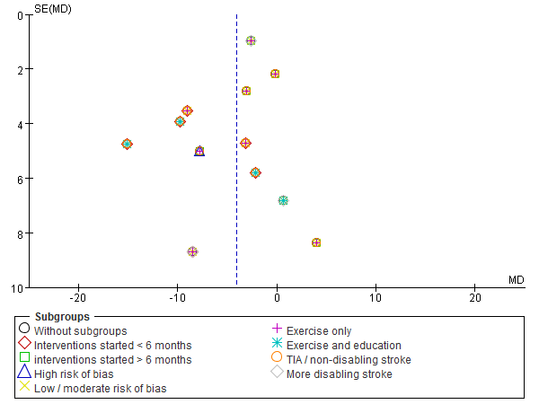

**(b) Diastolic blood pressure studies**

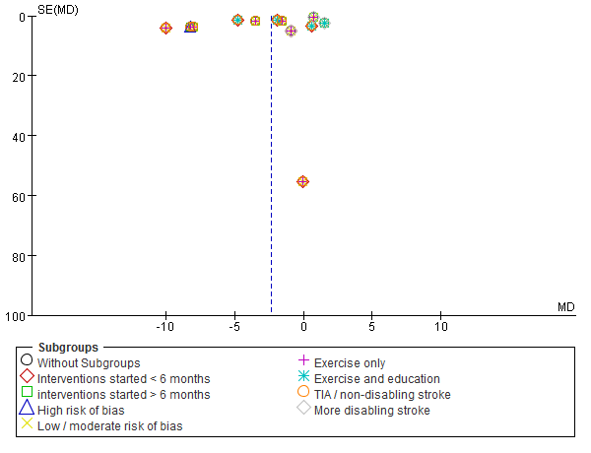

**6. Begg’s test for:**

**(a) Systolic blood pressure studies**



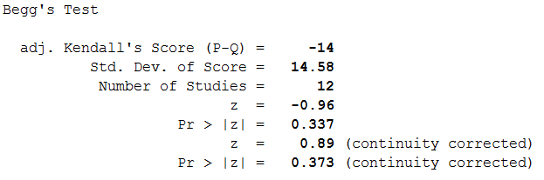

**(b) Diastolic blood pressure studies**



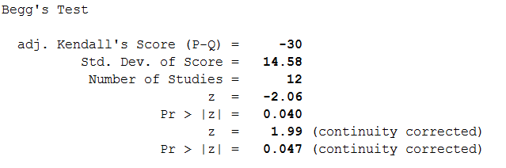

**7. Egger’s test for:**

**(a) Systolic blood pressure studies**



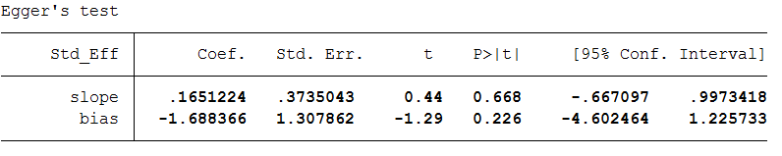

**(b) Diastolic blood pressure studies**



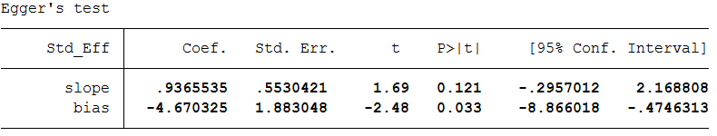

**8. Effect of studies at high risk of bias on meta-analyses for (a) systolic blood pressure, (b) diastolic blood pressure, (c) total cholesterol, (d) low density lipoprotein cholesterol, (e) high density lipoprotein cholesterol and (f) fasting glucose.**

**(a)**

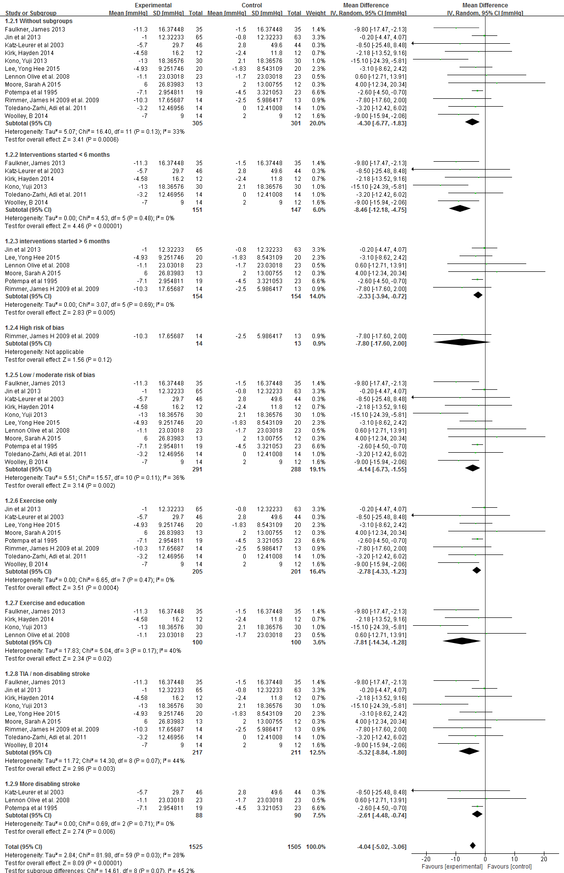



**(b)**

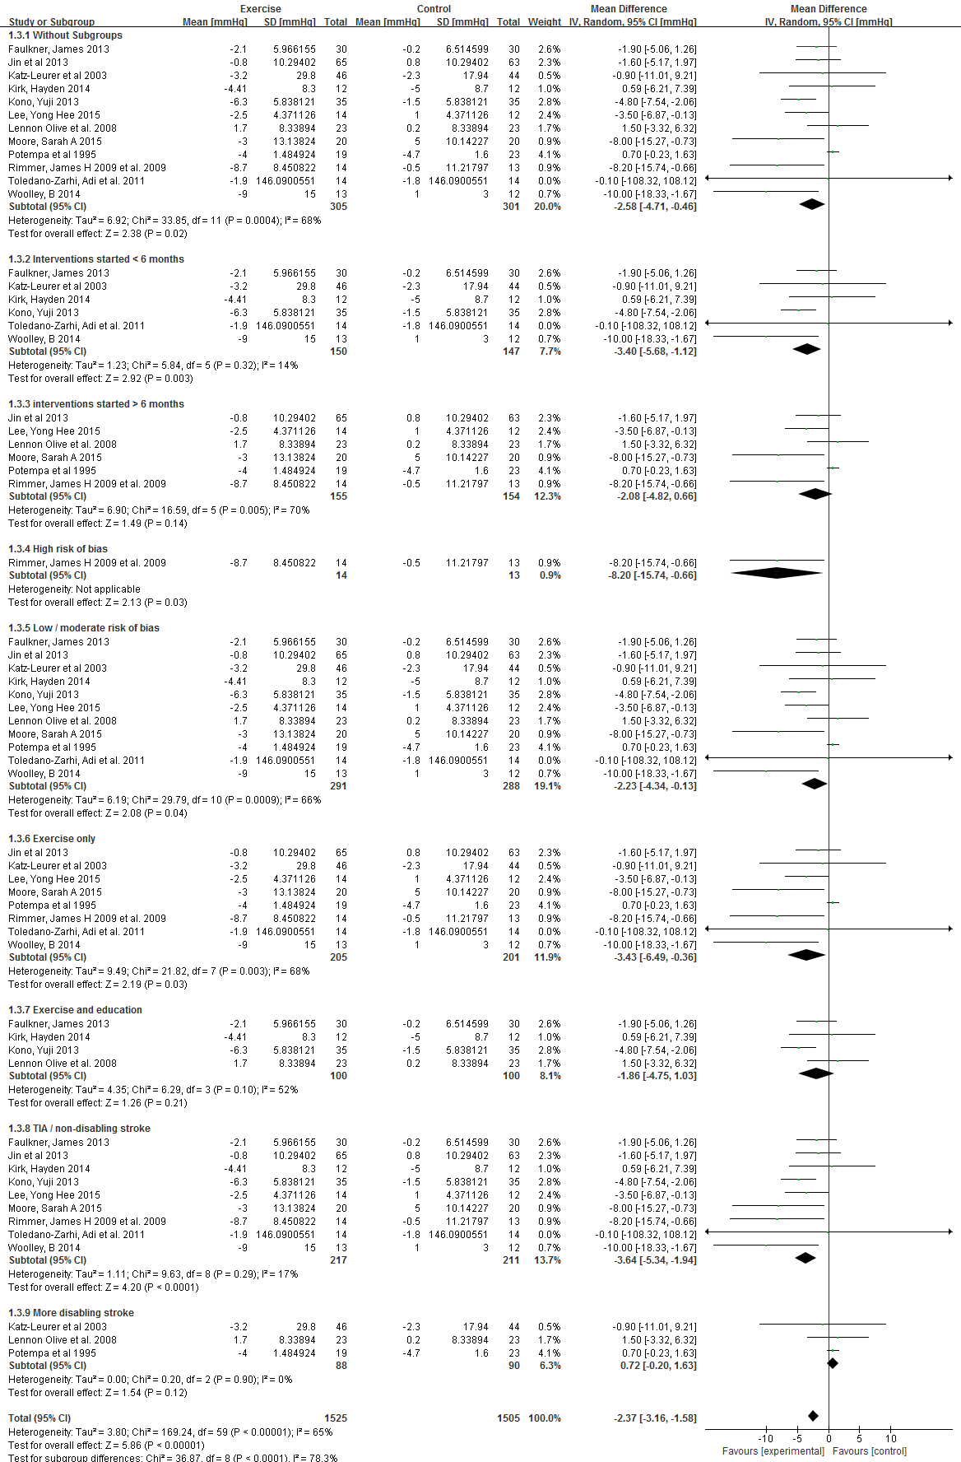



**(c)**

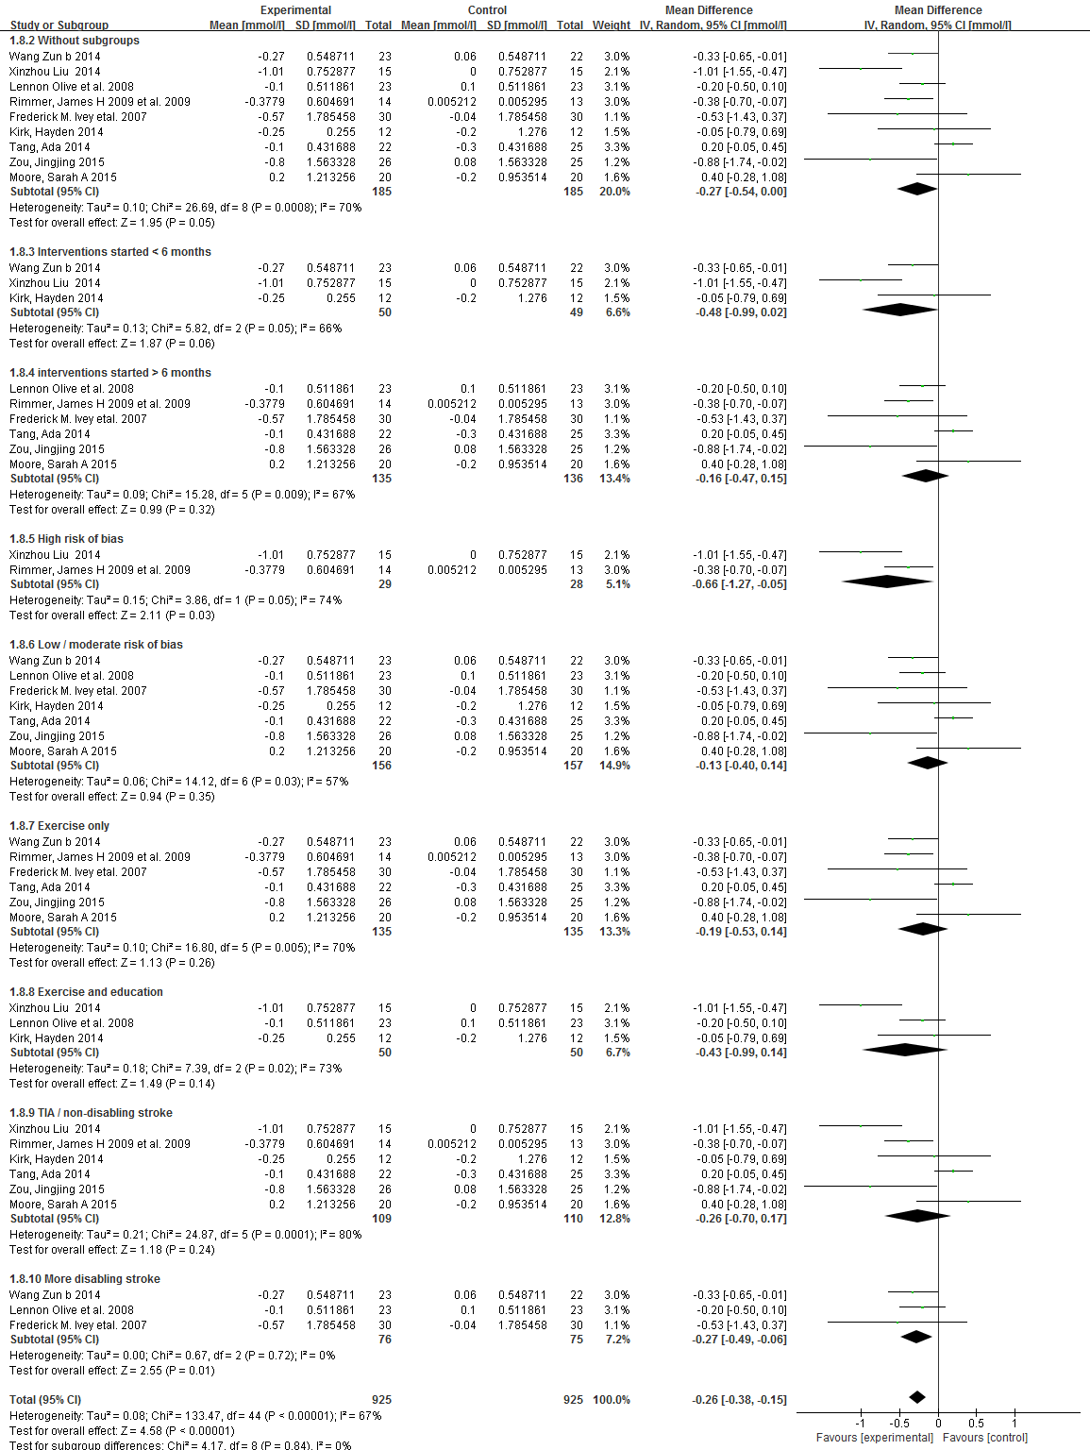



**(d)**



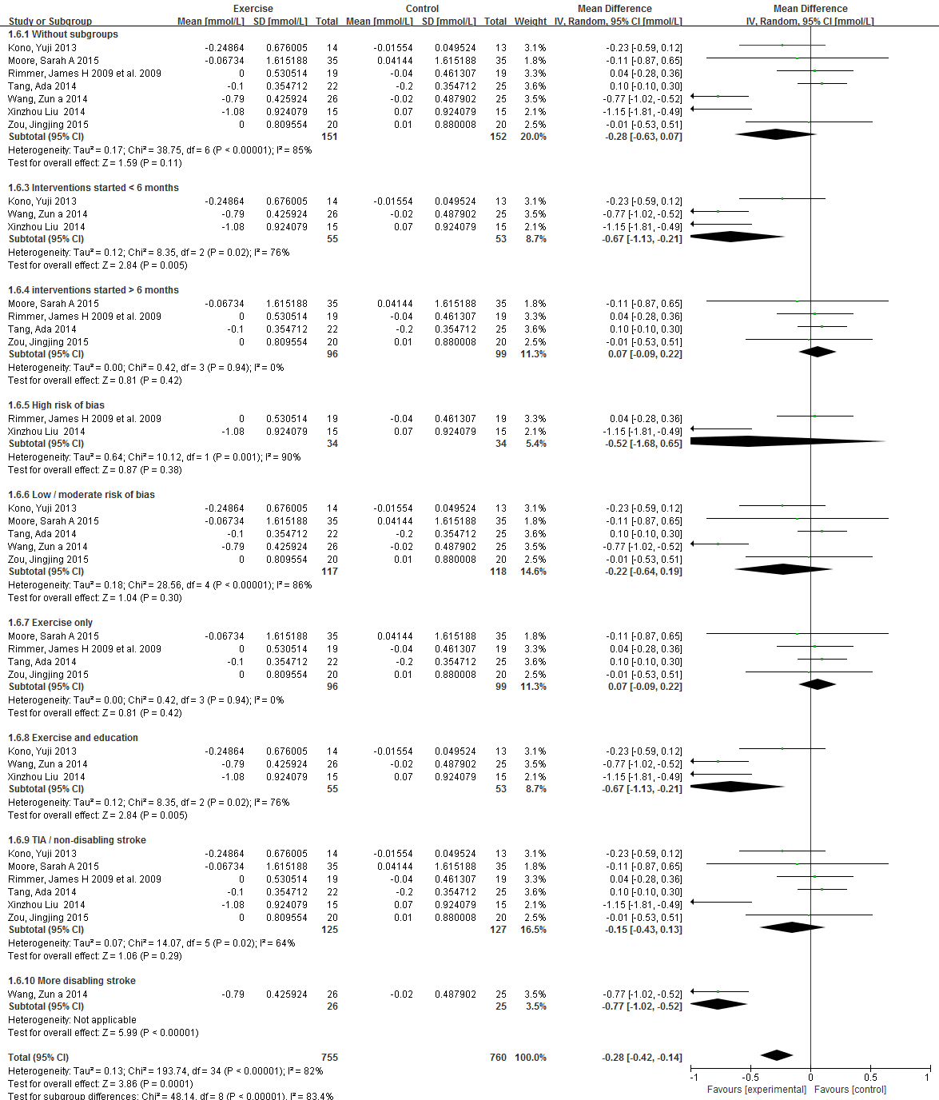

**(e)**



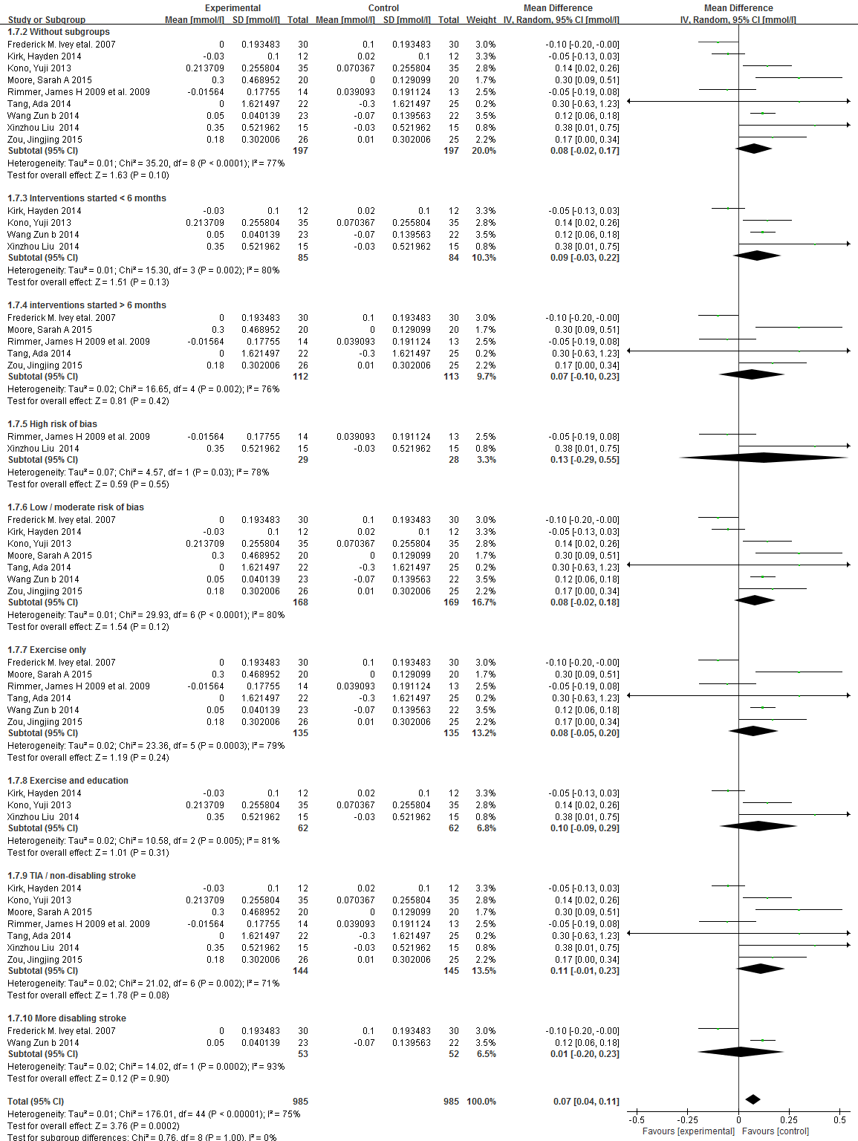

**(f)**



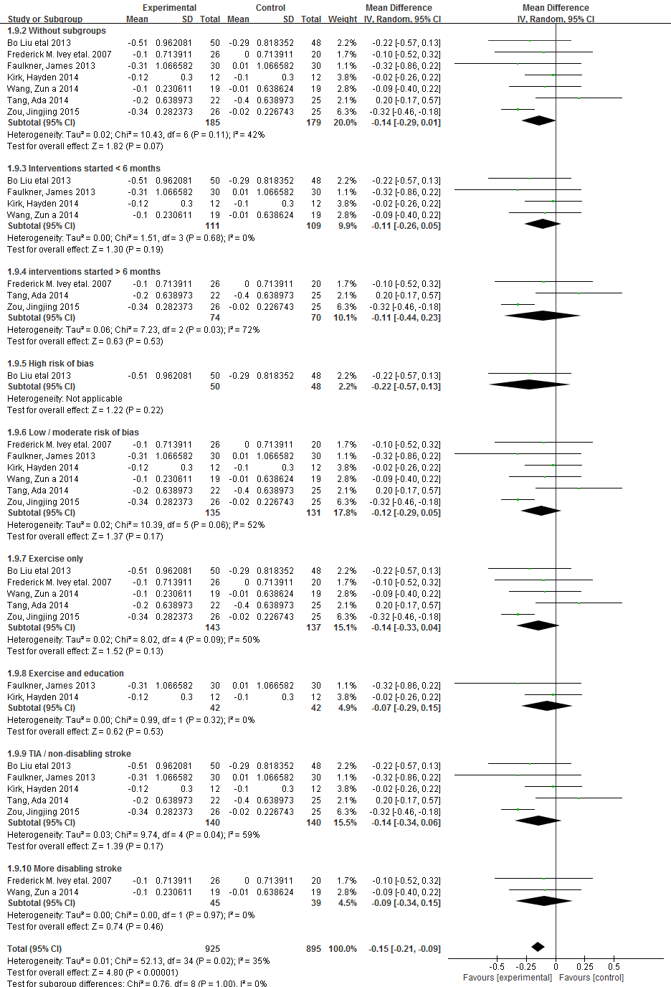

**9. Summary of study intervention characteristics according to the Consensus on Exercise Reporting Template (CERT)**

|  |  |  |  |
| --- | --- | --- | --- |
| **Study** | **CERT category** | | **Description** |
| **Potempa et al29 1995**  **US** | 1 | Type of exercise equipment | Bicycle ergometer |
| 2 | Qualifications / training of exercise instructor | NR |
| 3 | Individual or group exercises | Individual exercises |
| 4 | Supervised or unsupervised | Directly supervised |
| 5 | Measures and reporting of adherence | NR |
| 6 | Motivation strategies | None included |
| 7 | Decision rule for progressing exercise | During first 4 weeks, exercise workload increased from 30-50% maximal effort to highest level attainable by the subjects. |
| 8 | Descriptions for replication (e.g. illustrations) | Brief written description. |
| 9 | Home component | None |
| 10 | Non-exercise component | None |
| 11 | Adverse events documented | NR |
| 12 | Setting | Exercise laboratory |
| 13 | Detailed description of exercises | 30 minutes, 3 x per week  Leg cycle ergometry aiming for 30-50% HRR  Duration: 10 weeks |
| 14 | Generic or tailored | Generic |
| 15 | Decision rule for starting level | Graded exercise testing protocol evaluating maximal effort. |
| 16 | Whether exercise delivered / performed as planned | NR |
| **Katz-Leurer et al30 2003**  **Isreal** | 1 | Type of exercise equipment | Leg cycle ergometer |
| 2 | Qualifications / training of exercise instructor | Qualified physical therapist |
| 3 | Individual or group exercises | Individual exercises |
| 4 | Supervised or unsupervised | Directly supervised |
| 5 | Measures and reporting of adherence | NR |
| 6 | Motivation strategies | None |
| 7 | Decision rule for progressing exercise | None |
| 8 | Descriptions for replication (e.g. illustrations) | None |
| 9 | Home component | None |
| 10 | Non-exercise component | None |
| 11 | Adverse events documented | NR |
| 12 | Setting | Outpatient clinic |
| 13 | Detailed description of exercises | 10-30 minutes, 3-5 x per week  Leg cycle ergometry aiming for 60% HRR  Duration: 8 weeks |
| 14 | Generic or tailored | Tailored to the individual |
| 15 | Decision rule for starting level | Graded stress test evaluating maximal effort and HRR |
| 16 | Whether exercise delivered / performed as planned | NR |
| **Ivey et al31**  **2007**  **US** | 1 | Type of exercise equipment | Running treadmill |
| 2 | Qualifications / training of exercise instructor | NR |
| 3 | Individual or group exercises | NR |
| 4 | Supervised or unsupervised | Directly supervised |
| 5 | Measures and reporting of adherence | Reported proportion (%) of participants non-compliant and dropping out. |
| 6 | Motivation strategies | None included |
| 7 | Decision rule for progressing exercise | Gradually increased duration of weekly exercise by 5 minutes each 2 weeks if tolerating |
| 8 | Descriptions for replication (e.g. illustrations) | NR |
| 9 | Home component | None |
| 10 | Non-exercise component | None |
| 11 | Adverse events documented | NR |
| 12 | Setting | NR |
| 13 | Detailed description of exercises | 40 minutes, 3 x per week  Progressive treadmill exercise training aiming for 40-50% HRR  Duration: 6 months |
| 14 | Generic or tailored | Generic |
| 15 | Decision rule for starting level | Exercise testing to establish maximal effort |
| 16 | Whether exercise delivered / performed as planned | NR |
| **Lennon et al32 2008**  **Ireland** | 1 | Type of exercise equipment | Leg and arm cycle ergometers (Motomed Viva 2) |
| 2 | Qualifications / training of exercise instructor | Qualified physiotherapist |
| 3 | Individual or group exercises | Groups of 2 participants |
| 4 | Supervised or unsupervised | Directly supervised |
| 5 | Measures and reporting of adherence | Proportions (%) of patients dropping out due to non-compliance reported. |
| 6 | Motivation strategies | 2 life skills classes addressing stress management, relaxation and life balance. |
| 7 | Decision rule for progressing exercise | NR |
| 8 | Descriptions for replication (e.g. illustrations) | Brief written description only |
| 9 | Home component | None |
| 10 | Non-exercise component | Relaxation and stress management education |
| 11 | Adverse events documented | NR |
| 12 | Setting | Outpatient cardiac rehabilitation programme |
| 13 | Detailed description of exercises | 30 minutes, 2 x per week  Upper and lower limb cycle ergometry aiming for 50-60% HRR  Duration: 10 weeks |
| 14 | Generic or tailored | Tailored progression of resistance and speed |
| 15 | Decision rule for starting level | None |
| 16 | Whether exercise delivered / performed as planned | NR |
| **Rimmer et al33 2009**  **US** | 1 | Type of exercise equipment | Stationary cycle and recumbent stepper |
| 2 | Qualifications / training of exercise instructor | Qualified exercise physiologist and physical therapist |
| 3 | Individual or group exercises | NR |
| 4 | Supervised or unsupervised | Directly supervised |
| 5 | Measures and reporting of adherence | Participants lost to follow up reported only |
| 6 | Motivation strategies | None |
| 7 | Decision rule for progressing exercise | Gradual increased intensity every 4 weeks (40-49%, 50-59%, 60-69% HRR) |
| 8 | Descriptions for replication (e.g. illustrations) | Brief written description only |
| 9 | Home component | None |
| 10 | Non-exercise component | None |
| 11 | Adverse events documented | NR |
| 12 | Setting | University based medical center |
| 13 | Detailed description of exercises | 30-60 minutes, 3 x per week  Leg cycle ergometry and recumbent stepping for either moderate intensity short duration (MISD) – increasing target HR every 4 weeks (40-49% HRR, 50-59% HRR, 60-69% HRR). Low intensity longer duration (LILD) aimed to increase exercise time each 4 weeks (30 mins, 45 mins, 60 mins).  Duration: 14 weeks |
| 14 | Generic or tailored | Generic |
| 15 | Decision rule for starting level | Exercise testing to establish maximal effort |
| 16 | Whether exercise delivered / performed as planned | NR |
| **Adi toledano Zarhi et al34**  **2011**  **Isreal** | 1 | Type of exercise equipment | Leg and arm cycle ergometer, treadmill |
| 2 | Qualifications / training of exercise instructor | Qualified Physical therapist and cardiac rehabilitation staff |
| 3 | Individual or group exercises | Individual exercises |
| 4 | Supervised or unsupervised | Directly supervised |
| 5 | Measures and reporting of adherence | Compliance was monitored and the exercise prescription adjusted according to ability |
| 6 | Motivation strategies | None |
| 7 | Decision rule for progressing exercise | NR |
| 8 | Descriptions for replication (e.g. illustrations) | Brief written description only |
| 9 | Home component | Home exercise booklet provided |
| 10 | Non-exercise component | 1 session per week working on flexibility and coordination |
| 11 | Adverse events documented | Reported on adverse events |
| 12 | Setting | Outpatient clinic |
| 13 | Detailed description of exercises | 35-55 minutes, 3 x per week  2 x weekly sessions of treadmill, arm and leg cycle ergometry aiming for target 50-70% HRR, and 1 session of strength, flexibility and coordination training.  Duration: 6 weeks |
| 14 | Generic or tailored | Tailored according to ability |
| 15 | Decision rule for starting level | Bruce protocol exercise testing to establish maximal effort |
| 16 | Whether exercise delivered / performed as planned | NR |
| **Faulkner et al35 2013**  **New Zealand** | 1 | Type of exercise equipment | Leg cycle ergometer and treadmill, static machine for bicep curl and shoulder press, buso and swiss balls. |
| 2 | Qualifications / training of exercise instructor | Qualified exercise practitioner |
| 3 | Individual or group exercises | Group exercises (groups of 3-5) |
| 4 | Supervised or unsupervised | Directly supervised |
| 5 | Measures and reporting of adherence | Compliance was measured as a proportion (%) of participants completing all exercise sessions. |
| 6 | Motivation strategies | Group-focused education sessions based on health belief model of behavior change. |
| 7 | Decision rule for progressing exercise | Exercise intensity typically increased by 5% each week dependent on acceptable rate of perceived exertion (not greater than 15 = ‘hard’) and HRR increase (not greater than 85%). |
| 8 | Descriptions for replication (e.g. illustrations) | Detailed written description of exercise sequences. |
| 9 | Home component | None |
| 10 | Non-exercise component | 8 x 30 minute health education sessions |
| 11 | Adverse events documented | Reported on adverse events |
| 12 | Setting | Outpatient cardiac rehabilitation clinic |
| 13 | Detailed description of exercises | 30-90 minutes, 3 x per week  2 x weekly 90 min sessions of walking and cycling exercise aiming for 50-85% HRR, increasing incrementally each week. Also 1 x weekly 30 min health education session (vascular risk, stroke prevention, nutrition, BP, medication compliance, stress).  Duration: 8 weeks |
| 14 | Generic or tailored | Tailored to individual ability and progress by monitoring HRR throughout |
| 15 | Decision rule for starting level | Bruce protocol exercise testing to establish maximal effort |
| 16 | Whether exercise delivered / performed as planned | NR |
| **Bo Liu et al 36 2013**  **China** | 1 | Type of exercise equipment | NR |
| 2 | Qualifications / training of exercise instructor | NR |
| 3 | Individual or group exercises | Individual exercises |
| 4 | Supervised or unsupervised | NR |
| 5 | Measures and reporting of adherence | NR |
| 6 | Motivation strategies | None |
| 7 | Decision rule for progressing exercise | NR |
| 8 | Descriptions for replication (e.g. illustrations) | NR |
| 9 | Home component | None |
| 10 | Non-exercise component | None |
| 11 | Adverse events documented | NR |
| 12 | Setting | Hospital clinic |
| 13 | Detailed description of exercises | Aerobic exercise described only |
| 14 | Generic or tailored | NR |
| 15 | Decision rule for starting level | NR |
| 16 | Whether exercise delivered / performed as planned | NR |
| **Kono et al37**  **2013**  **Japan** | 1 | Type of exercise equipment | Leg cycle ergometer, static machine for chest press, push–up, pull-down, back extension, leg extension, knee flexion and extension, and abdominal muscle exercises |
| 2 | Qualifications / training of exercise instructor | Well-trained health care professional interventionist |
| 3 | Individual or group exercises | NR |
| 4 | Supervised or unsupervised | Directly supervised |
| 5 | Measures and reporting of adherence | Proportion (%) of participants dropping out reported only |
| 6 | Motivation strategies | Counseling on behavior changes provided |
| 7 | Decision rule for progressing exercise | Exercise progression titrated over initial 2 week period with gradual doubling in duration of leg cycling (15 to 30 minutes), provided HR did not exceed 110/min |
| 8 | Descriptions for replication (e.g. illustrations) | Detailed written description of aerobic and resistance exercises |
| 9 | Home component | Home based physical activity programme to increase daily step count |
| 10 | Non-exercise component | Salt reduction programme delivered by physical therapists 1-2 x per week for 24 weeks, aiming for daily salt intake of less than 9g/day |
| 11 | Adverse events documented | All adverse events documented clearly |
| 12 | Setting | Hospital clinic (center based) and home based |
| 13 | Detailed description of exercises | 60 minutes, 1-2 x per week center based  30-60 minutes, 3-5 x per week home based  Leg cycle ergometry 20-30 minutes per session followed by 30 minutes of resistance exercises (chest press, push –up, pull-down, back extension, leg extension, knee flexion and extension, and abdominal muscle exercises)  Duration: 24 weeks |
| 14 | Generic or tailored | Tailored depending on ability, progress, and diet |
| 15 | Decision rule for starting level | NR |
| 16 | Whether exercise delivered / performed as planned | NR |
| **Jin et al38**  **2013**  **China** | 1 | Type of exercise equipment | Leg cycle ergometer |
| 2 | Qualifications / training of exercise instructor | Trained physical therapists and cardiologists |
| 3 | Individual or group exercises | NR |
| 4 | Supervised or unsupervised | Directly supervised |
| 5 | Measures and reporting of adherence | Proportion (%) of participants dropping out reported only |
| 6 | Motivation strategies | None |
| 7 | Decision rule for progressing exercise | Exercise duration increased from baseline of 10-20 minutes by 5 minutes every 2 weeks, while intensity increased by 5% HR increase every 2 weeks |
| 8 | Descriptions for replication (e.g. illustrations) | Brief written description only |
| 9 | Home component | None |
| 10 | Non-exercise component | None |
| 11 | Adverse events documented | Adverse events reported |
| 12 | Setting | Outpatient rehabilitation clinic |
| 13 | Detailed description of exercises | 40 minutes, 5 x per week  Aerobic cycling training aiming for 50-70% HRR.  Duration: 12 weeks |
| 14 | Generic or tailored | Generic |
| 15 | Decision rule for starting level | Generic low level duration (10-20 minutes) and intensity (40-50% HRR) start level for all |
| 16 | Whether exercise delivered / performed as planned | NR |
| **Boss et al39**  **2014**  **Netherlands** | 1 | Type of exercise equipment | NR |
| 2 | Qualifications / training of exercise instructor | Qualified physiotherapist |
| 3 | Individual or group exercises | NR |
| 4 | Supervised or unsupervised | Directly supervised |
| 5 | Measures and reporting of adherence | Reported on proportion (%) completing the programme |
| 6 | Motivation strategies | Motivational interviewing on healthy lifestyle behaviors |
| 7 | Decision rule for progressing exercise | NR |
| 8 | Descriptions for replication (e.g. illustrations) | NR |
| 9 | Home component | None |
| 10 | Non-exercise component | Lifestyle advice |
| 11 | Adverse events documented | Well documented adverse events |
| 12 | Setting | Outpatient stroke clinic |
| 13 | Detailed description of exercises | 60 minutes, 3 x per week  Aerobic exercise and strength training with incrementing intensity  Duration: 8 weeks |
| 14 | Generic or tailored | NR |
| 15 | Decision rule for starting level | Exercise testing to establish maximal effort |
| 16 | Whether exercise delivered / performed as planned | NR |
| **Xinzhou Liu 40 2014**  **China** | 1 | Type of exercise equipment | Treadmill, elasticated therapy bands |
| 2 | Qualifications / training of exercise instructor | NR |
| 3 | Individual or group exercises | NR |
| 4 | Supervised or unsupervised | NR |
| 5 | Measures and reporting of adherence | NR |
| 6 | Motivation strategies | None |
| 7 | Decision rule for progressing exercise | NR |
| 8 | Descriptions for replication (e.g. illustrations) | Brief written description |
| 9 | Home component | None |
| 10 | Non-exercise component | None |
| 11 | Adverse events documented | NR |
| 12 | Setting | Hospital clinic |
| 13 | Detailed description of exercises | 40-60 minutes, 5 x per week  Aerobic treadmill training aiming for 50-80% HRR, with or without elastic band resistance training  Duration: 8 weeks |
| 14 | Generic or tailored | Tailored according to ability and progress with achieving target HRR |
| 15 | Decision rule for starting level | NR |
| 16 | Whether exercise delivered / performed as planned | NR |
| **Kirk et al41**  **2014**  **UK** | 1 | Type of exercise equipment | Dumbells, static machine for shoulder press and upright row, trampet, treadmill |
| 2 | Qualifications / training of exercise instructor | Qualified cardiac rehabilitation therapists |
| 3 | Individual or group exercises | Group and individual exercises |
| 4 | Supervised or unsupervised | Directly supervise individually or in groups |
| 5 | Measures and reporting of adherence | Reported proportion (%) of participant drop out |
| 6 | Motivation strategies | None |
| 7 | Decision rule for progressing exercise | None, start at intended duration and intensity |
| 8 | Descriptions for replication (e.g. illustrations) | Clear and detailed written description of exercise sequence |
| 9 | Home component | None |
| 10 | Non-exercise component | 6 x 1 hour health education sessions (medication, alcohol, exercise, diet, the heart, wellbeing), along with 10 minutes relaxation exercise using a relaxation tape |
| 11 | Adverse events documented | Detailed documentation of adverse events |
| 12 | Setting | Community cardiac rehabilitation clinic |
| 13 | Detailed description of exercises | 60 minutes, 1-2 x per week  Warm up (walking, upper limb and lower limb stretching) 10 minutes followed by 40 minute circuit classes involving high and low intensity exercises, aiming for target HRR of 50-70%.  - High intensity: step-ups, walking/running, heel rises with lunge, step backs with arm raises, side steps.  - Low intensity: bicep curls, lateral raises, shoulder press.  Duration: 18 weeks |
| 14 | Generic or tailored | Tailored according to Borg RPE |
| 15 | Decision rule for starting level | NR |
| 16 | Whether exercise delivered / performed as planned | NR |
| **Wang et al42,43**  **2014a,b**  **China** | 1 | Type of exercise equipment | Leg cycle ergometer |
| 2 | Qualifications / training of exercise instructor | Qualified physiotherapist |
| 3 | Individual or group exercises | Individual exercises |
| 4 | Supervised or unsupervised | Directly supervised |
| 5 | Measures and reporting of adherence | Reported proportion (%) of participants dropping out due to compliance as well as overall proportion (%) of exercise sessions completed |
| 6 | Motivation strategies | None |
| 7 | Decision rule for progressing exercise | None, initiated at target HRR |
| 8 | Descriptions for replication (e.g. illustrations) | Brief written description of exercise procedures |
| 9 | Home component | None |
| 10 | Non-exercise component | None |
| 11 | Adverse events documented | Well documented |
| 12 | Setting | Outpatient rehabilitation clinic |
| 13 | Detailed description of exercises | 40 minutes, 3 x per week  5 minutes warm up pedaling followed by 30 minutes at target HRR (50-70%) followed by 5 minutes of cool-down period  Duration: 6 weeks |
| 14 | Generic or tailored | Generic |
| 15 | Decision rule for starting level | Exercise testing to establish maximal effort |
| 16 | Whether exercise delivered / performed as planned | NR |
| **Tang et al44**  **2014**  **Canada** | 1 | Type of exercise equipment | Leg cycle ergometer, platform stepper |
| 2 | Qualifications / training of exercise instructor | Exercise instructors whose level of qualification was not reported |
| 3 | Individual or group exercises | Group exercises (groups of 12) |
| 4 | Supervised or unsupervised | Directly supervised |
| 5 | Measures and reporting of adherence | Reported proportion (%) of drop outs as well as overall class attendance and proportion (%) of participants achieving target HRR |
| 6 | Motivation strategies | None |
| 7 | Decision rule for progressing exercise | Intensity progressed from 40% to 70-80% HRR by increasing HRR by 10% every 4 weeks |
| 8 | Descriptions for replication (e.g. illustrations) | Detailed written description of exercise procedure |
| 9 | Home component | None |
| 10 | Non-exercise component | None |
| 11 | Adverse events documented | Well documented adverse events |
| 12 | Setting | Outpatient research facility |
| 13 | Detailed description of exercises | 60 minutes, 3 x per week  10 minute warm up followed by 30-40 minute aerobic component including recumbent cycle ergometry, repeated sit to stand, or step-ups to platform, followed by 10 minute cool down  Duration: 6 months |
| 14 | Generic or tailored | Tailored according to ability to progress HRR target and Borg RPE |
| 15 | Decision rule for starting level | Exercise testing to establish maximal effort |
| 16 | Whether exercise delivered / performed as planned | Reported on proportion (%) achieving HR targets along with attendance at exercise sessions |
| **Woolley et al45**  **2014**  **New Zealand** | 1 | Type of exercise equipment | Stationary cycle, treadmill |
| 2 | Qualifications / training of exercise instructor | NR |
| 3 | Individual or group exercises | NR |
| 4 | Supervised or unsupervised | NR |
| 5 | Measures and reporting of adherence | NR |
| 6 | Motivation strategies | None |
| 7 | Decision rule for progressing exercise | Increase in intensity by 5% HRR each week for target of 50-85% HRR |
| 8 | Descriptions for replication (e.g. illustrations) | Brief written description |
| 9 | Home component | None |
| 10 | Non-exercise component | None |
| 11 | Adverse events documented | NR |
| 12 | Setting | Outpatient rehabilitation clinic |
| 13 | Detailed description of exercises | 90 minutes, 2 x per week  30 min session of aerobic exercise (cycling and treadmill walking) aiming for 50-85% HRR. Followed by 60 min session of upper and lower body resistance, balance and core-stability exercises  Duration: 8 weeks |
| 14 | Generic or tailored | Tailored intensity increase according to Borg RPE |
| 15 | Decision rule for starting level | Exercise testing to establish maximal effort |
| 16 | Whether exercise delivered / performed as planned | NR |
| **Lee YH et al46 2015**  **Korea** | 1 | Type of exercise equipment | Treadmill, elasticated resistance bands |
| 2 | Qualifications / training of exercise instructor | Trained exercise rehabilitation specialist and physical therapist |
| 3 | Individual or group exercises | NR |
| 4 | Supervised or unsupervised | Directly supervised |
| 5 | Measures and reporting of adherence | Reported drop outs only |
| 6 | Motivation strategies | None |
| 7 | Decision rule for progressing exercise | Aerobic exercise intensity increased from target 50-60% HRR to 60-70% HRR at 8 weeks. Resistance exercises also increased in intensity from RPE 11 to 16 at 8 weeks. |
| 8 | Descriptions for replication (e.g. illustrations) | Detailed written description of exercise procedures |
| 9 | Home component | None |
| 10 | Non-exercise component | None |
| 11 | Adverse events documented | NR |
| 12 | Setting | Community rehabilitation clinic |
| 13 | Detailed description of exercises | 90 minutes, 3 x per week  10 minutes warm up followed by 20 minutes aerobic activity (incline walking, stepping), 20 minutes resistance exercises (squats, lunges, flexion/extension arm and leg joints, abdominal crunches) and a 5 minute cool down (stretching / walking)  Duration: 16 weeks |
| 14 | Generic or tailored | Tailored type of exercise according to disability, as well as intensity according to RPE |
| 15 | Decision rule for starting level | None, all started at similar level of duration and intensity |
| 16 | Whether exercise delivered / performed as planned | NR |
| **Zou et al47**  **2015**  **China** | 1 | Type of exercise equipment | Resistance training machine (Xiaya Medical Equipment Co, Ltd) |
| 2 | Qualifications / training of exercise instructor | NR |
| 3 | Individual or group exercises | NR |
| 4 | Supervised or unsupervised | NR |
| 5 | Measures and reporting of adherence | Reported proportion (%) of drop outs |
| 6 | Motivation strategies | None |
| 7 | Decision rule for progressing exercise | Resistance initially set at level to cause muscle failure at 10-12 reps. |
| 8 | Descriptions for replication (e.g. illustrations) | Resistance intensity increased every 2 weeks |
| 9 | Home component | None |
| 10 | Non-exercise component | None |
| 11 | Adverse events documented | NR |
| 12 | Setting | Outpatient rehabilitation clinic |
| 13 | Detailed description of exercises | 40 minutes, 3 x per week  Resistance leg training (leg press, extension, curls) aiming for muscle failure between 10-12 repetitions  Duration: 8 weeks |
| 14 | Generic or tailored | Tailored increases in resistance intensity accordingly ability |
| 15 | Decision rule for starting level | 1 repetition maximum test |
| 16 | Whether exercise delivered / performed as planned | Reported proportion (%) of participants completed exercise sessions |
| **Moore et al48**  **2015**  **UK** | 1 | Type of exercise equipment | Swiss ball, platform step, |
| 2 | Qualifications / training of exercise instructor | Physiotherapist and exercise instructor |
| 3 | Individual or group exercises | Group exercises |
| 4 | Supervised or unsupervised | Directly supervised |
| 5 | Measures and reporting of adherence | Reported proportion (%) of participant drop outs and completed exercise sessions. |
| 6 | Motivation strategies | None |
| 7 | Decision rule for progressing exercise | Aerobic exercise intensity increased from 40-50% HRR to 70-80% HRR by 10% every 4 weeks. Strength and balance exercises progressed by gradually increasing reps and loading |
| 8 | Descriptions for replication (e.g. illustrations) | Detailed written description of exercise procedures |
| 9 | Home component | None |
| 10 | Non-exercise component | None |
| 11 | Adverse events documented | Well documented |
| 12 | Setting | Community leisure center |
| 13 | Detailed description of exercises | 45-60 minutes, 3 x per week  10 minutes warm up / stretching followed by 15 minutes of functional strengthening (chair push-ups, sit-to-stand, squat with swiss ball), 15 minutes of balance exercises (forward reach, hell-to-toe walking, standing on one leg), and 15 minutes of agility and fitness (forward and side steps, walking/jogging, marching, box step, hamstring curl), followed by 5 minutes of cool down. |
| 14 | Generic or tailored | Tailored progression and circuit exercises |
| 15 | Decision rule for starting level | Heart rate training zone calculated using the Karvonen formula |
| 16 | Whether exercise delivered / performed as planned | Reported on pre-specified fidelity criteria |

*NR = not reported, HRR = heart rate reserve, reps = repetitions, RPE = rate of perceived exertion*

**10. GRADE assessment of quality of evidence according to outcome measure reported**

|  |  |  |  |
| --- | --- | --- | --- |
| GRADE criteria | Rating | Footnotes | Quality of evidence |
| Outcome: Systolic blood pressure (SBP) | | | |
| Study design | RCT (starts as high quality)  Non-RCT (starts as low quality) | High quality | Moderate  +++ |
| Risk of Bias | No | Most studies from low or unclear risk of bias, and plausible bias unlikely to alter results |
| Inconsistency | No | Low I2 statistic for SBP suggesting low heterogeneity. |
| Indirectness | No | Largely similar populations studied against similar comparators reporting resting blood pressure directly. |
| Imprecision | Serious (-1) | Total number of participants in studies reporting blood pressure is 606, however the confidence intervals span a range that include a less clinically meaningful blood pressure reduction. |
| Publication Bias | Undetected  Strong (-1) | Relatively symmetrical funnel plot of studies reporting SBP |
| Other  (upgrading factors) | Large effect (+1 or +2)  Dose response (+1 or +2)  No plausible confounding (+1 or +2) | NA |

|  |  |  |  |
| --- | --- | --- | --- |
| GRADE criteria | Rating | Footnotes | Quality of evidence |
| Outcome: Diastolic blood pressure (DBP) | | | |
| Study design | RCT (starts as high quality)  Non-RCT (starts as low quality) | High quality | Low  ++ |
| Risk of Bias | No | Most studies from low or unclear risk of bias, and plausible bias unlikely to alter results. |
| Inconsistency | Serious (-1) | Relatively high I2 statistic for DBP suggesting substantial heterogeneity |
| Indirectness | No | Largely similar populations studied against similar comparators reporting resting blood pressure directly. |
| Imprecision | Serious (-1) | Total number of participants in studies reporting blood pressure is 606, however the confidence intervals span a range that include a less clinically meaningful blood pressure reduction. |
| Publication Bias | Undetected  Strong (-1) | Funnel plot for DBP studies does not suggest overt publication bias. |
| Other  (upgrading factors) | Large effect (+1 or +2)  Dose response (+1 or +2)  No plausible confounding (+1 or +2) |  |

|  |  |  |  |
| --- | --- | --- | --- |
| GRADE criteria | Rating | Footnotes | Quality of evidence |
| Outcome: Total cholesterol (TC) | | | |
| Study design | RCT (starts as high quality)  Non-RCT (starts as low quality) | High quality | Low  ++ |
| Risk of Bias | No | Most studies from low or unclear risk of bias, and plausible bias unlikely to alter results. |
| Inconsistency | Serious (-1) | Relatively high I2 statistic for DBP suggesting substantial heterogeneity |
| Indirectness | No | Largely similar populations studied against similar comparators reporting total cholesterol, which is a known classical vascular risk factor. |
| Imprecision | Serious (-1) | Total number of participants in studies reporting TC was 370. Confidence intervals do span a range that includes no change in TC at all. |
| Publication Bias | Undetected | Funnel plot for total cholesterol symmetrical and does not suggest publication bias. |
| Other  (upgrading factors) | Large effect (+1 or +2)  Dose response (+1 or +2)  No plausible confounding (+1 or +2) |  |

|  |  |  |  |
| --- | --- | --- | --- |
| GRADE criteria | Rating | Footnotes | Quality of evidence |
| Outcome: Low-density lipoprotein cholesterol (LDL-C) | | | |
| Study design | RCT (starts as high quality)  Non-RCT (starts as low quality) | High quality | Very low  + |
| Risk of Bias | No | Most studies from low or unclear risk of bias, and plausible bias unlikely to alter results. |
| Inconsistency | Serious (-1) | High I2 statistic suggesting significant inconsistency. |
| Indirectness | No | Largely similar populations studied against similar comparators reporting LDL-C, which is a known classical vascular risk factor. |
| Imprecision | Serious (-1) | Total number of participants in studies reporting on LDL-C is 303, with very wide confidence intervals. |
| Publication Bias | Strong (-1) | Significant asymmetry of funnel plots and small studies suggesting presence of publication bias. |
| Other  (upgrading factors) | Large effect (+1 or +2)  Dose response (+1 or +2)  No plausible confounding (+1 or +2) |  |

|  |  |  |  |
| --- | --- | --- | --- |
| GRADE criteria | Rating | Footnotes | Quality of evidence |
| Outcome: High-density lipoprotein cholesterol (HDL-C) | | | |
| Study design | RCT (starts as high quality)  Non-RCT (starts as low quality) | High quality | Very low  + |
| Risk of Bias | No | Most studies from low or unclear risk of bias, and plausible bias unlikely to alter results. |
| Inconsistency | Serious (-1) | High I2 statistic suggesting significant inconsistency. |
| Indirectness | No | Largely similar populations studied against similar comparators reporting HDL-C, which is a known classical vascular risk factor. |
| Imprecision | Serious (-1) | Total number of participants in studies reporting on LDL-C is 396. Confidence intervals span range that suggest no improvements in HDL-C levels. |
| Publication Bias | Strong (-1) | Funnel plot asymmetry exists and still relatively small participant numbers in reported studies. |
| Other  (upgrading factors) | Large effect (+1 or +2)  Dose response (+1 or +2)  No plausible confounding (+1 or +2) |  |

|  |  |  |  |
| --- | --- | --- | --- |
| GRADE criteria | Rating | Footnotes | Quality of evidence |
| Outcome: Fasting glucose (FG) | | | |
| Study design | RCT (starts as high quality)  Non-RCT (starts as low quality) | High quality | Moderate  +++ |
| Risk of Bias | No | Most studies from low or unclear risk of bias, and plausible bias unlikely to alter results. |
| Inconsistency | No | Relatively low I2 suggesting low heterogeneity, little variation in effect estimates across studies. |
| Indirectness | No | Largely similar populations studied against similar comparators reporting FG, however the link with secondary risk of stroke is less direct than the other risk factors analyzed in this review. |
| Imprecision | Serious (-1) | Total number of participants in studies reporting on FG is 364. Upper and lower limits of CI’s span a range that could suggest no reduction in fasting glucose. |
| Publication Bias | Undetected | Funnel plot does not suggest publication bias but included studies are generally small. |
| Other  (upgrading factors) | Large effect (+1 or +2)  Dose response (+1 or +2)  No plausible confounding (+1 or +2) |  |

|  |  |  |  |
| --- | --- | --- | --- |
| GRADE criteria | Rating | Footnotes | Quality of evidence |
| Outcome: Body mass index (BMI) | | | |
| Study design | RCT (starts as high quality)  Non-RCT (starts as low quality) | High quality | Moderate  +++ |
| Risk of Bias | No | Most studies from low or unclear risk of bias, and plausible bias unlikely to alter results. |
| Inconsistency | No | Low I2 statistic with little variation in effect estimate across studies suggests relatively low inconsistency. |
| Indirectness | Serious (-1) | Largely similar populations studied against similar comparators reporting BMI, however the link with secondary risk of stroke is less direct than the other risk factors analyzed in this review. |
| Imprecision | No | Total number of participants in studies reporting on BMI is 446. Upper and lower CI’s suggest no effect of exercise on BMI. |
| Publication Bias | No | Funnel plot does not suggest publication bias |
| Other  (upgrading factors) | Large effect (+1 or +2)  Dose response (+1 or +2)  No plausible confounding (+1 or +2) |  |

Funnel plot for TC

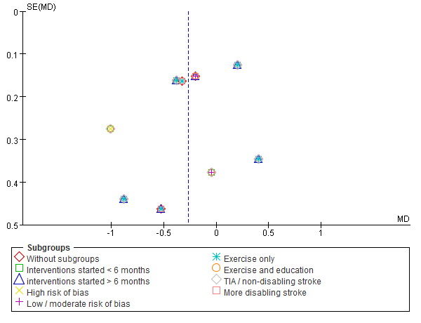

Funnel plot for LDL-C

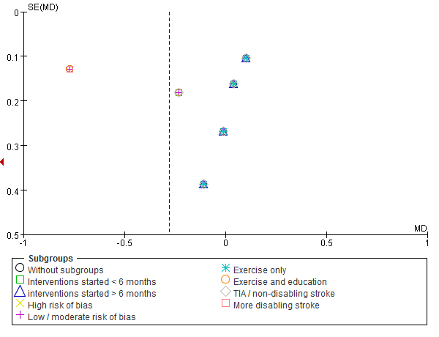

Funnel plot for HDL-C

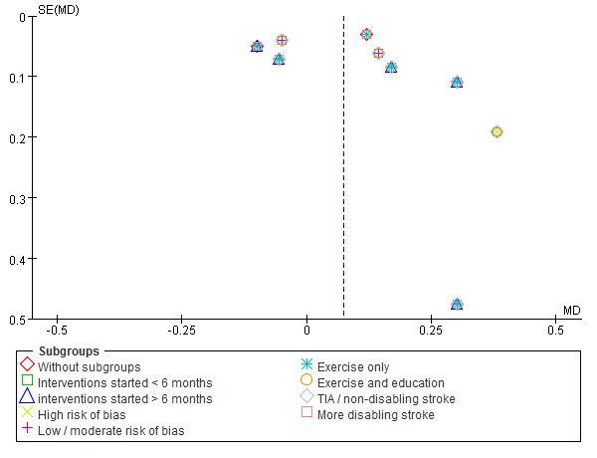

Funnel plot for Fasting glucose

