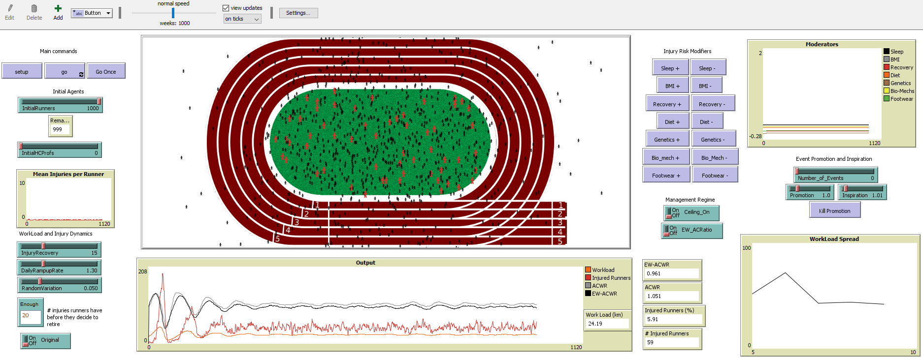
Figure 1: The distance running NetLogo interface and simulation environment. The distance running ABM includes several types of interface items, including buttons, switches, sliders, monitors, counts, and dynamic plots.

